GAUTENG DEPARTMENT OF EDUCATION

SENIOR CERTIFICATE EXAMINATION

FUNCTIONAL PHYSICAL SCIENCE SG
(First Paper: Physics)

TIME: 2 hours

MARKS: 150
REQUIREMENTS:

- An approved (non-programmable, scientific) calculator. Candidates should supply their own calculators.

INSTRUCTIONS:

- Write your examination number in the space provided on the cover of your answer book.

- Answer ALL the questions.

- Answer Question 1 on the answer sheet on the inside cover of your answer book.

- Answer all the other questions in your answer book. Number your answers exactly as they are numbered in the question paper.

- A data sheet is provided at the end of this question paper. It contains equations and constants. Some of the information given may be useful in answering this question paper.

- Rough work may be done at the back of your answer book.

QUESTION 1
A B C D
MULTIPLE CHOICE QUESTIONS

Each question has four possible answers. Choose the letter which in your opinion represents the correct answer and draw a cross (X) over the corresponding letter on the answer sheet in the inside cover of your answer book. If more than one cross appears in an answer, NO MARKS will be awarded.

EXAMPLE:

At what temperature does pure ice melt?

- -4°C
- 0°C
- 0 K
- 4°C

ANSWER:

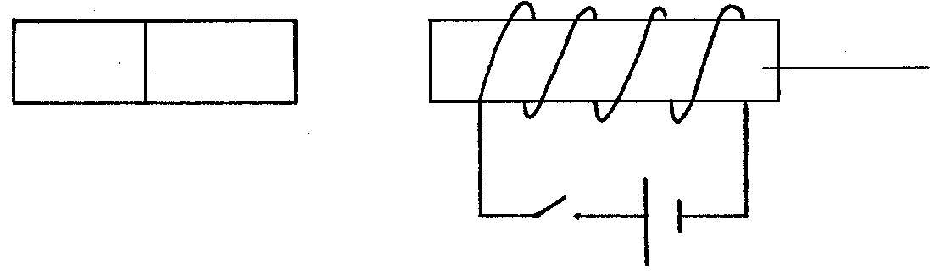  - When the switch in the accompanying circuit is closed  Cardboard cylinder  S  N  - the magnet will be repelled to the left.  - the magnet will be attracted to the right.  - the magnet will move vertically downward.  - the magnet will move vertically upward. | (3)

- The diagram shows a wire conducting a current between the poles of a magnet. The direction of conventional current is shown in the sketch.  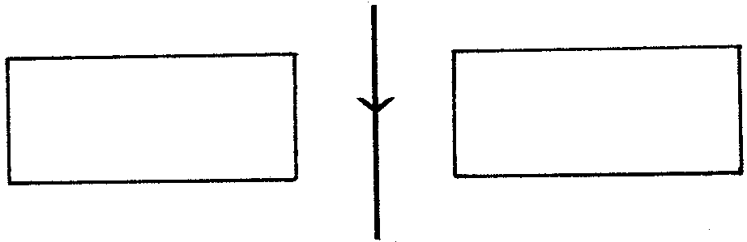  N  S  In which direction does the wire tend to move?  - Into the paper  - Out of the paper  - Towards the south pole of the magnet  - Towards the north pole of the magnet | (3)

- A teacher places a soft iron core in a current-bearing solenoid. What effect does the soft iron core have on the magnetic field of the solenoid?  The magnetic field  - changes its direction.  - changes into a permanent magnetic field.  - increases in strength.  - decreases in strength. | (3)

For a certain transformer Vp > Vs. Then  - Np > Ns.  - NpNs = NsVs.  - Np < Ns.  - NpVs < NsVp. | (3)

In an alternating current  - the magnitude and the direction of the current remain constant.  - the magnitude of the current remains constant, but the direction changes periodically.  - the magnitude and the direction of the current change periodically.  - the direction of the current remains constant, but its magnitude changes periodically. | (3)

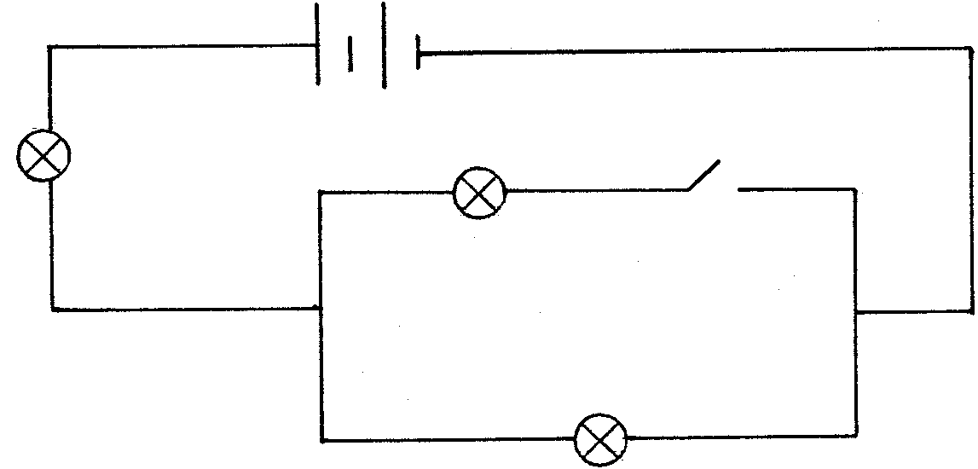
Bulbs P, Q, and R in the circuit have the same resistance.
S
Q
R
P

If the switch S is closed, the bulbs would appear as follows:  - P, Q and R burn equally bright.  - Q and R burn equally bright, but dimmer than P.  - Q and R burn equally bright, but brighter than P.  - P, Q and R are all burning at different degrees of brightness. | (3)

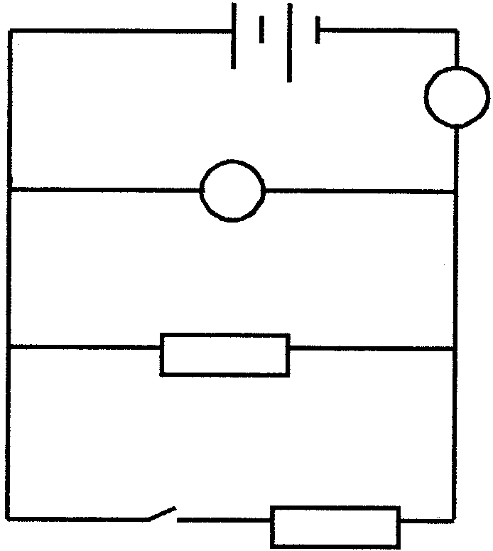
In the following circuit the internal resistance of the battery is negligible.
A
V
R
S
R

How would the ammeter and voltmeter readings change when switch S is closed?

 | AMMETER | VOLTMETER
A. | Increases | Remains constant
B. | Increases | Increases
C. | Decreases | Remains constant
D. | Decreases | Decreases
 |  |  | (3)

Two photons of electromagnetic radiation travelling in a vacuum have different energies. This implies that they inevitably differ in their  - velocity.  - intensity.  - charge.  - frequency. | (3)

Which statement is applicable to thermionic emission? Thermionic emission is the process whereby a heated metal  - gains ions.  - gains electrons.  - loses ions.  - loses electrons. | (3)

  - If four bodies P, Q, R and S are each charged so that P is repelled by Q and R is attracted by S, which of the following sets could list the charges on the four bodies?

 |  | P | Q | R | S
 | A. | - | - | - | +
 | B. | - | + | + | -
 | C. | + | + | - | -
 | D. | - | + | - | +
 |  |  |  |  |  |  | (3)

Two polaroid sheets are placed close together in front of a lamp so that no light passes through them. This proves that light  - can travel in straight lines.  - has particle properties.  - has wave properties.  - is a transverse wave. | (3)

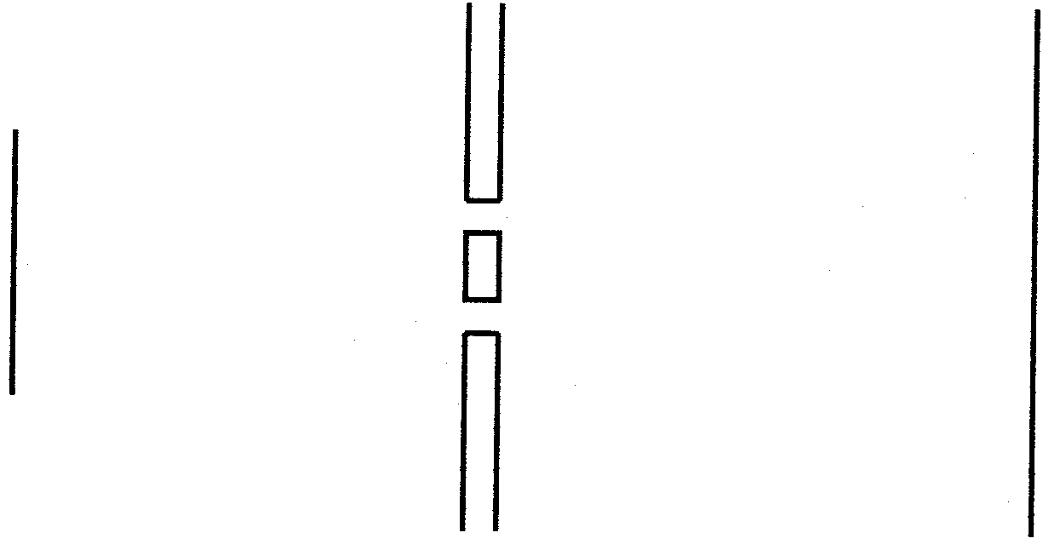  The experimental set-up shown in the accompanying sketch is used to observe interference fringes on the screen.  Double slit  Green filter  Light source  Screen  .  How can the distance between the observed interference fringes be increased?  - Replace the green filter with a blue one.  - Move the screen further from the slits.  - Increase the width of each slit.  - Increase the distance between the slits. | (3)

Which of the following phenomena can occur with sound waves?  - Interference only  - Interference and diffraction only  - Interference, refraction and polarisation  - Interference, refraction and diffraction | (3)

The speed of a water wave is 4 m/s. The wavelength of this wave is 0,5 m. What is the period of this wave?  - 2 s  - 0,5 s  - 0,25 s  - 0,125 s | (3)

When the line spectrum of a certain element is observed through a diffraction grating , the __________ line is seen farthest from the central bright line.  - violet  - red  - blue  - green | (3)  15x3=[45]

Answer the following questions in the answer book. Show all the necessary equations and calculations you have used in the answering of the questions.

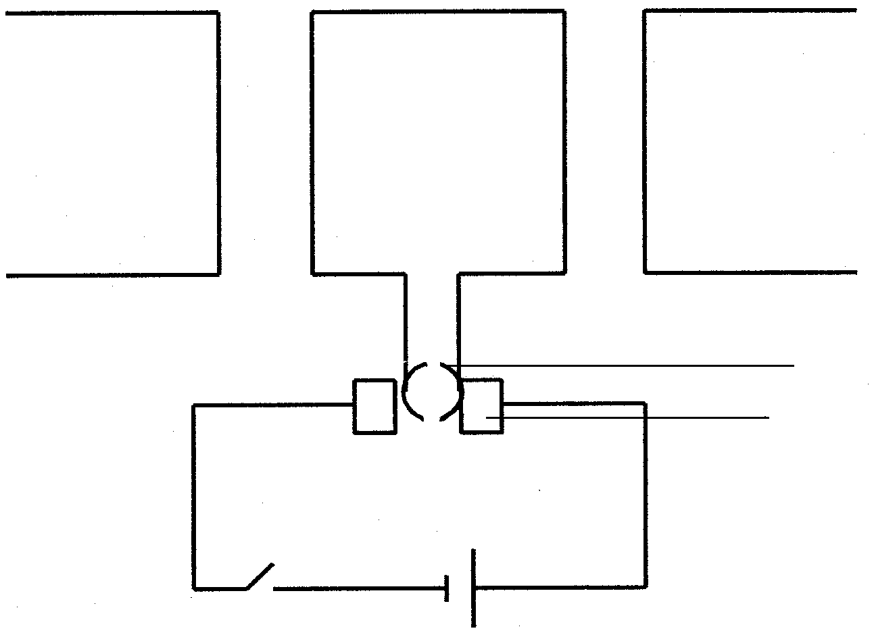  QUESTION 2  N  S  C  B  D  A  Y  X  MAGNETIC EFFECT OF AN ELECTRIC CURRENT  Electric motors are used frequently in everyday life. The following sketch is a simple presentation of an electric motor.  - In which direction will the coil ABCD rotate when the switch S is closed? Answer the question by writing: “Conductor AB will ...”  - Explain your answer in Question 2.1. | (2)  (3)

- Name the following parts:  - X  - Y | (1)  (1)

- What is the function of Y in the electric motor?  2.5 Name TWO changes which will cause the coil to rotate faster. | (2)  (4)  [13]

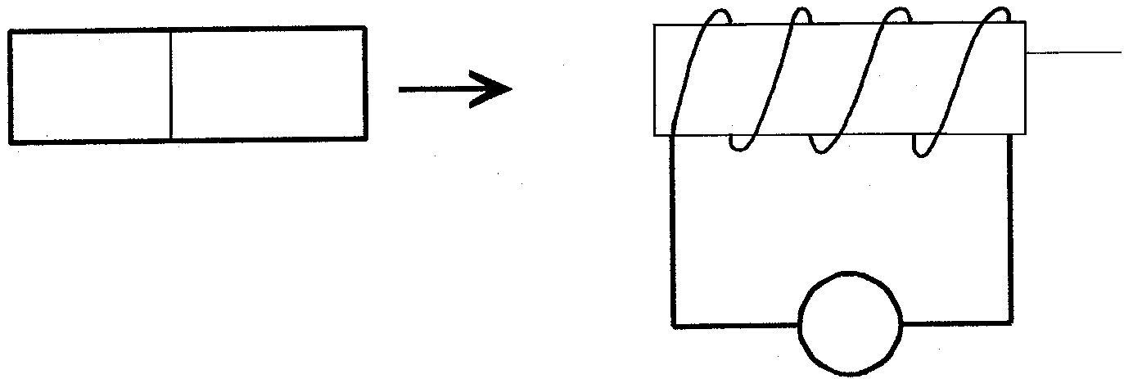  QUESTION 3  G  A⁺  B  N  S  Cardboard cylinder  MAGNETIC INDUCTION  Dirk moves a bar-magnet rapidly into a coil which is connected to a galvanometer as shown in the sketch.  - What is the direction of the induced conventional current through the galvanometer? Refer to the letters A and B in your answer.  - What will Dirk observe if he holds the bar-magnet stationary in the coil?  - Explain your answer in Question 3.2.  - Name TWO ways in which Dirk can change the direction of the current in Question 3.1.  - How can Dirk increase the reading on the galvanometer if he uses only the given apparatus? | (2)  (1)  (2)  (2)  (1)  [8]

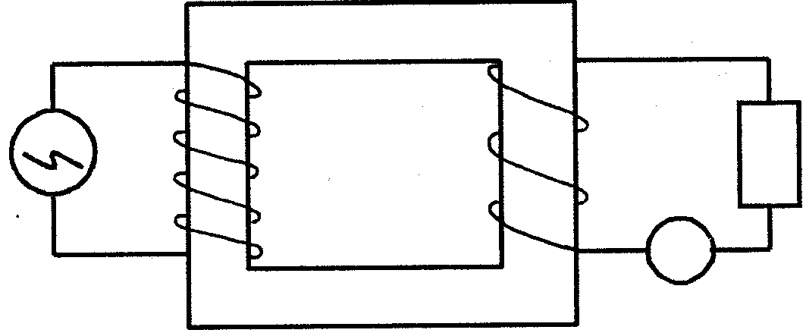  QUESTION 4  220 V  Y  A  TRANSFORMERS  An electrical apparatus (Y), which is used by a scientist who is busy with research to find an antidote against HIV, needs a potential difference of 48 V to function.  The laboratory where he does the research is supplied with 220 V. He connects the apparatus to a transformer with 360 turns on its secondary coil as shown in the sketch.  - What type of transformer is this? | (1)

- Calculate the number of turns on the primary coil.  - The apparatus (Y) has a resistance of 100 Ω. Calculate the reading on the ammeter.  4.4 Calculate the current in the primary coil. | (5)  (4)  (5)  [15]

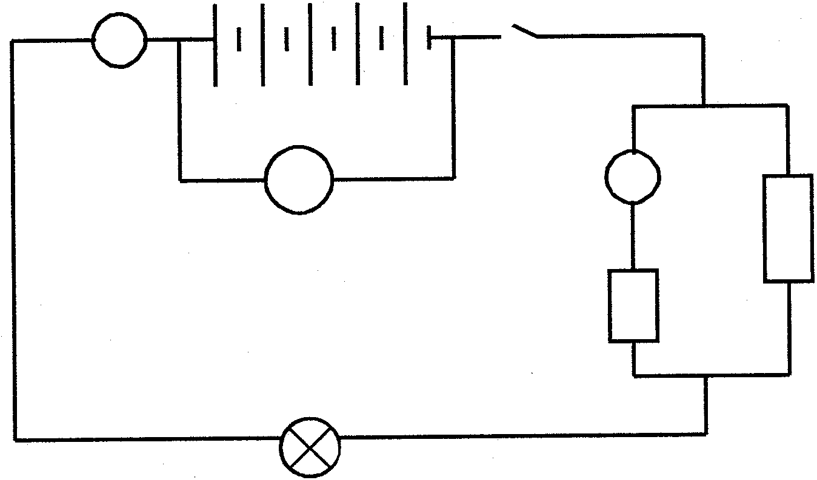  QUESTION 5  S  A  V  L  3 Ω  A₁  7 Ω  OHM’S LAW  In the circuit below the battery consists of five cells connected in series. The emf of each cell is 1,5 V. The internal resistance of the battery is negligible. L is a bulb with a resistance of 0,9 Ω.  - What is the reading on the voltmeter V and the ammeter A if the switch is open?  - The switch is now closed. Calculate the total resistance in the circuit.  - Calculate the current through the lamp.  - Calculate the reading on ammeter A₁.  - What will happen to the brightness of the lamp L if the 3 Ω resistor is removed from the circuit?  - Explain your answer in Question 5.5. | (4)  (5)  (4)  (5)  (1)  (3)  [22]

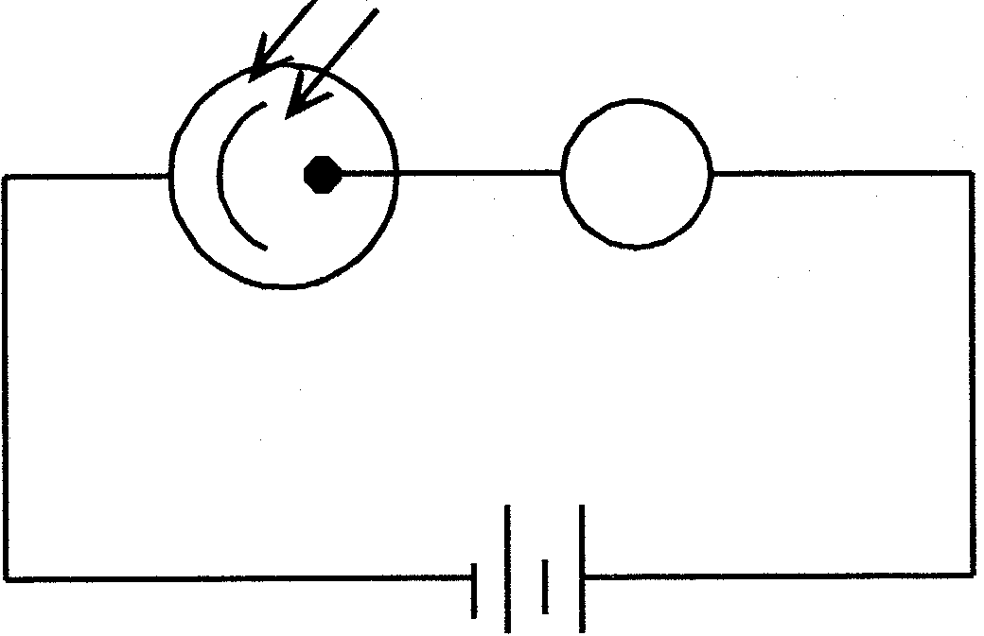
QUESTION 6
Light
μA

ELECTRONS IN THE ATOM

The sketch shows a photo-electric cell which is connected to a 12 V battery.

When the photo cell is irradiated with a 40 W red lamp, no reading on the μA is observed. If the photo cell is irradiated with a 40 W blue lamp, there is a reading on the μA.  - What will be observed if the photo cell is irradiated with a 100 W red lamp? Explain your answer.  - What will be observed if the photo cell is irradiated with a 100 W blue lamp? Explain your answer.  - The poles of the battery are switched around. How will the observation in Question 6.2 be affected? Explain briefly. | (4)  (4)  (4)  [12]

QUESTION 7  WAVES  - A science teacher generates a wave in a ripple tank. The wave has a speed of 0,5 m/s and a wavelength of 20 mm.  - State FOUR wave characteristics which could be illustrated with the above-mentioned type of waves.  - Calculate the frequency of these waves.  - What is the period of these waves?  - When this wave moves to shallower water, its speed decreases  to 0,4 m/s. Calculate the wavelength of this wave. | (4)  (4)  (3)  (4)

Peter looks at a source of white light through two narrow slits which have been marked very close to each other, on a blackened microscope slide.  - Describe the pattern of lines that Peter will observe.  - What is the phenomenon in Question 7.2.1 called?  - What is indicated by this phenomenon, regarding the nature of light?  - Mention TWO ways in which the width of the lines he observed in  Question 7.2.1 can be decreased. | (4)  (1)  (1)  (4)  [25]

QUESTION 8  LIGHT, COLOUR AND SPECTRA  Consider the light emitted by a mercury-vapour lamp.  - How would you show that this light is not monochromatic?  - Is the spectrum of this light continuous? How would you verify this?  - What is this type of spectrum called?  - How would you show that this light is unpolarised? | (3)  (3)  (1)  (3)  [10]

TOTAL: | 150

PHYSICS DATA SHEET

EQUATIONS

WAVES | ELECTRICITY
v = f λ  f = $\frac{1}{T}$ | R = r₁ + r₂ + r₃  $\frac{1}{R}$ = $\frac{1}{r_{1}}$ + $\frac{1}{r_{2}}$ + $\frac{1}{r_{3}}$  V_{p}I_{p} = V_{s}I_{s}  $\frac{V_{s}}{V_{p}}$= $\frac{N_{s}}{N_{p}}$

PHYSICS CONSTANTS

Miscellaneous constants (Approximate values)

NAME |  | SYMBOL |  | VALUE
Speed of light | c |  | 3,0 x 10⁸ m.s⁻¹
Charge on electron | e– |  | –1,6 x 10⁻¹⁹ C

