GAUTENG DEPARTMENT OF EDUCATION
SENIOR CERTIFICATE EXAMINATION

FUNCTIONAL PHYSICAL SCIENCE SG
(First Paper : Physics)

TIME : 2 hours

MARKS : 150

REQUIREMENTS:

- An approved (non-programmable, scientific) calculator. Candidates should supply their own calculator.

INSTRUCTIONS:

- Answer ALL questions.

- Answer Question 1 on the answer sheet on the inside cover of your answer book.

- Number all answers exactly as they are numbered in the question paper.

- A data sheet is provided at the end of this question paper. The data sheet contains equations and constants. Some of the information given may be useful in answering this question paper.

- Rough work may be done at the back of your answer book.

QUESTION 1
MULTIPLE CHOICE QUESTIONS

Study each item and the suggested answers indicated by the letters A, B C and D. When you have decided which answer is correct, make a cross (X) over the appropriate letter to indicate your answer. No marks will be awarded where more than one cross appears in any one answer.

EXAMPLE: At what temperature does pure ice melt?

- -4°C
- 0°C
- 0°K
- 4°C

ANSWER: | A | B | C | D

1.1 The direction of the magnetic field at point X is
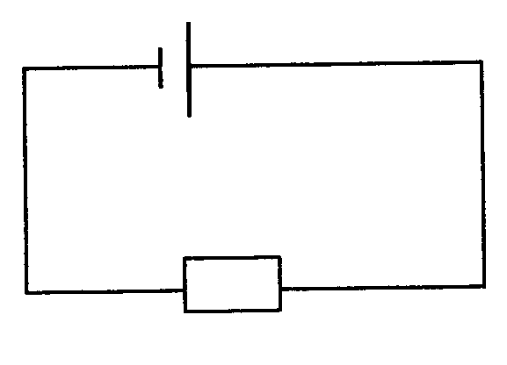
Xx

R

- to the right.  - to the left.  - perpendicular, into the paper.  - perpendicular, out of the paper. | (3)

  - In which of the situations below will the current bearing conductor be moved to the right?
.
N
○ : Conventional current out of the paper.
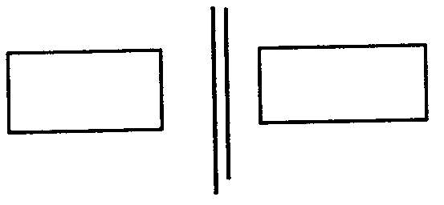

I
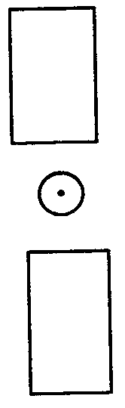
B.
↓
N
S
S
A.

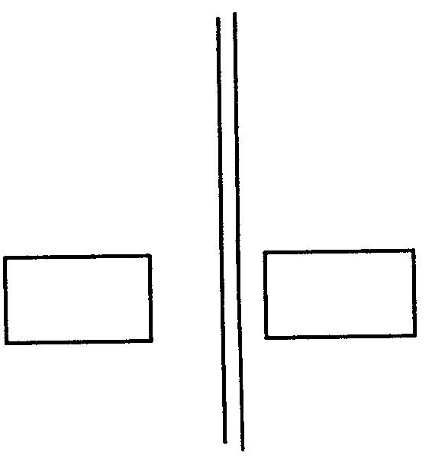  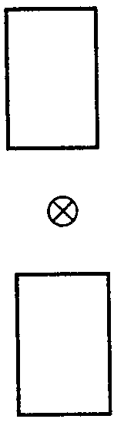  N  S  ↑  N  I  S  C.  D. | (3)

1.3 To induce a current in a coil in the direction indicated in the sketch

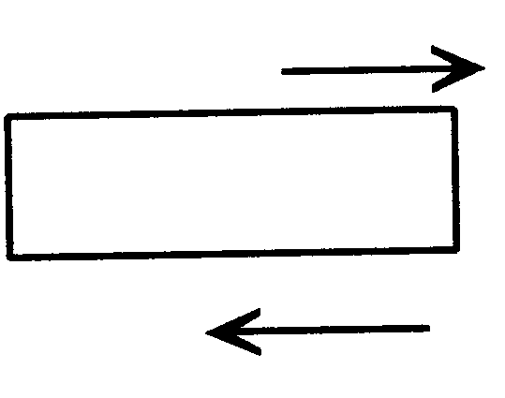
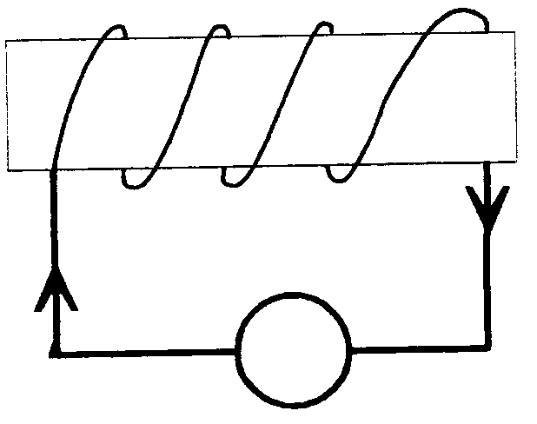
V
Cardboard
cylinder
A
B

N S

- the magnet must be moved in the direction of A.  - the magnet must be moved in the direction of B.  - both magnet and coil must remain stationary.  - both magnet and coil must be moved in the direction of A. | (3)

1.4 Which statement is applicable to a step-down transformer?  In a step-down transformer  - the current in the secondary coil is more than the current in the primary coil.  - the current in the primary coil is the same as the current in the secondary coil  - the number of turns on the primary coil is less than the number of turns on the secondary coil.  - the potential difference across the secondary coil is more than the potential difference across the primary coil. | (3)

- In an alternating current  - the magnitude and the direction of the current remain constant.  - the magnitude and the direction of the current change periodically.  - the magnitude of the current remains constant, but the direction changes periodically.  - the direction of the current remains constant, but its magnitude changes periodically. | (3)

1.6 An ammeter is connected in parallel with three resistors as shown in the diagram. The ammeter shows a reading A. One of the resistors is then removed. Which one of the following is observed on the ammeter?
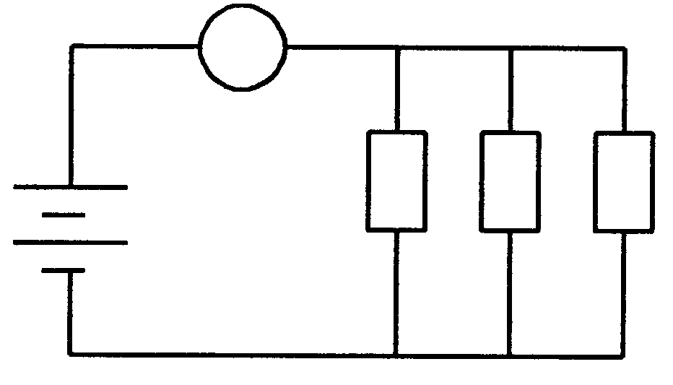
A

R R R

- The reading will be A.  - The reading will be zero.  - The reading will be less than A.  - The reading will be higher than A. | (3)

1.7 Which one of the following circuits can be used to measure the resistance of the resistor correctly?
A.
B.
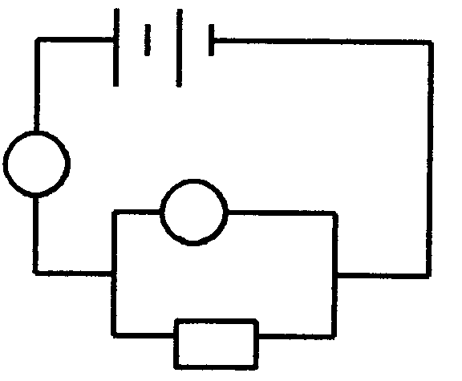  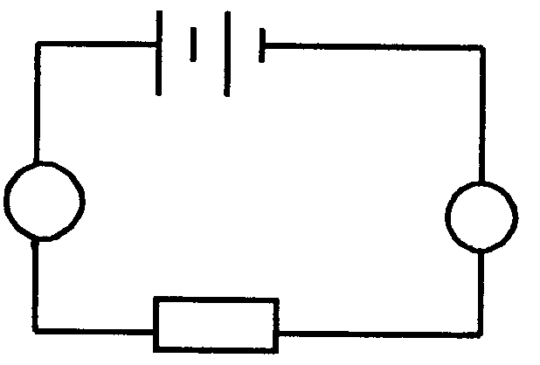  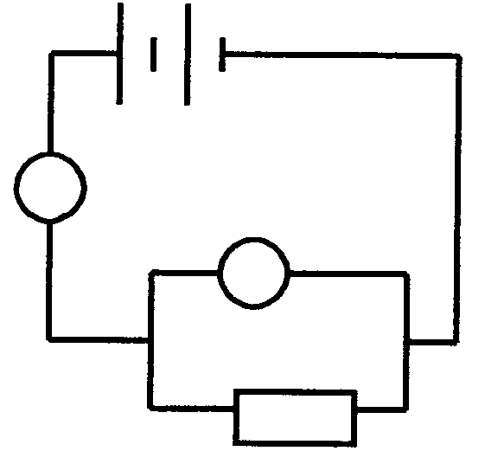  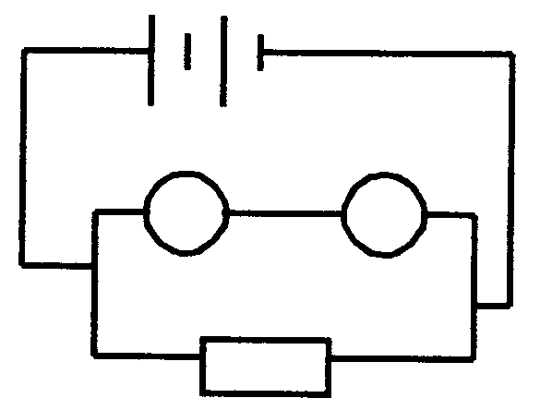  V  A  R  R  V  A  A  V  R  C.  A  V  R  D. | (3)

- The maximum kinetic energy of photo-electrons depends upon  - the frequency of the light.  - the kind of metal used.  - the intensity of the incident light.  - Only I  - Only III  - II and III  - I and II | (3)

- A positively charged metallic dome is brought into contact with a neutral metallic dome. The positively charged dome would become  - neutral.  - negatively charged.  - more positively charged.  - less positively charged. | (3)

- Which statement is applicable to the photo-electric effect?  The photo-electric effect  - can only occur with visible light.  - is evidence of the wave nature of light.  - is evidence of the particle nature of light.  - is the emission of electrons due to the heating of a metal. | (3)

1.11 The width of the single slit in the sketch can be changed by moving X to position 1, 2, 3 or 4. Monochromatic blue or red light waves move through the slit. The width of the slit and the wavelength of the waves are of the same order of magnitude.

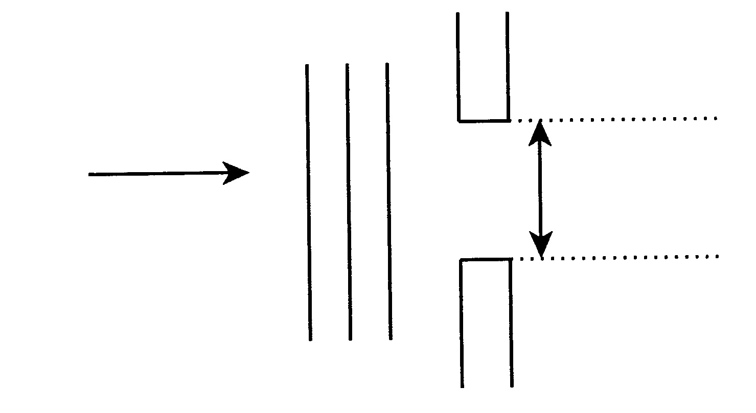
Monochromatic
light waves

X

1.
2.
3.
4.
Single slit

Which one of the following combinations will show the least amount of diffraction?

 | MONOCHROMATIC LIGHT WAVES | POSTION OF X
A. | Blue | 1
B. | Blue | 4
C. | Red | 1
D. | Red | 4

1.12 Which one of the following statements is true?  - Radio waves can be polarised, but not light waves.  - Light waves can be polarised, but not radio waves.  - Both light waves and radio waves can be polarised.  - Neither light waves nor radio waves can be polarised. | (3)

- When monochromatic light in a vacuum is totally reflected by a mirror, which property/ies of the light stay/stays the same after reflection?  - Speed, frequency and photon energy  - Speed and frequency only  - Photon energy only  - Frequency only | (3)

- Waves pass from deep to shallow water. If the wavelength in the deep water is 10 mm and the angle of incidence is 30°, the most probable values for the wavelength and the angle of refraction are:  - 8 mm; 25°  - 8 mm; 35°  - 10 mm; 25°  - 10 mm; 30° | (3)

- The characteristic emission spectrum of an element is produced when  - electrons are radiated by the atoms of the element.  - electrons are excited by higher energy levels in the atom.  - electrons are absorbed by the atoms of an element.  - electrons fall back to lower energy levels in the atoms.  15 x 3 = | (3)  [45]

Answer the following questions in your answer book. Show all the necessary equations and calculations you have used in the answering of the questions.

QUESTION 2
MAGNETIC EFFECT OF AN ELECTRIC CURRENT

Electromagnets are used frequently in everyday life. The sketch below shows a simple electromagnet. A permanent magnet is suspended from a thin string near the electromagnet. The permanent magnet is able to move freely.

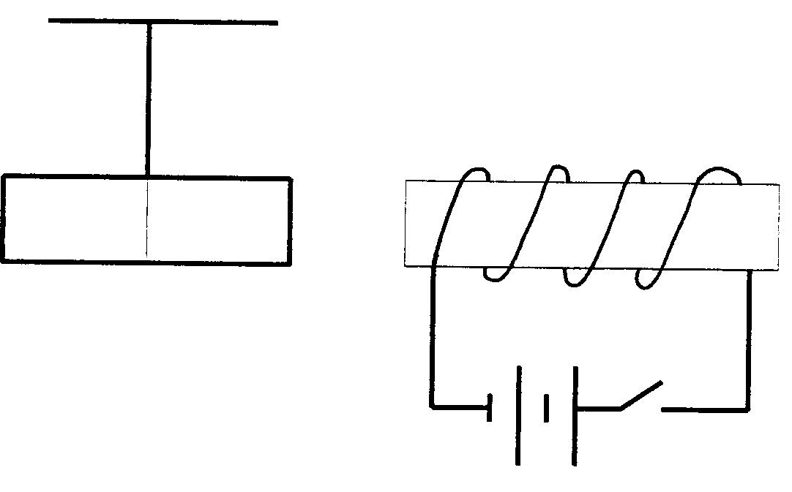
X

S N

S

- Name part X of the electromagnet.  2.2 Switch S is closed. What will be seen?  2.3 Explain your observation in Question 2.2  - Suggest TWO ways to strengthen the electromagnet.  - Explain briefly how the electromagnet can be changed into a permanent magnet. | (1)  (2)  (3)  (4)  (2)  [12]

QUESTION 3

MAGNETIC INDUCTION

Ria places two coils next to each other as shown in the sketch.

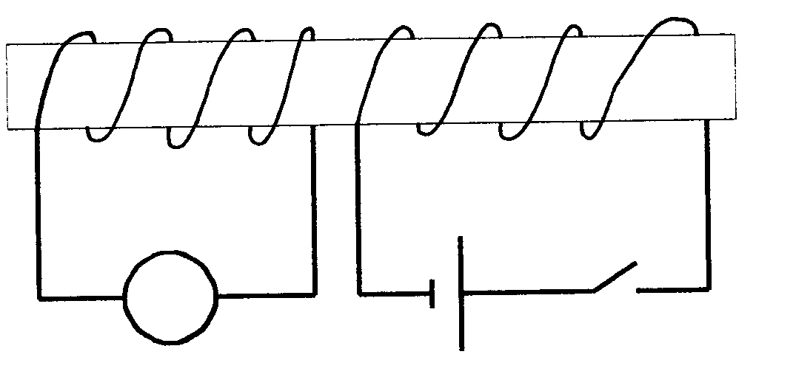
X Y
G
S

Cardboard
cylinder

3.1 The switch S is closed. What is the direction of the conventional current through the galvanometer? Refer to the letters X and Y in your answer.  3.2 What will Ria observe if the switch stays closed?  3.3 Explain your answer in Question 3.2  3.4 What will Ria observe if the switch is opened?  3.5 Which apparatus works on the principle demonstrated in the sketch? | (2)  (1)  (2)  (2)  (1)  [8]

QUESTION 4
TRANSFORMER

An electrical apparatus (Z) which is used to treat an Aids patient in a hospital, needs a potential difference of 4 400 V to function. The apparatus is connected to a transformer with 100 turns on its primary coil, as shown in the sketch.

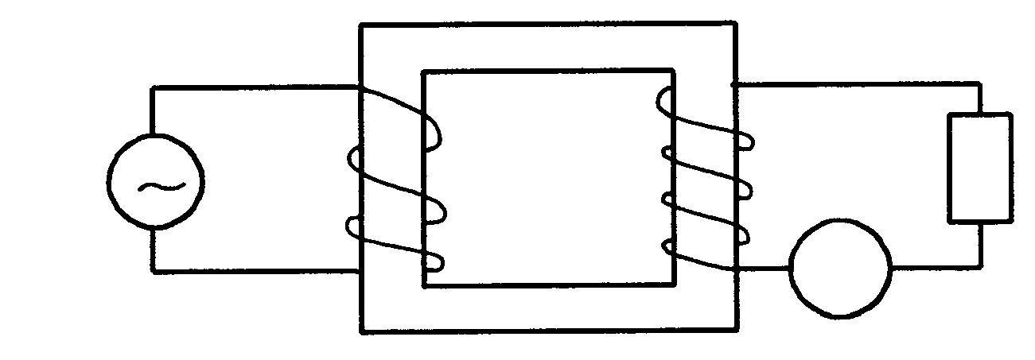
220 V
A
Z

- What type of transformer is this?  - Calculate the number of turns on the secondary coil.  - Calculate the current in the primary coil if the reading on the ammeter is 0,5 A.  - Calculate the resistance of the apparatus Z. | (1)  (5)  (5)  (4)  [15]

QUESTION 5
OHM’S LAW

An electric heater has two identical heating elements A and B, each with a resistance of 40 Ω. By a suitable arrangement of switches and wires, the two elements may be connected in three different ways to the household electric main supply in order to allow three settings of the heater: low, medium and high. The three different connections of the heating elements are shown in the diagram as circuit X, circuit Y and circuit Z.

Circuit X Circuit Y
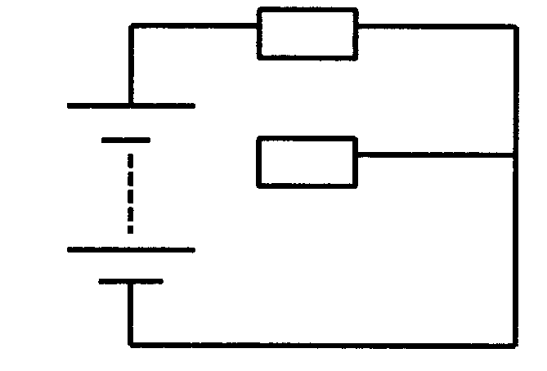
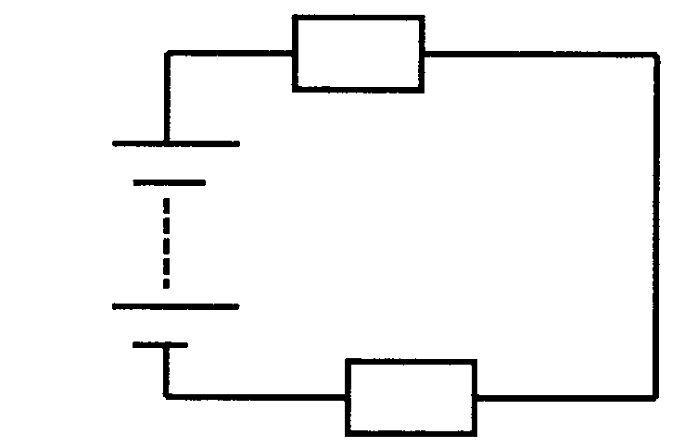
B
A
A
220 V
B
220 V

Circuit Z

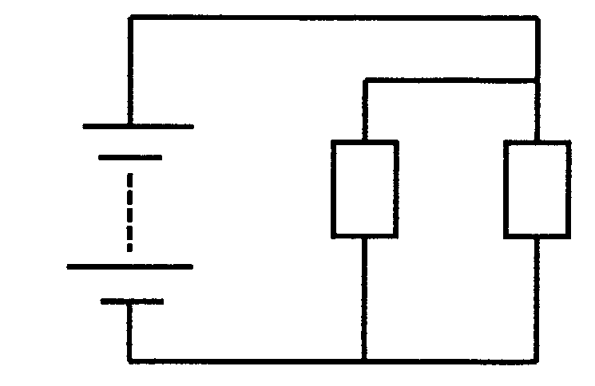
220 V

A B

- Which circuit has the two heating elements connected in  5.1.1 series?  - parallel?  5.2 Calculate the current in circuit  - X.  - Y.  - Z.  5.3 Which circuit is used as the  - highest heat setting of the heater?  - lowest heat setting of the heater? | (1)  (1)  (3)  (5)  (6)  (1)  (1)  [18]

QUESTION 8
ELECTRONS IN THE ATOM

6.1 The diagram shows two different photo-cells connected to identical cells.

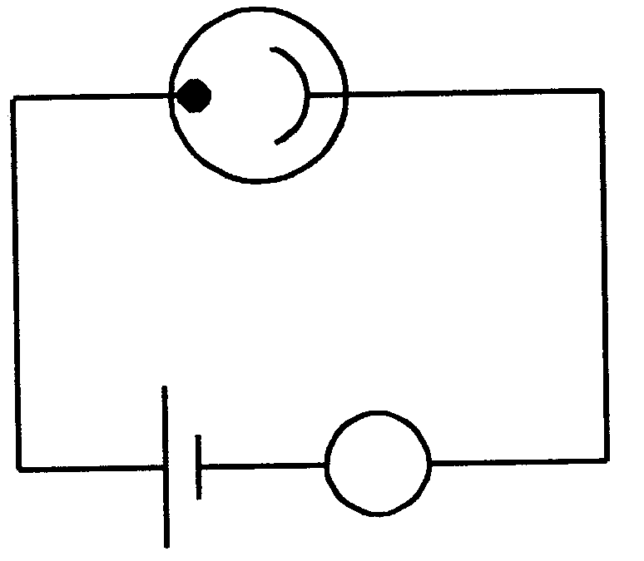
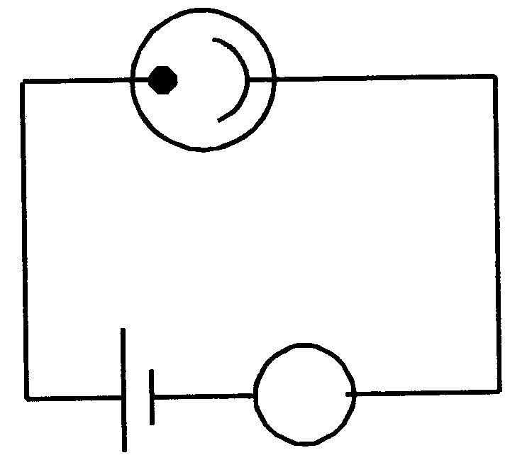
S
R
A₁
E
D
A₂

- Which TWO letters indicate the cathodes of the respective  photo-cells?  - Both cathodes are irradiated with red light of the same frequency from a 20 W lamp. A reading is recorded on micro-ammeter A₁ but not on micro-ammeter A₂. Explain how this is possible.  - How will the readings on A₁ and A₂ be affected if the red lamp of  20 W is replaced with a similar red lamp of 100 W? Explain your answer. | (2)  (4)  (4)

6.2 The following diagram presents a thermionic diode which is connected in a circuit.

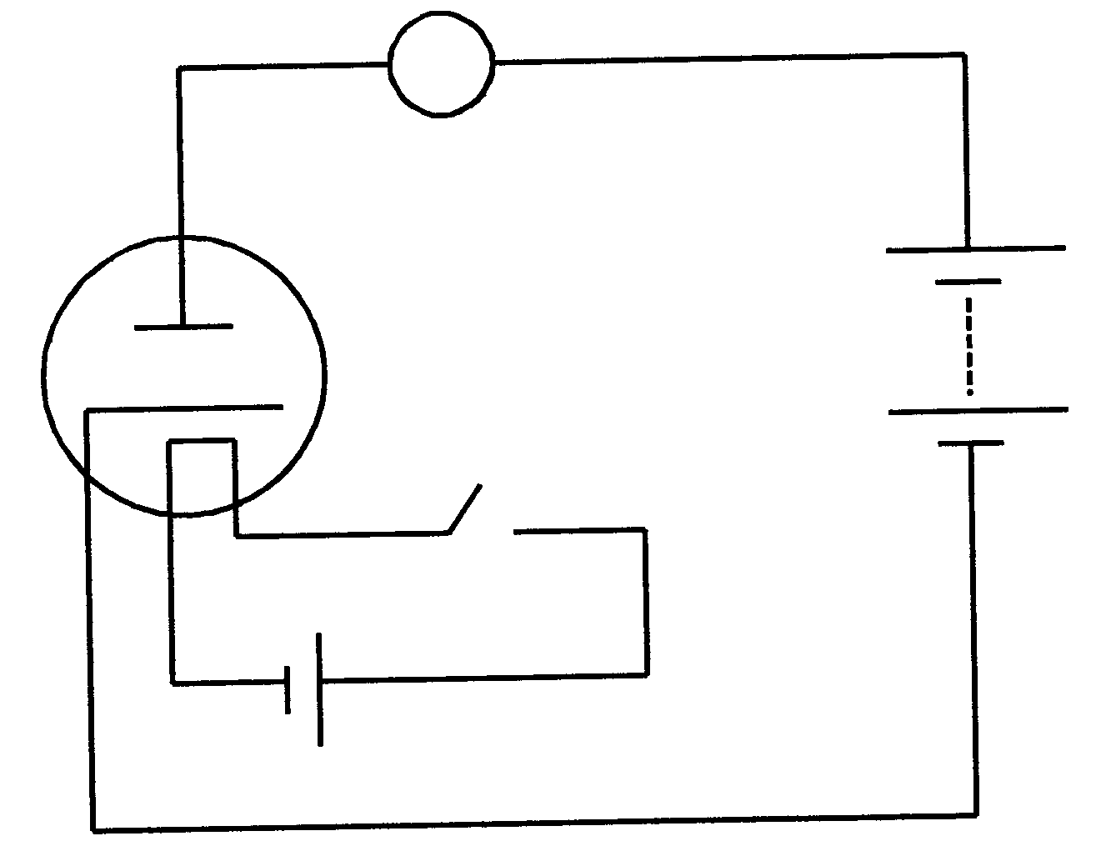
A
B
S
X

- Explain what “thermionic emission” means.  - What is the function of circuit X?  - When the switch is closed, there is a reading of 100 mA on the ammeter. What will happen with the reading on the ammeter if the poles of battery B are switched around?  - Explain your answer to Question 6.2.3. | (3)  (2)  (2)  (3)  [20]

QUESTION 7
WAVES

7.1 A science teacher generates waves in a ripple tank. He generates a wave every 0,5 s. The length of one complete wave is 40 mm. A small piece of cork floating on the water moves up and down through a total distance of 8 mm.

- Are these waves transverse? Explain your answer.  - Are these waves polarised? Explain your answer.  - What is the amplitude of these waves?  - Calculate the frequency of these waves.  - Calculate the velocity of propagation of these waves. | (3)  (3)  (2)  (3)  (4)

7.2 Electromagnetic waves originate when electric charges are accelerated.

- Which characteristic of these waves determines the energy of the waves?  - Name TWO types of electromagnetic waves with high penetrative power.  - The period of a certain electromagnetic wave is 4 x 10⁻¹⁴ s. Calculate the wavelength of this wave in a vacuum. | (1)  (2)  (6)  [24]

QUESTION 8
LIGHT, COLOUR AND SPECTRA

A teacher burns the metal salts NaCℓ and kCℓ successively in a flame during an experiment in the laboratory. Sue looks at the flame of each salt successively through a spectroscope and sees a spectrum.  - What kind of spectrum does Sue observe?  - What causes the coloured lines?  - Are the spectra of the two metal salts identical?  - Name an application of the principle which is demonstrated above. | (1)  (4)  (1)  (2)  [8]

TOTAL: | 150

PHYSICS DATA SHEET

EQUATIONS

WAVES | ELECTRICITY
v = f λ  f = $\frac{1}{Τ}$ | R = r₁ + r₂ + r₃  $\frac{1}{R}$ = $\frac{1}{r_{1}}$ + $\frac{1}{r_{2}}$ + $\frac{1}{r_{3}}$  V_{p}I_{p} = V_{s}I_{s}  $\frac{V_{s}}{V_{p}}$ = $\frac{N_{s}}{N_{p}}$

PHYSICS CONSTANTS

Miscellaneous constants (Approximate values)

NAME | SYMBOL | VALUE
Speed of light | c | 3,0 x 10⁸ m.s⁻¹
Charge on electron | e– | -1,6 x 10⁻¹⁹ C

