GAUTENG DEPARTMENT OF EDUCATION
SENIOR CERTIFICATE EXAMINATION

FUNCTIONAL MATHEMATICS SG
(Second Paper: Geometry)

TIME: 3 hours

MARKS: 150

INSTRUCTIONS;

- Sections A and B are COMPULSORY.

- Answer any TWO of Sections C, D, E or F.

- Non-programmable calculators may be used. If the question does not specify, then the final answer must be rounded off to two decimal places.

- All appropriate calculations must be shown.

- Diagram sheets are provided on pages 15 - 17. No answers may be written on them, but you may use the diagrams to determine your answer. The diagram sheets must be handed in with your examination number written on each. It is thus not necessary to redraw any sketches, unless specified.

- No answers may be determined by construction and measurement.

- A formula sheet is included on page 18 as well as graph paper on pages 19 and 20.

SECTION A
CO-ORDINATE GEOMETRY
COMPULSORY

QUESTION 1

A(-3;5), B(0;-2) and C(-4;0)

Calculate

1.1 the length of AB correct to 2 decimal places. | (5)

1.2 the midpoint of BC. | (3)

1.3 the gradient of AC. | (3)

1.4 the gradient of BC and state whether BC is parallel to AC. | (4)

1.5 the equation of the line that passes through the points A and B. | (4)  [19]

QUESTION 2

Given P(1;2), Q(3;4) and R(5;6). Show by means of calculation that points P, Q and R are collinear (lie on the same straight line). | [5]

QUESTION 3

The circle with centre origin touches the straight line at point P(-1; -3).
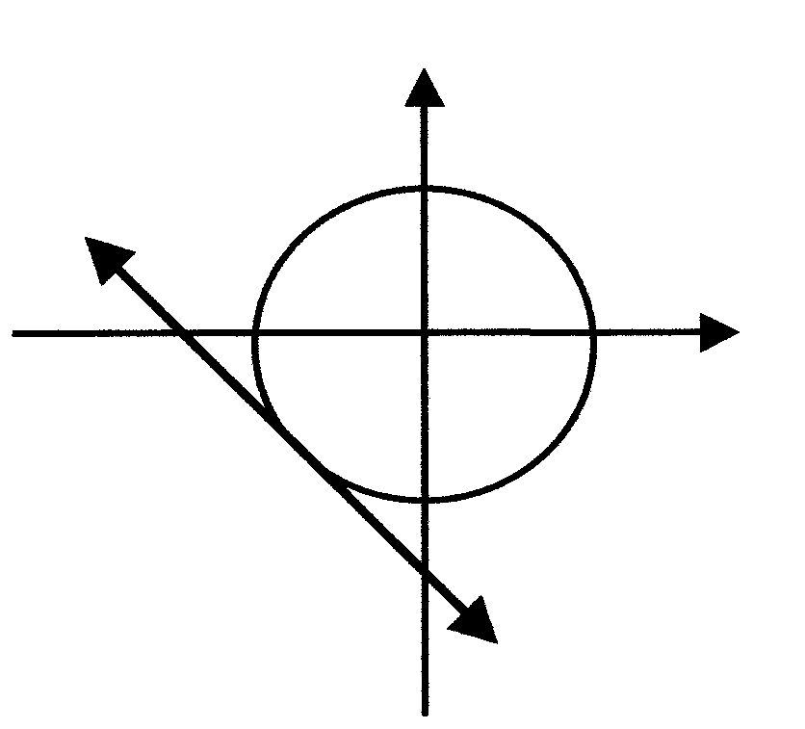
y
y
P(-1; -3)

3.1 Calculate the equation of the circle. | (4)

3.2 Calculate the radius of the circle if the equation of the circle is given by $x^{2}+y^{2}=\text{10}$. Round off your answer correct to one decimal place. | (2)  [6]

QUESTION 4

Calculate whether $\text{y-x-3}=0$ is a secant or tangent to the circle $x^{2}+y^{2}=\text{29}\text{.}$ | [8]

TOTAL FOR SECTION A: | [38]

SECTION B
TRIGONOMETRY
COMPULSORY

QUESTION 5

5.1
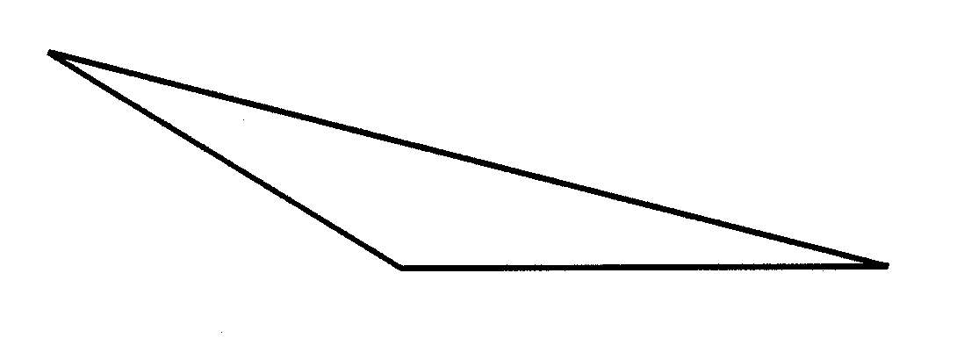
A
b
c
B
C
a

Complete using ΔABC:

5.1.1 $\frac{\text{sin }\hat{A}}{\text{.}\text{.}\text{.}}=\frac{\text{sin \{}\hat{B}}{b}=\frac{\text{.}\text{.}\text{.}\text{.}\text{.}}{c}$ | (2)

5.1.2 $a^{2}=\text{.}\text{.}\text{.}\text{.}+c^{2}−2\text{.}\text{.}\text{.}\text{.}\text{.}\text{cos }\hat{A}$ | (2)

5.1.3 Area of ΔABC = ………$\text{sin \{}\hat{B}$ | (2)
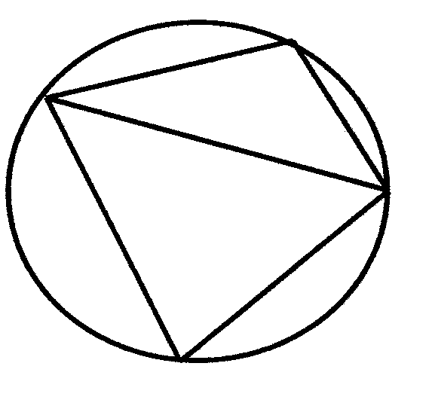
p
7
Q
4
9
S
5.2
R

The figure PQRS is a cyclic quadrilateral with PQ = 7 units, PS = 4 units and SQ = 9 units.

5.2.1 Show by means of calculation that $\hat{P}=\text{106,6}°$ | (5)

5.2.2 Calculate, with reasons, the size of $\hat{R}$. | (3)

5.2.3 $\text{If }Q\hat{S}R=\text{40,7}°\text{and}\hat{R}=\text{73,4}°\text{, calculate the size of}S\hat{Q}R\text{.}$ | (2)

5.2.4 Hence calculate the length of SR if $S\hat{Q}R=\text{ 65,9}°$. | (3)  [19]

QUESTION 6

C
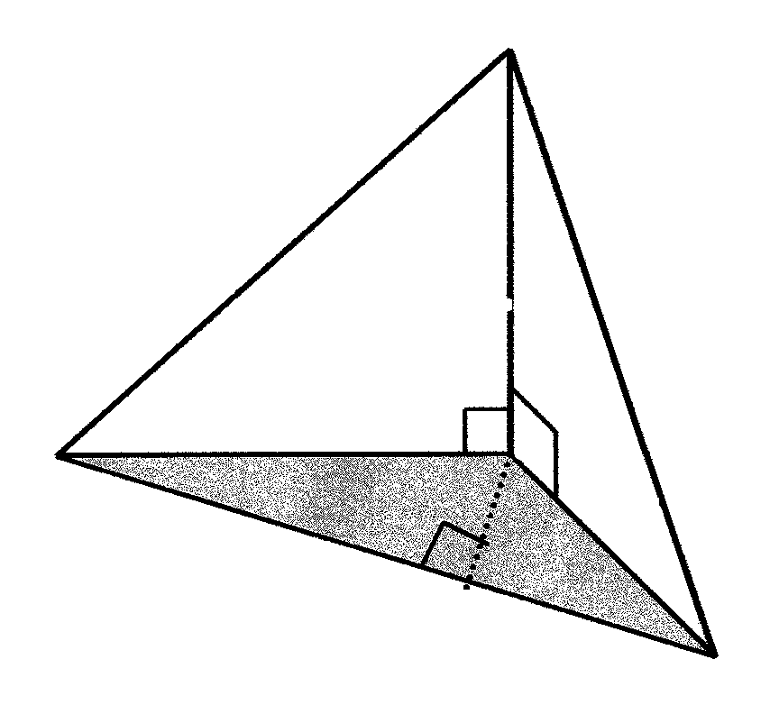
H
100 m
24,5º
21º
B
P
A
$$A\hat{C}B=\text{105}°$$
C

Use the accompanying diagram to answer the following questions:

Calculate

6.1 the length of AC. | (3)

6.2 the length of BC. | (3)

6.3 the length of AB, correct to ONE decimal place. Use AC = 219,43 m and BC = 260,51 m. | (5)

6.4 the area of ΔABC, by using AC = 219,43 and BC = 260,51 m. | (4)

6.5 the length of CP if AB = 382 m and the area of ΔABC is 27 608 m² | (4)  [19]

TOTAL FOR SECTION B: | [38]

SECTION C
CONSUMER MATHEMATICS
OPTIONAL

QUESTION 7

7.1 Calculate the simple interest if R2 500 is invested for 5 years at an interest rate of interest of 9% per annum. | (3)

7.2 If a bank charges 5c on each R1 withdrawn, calculate how much the bank will charge on the following amounts:

Amount | R20-00 | R30-00 | R40-00 | R50-00 | R60-00 | R70-00
Charge

Copy and complete the table in your answer book. | (3)

7.3 Represent the table in Question 7.2 graphically, on the given graph paper.

Scale: x - axis: Amount: 2 cm = R10  y - axis Charge: 2 cm = R1 | (5)

7.4 Use the graph to read off the following (show on your graph where the reading was taken):

7.4.1 The charge on R35-00 (Mark with A on the graph.) | (2)

7.4.2 To pay a charge of R3-25, how much must be withdrawn? (Mark with letter B on the graph.) | (2)  [15]

QUESTION 8

Mr Thango buys a car to the value of R168 000. The value of the car depreciates at a rate of 9% per annum, calculated monthly, for n years.

8.1 Show that Mr Thango’s investment can be calculated by the following formula, over n years.

A = R168 000 (O,9925)^{12n} | (4)

8.2 Calculate the value of A in each of the following instances. Redraw the table and complete it.

n (in years) | 1 | 2 | 3 | 4 | 5 | 6
A (in rands) | R153 488 | R140 230 | R128 117 |  |  |  | (3)

8.3 Using the graph paper provided, represent the data in Question 8.2 graphically with n on the x-axis where 20 mm → 1 year and A on the y-axis where 10 mm → R10 000. | (5)

8.4 Read the following off your graph:

- A if n = 5½ years  - n if A = R122 460 | (1)  (1)  [14]

QUESTION 9

TAX RATES FOR THE ….YEAR OF ASSESSMENT

MARRIED PERSONS
TAXABLE INCOME | RATES OF TAX
R 0 - 5 000  R 5000 - 10 000  R 10 000 - 15 000  R 15 000 - 20 000  R 25 000 - 30 000  R 30 000 - 40 000  R 40 000 - 50 000  R 50 000 - 60 000  R 60 000 - 80 000  R 80 000 + | 17% of each R1  R 850 + 18% of the amount over R 5 000  R 1 750 + 19% of the amount over R 10 000  R 2 700 + 20% of the amount over R 15 000  R 3 700 + 21% of the amount over R 20 000  R 5 800 + 28% of the amount over R 30 000  R 8 600 + 36% of the amount over R 40 000  R 12 200 + 41% of the amount over R 50 000  R 16 300 + 42% of the amount over R 60 000  R 24 700 + 43% of the amount over R 80 000

Mrs Honiball earned R72 500 for 1999. In 2000 she got an increase, which sets her Salary at R84 200. Calculate her annual income tax for:

9.1 1999 | (4)

9.2 2000 | (4)  [8]

TOTAL FOR SECTION C: | [37]

SECTION D
CIRCULAR MEASUREMENT
OPTIONAL

QUESTION 10
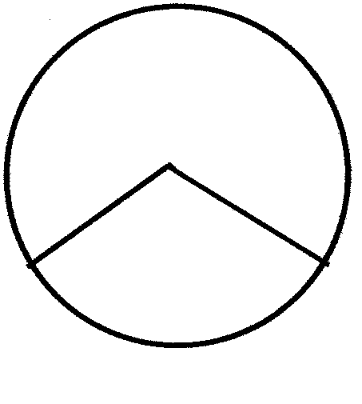
O
r
θ
s
O is the centre of the circle

10.1 Complete: If s = r, then θ = …….rad. | (1)

10.2 1 radian = ………º. | (1)

10.3 Convert 73,5º to radians. | (2)

10.4 Convert 2,6 radians to degrees. | (3)

10.5 Convert 225º to radians, expressed in terms of π. | (2)  [9]

QUESTION 11

In the circle θ = 150º at the midpoint. The radius of the circle is 30 metres.

Calculate

11.1 the diameter of the circle. | (1)

11.2 the length of the shorter arc BC. | (3)

11.3 the area of the shaded segment of the circle. | (5)  [9]

QUESTION 12

The windmill, with a diameter of 12 metres, rotates at 2 000 revolutions per minute.

Calculate

12.1 the number of revolutions produced by the windmill in one second. | (2)

12.2 the angular velocity of the windmill (expressed in radians per second). | (3)

12.3 the circumference velocity of the windmill in m/s. | (3)  [8]

QUESTION 13

In the figure, the radius of the base of a right cylinder is 12 millimetres and $A\hat{O}B=θ\text{.}$
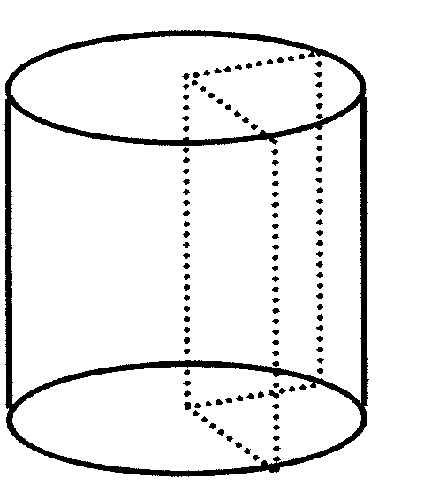
A
θ
B
O
h

13.1 If the length of arc AB is 25,75 millimetres, show that θ = 2,14 radians. | (4)

13.2 Use θ = 2,14 radians, and calculate the area of sector AOB. | (3)

13.3 If the volume of the prism with AOB as base is 2 312 mm³, calculate the height of the cylinder. | (4)  [11]

TOTAL OF SECTION D: | [37]

SECTION E
RATIO, PROPORTION AND SIMILARITY
OPTIONAL

QUESTION 14

14.1 In the accompanying figure, $\frac{\text{PS}}{\text{SQ}}=\frac{\text{PT}}{\text{TR}}$

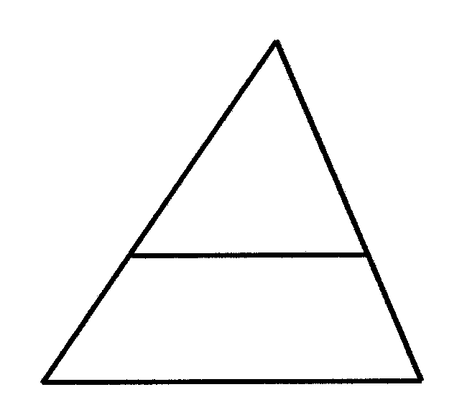
P
S
T
Q
R

Complete: ST … QR | (1)

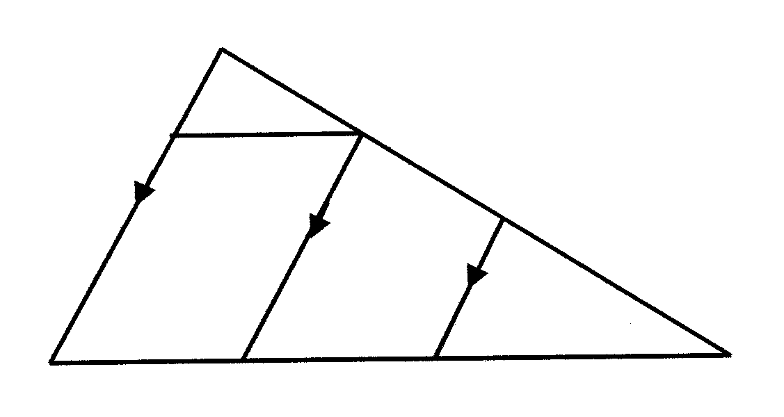
14.2
P
T
S
U
Q
M
N
R

In the accompanying figure, PQ//TM//UN; TR = 8; $\frac{\text{RN}}{\text{NQ}}=\frac{1}{3;}$ PT = 4; PS = 3 and SQ = 6

14.2.1 Calculate the value of $\frac{\text{PS}}{\text{SQ}}\text{and}\frac{\text{PT}}{\text{TR}}$and hence show that ST//QR. | (3)

14.2.2 Calculate the value of $\frac{\text{RU}}{\text{UP}}$ | (2)

14.2.3 Calculate the length of RU. | (3)

14.2.4 Hence, calculate the length of TU. | (2)

14.2.5 determine the value of $\frac{\text{RN}}{\text{NM}\text{.}}$ | (2)

14.2.6 Hence, determine the value of RN:NM:MQ. | (4)  [17]

QUESTION 15
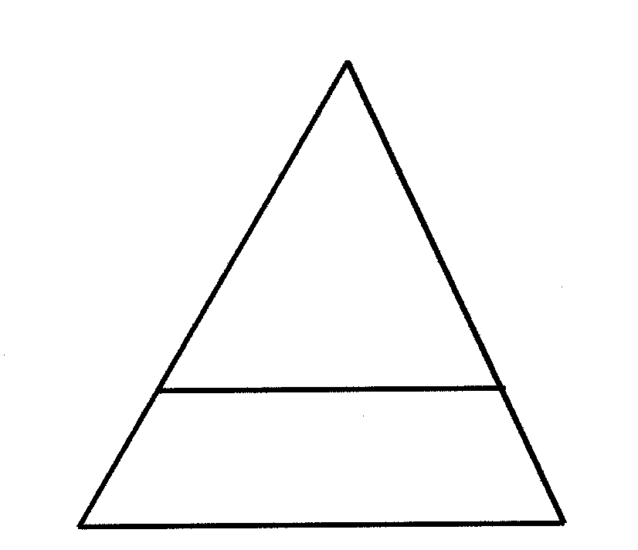
A
3
C
x + 2
7x - 6
B
D
E
3x - 1

In the accompanying figure, for what value(s) of x will BC//DE? | [5]

QUESTION 16

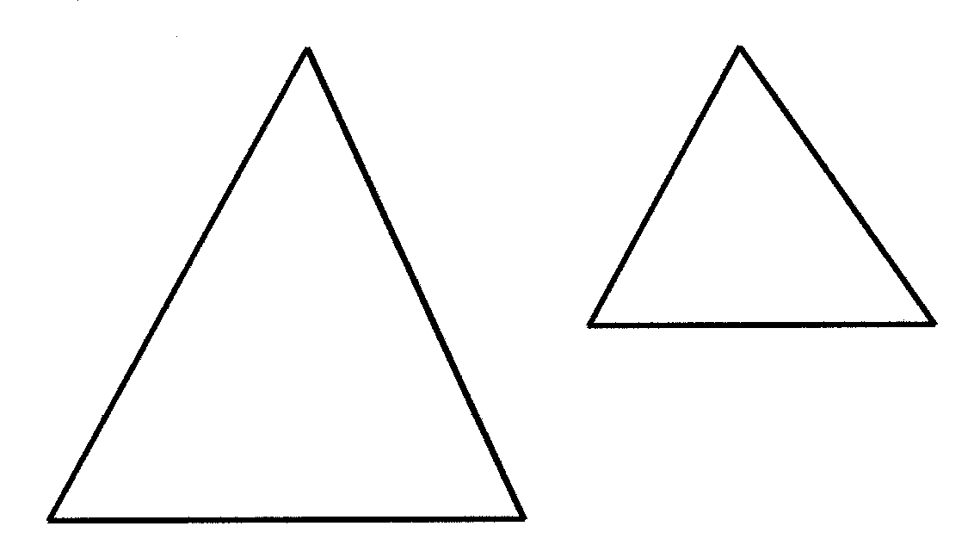
16.1
A
B
C
D
E
F

In the figure ΔABC///ΔDEF. Write down THREE ratios you can deduce. | (3)

16.2
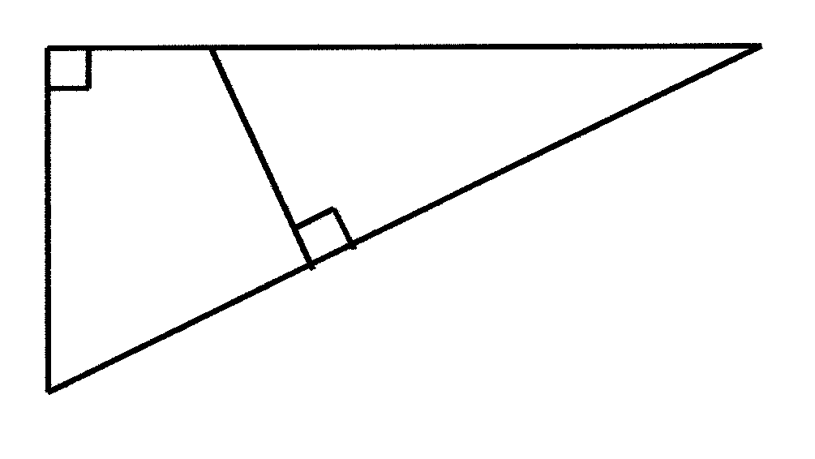
A

P

1
B
30º
2
1
T
C

In the accompanying figure, $\hat{B}=\text{30}°\text{and}\hat{A}={\hat{T}}_{2}=\text{90}°$.

16.2.1 Complete:

- ΔABC /// Δ…  - $$\frac{\text{AB}}{\text{.}\text{.}\text{.}}=\frac{\text{AC}}{\text{.}\text{.}\text{.}}=\frac{\text{BC}}{\text{.}\text{.}\text{.}}$$ | (1)  (3)

16.2.2 Calculate AC if AB = 120 mm; BT = 80 mm and PT = 40 mm. | (3)

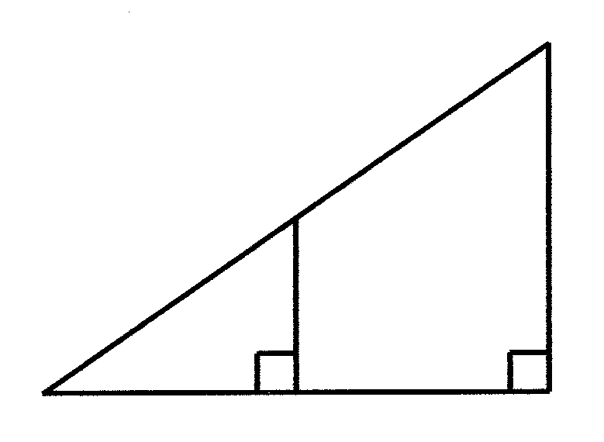
16.3
C
P
A
Q
B

ΔAPQ is constructed to determine the height of a cliff BC with PQ//BC.

- Give a reason why ΔAPQ///ΔACB  - Calculate the height BC of the cliff if AP = 130 mm; AQ = 120 mm and AB = 480 mm. | (1)  (4)  [15]

TOTAL FOR SECTION E: | [37]

SECTION F
STATISTICS
OPTIONAL

QUESTION 17

The following is a list of the heights of learners in a class. Heights are given in centimetres.

152 153 147 151 138 181 159 145 168
149 155 153 167 180 132 157 145 150
151 142 183

17.1 Draw up the frequency table for the above data. | (5)

17.2 Which height occurs most frequently? | (1)

17.3 How many of these learners are shorter than 150 cm? | (1)

17.4 If the learners were arranged from tallest to shortest, what would be the height of the learner standing in the middle? | (2)

17.5 How many learners are 153 cm tall? | (1)

17.6 Janet is the shortest learner in the class. How tall is she? | (1)

17.7 Richard is the tallest learner in class. How tall is he? | (1)

17.8 What is the range of this set of data? | (2)

17.9 How many learners are in this sample? | (2)

17.10 Calculate the

- median.  - arithmetic mean.  - standard deviation. | (3)  (4)  (6)  [29]

QUESTION 18

Eighty iron ball-rings are used in a roller mill. The original diameter of the rings was
100 mm. After a certain period of time, the ball-bearings were removed and the diameter measured to find the degree of wear. The following frequency table shows the result:

DIAMETER in mm | FREQUENCY
94 – 90  89 – 85  84 – 80  79 – 75  74 – 70  69 – 65  64 – 60  59 – 55 | 1  4  7  23  25  13  6  1

Use the table to draw up a cumulative frequency table and a cumulative frequency percentage table. | [8]

TOTAL FOR SECTION F: | [37]

TOTAL: | 150

DIAGRAM SHEET / DIAGRAMVEL

EXAMINATION NUMBER/
EKSAMENNOMMER

QUESTION / VRAAG 3 | QUESTION / VRAAG 5
y
y
P(-1; -3)  p  7  4  9  S  5.1  5.2  R  A  b  c  B  C  a | Q

QUESTION / VRAAG 6
H
24,5º
B
P
A

C
100 m  21º | $$A\hat{C}B=\text{105}°$$

QUESTION / VRAAG 10 | QUESTION / VRAAG 11

r  θ  s | 0

QUESTION / VRAAG 13 | QUESTION / VRAAG 14
A
B
O
h
P
P  T  U  R  N  M  Q  S  T  Q  R | 14.1  14.2

QUESTION / VRAAG 15

A
3
C
x + 2
7x - 6
B
D
E
3x - 1

QUESTION / VRAAG 16

A  B  C  D  E  F  C  P  A  Q  B  A  B  30º  2  1  T  C | 16.2  P  1  16.3

INFORMATION SHEET / INLIGTINGSBLAD

- CO-ORDINATE GEOMETRY/  KOÖRDINAATMEETKUNDE | - TRIGONOMETRY/  TRIGONOMETRIE

$$d_{\text{AB}}=\sqrt{(x_{B}−x_{A})^{2}+(y_{B}−y_{A})^{2}}$$  $$M(\text{x:y})=(\frac{x_{A}+x_{B}}{2};\frac{y_{A}+y_{B}}{2})$$  $$m_{\text{AB}}=\frac{y_{2}−y_{1}}{x_{2}−x_{1}}$$  $$\begin{aligned}y=\text{mx}+c \\ y−y_{1}=m(x−x_{1})\end{aligned}$$  $$\begin{aligned}\frac{y−y_{1}}{x−x_{1}}=\frac{y_{2}−y_{1}}{x_{2}−x_{1}} \\ \frac{x}{a}+\frac{y}{b}=1 \\ x^{2}+y^{2}=r^{2}\end{aligned}$$  - CONSUMER MATHEMATICS /  VERBRUIKERSWISKUNDE  $$\begin{aligned}1=\frac{\text{krt}}{\text{100}} \\ A=P(1+\frac{r}{\text{100}})^{n}\end{aligned}$$  - STATISTICS / STATISTIEKE  $∂=\frac{\sqrt{\sum{x^{2}−{\text{Nμ}}^{2}}}}{N}$  $s=\frac{\sqrt{\sum{{\text{fx}}^{2}−}\frac{(\text{fx})^{2}}{N}}}{N}$  $s=\sqrt{\frac{\sum{x^{2}−n\bar{x}}}{n−1}}$ | For any ΔABC:  $\frac{a}{\text{sinA}}=\frac{b}{\text{sinB}}=\frac{c}{\text{sinC}}$  $a^{2}=b^{b}+c^{2}−\text{2bc}\text{.}\text{cosA}$  $\text{Area}\text{ ΔAB}\text{C:}=$$\frac{1}{2}a\text{.}b\text{.}\text{ sin C}$  - CIRCULAR MEASUREMENT/  BOOGMAAT  s = rΘ  A = ½r²Θ  A = ½rs  $\begin{aligned}ν=\text{rω} \\ ω=\text{2πf} \\ ω=\frac{Θ}{t}\end{aligned}$  A = ½r²($θ$-sin$θ$)

