GAUTENG DEPARTMENT OF EDUCATION
SENIOR CERTIFICATE EXAMINATION

FUNCTIONAL MATHEMATICS SG
(Second Paper:Geometry)

TIME: 3 hours

MARKS: 150

INSTRUCTIONS:

- Sections A and B are COMPULSORY.

- Answer any TWO of Sections C, D, E or F.

- Non-programmable calculators may be used. If the question does not specify, then the final answer must be rounded off to two decimal places.

- All appropriate calculations must be shown.

- Please detach pages 17 – 22 and place each page alongside the relevant questions as required for easy reference.

- Diagram sheets are provided on pages 17 – 19. No answers may be written on them, but you may use the diagrams to determine your answer. The diagram sheets must be handed in with your examination number written on each. It is thus not necessary to redraw any sketches, unless specified.

- No answers may be determined by construction and measurement.

- A formula sheet is included on page 20 as well as graph paper on pages 21 – 22.

SECTION A
CO-ORDINATE GEOMETRY
COMPULSORY

QUESTION 1

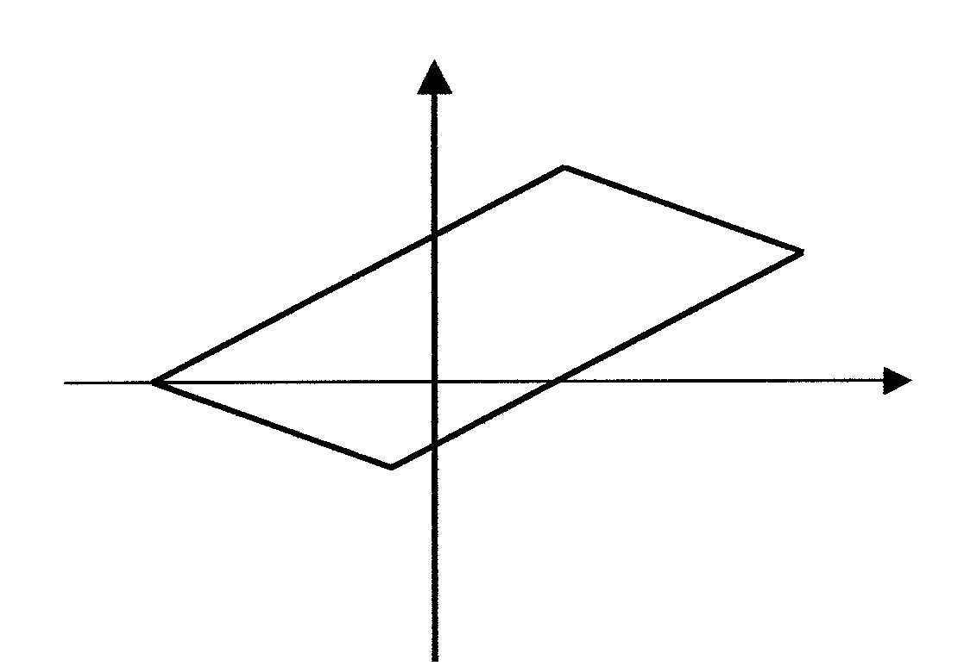
y
B(4 ; 4)
C(8 ; 2)
D(-2 ; -2)
A(-6 ; 0)
x

Points A (-6;0); B(4;4), C (8;2) and D (-2; -2) are vertices of quadrilateral ABCD.

Calculate

1.1 the length of AB. (Leave your answer in surd form.) | (3)

1.2 the midpoint of CD. | (4)

1.3 the gradients of AB and CD. | (5)

1.4 Use your answer from Question 1.3 to state whether AB is parallel or perpendicular to CD. | (2)  [14]

QUESTION 2

y – 3x + 2 = 0 is the equation of the straight line.

2.1 Express y in the form y = mx + c. | (2)

2.2 What is the gradient of the straight line? | (1)

2.3 Complete: The inclination of the straight line is… | (2)

2.4 Complete: The y-intercept is … | (1)

2.5 Calculate the x-intercept of the straight line. | (3)

2.6 Draw a sketch graph of the straight line. | (3)  [12]

QUESTION 3

3.1 The circle with centre at the origin passes through the point (–3 ; 2).

- Calculate the equation of the circle.  - Determine the radius of the circle if the circle is given by the equation  x² + y² = 13. (Leave your answer in surd form.) | (4)  (1)

- Find the point(s) of intersection of the straight line  y + 2x = 10 and the circle x² + y² = 25. | (7)  [12]

TOTAL FOR SECTION A: | [38]

SECTION B
TRIGONOMETRY
COMPULSORY

QUESTION 4
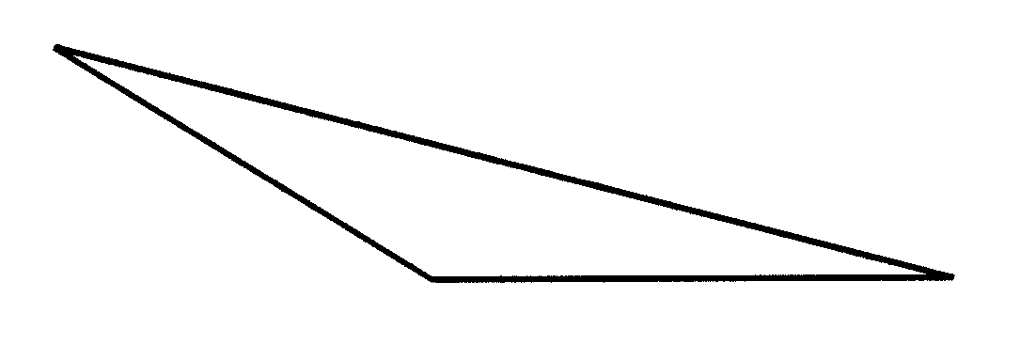
A
B
C
b
c
a

Complete using ∆ABC and name the rule used.

4.1 $\frac{\text{sin \{}\hat{A}}{a}=\frac{\text{sin \{}\hat{A}}{b}=\frac{\text{.}\text{.}\text{.}\text{.}\text{.}}{c}$ | (2)

4.2 a² = b² + c² – 2bc…. | (2)

4.3 Area of ∆ABC = $\frac{1}{2}\text{ac}\text{.}\text{.}\text{.}\text{.}$ | (2)  [6]

QUESTION 5

2
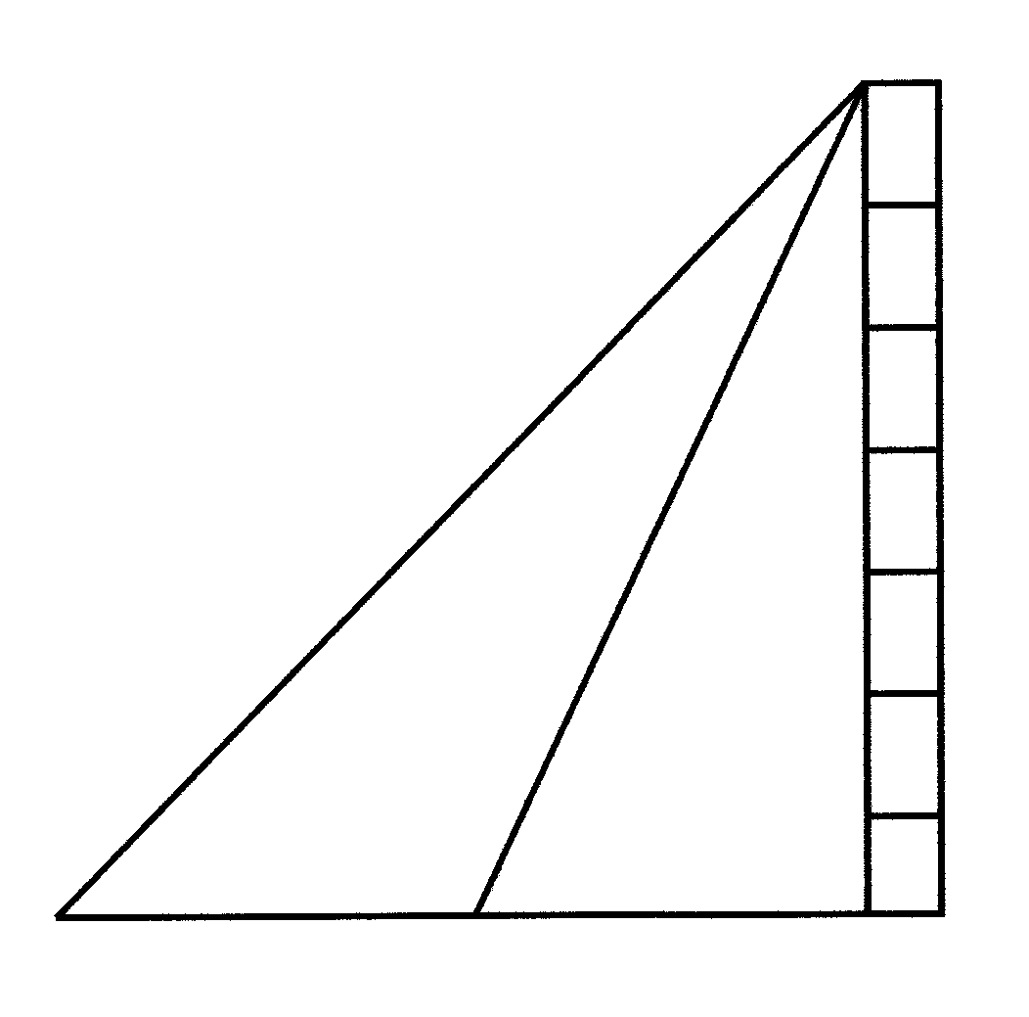
A
C
D
B
1
2
1
50º
43º
2

The angles of elevation to the top of tower AB, from two points D and C on the same horizontal plane as the foot of the tower B, are 43º and 50º respectively.
The distance DC = 90 metres.

5.1 Calculate, with reasons, the sizes of ${\hat{C}}_{1}\text{and}{\hat{A}}_{1}\text{.}$ | (4)

5.2 By using ${\hat{A}}_{1}=\text{ 7}°,$ calculate the length of AC, correct to one decimal place. | (4)

5.3 Calculate the length of AD. Use $C_{1}=\text{130}°$. | (4)

5.4 Calculate the height of tower AB. Use AC = 503 metres. | (3)

5.5 Calculate the area of ∆ADC correct to one decimal place. | (4)  [19]

QUESTION 6

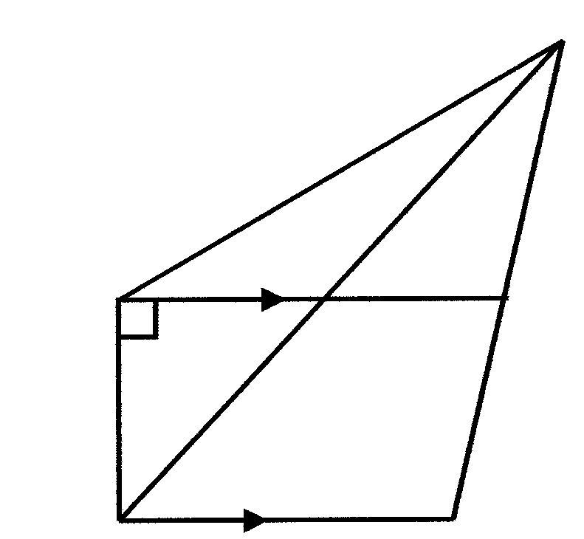
32º
41º
120º
A
D
B
C
500 m

E

F

In the accompanying figure, ABCD is a trapezium with AD // BC. The size
of $B\hat{A}D\text{ is 90}°\text{ and }B\hat{C}D\text{ is 120}°\text{.}$ CD produced to E, and the points A and B are joined to E. The line AD cuts BE in F. $E\hat{A}D=\text{32}°\text{ and }E\hat{B}C=\text{ 41}°\text{.}$

6.1 Calculate, with a reason, the size of $E\hat{F}D\text{.}$ | (2)

6.2 Calculate, with a reason, the size of $A\hat{E}F\text{.}$ | (3)

- Calculate, correct to one decimal place, the length of BE.  Use $E\hat{F}D$= 41º and $A\hat{E}F$ = 9º. | (4)

6.4 Hence, calculate the length of CE if BE = 2700 m. | (4)  [13]

TOTAL FOR SECTION B: | [38]

SECTION C
CONSUMER MATHEMATICS
OPTIONAL

QUESTION 7

7.1 Calculate the simple interest on R50 000 if it is invested for 10 years at the rate of 12% per annum. | (4)

  - The following graph represents VAT on different items as purchased by
Mrs Ntombela.

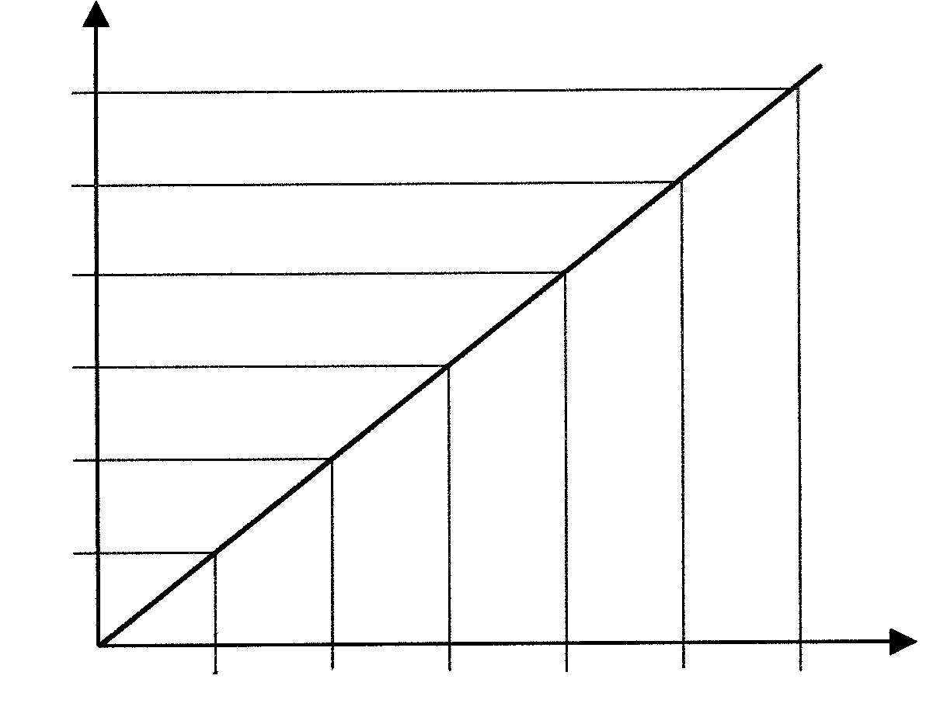

84

70

56

42

28

14

VAT
(R)
0 R100 R200 R300 R400 R500 R600

PRICE OF ITEM (R)

Use the graph to read off the following:

- The VAT on R500  - To pay VAT of R49, what must the price of an item be? | (1)  (2)

7.3 An amount of R100 000 is invested at 21% compound interest.

- Show that the investment can be calculated by the following formula, over n years, if the interest is compounded half-yearly.  A = R100 000 (1,105)^{2n} | (4)

7.3.2 Calculate the values of A in each of the following instances. Redraw the table in your answer book and complete it.

n | 1 | 2 | 3 | 4 | 5 | 6
A | R122 102 |  |  |  |  | R331 396 | (4)

- Using the graph paper provided, represent the data in Question 7.3.2 graphically with n on the x-axis where 10 mm → 1 year and A on the y-axis where 10 mm → R20 000. | (5)

7.3.4 Read the following off your graph:

- A if n = 5½ years  - n if A = R165 000 | (1)  (1)  [22]

QUESTION 8

TAX RATES FOR THE … YEAR OF ASSESSMENT

MARRIED PERSONS
TAXABLE INCOME | RATES OF TAX
R 0 – 5 000  R 5 000 – 10 000  R 10 000 – 15 000  R 15 000 – 20 000  R 25 000 – 30 000  R 30 000 – 40 000  R 40 000 – 50 000  R 50 000 – 60 000  R 60 000 – 80 000  R 80 000 + | 17% each R1  R 850 + 18% of the amount over R 5 000  R 1 750 + 19% of the amount over R 10 000  R 2 700 + 20% of the amount over R 15 000  R 3 700 + 21% of the amount over R 20 000  R 5 800 + 28% of the amount over R 30 000  R 8 600 + 36% of the amount over R 40 000  R12 200 + 41% of the amount over R 50 000  R16 300 + 42% of the amount over R 60 000  R24 700 + 43% of the amount over R 80 000

A married female, 30 years old, earns a salary of R85 000 per annum. Her tax rebate is R2 625. She is allowed the following deductions:

R3 600 – Medical Contributions
R3 800 – Travel Expenses
R4 200 – Pension Fund Contributions

8.1 What is her taxable income? | (4)

8.2 What is her tax on her taxable income? | (4)

8.3 What is her tax rebate? | (1)

8.4 What is the tax that she owes for the year? | (2)

8.5 If an amount of R20 400 was deducted from her salary for tax, what is the amount due to her or what is the amount that she owes for tax? | (4)  [15]

TOTAL FOR SECTION C: | [37]

SECTION D
CIRCULAR MEASUREMENT
OPTIONAL

QUESTION 9

O is the centre of the circle and θ=1 radian.

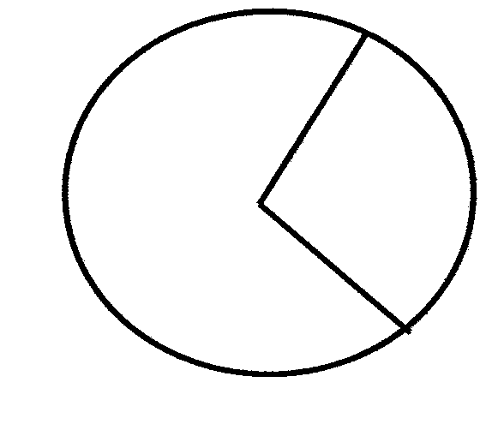
O
θ
s
r

9.1 Complete: s = … | (1)

9.2 Complete: 1 radian = …º | (1)

9.3 Convert 0,96 radians to degrees. | (2)

9.4 Convert 21º to radians. | (3)

9.5 Without using your pocket calculator, convert 360º to radians. Give your answer in terms of π. | (2)  [9]

QUESTION 10

The wheel of a car has a diameter of 600 millimetres.

Calculate

10.1 the radius of the wheel. | (1)

10.2 the circumference velocity of the wheel in m/s if the wheel moves at 90 km/h. | (2)

10.3 the angular velocity of the wheel. | (3)

10.4 the revolutions per second of the wheel. | (3)

10.5 the revolutions per minute of the wheel. | (2)  [11]

QUESTION 11

11.1 In the accompanying figure A and B are two points on the circumference of a circle with centre O. In ΔBOC is $\hat{B}=\text{90}°\text{, OB }=\text{ 45 cm and BC }=\text{ 75 cm}\text{.}$

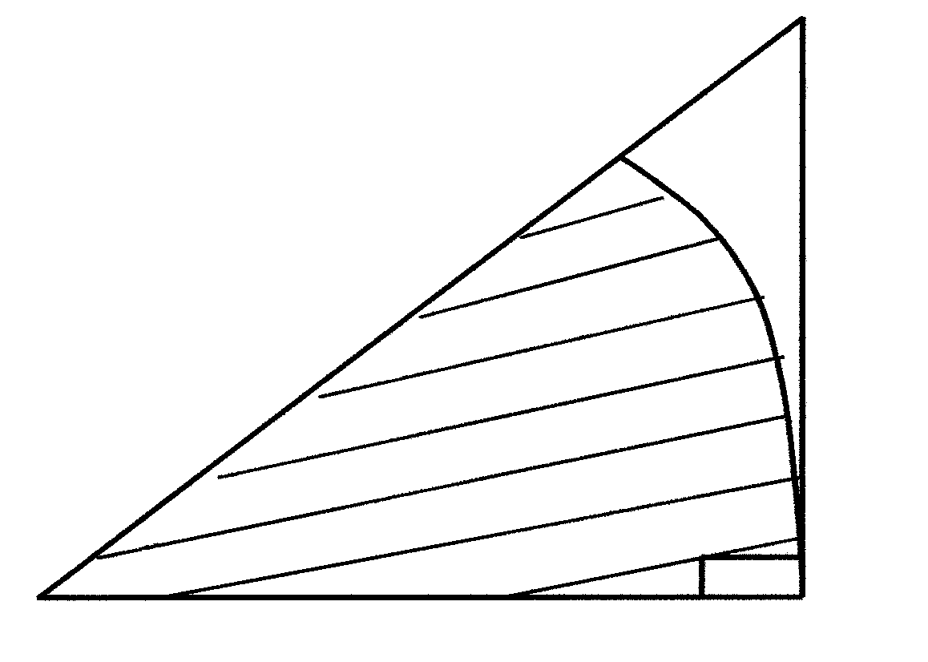
C
A
O
B
θ
45 cm
75 cm

11.1.1 Show by means of calculation that θ = 1,03 radians. | (3)

11.1.2 Calculate:

- The area of sector OBA (shaded region)  - The area of ΔBOC  - The area of the region covered by ABC | (3)  (3)  (2)

11.2
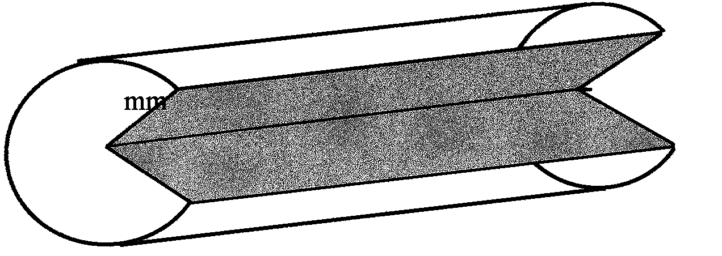
50 mm
A

B
D
C
E

20,5 mm
F

The accompanying figure shows a cylinder with radius 20,5 mm from which a sector ABCDEF was cut out. The reflex angle BAF is $\frac{4}{3}π$ radians and the length of the cylinder is 50 mm.

Calculate:

- the volume of the remaining part of the cylinder  - in terms of π, the magnitude of the acute angle BAF | (4)  (2)  [17]

TOTAL FOR SECTION D: | [37]

SECTION E
RATIO, PROPORTION AND SIMILARITY
OPTIONAL

QUESTION 12

12.1 If DE // BC, complete:
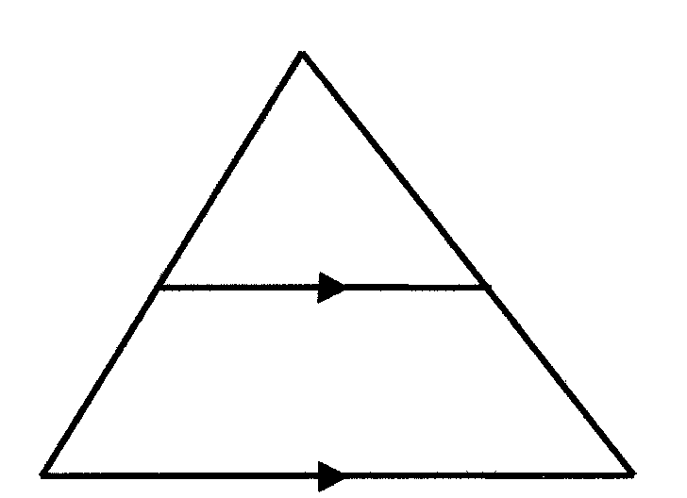
A
D
E
B
C
$\frac{\text{AD}}{\text{AB}}=\frac{\text{.}\text{.}\text{.}\text{.}}{\text{.}\text{.}\text{.}\text{.}}$ |  | (2)

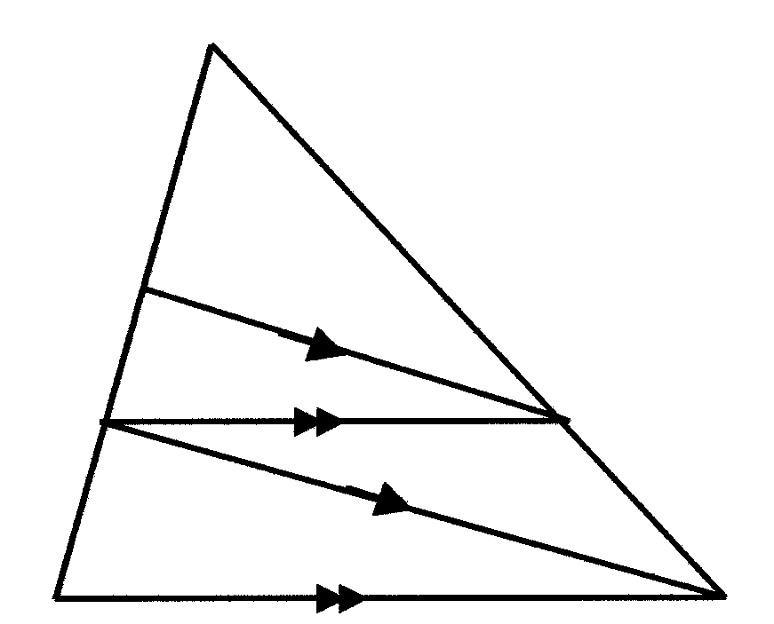
12.2
A
6
P
4
X
B
C
Y

In the accompanying figure, line XY is parallel to line BC, PY // XC, AP = 6 and PX = 4. Calculate, with reasons, the length of BX. | (7)

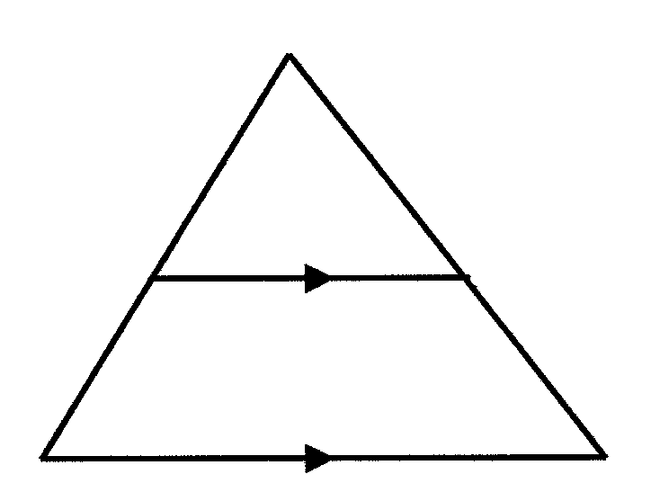
12.3
X
y + 1
B
2,4
Z
4
A
3
Y

In ΔXYZ, XA = 4; AY = 3; XB = y + 1; BZ = 2,4 and AB // YZ.  Calculate the value of y. | (5)  [14]

QUESTION 13

13.1 In the figures below, $\hat{B}=\hat{M}\text{and \{}\hat{A}=\hat{L}\text{.}$

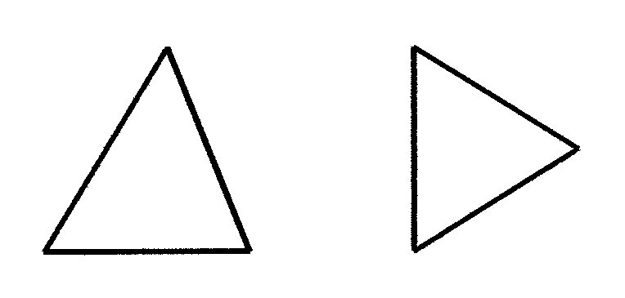

A

B

C

K

L

M

Complete:

- ΔABC … ΔLMK  - $$\frac{\text{AB}}{\text{LM}}=\frac{\text{AC}}{\text{.}\text{.}\text{.}}=\frac{\text{.}\text{.}\text{.}}{\text{KM}}$$ | (1)  (2)

  - In ΔPQR; U and T are points on PR and S is a point on PQ.
$${\hat{U}}_{1}=\hat{Q}\text{and ST // QR}\text{.}\text{ PR }=\text{ 24 cm; PS }=\text{ 10 cm and SQ }=\text{ 6 cm}$$

1
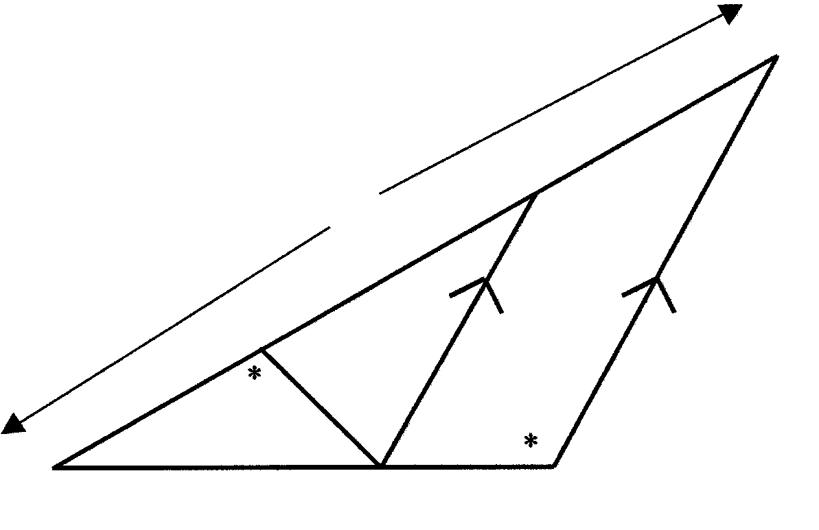
24
T

U
P
10
S
6
Q
R

1

- Give THREE reasons why ΔPUS /// ΔPQR. | (3)

13.2.2 Complete: $\frac{\text{PU}}{\text{PS}}=\frac{\text{.}\text{.}\text{.}}{\text{.}\text{.}\text{.}}$ | (2)

13.2.3 Calculate the length of PU. | (3)

13.2.4 Calculate the length of PT. | (4)

13.2.5 Calculate the length of TU. | (2)  [17]

QUESTION 14
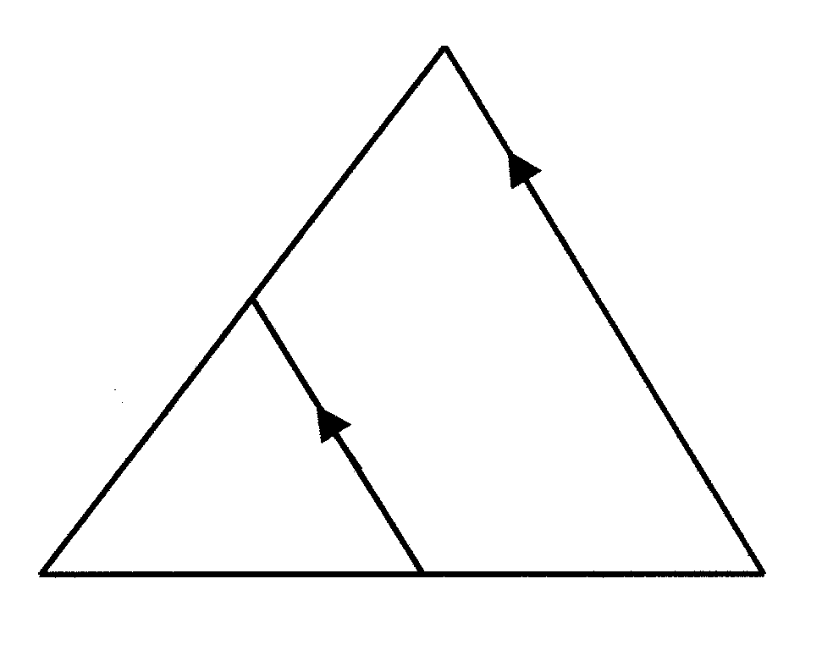
D
E
y
x
F
L
28
K
12

K

Given ΔDFL. ΔEFK is drawn so that EK // DL, with E on FD and K on LF.
$F\hat{K}\text{E }=\text{ x and}F\hat{E}K=\text{ y}\text{.}$DL = 28; EK = 12 and LF = 14 units respectively.

14.1 Determine $F\hat{L}\text{D }\text{in terms of }\text{x }\text{and }y$. | (1)

14.2 Determine $F\hat{D}\text{L }\text{in terms of}\text{ x }\text{and }y$. | (1)

14.3 Complete: ΔKFE /// Δ … | (2)

14.4 Hence complete: $\frac{\text{KF}}{\text{LF}}=\frac{\text{.}\text{.}\text{.}}{\text{DL}}=\frac{\text{EF}}{\text{.}\text{.}\text{.}}$. | (2)  [6]

TOTAL FOR SECTION E: | [37]

SECTION F
STATISTICS
OPTIONAL

QUESTION 15

Jaques Kallis attained the following scores in 14 of his ten pin bowling matches:

187 170 194 212 188 170 195
179 187 183 195 187 203 196

15.1 Rearrange his scores in ascending order. | (3)

15.2 Write down the mode of his scores. | (1)

15.3 Determine the median of his scores. | (2)

15.4 Calculate the arithmetic mean of his scores. | (3)

15.5 Calculate the range of his scores. | (2)

15.6 Calculate the standard deviation of his scores. Give your answer rounded off to two decimal digits. | (6)  [17]

QUESTION 16

The following frequency table shows the votes received by 60 learners in a prefect election:

Class Interval | Frequency | Class Midpoint | Cumulative frequency | Cumulative Percentage
75 – 84  65 – 74  55 – 64  45 – 54  35 – 44  25 – 34  15 – 24  5 – 14 | 2  3  21  19  9  3  2  1
Total | 60

16.1 Redraw the table in your answer book and complete it. | (12)

16.2 Use the graph paper supplied to draw a cumulative percentage graph.

Scale: x - axis: 1 cm = 10 units  y - axis: 1 cm = 5 units | (5)

16.3 Using A, B and C, show on the graph where the following can be read off:

Median (A), the first quartile (B) and the third quartile (C). | (3)  [20]

TOTAL FOR SECTION F: | [37]

TOTAL: | 150

DIAGRAM SHEET / DIAGRAMVEL

EXAMINATION NUMBER/
EKSAMENNOMMER

QUESTION / VRAAG 1 | QUESTION / VRAAG 4
y
x
B(4 ; 4)
C(8 ; 2)
D(-2 ; -2)
A(-6 ; 0)
A
B
C
b
c
a

QUESTION / VRAAG 5 | QUESTION / VRAAG 6
A
C
D
B
1
2
1
50º
43º
2
A
D
B
C
500 m
E
32º
41º
120º

QUESTION / VRAAG 7 | QUESTION / VRAAG 9

O
θ
s
r

84

70

56

42

28

14

BTW
(R)
VAT
0 R100 R200 R300 R400 R500 R600

PRICE OF ITEM (R)

QUESTION / VRAAG 11

C

A
O
B
θ
45 cm
50 mm
A

B
D
C
E

20,5 mm

75 cm

F

QUESTION / VRAAG 12
A
6
P
4
X
B
C
Y
A
D
E
B
C
12.1
12.2

QUESTION / VRAAG 13
X
y + 1
B
2,4
Z
4
A
3
Y

A

B

C

K

L

M
12.3
13.1

24
T

U
P
10
S
6
Q
R
D

E
y
x
F
L
28
13.2
QUESTION / VRAAG 14
12
K

1

INFORMATION SHEET / INLIGTINGSBLAD

- CO-ORDINATE GEOMETRY/  KOÖRDINAATMEETKUNDE | - TRIGONOMETRY/  TRIGONOMETRIE

$$d_{\text{AB}}=\sqrt{(x_{B}−x_{A})^{2}+(y_{B}−y_{A})^{2}}$$  $$M_{(\text{xy})}=(\frac{x_{A}+x_{B}}{2};\frac{y_{A}+y_{B}}{2})$$  $$m_{\text{AB}}=\frac{y_{2}−y_{1}}{x_{2}−x_{1}}$$  $$\begin{aligned}y=\text{mx}+c \\ y−y_{1}=m(x−x_{1})\end{aligned}$$  $$\begin{aligned}\frac{y−y_{1}}{x−x_{1}}=\frac{y_{2}−y_{1}}{x_{2}−x_{1}} \\ \frac{x}{a}+\frac{y}{b}=1 \\ x^{2}+y^{2}=r^{2}\end{aligned}$$  - CONSUMER MATHEMATICS /  VERBRUIKERSWISKUNDE  $$\begin{aligned}1=\frac{\text{krt}}{\text{100}} \\ A=P(1+\frac{r}{\text{100}})^{n}\end{aligned}$$  - STATISTICS / STATISTIEKE  $S=\sqrt{\frac{\sum{x^{2}−n{\bar{x}}^{2}}}{n−1}}$  $∂=\frac{\sqrt{\sum{x^{2}−{Nμ}^{2}}}}{N}$  $s=\frac{\sqrt{\sum{t^{2}−}\frac{(\text{fx})^{2}}{N}}}{N}$ | For any ΔABC  $\frac{a}{\text{sin}A}=\frac{b}{\text{sin}B}=\frac{c}{\text{sin}C}$  $a^{2}=b^{b}+c^{2}−2\text{bv}\text{.}\text{cos}A$  $\text{Area}\text{ΔABC}=$  - CIRCULAR MEASUREMENT/  BOOGMAAT  s = r θ  A = ½r² θ  A = ½rs  $\begin{aligned}ν=rω \\ ω=2πf \\ ω=\frac{Θ}{t}\end{aligned}$  A = ½r² (θ – sin θ)

