GAUTENG DEPARTMENT OF EDUCATION

SENIOR CERTIFICATE EXAMINATION

FUNCTIONAL MATHEMATICS SG
(First Paper: Algebra)

TIME: 3 hours

MARKS: 150
INSTRUCTIONS:

- Answer ALL questions.
- All relevant calculations must be shown.
- Pocket calculators may be used, unless otherwise stated.
- Final answers must be rounded off to TWO decimal digits, unless otherwise stated.
- Consult the information sheet at the back of the question paper.
- A sheet of graph paper is provided on page 8. Use it to answer the relevant questions.

QUESTION 1

- Simplify the following without using a calculator.  - ${\text{81}}^{34}$ – $8^{23}$ + 9⁰  - $$\frac{8^{x+3 ⋅ }(14)^{2x+3}}{2^{−x+1}}$$  - $$\frac{3\text{.}2^{m}−2^{m+2}}{2^{m+1}}$$  - $$2\sqrt{8}+\sqrt{\text{32}}−3\sqrt{\text{50}}$$ | (6)  (5)  (3)  (4)

- Solve for x:  - 3^{3x + 1} = 9^{2x–4}  - $x^{34}$ = 8 | (3)  (3)  [24]

QUESTION 2

2.1 Simplify without using a calculator:

2.1.1 $\frac{\text{log}\text{27}}{\text{log}9}$  2.1.2 log₃5 – log₃10 + log₃18  2.1.3 log₂64 – log₄1 + log₃₆6 | (3)  (4)  (6)

2.2 If log 2 = a and log 3 = b express log 12 in terms of a and b. | (3)

- Solve for x:  - log₅x = 4  - log_{x}64 = 3 | (2)  (3)

- Solve for x by using a calculator:  4^{x} = 40 | (3)

- Solve for x by using the interval bisection method. Round the answer off to two decimal digits:  3^{x} = 64 | (6)  [30]

QUESTION 3

3.1 In an arithmetical series the second term is 8 and the ninth term is – 13. Calculate the  - common difference.  - first term.  - 15th term.  - sum of the first 15 terms. | (4)  (2)  (3)  (5)

3.2 The first 3 terms of an arithmetical sequence are: t + 2; 2t – 6; 4t – 5.  - Calculate the value of t.  - If t = -9 determine the first 3 terms. | (4)  (3)  [21]

QUESTION 4

4.1 Given: -4; 8; -16 ...; 512. Which term of the sequence is 512?  - The general term of a geometric sequence is Tr = 3.2^{r – 1}. Determine  4.2.1 the first 3 terms of the sequence.  4.2.2 the constant ratio.  4.2.3 the sum of the first 8 terms. | (6)  (3)  (1)  (4)  [14]

QUESTION 5

- A balloon is inflated with air and the volume after t seconds is given by  V(t) = 5t² + 40t + 6.  5.1.1 Calculate the volume of the balloon after 1 second.  5.1.2 Calculate the volume of the balloon after 4 seconds.  5.1.3 Calculate the average rate of change of volume for the interval t = 1 and t = 4.  5.2 Determine: $\begin{matrix}\text{lim} \\ x→4\end{matrix}\frac{x^{2}−\text{16}}{x−4}$ | (2)  (2)  (2)  (3)

5.3 If f(x) = 3x² determine from first principles f'(x).  5.4 Determine g'(x) if:  5.4.1 g(x) = ¼x⁴ + 4x  5.4.2 g(x) = -x³ + 5x² – x  5.4.3 g(x) = (x + 2)(x– 2) | (6)  (2)  (3)  (2)

- If f(x) = -2x² – x + 6, determine:  5.5.1 f(1)  5.5.2 f'’(1)  5.5.3 The equation of the tangent to the curve of f at the point where x = 1 | (2)  (2)  (3)  [29]

QUESTION 6  Given: f(x) = x³ – 3x²  - Calculate where the curve of f intersects the x axis and the y axis.  6.2 Calculate the co-ordinates of the turning point of the curve of f. | (4)  (7)

- Use this information to draw a neat graph of f. | (3)  [14]

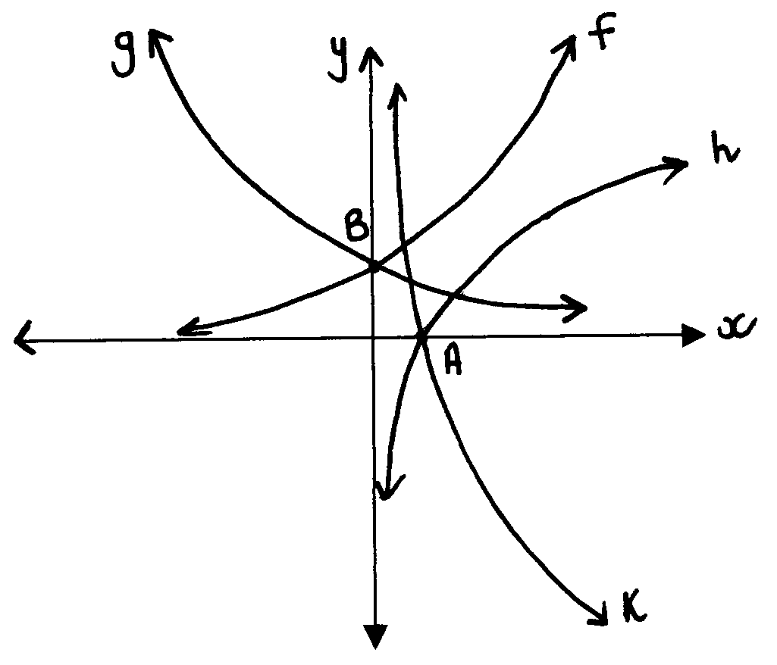

QUESTION 7

The sketch shows the graphs of y = 4^{x}; y = (¼)^{x}; y = log₄x and y = log_{¼}x. Use these graphs to answer the following questions.  - Choose the correct answer.  7.1.1 The equations of h and k are respectively:  (a) y = 4^{x} and y = log₄x  (b) y = 4^{x} and y = log_{¼}x  (c) y = 4^{x} and y = (¼)^{x} | (1)

- The equations of f and g are respectively:  (a) y = log₄x and y = log_{¼}x  (b) y = log₄x and y = log(¼)^{x}  (c) y = log₄x and y = 4^{x} | (1)

7.1.3 The equation of the graph which is symmetrical to f in the y axis is:  (a) y = (¼)^{x}  (b) y = log₄x  (c) y = log_{¼}x | (1)

7.1.4 The equation of the graph which is symmetrical to h in the x axis is:  (a) y = 4^{x}  (b) y = (¼)^{x}  (c) y = log_{¼}x | (1)

- The co-ordinates of A and B are respectively:  - (0 ; 1) and (1 ; 0)  - (1 ; 0) and (0 ; 1)  - (4 ; 0) and (0 ; 4) | (1)

7.2 For which value(s) of x is:  7.2.1 log₄x = log_{¼}x x = ?  7.2.2 4^{x} = (¼)^{x} x = ?  7.2.3 4^{x} = 1 x = ? | (1)  (1)  (1)

7.3 For which value(s) of x is log₄x defined?  7.4 For which value(s) of x is (¼)^{x} defined? | (1)  (1)  [10]

QUESTION 8

The crime rate in a certain town is 200 incidents in a certain year. It doubles at the end of each year. The crime rate in any year can be expressed by y, where y = 200(2)^{x}.

  - Complete the following table in your answer book and use the information to draw a neat graph of y = 200(2)^{x} on graph paper.

x (years) | 0 | 1 | 2 | 3 | 5 | 6 | (6)
y = 200(2)^{x} |  |  |  |  |  |  | (6)

- Use the graph to determine what the crime rate of the town will be immediately after four years.  - Use the graph to determine after how many years the town will have a crime rate of 8 000 incidents per year.  TOTAL: | (1)  (1)  [8]  150

INFORMATION SHEET / INLIGTINGSBLAD
h→o

log_{a} PQ = log_{a} P + log_{a} Q; log_{a} $\frac{P}{Q}$ = log_{a} P – log_{a} Q

log_{a} P^{n} = n log_{a} P; log_{a} P = $\frac{{\text{log}}_{b}P}{{\text{log}}_{b}a}$

T_{n} = a + (n – 1)d; T_{n} = ar^{n–1}

S_{n} = $\frac{n}{2}$[2a + (n – 1)d]; S_{n} = $\frac{a (r^{n} −\text{ 1})}{\text{r }−\text{ 1}}$ ; S_{n} = $\frac{n}{2}$[a + ℓ]

D_{x}[x^{n}] = nx^{n–1}

x = $\frac{−\text{b }±\sqrt{b^{2}−\text{ 4ac}}}{\text{2a}}$

f ' (x) = lim $\frac{f\left(x+h\right)−f\left(x\right)}{h}$

