GAUTENG DEPARTMENT OF EDUCATION

SENIOR CERTIFICATE EXAMINATION

FUNCTIONAL MATHEMATICS SG
(First Paper: Algebra)

TIME: 3 hours

MARKS: 150
INSTRUCTIONS:

- Answer ALL questions.
- All relevant calculations must be shown.
- Pocket calculators may be used, unless otherwise stated.
- Final answers must be rounded off to TWO decimal places, unless otherwise stated.
- Consult the information sheet at the back of the question paper.
- One sheet of graph paper is provided on page 7. Make use of it to answer the relevant question.

QUESTION 1

- The general term of an arithmetic sequence is Tn = -3n + 2. Determine  - the first three terms of the sequence.  - the 12th term of the sequence. | (3)  (3)

- 2x + 1; 3x + 3; 7x – 1 are the first three terms of an arithmetical sequence.  - Determine the value of x.  - If x = 2 determine the first three terms of the sequence.  - Determine the common difference of the sequence.  - Determine the sum of the first 12 terms of the sequence. | (4)  (3)  (1)  (5)

- Which term of the sequence 14; 8; 2; ... is equal to -34? | (4)  [23]

QUESTION 2

- Determine the eighth term of the series 2 + 1 + ½ + ...  - The sixth term of a geometric sequence is -64 and the third term is 8. Determine:  - the constant ratio.  - the first term of the sequence.  2.3 Determine the sum of the series 3 + 9 + 27 + ... up to 7 terms. | (4)  (5)  (2)  (4)  [15]

QUESTION 3

3.1 Simplify without using a calculator:

3.1.1 $\frac{\text{log}\text{81}}{\text{log}\text{27}}$  - 3 log₆2 + log₆45 – log₆10  - log₂16 + log₉27 – log₄1 | (3)  (5)  (7)

3.2 Solve for x:  - log₂(x + 5) = 4  - log_{x}125 = 3 | (3)  (3)

3.3 Solve for x, rounded off to 2 decimal digits:  4.5^{x} = 28 | (4)

3.4 Solve for x by using the interval bisection method, rounded off to two decimal digits:  2^{x} = 48 | (6)  [31]

QUESTION 4

- Determine: lim 2x² – 5x + 2  x→3  - Determine f '(x) from first principles f (x) = –2x² | (2)  (6)

- Determine g '(x) if:  - g(x) = 5  - g(x) = –2x³ + 12x² – 5x  - g(x) = (x – 3)(x + 2) | (1)  (3)  (3)

- If f(x) = 2x² – 3x + 5, determine  - f (2)  - f '(x)  - f '(2)  - the equation of the tangent to the curve of f (x) at the point where x = 2. | (2)  (1)  (1)  (3)  [22]

QUESTION 5

The sketch below represents the graph of f (x) = x³ + 6 x².
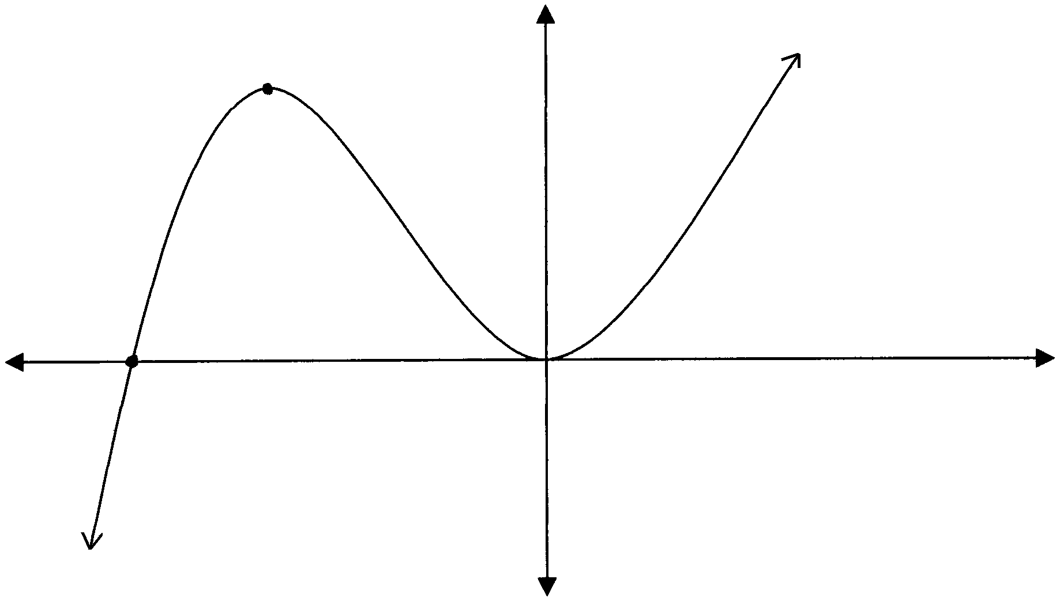
B
x
A
C
y

- Calculate the co-ordinates of A and B, the x intercepts of the curve of f (x).  - Calculate the co-ordinates of C, one of the turning points of the curve of f (x). | (3)  (6)  [9]

QUESTION 6

Simplify the following without using a calculator

6.1 27^{⅔} + (½)^{–2} – 5⁰  6.2 $\frac{4^{n−2} 8^{1−n}}{2^{−n+2}}$  • | (6)  (5)

6.3 $\frac{2^{n+2}− 3\text{.}2^{n+1}}{2^{n+1}}$ | (4)

6.4 $\sqrt{\text{18}}(\sqrt{\text{50}}−\sqrt{8})$ | (5)  [20]

QUESTION 7

Solve for x without using a calculator:

- 5^{3x + 1} = 25^{2x – 4}  - $x^{34}$ = 27 | (3)  (3)  [6]

QUESTION 8

8.1 On the same set of axes draw the graphs of f (x) = 2^{x}, g (x) = (½)^{x} and h(x) = 2.3^{x} by completing the following table.

x | -3 | -2 | -1 | 0 | 1 | 2 | 3 | (12)
2^{x} |  |  |  |  |  |  |  | (12)
(½)^{x} |  |  |  |  |  |  |  | (12)
2.3^{x} |  |  |  |  |  |  |  | (12)

8.2 On the same set of axes draw the graph of k(x) = log₂x by using symmetry. | (2)

8.3 Determine the value of x graphically if:

8.3.1 2^{x} = 7 x = ?  8.3.2 2.3^{x} = 5 x = ?  8.3.3 log₂x = 0 x = ?  8.3.4 2^{x} = (½)^{x} x = ? | (1)  (1)  (1)  (1)  [18]

QUESTION 9

The distance travelled by an object from a certain point at a time t, is given by the function f, with f(t) = t² + 20t.

- Calculate the velocity of the object after 1 second.  - Calculate the velocity of the object after 8 seconds.  - Calculate the average velocity of the object when it moved from t = 1 to  t = 8 seconds. f(t) is shown in metres. | (2)  (2)  (2)  [6]

TOTAL: | 150

INFORMATION SHEET / INLIGTINGSBLAD
h→o

log_{a} PQ = log_{a} P + log_{a} Q; log_{a} $\frac{P}{Q}$ = log_{a} P – log_{a} Q

log_{a} P^{n} = n log_{a} P; log_{a} P = $\frac{{\text{log}}_{b}P}{{\text{log}}_{b}a}$

T_{n} = a + (n – 1)d; T_{n} = ar^{n–1}

S_{n} = $\frac{n}{2}$[2a + (n – 1)d]; S_{n} = $\frac{a (r^{n} −\text{ 1})}{\text{r }−\text{ 1}}$ ; S_{n} = $\frac{n}{2}$[a + ℓ]

D_{x}[x^{n}] = nx^{n–1}

x = $\frac{−\text{b }±\sqrt{b^{2}−\text{ 4ac}}}{\text{2a}}$

f ' (x) = lim $\frac{f\left(x+h\right)−f\left(x\right)}{h}$

