GAUTENG DEPARTMENT OF EDUCATION

SENIOR CERTIFICATE EXAMINATION

FUNCTIONAL MATHEMATICS SG
(First Paper: Algebra)

TIME: 3 hours

MARKS: 150
INSTRUCTIONS:

- Answer ALL questions.
- All relevant calculations must be shown.
- Pocket calculators may be used, unless otherwise stated.
- Final answers must be rounded off to TWO decimal places, unless otherwise stated.
- Consult the information sheet on page 6.
- One sheet of graph paper is provided. Make use of it to answer the relevant question.

QUESTION 1  - Which term of the sequence $\frac{\text{19}}{4}$; 19; 76; … is equal to 4864?  - Calculate the first three terms of the geometric sequence of which the eighth term is 896 and the constant ratio is 2.  - The sixth term of an arithmetic sequence is 15 and the twenty-first term is 45. Calculate the first term of the sequence.  - Calculate the sum of the first fifty terms of the series 2 + 5 + 8 + …  - The first three terms of a geometric sequence are x; x + 1; x – 1; …  - Calculate the value of x.  - Determine the first three terms of the sequence if x=$−13$.  - Determine the constant ratio of the sequence. | (8)  (7)  (6)  (6)  (5)  (3)  (2)  [37]

QUESTION 2  - Simplify without the use of a calculator:  - log₃9  - log20 – log8 + log40  - log₄16 – log₅1 + log₉27 | (2)  (5)  (7)

2.2 Solve for x: log₅ (x–1) = 3.  2.3 Use a calculator and solve for x:  4^{x} = 54  2.4 Solve for x by using the interval bisection method, rounded off to one decimal digit: 2^{x + 1} = 19 | (3)  (3)  (5)  [25]

QUESTION 3  x → 1  - Determine lim $\frac{x^{2}−1}{x−1}$  - Determine f ' (x) from first principles if f(x) =6x².  - Determine g ' (x) if  - g (x) = –5  3.3.2 g (x) =$\frac{1}{4}$ x⁴ – 3x  3.3.3 g (x) = x (x⁴ –2x)  - If f(x) = x²–2x + 3, determine  - f(1).  - the equation of the tangent to the curve of the function f(x) = x² – 2 x + 3 at the point where x = 1. | (2)  (6)  (1)  (2)  (4)  (2)  (6)  [23]

QUESTION 4  The function f(t) =5t – t² gives the distance of a ball which is thrown vertically upwards (f(t) in metres and t in seconds).  - Calculate after how many seconds the ball will reach a maximum height.  - Calculate the maximum height which the ball will reach.  - Determine the average velocity of the ball from t = 1 to t = 3 seconds. | (3)  (2)  (4)  [9]

QUESTION 5  Given f(x) = x³ + 3 x²  - Calculate where the curve of f(x) intersects the x axis and y axis.  - Calculate the co-ordinates of the turning points of the curve of f(x).  - Use this information to draw a neat sketch graph of f(x). | (4)  (6)  (3)  [13]

QUESTION 6  •  Simplify the following without using a calculator:  - $$\frac{3\sqrt{\text{75}}}{\sqrt{\text{27}}}$$  - 4^{3/2} + 81^{3/4} + 5⁰  - $\frac{2^{x+1}−2^{x−1}}{2^{x}}$  6.4 $\frac{2^{x+1} 2^{x−1}}{2^{x}}$ | (3)  (7)  (3)  (3)  [16]

QUESTION 7  Solve for x without using a calculator:  - 2^{2x–6} = 64  7.2 4.3^{x} = 36 | (3)  (3)  [6]

QUESTION 8  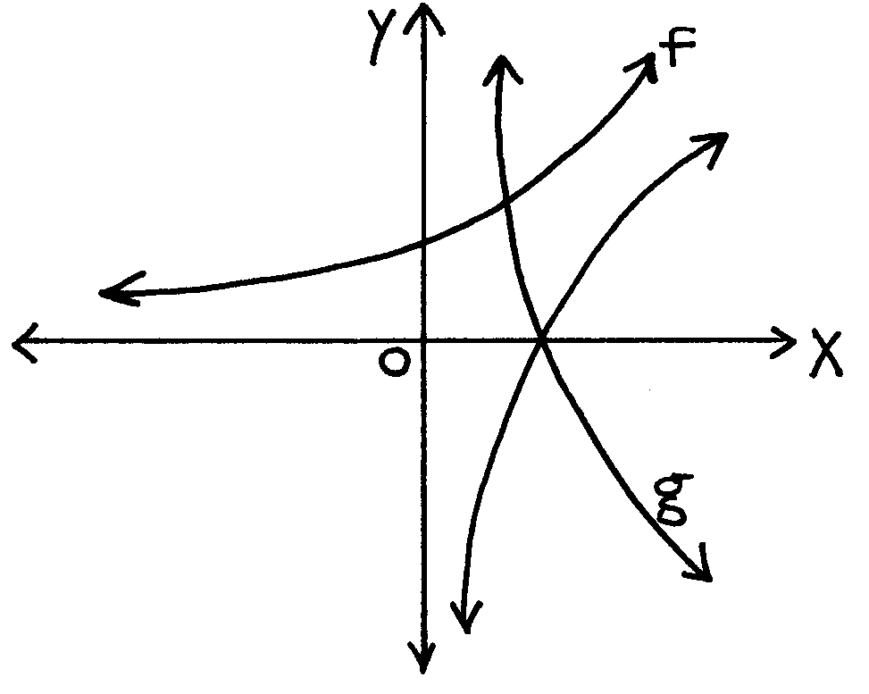  The sketch shows the curves of y=3^{x}; y = log₃x and y = log_{1/3}x. Use these graphs to answer the following questions.  - Write down the equations which define f and g respectively.  - For which value(s) of x is:  - log₃x = log_{1/3}x?  - log_{1/3}x =0?  8.2.3 3x = 1? | (2)  (1)  (1)  (1)

- For which value(s) of x is log₃x defined?  8.4 For which value(s) of x is log_{1/3}x negative? | (2)  (2)  [9]

QUESTION 9

The population of a certain town in a certain year is 100 and it doubles at the end of each year. The population in any year can be expressed by y, where y=100 (2)^{x}.

  - Complete the following table in your answer book and use the information to draw a neat graph of y=100 (2)^{x} on graph paper.

 | x (years) | 0 | 1 | 2 | 3 | 5 | 6
 | y=100 (2)^{x}
 |  |  |  |  |  |  |  |  | (8)

- Use the graph to determine what the population of the town will be immediately after 4 years. Show on the graph where the answer was read off. (Use A)  9.3 Use the graph to determine after how many years the town will have a population of 2000. Show on the graph where the answer was read off. (Use B) | (2)  (2)  [12]

TOTAL: | 150

INLIGTINGSBLAD / INFORMATION SHEET
h→o

log_{a} PQ = log_{a} P + log_{a} Q; log_{a} $\frac{P}{Q}$ ₌ log_{a} P – log_{a} Q

log_{a} P^{n} = n log_{a} P; log_{a} P = $\frac{{\text{log}}_{b}P}{{\text{log}}_{b}a}$

T_{n} = a + (n – 1)d; T_{n} = ar^{n–1}

S_{n} = $\frac{n}{2}$[2a + (n – 1)d]; S_{n} = $\frac{a (r^{n} −\text{ 1})}{\text{r }−\text{ 1}}$ ; S_{n} = $\frac{n}{2}$[a + ℓ]

D_{x}[x^{n}] = nx^{n–1}

x = $\frac{−\text{b }±\sqrt{b^{2}−\text{ 4ac}}}{\text{2a}}$

f ' (x) = lim $\frac{f\left(x+h\right)−f\left(x\right)}{h}$

CANDIDATE’S NUMBER / KANDIDAAT SE NOMMER
800

Graph paper for Question 9 / Grafiekpapier vir Vraag 9

INSTRUCTION / INSTRUKSIE

- Complete this graph paper for Question 9, and place at the back of your Answer Book.
- Voltooi hierdie grafiekpapier vir Vraag 9 en plaas dit agter in u Antwoordboek.

