GAUTENG DEPARTMENT OF EDUCATION

SENIOR CERTIFICATE EXAMINATION

FITTING AND TURNING SG

TIME: 3 hours

MARKS: 200
REQUIREMENTS:

- Pocket calculator and drawing instruments

INSTRUCTIONS:

- Answer ALL the questions.
- Unless otherwise indicated, all dimensions are indicated in millimetres.
- For ALL applicable questions, the dividing head ratio is 40:1.
- THREE information sheets (pages 8 – 10) are supplied with this question paper. Please detach these pages for ease of reference.
- Use ONLY the formulae as indicated on the information sheets. However, derivatives of these formulae may also be used.
- Answer Question 1 on the answer sheet on the inside cover of your answer book.

QUESTION 1

MULTIPLE-CHOICE QUESTIONS

Answer the following questions on the answer sheet on the inside cover of the answer book. The mark allocation on the right-hand side should indicate whether one or more than one answer is expected. For each question, indicate the correct answer(s) by drawing a cross (X) over the corresponding letter(s) on the answer sheet.

- Coarse tooth milling cutters have distinct advantages when compared to fine tooth cutters. Choose the advantages from the list below:  - Coarse tooth cutters can take much heavier cuts.  - The teeth operate at much cooler temperatures because there is less friction.  - There is more room for cooling liquids.  - Wider spaces between teeth allow teeth to be well backed-off. | (2)

- Choose the reasons for milling cutter failure during milling operations from the list below.  - Loose arbor bearings  - Incorrect clearance angle  - Cutter too small  - Cutter teeth too small | (2)

- Gear teeth may be cut in different shapes of which the most common is the involute shape. From the list below, choose the most likely reasons why this shape is preferred.  - It is the best form of gear teeth.  - It is stronger at the crest.  - It can be machined very easily.  - All gears with the same pitch and pressure angle will mesh properly. | (2)

- Transmission guards are used on  - machine gearboxes.  - rotating shaft-ends.  - chain drives.  - guillotines. | (2)

- Which of the following are advantages that multiple-start screw thread has over single-start screw thread?  - Fast radial movement  - Smaller pitches can be cut  - Larger diameter workpieces can be used  - Shallower thread; thus stronger thread cores | (2)

- Screw thread is used to  - fasten two steel plates permanently.  - make fine adjustments.  - exert pressure.  - decorate workpieces. | (2)

- Grinding milling cutter teeth with the grinding wheel rotating away from the cutting edge has certain disadvantages. Select the disadvantages from the list below:  - Grinding takes longer because of the possibility of burning the teeth.  - It always leaves a burr on the cutting edges.  - The cutting edge is not always very sharp.  - There is the danger that the grinding wheel will rotate the cutter into the wheel. | (2)

- The reasons why square thread has been replaced by ACME screw-thread are that ACME thread  - is less expensive to machine.  - can transmit more power.  - is more suitable for quick engagement and disengagement.  - is much stronger. | (2)

- Multiple screw-thread is used  - when rapid movement of a nut is required.  - to limit wear on a nut.  - so that a finer pitch can be cut.  - for easy movement of a nut on the shaft. | (1)

- It is advisable to frequently sharpen milling cutter teeth because  - the teeth will rapidly deteriorate if used when blunt.  - burrs will occur on the cutting edge.  - blunt cutters usually damage the machine spindle.  - it will prolong the life of the cutter. | (2)

- Certain elements of a screw thread must be known before it can be cut on a centre lathe. Select these elements from the list below:  - Helix angle  - Number of starts  - Module  - Pitch | (2)

- Accidents in a workshop are caused by either personal or work-related factors. Which of the following are personal factors?  - Don’t care-attitude  - Broken tools  - Too little knowledge of the work  - Inadequate maintenance of machines | (2)

- The purpose of undercutting at the start of a screw thread would be to  - facilitate easy movement of a nut on the thread.  - increase the strength of the screw thread.  - indicate the root diameter of the screw thread.  - guide the nut onto the screw thread. | (2)
 | [25]

QUESTION 2

2.1 A 150 mm diameter cup grinding wheel is used to sharpen the teeth of a 200 mm diameter side and face milling cutter. The clearance angle on the teeth is 7°.  - Draw a neatly labelled sketch, to indicate the position of the tooth rest.  - Calculate the set-over of the tooth rest. | (6)  (4)

- List FOUR basic concepts of production control. | (4)

- Draw a neat sketch to illustrate what you understand by the product layout of machines. | (4)

- A steel bar is tightly clamped in a hydraulic machine vice. It is then pulled by a force of 10 kN. The stress developed in the bar is 6,0172 MPa. Calculate the diameter of the round bar in millimetres.  - A football stand can accommodate 500 high school learners. The steel construction of the stand has a mass of 3 000 kg. The average mass of a high school learner is 60 kg. Ten steel pillars are used to support this structure. During a football match the stand is full to capacity (500 learners). Calculate the stress induced in each pillar if each of the ten pillars is 250 mm in diameter. Take “g” as 10 m/s². | (8)  (9)  [35]

QUESTION 3

  - The dovetail shown in Figure 1 below must be tested for accuracy using 15 mm diameter precision rollers.
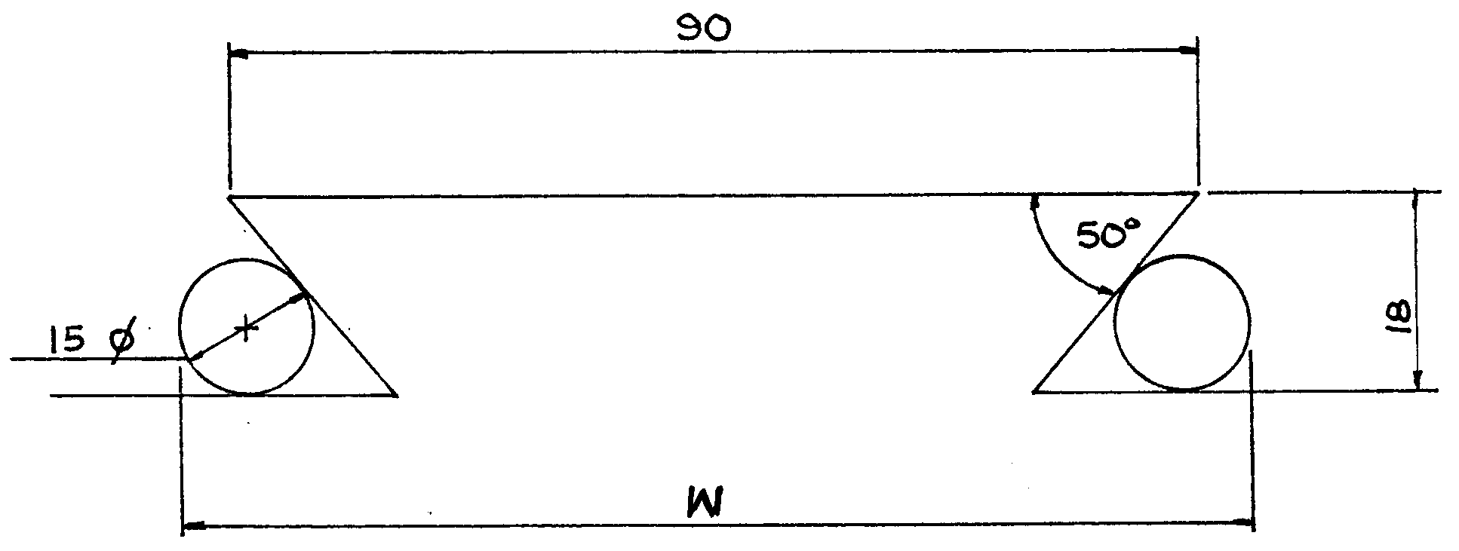

Figure 1
DOVETAIL THAT MUST BE TESTED FOR ACCURACY

- Name the type of dovetail illustrated in Figure 1.  - Draw a neat sketch to clearly indicate ALL the geometric constructions that you will use to calculate the distance (W) over the rollers.  - Calculate the distance over the rollers (W). | (1)  (4)  (12)

- A gear with 119 teeth must be machined on a milling machine. Choose 120 teeth and determine the  - required indexing.  - necessary change gears.  - rotation of the index plate. | (3)  (4)  (1)

- Use angular indexing to index 27 divisions.  - State FOUR functions of a milling machine dividing head. | (6)  (4)
 | [35]

QUESTION 4

- A hydraulic jack has a lifting capacity of 32 000 kg. The piston of the jack is  50 mm in diameter. Calculate the pressure inside the jack. Take “g” as 10 m/s². | (6)

- When a certain force is applied on a hydraulic press, the piston moves 15 mm downwards. A load of 6 500 kN is then lifted through a distance of 5 mm at the ram of the press. The diameter of the ram is 156 mm.  Calculate the  - pressure in the system.  - diameter of the piston.  - force exerted on the piston. | (4)  (6)  (3)

- Nine equally spaced holes must be bored out on a centre lathe. The diameter of the toolmakers’ buttons used for the setup is 12 mm. The distance between buttons no. 1 and no. 2 is 105 mm.  - Calculate the angle between two consecutive buttons.  - Draw a neat, clearly annotated sketch with dimensions, of the setup to show ALL the geometric constructions you are going to use in your calculations.  - Determine the pitch circle diameter (PCD) of the holes.  - Calculate the distance between buttons no. 3 and no. 6. | (1)  (4)  (5)  (5)

- State the reason why one button in a set of toolmakers’ buttons should always be longer than the other buttons in the set. | (1)  [35]

QUESTION 5

- Draw TWO neatly labelled sketches to illustrate the most important differences between right-hand and left-hand square screw threads. Indicate the  - cutting tools in the grooves.  - helix angles.  - leading tool angles.  - following tool angles.  - direction of rotation of the workpieces.  - direction of movement of the cutting tools. | (12)

5.2 A two-start internal square screw thread with a pitch of 6 mm is to be cut on a centre lathe. To cut the second thread, the change gears are turned. The work is already mounted and turned to size.  5.2.1 Explain in detail how this thread should be cut. Begin your answer by explaining how the cutting tool must be ground. | (10)
5.2.2 Name ONE advantage and ONE disadvantage of this method of cutting multiple-start screw thread. | (2)

5.3 Name THREE friction materials used in engineering. | (3)

5.4 A helical gear with a helix angle of 20° and a pitch circle diameter of 145,98 mm has to be cut on a milling machine. The machine lead screw pitch is 6 mm. Calculate the change gears needed to mill the gear. | (8)  [35]

QUESTION 6

  - Engineers at a certain factory have designed a cranked lever that must be fitted to a shaft in an engine as indicated in Figure 2. After some testing, they found that the shaft was completely out of balance. The only available space to fix a balance mass on the shaft is at an angle of 116° to the right of the 3 kg arm of the lever. Draw up a mass-distance table and construct a vector diagram to a scale of
1 cm = 5 units to determine the

- centre of gravity of the balance mass.  - angle θ. | (6)  (5)

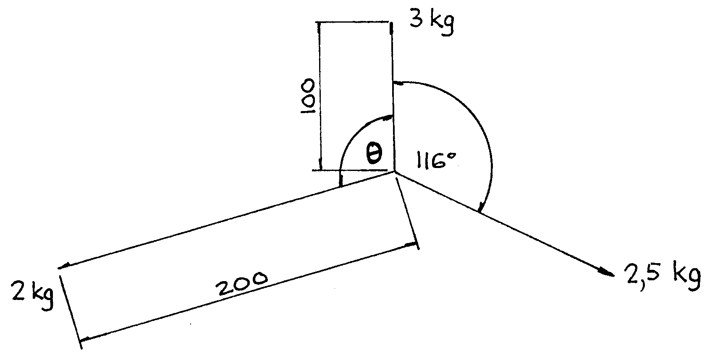

Figure 2

CRANKED LEVER

6.2 If a workpiece is unbalanced while it is being machined, it usually damages the lathe. List FOUR such possible damages that can be caused by an unbalanced workpiece. | (4)

6.3 Draw simple sketches to illustrate the difference between straddle milling and gang milling. | (4)

6.4 Explain in detail how to mount a side and face milling cutter on the arbor of a universal milling machine using two arbor supports. The machine was previously used with the vertical head in position. | (6)

6.5 State THREE factors that must be taken into account when the rate of table feed for a milling operation has to be determined. | (3)

6.6 Give the THREE movements of a plain horizontal milling machine. | (3)

6.7 Name FOUR components of good workshop organisation. | (4)  [35]

TOTAL: | 200

INFORMATION SHEET

- Gears for milling machine

Standard and special gear wheels

24 (two of); 28; 32; 40; 44; 46; 47; 48; 52; 56; 58; 64; 68; 70; 72; 76; 84; 86 and 100 teeth.

- Index plate for milling machine

24; 25; 28; 30; 34; 37; 38; 39; 41; 42; 43; 46; 47; 49; 51; 53; 54; 57; 58; 59; 62 and 66 holes.

- Formulae

3.1 Stress = $\frac{F}{A}$

3.2 Cross-sectional area of solid cylinder = $\frac{π}{4}D^{2}$

3.3 Cross-sectional area of hollow cylinder = $\frac{π(D^{2}−d^{2})}{4}$

  - Fluid pressure in a hydraulic press: $\frac{F1}{A1}=\frac{F2}{A2}$

Volume of fluid displaced by plunger = volume displaced by piston
volume = area x L

  - Spur gears:

3.5.1 PCD = Tm

3.5.2 add = m

3.5.3 ded = 1,157_{m}

3.5.4 Clearance = 0, 157_{m}

3.5.5 OD = PCD + 2 add

3.5.6 T = $\frac{\text{PCD}}{m}$

3.5.7 Chordal addendum = m + $\left[\frac{\text{mT}}{2}(1−\text{cos}\frac{\text{90}°}{T})\right]$

3.5.8 Chordal width = mT sin $\frac{\text{90}°}{T}$

3.5.9 Circular pitch = πm

3.6 Helical gears

3.6.1 PCD = TM_{w}

3.6.2 add = m_{n}

3.6.3 ded = 1,157 m_{n}

3.6.4 clearance = 0,157 m_{n}

3.6.5 OD = PCD + 2 add

3.6.6 T = $\frac{\text{PCD}}{m_{c}}$

3.6.7 m_{n} = m_{c}cosθ

3.6.8 Number of teeth marked on the milling cutter:
Number = $\frac{T}{(\text{cos}θ)^{3}}$

3.6.9 Chordal addendum = m_{n} + $\left[\frac{m_{n}T}{2}(1−\text{cos}\frac{\text{90}°}{T}\right]$

3.6.10 Chordal thickness = m_{n}T sin $\frac{\text{90}°}{T}$

3.6.11 Lead of helix : ℓ = π x PCD x cot θ

or

ℓ $\frac{πx\text{PCD}}{\text{tan}θ}$

3.6.12 Helix angle : tan θ = $\frac{πx\text{PCD}}{ℓ}$

3.6.13 Circular pitch = πm_{n}

    - Lead of milling machine = Dividing head ratio x pitch of leadscrew

    - Change gears required $\frac{\text{Dr}}{G}=\frac{L}{ℓ}$

  - Indexing:

3.7.1 Simple indexing = $\frac{\text{40}}{N}$

3.7.2 Angular indexing = $\frac{θ}{9°}$

3.7.3 Differential indexing = $\frac{\text{Dr}}{G}=\frac{(\text{A-N})}{A}x\frac{\text{40}}{1}$

    - Rack:

Indexing = $\frac{\text{Dividing head ratio}}{\text{Pitch of head screw}}x\frac{\text{Pitch of rack}}{\text{Gear ratio}}$

  - Grinding of milling cutter teeth:

    - Disc grinding wheel : Offset = R sin θ
    - Cup wheel: Offset = r sin θ

  - Graphical solution of static balancing:

Out-of-balance effect = Mass X distance of mass from centre of face plate

  - Tool angles for cutting square threads:

3.10.1 Helix angle: tan η = $\frac{\text{Lead}}{{πD}_{m}}$

    - Leading tool angle = 90° – (Helix angle + Clearance angle)

    - Following tool angle = 90° – (Helix angle – Clearance angle)

