GAUTENG DEPARTMENT OF EDUCATION

SENIOR CERTIFICATE EXAMINATION

FITTING AND TURNING SG

TIME: 3 hours

MARKS: 200
REQUIREMENTS:

- Pocket calculators and drawing instruments

INSTRUCTIONS:

- Answer ALL the questions.
- Unless otherwise indicated, all dimensions are in millimetres.
- For ALL applicable questions, the dividing head ratio is 40:1.
- THREE information sheets (pages 9 – 11) are supplied at the end of this question paper. Please detach these pages for ease of reference.
- Use ONLY the formulae as indicated on the information sheet. However, derivatives of these formulae may also be used.
- Answer question 1 on the answer sheet on the inside cover of your answer book.

QUESTION 1

MULTIPLE–CHOICE QUESTIONS

Answer the following questions on the answer sheet on the inside cover of the answer book. Indicate the correct answer(s) by drawing a cross (X) over the corresponding letter(s) on the answer sheet. The mark allocation on the right-hand side should indicate to you whether one or more than one answer is expected.

- Fine tooth milling cutters have certain advantages and disadvantages. Choose the disadvantages from the list below:  - More power is used.  - Finishing is worse than when coarse tooth cutters are used.  - They are only effective on thin plates.  - They exert a smaller twisting moment on the machine arbor. | (2)

- Choose the reasons from the list below why milling cutters with the smallest possible diameter should be used for a milling operation.  - They can cut thin workpieces.  - They cause less chattering.  - Cutter teeth are stronger because the clearance angle is smaller.  - The cutters provide a better finish. | (2)

- The pressure angle of a gear is the angle between  - the line of action and a tangent to the pitch circle of the gear.  - a tooth and the following tooth of the same gear.  - the vertical centre line of one gear and that of the meshing gear.  - the line of action and the vertical centre line of a gear. | (1)

- Point of action guards are used on  - gear drives.  - milling machine gearboxes.  - guillotines.  - circular saws. | (2)

- Helical gears have a distinct disadvantage when compared to spur gears. Select the disadvantage from the list below:  - It causes end thrust.  - It can only take small cuts.  - It gets blunt very quickly.  - It takes a long time to set up. | (1)

- Gauge blocks are used to  - test dovetails.  - test plug gauges.  - set up toolmakers’ buttons.  - accurately measure workpieces. | (2)

- When the grinding wheel rotates towards the cutting edge during the sharpening of milling cutter teeth, certain advantages are achieved. The following are examples of such advantages:  - The cutting edge is free from burrs.  - The cutter produces a better finish.  - There is less chance of burning the teeth.  - The cutting edge is always very sharp. | (2)

- Acme screw-threads are used where  - strong teeth are of the utmost importance.  - backlash has to be eliminated.  - seizing of the thread as a result of sagging must be avoided.  - quick axial movement is required. | (2)

- Two spur gears will only mesh properly if  - their circular pitches are equal to their modules.  - they have an equal number of teeth.  - the pitch circle diameters are the same.  - they have the same pitch and module. | (1)

- Choose the disadvantages of form milling cutters from the list below:  - Form milling cutters can only cut curves.  - They are expensive to manufacture.  - They are difficult to resharpen to the exact profile.  - They always give a poor finish. | (2)

- Mark off the particulars that must appear on the side of an involute gear cutter.  - Cutting depth  - Circular pitch  - Diameter of the hole and the outside diameter of the cutter  - The type of profile of the cutter | (2)

- Accidents in a workshop are caused by either personal or work-related factors. Which of the following are work-related factors?  - Careless attitudes  - Faulty electrical wiring of machines  - Lack of knowledge or skills  - Inadequate tooling | (2)

- Which of the following would influence the magnitude of the helix angle of a screw thread?  - The pitch of the screw thread  - The outside diameter of the screw thread  - The lead of the screw thread  - The type of screw thread | (2)

- Involute gear cutters and form milling cutters have the following common characteristics:  A. They are both resharpened using disk grinding wheels.  - They are both resharpened at the front of the teeth.  - After resharpening, their profiles are never the same.  - They both have specific profiles. | (2)
 | [25]

QUESTION 2

2.1 A 200 mm disk-grinding-wheel must be used to sharpen the teeth of a 150 mm side-and-face cutter. The cutter clearance angle is 4°.  - Calculate the set-over of the tooth rest.  - Draw a neatly labelled sketch of the setup to indicate the set over of the tooth rest calculated in Question 2.1.1. | (10)

- State FOUR basic concepts of good workshop organisation.  - Briefly describe what you understand by the process layout of machines.  - The stress developed in a hollow steel tube is 5,047 MPa when it is subjected to a compressive force. The tube has an outside diameter of 100 mm and an inside diameter of 85 mm. Calculate the compressive force applied to the steel tube.  - A grain silo is supported by eight similar pillars. When the silo is completely filled up, the total mass resting on the pillars is 500 metric tons. Calculate the diameter of each pillar if the total induced stress is 40 MPa. Take “g” as 10 m/s². | (4)  (4)  (8)  (9)  [35]

QUESTION 3

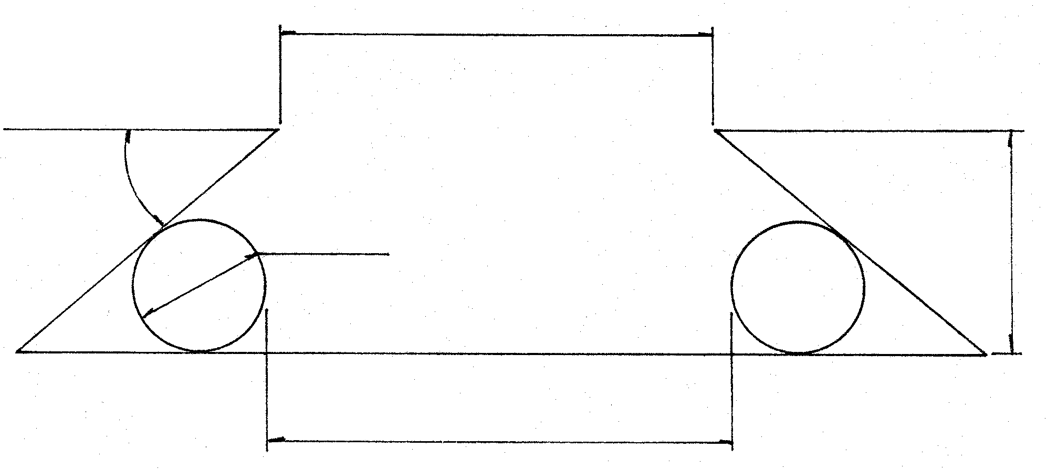
  - Figure 1 below shows a dovetail which must be tested for accuracy.
86
40°
12Ф
20
W
Two 12 mm diameter precision rollers are used to carry out the test.

Figure 1
DOVETAIL TO BE TESTED FOR ACCURACY

- Name the type of dovetail illustrated above.  - Draw a neat sketch of at least half of the dovetail to clearly indicate ALL the geometric constructions that you will use to calculate the distance between the rollers (W).  - Calculate the distance between the rollers (W). | (1)  (4)  (12)

3.2 Name FOUR essential features of a well-designed sine bar. | (4)

3.3 A gear rack must be cut to mesh with a spur gear pinion with 12 teeth and an outside diameter of 70 mm. The milling machine lead screw pitch is 6 mm and the driving gear has three times the number of teeth as the driven gear. Calculate the indexing necessary to mill the gear rack. | (10)

3.4 Determine the indexing for 65 divisions. | (4)  [35]

QUESTION 4

4.1 The fluid pressure in a hydraulic system is measured at 252,7 MPa. The diameter of the piston is 80 mm. Calculate the load (in kg) that can be lifted by this pressure. Take “g” as 10 m/s². | (6)

- The diameter of the ram of a hydraulic press is 250 mm and the press is able to lift a load of 32 000 kN through a distance of 6 mm. The piston has a diameter of 65 mm. Calculate the  - pressure in the system.  - volume displaced by the ram when the load is lifted.  - force needed at the piston to lift the load.  - distance the piston must move downward to lift the load 6 mm upward. | (4)  (2)  (2)  (6)

- Twelve equally spaced holes must be drilled on a pitch circle diameter of 308 mm. Toolmakers’ buttons with a diameter of 10 mm are used for the setup.  - Calculate the angle between the holes.  - Draw a neat fully-dimensioned sketch of the setup and indicate ALL the geometric constructions you would use. Clearly indicate how the angles were obtained.  - Calculate the distance between buttons no. 1 and no. 4.  - Determine the distance between buttons no. 1 and no. 8. | (1)  (4)  (5)  (5)  [35]

QUESTION 5

- A three-start external square thread with a pitch of 7 mm must be machined on a centre lathe. The root diameter of the thread is 74,87 mm and the clearance angle on the cutting tool is 4°. Calculate the  - depth of the thread.  - helix angle.  - leading angle.  - following angle. | (2)  (7)  (2)  (2)

5.2 5.2.1 Describe in detail how you would proceed to machine a two-start, right hand external square thread on a centre lathe using the graduated sleeve on the compound slide to move the cutting tool to cut the second thread. You have a rough workpiece. | (9)
5.2.2 State one advantage and one disadvantage of this method of cutting multiple start screw threads. | (2)

5.3 State THREE instances where friction is treated as a disadvantage in an engineering workshop. | (3)

- A helical gear with 35 teeth and a real module of 2,319 mm must be machined using an involute gear tooth cutter. The helix of the gear is 30°.  Calculate the  - chordal addendum and the  - chordal width of the gear. | (6)  (2)  [35]

QUESTION 6

  - An experiment has indicated that the cranked lever in Figure 2 is completely out of balance. It is then decided to balance the lever by adding a balance mass 330 mm from the hub.
Draw up a mass/distance table and construct a vector diagram to a scale of
1cm = 10 units and determine the

- mass of the balance piece.  - angle θ. | (10)  (1)
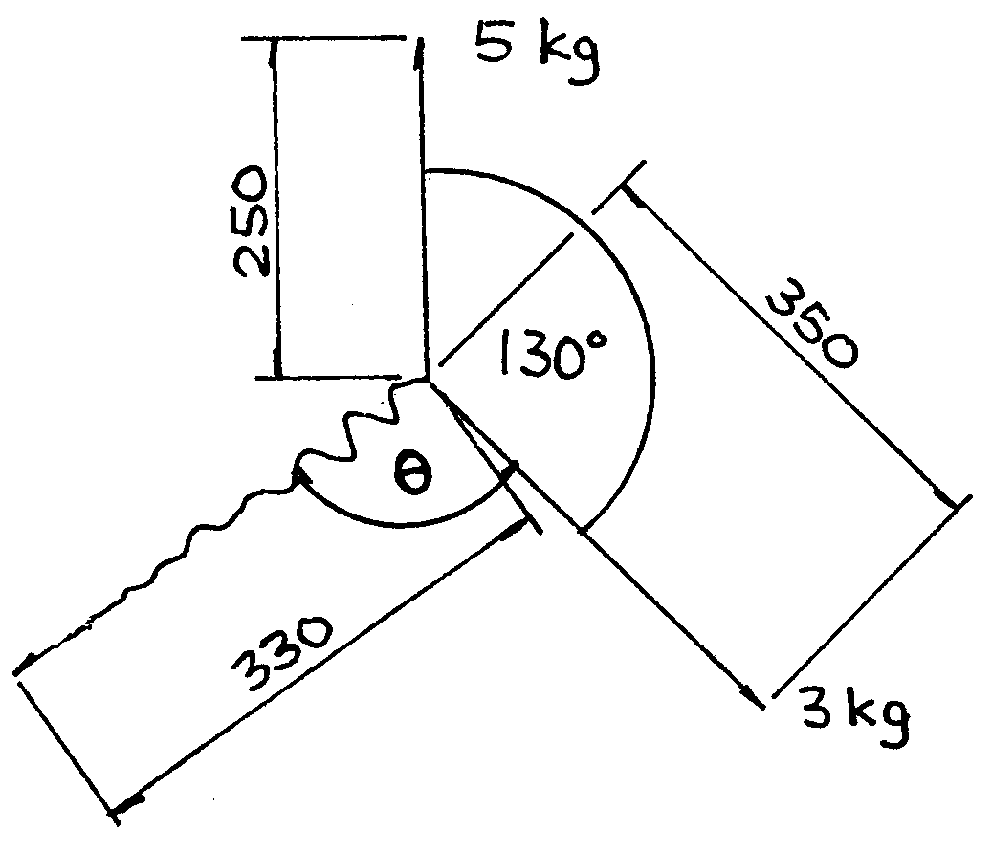

Figure 2

CRANKED LEVER

6.2 Show by means of a simple sketch how an unbalanced workpiece should be statically balanced using two unequal balance masses. | (4)

6.3 Draw simple sketches to illustrate the difference between up-cutting and climb milling. | (4)

6.4 Briefly describe how the arbor of a plain horizontal milling machine should be removed from the machine spindle without damaging the arbor or the spindle. | (5)

6.5 Chattering frequently occurs during a milling operation. Give FOUR reasons for this condition. | (4)

- Why is it necessary that the  - arbor of a milling machine always rotates true over its entire length?  - sides of arbour collars must always be flat and parallel? | (2)  (2)

6.7 Name THREE basic concepts of good workshop administration. | (3)  [35]

TOTAL: | 200

INFORMATION SHEET

- Gears for milling machine

Standard and special gear wheels

24 (two of); 28; 32; 40; 44; 46; 47; 48; 52; 56; 58; 64; 68; 70; 72; 76; 84; 86 and 100 teeth.

- Index plate for milling machine

24; 25; 28; 30; 34; 37; 38; 39; 41; 42; 43; 46; 47; 49; 51; 53; 54; 57; 58; 59; 62 and 66 holes.

- Formulae

3.1 Stress = $\frac{F}{A}$

3.2 Cross-sectional area of solid cylinder = $\frac{π}{4}D^{2}$

3.3 Cross-sectional area of hollow cylinder = $\frac{π(D^{2}−d^{2})}{4}$

  - Fluid pressure in a hydraulic press: $\frac{F1}{A1}=\frac{F2}{A2}$

Volume of fluid displaced by plunger = volume displaced by pistion
volume = area x L

  - Spur gears:

3.5.1 PCD = Tm

3.5.2 add = m

3.5.3 ded = 1,157_{m}

3.5.4 Clearance = 0, 157_{m}

3.5.5 OD = PCD + 2 add

3.5.6 T = $\frac{\text{PCD}}{m}$

3.5.7 Chordal addendum = m + $\left[\frac{\text{mT}}{2}(1−\text{cos}\frac{\text{90}°}{T})\right]$

3.5.8 Chordal width = mT sin $\frac{\text{90}°}{T}$

3.5.9 Circular pitch = πm

3.6 Helical gears

3.6.1 PCD = TM_{w}

3.6.2 add = m_{n}

3.6.3 ded = 1,157 m_{n}

3.6.4 clearance = 0,157 m_{n}

3.6.5 OD = PCD + 2 add

3.6.6 T = $\frac{\text{PCD}}{m_{c}}$

3.6.7 m_{n} = m_{c}cosθ

3.6.8 Number of teeth marked on the milling cutter:
Number = $\frac{T}{(\text{cos}θ)^{3}}$

3.6.9 Chordal addendum = m_{n} + $\left[\frac{m_{n}T}{2}(1−\text{cos}\frac{\text{90}°}{T})\right]$

3.6.10 Chordal thickness = m_{n}T sin $\frac{\text{90}°}{T}$

3.6.11 Lead of helix : ℓ = π x PCD x cot θ

or

ℓ $\frac{πx\text{PCD}}{\text{tan}θ}$

3.6.12 Helix angle : tan θ = $\frac{πx\text{PCD}}{ℓ}$

3.6.13 Circular pitch = πm_{n}

    - Lead of milling machine = Dividing head ratio x pitch of leadscrew

    - Change gears required $\frac{\text{Dr}}{G}=\frac{L}{ℓ}$

  - Indexing:

3.7.1 Simple indexing = $\frac{\text{40}}{N}$

3.7.2 Angular indexing = $\frac{θ}{9°}$

3.7.3 Differential indexing =$\frac{\text{Dr}}{G}=\frac{(\text{A-N})}{A}x\frac{\text{40}}{1}$

    - Rack:

Indexing = $\frac{\text{Dividing head ratio}}{\text{Pitch of head screw}}x\frac{\text{Pitch of rack}}{\text{Gear ratio}}$

  - Grinding of milling cutter teeth:

    - Disc grinding wheel : Offset = R sin θ
    - Cup wheel: Offset = r sin θ

  - Graphical solution of static balancing:

Out-of-balance-effect = Mass X distance of mass from centre of face plate

  - Tool angles for cutting square threads:

3.10.1 Helix angle: tan η = $\frac{\text{Lead}}{{πD}_{m}}$

    - Leading tool angle = 90° – (Helix angle + Clearance angle)

    - Following tool angle = 90° + (Helix angle – Clearance angle)

