GAUTENG DEPARTMENT OF EDUCATION
SENIOR CERTIFICATE EXAMINATION

FARM MECHANICS SG
(Second Paper: Theory)

TIME : 2 hours

MARKS : 125

INSTRUCTIONS:

- Answer ALL questions.

- Answer Question 1 (Multiple Choice Questions) on the answer sheet on the inside cover of your answer book.

- Number your answers in exactly the same way as the questions are numbered.

- Neat and legible work will influence the examiner favourably.

SECTION A

QUESTION 1

MULTIPLE-CHOICE QUESTIONS

The following questions have been provided with a number of possible answers of which only ONE possibility is correct in each case. Make use of the answer sheet on the inside cover of your answer book and draw a cross (X) over the letter which in your opinion represents the correct answer.

________ is the inherent strength of an adhesive.

A. Adhesion B. Cohesion
C. Load capacity D. Epoxy

The ability of molecules of an adhesive to cling to the molecules of other substances, is called

A. epoxy. B. adhesion.
C. cohesion. D. PVC.

_______ increases resistance against corrosion.

A. Manganese B. Perspex
C. Nickel D. Chromium

______ combats corrosion of metals.

A. Chromium B. Nickel
C. Manganese D. Copper

_______ takes place when oxygen and water in the air combine with a metal.

A. Oxidation B. Electrolysis

Which one of the following metals is the most deltile, malleable and forgeable?

A. Chromo-steel B. Cast iron
C. Mild steel D. High-carbon steel

_______ is the process by which worn parts can be built up by padding with a wear resistant metal.

A. Pipe welding B. Hard facing
C. Vertical welding D. Overhead welding

1.8 Steel can be hardened by means of putting in it.

A. lead B. carbon
C. zinc D. chrome

The heat loss via the cooling system of diesel engines is

A. 27%. B. 21%.
C. 12%. D. 33%.

The heat released in useful working form in a carburetted engine is

A. 22%. B. 33%.
C. 7%. D. 27%.

The __________ is used to control the accuracy of the angle of the tip of the thread cutting tool after it has been whetted.

A. centre gauge B. thread cutting tool
C. screw-cutting (chasing) dial D. apron

The _________ is the part situated between the operator and the main slide.

A. cross slide B. tailstock
C. centre gauge D. apron

The ________ is on top of the bed and moves parallel to the bed for turn-off operations.

A. lead screw B. feed shaft
C. main slide D. cross slide

One of the advantages of using a submersible pump is that

A. just about no maintenance is necessary. B. no maintenance is needed.
C. the pump has a basic construction. D. no rods are required.

All three point mechanisms are equipped with a/an

A. oil pump. B. feed shaft.
C. submersible pump. D. levelling box.

The following is a function of shear bolts:

A. Lubrication B. To protect components
C. To check tyre pressure D. To check the tension of all toothed gears

An advantage of flat drive belts is that

A. they are easily joined. B. they can be used over a
long distance.
C. lubrication is never necessary. D. Both A and B apply.

The turning direction of the power take-off drive shaft is

A. up and down. B. clockwise and
anti-clockwise.
C. clockwise. D. anti-clockwise.

The _______ is the “heart” of a diesel engine.

A. fuel system B. cooling system
C. gearbox D. take-off drive shaft

The ________ enables the operator to engage the drive of the engine to the rest of the transmission system.

A. take-off drive shaft B. gearbox
C. clutch D. three point mounting

The cross slide and feed shaft are parts of the

A. submersible pump. B. pick-up wheel.
C. ram type of baler. D. centre lathe.

The circlip, spider bearing with inset and ratcher pins are parts of the

A. packer arms. B. centre lathe.
C. rotary pump. D. submersible pump.

Resorcinol, latex and silicon are

A. lubricants. B. coolants.
C. fluxes. D. adhesives.

The temper colour for ordinary carbon steel at 270ºC is

A. dark red. B. purple.
C. bright blue. D. light yellow.

The recrystallising temperature of iron is

A. 150ºC. B. 450ºC.
C. 590ºC. D. 200ºC.
25x1=[25]
TOTAL FOR SECTION A: [25]

SECTION B

QUESTION 2

2.1 Name FOUR different types of welding runs. | (4)
2.2 Name THREE positions of pipe welding. | (3)
2.3 Name FOUR kinds of wear. | (4)
2.4 Name FOUR advantages of flat drive belts. | (4)
2.5 Name THREE disadvantages of v-belts. | (3)
2.6 Name FOUR advantages of coolants. | (4)
[22]

QUESTION 3

Name the following parts of the centrifugal pump.
Write only the numbers 1–15 in your answer book and alongside each the name of the part.

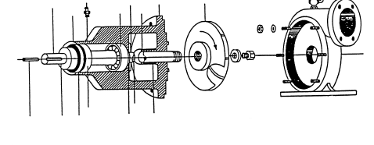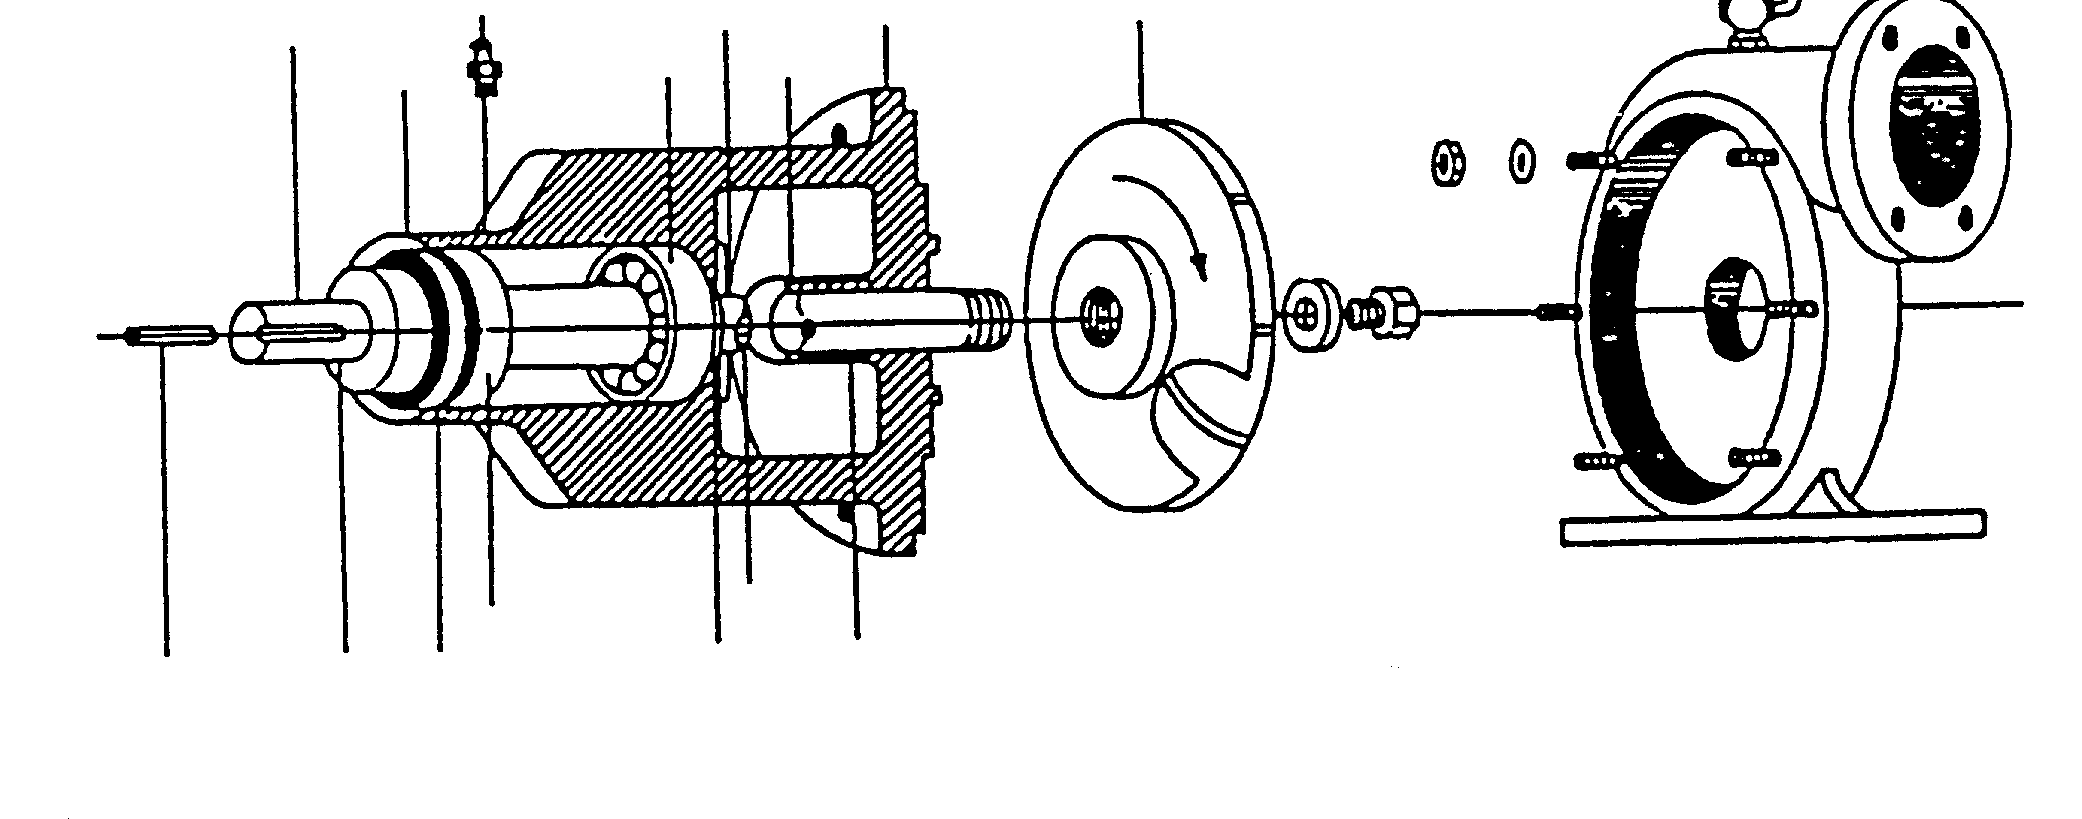
2
7
4
10
14
15
13
5
6
11
9
8
1
3
12

[15]

QUESTION 4

4.1 Name SIX factors for the maintenance of balers. | (6)
4.2 Name THREE types of oil pumps. | (3)
4.3 Name SEVEN aspects you would consider if you want to buy a used tractor. | (7)
4.4 Name FOUR disadvantages of air-cooled engines. | (4)
4.5 Name FOUR advantages of water as a cooling medium. | (4)
4.6 Name FOUR disadvantages of water as a cooling medium. | (4)
[28]

QUESTION 5

5.1 Name the colour of oxidation for each of the following metals:

5.1.1 Copper

5.1.2 Lead

5.1.3 Aluminium
5.1.5 Zinc | (4)

5.2 What is electrolysis? | (3)

5.3 What is electroplating? | (3)

5.4 Name FIVE types of metals that are used for electroplating. | (5)
[15]

QUESTION 6

6.1 Give the names for each of the following parts of the packer arms of the baler.
Write only the letter and the name of the part in your answer book.
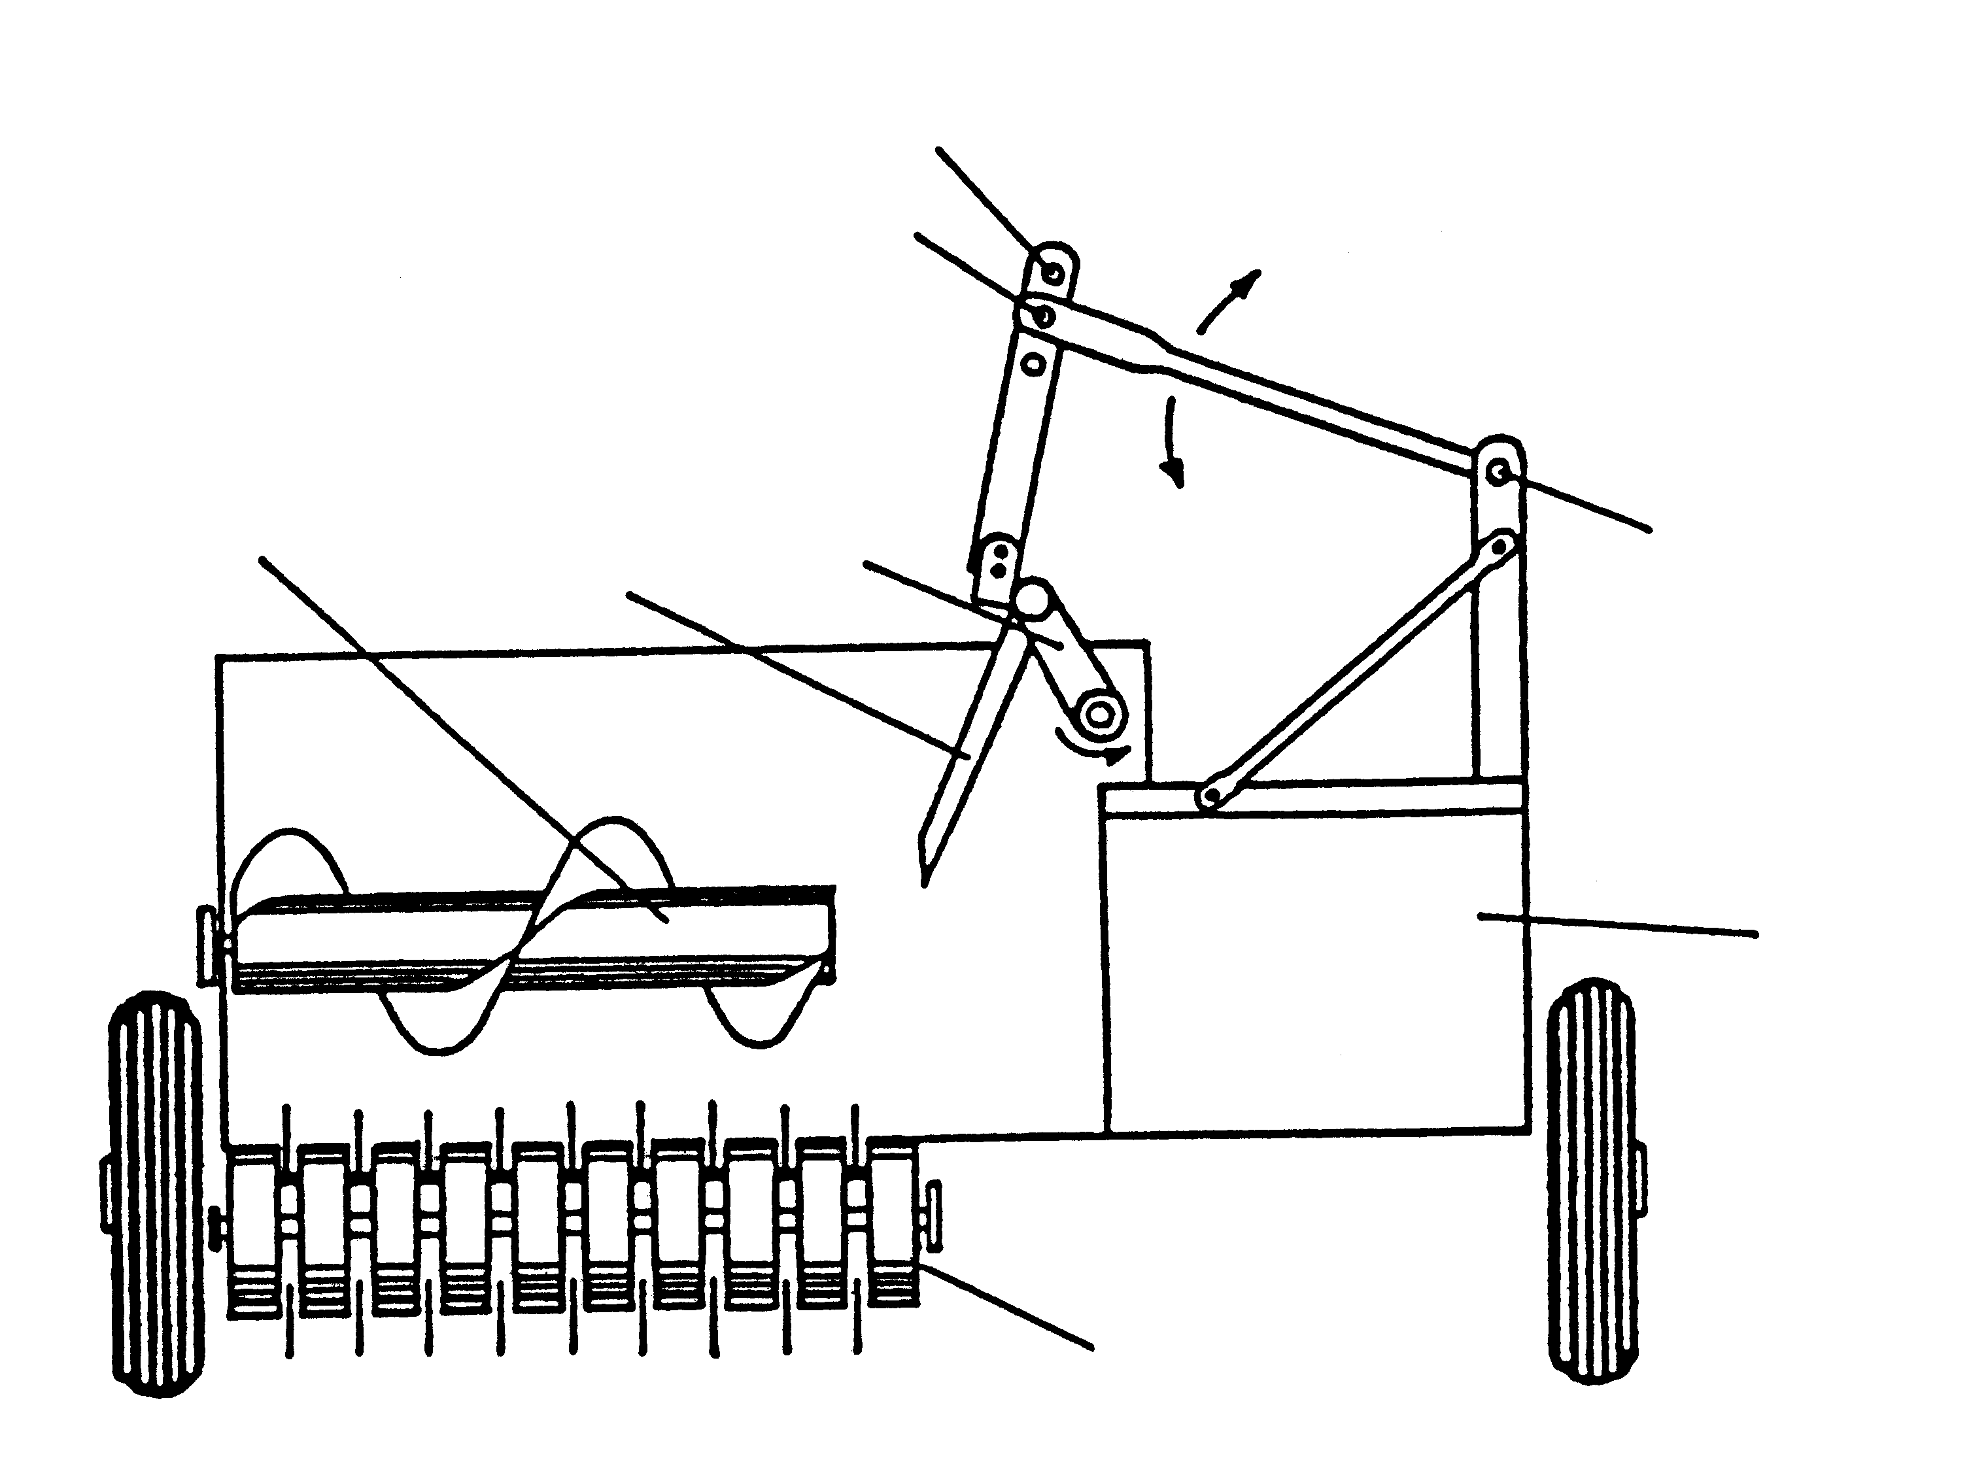
A
B
C
D
E
F
G
H

(8)

6.2 Name TWO types of balers. | (2)

[10]
TOTAL FOR SECTION B: [90]

SECTION C

QUESTION 7

Indicate whether the following statements are TRUE or FALSE. Write only the words TRUE or FALSE next to the corresponding question number in your answer book.

7.1 The clutch enables the operator to engage or disengage the drive of the engine to the rest of the transmission system at will.

7.2 The capsule-type thermostat is filled with alcohol.

7.3 A low water level in the cooling system can let the system overheat.

7.4 Stainless steel is corrosion resistant.

7.5 Undercutting is usually found in the end of a welding run.

7.6 The submersible pump needs a lot of maintenance.

7.7 The independent power take-off shaft can be stopped while the tractor continues moving.

7.8 The thermosiphon cooling system is quite simple because of the absence of a water pump in the system.

7.9 The synchronised gearbox is commonly used on cars and trucks.
7.10 The function of the distributor is to open and close the contact points at the right moment. | [10]
TOTAL FOR SECTION C: [10]
TOTAL: 125

