GAUTENG DEPARTMENT OF EDUCATION
SENIOR CERTIFICATE EXAMINATION

FARM MECHANICS SG
(First Paper: Drawing)

TIME : 2 hours

MARKS : 75

REQUIREMENTS:

- 1 sheet A3 drawing paper

INSTRUCTIONS:

- Answer ALL the questions.

- Answer Question 1 on the front of the drawing paper and Question 2 on the back.

- Provide a margin and title block for Question 1 only.

- Write your examination number on the drawing paper.

- Number your questions clearly.

- Use a scale of 1:1.

- Approximate all dimensions not given.

- All construction and projection lines must be shown.

QUESTION 1

Figure 1 on page 3 shows an isometric drawing. Draw to a scale of 1:1 in first angle orthographic projection, the following views:

1.1 A front view | (11)
1.2 A left view | (13)
1.3 A top view | (11)

FIGURE 1
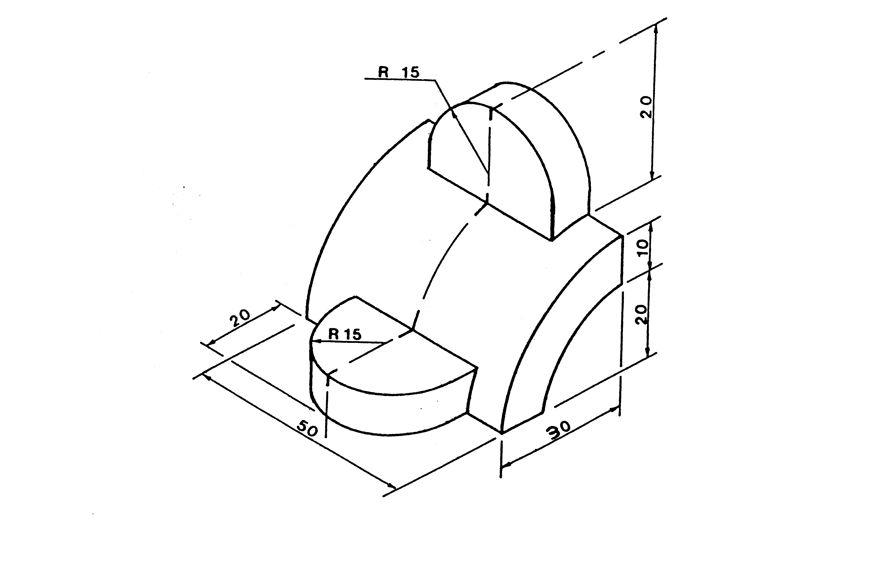
[35]

QUESTION 2

Figure 2 below shows a front view and top view of a block in first angle orthographic projection. Draw to a scale of 1:1 an isometric drawing of this block.
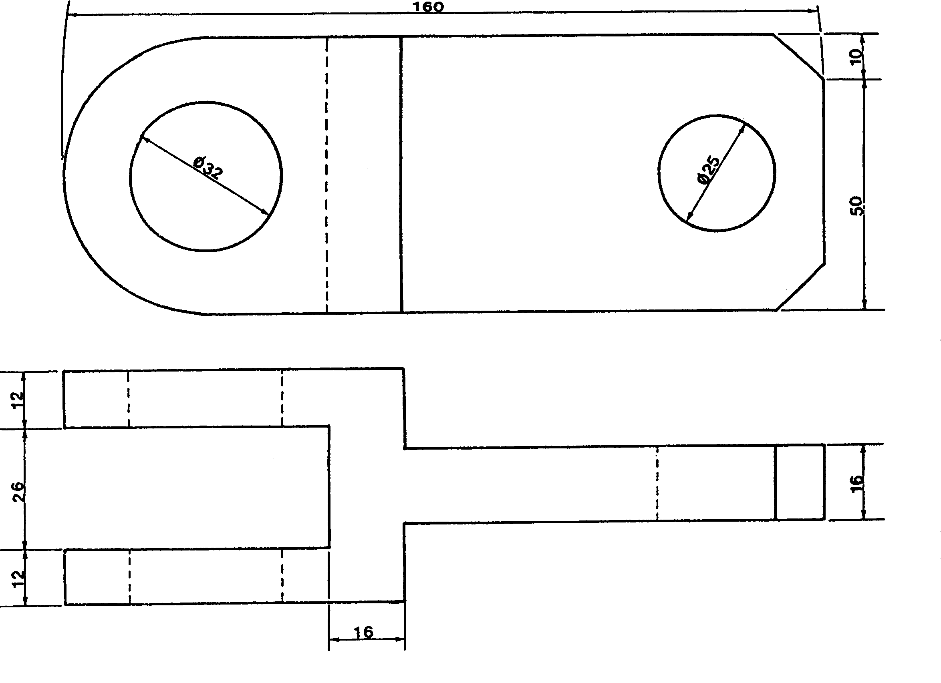

FIGURE 2

(40)
TOTAL: 75

