GAUTENG DEPARTMENT OF EDUCATION
SENIOR CERTIFICATE EXAMINATION

ENGLISH FIRST LANGUAGE SG
(Third Paper: Creative Writing and Literature)

TIME: 2 hours

MARKS: 80

INSTRUCTIONS:

- Answer FOUR questions as follows:

– Section A: ONE essay only
– Section B: TWO transactional pieces:
ONE long and ONE short piece
– Section C: ONE question only

- In Section A careful planning, editing and proof-reading will be of benefit to you as you will be marked on the content of your essay as well as its presentation (i.e. structure, style, grammar, punctuation and spelling).

- In Section C, the length of your answers must be guided by the number of marks given for each question.

- Answer ONE question from this section: either the contextual OR essay question on the text you have studied.

SECTION A
CREATIVE WRITING

Write a prose composition of between 350 and 400 words on ONE of the following topics. Please indicate the number of the topic and supply a title if one is not already given.

1. Leadership starts with me!
How can you make a difference to your life and the lives of others?
2.
“Put a shy person in a red chair and watch them blossom.”
Elsie de Wolfe

Night fever
3.

Write a short story or narrate a personal experience using the above title.

4.
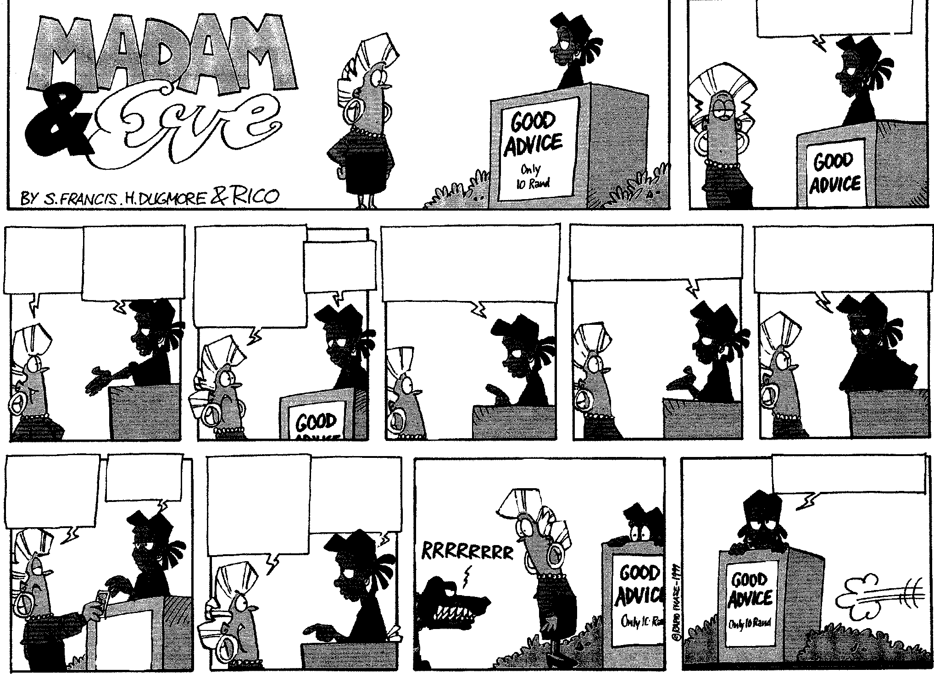

If I WERE YOU, I’D
GIVE ME TEN BUCKS.
HA! YOU
JUST GAVE ME FREE

ADVICE!

OKAY, THEN IN
THAT CASE,

PAY ME
TWENTY RAND.

WAIT A MINUTE.

YOU ADVISE

ME TO PAY YOU

TEN RAND…
AND THEN YOU CHARGE ME FOR
THAT?

PRETTY
CLEVER,’
HUH?
DON’T BE SO SKEPTICAL
MY ADVICE HAS HELPED MANY PEOPLE... I ADVISED NELSON MANDELA TO
WEAR COLOURFUL SHIRTS.
I ADVISED THABO MBEKI
TO TRY RUNNING FOR
PRESIDENT.

I ALSO ADVISED DR. ZUMA
NOT TO PRODUCE

SARAFINA II… BUT DID

SHE LISTEN?

OKAY! OKAY!
HERE’S MY
TEN BUCKS,
WHAT’S MY ADVICE?
START RUNNING.

THAT’S IT?!
WHY SHOULD
I “START
RUNNING”

JUST BECAUSE
YOU TELL ME TO?
THE NEIGHBOURS DOG IS LOOSE. HE’S RIGHT BEHIND YOU.
YOU CAN’T PUT A PRICE
ON GOOD ADVICE.

Respond to the message of the above cartoon in either a serious or light- hearted manner.

5. “Democracy is just a word!”

Consider the South Africa in which you live and state clearly whether you agree or disagree with the statement above.

6. P.S. I LOVE…

7.
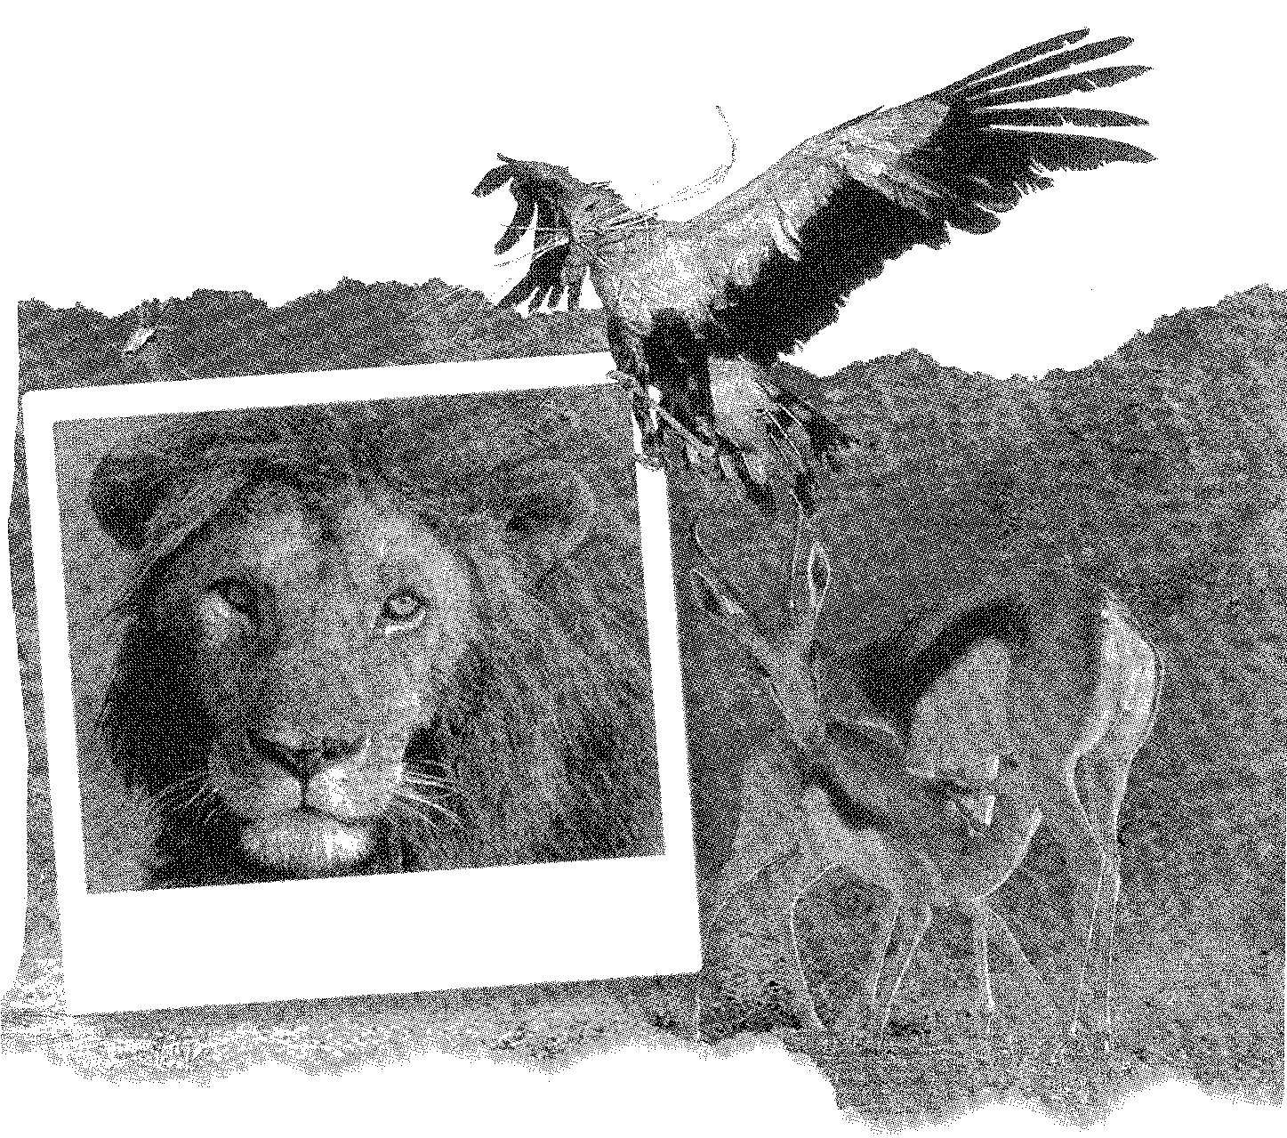

Imagine a land which offers you everything – bird watching in the Wetlands – big game in natural reserves – the sheer thrill of springbuck, buffalo and other wildlife, side by side on open plains – and yet, a land uncomplicated enough to truly allow you to rediscover your soul…

HOT
8.

gossip

9. We are the champions, my friend …(Queen)

10. The pictures below may spark your imagination and generate ideas and feelings. Drawing on your own knowledge and experience, select ONE of the pictures as your creative stimulus. Remember that there must be a clear connection between the picture and your response. Supply a title for your essay.

10.1
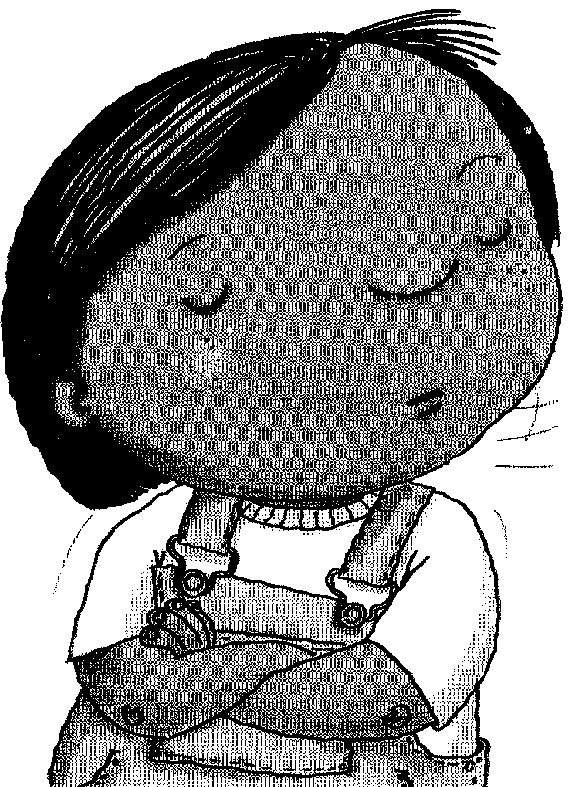

10.2


TOTAL FOR SECTION A: | [30]

SECTION B
TRANSACTIONAL WRITING

LONGER PIECES

Select ONE of the topics below and write 180 to 200 words as a response. Some of the topics require the format of a letter while others do not. Pay particular attention to format, audience and tone in your response.

11. | Fact: The council has not fined anybody for littering in ten years.  Fact: Every month, litter bugs leave enough junk in the parks and streets of Metropolitan Johannesburg to fill three storeys of the Carlton Centre from floor to ceiling.  Fact: The city is one big mess. It’s time to do something.

You were deeply distressed by the article and photographs regarding litter and litterbugs which appeared recently in a local newspaper. Write a letter to the Mayor of Johannesburg in which you give your constructive suggestions for improving the situation.

12. As a student in a tertiary institution, you have had to move away from home for the first time in your life. Write your diary entry for your first night away from home.

13. A sincere letter of thanks is due to a generous / kind person who helped you out of a very awkward or dangerous situation. Sincerity is important in the writing of this letter.

14. You are the chairperson of the catering committee at your school / college. Recently the learners have been complaining about the food served in the canteen. The principal of the institution has asked you to conduct an investigation into the matter and to report your findings and recommendations to him/her. Write a formal report, using the format you have been taught. | (15)

SHORTER PIECES

Respond to ONE of the topics below in 80 to 100 words. Pay attention to format, audience and register in your response.

15. As a member of your local theatrical association, you have been asked to design the poster advertising your latest production of a Shakespearian play. Your advertisement will be posted in local schools, shops and community centres.

16. You are the secretary of the student body at your school or college. Send an urgent memorandum to the members reminding them of an extraordinary meeting on a matter of grave importance. Specify the matter in your memorandum.

17. E-mail a friend whose eighteenth birthday you have forgotten. Although your tone should be sincere, you may employ humour in your e-mail. | (15)

TOTAL FOR SECTION B: | [30]

SECTION C
LITERATURE

Answer ONE question from this section.

QUESTION 1
FOCUS
CONTEXTUAL

Read the following passages, then answer the questions that follow.

Passage A

The Visits – Richard Rive  ‘Look’, he said, ‘I’ll give you food for the last time. For the last time. You understand? You must never come again. If you do come I’ll call the police. Then you go to jail! Understand?’  She stared at him, her eyes no longer downcast.  ‘Jail! Police! Jail!’  Then he noticed, almost with a start, that she was crying. Two tears rolled down her cheeks, but her face remained immobile. The tears did not seem part of her. He felt the sense of guilt again. Felt like assuring her that he would not call the police. That he was only pretending. But she must not come again.  He went into the kitchen, and when he returned she took the carrier with the same quaint bow. He watched her walking down the driveway. | 5  10

- When the woman comes the first time, the teacher gives her a lot of food.  Why do you think he does this? | (2)

1.2 However, what has happened by the time we read about her continued visits in the passage above? How does the teacher feel now? | (3)

1.3 When she leaves, we read that the woman meets with someone. What do they do that makes the teacher feel ‘sick to the stomach’? | (2)

1.4 At the end of the story what does the student do to the woman? | (1)
1.5 How does the teacher feel about this? | (2)

1.6 What do you think the story tells us about whether we should (or should not) help our fellow human being? | (2)

AND

Passage B

The Luncheon – W Somerset Maughan  It was twenty years ago and I was living in Paris. I had a tiny apartment in the Latin Quarter overlooking a cemetery and I was earning barely enough money to keep body and soul together. She had read a book of mine and had written to me about it. I answered, thanking her, and presently I received from her another letter saying that she was passing through Paris and would like to chat with me; but her time was limited and the only free moment she had was on the following Thursday; she was spending the morning at the Luxembourg and would I give her a little luncheon at Foyot’s afterwards? Foyot’s is a restaurant at which the French senators eat and it was so far beyond my means that I had never even thought of going there. But I was flattered and I was too young to have learned to say no to a woman. | 5  10

1.7 The writer is very young. What difference does this make to the story? | (2)

1.8 Describe in a sentence or two what does happen once he meets with the lady at the restaurant. | (4)

1.9 What does the author find at the end of the story that makes him feel good? | (2)  [20]

OR

QUESTION 2
FOCUS
ESSAY

Write an essay of about 250 – 300 words on the following topic:

The climax of a short story usually comes at the very end. Choose TWO stories you have studied. Explain why the ending in each case is so important.

In answering, you might like to think about the following:

- The plot of each story: what takes place?  - What happens at the end?  - Why this is so important (you could include themes here).  OR | [20]

QUESTION 3
TO KILL A MAN’S PRIDE
CONTEXTUAL

Read the following passages then answer the questions which follow.

Passage 1

The Wind and a Boy – Bessie Head  Now and then the activities of a single family  could captivate the imagination and heart of all the people of their surroundings; for years and years, the combination of the boy, Friedman, and his grand-mother, Sejosenye, made the people of Ga-Sefete-Molemo ward, smile, laugh, then cry. | 5
They smiled at his first two phases. Friedman came home as a small bundle from the hospital, a bundle his grandmother nursed carefully near her bosom and crooned to day and night with extravagant care and tenderness.  ‘She is like that,’ people remarked, ‘because he  may be the last child she will ever nurse. Sejosenye is old now and will die one of these days; the child is a gift to keep her heart warm.’ |  | 10  15

3.1 3.1.1 Explain from where Friedman acquired his name.  3.1.2 Why is the boy brought up by his grandmother?  3.1.3 How do the boy and Sejosenye respond to one another? | (2)  (2)  (2)

3.2 What is the relevance of the comment in line 6, that Friedman and Sejosenye cause the people of the area to “smile, laugh, then cry?” | (2)

3.3 Later, we read that Sejosenye herself had had “a flaming youth.” In the context of this story, what do you understand by this? | (3)

AND

Passage 2

Ha’penny – Alan Paton  And then he knew the deception was revealed.  Another boy might have said, ‘I told you it was  Dickie,’ but he was too intelligent for that; he knew  that if I had established that the boy’s name was  Dickie, I must have established other things too. I was  shocked by the immediate and visible effect of my  action. His whole brave assurance died within him  and he stood there exposed, not as a liar, but as a  homeless child who had surrounded himself with  mother, brother, and sisters, who did not exist. I had  shattered the very foundations of his pride and his  sense of human significance. | 5  10

3.4 3.4.1 What is the “deception” which has been revealed here?  3.4.2 Why has Ha’penny struggled to maintain this deception?  3.4.3 What is the physical result of Ha’penny’s pride having been shattered? | (2)  (1)  (2)

3.5 3.5.1 What are the feelings of the writer, Alan Paton, as suggested by the final sentence of this passage?  3.5.2 Explain why he feels as he does. | (2)  (2)  [20]

OR

QUESTION 4
TO KILL A MAN’S PRIDE
ESSAY

Write an essay of about 250 – 300 words on the following topic:

This is an anthology about South Africa, its people and politics. Choose TWO stories. Write about the effect the South African setting has on the plot (story) and the themes of the story.

In answering, you might like to think about the following:

- A short summary of what happens in the story.  - The importance of the setting.  - What the story tells about South Africa at that time in its history (the themes of the story). | [20]

OR

QUESTION 5
STRICTLY BALLROOM
CONTEXTUAL

There have been rumours about new steps being introduced and something has to be done to stop these ideas. Here is the newspaper report that appears.


5.1 Who is the Australian Dance Federation president (the man in the bottom right hand corner of the still)? Give the person’s name and surname. | (2)

5.2 Why is it so important to this man that there should be ‘no new steps’? | (3)

5.3 Why does Scott first introduce the idea of ‘new steps’? | (3)

5.4 Other characters in the film react differently to the idea of ‘new steps’. Choose TWO of the following. Explain what their attitude is to this idea of changing Dance Federation rules:

5.4.1 Shirley  5.4.2 Fran  5.4.3 Liz | 2x2=(4)

5.5 We hear from Fran that a life lived in fear is a life half lived. How true is this statement of Doug Hastings? Explain how he overcomes his fears. | (3)

5.6 At the end of the film, who really wins the struggle for ‘new steps’ – the Dance Federation or Scott and Fran? Give a reason for your answer. | (3)

5.7 Why do you think the film is called Strictly Ballroom?  OR | (2)  [20]

QUESTION 6
STRICTLY BALLROOM
ESSAY

Write an essay of about 250 – 300 words on the following topic:

‘Strictly Ballroom is a fairy tale. These are not real people or situations. We cannot believe in them. This spoils our enjoyment of the film.’

What is your opinion of the above statement? In presenting your ideas, you should refer to specific episodes and scenes from Strictly Ballroom.

In answering, you might like to think about the following:

- Making clear your opinion about the characters: ‘fairy tale’ or ‘real people’?  - Explaining your choice, based on examples from the film.  - Making a final statement about whether this spoils or increases our enjoyment of the film. | [20]

TOTAL FOR SECTION C: | [20]

TOTAL: | 80

