GAUTENG DEPARTMENT OF EDUCATION
SENIOR CERTIFICATE EXAMINATION

ENGLISH FIRST LANGUAGE SG
(Third Paper: Creative Writing and Literature)

TIME: 2 hours

MARKS: 80

INSTRUCTIONS:

- Answer FOUR questions as follows:

– Section A: ONE essay only
– Section B: TWO transactional pieces:
ONE long and ONE short piece
– Section C: ONE question only

- In Section A careful planning, editing and proof-reading will be of benefit to you as you will be marked on the content of your essay as well as its presentation (i.e. structure, style, grammar, punctuation and spelling).

- In Section C, the length of your answers must be guided by the number of marks given for each question.

- Answer ONE question from this section: either the contextual OR essay question on the text you have studied

SECTION A
CREATIVE WRITING

Write a prose composition of between 350 and 400 words on ONE of the following topics. Please indicate the number of the topic and supply a title if one is not already given.

- Faces of the Future.
Who are the faces of the future and how will they influence your life?

2. “I’VE GOT
a great ambition to
die of exhaustion
rather than boredom.”
Sir Angus Grossart

3. These are a few of my favourite things…

4. “One’s mind works very slowly at times. Stunned, I stood there dumbly. The scuffling noises were dying, someone wheezed and the night was still again.”

Write a short story in which you use the above quotation as your opening sentence.
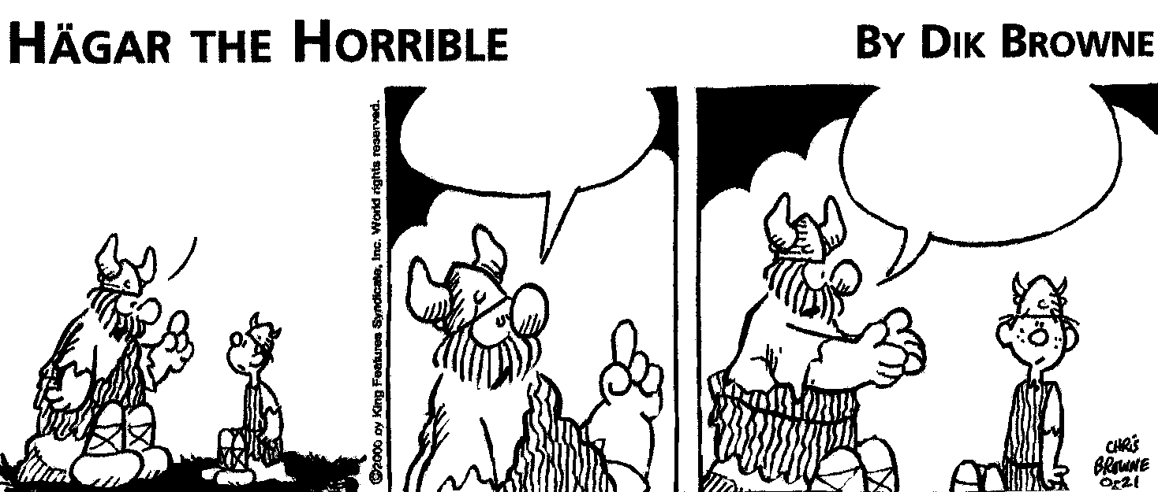
5.

REMEMBER, SON –
THERE IS MORE TO
LIFE THAN JUST

WINNING

THAT’S WHY
WINNING IS SO

IMPORTANT
!!

THERE’S ALSO
LOSING

Respond to the message of the above cartoon in a serious or light-hearted manner.

6. “The South African police should not be concerned about the smoking of cigarettes in public places and the use of cellphones while driving a motor vehicle. There are far greater problems in this country.”

Present a well-reasoned argument for or against the above statement.
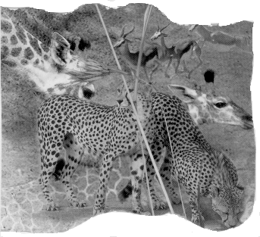
7.

Imagine a land of thrilling opportunities, exciting destinations, a land where an abundance of wildlife gracefully roam the majestic, pristine landscape, where the freshness of the open air burns your lungs…

8.
CIRCLE
OF FRIENDS

- “It wasn’t me!” (Shaggy)
Recall an experience in which you have used these words either truthfully or untruthfully.

10. The pictures below may spark your imagination and generate ideas and feelings. Drawing on your own knowledge and experience, select one of the pictures as your creative stimulus. Remember that there must be a clear connection between the picture and your response. Supply a title for your essay.

10.1
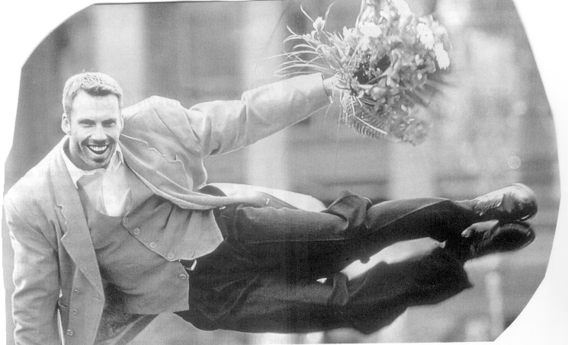

10.2
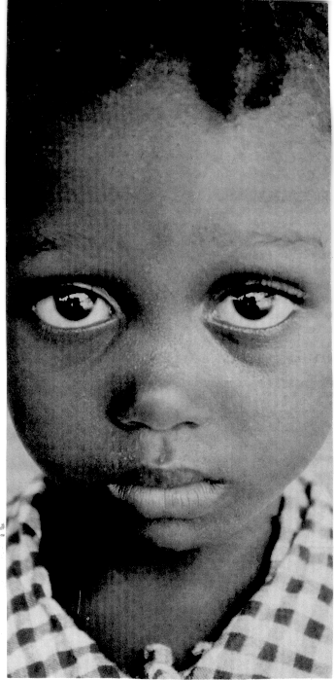

TOTAL FOR SECTION A: | [30]

SECTION B
TRANSACTIONAL WRITING
(LONGER PIECES)

Select ONE of the topics below and write 180 to 200 words as a response. Some of the topics require the format of a letter while others do not. Pay particular attention to format, audience and tone in your response.

11. “I am tired of standing in a queue only to reach a sulky cashier who grabs my purchases with such a pained expression that it makes me think she is about to give birth to triplets behind the counter.” Phylicia Oppelt Sunday Times.

You have recently experienced the same type of feelings as Phylicia Oppelt in one of your local stores. Write a letter of complaint to the manager of the store, giving details of your experience and making suggestions for improved service.

12. A person very dear to you has just passed away. Compose a sincere obituary for the funeral service.

13. Write a letter of congratulations to a friend who has just achieved a lifelong ambition.

14. As one of the more creative learners at the College of Care, you have been asked to write the copy of an advertisement which is designed to attract students to the college. Write the copy of the advertisement, attempting to incorporate some of the advertising techniques that you have been taught. No illustration is necessary. | (15)

TRANSACTIONAL WRITING
(SHORTER PIECES)

Respond to ONE of the topics below in 80 to 100 words. Pay attention to format, audience and register in your response.

15. As captain of the volleyball team for your local club, it is your task to arrange fixtures with your opponents. Send a facsimile (fax) to the captain of the opposing team, rearranging a fixture which you had had to postpone.

16. Design a flyer which will be distributed in your community to advertise a major fundraising event at the local Youth Centre.

17. You are finally on your dream holiday. Write a postcard to your grandparents, telling them of a memorable experience you have had. | (15)

TOTAL FOR SECTION B: | [30]

SECTION C
LITERATURE

Answer ONE question from this section.

QUESTION 1
FOCUS
CONTEXTUAL

Read the following passages, then answer the questions that follow.

Passage A

The Jackal – Hannah Browne  ‘If we could only get our hands on the young ones, it would save us a lot of trouble.’  He spilled his coffee and could only stare at this mother. Did she know?  But she was already on to another subject. ‘You will have to help with the milking for a few days. Krot is away again.’  Down in the vlei the jackal was sniffing along the trail to her  cubs. The smell of man, the smell of danger, was strong in her nose and getting stronger. She stood uncertainly, walking in a big circle. She was swollen with milk. She turned her head, listened, heard the faint mewling of the cubs. She circled the area and the smell became even stronger. Throwing all caution to the winds, she trotted to the hollow, whining softly. They were thirsty, and mewling louder now that they were aware of her. | 5  10

1.1 Why does the boy spill his coffee and stare at his mother in this passage? | (2)

1.2 What sort of relationship does the boy have with his mother? | (2)

1.3 How do you feel about the way the jackal mother treats her young? Refer to the passage to prove your answer. | (3)

1.4 How does the story end and what does this tell of the boy? | (4)

Passage B

Plymouth – Mervyn Woodrow  It was Corrie’s getting the driver’s job with the railway bus that started it, probably. Corrie sitting high up in the cab with his blue cap on the side of his head. And knowing all about those levers and handles and things that made the great iron beast throb and roar and move. Although he was afraid of it, Kerneels did not budge when his son started it up. | 5

He set his jaw, pretended that he did not notice the grey smoke and the dust that spurted out from the thing’s underbelly. He hardly blinked when the sand and pebbles churned up by the huge wheels pelted into his face and body… Kerneels remembered that when he was a young man of twenty he could handle his six mule team and wagon with the best. But now, fifty years later, that was still all he could drive. | 10

1.5 Study the first sentence: ‘It was Corrie’s getting the driver’s job with the railway bus that started it, probably’. What does Corrie getting a driver’s position start? | (2)

1.6 How do you think Kerneels feels at this moment in the story? Quote from the passage to prove your opinion. | (3)

1.7 There is a reference to mules in this passage. Explain how the story ends with mules too. | (3)

1.8 Why do you think the story is entitled Plymouth? | (1)  [20]

OR

QUESTION 2
FOCUS
ESSAY

Write an essay of about 250 – 300 words on the following topic:

In Focus the place (setting) where the stories take place has a great deal to do with what the author wants to share with the reader. Choose TWO stories. Explain what the setting adds to the story and its themes.

In answering, you might like to think about the following:

- What happens in that particular story.  - How the setting influences events and the characters.  - A brief summing up that looks at both stories.  OR | [20]

QUESTION 3
TO KILL A MAN’S PRIDE
CONTEXTUAL

Read the following passages then answer the questions which follow.

Passage 1

The Suit – Can Themba

Then she appeared in the doorway of the bedroom.  Heavens! Here was the woman he had married; the  young, fresh, cocoa-coloured maid who had sent  rushes of emotion shuddering through him. And the  dress she wore brought out all the girlishness in her,  hidden so long beneath German print. But no hint of  coquettishness, although she stood in the doorway  and slid her arm up the jamb, and shyly slanted her  head to the other shoulder. She smiled weakly.  What makes a woman like this experiment with  adultery, he wondered.  Philemon closed his eyes and gripped the seat of  his chair on both sides as some overwhelming, un-  disciplined force sought to catapult him towards her.  For a moment some essence glowed fiercely within  him, then sank back into itself and died… | 5  10  15
He sighed and smiled sadly back at her.  ‘I’m hungry, Tilly.’  The spell snapped, and she was galvanised into  action. She prepared his supper with dexterous hands  that trembled a little only when they hesitated in  mid-air. She took her seat opposite him, regarded him  curiously, clasped her hands waiting for his prayer,  but in her heart she murmured some other, much  more urgent prayer of her own. | 20  25

3.1 What dramatic event has taken place in this house earlier in the day? | (2)

3.2 Read lines 1 to 9. What evidence is there in this paragraph to suggest that Matilda is making an effort to please her husband? | (2)

3.3 Why do you feel, Matilda smiles “weakly”? (line 9) | (1)

3.4 3.4.1 Read lines 12 to 16.  What feeling is Philemon experiencing here? | (1)

3.4.2 How does he respond to this emotion? | (2)

3.5 Line 25 mentions Matilda’s “more urgent prayer of her own”. Write down what you think this prayer could have been. | (2)

AND

Passage 2

THE VISITS – Richard Rive

It was then that he heard the knocking at the  door. Not loudly but it could be heard throughout  the flat. Who could it be? He was curious but didn’t  answer the door at once. He fussed loudly in the  kitchen to show that he was in (he knew he could be  heard at the entrance), until the knocking was repeated.  He coughed and said, ‘Coming.’  When he opened the door he was surprised and dis-  appointed to see the African woman standing there.  ‘Yes?’ he asked somewhat annoyed.  She said nothing, just stood there, her eyes down-  cast. He took in her appearance. She was extremely  unattractive, seemed all of a heap from her doughy  bosom to her thick ankles hanging over her shoes.  ‘Yes?’ he repeated, showing his impatience. | 5  10  15
She looked at him for the first time and he noticed  a mixture of shyness and aggression. He felt like  shutting the door on her, but was incapable of such  behaviour. He braced himself and became the teacher.  (For God’s sake boy, open your mouth when you  recite. Can denotes ability. May possibility.)  Then she said in a half-whisper, ‘I want food.’ And  as an afterthought, ‘Please.’ | 20

3.6 What work does the main character in this short story do? | (1)

3.7 Suggest why the narrator does not respond to the knocking at his door immediately. | (2)

3.8 In lines 11 – 12, we are told that the women’s eyes are “downcast”.

3.8.1 What does this suggest about the woman’s personality? | (2)

3.8.2 Is this first impression accurate? Explain your answer clearly. | (3)

3.9 What is significant about the fact that the woman mentions the word “Please” as an afterthought? (line 23) | (2)  [20]
OR

QUESTION 4
TO KILL A MAN’S PRIDE
ESSAY

Write an essay of about 250 – 300 words on the following topic:

The title of this anthology is significant. Choose the TWO stories that you feel best represent the title, then write an essay in which you show how the stories tell of destroying a man’s pride.

In answering, you might like to think about the following:

- A brief description of the plot (story).  - What the story tells of the destruction of a man’s pride.  - How the character feels at the end of the story.  OR | [20]

QUESTION 5
STRICTLY BALLROOM
CONTEXTUAL

You should recognise this still as coming very early on in the film – in fact, it opens the story of Strictly Ballroom.

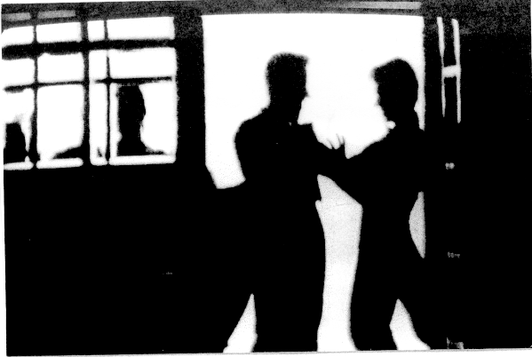

5.1 Explain what is happening in this still. | (2)

5.2 This still suggests the elegant world of dancing, something people do with great joy. Is this really the truth? Explain your answer. | (3)

5.3 Choose TWO of the following and explain what dancing means to them:

5.3.1 Scott  5.3.2 Fran’s family  5.3.3 Scott’s family | 2x2=(4)

5.4 The film opens with a waltz. It ends with the Paso Doble. Why, in your opinion, does the director choose these two very different types of dance styles? | (4)

5.5 Do you feel Scott is only a rebel who wants his own way or is he fighting for something in which he believes? Explain your answer. | (3)

5.6 During the film Fran changes. Explain how what she wears (the costumes) help us understand the changes that take place as the story progresses. | (4)  [20]

OR

QUESTION 6
STRICTLY BALLROOM
ESSAY

Write an essay of about 250 – 300 words on the following topic.

Is Strictly Ballroom a ‘celebration of dance’ or is it a film about a ‘struggle to overcome restrictions’?
In your answer you should refer to specific episodes and scenes from the film to prove your opinion.

In answering, you might like to think about the following:

- Stating your opinion as to whether it is about a ‘celebration’ or a ‘struggle’.  - Explaining your choice, based on examples from the film.  - Making a final statement that sums up what you have set out to illustrate. | [20]

TOTAL FOR SECTION C: | [20]

TOTAL: | 80

