GAUTENG DEPARTMENT OF EDUCATION
SENIOR CERTIFICATE EXAMINATION

ENGLISH FIRST LANGUAGE SG
(First Paper: Comprehension, Summary and Language)

TIME: 2 hours

MARKS: 75
INSTRUCTIONS:

- This examination paper consists of passages and questions based on the theme of DANGERS IN SOUTH AFRICAN SOCIETY.

- Answer ALL the questions.

- Skim through all the passages in order to formulate an idea of the theme.

- Read each passage carefully and then answer the questions set on each one. Some answers may be of a comparative nature.

- Base your answers on the given passages unless you are instructed otherwise.

- Attempt to use your own words in your answers.

- Use the mark allocation as a guide to the amount of detail required in your answers.

- Number your answers exactly as the questions have been numbered, using the decimal system, e.g. 2.4.2.

- Number your answers in the middle of the page, e.g.

2.4.2

- Leave a line open after each answer.

- Rule off after each full question.

- Start each new question on a clean page.

SECTION A

QUESTION 1
COMPREHENSION

Carefully read the passage below and answer all the questions.

Reading for Meaning and Interpretation.

EXTRACT 1

THE LAUGH AND TIMES OF A PERPETUAL VICTIM
Casper Greeff (adapted)
- My initiation into the world of crime began on a morning when I stumbled out of the house and climbed into my station wagon. The engine started, but the car wouldn’t move, even though I pumped the accelerator furiously.  - When I got out to investigate, the problem became apparent, The car was up on bricks, and all four wheels were gone – they’d been nicked during the night.  - The message was clear: welcome to South Africa, pal. Up till then I had been living in a fool’s paradise where crime happened in newspapers, and the villains left me alone because I was a nice guy.  - I had become a victim in the second sense of the word: “victim n 2. a person who is tricked or swindled.” In the course of my career as a victim, several other verbs came to nestle next to “tricked or swindled”. Words like mugged, robbed, burgled, gagged, bound, shot.  - The shooting was fairly dramatic. It happened when a gang of motorcycle thugs pulled me and some friends off the road and beat us all up, and then one of them shot me in the leg while I was lying on the ground.  6. The bikers left with bleeding knuckles and a smoking revolver, and were later acquitted in court on the grounds of self-defence. |  | 7. But the shooting didn’t leave such a bad taste in my mouth as did the bondage incident.  - This began early one afternoon while I was snoozing. I was awakened by two youths rummaging in the next room.  One of them said: “We are looking for work.” “Sorry, I don’t have any,” I mumbled, then nodded off, vaguely wondering why they hadn’t knocked on the door in the manner of other unemployed folk.  - When I woke up again a few seconds later the adolescent job-seekers were in my room. One of them was rifling through my cupboard, and the other had a kitchen knife at my throat. They stole all my money – a pretty substantial amount – and one of them told me, smugly: “We have to do this. It is our job.”  - Before leaving, they tied my hands and feet with shoelaces and the distasteful part – gagged me with a tennis sock that my housemate had been wearing for a week. “So that’s why they call it a gag,” I thought, before freeing myself and chasing the miscreants down the street, clad only in underpants, with the sock dangling round my neck.  - I underwent many straightforward burglaries and robberies and some muggings. And then last week I had a breakthrough.

- My mother phoned me at work: “You must go home at once. The police are waiting for you – you’ve had the most amazing robbery…”  - The burglary had astonished and even amused the seven detectives who awaited me, and when they showed me what had happened I had to laugh, although with a certain note of hysteria.  - The perps had come in through the floor. They’d used a hammer and scissors to pry open the Oregon pine floorboards which form the ceiling of my cellar, and had popped up under my bed in what must have been a “Eureka!” moment. They took the usual stuff – the VCR, the Snackwich machine, selected CDs and clothing. Unfortunately for the two cunning young men, patrolling policemen had spotted them leaping over the gate into my backyard. A stakeout ensued, and the ingenious perps were caught with my goods in their possession. |  | - I signed a sworn statement that I had not given them the right to enter my house through the floor, nor had I given them permission to remove the items listed in the aforementioned schedule. It had been a true breakthrough, a burglary where the victim’s goods are returned, a felony where innovative perpetrators are arrested, a crime that makes detectives chuckle.  16. It was also the initial breakthrough. Yep. They came back. My fault. I didn’t expect them back so soon, and didn’t secure the area until four days later.  - It happened while I was at the hardware store purchasing a padlock and bolt for the cellar door. They came in through the floor again, and made the customary mess, and took all the usual stuff, and I’m pretty sure they had a good laugh at their host, who had so obligingly left a hole in the floor for them.

1.1 Refer to Paragraph 1.

Explain the meaning and implication of the phrase My initiation into the world of crime as it is used here by Caspar Greeff. | (2)

1.2 Re-read paragraph 3.

- Identify the figure of speech used in the second sentence of this paragraph.  - What typically South African attitude towards danger or disaster is highlighted in this paragraph? | (1)  (2)

1.3

1.3.1 Which TWO incidents mentioned in this extract were potentially life-threatening to the writer? | (2)

1.3.2 Explain precisely why one of the two incidents from your answer to Question 1.3.1 was particularly distasteful to Casper Greeff. You must use your own words as far as possible in answering this question. | (2)

1.4 Refer to Paragraphs 13 to 17.

A careful reading of these paragraphs will reveal references to at least three different kinds of laughter. Provide a short phrase of your own to describe each of the following:

- The emotion experienced by the writer when he was shown how the burglars had entered his home.  - The manner in which the police laughed when they caught the burglars red-handed.  - The type of laugh emitted by the successful burglars. | (1)  (1)  (1)

1.5 Mention TWO incidents from this extract which seem to imply that criminals receive more protection from the justice system than their victims do. | (2)

1.6 Identify and explain ONE example of irony of situation from paragraph 17. | (2)

1.7 Extract 1 is an adapted version of an article which was published in a popular Sunday newspaper. Give a possible reason why Casper Greeff might have written such an article. | (1)  [17]

QUESTION 2
COMPREHENDING CARTOONS

Study the Cartoons labelled 2A and 2B and then read the definition of SATIRE given below them.

EXTRACT 2A

MADAM & EVE BY S. FRANCIS, H. DUGMORE & RICO
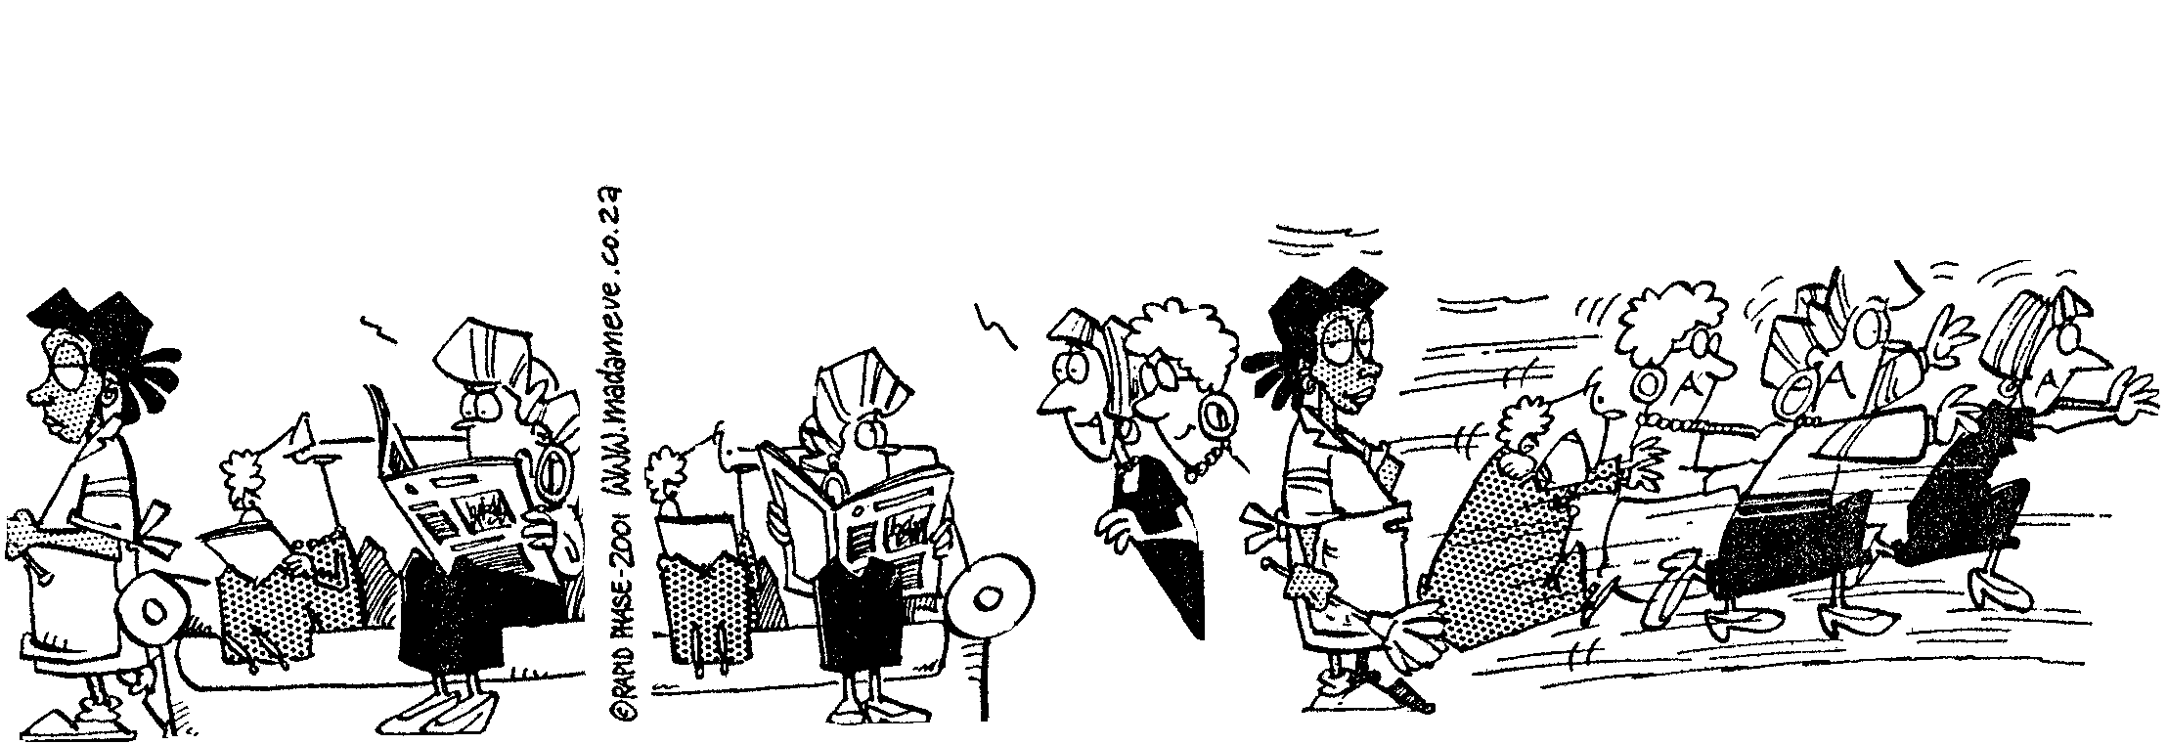
1.
2.
3.
LOOK AT THIS!!

STUDENTS AND COMMUTERS

STAMPEDING IN THE

STREETS! WHAT IS THIS

WORLD COMING TO?!!
GWEN! DID YOU HEAR?!

EDGARS IS RUNNING A SALE!!
50% OFF ALL LADIES’
SHOES!!
KLOMP! KLOMP! KLOMP!
KLOMP! KLOMP!!

EXTRACT 2B

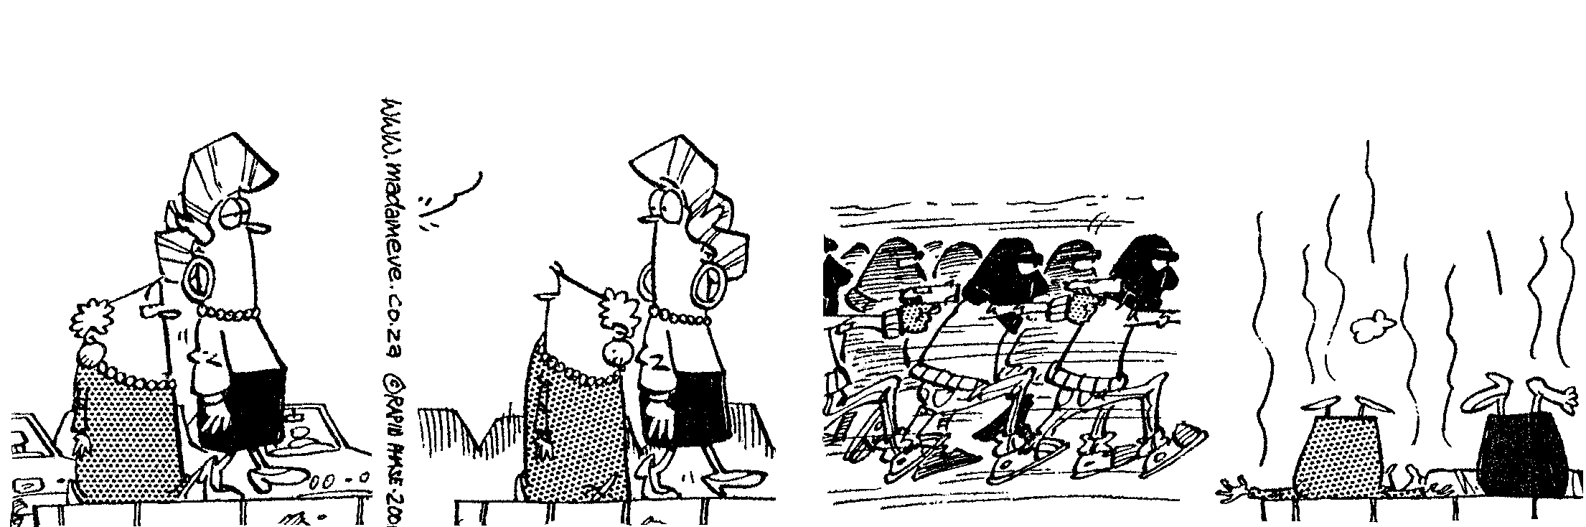
MADAM & EVE BY S. FRANCIS, H. DUGMORE & RICO
1
2
3
4
KLOMP! KLOMP!
KLOMP! KLOMP!

HIJACKER
STAMPEDE.

LOOK
A BMW

A satire is a composition in which irony, sarcasm, ridicule or wit of any form is used to expose foolishness or wickedness of institutions, governments or people. The intention of the satirist is to discourage foolish or wicked behaviour.

2.1 Bearing in mind the definition above, describe THREE types of human behaviour being ridiculed in these cartoons. | (3)

2.2 Mention TWO features of the drawings which convey a threatening atmosphere in Cartoon 2B. | (2)

2.3 Refer to frame 3 of Cartoon 2A.

- Give a word or phrase to describe Eve’s attitude to the stampeding ladies in this frame.  - Explain how this attitude is conveyed by her body language and facial expression in frame 3. | (1)  (2)  [8]

TOTAL FOR SECTION A: | [25]

SECTION B

QUESTION 3
SUMMARY SKILLS

Carefully read Extract 3 which also appeared in a popular Sunday newspaper.

EXTRACT 3

THE TERROR THAT HIJACKS OUR ROADS
WILLEM STEENKAMP (edited)
- For each hijacking reported in the South African media – and these days only the extraordinarily brutal and vicious ones make the papers – there are many others that slip by unremarked. Only the victims’ families and friends know of the loss.  - It is therefore not difficult to hold to the overriding belief of most South Africans: that hijacking is this country’s criminal monster that cannot be slain. Those who believe this may not be too far off the mark, and the reasons are relatively straightforward.  - We all know that police officers struggle against tremendous odds – a lack of manpower and resources, a shortage of necessities like transport and airtime for their cellphones and an overload of cases. It is little wonder officers battle to investigate cases thoroughly and solve so few.  - Add to these problems the corruption that plagues the criminal justice system – as evidenced by the all too frequent disappearance of case dockets – and it becomes clear why hijackers literally get away with murder.  - But police inefficiency and corruption cannot completely explain why the battle against hijackers seems lost. Ordinary South Africans, who so quickly and vociferously |  | complain about the police’s failure to curb this crime, are less than enthusiastic about their own role in fighting hijacking – either because they fear reprisals if they testify against criminals or because they simply cannot be bothered.  - Yet the public cannot afford to stand on the sidelines. According to a recent Institute of Security Studies’ survey, hijacking is on the increase in Cape Town, Pretoria, Soweto, Durban and Port Elizabeth. While there are still substantially more hijackings in Johannesburg, their number has, by contrast, dropped since 1994.  7. Police on the hijacking frontline say their problems begin with victims who can seldom identify their assailants.  Superintendent Piet Cilliers, commander of Johannesburg Central’s Hijacking Investigations Unit, says most hijackers can be arrested and convicted only on the basis of an identification, but most victims cannot identify their attackers because hijackings happen so quickly. Victims are also often too traumatised to note details such as identifying marks or clothing. Cilliers estimates that victims in 30% of the cases his unit handles, cannot identify suspects, often leading to the withdrawal of court cases.

8. He says other problems facing investigators include an inability to arrest the middleman because it is often impossible to link him with the vehicle, as well as a need for better technology and better computer systems. Insurance companies are no longer scrapping wrecked cars, making it easy for people to duplicate documentation for stolen cars and making cars difficult to trace.  9. Also problematic are motorists who do not |  | notice what is happening around them; corrupt policemen, licensing department officials and border control officers; and a lack of dedicated courts and prosecutors outside Central Johannesburg to deal with hijackings. The face of hijacking is also changing. In the past, police were up against well-organised syndicates, but the crime is increasingly committed by opportunistic individuals.

Lately there have been a number of hijackings in your neighbourhood. After reading the above article, you decide to design and distribute a flyer which is intended to warn the people of your neighbourhood about hijackings. Design your flyer according to the instructions below.

- Your flyer must contain 10 points.
- Each point must be preceded by an asterisk (*).
- Write a full sentence for each point.
- Attempt to keep each point to one line or less.
- Use the following title for your flyer: TEN REASONS WHY HIJACKERS ARE DIFFICULT TO CATCH.

Penalties will be imposed if you do not obey the above instructions. | [10]

QUESTION 4
COMPARISON OF TEXTS

By comparing the subject matter, style of writing and use of vocabulary in Extracts 1 and 3, say which piece of writing is more serious in its intention. | (5)  [5]

QUESTION 5
LANGUAGE IN ADVERTISING

All previous extracts have presented us with a clear picture of some of the dangers facing South Africans at present.

Now study the following advertisement and answer all the questions.
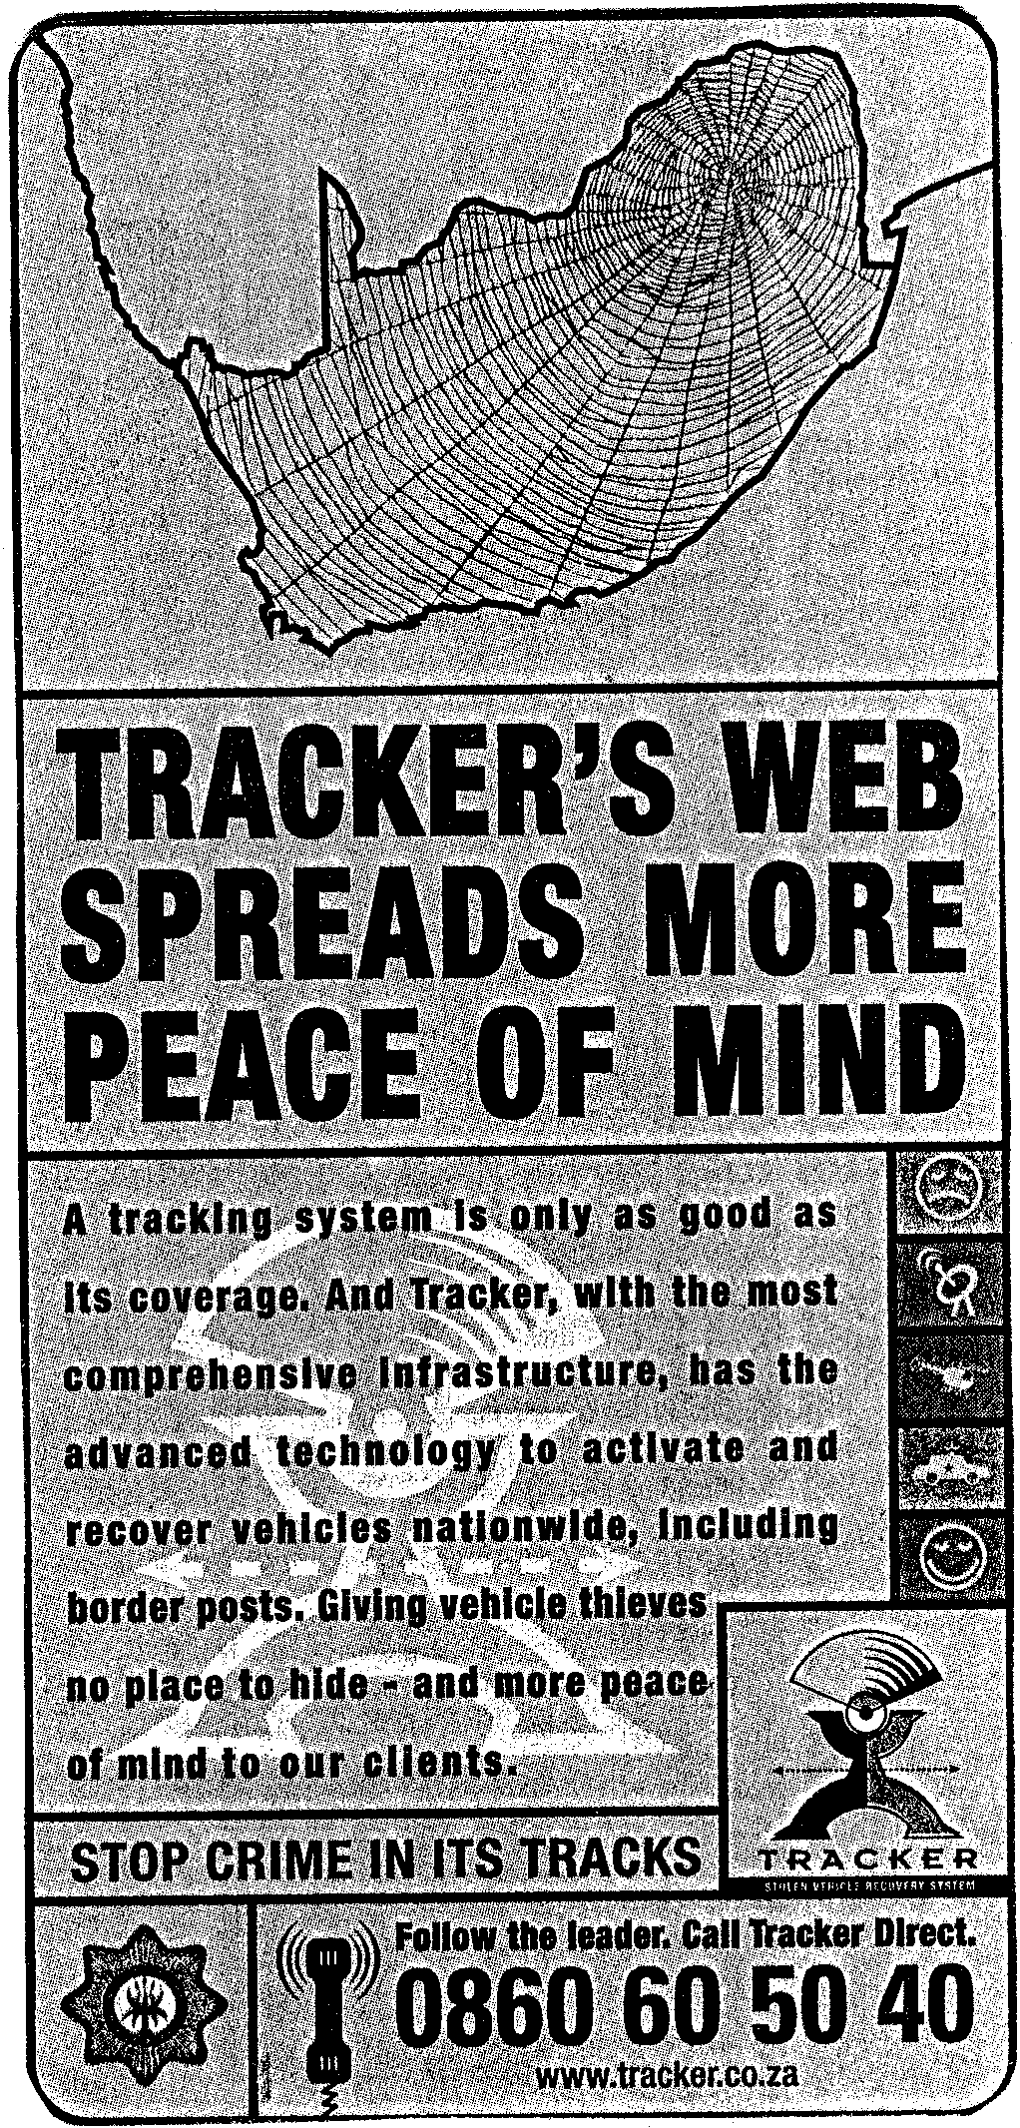
EXTRACT 4

5.1 In the light of the theme of this examination paper, explain why this simple advertisement is likely to be successful in its intention. | (2)

5.2 Advertisers are adept at appealing to our emotions and to our admiration for scientific and technological advances. From the advertisement, quote an example of:

- A phrase which is designed to have emotional appeal.  - A phrase which indicates the sophistication of the product. | (2)  (2)

5.3 5.3.1 The figurative device which is most prominently used in this advertisement is

- the metaphor.
- the pun.
- alliteration.
- hyperbole.

Write down only the letter which corresponds with the correct answer. | (1)

5.3.2 Explain your selection of figurative device in Question 5.3.1. | (2)

5.4 5.4.1 Explain the function of the apostrophe in the large bold type of the advertisement.  5.4.2 The word its is used twice in its correct form, without an apostrophe, in the body and slogan of the advertisement. Write a sentence of your own in which you correctly use the word it’s, with an apostrophe. | (1)  (2)

5.5 5.5.1 Explain why the following statement from the advertisement cannot be considered a full sentence:  Giving vehicle thieves no place to hide – and more peace of mind to our clients.  5.5.2 Rewrite the above statement, creating a grammatically acceptable sentence. | (2)  (2)
 | [16]

QUESTION 6
LANGUAGE IN USE

Read the extract below which is written from the point of view of the criminal rather than that of the victim or law-enforcer. Answer all the questions below it.

EXTRACT 5

INSIDE THE MIND OF A MAN OF THE GUN
Gillian Anstey (edited)
- He hijacked so many drivers that he says he can’t remember how many victims there were in his six-year spree.  - But the slightly built 26-year old, who prefers to be called Peter, can clearly remember many of the petrified faces that stared back at him.  - “I’d say, ‘get out the car’ and they’d scream,” he says, waving his hands in the air to demonstrate.  - “I’m wild. I feel nothing. I just take the car and worry about the police, not the person. My friend was the best driver. Me? I’m the best slinger, the gunslinger. If they talk, I shoot. I don’t want to understand, I don’t want to listen.”  - Peter claims to have given up his life of crime late last year, a life he embarked on at the age of 12. Growing up in Klipspruit with his grandmother, there was never enough money.  - What really irked him was that his friends had pocket money to buy takeaways after school. He didn’t. Sometimes the money he took home provided the only food in the house. His grandmother never asked where the money came from. |  | - At first, Peter played dice on Soweto’s street corners and soon found he could make R100 or more a day.  - But then, at the age of about 15, him and his friends started robbing people in the streets and alleys of Soweto, prefarably after dark and on Fridays, when potential victims had just recieved their weekly pay. Sometimes the victims pulled out guns. Peter and his friends simply ran away.  - At 19, Peter started hijacking. Working with three friends – two who have since died after being shot by police – he began by stealing his first car to make him mobile.  - Peter says he gave up his life of crime in November last year. He isn’t specific about the reason, but appears to have been shocked by the violent deaths and injuries suffered by his comrades. “You can’t prosper in hijacking. It’s prison or death,” he says.  - “I still want to live. I know I’ve got a bad heart sometimes but I can control myself. I want to work. One day things will go right for me.”

- A noun which corresponds with the verb hijacked in paragraph 1 is hijacker. Provide corresponding nouns of the same type for the following verbs (both of which can be found in Extract 1).  - Swindled  - Tricked | (2)

6.2 Strictly speaking, paragraph 1 is written in the incorrect tense and is therefore not grammatically acceptable. Rewrite the paragraph, using the correct tense. | (2)

6.3. Provide an antonym for the underlined word in paragraph 2. | (1)

6.4 Explain the writer’s use of single and double inverted commas (quotation marks) in paragraph 3. | (2)

6.5 Refer to sentence 1 of paragraph 5 of the extract and rewrite Peter’s words as they would have been said in direct speech. | (3)

6.6 Refer to paragraph 8.

- A pronoun has been incorrectly used in sentence 1 of this paragraph. Write down the pronoun which should have been used and explain the reason for your correction.  - From the list below, select the word which best corresponds to the term weekly pay. Write down only the letter which appears next to your choice of answer. | (2)
- salary  - remuneration  - wages  - inheritance | (1)

6.6.3 Correct the TWO spelling errors in this paragraph. | (2)

6.7 Explain the function of the dashes in paragraph 9. | (2)

6.8 Refer to paragraph 11.

I know I’ve got a bad heart sometimes ...  Is Peter using the phrase bad heart in its literal or figurative sense here? Explain your answer. | (2)  [19]

TOTAL FOR SECTION B: | [50]

TOTAL: | 75

