GAUTENG DEPARTMENT OF EDUCATION
SENIOR CERTIFICATE EXAMINATION

ENGLISH FIRST LANGUAGE SG
(First Paper: Comprehension, Summary and Language)

TIME: 2 hours

MARKS: 75
INSTRUCTIONS:

- This examination paper consists of passages and questions based on the theme of INFLUENCES ON THE LIVES OF YOUNG PEOPLE.

- Answer ALL the questions.

- Skim through all the passages in order to formulate an idea of the theme.

- Read each passage carefully and then answer the questions set on each one. Some answers may be of a comparative nature.

- Base your answers on the given passages unless you are instructed otherwise.

- Attempt to use your own words in your answers.

- Use the mark allocation as a guide to the amount of detail required in your answers.

- Number your answers exactly as the questions have been numbered, using the decimal system, e.g. 2.4.2.

- Number your answers in the middle of the page, e.g.

2.4.2

- Leave a line open after each answer.

- Rule off after each full question.

- Start each new question on a clean page.

QUESTION 1
COMPREHENSION

Carefully read the passage below and answer all the questions.

Reading for Meaning and Interpretation.

EXTRACT 1

OUT OF THE MOUTHS OF BABES SPILL BRAND NAMES
Merle Colborne (adapted)
- The other day I saw something one seldom sees anymore: a young boy bending down further than the bottom shelf of the fridge. What made this exertion so exceptional was that (a) he did it of his own free will and (b) he wasn’t looking for a Coke.  - Our occasional visitor has finally got his mind, though not his disbelief, around the idea that we don’t do cool drinks, crisps, cheese curls or popcorn – except for the kind that we will, if you like, help you make all by yourself, as long as you clean up properly afterwards.  - There are generally no takers. Kids prefer the homemade stuff you buy in a shop.  - What this solicitous young man was in fact doing was checking out the footwear of our neighbour, to see how much this boy’s parents cared for him and whether he merited a greeting or just a piteous stare.  - It’s a shame kids today have so much trouble with their feet. They need footwear with technologically engineered side supports, and the air they walk on has to be contained in small, specially designed cushions.  - And, most importantly, the footwear must have a logo that shows exactly – give or take the odd discount – the amount parents love  their kids. |  | - Martin Luther King jnr dreamt that little boys and girls would one day be judged not by “the colour of their skin but by the content of their character”. My two little visitors, who had the same colour skin as the reverend, were judging each other by the contents not of their character but of their wardrobe. Poor Reverend King.  - Unlike bare feet, which have pretty much disappeared, pockets have proliferated. But today’s pockets – all 27 of them – are design elements. If a boy puts things in the pockets of those “shorts” which reach, stiff as planks, to the shins, his pants would probably fall down. The shorts are designed for the sort of comfort you’d feel wearing a sandwich board.  - Because parents care enough to spend a couple of weeks’ wages on a single item of a kid’s wardrobe, children should show their gratitude by taking proper care of their clothes.  - And they do. For a start, they make sure their pants (both the inner and the outer sides) come into contact only with soft surfaces. Easy chairs (especially those with TVs in front of them) are good. Couches and beds – on which you can lie down so the wear and tear is evenly distributed – are even better.

- Soil soils; dirt, as Americans call it, dirties. Children know to keep well away from the stuff. If people start saying that, according to a British scientist, a lack of contact with the ground is making children ill and that children who loll about in front of the TV are showing spinal problems, pay no attention. You can’t afford to. Not after what you paid for their clothes.  - With careful nurturing, today’s tots are imbibing fashion sense and brand awareness with their mother’s milk formula. Out of the mouths of babes and sucklings come recycled Lactogen, Purity and Oshkosh – specially designed for those with no enunciation skills.  - Children are naturally intelligent. They know the only reason their parents had them – instead of puppies that come with all their kit – is for the shopping opportunities they present. They milk this |  | for all they’re worth.  - South Africa is, of course, hugely disadvantaged: we have school uniforms. But fortunately this hasn’t stopped fashion and brand awareness developing in the classroom – and outside the school gates with parents’ cars, sunglasses, clothes. Or lack thereof.  - When your child goes to school there are certain things that should never be forgotten: triangles of processed cheese, called Melrose, and thin rounds of fried potato that come in a bright plastic box. These are called Pringles. Without them your kid is sunk. And remember: no Skippy, no school.  - You might have to forego paying school fees to make sure your child displays all the right names, but what’s the alternative? Raising a misfit?  Sunday Times

- Refer to Paragraph 1.  1.1.1 Write down ONE word/noun from this paragraph which implies that the young boy was performing a task with effort.  - Give TWO reasons why the writer found this behaviour unusual. | (1)  (2)

1.2 There are generally no takers (Paragraph 3).  Provide TWO good reasons why there are no takers. | (2)

1.3 1.3.1 What was this young boy actually doing while he was bending down?  1.3.2 In the writer’s opinion, why was the young man performing this task? | (1)  (2)

1.4 In the light of your answer to Question 1.3.2, what criticism could Merle Colborne be said to be levelling against:

- Parents?  - Society in general? | (2)  (2)

1.5 How would the incident described in paragraphs 1 – 6 have dismayed Martin Luther King? | (2)

1.6 Refer to Paragraph 8.

- What was the original purpose of pockets in trousers or shorts?  - According to the writer, pockets now have a different purpose. In your own words, explain this purpose. | (1)  (1)

1.7 What is Merle Colborne implying about children in paragraph 10? | (2)

1.8 In general the tone of this article is light-hearted, but two serious points are raised in paragraph 11. Explain these points. | (2)

1.9 Paragraphs 12 and 15 contain references to the brand names of certain well-known products. By using these brand names the writer is suggesting that parents and children are often influenced into buying certain products. What powerful medium would most logically influence the purchase of such products? | (1)

- Study the following definition:  A satire is a composition in which irony, sarcasm, ridicule or wit of any form is used to expose foolishness or wickedness of institutions, governments or people. The intention of the satirist is to discourage foolish or wicked behaviour.  In the light of the above definition, explain why this extract could be considered satirical. | (4)
 | [25]

QUESTION 2
SUMMARY SKILLS

Read Extract 2 which is an edited version of an article which appeared in a Sunday newspaper.

EXTRACT 2

BE AFRAID. BE VERY AFRAID
Laurice Taitz (abridged)
- Despite having the advantages and opportunities of being part of a post-apartheid generation, the majority of South African youth are a lot like their parents.  - Their greatest fear is crime. Their favourite TV programmes are soapies like Generations and Days of our Lives. They go to church and love watching sport, and, while they believe it is important to vote in an election, they would rather be cricketers than politicians.  - Where they differ is in regard to sex. Not only are many children starting to have sex fresh out of primary school, but they are doing it in the shadow of an Aids pandemic |  | that threatens to rob them of what should be a bright future.  - One could argue that kids today are growing up faster because they are exposed to more than their parents ever were. But the generation gap is much more starkly drawn, because many young South Africans may not live to be parents themselves. At the present rate of infection, one in two South Africans under the age of 15 is expected to die of Aids-related causes in the next 10 years.  - Despite this, the topic of sex remains taboo in most households, and many parents still feel squeamish about tackling it head-on.

This is according to the findings of the largest-ever national survey of South African youth between the ages of 12 and 17.  - But while children are making an early leap into adulthood, their attitudes betray their ages. When asked, most of them list HIV/Aids as one of their greatest concerns and even go so far as to say that they are afraid they may get infected and believe that they could die from this. Yet they seem dangerously ignorant of how their sexual behaviour puts them at risk.  - While young South Africans have increasingly been targeted by safe-sex campaigns, they seem hopelessly confused by the message. Ninety percent of respondents say they have at least heard of Aids, but such basic awareness fails to translate into meaningful behaviour change.  - The simplest prevention maxims – abstaining from sex, being faithful to one partner or using condoms – have failed to get through. More than half of all sexually experienced teens think they won’t get infected by their sexual partner, and one in five has had sex with more than two people.  - While it may be reassuring to learn that nine out of 10 kids have heard of Aids, one in 10 has not. The problem here is that those wholly ignorant of the disease’s existence are concentrated in certain regions – informal |  | settlements and rural areas in the Northern Province and North West. In places where recreation and even education is a luxury, sex becomes a way of alleviating boredom.  - Two out of five kids think that Aids can be cured. One in three young girls says that at one time or another she has been forced to have sex. Coercion and fear play a role in many young people’s sexual relationships.  - At the more subtle end of the continuum is peer pressure. One out of five sexually experienced young people say they have sex with their boyfriend or girlfriend because they’re scared of what their friends will say if they don’t.  - The survey reveals that, when it comes to frank, open discussions about sex, South Africa’s teens are often being failed by the government , the church and their parents.  - Many say they learn about sex from their friends, from visitors to their school, TV and magazines. Few say they learn from their parents, but when they do, they say that their mothers are more helpful than their fathers in this regard. Few young people get the kind of information they need about HIV/Aids at home. So it is not surprising that, more than 10 years into the pandemic, the stigma attached to HIV/Aids is pervasive.

After reading this article in the newspaper, you are concerned for the young people in your community. You decide to write a point form summary of the article for publication in your school / local community newspaper.

- Your summary must contain 10 points.
- Each point must be numbered, i.e. 2.1 – 2.10.
- You must write full sentences.
- Attempt to keep each point to ONE line or less.
- Use the following title for your summary: WHY AIDS IS A HUGE THREAT TO YOUNG SOUTH AFRICANS.

Penalties will be imposed if you do not obey instructions. | [10]

QUESTION 3
COMPARISON OF TEXTS

By comparing the subject matter, style, diction and tone of Extracts 1 and 2, say which piece of writing is more serious in its intention. | [5]

QUESTION 4
LANGUAGE IN CARTOONS

Refer to the cartoons labelled 3A and 3B.

EXTRACT 3A and 3B

CARTOON 3A
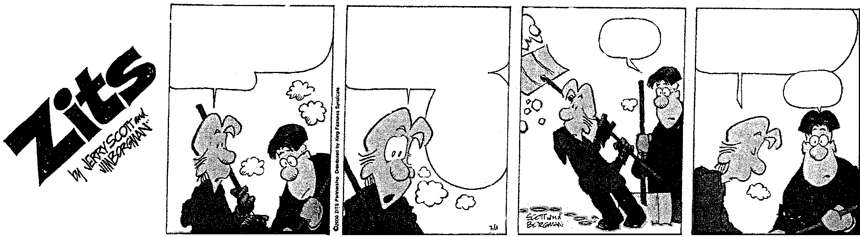
1.
2.
3.
4.
my mom was really mad that i didn’t tell her
about getting that
detention
at first she made me
promise to tell her
every single thing that
happens at school
but I got
her to
change her
mind about
that.
how?
by telling her every
single thing that
happens at school
ooh!
LOOK AT THIS!!

STUDENTS AND COMMUTERS

STAMPEDING IN THE

STREETS! WHAT IS THIS

WORLD COMING TO
GWEN! DID YOU HEAR?!

EDGAR IS RUNNING A SALE!!
50% OFF ALL LADIES
SHOES!!
KLOMP! KLOMP! KLOMP!
KLOMP! KLOMP!!

Refer to Cartoon 3A.

4.1 Rewrite the words of the speaker in frame 1 of cartoon 3A in reported speech. | (4)

4.2 Replace the word mad in this cartoon with a more formal word of the same meaning. | (1)

4.3 4.3.1 Account for the use of the apostrophe in frame 1 of this cartoon.  4.3.2 Briefly explain another common use of the apostrophe which is not reflected in the cartoon. | (1)  (2)

4.4 Refer to the drawing in frame 4.

- Give a word or phrase to describe the mood of the blonde-haired boy in this frame.  - Mention ONE feature of the drawing which reinforces your answer to Question 4.4.1. | (2)  (1)

CARTOON 3B
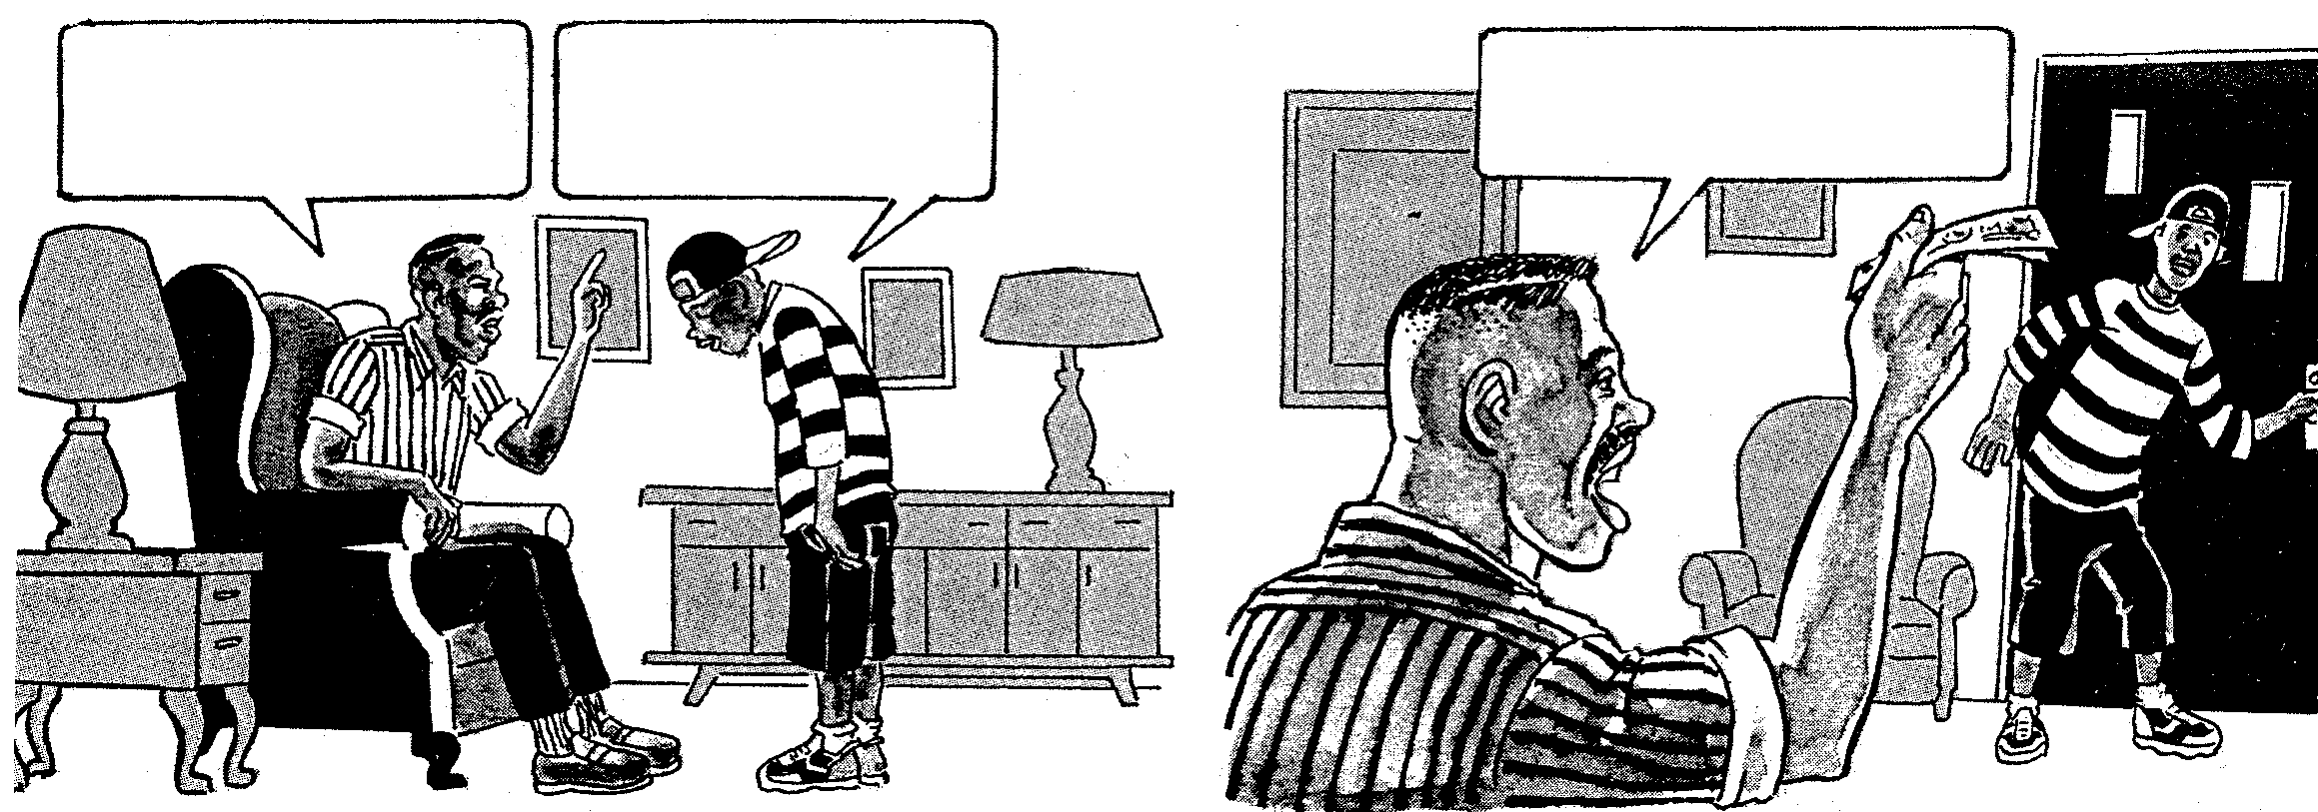
You didn’t get your mother anything for her birthday? After all she does for this family? Shame on you!
Gee, I feel so rotten!
I’m going to go to the
mall right now and
buy her something!
Good idea! And while you’re
at it, here’s a few bucks!
Pick her up something for me!
1 2

Refer to Cartoon 3B

- Describe any TWO features from Frame 1 which convey the apparent anger of the father. | (2)

4.6 The father’s words and sentence construction in Frame 2 would be considered unacceptable in Standard English. Rewrite his words, paying attention to sentence structure and diction. | (5)

4.7 Explain the irony which is apparent in this cartoon. | (2)  [20]

QUESTION 5
LANGUAGE IN ADVERTISING

Study the advertisement and answer all the questions.

EXTRACT 4
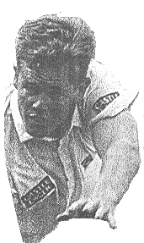

It’s just the way it is. When you take a batsman out, it’s not personall. Shaun Pollock wears the new Nike Air Delivery. With air bags in the heel and fourfoot, it keeps him stable while taking aim at full speed. To Shaun they’re a boost; to the batsman -quack quack.

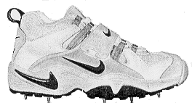

NIKE AIR DELIVERY
JUST DO IT

DESIGNED

FOR HUNTING

DUCKS

5.1 What is the main device used to encourage the reader to buy this product? | (2)

5.2 The figurative device which is used most frequently in this advertisement is the pun. Select TWO examples of the use of this device and explain their effectiveness. | (4)

5.3 The word it’s, with an apostrophe, has been used twice in this advertisement. Create a sentence of your own in which you correctly use the word its without an apostrophe. | (2)

5.4 Correct two spelling errors in this advertisement. | (2)

5.5 5.5.1 Carefully read sentence 4 of the advertisement and explain why the pronoun it might not be considered grammatically acceptable.  5.5.2 Rewrite the entire sentence, correcting the pronoun and resulting error of concord. | (2)  (2)

5.6 Replace the semi-colon in the last sentence of the advertisement with a more appropriate punctuation mark. | (1)
 | [15]

TOTAL: | 75

