GAUTENG DEPARTMENT OF EDUCATION
SENIOR CERTIFICATE EXAMINATION

ENGLISH FIRST LANGUAGE HG
(Third Paper: Creative Writing and Literature)

TIME: 2½ hours

MARKS: 120

- Answer FIVE questions as follows:

- Section A: ONE Essay only
- Section B: THREE Transactional pieces
- Section C: EITHER the Literary Essay OR Contextual questions

- Clearly number your choices.

- In Section C, do not attempt to read through the questions set on all the setworks. Consult the TABLE OF CONTENTS on page 7 and mark the numbers of the questions relating to the setworks which you have studied during 2002.

- In contextual questions, the length of each answer should be guided by the mark allocation.

- Rule off after each complete question.

The examiners trust that you will enjoy answering this paper.

SECTION A

CREATIVE WRITING

Write a prose composition of 450 – 550 words on ONE of the following topics. Please indicate the number of the topic and supply a title if one is not given already. Thorough planning and editing will create a favourable impression.

Your composition should reflect your values, perspectives and experiences. Be careful of misinterpreting the topic you choose or simply tailoring a prepared essay to a particular topic.

1. Sunsets and sunrises

2. Her fingers were like silk against my face …

3. Independence versus my boss

4. In the air tonight ...

5. Life is sweet.

6. Crime and poverty

7. Moving on …

8. If I had unlimited power for a day

9. Impatience versus procrastination

10. What is beauty?

11. “Love’s blossoming here inside me
As we stroll underneath blossoming trees;
I’ve the feeling I’m walking on clouds, dear,
With rather wobbly knees.” Heinrich Heine

12. Write an essay in response to ONE of the following images. Clearly indicate the number of your choice.

12.1

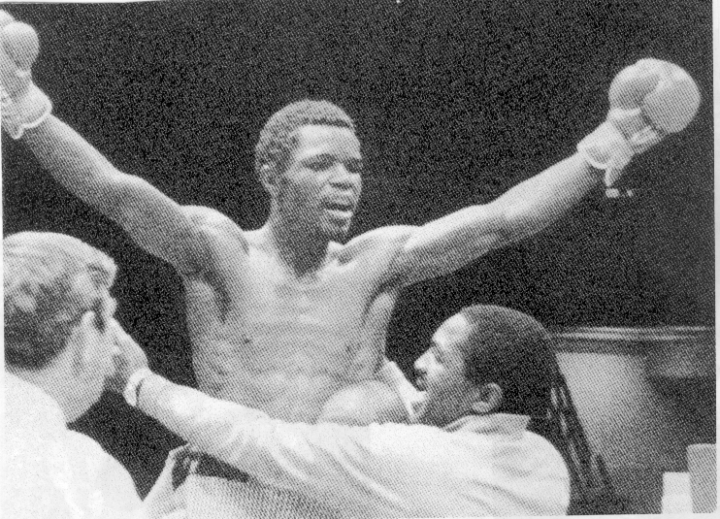

12.2

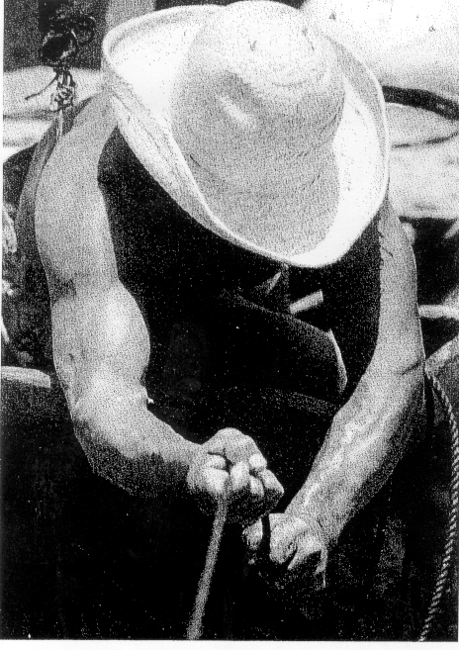

TOTAL FOR SECTION A: | [40]

SECTION B

TRANSACTIONAL WRITING

You are required to answer THREE questions from this section. Your answers must consist of the following:

- A formal letter;
- Other transactional writing;
- A shorter piece of tailored prose.

2.1 Formal letter topics

You must answer ONE (and only one) of the topics below. Your answer should be about 200 words in length.

2.1.1 Everybody makes promises that cannot be delivered. Write a letter to an organisation or individual, which has disappointed you in this fashion, in which you carefully express your disappointment and dissatisfaction.

2.1.2 MARKET YOURSELF! Write an open letter in which you describe the services and expertise you offer and the strengths that you could bring to any place of prospective employment.

2.1.3 More and more people are turning to prostitution in order to survive. Write a letter to the editor of your local newspaper to air your views on this matter. | (20)

2.2 Other transactional writing

You must answer ONE (and only one) of the topics below. Your answer should be about 200 words in length.

2.2.1 You have been asked to compile a brochure to advertise the company for which you work. In this brochure you should write a brief description of the company and its services. You should also outline why customers should choose this company rather than similar enterprises. Be realistic and beware of exaggeration.

2.2.2 Imagine that the matric results are due to be released the next day. Write a diary entry for the night before in which you record your thoughts and feelings.

2.2.3 Are part-time candidates advantaged or disadvantaged by this paper? Write a formal report in which you investigate how full-time students feel about portfolio work versus how part-time candidates feel about writing extra papers. Address your report to the director or principal of the institution at which you are registered. | (20)

2.3 Shorter transactional work

You must answer ONE (and only one) of the topics below. Your answer should be about 80 words in length.

2.3.1 Compose a memorandum to the colleagues in your section at work in which you inform them of an urgent meeting to be held later during the day. You should include all the relevant details concerning the nature of the meeting, its time and venue.

2.3.2 A friend of yours is looking for work. Send him/her a facsimile (fax) message in which you outline how to write an effective Curriculum Vitae for himself/herself.

2.3.3 The local community centre is organising a flea market and jumble sale day. You have offered to design a poster for the event. In your answer book draft a copy of the poster. You will not be judged on artistic ability but layout and spacing is important. | (10)

TOTAL FOR SECTION B: | [50]

SECTION C

LITERATURE

- Consult the TABLE OF CONTENTS below and mark off the question number relating to the setwork which you have studied in 2002.

- Answer ONE question only.

- The length of an essay should be approximately 500 words.

TABLE OF CONTENTS

Question 1 | Focus – Short Stories Essay
Question 2 | Focus – Short Stories Contextual
Question 3 | To Kill a Man’s Pride – Short Stories Essay
Question 4 | To Kill a Man’s Pride – Short Stories Contextual
Question 5 | Strictly Ballroom – Film Essay
Question 6 | Strictly Ballroom – Film Contextual

Answer ONE question from this section

FOCUS – edited by R. Meyer

QUESTION 1

Essay

One of the criteria of a successful short story is an effective climax. “A Bekkersdal Marathon” and “The Schoolmaster” both fulfil this requirement but in very different ways. Compare and contrast the climaxes of these two stories and discuss the impression that each makes on the reader.  You need to  - Identify the climax of each story  - Discuss the effectiveness of the climax in the context of the overall themes of each story  - Discuss the reader’s likely reaction to each climax | [30]

OR

QUESTION 2

Contextual

Carefully read the extract below, then answer the questions that follow.

 | Manhood – J. Wain
 | ‘Five feet eight, Rob,’ said Mr Willison, folding up the  wooden ruler. ‘You’re taller than I am. This is a great land-  mark.’  ‘Only just taller.’  ‘But you’re growing outwards as well up upwards. We’ll  have you in the middle of that scrum. The heaviest forward in  the pack.’  Rob picked up his shirt and began uncertainly poking his  arms into the sleeves.  ‘When do they pick the team?’ Mr Willisom asked. ‘I should  have thought they’d have done it by now.’  ‘They have done it,’ said Rob. He bent down to pick up his  socks from under a chair.  ‘They have? And you –‘  ‘I wasn’t selected,’ said the boy, looking intently at the  socks as if trying to detect minute differences in colour and  weave.  Mr Willison opened his mouth, closed it again, and stood for  a moment looking out of the window. Then he gently laid his  hand on his son’s shoulder. ‘Bad luck,’ he said quietly. | 5  10  15  20
 | ‘I tried hard,’ said Rob quickly.  ‘I’m sure you did.’  ‘I played my hardest in the trial games.’  ‘It’s just bad luck,’ said Mr Willison. ‘It could happen to  anybody.’ | 25

 | There was silence as they both continued with their dressing.  A faint smell of frying rose into the air, and they could hear Mrs  Willison laying the table for breakfast.  ‘That’s it, then, for this season,’ said Mr Willison, as if to  himself.  ‘I forgot to tell you, though,’ said Rob. ‘I was selected for  the boxing team.’  ‘You were? I didn’t know the school has one.’ | 30

2.1 Explain the boy’s feeling when he tells his father that he wasn’t selected for the team. | (3)

- What is implied about the father’s feelings in the following sentence:  “Mr Willison opened his mouth, closed it again, and stood for a moment looking out of the window”? | (3)

2.3 Why does Rob lie about being selected for the boxing team? | (3)

2.4 2.4.1 How does Mrs Willison react to Rob’s announcement that he is going to train for boxing? | (2)

2.4.2 What does this tell us about her as a mother? | (3)

2.5 Discuss the relationship between Rob’s parents. | (4)

2.6 Do you think Rob’s parents are reasonable in their dealings with their son? Give reasons for your argument. | (4)

2.7 What theme/s emerge from a study of “Manhood”? | (4)

2.8 Compare the father and son relationship explored in “Manhood” to the relationship between Corrie Cronje and Kerneels in “Plymouth”. | (4)  [30]

OR

TO KILL A MAN’S PRIDE

ESSAY

QUESTION 3

In the short story “Beggar my Neighbour” pride is the main factor which leads to the breakdown in interaction between the black children and Michael.

Discuss the above statement. You may wish to consider the following issues:

Reasons for:

- Michael’s pride compared with that of the children  - The inexorable increase of tension and resentment  - The resolution of anger and bitterness | [30]

OR

QUESTION 4

CONTEXTUAL

Read the following passages carefully then answer the questions which follow.

passage 1

 | Ha’penny – A. Paton
 | He in his turn gave his whole attention to her, and  when I visited him he was grateful, but I had passed  out of his world. I felt judged in that I had sensed  only the existence and not the measure of his desire. I  wished I had done something sooner, more wise,  more prodigal.  We buried him on the reformatory farm, and Mrs  Maarman said to me, ‘When you put up the cross, put  he was my son.’  ‘I’m ashamed,’ she said, ‘that I wouldn’t take him.’  ‘The sickness,’ I said, ‘the sickness would have  come.’  ‘No,’ she said, shaking her head with certainty. ‘It  wouldn’t have come, and if it had come at home, it  would have been different.’  So she left for Bloemfontein, after her strange visit  to a reformatory. And I was left too, with the resolve  to be more prodigal in the task that the State, though  not in so many words, had enjoined on me. | 5  10  15

4.1 In the context of this story, what do you understand by Alan Paton’s comment “I had passed out of his world.” (lines 2 - 3)? | (4)

4.2 It is clear, in the first paragraph of the passage, that Paton is experiencing guilt. Explain, in your own words, the source of his guilt. | (4)

4.3 Mrs Maarman, too, feels guilty. Do you consider that she should be ashamed of her actions? Discuss your response in a paragraph of 5 to 6 lines. | (4)

4.4 Refer to lines 13 to 15. What is Mrs Maarman implying by the views she expresses here? | (3)

AND

PASSAGE 2

 | Beggar My Neighbour – J. Jacobson
 | ‘What do you want now?’ he asked.  A last anxiety flickered in Michael and left him, as  the boy slowly shook his head. He began to step  back pulling his sister with him. When he was through  the door he turned his back on Michael and they  walked away down the passage. Michael watched  them go. At the door of the kitchen, on their way  out of the house, they paused, turned once more, and  lifted their hands, the girl copying the boy, in a silent,  tentative gesture of farewell.  Michael did not follow them. He heard the back  gate swing open and then bang when it closed. He  went wearily back to his bed, and as he fell upon it,  his relief and gratitude that the bed should be there  to receive him, changed suddenly into grief at the  knowledge that he was already lying upon it – that  he had never left it.  His cold grew worse, turned into bronchitis, kept  him in bed for several weeks. But his dreams were no  longer of violence; they were calm, spacious, empty  of people. As empty as the lane was, when he was at  last allowed out of the house, and made his way there  immediately, to see if the children were waiting for  him.  He never saw them again, though he looked for  them in the streets and lanes of the town. He saw a  hundred, a thousand, like them, but not the two he  hoped to find. | 5  10  15  20  25

4.5 What action has taken place immediately before the first line of this passage? | (3)

4.6 Suggest what dramatic effect the writer intended by his inclusion of this sentence: “He heard the back gate swing open and then bang when it closed.” (lines 11 - 12). | (3)

4.7 Explain carefully why Michael experiences “grief” (line 15). | (4)

4.8 What is the significance, in the context of the story, of Michael’s dreams, now “calm, spacious, empty of people” (lines 19 - 20)? | (3)

4.9 How would you describe the tone of the final four lines of this short story? Explain your response briefly. | (2)  [30]

OR

STRICTLY BALLROOM

QUESTION 5

ESSAY

The critic Roger Ebert writes about the film that the characters ‘are profoundly frightened of change, and have created an insular little world, with rigid rules and traditions’.

Discuss this view of Strictly Ballroom. In answering the question remember you are writing about a film. Refer to what we see and hear to motivate your response.

In answering this question you might like to consider the following:

- The idea of the little world of dance, bound by rigidity and fear of change  - The characters who are caught up in this world  - Their motivation for denying change  - The rebels who do not accept the confines of the dancing world | [30]

OR

QUESTION 6

CONTEXTUAL

Carefully examine this still from the film. Here we see Fran and Scott share a moment of intimacy, walking out in the open.

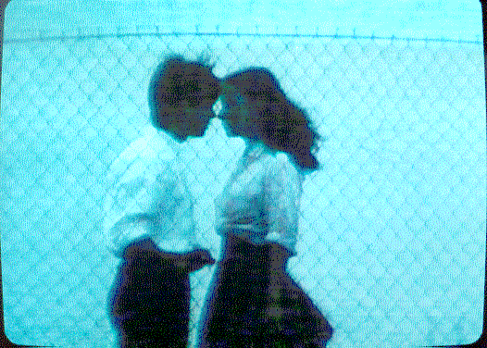

6.1 How is the feeling of closeness established in this shot? | (3)

6.2 Why, in your opinion, is the scene shot from behind a fence? | (2)

6.3 Earlier on in the film Scott had asked Fran, ‘Can you dance without these?’

6.3.1 Describe what was taking place at the time when he asked the question. | (3)

6.3.2 Show how both Scott’s chance remark, ‘Can you dance without these?’, and the scene from which the above still has been taken, relate to the fairy tale aspect of the film. | (4)

6.4 Very soon after the scene portrayed in this still, Barry Fife tells Scott of his father’s (Doug’s) career as a ballroom dancer.

6.4.1 What is the story he tells? | (4)

6.4.2 How does the director choose to ‘tell’ this story in the film? In answering, refer to specific film techniques. | (4)

6.5 Although Scott is the hero of Strictly Ballroom, he is in fact a selfish and difficult young man. Do you agree with this statement? Motivate your response. | (4)

6.6 Explain how costume plays an important role in the transformation of Fran. | (3)

6.7 The film concludes with the song, ‘Love is in the Air’. What is happening on the vision track as the film ends? | (3)

TOTAL FOR SECTION C: | [30]

TOTAL: | 120

