GAUTENG DEPARTMENT OF EDUCATION
SENIOR CERTIFICATE EXAMINATION

ENGLISH FIRST LANGUAGE HG
(First Paper: Comprehension and Language)

TIME: 2½ hours

MARKS: 100

INSTRUCTIONS:

- Your examination today is based on issues related to GENDER ATTITUDES.

- The paper consists of FIVE questions.
- It is suggested that you spend 15 minutes reading through the entire paper.

PLEASE NOTE:

- Pay attention to the mark allocation in determining the length of your answers.
- Use your own words, unless asked to quote.
- Number your answers in the centre of the page.
- Write only the letter in response to multiple-choice questions, e.g. 1.2–B.
- Use the same numbering as in the question paper.
- Leave a line after answers.
- Rule off after each complete question.

QUESTION 1

COMPREHENSION

Carefully read the passage printed below and answer the questions that follow.

–

1. | What does a young woman look for in a man these days? Well, if research from Cape Town to Pretoria is to be believed, it’s the ‘triple Cs’. | 7.  8.  9.  10.  11. | ‘For young men, trying to live up to the triple Cs is a source of tension. A man is expected to have a good job, a wife and support his family. There are few jobs, however, and a man feels inadequate if he can’t provide which can lead to aggression,’ stated fellow researcher Nwabisa Juma.  Tension between men and women over differing views of love and sex is a theme that came up time and again at the recent Aids in Context conference. ‘There’s a low intensity warfare between men and women,’ says David, a young Sowetan delegate.  Mark Thorpe from his experience of conducting 15 workshops for teenagers in Durban’s townships, says, ‘The most taboo things for Durban school pupils are homosexuality, masturbation and virginity.’  Sunanda Ray, a Zimbabwean researcher, says that ‘sex has become a commodity’ in relationships between men and women. ‘Many women feel the need to gain status from being with a man and not from being independent and able to support themselves.’  Uncovering people’s sexual habits and beliefs are important keys to unlocking the forces driving HIV/Aids. But such studies take time, a luxury Africa does not have as the pandemic drives on.  Adapted from The Sunday Independent
2. | Caring, compassion and confidence? Nope, it’s the rather more basic: ‘car, cash and a cellphone. | 7.  8.  9.  10.  11.
3. | And men? Well, say young women, they want sex. And they are prepared to pay for it, in cash and gifts. And once a man has ‘invested’ his cash, says a Durban youngster, ‘he will go for it, flesh to flesh.’ | 7.  8.  9.  10.  11.
4. | While the different interpretations of ‘love’ that men and women have is the stuff that women’s magazines are based on, the context for this discussion was a serious academic conference at Wits University looking at the social, cultural and historical reasons for the HIV/Aids epidemic. | 7.  8.  9.  10.  11.
5. | Prevention programmes that emphasise abstinence, monogamy and condoms have had little success. Researchers are now turning their attention to the many factors at play in sexual interactions to try to find better ways of understanding – and combating – the rapid spread of HIV/Aids in Southern Africa. | 7.  8.  9.  10.  11.
6. | ‘Girls are expected to stay away from boys, be submissive to elders and not have any children before marriage’, says Mzikazi Nduna from the Medical Research Council’s Stepping Stones programme, ‘But the reality is that mostly their parents are absent, so girls experiment with sex and alcohol and even drugs. Girls have a more romantic idea of sex than boys. But for girls, love means support while for boys, love means sex.’ | 7.  8.  9.  10.  11.

1.1 Using your own words, discuss, in full, the meaning of the title of this passage. | (3)

1.2 How does the writer attempt to give the researchers credibility in  paragraph 1? | (2)

1.3 | Nope, it’s the rather more basic: car, cash and a cellphone.
 | Identify the tone of these words in paragraph 2. | (1)

1.4 The men and women questioned in this passage have very different expectations of one another.

1.4.1 In your opinion, which is more demeaning – male or female expectations? Explain your choice. | (2)

1.4.2 Discuss the extent to which you think these views are prevalent in South Africa. | (2)

1.5 Examine paragraph 4. What attitude towards ‘women’s magazines’ does the writer appear to hold? | (2)

1.6 Give a reasoned answer to account for why ‘HIV’ is in capital letters while the abbreviation ‘Aids’ is not. | (2)

1.7 Identify the function of the dashes in paragraph 5. | (1)

1.8 The words quoted in the first half of paragraph 6 are in the passive voice. Rewrite the beginning of the sentence so that it is in the active voice. What is the effect of this change? | (2)

1.9 What are the implications of the word ‘even’ as used in paragraph 6? | (2)

1.10 Discuss the appropriateness of the title of the conference as revealed in paragraph 8. | (2)

1.11 Examine paragraph 9. Explain the meaning of the word ‘taboo’ and explain why its usage can be considered ironic in this context. | (3)

1.12 ‘A commodity’, as used in paragraph 10, means  A. a luxury in life.  B. a necessity of life.  C. an object of trade.  D. taken for granted. | (1)

1.13 A possible solution to the problem discussed in the article is given in paragraph 10. Explain what it is, in your own words. | (2)

1.14 Quote and explain the metaphorical use of words in the last paragraph. | (3)  [30]

QUESTION 2

HUMOUR AND STYLE

Carefully read the passage below and then answer the questions that follow.

1.  2.  3.  4.  5. | There was a hush down in the Chalk ŉ Cue this week, as well as some awkward scratching, when Karl the barman’s wife insisted on watching Mr South Africa. (There may have been some confusing syntax in that last sentence. I should pause to explain that the barman’s wife is not named Karl. Karl is the barman and he has a wife, but no one can remember her name.) Karl’s wife soon wanted to switch off again, but by that time we were so caught up in the momentum of our horror we were compelled to see it through to the tight and bitter end.  I hope you were watching, ladies, because the only thing I can think of is that the Mr South Africa competition is men’s way of saying sorry. There must be a better way of repairing the injuries and insults of decades of beauty contests than to inflict the same atrocities on ourselves, but we don’t seem to have found it. The gender war is hell.  The venue for the guy-fest was the Menlyn Park shopping centre in Pretoria, which strikes me as being right. In addition to the prizes for winning, no doubt each competitor received free entrance to the underground parking and a voucher to be spent on any product excluding the CDs at the local CNA.  The visions of masculine splendour arrived at the stage on horseback, dressed up like Roman centurions on their way to camp for the night. Or perhaps they were already camping for the night. Is dressing up like Mr October in a soft-porn calendar really the best way to showcase masculinity?  Up popped Mikey Mol and Basetsana Makgalamele to explain the criteria: “We’re looking for someone who is good-natured, well-balanced, a role |  | 6.  7.  8.  9. | model for the youth and has a self-satisfied smirk just like mine,’ said Monsieur Mol. Did he really say that last bit? Does it matter? Out came the role models for the youth, dressed in swimming trunks and goggles. Some style fiends pushed their goggles onto their foreheads like sunglasses, as though they were doing the Saturday morning shopping. All around the country, the youth were feverishly taking notes so as to be just like their heroes.  As ever, the highlight was the section in which the contestants display their personalities. ‘The modern South African man doesn’t give from his pocket, he gives from his heart,’ declared one, by which I understood him to mean he doesn’t roll down his window when the guy with the cardboard sign approaches at traffic lights.  Another gem offered this insight: ‘Everything in your life is there for a reason.’ I wanted to discover his reasons for tonsils, the male nipple and that pigeon roosting in the eaves outside my bedroom window, but there was no time.  Here’s Paul Carlisle, sharing how he’d like to be remembered: ‘I want to get a law instituted recognising that men can get raped.’ I would have thought that a law suggesting that men shouldn’t be raped would be more useful, but I am not a Mr SA runner-up.  Who won in the end, you ask? Oh, I don’t know, some guy with a self-satisfied smirk like Mikey Mol’s. For a terrible moment I thought he was going to weep with happiness. The Chalk ŉ Cue was quiet for a long time afterwards. We were like a roomful of war journalists who had seen too much of the darkness of which humanity is capable …
 |  | Darrel Bristow-Bovey, The Sunday Independent, abridged

2.1 How is setting established in the first paragraph of this article? | (2)

2.2 This article is taken from a weekly television review column. For what possible reasons does the writer include the bar room discussion from the Chalk ŉ Cue (paragraphs 1 and 9)? | (3)

2.3 What is meant by syntax in paragraph 1? | (2)

2.4 How does the writer account for the existence of the Mr South Africa pageant in paragraph 2? | (2)

2.5 Describe the tone of the last sentence of paragraph 2. | (2)

2.6 Discuss how a cutting approach to the writer’s subject is established in paragraph 3. | (2)

2.7 Explain the ambiguous use of the word ‘camp’ in paragraph 4. | (2)

2.8 ‘Style fiends’ are referred to in paragraph 5. Who are they and what attitude is conveyed through this phrase? | (2)

2.9 Why can the last sentence of paragraph 5 be considered ironic? | (2)

2.10 Describe, with reference to the text, the attitude displayed towards the male presenter in paragraphs 5 and 9. | (3)

2.11 Much of the humour in paragraphs 6, 7 and 8 derives from the writer deliberately misinterpreting the words of the contestants. Discuss the effectiveness of this technique with reference to at least ONE instance in the passage. | (4)

2.12 The final paragraph appears to end on a sombre note.  What is the possible intention in doing this? (It may help you to refer to the title in your answer.) | (2)  [28]

QUESTION 3

GENDER AND LANGUAGE

Carefully read the extract below and answer the questions that follow.

The word man has two meanings. One refers to all people as a species; the other to an adult male. The two meanings have become blurred, however, and to many people man does not clearly include women. It is therefore no longer useful as a generic term, and introduces ambiguity and uncertainty into the language. (If man were accepted as a true generic term the phrases “a man-eating lion with a taste for women” and “man breastfeeds his young” would not sound humorous.) False generic terms should not be used.

In most cases it is easy to substitute expressions that do not exclude women, when it is intended that the reference include both women and men. Care should be taken that a relevant and accurate alternative is chosen.

 | Example | Possible alternative
 | man | people, humanity
 | manpower | labour, workforce
 | man-made | synthetic, artificial
 | There are other words or phrases containing man which sometimes overlook the contribution of woman and the fact that they often have different experiences from men. For example, much historical writing suggests, by neglect, that women have made no contribution.
 | Example | Possible alternative
 | pioneering fathers | pioneering forebears
 | founding fathers | founders
 | Clichéd terms should be abandoned in favour of original thought, or reworded.
 | Example | Possible alternative
 | man’s best friend | a faithful dog
 | a man-sized task | a demanding task
 | Generalisations can contain the assumption that all women are the same, or exclude women. “Average person” is inclusive but “average man” is not. Similarly, “average wage earner” or “taxpayer” is preferable to “average working man”. “Average consumer”, “average household”, “average homemaker” are better than “average housewife.”

3.1 This passage is taken from a booklet designed by the Equal Employment Opportunities office of Victoria University of Wellington. Why is it necessary for such a booklet to be written? | (3)

3.2 Refer to the first paragraph. Why can ‘man’ not be considered a ‘generic’ term? You should show some understanding of the word ‘generic’ in your answer. | (2)

3.3 Give any THREE of your own sexist terms or phrases which may be suggested to you from the categories (historical, clichéd terms, generalisations) discussed in the passage.  Then supply a more acceptable alternative for each one. | (3)

3.4 Terminology of this kind is also known as politically correct language.

3.4.1 Explain what is meant by ‘political correctness’. | (2)

3.4.2 Printed below is the front cover of The Politically Correct Phrasebook. How can you tell that this is intended to be a humorous publication? | (2)

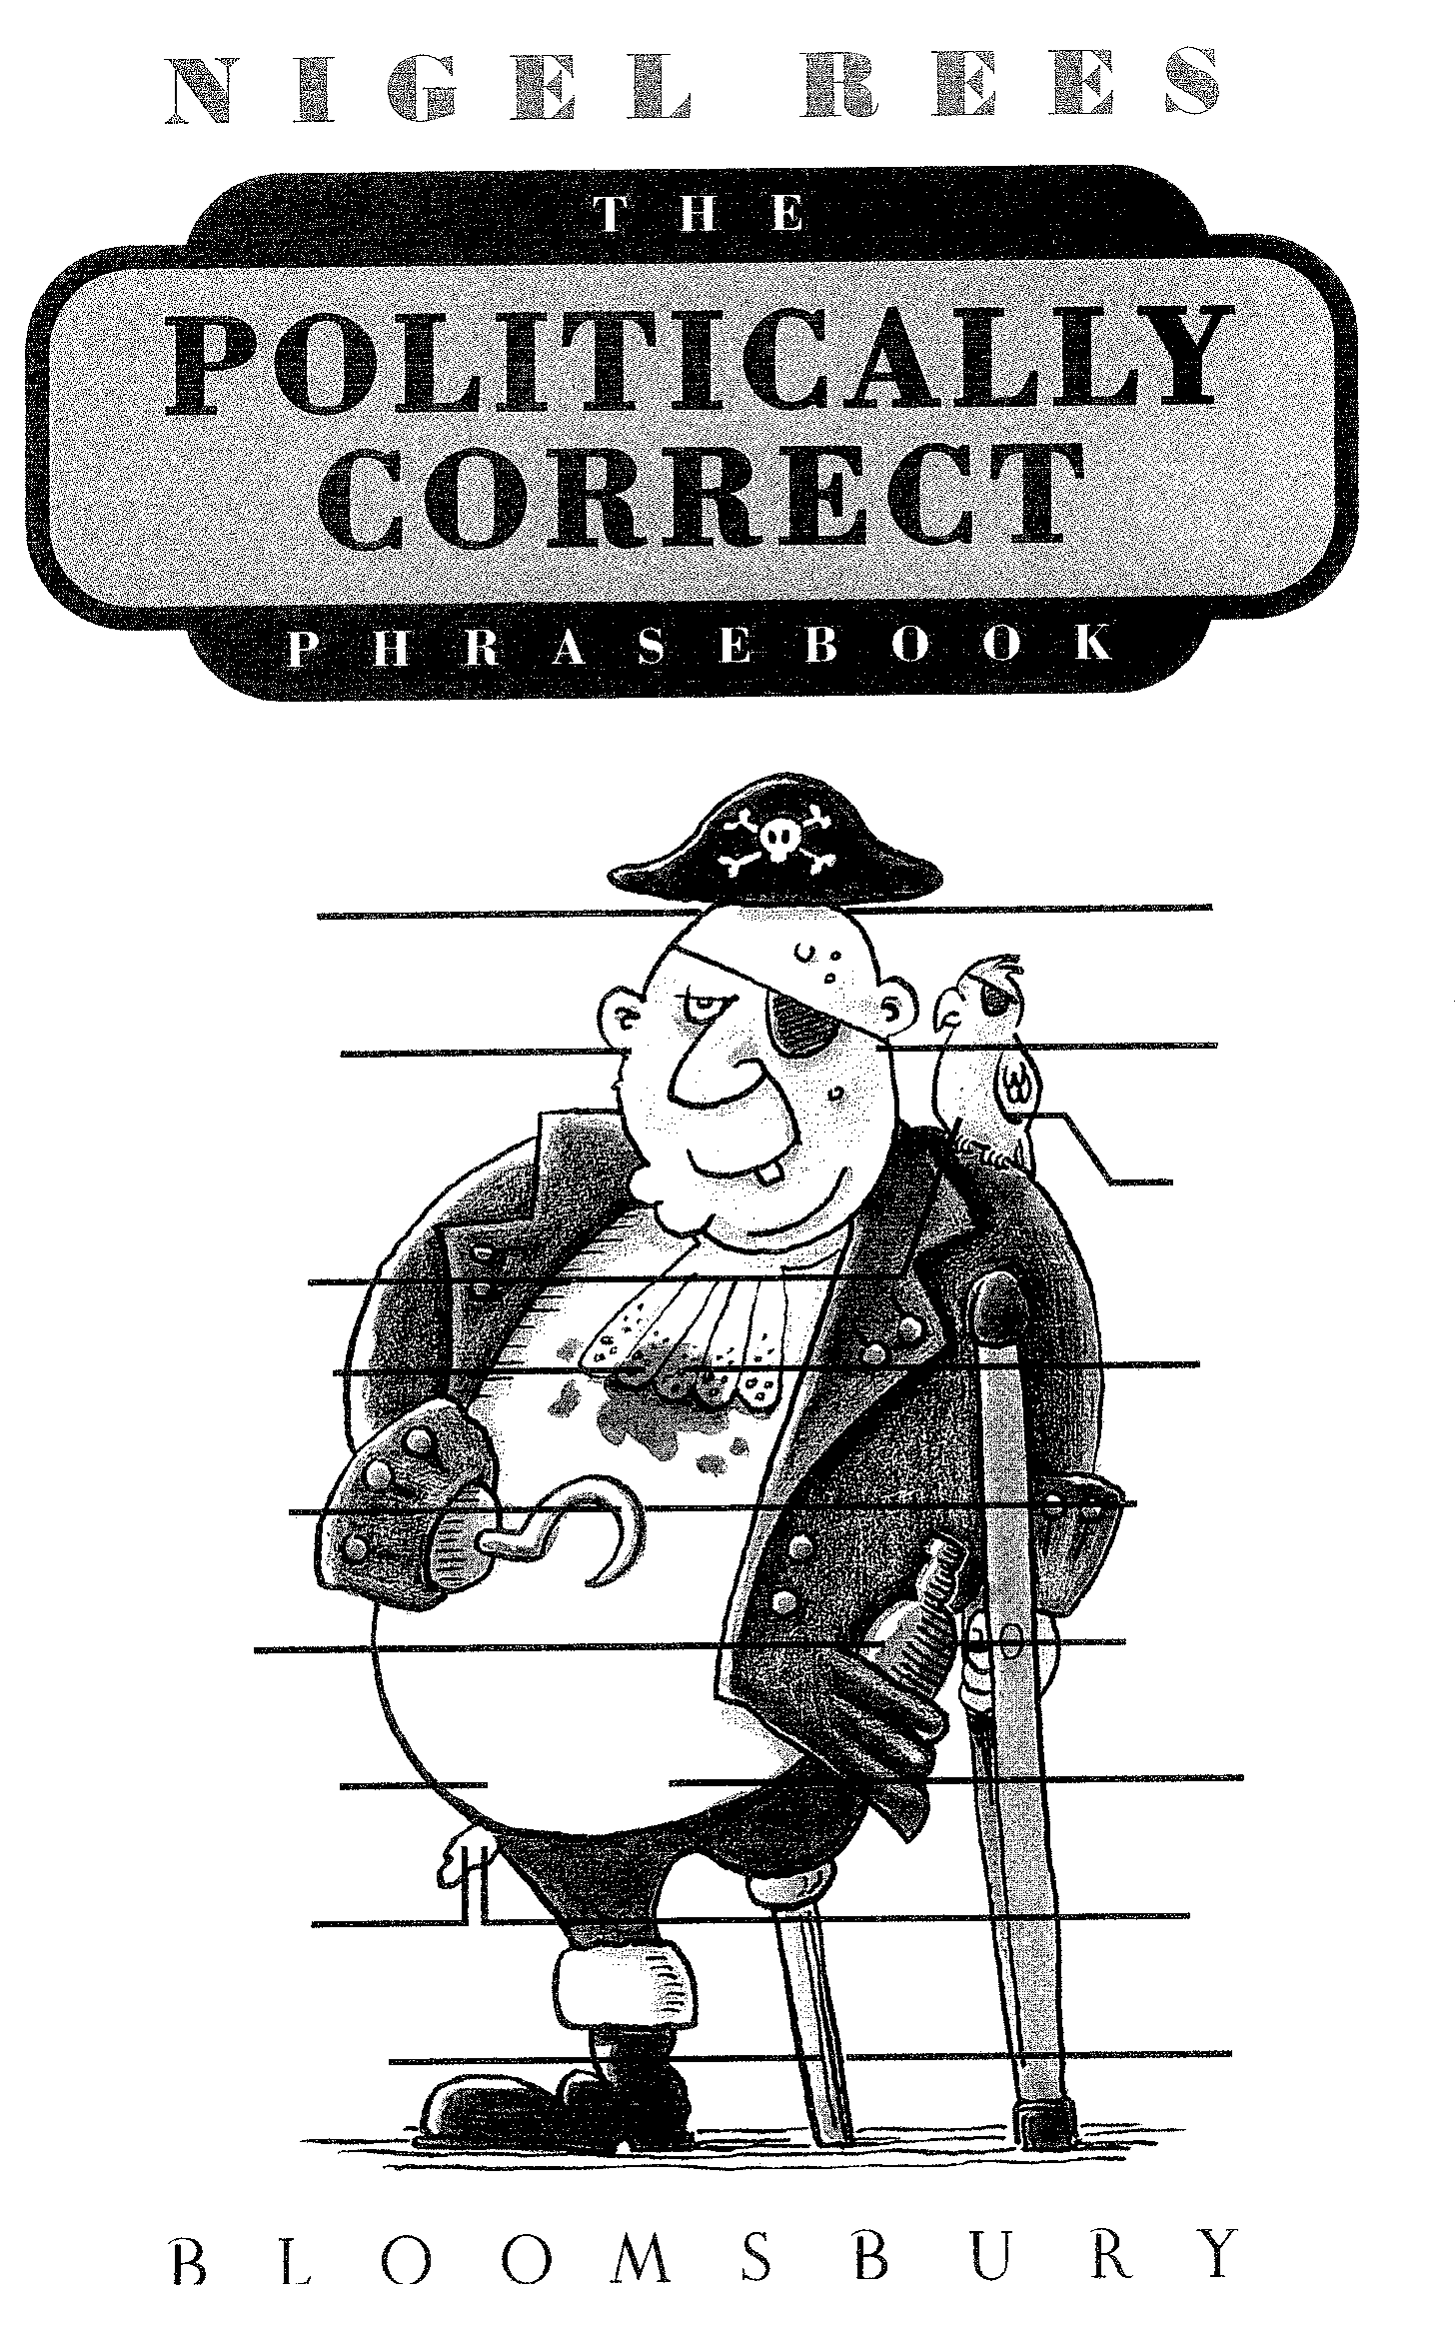  Bald  Ugly  Parrot  Dirty  Disabled  Alcoholic  Fat  Broke  One Legged  Follicularly Challenged  Aesthetically Challenged  Non-human Animal Companion  Physiologically Disenfranchised  Financially Disadvantaged  Horizontally Challenged  Problem Drinker  Physically Different  Hygienically Challenged | [12]

QUESTION 4

SUMMARY

Read through the passage below and summarise according to the instructions that follow.

–
 | On the whole men tend to be bigger, stronger and (let’s not beat about the bush here) brainier than women. We’re taller with far bulkier muscles (about 15 per cent longer and 40 per cent thicker than women’s) and our brains, on average, are 11.5 per cent larger than that of the opposite sex. All of which, unfortunately, may count for sod all.  Women, it appears, do far better at actually living than men do. For a start, they survive longer: female life expectancy in Britain is 78 years, men’s a measly 72. And, despite their smaller cranial capacity, women average the same on IQ tests as men. In addition, when they’re little, they usually outperform boys at school.  Nature’s partiality to women starts even before birth. The basic template for the human body is, as it happens, female. At the sixth week, those embryos that will develop into males start producing testosterone. But for that flood of testosterone, all foetuses – even genetically male ones – would develop into ‘girls’.  Women are generally healthier than men because, to put it bluntly, they have a more efficient chromosome structure. Of |  | the 46 chromosomes that transmit genetic information, two – the X and the Y – are responsible for the determination of sex. Men are XY, in that they have one chromosome (from mum) and one Y (from dad), the Y governing maleness. Women, by contrast, have two X chromosomes.  By and large, the X chromosome carries the information that controls how we develop. Women, with a double helping of X, have two founts of this genetic data; if one is damaged, they can rely on the other.  Men, on the other hand, with one X and one Y, have no such secondary source; if the X is damaged, men have to live with the consequences – and those can include such delights as colour-blindness, haemophilia and certain sorts of rickets and diabetes.  Women also appear better at coping with stress than men. Proof of this may lie in the suicide statistics. Men are now, apparently, four times as prone to kill themselves as women, and certainly a great deal more efficient at it. (Roughly 80 per cent of successful suicides are men.)  So who said nature was fair?  GQ Magazine, adapted

This passage was taken from a men’s magazine and is obviously written for a male audience.  You are required to write a summarised version for a female audience. Think of a suitable heading and write an article for a women’s magazine using no more than 130 words. | [10]

QUESTION 5

EDITING SKILLS

Read the extracts below and answer the questions on them.

5.1 Identify and correct the split infinitive in the sentence below. | (2)

5.2 Quote another infinitive verb from this sentence. | (1)

Parents tend to vigorously play with boys, while girls are encouraged to smile and speak more often than their brothers.

5.3 Explain how the idiomatic nature of English makes this sentence deliberately ambiguous. | (2)

If I said you had a beautiful body would you hold it against me?

5.4 Correct the concord error in the sentences below. Give a reason for the change you make. | (2)

Equality is a myth. Woman are better.

5.5 Explain why the word ‘fraternise’ can be considered out of place in this context. | (2)

Sign in hostel: GIRLS MAY NOT FRATERNISE AFTER 10 P.M.

5.6 Discuss why ‘es’ is added to form the plural of ‘sex’ and not just simply an ‘s’. | (2)

The battle of the sexes will continue as long as we continue to refer to the opposite sex as the opposite sex.

5.7 Answer the questions based on the cartoon below.

5.7.1 Which is correct? ‘Meeting Mister Right’ is an example of  A. an idiom;  B. a cliché;  C. an oxymoron;  D. a metaphor. | (1)

5.7.2 Discuss whether or not the word ‘Mister’ has been correctly abbreviated in this cartoon. | (2)

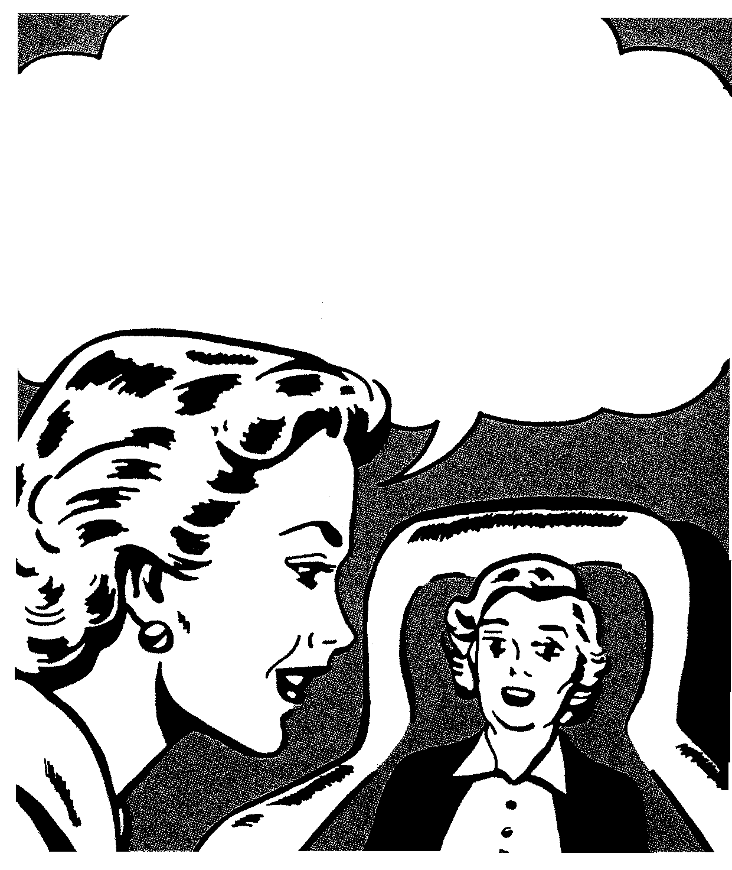

No Mother, I
haven’t met Mr. Right yet …. But I have met Mr. Cheap, Mr. Rude and Mr. Married!

5.8 Rewrite the passage below, correcting the errors you find. | (6)

The gender distinction also manifests itself in what we talk about. In general, woman talk about other people; men, on the other hand, detail experiences, usually they’re own. Mail conversation, not to put to fine a point on it, is self-advertisement; women’s is negotiation. Women are more skilfull at expressing negative emotions and do not ‘bottle things up’ as men does.
[20]

TOTAL: | 100

