GAUTENG DEPARTMENT OF EDUCATION
SENIOR CERTIFICATE EXAMINATION

ENGLISH FIRST LANGUAGE HG
(First Paper: Comprehension and Language)

TIME: 2½ hours

MARKS: 100

INSTRUCTIONS:

Your examination today is based on issues related to images of masculinity.

The paper consists of 6 questions.
It is suggested that you spend 15 minutes reading through the entire paper.

PLEASE NOTE:

- Pay attention to the mark allocation in determining the length of your answers.
- Use your own words, unless asked to quote.
- Number your answers in the centre of the page.
- Write only the letter in response to multiple-choice questions, e.g. 1.2–B.
- Use the same numbering as in the question paper.
- Leave a line after answers.
- Rule off after each complete question.

QUESTION 1

COMPREHENSION

Carefully read the passage below and then answer the questions that follow.

 | 1.  2.  3.  4.  5.  6. | Men are discovering what it is like to be turned into sex objects, and they are not very happy about it, psychologists say.  Many men feel frustrated, inadequate and angry because of glossy magazine images depicting male models with rippling muscles and taut, flat stomachs.  Researchers showed a series of pictures, including adverts for designer label underwear and aftershave, and covers of Men’s Health magazine, to 140 teenagers and men aged 15 to 35 and asked them for their reactions.  “About half the men in our sample felt very intimated by these images,” Dr Rosalind Gill, of the London School of Economics, said. “They were stressed, frustrated and felt they couldn’t live up to them. Some were very angry about it. They also felt a sense of outraged injustice.”  Gill’s team identified several different reactions, including feelings of pressure, anger, indifference and desire.  Just under a third were unaffected by the images, all of whom were heterosexual, Gill said. These men tended to be individuals who were in long-term relationships or who believed women were more | 7.  8.  9.  10. | interested in men’s minds than their bodies.  Gay men were far more vulnerable to body image pressure than heterosexual men, the researchers found. Gill said the ‘perfect male’ phenomenon had emerged only in the last decade, probably driven by gay culture. “These kind of male images did not exist 10 years ago so it is a very new phenomenon for men to cope with. Men have been portrayed as attractive before, but what’s new is that these images portray men as objects to be looked at and consumed, very much as women have been for a long time," Gill said. “I think that’s very much to do with gay culture.”  She added: “People need to be more aware of the effects that these images have on men and the fact that we are becoming a much more ‘lookist’ culture.”  Simon Geller, editor of the UK edition of Men’s Health magazine, said the images on the front of his publication were ‘inspirational’ rather than ‘aspirational’.  He said: “We tell people inside the magazine that we can make them look like the man on the cover but they will never be identical to them. We make it clear that these men are genetically freaky, that they are models and live that sort of extreme lifestyle.”
 |  | Adapted from an article by Elizabeth Judge, The Times, London

1.1 Discuss how the term ‘sex object’ (paragraph 1) has both positive and negative connotations. | (2)

1.2 In your own words, explain why men are unhappy about these ‘glossy magazine images’ (paragraphs 1 to 5). | (4)

1.3 Refer to paragraph 6.

1.3.1 What percentage of men was emotionally affected by the images shown to them? | (1)

1.3.2 Why were some men ‘unaffected by the images’? | (2)

1.4 Why, do you think, were gay men found to be ‘more vulnerable to body image pressure’ (paragraph 7)? | (3)

1.5 | “Men have been portrayed as attractive before, but what’s new is that these images portray men as objects to be looked at and consumed, very much as women have been for a long time.” (Paragraph 7)

1.5.1 In your own words, how has the portrayal of men changed? | (3)

1.5.2 In this sentence, what comment is the speaker making about the sexist nature of society? | (2)

1.6 Refer to paragraph 8.

1.6.1 Explain the use of inverted commas around the word lookist. | (2)

1.6.2 Discuss your understanding of a ‘lookist culture’. | (2)

1.7 Discuss the differences in the meaning of the words ‘inspirational’ and ‘aspirational’ as used in paragraph 9. | (3)

1.8 From paragraph 10, explain why it is that male models are able to have ‘the perfect body’. Do not merely quote from the passage. | (4)

1.9 Explain the pun contained in the heading of this article. | (2)  [30]

QUESTION 2

ISSUES ABOUT STYLE AND EDITING

Use the passage below to answer the questions that follow.

 |  | 1.  2.  3.  4. | Pop quiz. Who are more likely to be dissatisfied with the appearance of their chests. American men or women? Who are more likely to be concerned about acne, a teenage boy or his sister? And who is more likely to binge eat, a young girl or her brother?  If you chose the women and girls, you are right only for the last question – and even then, not by the margin you might expect. About 40% of Americans who go on compulsive-eating sprees are men. Thirty-eight percent of men want bigger pecs, while only 34% of women want bigger breasts. And more boys have fretted about zits than girls, going all the way back to a 1972 study.  A groundbreaking new book declares that these numbers, along with hundreds of other statistics and interviews the authors have compiled, mean something awful has happened to American men over the past few decades. They have become obsessed with their bodies. Authors Harrison Pope, Katharine Phillips and Roberto Olivardia, have a catchy name to describe this obsession – the Adonis complex.  The name, which refers to the gorgeous half man, half god, of mythology, will start a wonderful debate. Based on original research involving over 1 000 men over the past 15 years, the book argues that many men desperately want to look like Adonis because they constantly see the ‘ideal’, steroid-boosted bodies of actors and models and because their muscles are all they have over women today. In an age when women fly combat missions, the | 5.  6.  7. | authors ask, ‘What can a modern boy or man do to distinguish himself as being “masculine”?’  Nearly half of all men don’t like their appearance, in contrast to just 1 in 6 in 1972. 46% of men of normal weight think about their appearance ‘all the time’ or ‘frequently.’ And some men – probably hundreds of thousands, if you extrapolate from small surveys – say they have passed up job and even romantic opportunities because they refuse to disrupt workouts or dine on restaurant food. In other words, an increasing number of men would rather look brawny for their girlfriends than have sex with them.  Ripped male bodies are being used to advertise everything that shapely female bodies advertise: not just fitness products but also dessert liqueurs, microwave ovens, and luxury hotels. The authors of The Adonis Complex want guys to rebel against these images, or to at least see them for what they are: a goal unattainable without drug use.  Feminists raised these issues for women years ago, and more recent books such as The Beauty Myth were part of a backlash against the hourglass ideal. Now, says Phillips, ‘I think it may be harder for men than women to talk about these problems because it is not considered masculine to worry about such things.’ But maybe there is a masculine alternative: next time wrestling comes on, guys, throw the TV out the window. And order a large pizza.  Adapted from Time Magazine.

2.1 Explain why the opening statement is not a complete sentence. | (2)

2.2 Correct and identify the error of concord in paragraph 1. | (2)

2.3 Examine paragraph 3. Identify the topic sentence and explain its effectiveness in terms of length. | (2)

2.4 Look at the word ‘groundbreaking’ in paragraph 3.

- This is an example of a:  compound word  present participle  gerund  adjective. | (1)

- Give a reason for your answer above. | (1)

2.5 Explain the function of the dashes in paragraph 5. | (1)

2.6 Paragraph 5 contains many statistics. Why are some written out in words while others are written in numerals?  Try to formulate the rule that would govern when it is appropriate to use either numerals or words to express such information. | (2)

2.7 The words ‘dessert’ and ‘desert’, ‘liqueur’ and ‘liquor’ are commonly confused. Is the usage of ‘dessert liqueur’ in paragraph 6 correct? Give a reason for your answer. | (2)

2.8 The words ‘The Adonis Complex’ and ‘The Beauty Myth’ are written in italics. Explain why this is the case and suggest an alternative to this method of emphasis. | (1)

2.9 Identify and correct the split infinitive in paragraph 6. | (2)

2.10 The final phrase of paragraph 6 is separated from the rest of the sentence by a colon. What other form of punctuation could have been used to achieve the same effect? | (1)

2.11 The word ‘harder’ in paragraph 7 is considered colloquial.

2.11.1 Explain why this is the case. | (2)

2.11.2 Rewrite the relevant part of the sentence in which you include a more formal alternative to this usage. | (1)  [20]

QUESTION 3

HUMOUR

Carefully read the passage below and then answer the questions that follow.

 | 1.  2.  3. | I cannot wait to lather up my naked, hairy body in an inflatable pool full of testosterone gel. I have felt testosterone deficient since I was five, when, surrounded by my female friends, I spent my days compiling my sticker collection, listening to the Annie soundtrack, baking in my Easy-Bake Oven and arranging my glass animal collection. Some women have had a more masculine childhood than I did.  But I needed to know precisely how unmanly I am, so I went to my doctor to get my T count checked. Unfortunately, my doctor could not administer the test via saliva; he would need a blood sample. That made me consider cancelling the appointment, which in and of itself delivered the result I needed. But I made the appointment anyway. In 48 hours I would know how much man was in me.  For a long time, I’ve overcompensated for my lack of manliness through sportswriting, porn watching and stock buying, but deep down I know I’m a little shy on T. I cannot yell at other drivers, raise my voice, pick up women in a bar or grow a full beard. All whiskey, no matter how expensive, just tastes like burning. Yet deep down inside I long to sleep around, to kick some ass, to release my first rap album. As I saw it, I had little choice | 4.  5. | but to score some of that testosterone gel when it comes out. I could keep it in my jacket pocket for emergency situations, next to my lip balm and anti-bacterial hand gel. I’m thinking of marketing this as a first-aid kit for wusses.  After two neurosis-filled days, my doctor called and told me my testosterone level was totally normal. When I pressed him for a number, he said it was within the normal rage of 260 to 1000. When I really pressed him for a number, he told me it was 302. When I started to freak out about being in the bottom 10%, he again reassured me that was completely normal. Yeah, normal in that I don’t have breasts.  One of my female friends tried to comfort me, saying the women may have hot, wild flings with high-testosterone men, but they settle down with hormonally balanced guys. This did not make me feel better. You’d have to have a T count of 20 for this to make you feel any better. All I could think about was that now I have one less excuse for having an affair. Unless, of course, I’m hopped up on man gel.  Joel Stein, adapted.

3.1 How is a light-hearted atmosphere established in the first paragraph? Quote to support your answer. | (2)

3.2 Refer to paragraph 2.

3.2.1 How does this paragraph help to explain the heading of the passage? | (1)

3.2.2 Why does the writer suggest his doctor’s appointment was unnecessary? | (1)

3.3 Many male stereotypes are mentioned in paragraph 3.

3.3.1 What is a stereotype? | (2)

3.3.2 To what extent is the writer mocking images of masculinity in this paragraph? Discuss in full. | (4)

3.4 Refer to paragraph 4. Discuss the effect of so many sentences beginning with the words “When I …”. | (2)

3.5 What is the tone of the last sentence of paragraph 4? Explain your choice. | (2)

3.6 The style of this passage is very colloquial. Supply more formal equivalents for TWO of the following phrases:  3.6.1 ‘pick up women’ (paragraph 3)  3.6.2 ‘kick some ass’ (paragraph 3)  3.6.3 ‘to freak out’ (paragraph 4) | (2)

3.7 This passage deals with similar issues to those in the passages in Question 1 and 2. The register, however, is very different. Discuss how the passages differ in terms of style, diction and tone. You should quote or refer to the texts in your answer. | (4)  [20]

QUESTION 4

SUMMARY

Carefully read the passage and then follow the instructions that follow.
’
 | 1.  2.  3.  4. | Men are fine at showing their emotions. You just have to be at a football match to see it. They are five times more likely than women to cry with happiness, a study has shown. The cause is usually a direct result of their love of football.  Moira Maguire, who presented the findings at the British Psychological Society conference in Canterbury, England, recently, said: “They didn’t just cry if their team won. It was also just getting caught up in the whole atmosphere of the game.”  One out of 50 men said the last time they wept it was with joy, nine out of 10 of them prompted by football matches. Only one in 50 women had wept tears of joy when they last cried. They were much more likely to have cried as a result of an argument or feelings of inadequacy.  The biggest single cause of anyone crying was that of grief or a relationship break-up, and men | 5.  6. | were almost twice as likely to cite this as women. Two-fifths of men as opposed to a fifth of women said this was the cause of their last tears. Men were also more likely to say that they cried because they felt touched.  On average, the women had their last cry two weeks before the survey. The average man had gone six months without crying. Women also recorded more emotions while crying, in particular fear, self-pity, powerlessness and anger. By contrast men reported an average of two emotions such as ‘sadness’ or ‘pain’.  Both men and women said they felt mentally better after crying, although women were more likely than men to feel physically worse after the outpouring. Women were much more likely to stop crying because they were comforted, which men rarely reported.  Abridged, The Times, London

4.1 Imagine you are Moira Maguire, the psychologist who did the original research upon which this article is based.

In no more than 120 words, write the summary of the report in which she would have originally submitted her research. Write in clear, formal English. Use the following headings (NOT to be included in your word count):

Title of report | Aim | Methodology | Findings | Conclusions. | [10]

QUESTION 5

CARTOON ANALYSIS

Carefully examine Cartoons A and B and answer the questions on each.

CARTOON A

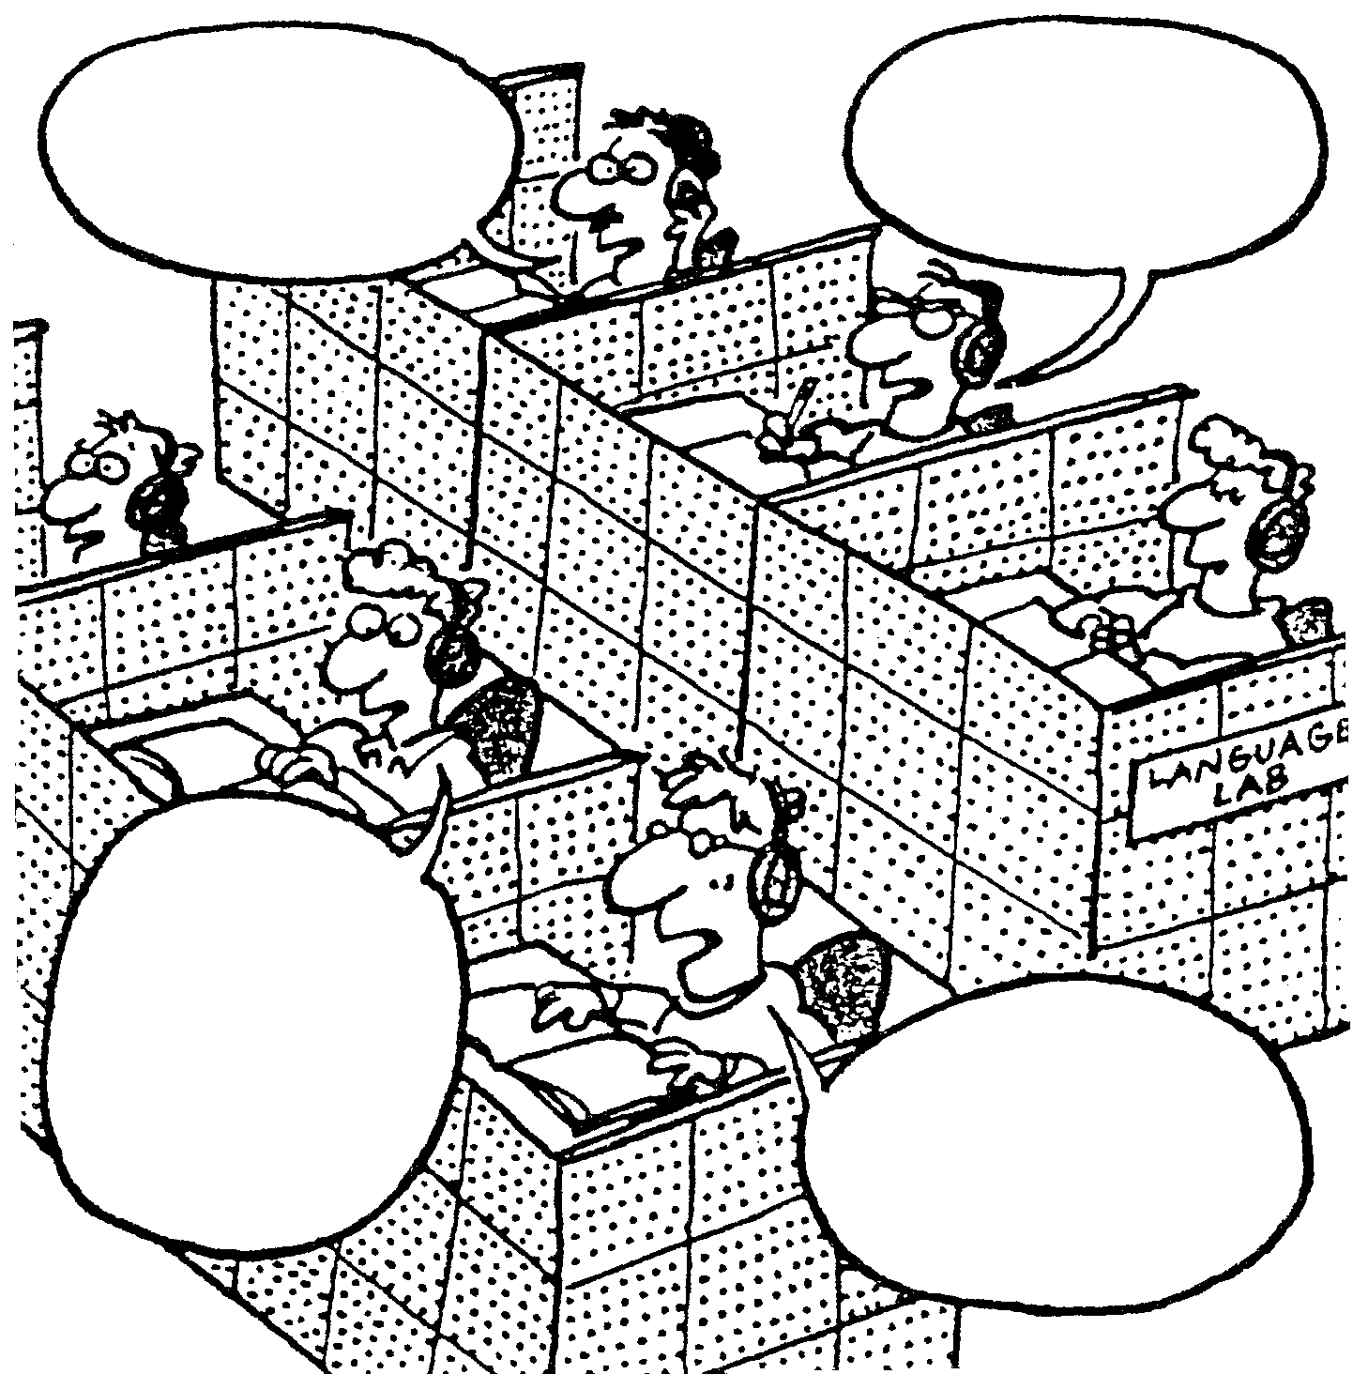
I adore you.
I love you.
Let’s do something romantic
I want to make a commit-
ment

MEN LEARN A FOREIGN LANGUAGE

5.1 What is the ‘foreign language’ being learnt in this cartoon? | (1)

5.2 In what way can this cartoon be considered satirical? | (3)

5.3 Why is the use of a high angle viewpoint effective in this cartoon? | (2)

CARTOON B

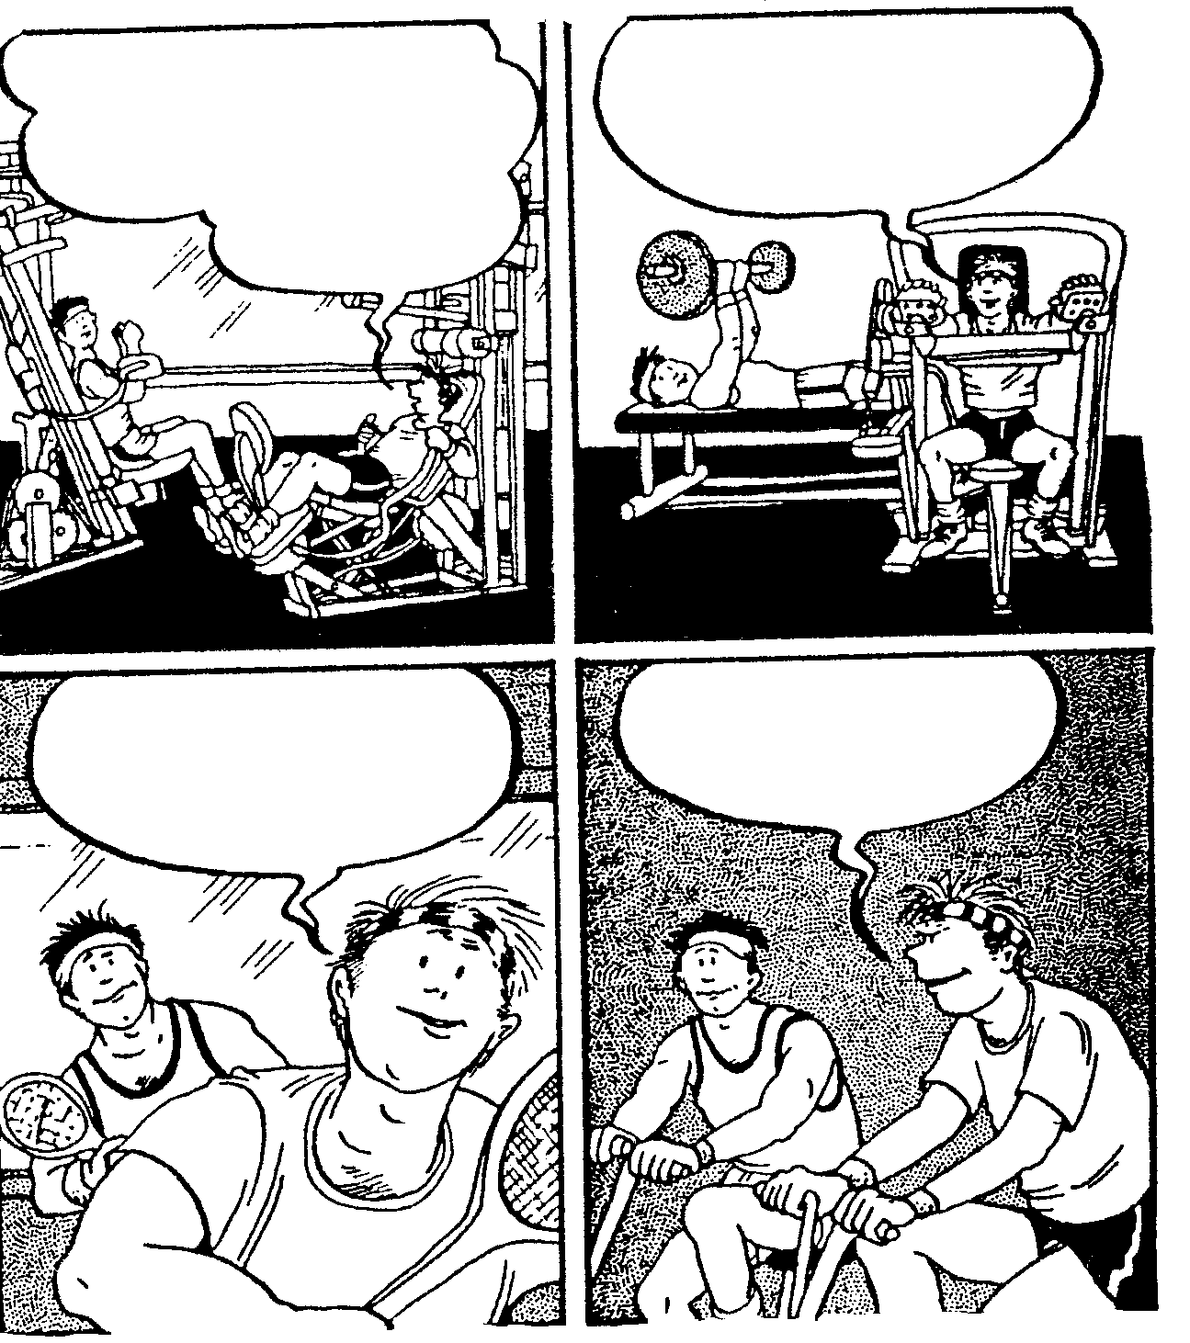
I’m a successful guy … I deserve a woman who’ll fit in with the rest of my things …
strictly top of
the line.
She’s got to look like she was born with a rolex on her wrist.
She should have exquisite taste and know how to spend money
…. and she has to love me for myself

5.4 What is the setting for this cartoon and how is it established? | (2)

5.5 Explain why this cartoon can be considered humorous. | (2)  [10]

QUESTION 6

ADVERTISING

In the outrageous
October issue of

sharper image
active mind
no worries
fine food
explosive sex
fitter body

The complete Men’s Health
kitchen guide
It’s a lot more than just beans on toast

well,
excuuuuussse me
Talk your way out of anything

the hernia files
Don’t lift anything before reading this

Pass the advanced sex test
Have lots of vitamin E handy

The last fat-burning
story you’ll ever need (well, for now)

Why arthritis attacks
young men

96 things you don’t do anymore,
but know you should

Men’s Health on the shelf 19 September
If you don’t get it, how can we save you?

Read the advertisement printed on page 12 and answer the questions below.

6.1 Carefully identify the target audience for this paper. | (2)

6.2 List THREE desires appealed to in this advertisement. Quote to justify your choices. | (3)

6.3 Account for the spelling of ‘excuse’ as ‘excuuuuusse’ in the advertisement. | (2)

6.4 Comment on the effectiveness of the rhetorical question at the end of this advertisement. | (2)

6.5 Would you classify this as a ‘hard sell’ or ‘soft sell’ advertisement? | (1)  [10]

TOTAL: | 100

