INSTRUCTIONS

NB: | This paper is divided into three sections: Section A, Section B and Section C.  Section A: Extended writing (40 marks)  Section B: Shorter piece of writing (20 marks)  Section C: Other shorter pieces of writing (20 marks)

1.  2.  3.  4.  5.  6.  7. | Candidates must answer ONE question from Section A, ONE question from Section B and ONE question comprising TWO parts from Section C.  Please read the instructions and questions carefully.  Candidates are advised to plan their answers.  ALL rough work should be crossed out.  Start each question on a new page.  Number the questions you choose as they appear on the question paper.  Do not use capital letters unless they are necessary.

SECTION A: EXTENDED WRITING

INSTRUCTIONS

- Spend about 60 minutes on this section.
- Write a composition of 250 – 300 words on ONE of the topics given below (for 40 marks).
- Number the questions you choose exactly as they appear on the question paper.
- You should give your composition a title if no title is supplied.
- It is advisable to draw up a brief plan before you write your composition.
- Neatly cross out all rough work.

QUESTION 1

Write an essay which includes the following line:  "And there he/she was … my worst nightmare had come true!"  (This line could be at the beginning, in the middle or at the end of your essay.)  Supply our OWN title. |  | (40)

OR

QUESTION 2

Study the following cartoon carefully. (The cartoon serves as a stimulus only.)  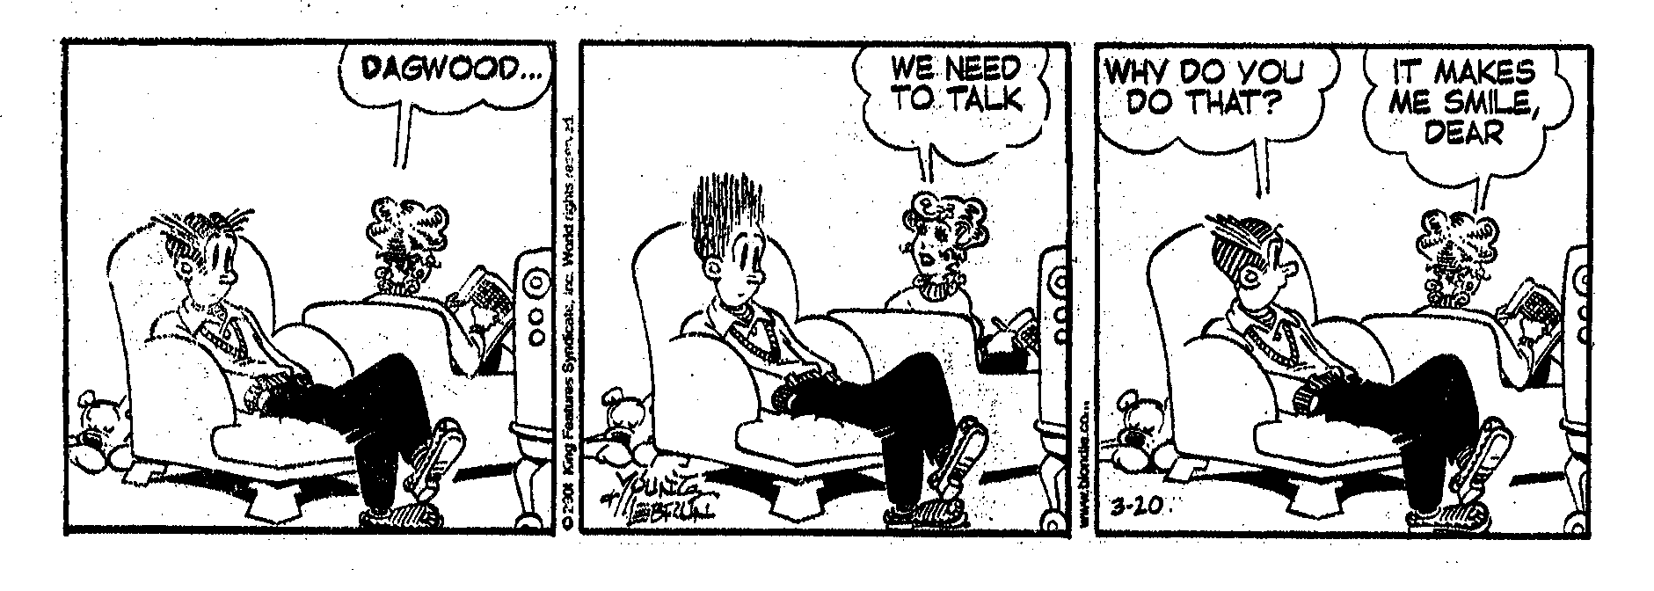  In a light-hearted essay, compare and contrast the ideas men and women have about the need for communication in a relationship or marriage.  Supply your OWN title. |  | (40)

OR

QUESTION 3

Write an essay entitled:  The advantages and disadvantages of being a single parent. |  | (40)

OR

QUESTION 4

BRING BACK THE DEATH PENALTY!

Many people in South Africa feel that the only way to discourage criminals from wilfully killing innocent people, is to bring back the death penalty.  Write an essay in which you air your views on the abolition of the death penalty.  Supply our OWN title. |  | (40)

OR

QUESTION 5

TO VOTE OR NOT TO VOTE?

Do you think it is important to vote?  Write an essay in which you discuss why people should or should not vote.  Supply your OWN title. |  | (40)

TOTAL SECTION A: |  | [40]

SECTION B: SHORTER PIECE OF WRITING

INSTRUCTIONS

- In this section THREE shorter pieces of writing are given. You must choose ONE question (for 20 marks).
- Spend about 30 minutes on this section.
- Write about 120 – 150 words.
- If you choose to write a letter, the address(es), salutation and ending will not be included in the allocated number of words.

QUESTION 6: SPEECH

You are a very successful and well-known business person or sportsman/-woman in South Africa. The high school where you matriculated has invited you to be the guest speaker at their annual prize-giving ceremony. They have asked you to bring a message of hope to the learners, showing them that, through hard work, they can become successful, no matter what their background is.  Write the speech you are going to deliver to them. |  | (20)

OR

QUESTION 7: TELEPHONE CONVERSATION

"Everything is fine now." You get up and slowly walk to the window after you have put down the receiver of the telephone. You stare unseeingly in front of you and think: "No, everything is not fine at all!"

Write down the telephone conversation that has just taken place between Angelina and yourself. The content of your conversation should indicate that you are quite upset.  BEGIN: Angelina: What is wrong? Why do you sound so miserable? |  | (20)

OR

QUESTION 8: LETTER TO THE EDITOR

Study the following cartoon carefully. (The cartoon serves as a stimulus only.)
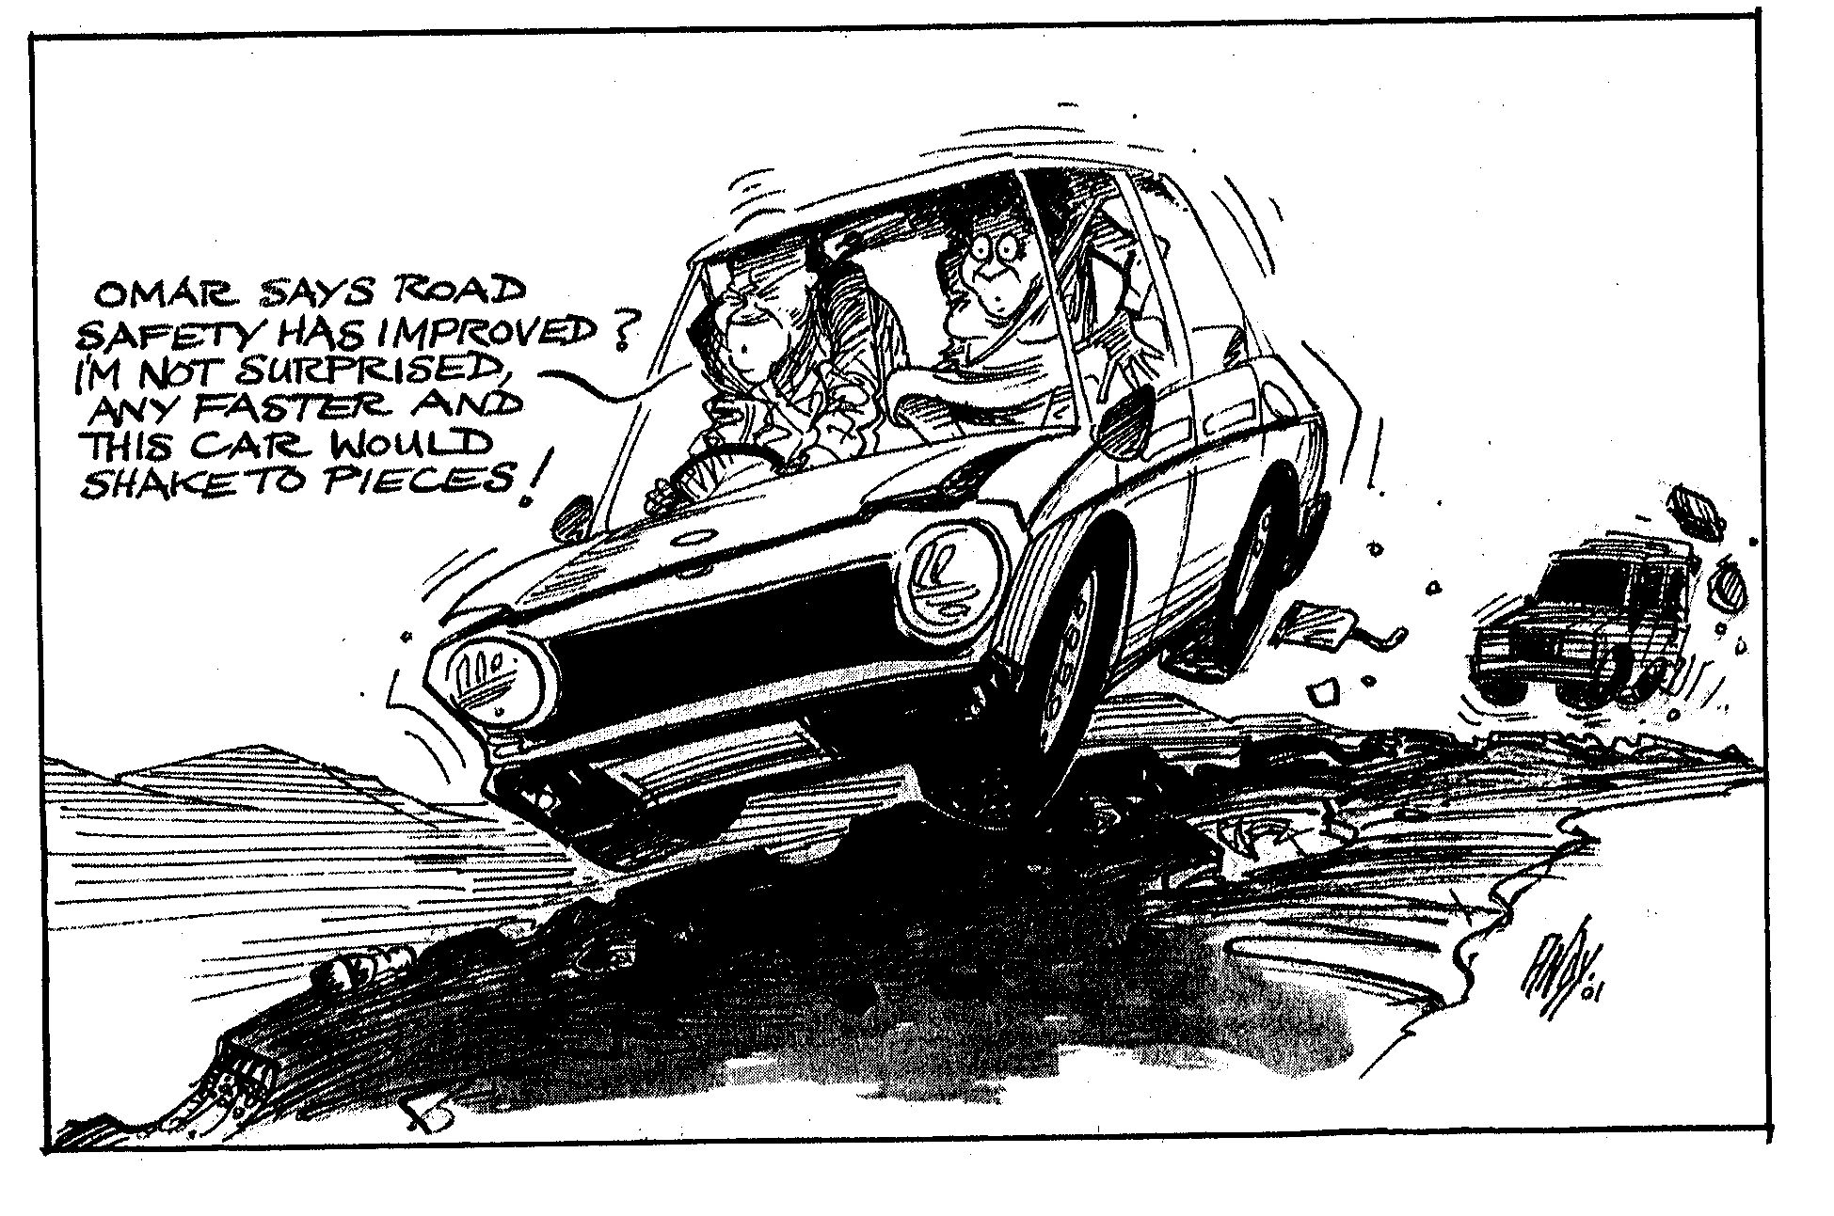

Write a letter to the editor of any South African newspaper in which you air your views on the condition of South African roads. Relate a personal experience to support your point of view. |  | (20)

TOTAL SECTION B: |  | [20]

SECTION C: OTHER SHORTER PIECES OF WRITING

INSTRUCTIONS

- In this section there are THREE questions.
- Choose ONE question but note that each question comprises two parts (totalling 20 marks).
- Spend about 30 minutes on this section.

QUESTION 9: COVERING LETTER AND CURRICULUM VITAE (CV)

Study the following job advertisement carefully:

HOTEL MANAGER – White River

Up-market hotel in White River, Mpumalanga, requires a manager for day-to-day running of hotel, including staff management and budgeting.
Experience of running small hotel/lodge essential. Salary negotiable.

Fax your covering letter and CV to Sue Brown at (011) 325-5057 as soon as possible.

You are interested in the advertised position above and have decided to apply.

9.1 | Write the covering letter that will accompany your CV. The letter should contain a brief motivation why you think you are the most suitable person for this post.  Length: 50 – 60 words  AND |  | (5)

9.2 | Write out the Curriculum Vitae (CV) that you will fax to Sue Brown.  Length: Approximately one page. |  | (15)  (20)

OR

QUESTION 10: NOTICE AND MINUTES OF A MEETING

Residents of a prime residential area are very concerned about the growing number of squatters in the area and the increasing number of crimes committed in the area. They have proposed that the squatters should be removed. However, the squatters feel that the ground was taken away from them 20 years ago and that it is rightfully theirs.
The parties decide on a meeting in which they will try and resolve the problem amicably (in a friendly manner).

You are the secretary of the Residents and Ratepayers' Association of this area:

10.1 | Write out the notice for this meeting, which will go out to all concerned. |  | (5)

AND

10.2 | Write out the minutes of the meeting which eventually took place. |  | (15)  (20)

OR

QUESTION 11: OBITUARY AND NOTE

An obituary is a brief biography placed in a newspaper after a person has passed away.

You have been asked by the family of a friend, who died unexpectedly, to write his/her obituary for the newspaper.

11.1 | Write the obituary for your local newspaper.  Length: 80 – 100 words |  | (15)

AND

11.2 | Write a short note to another friend, informing him/her of the funeral arrangements.  Length: 15 – 20 words |  | (5)  (20)

TOTAL SECTION C:  GRAND TOTAL: |  | [20]  80

