GAUTENG DEPARTMENT OF EDUCATION
SENIOR CERTIFICATE EXAMINATION

ENGLISH FIRST LANGUAGE SG
(First paper: Comprehension, Language and Writing)

TIME: 2½ hours

MARKS: 90

INSTRUCTIONS:

- This examination paper contains passages and questions on the subject of schooling and its related issues.
- The paper consists of TWO sections: Sections A and B.

SECTION A

Comprehension and Language

- Answer ALL the questions in this section.
- Use the mark allocation as a guide to the amount of detail required in your answers.
- Base your answers on the given passages only, unless you are instructed otherwise.
- Use your own words, unless you are instructed to quote.
- Number your answers exactly as the questions have been numbered, using the decimal system, e.g. 2.4.2.
- Number your answers in the centre of the page, e.g.

2.4.2

- Leave a line open after each answer. Rule off after each completed question.

SECTION B

Transactional Writing

- Answer ONE question in this section.
- Your response to the question should consist of approximately 150 words.
- Marks will be allocated to format, content and quality of writing.

SECTION A

COMPREHENSION AND LANGUAGE

QUESTION 1

Read the following passage and answer all the questions following it.

Alas, the School Bell Tolls for Me

Charlotte Bauer: Sunday Times (Edited)
- Next time someone rings the door bell looking for food/old clothes/train fair, I’ve got a piecejob for them covering school books.  - Of all the reccurring episodes that make up the life cycle of a suburban family, covering school books has to be the annual low point, beating even:  - Cooking for tartrazine tots whose likes and dislikes never coincide and who remain indifferent to lectures on how much their starving peers in Ethiopia would appreciate tuna bake;  - Enrolling for music lessons they give up before the piano’s paid off and when the only thing they can play is the theme tune to Titanic with two fingers; and  - Taking small children to birthday parties and having to stay and share homeopathic remedies for croup with other mothers while toddlers in Tele-Tubbies suits hit each other and fall off jungle gyms.  - A school-teacher friend who had the misfortune to call me in the thick of a  spine-cracking workout last week got short shrift.  - “Have you got a moment?” he asked.  - “No, I’m tied up,” I said, trying to unravel myself from a twisted mile of Sellotape that had me trapped like a bug on one of those disgusting fly papers that some people hang from their ceilings. “Why do you lot insist on books being covered? What’s the point?” | - Like a man explaining civilisation to a cannibal, he told me that covers protect books from wedges of Wicks and licks of Cream Soda.  - As importantly, he added, there is a philosophic angle on book covering that sees the hard work and glossy results as inspiring a sense of pride in one’s work and persuading young people to see books as things worth looking after.  - This, however, assumes two things: that A4 exam pads are worthy of such long-range coddling and that children do the covering themselves.  - Does my eight-year-old care that his father and I stayed up till 1 a.m. decorating exercise books with layers of giftwrap and plastic that either exploded when we tried to close the book because it was too tight or sagged at the edges?  - On the contrary, he complained that I’d bought the wrong kind of giftwrap and tried to make us do it over.  - By the time they’re in high school it’s worse because the brainwashing cycle is complete and they start doing it to be like everyone else. Any hope I might have had that surly adolescents would spit on the system’s attempts to control them vanished when my 14-year-old daughter not only covered her books in regulation two-ply paper ’n plastic, but spent hours embellishing them with teen-magazine slogans (“Zip yo’ Lip!”) and extravagant collages.

- A co-parent I called at 11 p.m. one night to see if she had any leftover labels said she’d covered her daughter’s books in old newspapers, thus fulfilling the stated mandate to protect them and saving loads of money in the process.  - Even I was shocked by such brazen revolt (and secretly envious I hadn’t thought of it first). But had she considered the consequences?  - As we speak I predict that she is writing out 200 times: “Never again shall I wilfully damage my daughter’s chances of being chosen to carry the teacher’s bags to the car, landing a speaking part in the school play or in any other way jeopardise her school career and have her wind up in remedial pottery.” | - As for wrapping lever arch files already coated in durable one-wipe plastic, what better evidence that school culture has a tendency to promote form at the expense of content?  - In its latest issue, The Teacher newspaper publishes some real answers to real questions from last year’s Grade 8 exams:  Q: What does the TRC stand for?  - The Red Cea;  - Tea and Recreation Centre; or  - That thing where if you speak the truth they will reconcile you with Tutu.  17. Hey, at least their books were covered.

READING FOR MEANING AND INTERPRETATION  - Explain precisely what the writer of the passage means when she speaks of a piecejob in paragraph 1.  - In point form (1.2.1 – 1.2.4), summarise FOUR of the writer’s intense dislikes as they are revealed to us in paragraph 2. You must use your own words as far as possible when answering this question. Each point should contain at least TWO facts.  - Charlotte Bauer’s school-teacher friend phoned her at an inconvenient moment.  1.3.1 Why was the moment inconvenient?  - Give one word of your own to describe her reaction to the friend’s call.  - Quote a phrase from paragraph 3 to support your answer to Question 1.3.2.  1.4 1.4.1 According to the teacher, there are three main reasons for insisting that children cover books. List these reasons, one under the other.  - The writer does not understand her friend’s reasons for the supposed importance of covering books. Write down two points from the passage which seem to contradict his reasoning. | (2)  (8)  (2)  (1)  (1)  (3)  (2)

1.5 Explain why the writer might reasonably have expected her teenage daughter to ‘spit on the system’s attempts to control’ her and why the daughter reacted as she did.  1.6 In paragraph 13, the writer uses the words brazen revolt. In this context the words brazen revolt mean:  A. shameless action B. insolent behaviour C. defiant reaction  Select and write down the letter which reflects the correct definition.  - Carefully read paragraph 14 again. According to the writer, how does the system of punishment and reward work in schools?  - In paragraph 15, Charlotte Bauer uses a rhetorical question.  This type of question does not require an answer as the answer is obvious and the question itself is making a specific point.  Explain how the writer uses this rhetorical question to criticise school culture.  1.9 A number of amusing answers to the questions from the Grade 8 exam paper are provided in paragraph 16. Give the correct explanation for the abbreviation TRC. | (4)  (1)  (2)  (3)  (1)

LANGUAGE ISSUES  1.10 There are two spelling errors in the passage, one in paragraph 1 and the other in paragraph 2. Rewrite the words, spelling them correctly.  1.11 1.11.1 Explain the writer’s use of the colon in paragraph 2.  - What type of word has been created by the use of a hyphen in the word school-teacher (paragraph 3)?  - For what purpose has Charlotte Bauer used the apostrophe in piano’s (paragraph 2)?  - Refer to paragraph 11. Here, the writer has correctly used the word it’s with an apostrophe. Write a sentence of your own in which you use the word its without an apostrophe. | (2)  (1)  (2)  (1)  (2)

1.12 1.12.1 I’m tied up (paragraph 5). Explain the literal and figurative meanings of this statement.  - To what does the writer compare herself in paragraph 6 and why is this comparison effective in this context?  1.13 Provide a synonym or phrase of similar meaning for the following words:  - annual (paragraph 2)  - indifferent (pararaph 2)  1.14 In each of the following sentences, select the correct pronoun from the words in brackets. Write down the correct word only.  - Between you and (me/I) I was shocked to see her books covered in newspaper.  - My friend and (me/I) disagreed on the issue of the importance of covering books.  1.15 Identify the predominant register used by Charlotte Bauer in this article. Select  one word from the following list and write down only the letter placed before it.  A. Colloquial B. Formal C. Jargon D. Slang | (4)  (3)  (1)  (1)  (1)  (1)  (1)  [50]

QUESTION 2
I HEAR THE SCHOOL TUCK SHOP IS UNDER NEW MANAGEMENT.



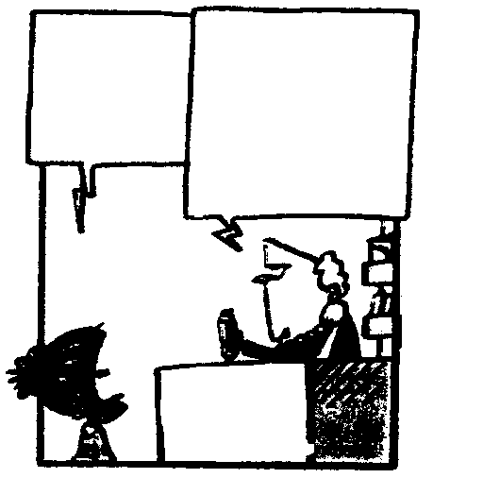

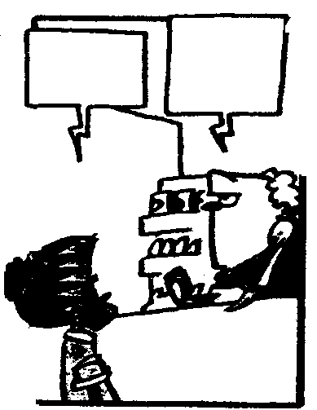

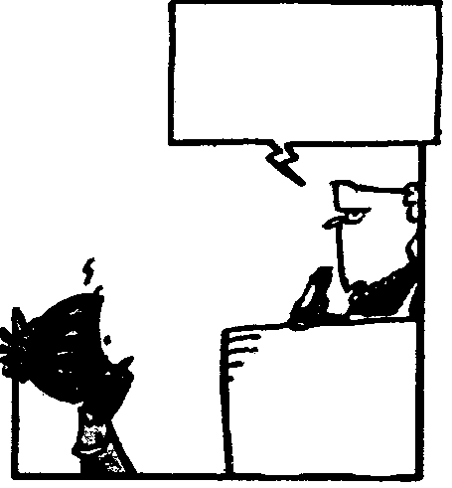

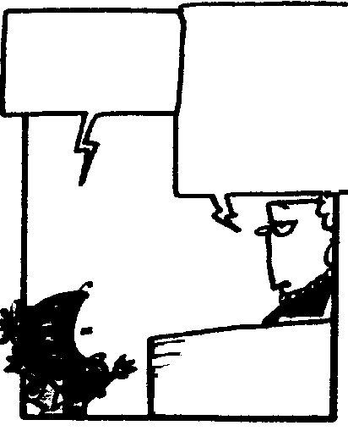

BY S. FRANCIS, H. DUGMORE & RICO
1
2
3
4
5
6

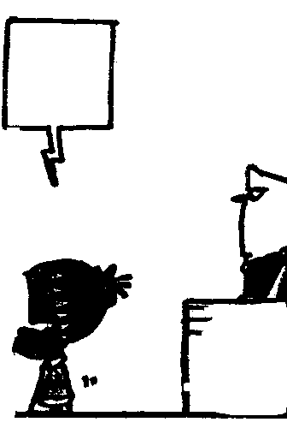

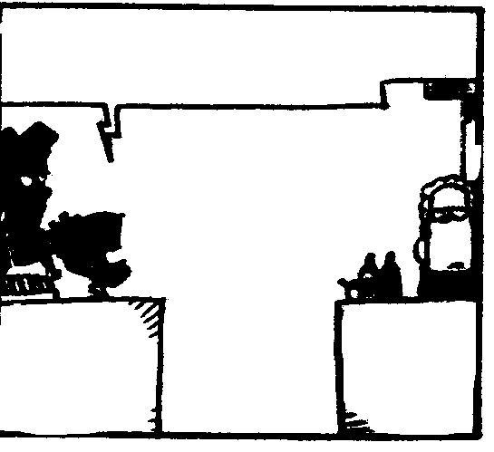
7
8
OKAY, I’LL HAVE A TOASTED CHEESE SANDWICH.
SORRY, TOASTED SANDWICHES ARE LOW PROFIT ITEMS. HOW ABOUT A NICE GOOEY CHOCOLATE BAR?
HOW MUCH?

EIGHT BUCKS
DON’T YOU HAVE ANY PRINCIPLES?!!
DON’T MENTION PRINCIPALS. I HAD TO PAY YOUR SCHOOL PRINCIPAL JUST TO GET THIS CONCESSION.

I’LL BE
BACK
NOTHING LIKE A LITTLE HEALTHY COMPETITION FOR A GOOD BUSINESS ENVIRONMENT
HONEST THANDI’S
TUCKSHOP
YOU’RE RUNNING THE SCHOOL TUCK-
SHOP?!!
I HEARD IT WAS AN EXCELLENT INVESTMENT OPPORTUNITY.
EIGHT BUCKS FOR A CHOCO-LATE BAR?!!
IT’S MY NEW PRICE STRUCTURE. I HAVE LOTS OF OVERHEADS

Study the cartoon below and answer the questions.

UNDERSTANDING THE CARTO`ON  - This cartoon, although humorous, has a serious message. Explain this message.  - Refer to frame 5. What is the cartoonist indicating by the use of large, dark print for Thandi’s words?  - Mention ONE feature of the drawings which clearly indicates each of the following:  2.3.1 Thandi’s anger at the situation presented  2.3.2 Her determination to change the situation | (2)  (2)  (1)  (1)

LANGUAGE IN ACTION  - In frame 6, humour is created by the use of homophones, i.e. principle and principal. These words sound the same but have completely different meanings.  Use the following words in two different simple sentences which illustrate the difference in meaning.  2.4.1 stationery  - stationary  - Rewrite the boy’s words in frame 1 in reported (indirect) speech. Begin your answer with the words “The boy told Thandi …” | (1)  (1)  (3)  [11]

QUESTION 3
Introducing a range of study aids for people who already know the facts. Intersoft’s range of books for experienced computer users is designed to help you improve your exam technique, and provide useful tips on how to pass your exams the first time round.

www.intersoft.co.za

Carefully study this simple advertisement and answer all the questions below it.



- Say which feature of this advertisement is the most eye-catching.  - Give THREE reasons why this feature catches the eye.  - Why might this feature be said to be giving the wrong impression of the actual product being advertised?  3.2 At which sector of the population is this advertisement aimed?  3.3 Mention TWO possible disadvantages of these products, considering those who might wish to purchase them.  TOTAL FOR SECTION A: | (1)  (3)  (2)  (1)  (2)  [9]  [70]

SECTION B

TRANSACTIONAL WRITING

Select ONE topic from this section.

Write approximately 150 words in response to one topic from this section. Should you choose to write a letter, the body of the letter excluding the salutation, address and conclusion should consist of approximately 150 words.

- The tuckshop at your school is run by a group of ladies who belong to the Mothers’ Communication Group. They have devoted much time to feeding the members of the school community, and at the same time they raise money which is spent on improving facilities at the school. Write a sincere letter of thanks to the chairperson of the group.

OR

- In passage 1 of this paper, we are made aware of a number of things which Charlotte Bauer really dislikes. Write an article (either serious or humorous) in which you discuss the things most disliked by teenagers. Your article is to be published in a magazine for young people.

OR

- Write a letter to the Advertising Standards Bureau in which you report on a misleading advertisement to which you responded and which has caused you embarrassment or a substantial financial loss. Address your letter to:

The Director
Public Relations
Advertising Standards Bureau
PO Box 80
JOHANNESBURG
2000

- As president of your school’s Learner Representative Council, you have been asked by the principal to prepare a report on a school rule which learners would like to see changed. You investigate the matter and write your formal report for the principal. Use the headings you have been taught.  OR  - You have just experienced the most successful day of your life. Write your diary entry, capturing the excitement you feel. | [20]

TOTAL FOR SECTION B:  TOTAL: | [20]  90

