GAUTENG DEPARTMENT OF EDUCATION
SENIOR CERTIFICATE EXAMINATION

ENGLISH FIRST LANGUAGE SG
(First Paper : Comprehension, Language and Writing)

TIME : 2 ½ hours

MARKS : 90

INSTRUCTIONS:

- This examination paper contains passages and questions on the subject of the problems and desires of the young.
- The paper consists of TWO sections : Sections A and B.

Section A : Comprehension and Language

- Answer ALL the questions in this section.
- Use the mark allocation as a guide to the amount of detail required in your answers.
- Base your answers on the given passages only, unless you are instructed otherwise.
- Use your own words, unless you are instructed to quote.
- Number your answers exactly as the questions have been numbered, using the decimal system, e.g. 2.4.2.
- Number your answers in the centre of the page, e.g.

2.4.2

- Leave a line open after each answer. Rule off after each completed question.

Section B : Transactional Writing

- Answer ONE question from this section.
- Your response to the question should consist of approximately 150 words.
- Marks will be allocated to format, content and quality of writing.

SECTION A

COMPREHENSION AND LANGUAGE

QUESTION 1

Read the following passage and answer all the questions.

Do Parents Know Their Kids?

Newsweek (adapted)

1. In survey after survey, many kids – even those on  the honour roll – say they feel increasingly alone and alienated, unable to connect with their parents, teachers and sometimes even classmates. They’re desperate for guidence, and when they don’t get what they need at home or in school, they cling to cliques or imerse themselves in a universe out of their parents’ reach; a world defined by computer games, TV and movies, where brutality is so common it has become mundane.  2. Many teens say they feel overwhelmed by pressure  and responsibilities. They are juggling part-time jobs and hours of homework every night; sometimes they’re so exhausted that they’re nearly asleep in early-morning classes. Half have lived through their parents’ divorce. Sixty-three percent are in households where both parents work outside the home and many look after younger siblings in the afternoon. Others are home by themselves after school. This unwelcome solitude can extend well into the evening; mealtime for this generation too often begins with a forlorn touch of the microwave.  3. In fact, of all the issues that trouble adolescents,  loneliness ranks at the top of the list. Loneliness  creates an emotional vacuum that is filled by an intense peer culture, a critical buffer against kids’ fear of isolation. Some of this bonding is normal and appropriate; in fact, studies have shown that the human need for acceptance is almost a biological drive, like hunger. It’s especially intense in early adolescence.  4. Dressing alike is a refuge, a way of hiding in the  group. When they’re 3 and scared, they cling to a security blanket; at 16, they want body piercings or Nike shirts.  - If parents and other adults abdicate power,  teenagers come up with their own rules. Bullying  has become so extreme and so common that many  teens just accept it as part of high-school life in the  90’s. |  | In the past, parents and teachers served as mediating forces in the classroom jungle.  6 When they’re isolated from parents, teens are also  more vulnerable to serious emotional problems. Even the best, most caring parents can’t protect their teenagers from all these problems, but involved parents can make an enormous difference.  7 In the teenage years, the relationship between parents  and children is constantly evolving as the kids edge towards independence. Early adolescence is a period of transition, when middle-school kids move from one teacher and one classroom to a different teacher for each subject. In puberty, they’re moody and irritable.  8 In middle adolescence, roughly in the first three years  of high school, teens are increasingly on their own. To a large degree, their lives revolve around school and their friends.  9 Late adolescence is another transition, this time to  leaving home altogether. Contrary to stereotypes, it isn’t mothers who are most likely to mourn in the empty nest. They’re often relieved to be free of some chores. It appears, however, that fathers suffer from thoughts of missed chances.  10 Parents need to share what they really believe in, what  they really think is important. These basic moral values are more important than maths skills or grades. Seize any opportunity to talk – in the car, over the breakfast table, watching TV. Parents have to work harder to get their points across. Ellen Galinsky, president of the Families and Work institute, has studied teenagers’ view of parents. One 16-year-old told us, “I am proud of the fact that my mother deals with me even though I try to push her away. She’s still there.” So pay attention now. The kids can’t wait.

READING FOR MEANING AND INTERPRETATION  - Refer to paragraph 1.  1.1.1 According to the writer of this article, how do teenagers occupy themselves when they feel that their parents and the school have failed them?  - By placing the words even those on the honour roll between dashes, the writer clearly wishes to make a specific point about unhappy teenagers. In your own words, explain the point which is being made.  - Some of the activities which occupy these teenagers may have a negative effect on them. Describe this negative effect. (Paragraph 5 may also give you a clue.) | (4)  (2)  (2)

1.2 It appears that present day teenagers are subject to pressures unknown to teenagers of previous generations. List FOUR of these pressures which are outlined in paragraph 2.  1.3 In paragraph 3, the writer mentions an intense peer culture.  - What single factor is the most important in creating the need for this peer culture?  - Mention TWO ways, according to the passage, in which teenagers are influenced by their peers.  1.4 In paragraphs 7, 8 and 9 the writer illustrates the different stages of adolescence by describing certain characteristics which are common to each stage. Select ONE characteristic from each stage and write it down as follows:  - Early adolescence –  - Middle adolescence –  - Late adolescence – | (4)  (1)  (2)  (3)

1.5 Study the following dictionary entry for the word STEREOTYPE
(paragraph 9):
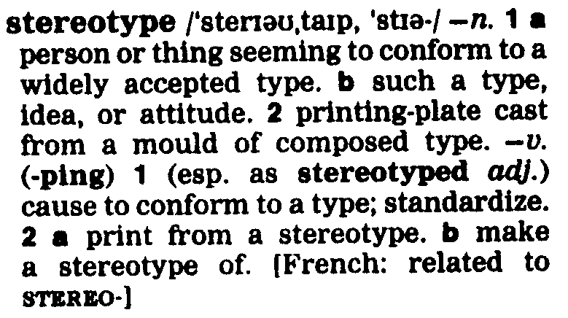

- Using the dictionary entry, provide the best definition of the word as it is used in the passage.  - In your own words, explain the stereotyped and clichéd idea of the mother mourning in the empty nest.  - According to the passage, the father often suffers more when the children leave home. Explain why this is so. | (2)  (2)  (2)

1.6 From paragraph 10, write down FOUR points which could be used as advice to parents who wish to communicate successfully with their teenagers. | (4)

LANGUAGE ISSUES  1.7 From the passage, select and write down the words which are closest in meaning to the following words or phrases:  - an exclusive set of associates  - renounce, give up  1.8 There are TWO spelling errors in paragraph 1. Correct these errors.  1.9 Refer to paragraph 2.  - They are juggling part-time jobs. Besides the creation of a compound word, suggest another reason why it is necessary to use a hyphen in the word part-time.  - In the third sentence of this paragraph, the apostrophe has been used in the phrase their parents’ divorce. For what specific purpose has the apostrophe been used here?  - There is an obvious difference between the word parents’ and the word parent’s because of the position of the apostrophe. Construct a sentence of your own in which you use the word parent’s correctly. | (2)  (2)  (2)  (2)  (2)

1.10 Re-read paragraph 2, paying attention to the word unwelcome. In this word, the prefix has the clear meaning of NOT, illustrating that the word unwelcome means NOT welcome. From the list below, select two words in which the prefix IN has been used for the same purpose as in the example above.

- insensitive
- initiative
- intentional
D. inactive

Write down only the letters representing the correct words. | (2)

1.11  - Identify the figure of speech which has been used in the last line of paragraph 5.  - What is the writer suggesting by using this comparison? | (1)  (2)

1.12  - As what part of speech has the word revolve been used in  paragraph 8?  - Alter the form of the word revolve and use it as an adjective (in participial form) in a sentence of your own. | (1)  (2)  [46]

QUESTION 2

Study the cartoon below and answer all the questions.

Hi, Eric, what are you doing home? How’s everything at university?
We’ve won, Mom. The Struggle’s over.
The Government of National Unity is finally a reality! No more protests and demon-strations! No more tear gas! No more riots and boycotts!
Rebel without a cause.
I’m so depressed!
He’s having trouble ad-justing to university life in the New South Africa
What’s wrong with Eric?
It’s so boring without the struggle! No more demonstrations! No more protests! Why, there’s nothing left to do at University now, except … except …
… go to class!
One step at a time, Mom. I’ve got to take this slow.
… and study.
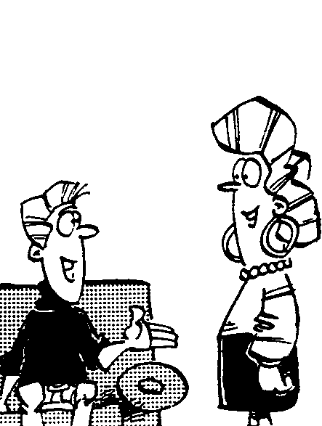
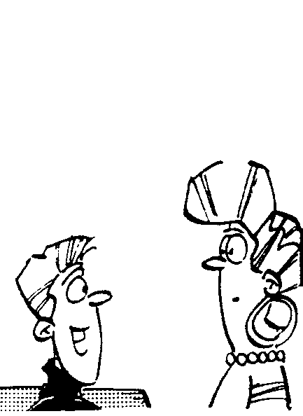
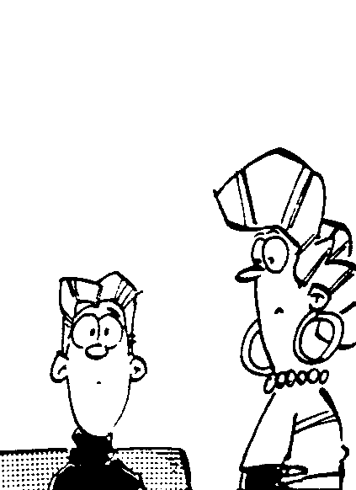
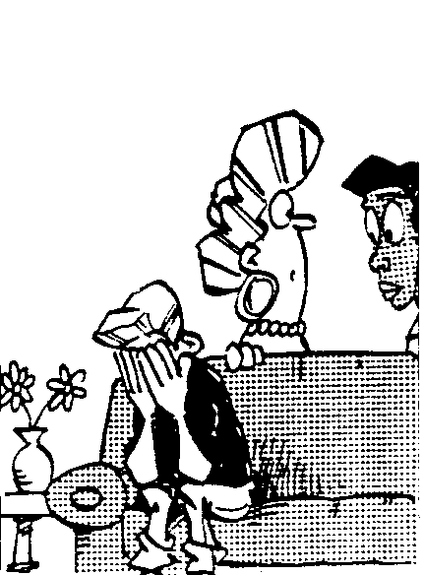
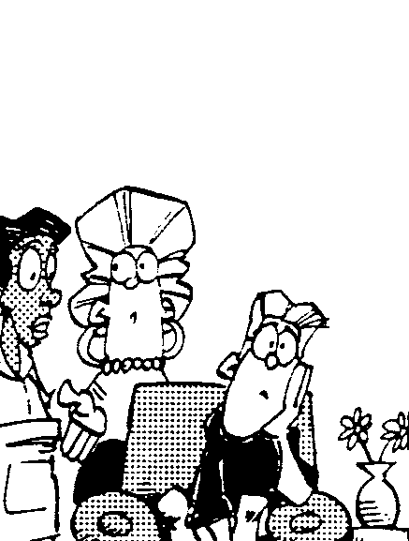
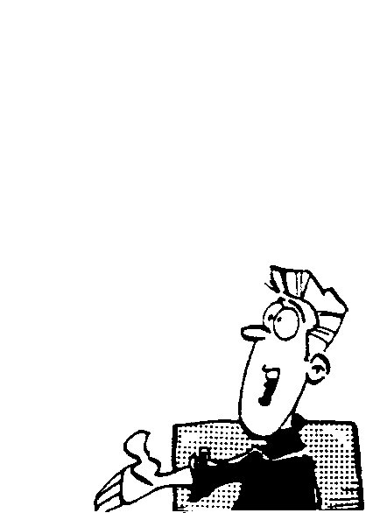
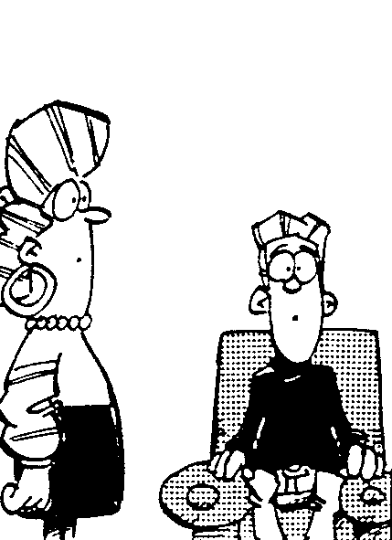
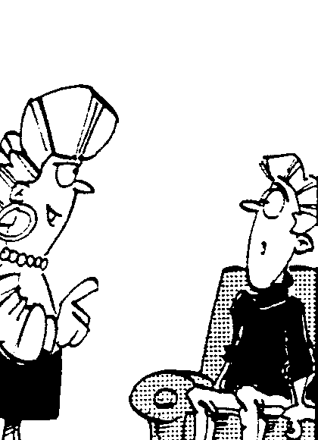
1
2
3
4
5
6
7
8

UNDERSTANDING THE CARTOON  - Gwen Anderson (Madam) and her son, Eric, obviously have very different views on the important aspects of university life.  2.1.1 Which aspect is important to Eric?  2.1.2 According to Madam, why does one attend university? | (1)  (1)

2.2  - Why is Eric depressed (frame 4)?  - Mention TWO features of the drawings which clearly illustrate his depression. Body language should be taken into account when answering this question. | (2)  (2)

2.3 Explain the humour which is created by Eric’s words in frames 6, 7 and 8. | (2)

LANGUAGE IN ACTION  2.4 Rewrite Eric’s words in frame 1 in reported speech. Begin your answer with “Eric told his mom …”  - Eric has made a grammatical error in his statement in frame 8 as he has used the incorrect form of an adverb. Give the correct form of the adverb. You need only write the word. | (3)  (1)  [12]

QUESTION 3

Study the advertisement below and answer the questions.

BRAD

Lambrecht and his

PIT

Bull, Spike,

SNAPPED
IN HIS
SOHO!
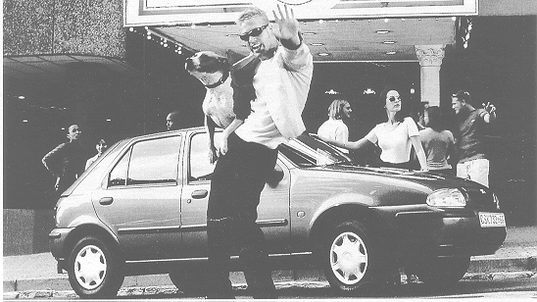

Considering all those unexpected luxury features, and that performance-wise it has some
real bite – is it any wonder why the in-crowd are seen in a Soho?



- What is the main device which has been used to attract the consumer into buying a Soho?  3.2  - To whom is this advertisement likely to appeal?  - Explain how the photograph reinforces your answer to Question 3.2.1.  3.3  - Consumers are always advised to read the small print. What effect does the small print between the large print above the photograph have in adding to the success of this advertisement?  - Advertising often appeals to our desire to be part of a particular group or to have a certain image. Quote one phrase from the small print below the photograph to illustrate how the advertiser attempts to manipulate the potential buyer into succumbing to his strategy. | (1)  (2)  (2)  (2)  (1)

3.4 Mention TWO other features of the car which are likely to appeal to the consumer.  3.5 Explain the play on words at the bottom of the advertisement.  TOTAL FOR SECTION A: | (2)  (2)  [12]  [70]

SECTION B

TRANSACTIONAL WRITING

Select ONE topic from this section.

Write approximately 150 words in response to one topic from this section. Should you choose to write a letter, the body of the letter, excluding the salutation, address and conclusion should consist of approximately 150 words.

- Lately you have not been able to communicate with your parents at all. Your best friend has moved to Cape Town so now you feel you have no one to talk to. Write a letter to your friend in Cape Town, explaining your problems.

OR

5. The annual ‘Youth Day’ celebration is approaching and your principal has invited the Mayor of the town / city to your assembly. You have been selected to address the assembly on the topic ‘What The Youth Can Do For The Community’. Write the speech you will deliver on this occasion.

OR

6. Write a magazine article (either serious or humorous) entitled “Do Kids Know Their Parents?” Your article is to be published in a family magazine.

OR

7. Corporal punishment (any form of physical punishment, including caning, punching, pulling hair etc.) to enforce discipline is a controversial issue in South Africa, as it is in many other countries. Write a letter to the editor of the Daily Sun in which you express your views on this form of punishment.

OR

8. You recently purchased a famous name brand T-shirt from a popular department store. The shirt was expensive but shrank when you washed it. The credit officer of the store refused to allow you to exchange the shirt and would not give you a refund. Write a letter of complaint to the manager of the department store.

TOTAL FOR SECTION B:  TOTAL: | [20]  90

