GAUTENG DEPARTMENT OF EDUCATION

SENIOR CERTIFICATE EXAMINATION

ENGLISH FIRST LANGUAGE HG
(Second Paper: Comprehension, Language and Writing)

TIME: 3 hours

MARKS: 160
INSTRUCTIONS:

Your examination today is based on THE IMPACT OF NEW TECHNOLOGY.

The paper consists of SIx questions.
It is suggested that you spend 10 minutes reading through the entire paper. You should set aside at least 50 minutes for Question 5 and Question 6, to ensure you complete the paper in time.

PLEASE NOTE:
- Keep your answers brief. Pay attention to the mark allocation in determining the length of your answers.
- Use your own words, unless asked to quote.
- Number the questions in the centre of the page.
- Write only the letter in response to multiple choice questions e.g. 1.2 – B.
- Use the same numbering as in the question paper.
- Leave a line open after answers.
- Rule off after each completed question.

QUESTION 1

Carefully read TEXT ONE and answer the questions which follow.

TEXT ONE: THE HISTORY OF THE INTERNET
(1) The Internet evolved from a computer system built 25 years ago by the US Defence Department to enable academic and military researchers to continue to do government work even if part of the network were taken out in a nuclear attack. It eventually linked universities, government facilities and corporations around the world, and they all shared the costs and technical work of running the system.  (2) The scientists who were given free Internet access quickly discovered that the network was good for more than official business. They used it to send each other private messages (e-mail) and to post news and information on public electronic bulletin boards (known as Usenet newsgroups). Over the years the Internet became a favourite haunt of graduate students and computer hackers, who loved nothing better than to stay up all night exploring its weblike connections and devising interesting things for people to do. They constructed tools for navigating the Net – like the University of Minnesota’s Gopher, which makes it easy for Internet explorers to tunnel from one place on the network to another. Or like the programs whimsically named Archie, Jughead and Veronica (after the comicstrip characters), which allow users to locate a particular word or program from vast libraries of data available to Net users. More and more news groups | were added, until the bulletin board system had grown into a dense tangle of discussion topics with bizarre computer-coded titles.  (3) Until quite recently it was painfully difficult for ordinary computer users to reach the Internet. Not only did they need a PC, a modem to connect it to the phone line and a passing familiarity with something called UNIX, but they could get on only with the co-operation of a university or government research lab.  (4) Now, most of these impediments have disappeared. There are now dozens of small businesses that will sell access to the Net in the US starting at $10 to $30 a month. But with floods of new arrivals have come new issues and conflicts. To withstand a nuclear blast and keep on ticking, the Net was built without a central command authority. That means that nobody owns it, nobody runs it, nobody has the power to kick anyone off for good. There isn’t even a master switch that can shut it down in case of an emergency. “It’s the closest thing to true anarchy that ever existed,” says Clifford Stoll, a Berkeley astronomer famous on the Internet for having trapped a German spy who was trying to use it to break into US military computers.  P. Elmer-Dewitt, adapted from TIME Magazine

- Refer to Paragraph 1.  In your own words, explain the original purpose of the Internet.  - “Taken out” in Paragraph 1 is an example of EUPHEMISTIC language.  - Explain the meaning of “to take out” in this context.  - Provide a possible reason for the writer’s avoidance of a more DIRECT phrase in this instance.  - The following are possible functions of the parentheses (brackets) in Paragraph 2:  - to offer a satirical aside.  - to include current computer terminology.  - to provide additional but unnecessary information.  - to condescend to the non-technical reader.  - The first use of parenthesis in Paragraph 2 is “(e-mail)”.  Which of the above would BEST fit its function?  - Would your answer above be the same for the second use of parenthesis  in this paragraph: “(after the comic-strip characters)”? Explain. | (3)  (2)  (2)  (1)  (2)

- Refer to Paragraph 2.  Offer a brief definition of the underlined word, “haunt”, from its context.  - “Data”, also used in paragraph 2, is an example of an unusual PLURAL. Give the SINGULAR form of this word.  - Explain how the words “navigate”, “weblike” and “tunnel” are used in  Paragraph 2. Discuss how these words have appropriate connotations in this context.  - From Paragraph 3, name TWO requirements an ordinary person has to meet in order to use the Internet.  - Refer to the quotation below.  … nobody owns it, nobody runs it, nobody has the power to kick anyone off for good. (Paragraph 4)  - What is the writer emphasising here?  - How does the writer achieve this effect?  - 1.9.1 “It’s the closest thing to anarchy that ever existed”  This use of inverted commas, quoted from Paragraph 4, indicates  - direct quotation of someone else’s words.  - uneasy use of informal English.  - the writer is unsure of his facts.  - the writer disagrees with these words.  - This use of inverted commas is a journalistic technique intended  - to pin the blame on someone else.  - to appeal to a renowned authority.  - to disassociate the writer from his/her source.  - to unwillingly promote an unsavoury idea.  - The Internet has caused the entry of new terms into the English language.  - Such terms are often labelled jargon.  What is meant by this word?  - Explain why the growth of new technology demands the introduction of new terms.  - Write down ONE example of computer jargon from the passage.  - Is this article written in a neutral or biased manner? QUOTE from the passage to substantiate your choice. | (2)  (1)  (6)  (2)  (2)  (2)  (2)  (2)  (2)  (2)  (1)  (4)  [38]

QUESTION 2

Carefully read TEXT TWO and answer the questions that follow.

TEXT TWO: IS THE BOOK AT DEATH’S DOOR?
(1) An office-party atmosphere pervaded the headquarters of Wired magazine. Wired is the oracle of the computer-literate generation. When I had first called Wired’s co-founder, Louis Rosetto, I got through to him immediately. Later I had to go through a secretary and a publicist for an interview. The information highway had become a hot subject.  (2) What I wanted was his opinion on where the rise of the computer culture would end. With the elimination by CD-ROMs and networked computer databases of books? Of the hardcover, the paperback and the world of libraries and literate culture that had grown up alongside them? Was print on its way out?  (3) He set out his vision of a fast-changing computerised paperless, nearly book-free society, and did so with a certainty that would frighten almost anyone. "The changes going on in the world now are literally a revolution in progress, a revolution that makes political revolution seem like a game,” Rosetto said. “It will revolutionise how people work, how they communicate, and how they entertain themselves, and it is the biggest engine for change in our world today. In some ways what is happening today online is a return to our earlier oral tradition. In other ways, it is utterly new, a direct connection of minds.”  (4) Look at the book without sentiment and its limitations are evident: books can excite the imagination, but they can’t make us see and hear. “What’s the use of a book without pictures or conversations?” Lewis Carroll’s Alice grouses, before tumbling down the rabbit hole into the more absorbing precincts of Wonderland. One view is that the book will become the equivalent of the horse after the invention of the automobile or the phonograph | after the invention of compact disc – a thing for eccentrics and historians. It will not disappear, but it will become obsolete.  (5) But there is another side to the story. Even the computer industry acknowledges that what most readers think of as books – that is, novels and non-fiction text – gain nothing from being on screen; the appeal of the product depends upon the quality of the prose, and the research, neither of which are enhanced by current screens.  (6) The book has great advantages over the computer: it’s light and it’s cheap. That it has changed little in 400 years suggests an uncommonly apt design. John Updike says: “It seems to me the book has not just aesthetic values – the charming little clothy box of the thing, the smell of the glue, even the print, which has its own beauty. But there’s something about the sensation of ink on paper that is in some sense a thing, a phenomenon. Words on the screen give the sense of being just another passing electronic wiggle.”  (7) You can drop a book in the bathtub, dry it out on the radiator, and still read it. You can put it in the attic, pull it out 200 years later, and probably decipher the words. You can curl up in bed with it or get suntan lotion on it. These are definitely not possibilities suggested by the computer.  (8) However much dictionaries and encyclopaedias might be superseded, a well-thumbed paperback blowing in a beach breeze represents a technological stranglehold the computer may never invade.  DT MAX, adapted from the Weekly Mail and Guardian.

- Describe the “atmosphere” suggested by the term “office-party” in line 1.  - “Office-party” is an example of  - a compound noun.  - a compound adjective.  - a gerund.  - a clause. | (2)  (2)

- The word “oracle” in Paragraph 1 means both “seer of the future” and “speaker of the truth”.  - What does this suggest about the magazine Wired?  - How does your answer to question 2.2.1 explain the writer’s decision to interview Louis Rosetto?  - The word “hot” is used figuratively at the end of Paragraph 1.  - Give the word’s meaning in this context.  - Would this be an example of colloquial language? Explain fully.  - Paragraph 2 lists the writer’s concerns.  Briefly outline how they relate to the headline.  - Comment on how the use of questions in this paragraph gives the reader an insight into the writer’s emotional state.  - Name the main limitations of a printed book (paragraph 4).  - In Paragraph 4 a literary allusion is made.  - What is meant by the term ‘allusion’?  - Write down and explain the allusion in paragraph 4.  - In Paragraph 4 it is stated that books will become “obsolete”.  - Carefully discuss the meaning of this word.  - Why would an “eccentric” still value a book?  - Refer to Paragraph 5.  - This paragraph does not begin with conventional grammatical correctness.  Explain WHY the writer has chosen to open the paragraph in this way.  - There is an error of concord in Paragraph 5.  Correct the error and give a reason for your change.  - What is meant by “the quality of the prose”?  - Refer to Paragraph 6.  Updike suggests his love of books through EMOTIVE language.  Write down and discuss the effect of THREE emotive terms he uses.  2.11 2.11.1 In which person does the writer address the reader in Paragraph 7  - first  - second  - third  - none of the above?  - Explain why the writer has chosen this form of address.  - Why is the word “may” used, rather than “will” or “can”, in the final line of the article? | (2)  (2)  (2)  (3)  (2)  (2)  (2)  (2)  (2)  (2)  (2)  (2)  (3)  (2)  (6)  (1)  (2)  (2)  [45]

QUESTION 3
SUMMARY

  - POINT FORM SUMMARY
Both TEXT ONE and TEXT TWO are concerned with the way the INTERNET is GROWING and in doing so is changing people’s lives.
Copy out the table below and complete the information, using the text and paragraph references given.

GROWTH AND IMPACT OF THE INTERNET
POINT NUMBER | PARAGRAPH NUMBER | SUMMARY
Growth of the Internet
 | Refer to TEXT ONE
1 | 1
2 | 1
3 | 2
4 | 2
5 | 2
6 | 4
Impact of the Internet
 | Refer to TEXT TWO
7 | 3
8 | 3
9 | 3
10 | 3
Write in POINT FORM and use only one line per point. (10)

- FORMAL SUMMARY  Write a formal summary in two brief paragraphs, in no more than 100 words, in which you link the 10 points listed in Question 3.1 above.  N.B. Here you are being evaluated more for the QUALITY of your writing than on the factual content.  - Give your summary an appropriate title (This will NOT be included in your word count).  - Do not use subheadings.  - Write in fluent, connected sentences.  - Use your own words BUT do not add your own ideas or views.  - In ink, write in brackets at the end of your summary, the exact number of words used. Dishonesty will be penalised. | (10)  [20]

QUESTION 4
A
book
A Boog?
A Bog? Bok?
Boork?
Grunt!

A.
B.
C.

A
book
A
book
A
book
?

Carefully examine the cartoons below and answer the questions that follow them.

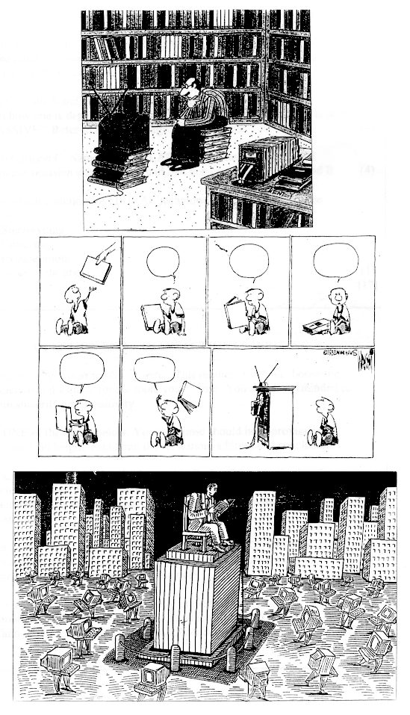

- Cartoon A criticises society. What is criticised here?  - The humour in Cartoon A is derived from IRONY. Explain this statement.  - Cartoon A consists of a single panel. Cartoon B takes seven panels to make the same point. In your opinion, which one is more effective in getting its message across? Give reasons for your answer.  - In both Cartoon A and B the characters watch television.  Explain how one is depicted as an “ACTIVE” viewer while the other is seen as “passive”. Refer to body language in your answer.  - Refer to Cartoon C. Name one SIMILARITY and one DIFFERENCE between the situation depicted here and that depicted in cartoons A and B.  - Choose which common SATIRICAL technique is common to all three cartoons:  - Stereotyping  - Criticism  - Exaggeration  - None of the above.  QUESTION 5  TRANSACTIONAL WRITING  Here you are asked to write a letter. This requires that you choose the correct diction and format for the topic you select. You are also reminded to write with sincerity and sensitivity.  Choose ONE of the topics below. Your response should be approximately  150 – 200 words in length, excluding the salutation, address and conclusion.  - Write a FORMAL letter to the Governing Body of your institution, in which you request that computer facilities be upgraded/made available to facilitate the needs of learners. You should be convincing but not demanding.  OR  - Write a letter to the EDITOR of Wired magazine (TEXT TWO) in which you agree OR disagree with his views of a future society as described in Paragraph 3 of the article.  or  - A new radio OR television programme has recently impressed you. Write a letter to a friend in which you try to persuade her/him to put it on her/his list of recommended programmes. | (2)  (3)  (3)  (4)  (4)  (1)  [17]  (20)  (20)  (20)  [20]

QUESTION 6  FURTHER TRANSACTIONAL WRITING  This question requires you to communicate with a wider audience. Each topic requires you to select the correct format and the appropriate register and style.  Choose ONE of the topics below. Your response should be approximately  150 – 200 words in length.  - Write a brief magazine article in which you stress the ADVANTAGES of books. You may make mention of the points made in the last THREE paragraphs of TEXT TWO.  OR  - Many people are not computer literate and perhaps fear new technology. Write a light-hearted guide, introducing the topic in a non-technical manner.  OR  - You have been requested to write an advertisement for a new training college, which specialises in computer-related fields. Using the media skills you have been taught, create a name for the college, as well as a heading which will attract readers’ interest. In your advertisement, clearly outline the aims of the college and explain why someone should enrol there.  TOTAL : | (20)  (20)  (20)  [20]  160

