GAUTENG DEPARTMENT OF EDUCATION

SENIOR CERTIFICATE EXAMINATION

ENGLISH SECOND LANGUAGE SG
(Second Paper: Literature)

TIME: 2 hours

MARKS: 80
INSTRUCTIONS:

- Write all answers in the answer book provided. This includes multiple-choice answers which require the question number followed by a letter (A, B, C or D) or a word.

- Number your answers clearly, using the same numbering as the question paper.

- Write neatly and clearly.

- Do not quote unless asked to do so. Use your own words.

- You must answer TWO sections only. Answer ONE question from each section of your choice.

- Answer all the questions on the two set-works you have studied.

TABLE OF CONTENTS

SECTION A

POETRY

QUESTION 1: Poems taken from:  THE WIND AT DAWN – An Anthology of poems edited by  S. Smith and V. Swacina  NEW INSCAPES – Compiled by R. Malan  THE WILD WAVE – Compiled by Houghton-Hawksley and ABS Eaton | page 4

SECTION B

NOVEL

QUESTION 2: MARU by Bessie Head | page 7

SECTION C
DRAMA

Answer Question 3 OR Question 4.

QUESTION 3: | JULIUS CAESAR by W. Shakespeare | page 10

OR

QUESTION 4: | MACBETH by W. Shakespeare | page 13

SECTION D
SHORT STORIES

Answer Question 5 OR Question 6.

QUESTION 5: | FOCUS – a collection of short stories compiled by R. Meyer | page 16

OR

QUESTION 6: | STORIES SOUTH AFRICAN compiled by A. Lennox-Short | page 18

SECTION A
POETRY

QUESTION 1

Read the TWO poems that follow and answer the questions based on each.

The Unknown Citizen  (To JS/07/M/378  This Marble Monument Is Erected by the State)  He was found by the Bureau of Statistics to be  One against whom there was no official complaint,  And all the reports on his conduct agree  That, in the modern sense of an old-fashioned word, he was a saint,  For in everything he did he served the Greater Community  Except for the War till the day he retired  He worked in a factory and never got fired,  But satisfied his employers, Fudge Motors Inc.  Yet he wasn’t a scab or odd in his views,  For his Union reports that he paid his dues,  (Our report on his Union shows it was sound)  And our Social Psychology workers found  That he was popular with his mates and liked a drink.  The Press are convinced that he bought a paper every day  And that his reactions to advertisements were normal in every way.  Policies taken out in his name prove that he was fully insured,  And his Health-card shows he was once in hospital but left it cured.  Both Producers Research and High-Grade Living declare  He was fully sensible to the advantages of the Instalment Plan  And had everything necessary to the Modern Man,  A phonograph, a radio, a car and a frigidaire.  Our researchers into Public Opinion are content  That he held the proper opinions for the time of year;  When there was peace, he was for peace, when there was war; he went.  He was married and added five children to the population,  Which our Eugenist says was the right number for a parent of his generation,  And our teachers report that he never interfered with their  education.  Was he free? Was he happy? The question is absurd:  Had anything been wrong, we should certainly have heard.  W.H. Auden | 5  10  15  20  25  30

- What is the usual reason why monuments are erected by the state?  - Why is this citizen unknown? | (2)  (2)

- Give TWO reasons why you find the inscription on the pedestal cold and impersonal. | (2)

- ‘Fudge Motors Inc.’ (line 8)  - ‘To fudge’, according to the Pocket Oxford, means to patch up in a dishonest way. Choose the correct word from the two in brackets in the following sentence and write it down.  The citizen was loyal to his company, but the company delivered (inferior/superior) products.  - What does Inc. stand for? | (2)  (2)

- All the institutions that spied on the citizen are written in capital letters, making them sound very important.  Why do you think ‘Modern Man’ is written in capital letters? | (2)

- ‘in the modern sense of an old-fashioned word, he was a saint’  - How does a person become a saint?  - How, according to the poem, can a person become a saint?  - Give THREE examples from the poem of the ‘good’ behaviour by the citizen. | (2)  (2)  (6)

AND

Mending Wall  Something there is that doesn’t love a wall,  That sends the frozen-ground-swell under it,  And spills the upper boulders in the sun,  And makes gaps even two can pass abreast.  The work of hunters is another thing:  I have come after them and made repair  Where they have left not one stone on a stone,  But they would have the rabbit out of hiding,  To please the yelping dogs. The gaps I mean,  No one has seen them made or heard them made,  But at spring mending-time we find them there.  I let my neighbour know beyond the hill;  And on a day we meet to walk the line  And set the wall between us once again.  We keep the wall between us as we go.  To each the boulders that have fallen to each.  And some are loaves and some nearly balls  We have to use a spell to make them balance:  ‘Stay where you are until our backs are turned!’  We wear our fingers rough with handling them.  Oh, just another kind of outdoor game,  One on a side. It comes to little more:  There where it is we do not need the wall:  He is all pine and I am apple orchard.  My apple trees will never get across  And eat the cones under his pines, I tell him.  He only says, ‘Good fences make good neighbours.’  Spring is the mischief in me, and I wonder  If I could put a notion in his head:  ‘Why do they make good neighbours? Isn’t it | 5  10  15  20  25  30

Where there are cows? But here there are no cows.  Before I built a wall I’d ask to know  What I was walling in or walling out,  And to whom I was like to give offence.  Something there is that doesn’t love a wall,  That wants it down. I could say ‘Elves’ to him,  But it’s not elves exactly, and I’d rather  He said it for himself. I see him there,  Bringing a stone grasped firmly by the top  In each hand, like an old-stone savage armed.  He moves in darkness as it seems to me,  Not of woods only and the shade of trees.  He will not go behind his father’s saying,  And he likes having thought of it so well  He says again, ‘Good fences make good neighbours.’  Robert Frost | 35  40  45

- Explain the TWO reasons the poet gives for the gaps in the wall.  - Explain in your own words what these two neighbours grow on their farms.  - ‘In each hand, like an old-stone savage armed  He moves in darkness as it seems to me’ (lines 40 – 41)  - What does his neighbour look like?  - What does this imply?  - Which words reinforce this idea?  - What purpose does the wall serve for the neighbour?  - The wall is only mended once a year. Is it therefore a matter of principle or for practical reasons that the wall is still in use? | (4)  (2)  (1)  (2)  (2)  (2)  (1)

- 1.12.1 Explain in your own words the suggested meaning of the line ‘Good fences make good neighbours’ (line 45).  - The above statement can be regarded as a/an:  - simile  - metaphor  - proverb  - onomatopoeia | (3)  (1)

TOTAL FOR SECTION A: | [40]

SECTION B

NOVEL

QUESTION 2

MARU – BESSIE HEAD

Read the following extract from the novel, then answer the questions based on it.
Extract A:

'You must not be so afraid of the world, Mistress,' he said  kindly. 'People can't harm you.'  There it shot out again, one single abrupt tear from one  eye.  Was that really true? Did many people behave like him,  so spontaneous in their kindness? They ate in silence.  Suddenly the truck driver pricked up his ears, his face alight  with interest. The tap, tap, tap of high heeled shoes  approached their way. He swung around in his chair as one  elegant leg swung through the partition.  'Mistress Dikeledi,' he called out loudly. 'Don't you teach  at Leseding School?'  She was so startling and unexpected in her elegance that  anyone could draw any number of conclusions about her  and still be puzzled. The clothes were too bold, the skirt too  tight but the feel of her was like a cool, Ionely breeze, the  kind that calms the tense, stifled air of a summer afternoon.  She had a way of looking at people with one quick, wide  stare, then immediately looking away into a far-off distance  as though she did not particularly want anything from life  or people. She had a long, thin, delicate face, with a small  mouth, and when she smiled she seemed very shy.  She walked over and sat down at their table, immediately  lighting a cigarette with a quick, almost hidden movement  of her hands.  'Hullo, Josh,' she said quietly.  She threw a quick look at the girl opposite her, then  added: 'We were expecting her. Don't worry. I'll settle  everything.'  The truck driver stood up and walked away. He still had  many places of call. The young woman named Dikeledi  looked away into the distance and spoke at the same time in  that cool, assured voice: 'Would you like some tea?'  'Yes, please,' the other young woman said.  Dikeledi looked down. A slight frown flitted across her  face. It was the first time the other had spoken and she could  not quite place her in the scheme of things. The near perfect  English accent and manners did not fit her looks. In fact,  not one thing about her fitted another and she looked half  like a Chinese and half like an African and half like God  knows what.  'What's your name?' she asked at last.  'Margaret Cadmore,' the other said.  'Is your father a white man?' asked Dikeledi. | 5  10  15  20  25  30  35  40

- Explain why Margaret Cadmore has come to Dilepe.  - Why does a tear shoot out of Margaret’s eye(line 3)? Choose ONE answer.  - Because the truck driver is unkind to her.  - Because the truck driver is kind to her.  - ‘The tap, tap, tap of high heeled shoes’ (line 8)  - This is an example of (choose the correct answer):  - simile  - metaphor  - onomatopoeia  - personification  - What does the phrase suggest about the way Dikeledi walks? | (2)  (2)  (2)  (2)

- Choose THREE words from the following list to describe Dikeledi as the author wants us to imagine her from the description in paragraph 5 (lines 13 to 22):  Untidy, smart, dignified, attractive, independent, aggressive, humble | (3)

2.5 From whom has the young woman learned her ‘near perfect English accent and manners’ (lines 37 and 38)? | (2)

2.6 Why does Dikeledi frown (line 35)? Choose the correct answer.  A. She does not like Margaret.  B. She is puzzled by Margaret’s appearance and manners.  C. She is worried about Margaret’s job. | (2)

2.7 Is Margaret’s answer to Dikeledi’s question in line 44 YES or NO? | (1)

2.8 What is Margaret’s race? | (2)

2.9 Does Margaret find happiness at Dilepe village? Give a reason for your answer. | (2)

AND

Extract B:

At that time the beginners' grade consisted of children of  a varied age range. Most of the girls were six or seven, but  the boys who worked as cow-herds started school from  about the age of ten to fourteen. Pete coached a fourteen-  year-old boy, and by early Monday morning the whole class  of the Masarwa teacher was prepared for what was to take  place. The only sign they gave of their preparedness was  nervous giggles as they filed into the classroom. But as she  closed the door and walked to the table to call the roll, a  deathly silence fell upon the children. She looked up. A boy  at the far end of the room had his hand raised. She knew  there was something wrong. For the first week they had  been restless, absent-minded. They had hardly noticed her,  being involved in their adjustment to their new situation.  Now they all stared at her with fascination and attention. A  cold sweat broke out, down her back.  'Yes?' she asked, unsmiling.  The boy shook his head and laughed to himself. 'I am  thinking about a certain matter,' he said.  Then he looked directly into her face with an insolent  stare: 'Tell me,' he said. 'Since when is a Bushy a teacher?'  The room heaved a little and the whole classroom of  children blanked out before her. Yet she still stood upright  with wide open eyes. From a distance their voices sounded  like a confused roar: 'You are a Bushman,' they chanted.  'You are a Bushman.' | 5  10  15  20  25

- What is the full name of the teacher in this extract?  - Who is Pete (line 4)?  - What did Pete ‘coach’ the fourteen year old boy to do? (Choose the correct option and write down only the letter.)  - To be restless and misbehave.  - To be stubborn and not do his work.  - To mock the teacher about her race. | (2)  (2)  (2)

- Answer TRUE or FALSE to the following statements and quote a phrase from the passage to support your answer:  - The boys start school at a younger age than the girls.  - The class has been quiet and well behaved all week.  - The class is quiet on this occasion.  - The teacher is nervous as she faces the class. | (8)

- Write down another word from the extract which has the same meaning as ‘Bushman’ (line 25). | (2)

- Why has Pete ‘coached’ the boy to do what he does?  - What happens after this? | (2)  (2)

TOTAL FOR SECTION B: | [40]

SECTION C

DRAMA

Answer Question 3 or Question 4

QUESTION 3

JULIUS CAESAR – WILLIAM SHAKESPEARE

Read the extracts and answer the questions that follow.

Extract 1: Act 1 Scene 2

Flourish and shout  BRUTUS  What means this shouting? I do fear, the people  Choose Caesar for their king.  CASSIUS  Ay, do you fear it?  Then must I think you would not have it so.  BRUTUS  I would not, Cassius; yet I love him welI.  But wherefore do you hold me here so long?  What is it that you would impart to me?  If it be aught toward the general good,  Set honour in one eye, and death i' the other,  And I will look on both indifferently;  For let the gods so speed me as I love  The name of honour more than I fear death.  CASSIUS  I know that virtue to be in you, Brutus,  As well as I do know your outward favour.  Well, honour is the subject of my story.  I cannot tell what you and other men  Think of this life; but, for my single self,  I had as lief not be as live to be  In awe of such a thing as I myself.  I was born free as Caesar; so were you;  We both have fed as well, and we can both  Endure the winter's cold as well as he.  For once, upon a raw and gusty day,  The troubled Tiber chafing with her shores,  Caesar said to me, 'Dar'st thou, Cassius, now  Leap in with me into this angry flood,  And swim to yonder point?' Upon the word,  Accoutred as I was, I plunged in  And bade him follow; so indeed he did. | 5  10  15  20  25

3.1 “What means this shouting” (line 1).  From your knowledge of the play explain why the people are shouting. | (3)

3.2 Who are Brutus and Cassius? | (2)

3.3 Answer TRUE or FALSE to the following and support your answer by quoting from the text.  3.3.1 Brutus does not like Caesar.  3.3.2 Brutus wants Caesar to be king.  3.3.3 Cassius admires Caesar.  3.3.4 Brutus would rather die than lose honour. | (2)  (2)  (2)  (2)

3.4 Explain why Cassius wants to talk to Brutus at this stage. | (3)

3.5 What would the weather be like on a ‘raw and gusty day’ (line 23)? | (2)

3.6 In line 25 Cassius tells Brutus how Caesar challenged him to swim in the river Tiber. How does Cassius’ story end? | (2)

AND
Extract 2: Act 3 Scene 1

ANTONY  O mighty Caesar! Dost thou lie so low?  Are all thy conquests, glories, triumphs, spoils,  Shrunk to this little measure? Fare thee well.  I know not, gentlemen, what you intend,  Who else must be let blood, who else is rank.  If I myself there is no hour so fit  As Caesar's death hour; nor no instrument  Of half that worth as those your swords, made rich  With the most noble blood of all this world.  I do beseech ye, if you bear me hard,  Now, whilst your purpled hands do reek and smoke,  Fulfil your pleasure. Live a thousand years,  I shall not find myself so apt to die.  No place will please me so, no mean of death,  As here by Caesar, and by you cut off  The choice and master spirits of this age.  BRTUS  O Antony, beg not your death of us.  Though now we must appear bloody and cruel,  As by our hands and this our present act  You see we do, yet see you but our hands  And this the bleeding business they have done.  Our hearts you see not; they are pitiful;  And pity to the general wrong of Rome-  As fire drives out fire, so pity pity- | 5  10  15  20
Hath done this deed on Caesar. | 25

3.7 Explain what has happened just before this extract in the play. | (2)

3.8 Describe what Antony is looking at as he speaks the first line of the extract. | (2)

3.9 When Antony says, ‘Dost thou lie so low…’ (line 1) he suggests that Caesar  A: is telling lies.  B: has lost all of his glory.  C: has fallen over.  D: is tired. | (2)

3.10  3.10.1 ‘Your purpled hands do reek and smoke…’ (line 11) is an example of  A: simile.  B: metaphor.  C: personification.  D: onomatopoeia.  3.10.2 What does the line tell us about their hands? | (2)  (2)

- Why does Antony feel it would be a good time for him to die?  Choose the most suitable answer:  A: He is old and tired.  B: He is feeling very sad.  C: He is afraid of the conspirators.  D: He feels it would be an honour to join Caesar in death. | (2)

- What is the ‘bleeding business’ (line 21)?  - How does Brutus feel at this stage? Choose the most suitable answer and write down only the letter.  A: Sad and regretful  B: Confident and ruthless  C: Proud and grateful | (2)  (2)

- Antony asks the conspirators for a favour. What is it?  Choose one answer.  A: He wants to bury Caesar.  B: He wants to speak at Caesar’s funeral.  C: He wants to lead the army. | (2)

- Describe briefly what happens after this in the play. | (2)
 | [40]

QUESTION 4

MACBETH – WILLIAM SHAKESPEARE

Extract 1: Act 2 Scene (i)

Banquo  Hold, take my sword. There’s husbandry in  Heaven;  Their candles are all out. Take thee that too.  A heavy summons lies like lead upon me,  And yet I would not sleep. Merciful Powers,  Restrain in me the curséd thoughts that nature  Gives way to in repose. Give me my sword.  Enter MACBETH, and a SERVANT with a torch  Who’s there?  Macbeth  A friend. | 5  10
Banquo  What, sir, not yet at rest? The king’s a-bed.  He hath been in unusual pleasure, and  Sent forth great largess to your offices.  This diamond he greets your wife withal,  By the name of most kind hostess, and shut up  In measureless content.  Macbeth  Being unprepared,  Our will became the servant to defect,  Which else should free have wrought.  Banquo  All’s well.  I dreamt last night of the three Weird Sisters.  To you they have showed some truth. |  | 15  20

- What kind of night is this?  - Why is Banquo feeling uneasy?  - Why do you think it is ironic that Macbeth says ‘A friend’ (line 10)?  - A diamond in Shakespeare’s time was considered to be a lucky charm against evil and witchcraft.  - Who receives a diamond from Duncan?  - Who is sometimes considered to be the fourth witch?  - Quote a phrase from the extract which is ironic under these circumstances. | (2)  (2)  (2)  (2)  (2)  (2)

- Quote the reason why Banquo cannot sleep.  - What truths have the witches shown Macbeth? | (2)  (2)

  - Complete the paragraph by choosing a correct answer from the words below. Write down only the number and the answer.

hallucinatory, tired, sleep, conscience, guilt, hell, dagger, soul, doomed, handle, blood, water.

‘A heavy summons’ suggests that Banquo is very 4.7.1._________ yet he is not able to 4.7.2._________.  Macbeth’s 4.7.3._________ is so disturbed by feelings of 4.7.4._________ that he sees a 4.7.5._________ 4.7.6._________ showing him the way to Duncan’s bed chamber. The blade, as well as the 4.7.7._________ has drops of 4.7.8._________on it.  Ironically Macbeth’s 4.7.9._________ will be 4.7.10._________ to hell for committing the murder. | (10)

AND

4.8 Which quote is best suited to the following picture or word? Write only the number and the answer. e.g. 4.8.7.Y

- ‘Macbeth shall never vanquished be until Great Birnam wood to high Dunsinane hill shall come...’  - ‘Hail. King! For so thou art. Behold, where stands th’ usurper’s curséd head.’  - ‘It is an accustomed action with her, to seem thus washing her hands.’  - ‘Is this a dagger which I see before me...’  - ‘But bear-like I must fight the course.’  - ‘On Tuesday last, an owl swooped down and killed a royal falcon...’  - ‘The raven himself is hoarse that croaks the fatal entrance of Duncan...’  - ‘...your leafy screens throw down...’ | (14)

4.8.1 4.8.2
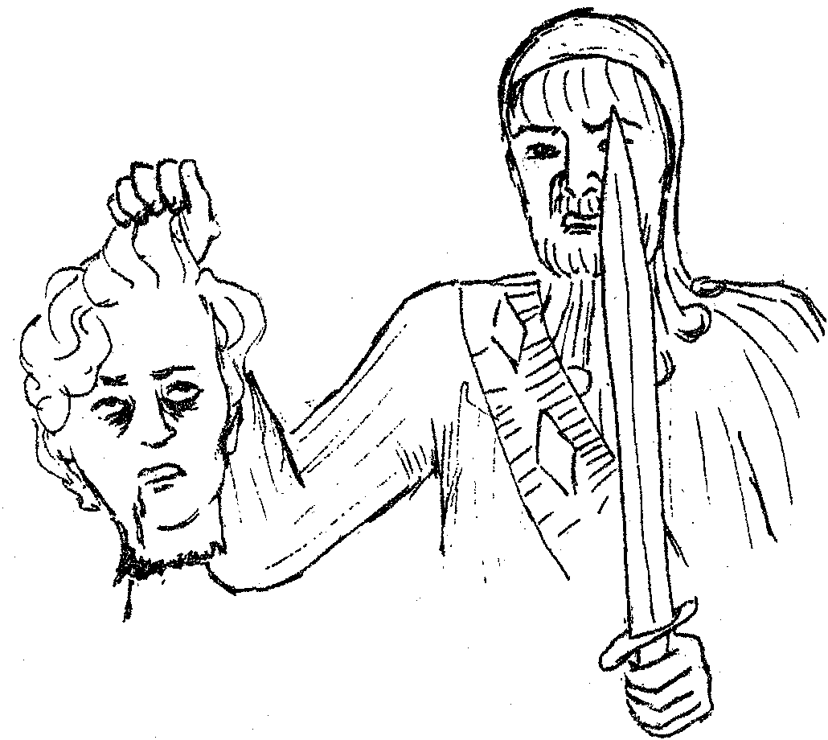
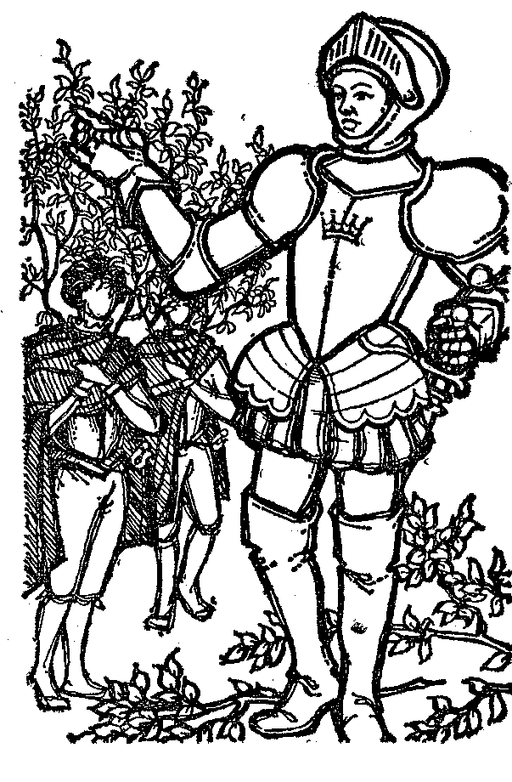
Falcon
Dagger

4.8.3
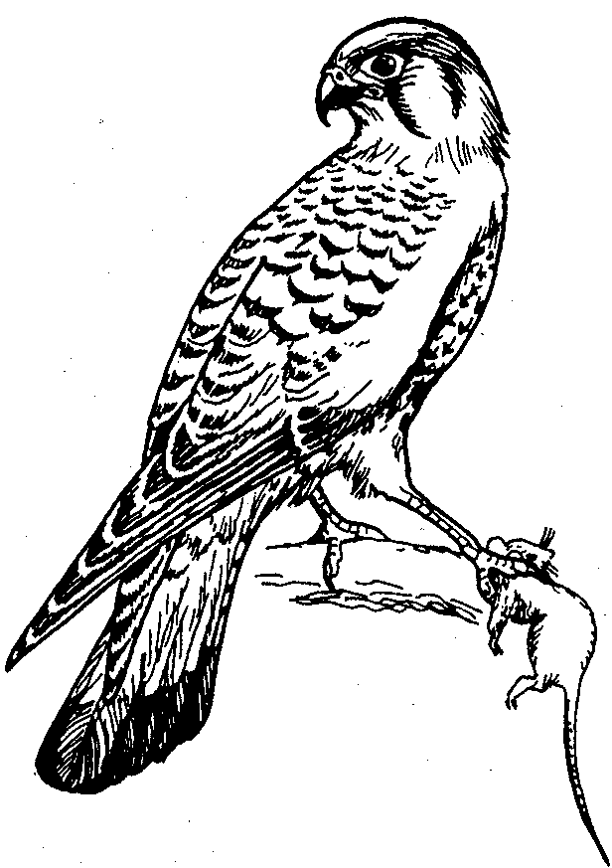

4.8.4
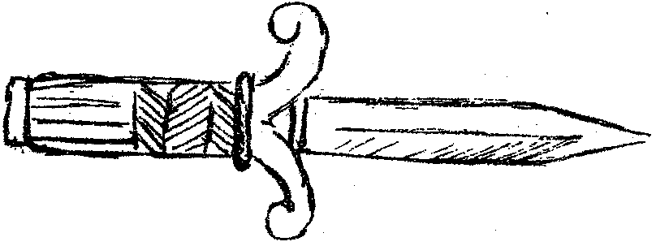

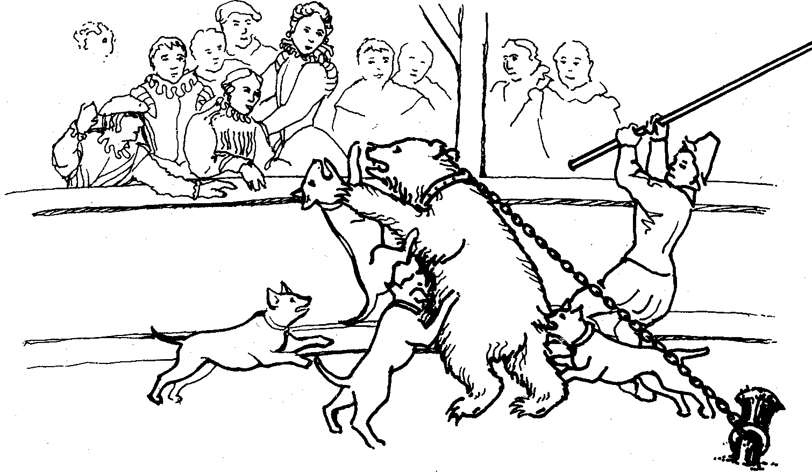
4.8.5

4.8.7
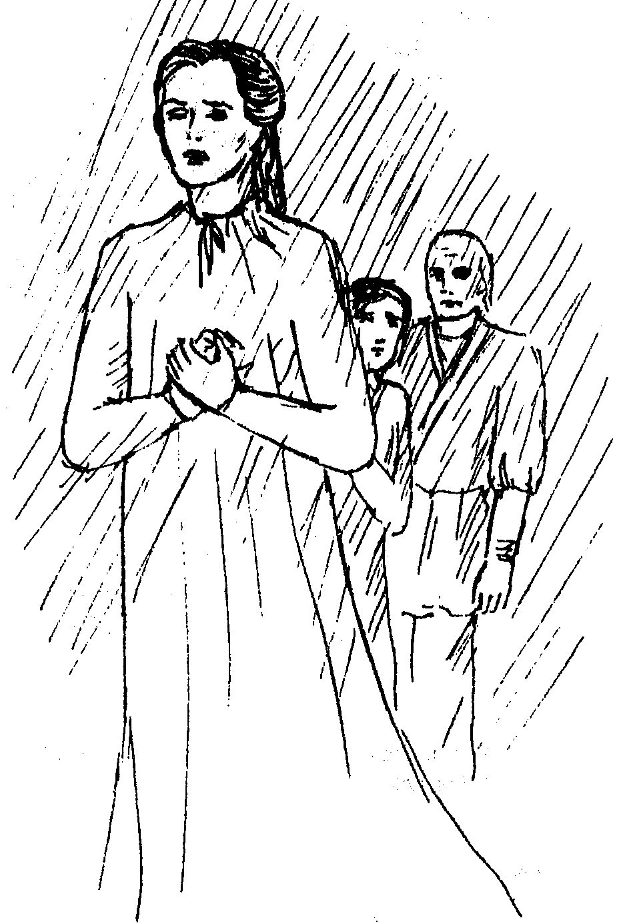

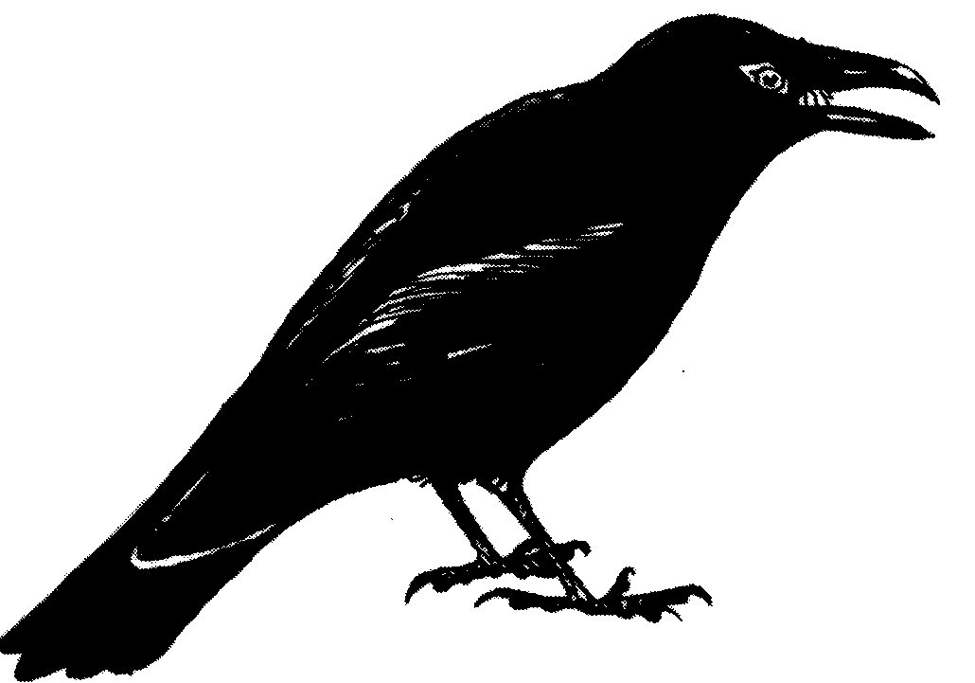
4.8.6

[40]

TOTAL FOR SECTION C: | [40]

SECTION D

SHORT STORIES

Answer Question 5 or Question 6

QUESTION 5

FOCUS – A collection of short stories compiled by R Meyer

Extract A: THE SCHOOLMASTER by PAULINE SMITH

God knows how it was that I gathered the children together and, sending  the bigger boys in haste back to the farm, came on myself with Neeltje and  the little ones. My grandfather rode out to meet us. I told him what I could,  but it was little that I could say, and he rode on down the river. When we  came to the farm the children ran up to the house to my grandmother, but I  myself went alone to the waggon-house. I opened the door and closed it  after me again, and crept in the dark to Jan Boetje's chair. Long, long I sat  there, with my head on my arm on his table, and it was as if in all the world  there was nothing but a sorrow that must break my heart, and a darkness  that smelt of tobacco and brandy and hides. Long, long I sat, and when at  last my grandmother found me, 'My little Engela,' she said. 'The light of my  heart! My treasure!'  The mules that Jan Boetje had blinded were found and shot by my  grandfather, and for long the splinters of the cart lay scattered down the  bed of the river. Jan Boetje himself my grandfather could not find, though  he sent men through all the valley looking for him. And after many days it  was thought that Jan Boetje had gone up-country through the pass at night.  I was now for a time so ill that my father came down from his farm in  Beaufort district to see me. He would have taken me back with him but in  my weakness I cried to Grandmother to keep me. And my father, to whom  everything that my grandmother did was right, once again left me to her. | 5  10  15  20

5.1 Describe the events that took place just before this extract in the story. | (4)

- What work has Jan Boetje been doing on the farm?  - Explain why Engela is living with her grandparents.  - Why are the other children staying there?  - What has the wagon house been used for recently?  - Why does Engela feel ‘a sorrow that must break my heart’ (line 9)? | (2)  (2)  (2)  (2)  (3)

  - Choose TWO words from the list below to describe Engela’s character:

spiteful, gentle, forgiving, vindictive, enthusiastic, energetic, kind, revengeful | (2)

5.8 Describe what happens to Jan Boetje after the events in the extract. | (3)

AND

Extract B: PLYMOUTH by Mervyn Woodrow

As he approached the familiar turnoff to Grootbomen, Kerneels began to feel the pride of achievement welling up within him. He felt young again, level pegging with twenty year olds.  He smiled in anticipation of their amazement. Kerneels and his shiny Plymouth. He would show them. Of course, he would receive their acclaim modestly. A commonplace, this car and driving business. Really very easy, actually. And quite fun. Then, like a mule kick on the head, bludgeoning his euphoria, a horrible thought struck him. How did you stop this thing? He had studied carefully, and successfully, the routine of motion. But inertia, that was another matter. His concentration shattered by this great gap in his knowledge, he narrowly missed his gatepost. A desperate tug at the wheel saw him safely into the farmyard. Fortunately, as with most farmhouses north of the Zoutpansberg, there was neither tree nor shrub within a fifty yard radius of the dwelling. In this wide bare arena the Plymouth circled the house like a wild dog circling a bush-  buck at bay. | 5  10  15

5.9 How fast is Kerneels driving in the Plymouth?  (Give the approximate miles per hour.)  5.10 In which year was the Plymouth made?  5.11 Explain why Kerneels feels the ‘pride of achievement’ (line 2).  5.12 ‘level pegging with twenty year olds’ (line 3)  Choose the correct meaning of the above phrase from the options below and write down only the letter.  A: Achieving the same standards as twenty year olds.  B: Doing better than twenty year olds.  C: Feeling younger than a twenty year old. | (2)  (2)  (3)  (2)

5.13 Explain why Kerneels has bought himself the Plymouth. | (3)

- ‘like a mule kick on the head’ (line 7)  - The above quotation contains an example of  A: Simile  B: Metaphor  C: Personification  D: Alliteration  5.14.2 What is suggested by the quotation about the thought that strikes Kerneels? | (2)  (2)

- Kerneels is very frightened because of a ‘gap in his knowledge’ (line 11)  What is it that he does not know?  5.16 How does the story end? | (2)  (2)  [40]

OR

QUESTION 6

STORIES SOUTH AFRICAN compiled by A. Lennox-Short

Read through the extracts below and answer the set questions:

THE FOLLOWER – F. C. Cornell  “Carfax, man,” I said, “this is wonderful! Can you find  your way back? It will make us all rich.” he shuddered.  “No! No!” he said, his hand pressed to his eyes as  though to shut out a scene of horror. “he is there! No,  he cannot be; he is watching here for me – he will fol-  low me always! Oh! Jason, don’t leave me alone, old  man; don’t leave me; we’ll get away together when the  boat comes. There’s enough for us both! Don’t leave  me!” | 5

- Choose either A, B, C or D as your answer. Write only the correct letter; eg 1.1.C  - Who is telling this story?  - Jason  - Carfax  - Sidney  - Ransford | (2)

- What do we call this kind of storyteller?  - First person narrator  - Third person narrator  - Traditional storyteller  - Omniscient narrator | (2)

6.1.3 Who is the more greedy of the two?  - Carfax  - Jason | (2)

- Who is ‘he’ that Carfax is talking about?  - Why will he always follow him?  - Why is he anxious not to be left alone?  - Does Jason believe him at this stage?  - What has made him decide that Carfax might be telling the truth? | (2)  (2)  (2)  (1)  (2)

AND

‘Did I follow them? No! I’m ashamed to say I  did not – at any rate, not then. Instead, I walked down  to the shore, where the solemn breakers offered some  sort of companionship, and prayed for morning to come  and blot out the ghastly moon and all it had shown me,  and save my reason. | 5

- Choose either A, B, C or D as your answer. Write down only the correct letter,  e.g. 1.1.C.  - What is the function of the many different punctuation marks in the first two lines?  - The storyteller asks a question and answers it himself.  - The storyteller wants us to agree with his answer to the question asked.  - It emphasises how confused and startled the storyteller felt at this shocking discovery.  - It emphasises that you must always believe what people tell you, even if it is strange. | (2)

Another word for ‘reason’ (line 6) is  - sanity.  - understanding.  - aim.  - land. | (2)

Why can’t this storyteller sleep when ‘there’s a moon’?  - What do you think happened to Carfax? | (4)  (2)

AND

LA MISERIA – Uys Krige
‘...she noticed a beggar. He was in a poor state for he stood there, leaning with bent head against the cathedral wall, not even begging any longer. Miseria stopped beside him and as he looked up she was struck by the calmness of his large, dark eyes. She offered him a coin.

6.10 Choose either A, B, C or D as your answer.  What we learn from this confrontation with the beggar is  - it is better to beg.  - begging is wrong.  - it is better to give than receive.  - that sometimes you have to give beggars something. | (2)

6.11 State whether the following statements are TRUE or FALSE. Motivate your answer from what you can remember of the text.  - The story is told by a Spanish gentlemen.  - This story is a legend.  - Miseria made poverty immortal.  - The stranger came for Miseria because she was poor.  - The stranger traps Miseria into coming with him.  - The mine dumps next to the railway line indicated wealth. | (12)

6.12 What is the Spanish word for ‘poverty’? | (1)

TOTAL FOR SECTION D:  TOTAL: | [40]  80

