GAUTENG DEPARTMENT OF EDUCATION

SENIOR CERTIFICATE EXAMINATION

ENGLISH SECOND LANGUAGE SG
(Creative Writing)

TIME: 1 hour

MARKS: 40

Dear Candidate

Pay careful attention to the following:

- Read the instructions carefully.

- Write neatly and legibly.

- Write in ink – do not use pencil.

- Plan your work carefully.

We the examiners, hope that you will enjoy sharing your ideas, feelings and stories with us.

COMPOSITION
A RAND A MINUTE
DAD'S TAXI
Turn crafts into money
Sam's swops
Recycle waste

Write a composition of between 300 – 350 words in length on ONE of the following topics. Please indicate the number of the topic (e.g. 1 or 3) and the title.

- If you had three wishes, what would you wish for, and why?

Entitle your essay: I wish …

- We live in tough times. Many people are retrenched and have to find ways to survive. Discuss a few ways in which your friends make a living and say what you would do to make money.

The following ideas may be used but you can also use your own.

Entitle your essay: YOU CAN SURVIVE!

- Recently, new neighbours moved in next door. Describe the family and some of the experiences you have had with them.

Entitle your essay: OUR NEW NEIGHBOURS



- My mom is a super mom. What makes your mother such a special person?

Entitle your essay: SUPER MOM



- During your high school career, you have been very successful both academically and on the sports field. Discuss a few factors (e.g. determination and hard work) which have contributed to your achievements.

Entitle your essay: THE SECRET TO SUCCESS.

- Your parents gave you a brand new car for your eighteenth birthday. Relate some of your experiences while learning to drive.

Entitle your essay: LEARNING TO DRIVE

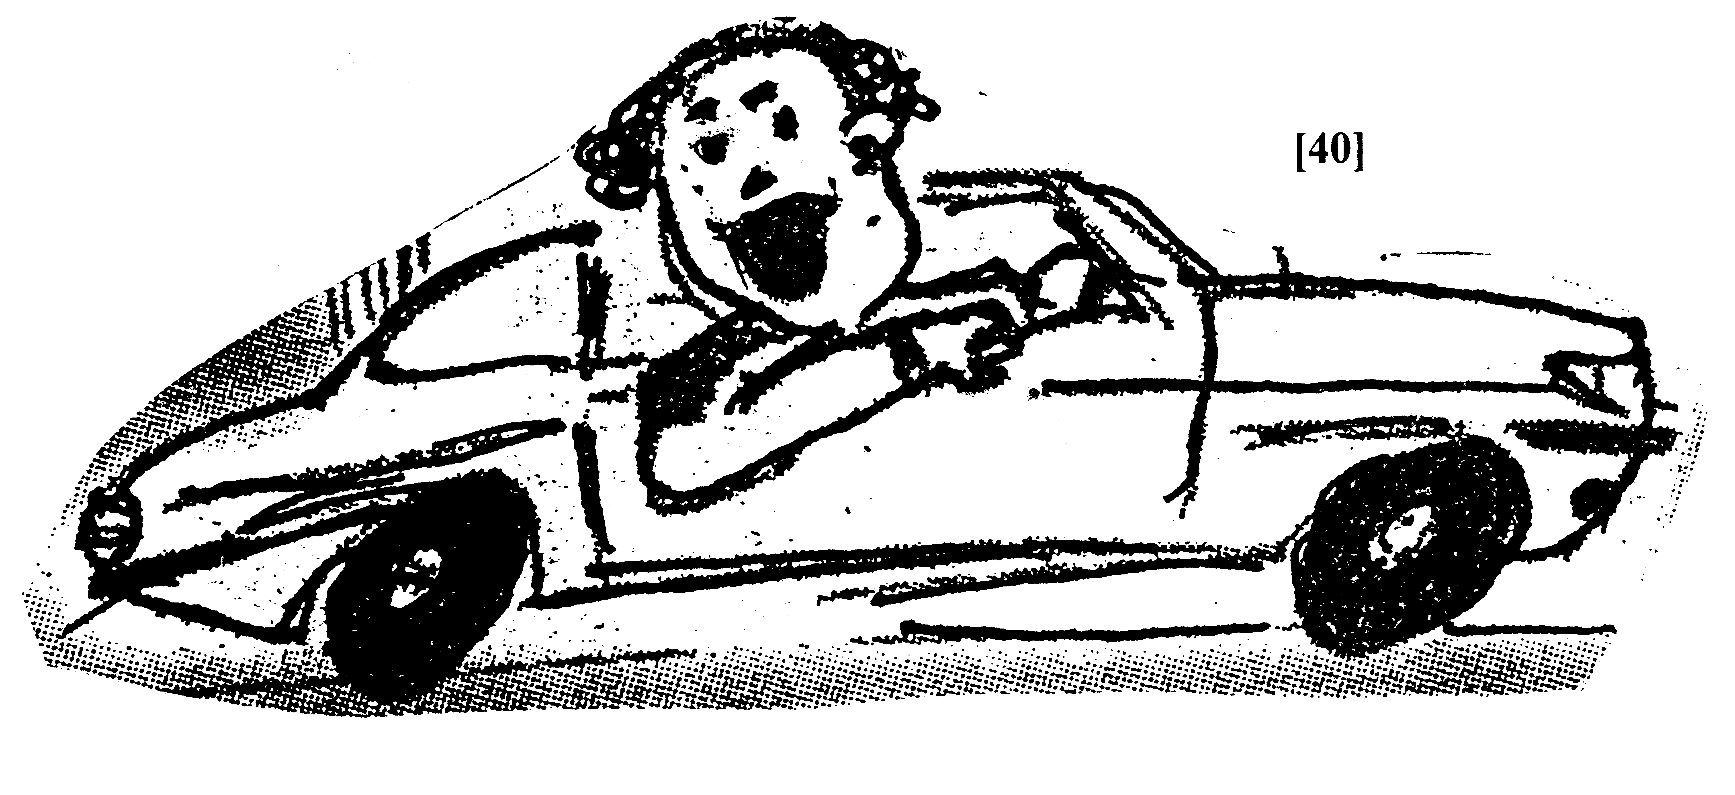

[40]

TOTAL: 40

