GAUTENG DEPARTMENT OF EDUCATION
SENIOR CERTIFICATE EXAMINATION

ENGLISH SECOND LANGUAGE HG
(First Paper : Transactional Writing and
Language Competence)

TIME : 2½ hours

MARKS : 90

INSTRUCTIONS:

Dear Candidate

In this paper we, the examiners, would like to assess your writing skills as well as your language competence.

Pay attention to the following when answering the paper:

- Read the instructions carefully.

- Write neatly and legibly.

- Write in ink – do not use pencil, even if you want to correct something.

- Start each section on a new page.

- Please number your answers exactly as the questions are numbered, using the decimal numbering system e.g. 1.1.1.

- Rule off after each section.

- The paper consists of THREE sections.

- SECTION A : Letter (choose one topic)

- SECTION B : Transactional writing (choose one topic)

- SECTION C : Communicative Competence (do all questions)

Do all these things and you will be generously rewarded.

GOOD LUCK!

THE EXAMINERS

SECTION A

QUESTION 1

LETTER

- Choose and write ONE of the following letters.
- The body of your letter should be between 130 and 150 words in length.
- Pay careful attention to the form of the letter that you choose to write. Indicate which letter you have written by writing the number of the option you have chosen in your answer book.

1.1 The following note appeared in What’s Up! magazine in 1999. It was written by the Editor, Marion. Read it carefully.

Dear Readers,

Thanks for all your letters, e-mails and phone calls telling us what you think of the mag, and thanks to those who just wrote in to say hello and tell us about yourselves. I enjoyed talking to you and reading all your letters. Your comments are very important to us and we intend using as many of them as possible.

This leads me to my next exciting bit of news for you: all of us at What’s Up! are working on a new image for the magazine. We are incorporating all your good ideas with some of our own to create a whole new look. The What’s Up! mission has not changed, however. We will continue to bring you the education, information and entertainment that you are used to, but with a whole new flavour.

We are encouraging you now more than ever to write in and phone in and give us more ideas. You can give us general comments or you can use the following questions as a guideline:

- What would you like to see on the cover?
- How can we make the magazine more hip, hop and happening?
- When you write in tell us how old you are.
- What articles would you be interested in reading?

Hope to hear from you soon.
Happy reading!
MARION

Now write a suitable reply, bearing in mind what Marion has asked of you. | (20)

OR

  - Study the following extract of William Smith’s STARS which appeared in The Star of Friday, 10 September 1999.

IF TODAY
IS YOUR

BIRTHDAY

Another anniversary to
savour. It marks the end of
one chapter and the
beginning of a new one. Your
main aspiration will crystallise
during what ought to be a
very good year. Go ahead
with your plan and put your
trust in providence.

Astro Technical enquiries:
Bronwyn (011) 289-1005
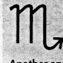

Now imagine that you are having a birthday today and that this is what  William Smith would like to say to you regarding the year that lies ahead. After reading this you decide to take to heart what he has written for you. Write a letter to your friend telling him/her what you plan to do to make these comments come true. | (20)

OR

- 1.3 Study the following newspaper report carefully:  TOP ACHIEVER WALKS AWAY WITH COVETED TITLE  Esme Brink triumphed over hundreds The finale of the competition took  of entrants to win the coveted 1999 place at the National Secretaries  National Secretary of the Year Day lunch, at the Sandton Sun &  award on National Secretaries Day Towers Intercontinental Hotel.  last week. Esme is private assistant Master of ceremonies, Gerry  to the executive director of the Rantseli, was an expert at putting  Rembrandt Group. the contestants at ease and holding  the attention of the audience of  Second place was taken by Dombolo close to 400 managers and  Masilela of Johannesburg, personal secretaries.  assistant to the CEO of the  Johannesburg Housing Company Sponsoring patrons of the PSA are:  (Pty) Ltd. First National Bank, Kelly Personnel,  the Filette SA Stationary Division,  In the third place was Lynne Torrente CompuTravel and Andre de Mellon  of Port Elizabeth, secretary to the Consultants.  Financial Director of Intramed (Pty) Ltd.  The Star Friday, 10 Sept, 1999  - Pretend that you know one of the ladies who won an award. Write a letter to congratulate her on winning the award. Also ask her what is the secret of her success is.  OR  1.3.2 Write a letter to Gerry Rantseli, the Master of Ceremonies, to congratulate her on her expert handling of the event, specifically mentioning what you found so admirable. | (20)  (20)  [20]

SECTION B

QUESTION 2
TRANSACTIONAL WRITING

Choose ONE of the following shorter pieces and write 130 to 150 words on the topic.

2.1 Study the following advertisement carefully.

The fun way to communicate
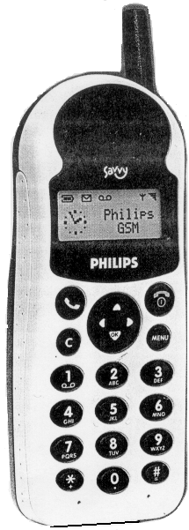


Pretend that you have purchased this particular cellphone a few weeks ago. Now you find to your dismay that the cellphone is no longer functioning as it should. As it is still under guarantee, you return it to the dealer. Write down the conversation that takes place between you and the salesman. | (20)

OR

2.2 You responded to an advertisement and landed a significant role in a new series which will soon be screened on television. Write THREE to FIVE diary entries in which you describe the effect that this role had on your own life and the lives of your family. | (20)

OR

2.3 Study the following:


Metro Kidz

Gift Voucher
Don’t know what present to get for a friend’s birthday? How about a “Kidz Gift Voucher”? With this voucher, your friends will be able to watch a movie of their choice on any day between 09:00 and 16:00. And …. they will get a free coke and popcorn as well.
Your friends will be really impressed with this funky present! You can even suggest to your teacher or sports coach that he/she gives the movie vouchers away as prizes for special achievements at school.
How can you get one? The same way you would book a movie ticket. For more information, contact your nearest Nu Metro cinema.

You would like your teacher to give a “Metro Kidz Gift Voucher” to one of your friends because he/she has performed exceptionally in activities of which your teacher is unaware. Write a paragraph or two in which you explain why your  friend is deserving of this voucher. Remember you have to be convincing if you would like your friend to receive this voucher.  TOTAL FOR SECTION B: | (20)  [20]  [20]

SECTION C
LANGUAGE COMPETENCE

This part of the paper tests your language and communicative ability. The questions are based on passages and pictures that may help you to answer the questions. Please read through each of these carefully before you attempt your answers.

- Start this section on a new page.

- Please number questions in the middle of the page.

- Make sure that you number your answers correctly.

- Skip a line after each answer.

- Write neatly and legibly, as the marker cannot mark what he/she cannot read!

- Spelling will be taken into account.

The Language section of the paper deals with relationships between parents and children. Question 3 explores ways in which parents should handle their children.

QUESTION 3
COMMUNICATIVE LANGUAGE

Look at the following illustrations and then answer the questions set on them.

SUMMING UP IN A WORD

In these frames, the writer encourages parents to sum up their children’s feelings and actions in one word. Look at the example in Frame A.

Frame A:
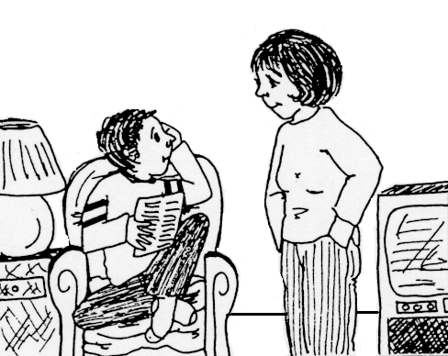
You’ve been working to memorise that vocabulary list for over an hour. That’s what I call perseverance!

Frame B Frame C
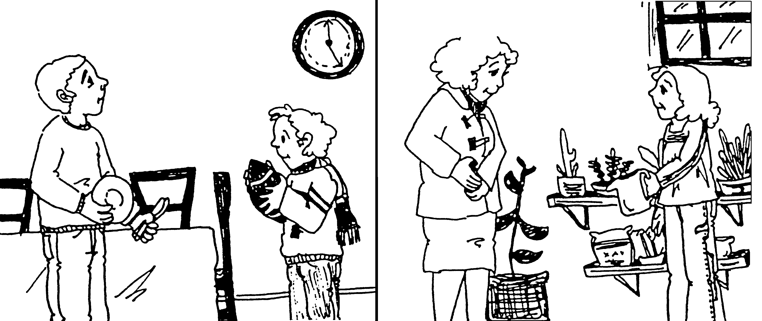
You said you’d be home at 5 o’clock and it’s exactly five. That’s what I call
3.1.1__________.
You noticed that the plants were dry and you watered them. That’s what’s known as taking
3.1.2_______.

- Provide ONE word for the open space, which sums up the child’s feelings or actions in  3.1.1 Frame B.  3.1.2 Frame C. | (2)

3.2 Look at Frame A again. The boy was really happy at the way his mother handled this situation and told his father all about it later that night. Write down the sentences in which he reported his mother’s words.

Start with: Mother said that …………………….. | (3)

3.3 Look carefully at the following case study. You are expected to provide ONE word for the space or to give the correct form of the word in brackets. Write down only the number of the question and your answer.

Brian is nine years old and 3.3.1 ________________ always (be) shy and
lacking 3.3.2 ____________ confidence. I’ve been listening to his feelings
a lot lately, trying not to give him advice – the way I always do, and
3.3.3. (give) him lots of praise instead. Two days ago we had this conversation:

BRIAN: Mom, I’m having problems with Mrs X. She’s always picking on me and making remarks 3.3.4 _____________ the class about me. Charles and 3.3.5. ______________ are always in trouble.
MOM: Oh.
BRIAN: Yes, you know when I got my haircut she said, “Look class, we have a
3.3.6 (beauty) new boy in school.”
MOM: Hmmm.
BRIAN: And then when I 3.3.7 (wear) my new chequered pants last week,
she called me Mister Fancy Pants!

 | MOM: Do you think you should have a talk with her?  BRIAN: I already 3.3.8 ______________ ! I asked her, “How come you always seem to be picking on me? 3.3.9 __________ you hate me, or I am doing something wrong.” She said, “One more crack like that and I’ll send you to the 3.3.10. (Headmaster) office.”  Mom, I felt so low, what can I do? If I 3.3.11 _____________ only able to handle this like 3.3.12 _____________ adult!  MOM: Hmmm.  BRIAN: Well, maybe I’ll just have to grin and 3.3.13. ____________ it. 3.3.14. ____________ are only thirty more days left.  MOM: That’s true. I 3.13.15. (belief) you are handling this  3.3.16. (situate) in a mature way. I have confidence in you. Chances are, you’ll do the 3.3.17 (not wrong) thing.  The next day ……..  BRAIN: Mom, I feel so good about 3.3.18. (me). I went to the Headmaster and he said I 3.3.19. …………….. courage to come to him. He believes one has to be strong to face up to 3.3.20. ………………. problems. He was glad I 3.3.21. (think) enough about him to share my problems with him. | (21)
 |  | [26]

Questions 3.4 to 3.7 are based on the following passage:

SPOCK’S GUIDE TO PARENT CARE

Michael Frayn, at Bay in Gear Street

- PARENTS ARE JUST LARGE HUMAN BEINGS. It’s only natural for a small child to feel a little over-powered by the hard work and responsibility of coping with parents. All parents get headstrong from time to time. They go through phases that worry their children. All children get tired and discouraged and wonder whether they’re doing the right thing.

2. EVERY PARENT IS DIFFERENT. This one flies into a fury at the sight of crayoning on the wallpaper. That one bursts into tears. Yet another goes into a sulk and won’t say anything all afternoon. All these are perfectly normal, healthy reactions. I would be suspicious of the parent who seems a little too good to be true. He or she may not get enough opportunity for emotional experiences. I think I’d ask myself, in this case, if I were drawing on the wallpaper enough.

3.4 Change the following sentence into a question without using a question word like who, what, where etc.

This one flies into a fury at the sight of crayoning on the wallpaper. | (2)

  - In the following sentence the writer uses two words that are easily confused, namely “too” and “to”.

I would be suspicious of the parent who seems a little too good to be true.

Fill in the correct word to show that you are not confused by them.

I love to listen 3.5.1 __________ rock-and-roll although I enjoy classical music 3.5.2 __________. | (2)

3.6 Have a look at the underlined word in paragraph 1. In a sentence of your own, use another word, which sounds like whether, but is spelt differently and has a different meaning. | (1)

3.7 Look at the following sentence and give the antonym of the underlined word to complete the statement with the opposite meaning.

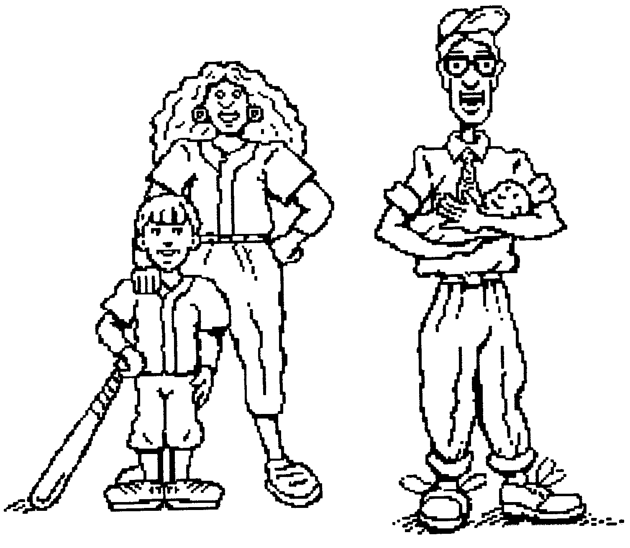  Every parent is different.  All parents are ______________ | (1)

Question 3.8 to 3.12 are based on this passage:

SPOCK’S GUIDE TO PARENT CARE
(continued)

3. THEY AREN’T AS FRAGILE AS THEY LOOK. Handle them confidently. Many parents look as though they’ll have a nervous breakdown if you bang your toy on the table just once more. Don’t worry – nine times out of ten they won’t.

- DON’T BE AFRAID TO INSIST ON YOUR OWN STANDARDS. There’s been a great swing away from the over-permissiveness that used to be the fashion. Then a parent’s every whim was regarded as sacred. Nowadays we’ve come to realise that on the whole, people don’t have any clear idea about manners and morals until they become parents, when they hastily start to make them up as they go along. They’re secretly very grateful for a little firm but tactful guidance.

5. PLAY IS EDUCATION TOO. All the time you are with your parents you are educating them in tolerance and self-discipline. Playing games and romping with them is especially useful. It’s not only great fun for them - it’s helping them to form their characters. Various games such as hitting your little brother, and then bursting into tears before he does, train their powers of detection and judgement.

3.8 Rewrite the underlined sentence in paragraph 5 starting with

It is especially useful to …………. | (2)

3.9 Change the following sentence into a question by adding a suitable tag:

Various games train their powers of detection and  judgement, ___________ ___________? | (2)

3.10 Let’s see if you can use the word “confident” (compare ‘confidently’ par. 3) in its various forms. Write down only the number of the question and your answer instead of writing down the sentence.

I was very 3.10.1 ___________ that you would understand  my situation. That is why I chose to 3.10.2 ___________ in  you. I have a great deal of 3.10.3 ___________ that you  will keep this secret. | (3)

3.11 Rewrite the following sentence starting with the words given:

You are educating them in tolerance.  They …………… | (2)

3.12 Look at the following example of degrees of comparison:

Mary is a good parent, Maude is an even better parent, but Mira is the best.

Now provide the degree of comparison for the following word from par. 4:

It is great to play with my sister. It is even 3.12.1 ___________ to play  with my brother, but playing with my dad is the 3.12.2 ___________. | (2)

Questions 3.13 to 3.16 are based on this passage:

SPOCK’S GUIDE TO PARENT CARE
(continued)

6. TEMPER TANTRUMS. Almost all parents have temper tantrums from time to time. You have to remember that between the ages of 20 and 60, parents are going through a difficult phase of their development. They are discovering the surprising limitation of their personalities and learning to be dependent. It’s natural enough for them to want to explode at times.

7. BE FRIENDLY BUT FIRM. In general, don’t give your parents too much chance to argue. Just quietly get on with whatever you want to do, perhaps chatting pleasantly to distract their attention. Parents can sometimes drive a small child up the wall by dawdling about in shops or talking to friends. It doesn’t really help to keep nagging, or to try dragging them along by brute force. If I were you I’d hop cheerfully from foot to foot and say in a firm friendly voice: “I want to go to the lavatory.” If that doesn’t work, you could try turning white and saying you’re going to be sick.
- REMEMBER, YOU’RE HELPING THEM TO GROW UP. It’s your job to help your parents grow up into mature, responsible old-age pensioners, self-confident, too exhausted in mind and body to make trouble for anyone else.

3.13 Explain the meaning of the phrase “temper tantrum” (paragraph 6). | (1)

3.14 In paragraph 7 the writer uses the expression “by brute force”. Explain in your own words what this expression means. | (1)

3.15 Why is the underlined sentence in paragraph 7 written in inverted commas? | (1)

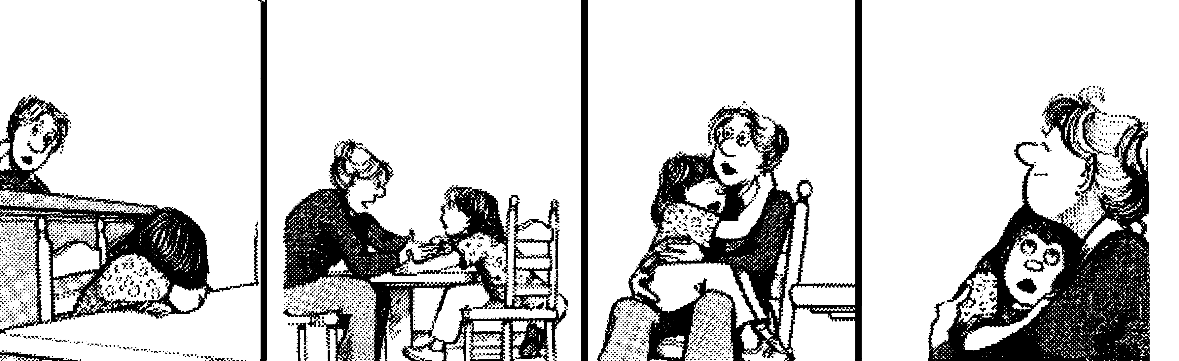
April, what’s the matter?
Elizabeth is packing and she’s going to go away.
I know. She’ll be in a new school in a new town – but we’ll visit and we’ll see her on holidays and we’ll write!
I don’t want her to go!!!
People grow up, honey, and they start lives of their own! Some day you’ll go away too.
Then I’ll try an’ grow up as slowly as possible.

3.16 Change the following sentences, taken from the strip, into the negative.

3.16.1 People grow up, honey.  3.16.2 She’ll be in a new school in a new town. | (2)

3.17 Combine the following two sentences by using although:

She is going far away.  We’ll write her letters. | (2)

TOTAL SECTION B:  TOTAL: | [24]  [50]  90

