GAUTENG DEPARTMENT OF EDUCATION
SENIOR CERTIFICATE EXAMINATION

ELECTRONICS SG

TIME: 3 hours

MARKS: 200

INSTRUCTIONS:

- Answer ALL the questions.

- Sketches and diagrams must be large, neat and labelled.

- All calculations must be shown.

- Answers must be clearly numbered.

- An approved pocket calculator may be used.

- A formula sheet is attached on pages 8 - 10.

QUESTION 1
ELECTRIC CURRENT THEORY

1.1 A series circuit consists of a resistor, an inductor and a capacitor all connected across a 100 V supply. The supply frequency is 50 Hz. The resistor has a value of 10 ohms and the inductor an inductive reactance of 18 ohms. The capacitor has a capacitive reactance of 13 ohms.  Calculate  - the value of the capacitor.  - the value of the inductor.  - the current through the circuit.  - the voltage drop across each component.  - Draw a neatly labelled voltage vector diagram. | (4)  (4)  (9)  (6)  (6)

1.2 A coil having a power factor of 0,54 draws a current of 19,7 amp. and is connected across a 220 V, 50 Hz supply.  Calculate  - the true power.  - the reactive power.  - the apparent power. | (3)  (3)  (3)

1.3 Draw a neatly labelled power diagram (triangle) to explain the concepts true power, reactive power and apparent power. | (3)  [41]

QUESTION 2
THREE-PHASE ALTERNATING CURRENT SYSTEMS

2.1 Connect, with reference to Figure 2.1, the balanced load in a STAR configuration to the three-phase supply. | (5)

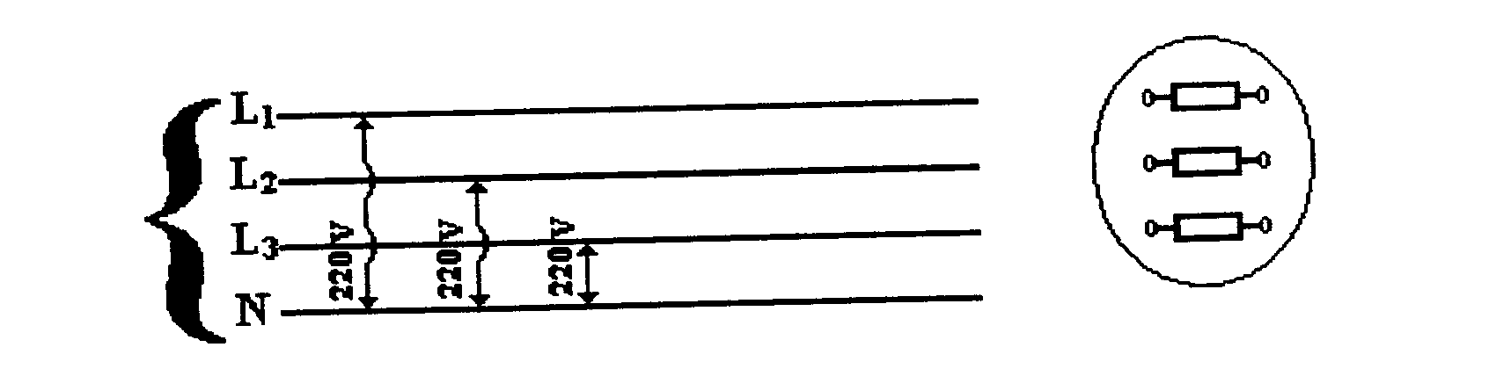
1000Ω

1000Ω

1000Ω
Supply
Load

Figure 2.1
Balanced three-phase supply

- Calculate with reference to Question 2.1 the following:  - The line voltage of the system  - The line and phase currents of the system | (3)  (4)  [12]

QUESTION 3
SEMICONDUCTORS

3.1 Figure 3.1 shows part of a colour television circuit. Identify the following electronic components with reference to Figure 3.1. (Example: R270 is a 220 kΩ resistor.)

- R265  - D221  - R260  - T204  - R254 | (2)  (2)  (2)  (2)  (3)
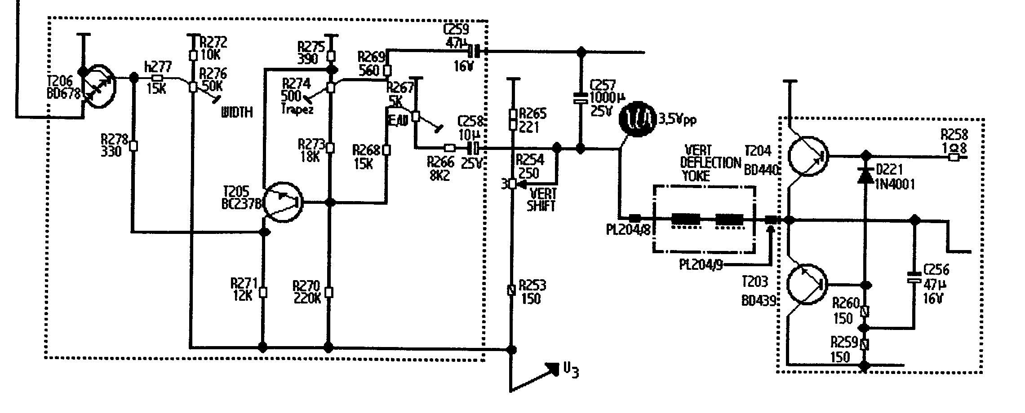

Figure 3.1
Electronic circuit

3.2 Illustrate the operating principle of an NPN or PNP transistor by means of a neatly labelled circuit diagram. Clearly indicate the reverse and forward bias regions.  3.3 Sketch a transistor connected in the common emitter configuration. Input and output waveforms must be shown. Also indicate the properties of this transistor when coupled in this mode. | (8)  (10)  [29]

QUESTION 4
AMPLIFIERS

- To drive a loudspeaker or a recording instrument requires an appreciable amount of electronic power. In designing a power amplifier to obtain the desired amplification, transistors are connected in stages to amplify the signal and minimise distortion. Explain with the aid of a neatly labelled circuit diagram the basic principle of operation of a push-pull amplifier.  - Explain by means of a neatly labelled sketch the basic principle of operation of a class B amplifier. | (20)  (10)  [30]

QUESTION 5
SWITCHING AND CONTROL CIRCUITS

- Explain with the aid of a neatly labelled circuit diagram the principle of operation of any electronic experiment or model that you have built or designed this year. All waveforms (if applicable) should be shown.  5.2 Clippers and clamps are known as diode waveshaping circuits which transmit parts of waveforms and suppress others. Find the output waveshape for the inputs shown in Figure 5.2. Only sketch the output voltage waveshape in your answer book. | (15)  (12)

(2) (2)
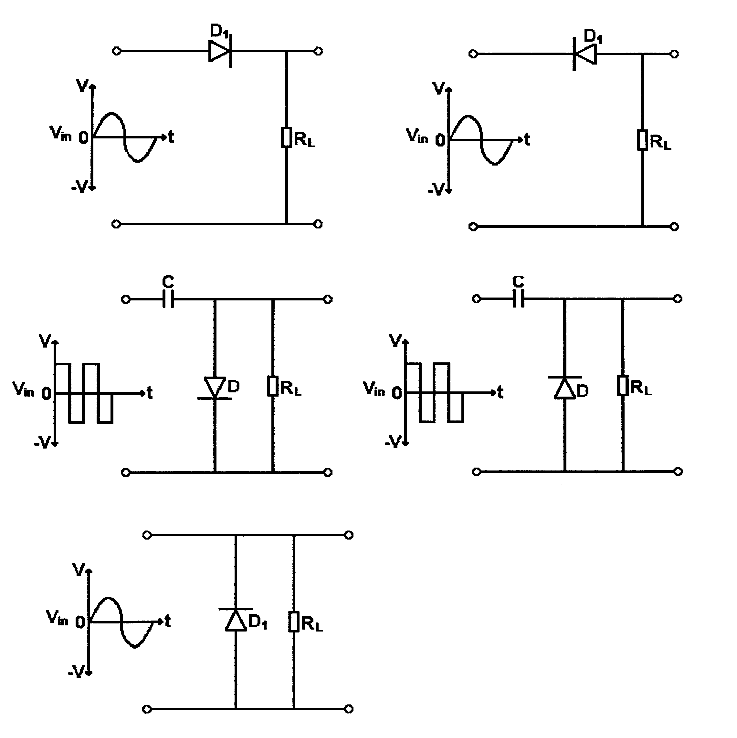
(a)
(b)
(c) (d)
(3) (3)
(e)
(2)
(2) (2)

Figure 5.2  Waveshaping circuits | [27]

QUESTION 6
OSCILLATORS

- Explain with the aid of a neatly labelled sketch the basic operating principle of a crystal-controlled oscillator.  - Explain briefly the piezo-electrical effect with reference to crystals. | (12)  (2)  [14]

QUESTION 7
COMPUTER PRINCIPLES

- Computers consist of large numbers of logic gates and memory elements organised to process data at high speed. To identify these logic circuits it is important to know their symbols. Sketch the symbols and indicate the truth tables of the following gates:  7.1.1 AND gate  7.1.2 OR gate | (7)  (7)

- Sketch a combination circuit of the logic gates to satisfy the following Boolean equation:  F = A.B . C.D | (6)

7.3 Refer to Figure 7.3 and make use of a truth table to indicate the conditions for the LED (light-emitting diode) to be switched on. Note that the gate used, is the American equivalent of a NOR gate. | (4)

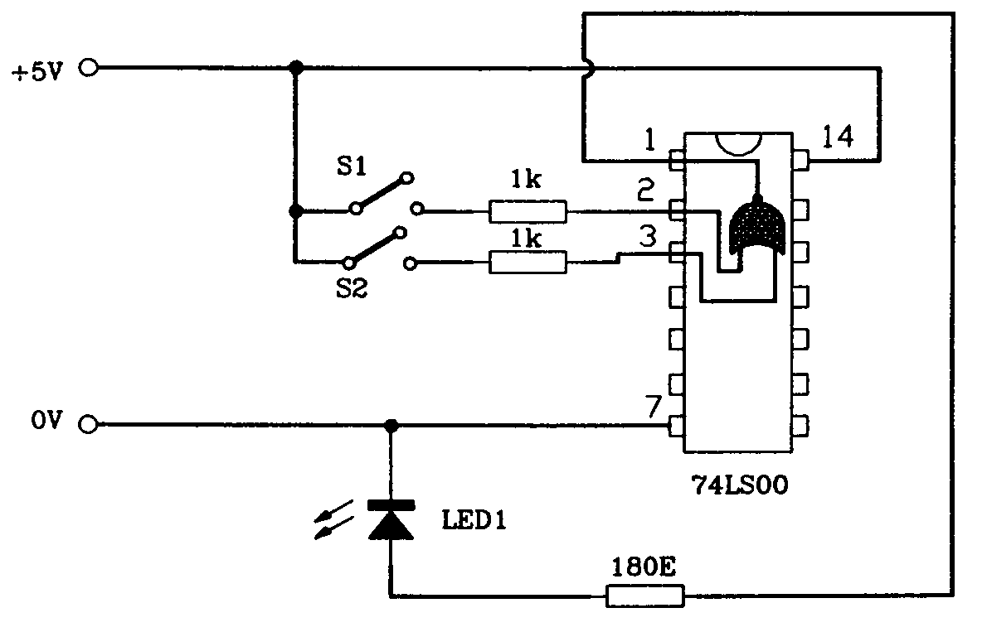

Figure 7.3  Logic circuit | [24]

QUESTION 8
ELECTRONIC APPARATUS

8.1 Sketch a neatly labelled block diagram of an FM radio receiver. Explain the basic operating principle of the antenna, mixer and oscillator. | [16]

QUESTION 9
SAFETY PRECAUTIONS

- Explain how Aids can be spread from one person to another.  9.2 Name THREE workshop safety precautions that were applied in your workshop this year. | (4)  (3)
TOTAL: | [7]  200

