GAUTENG DEPARTMENT OF EDUCATION

SENIOR CERTIFICATE EXAMINATION

ELECTRONICS SG

TIME: 3 hours

MARKS: 200

INSTRUCTIONS:

- Answer ALL the questions.
- Sketches and diagrams must be large, neat and labelled.
- All calculations must be shown.
- Answers must be clearly numbered.
- An approved pocket calculator may be used.
- Formula sheet is attached on pages 5 - 7.

QUESTION 1  ELECTRIC CURRENT THEORY  1.1 An alternating current circuit consists of a coil with an inductance of 10 μH and an internal resistance of 0,2 ohm which is coupled in parallel with a 10 pF capacitor. The supply voltage is 5 volt. Sketch the circuit diagram and indicate all values.  - Calculate with reference to the circuit in Question 1.1:  - The resonant frequency  - The supply current at resonance  - The Q factor of the circuit  - The current in the coil  - The current in the capacitor  - A series circuit has a coil with a resistance of 6 ohms and an inductor of 35 mH, as well as a capacitor. The circuit is supplied by a 3,5 volt supply and resonates at 200 Hz.  Calculate the  - inductive reactance.  - value of the capacitor.  - circuit impedance.  - total current. | (4)  (3)  (3)  (3)  (9)  (6)  (3)  (4)  (2)  (3)  [40]

QUESTION 2  THREE-PHASE AC SYSTEMS  - Three resistances (load) of 20 Ω each are connected to a 240 volt star-connected three-phase supply. Sketch a fully labelled diagram of this system, and calculate:  - The phase currents of the system  - The line currents of the system  - The line voltage of the system  QUESTION 3  SEMICONDUCTORS  - Explain the operating principle of a SCR with the aid of a neatly labelled characteristic curve.  - Explain how a SCR is switched on.  - The common base amplifier is usually used in RF amplifiers, while the common collector amplifier is used where current amplification is needed. Choose any one of the transistor configurations and sketch a neatly labelled circuit diagram to explain the biasing technique used. Also indicate the characteristics for the configuration chosen.  - Give FOUR precautions to be followed when handling CMOS devices.  QUESTION 4  AMPLIFIERS  - Show all calculations and make a neat labelled sketch of a load line for a common emitter amplifier with the following data:  A load resistor of 2 k ohm  A supply voltage of 24 volt  - Sketch a neatly labelled circuit diagram of a resistor-capacitor coupled amplifier.  QUESTION 5  SWITCHING & CONTROL CIRCUITS  - Explain by means of a neatly labelled circuit diagram the operation of a DC motor speed control circuit.  - Sketch a neatly labelled circuit diagram of a positive parallel clipping circuit. Also indicate the in and output waveforms.  - Sketch a neatly labelled circuit diagram of a monostable multi-vibrator. | (4)  (5)  (1)  (3)  [13]  (7)  (3)  (10)  (4)  [24]  (11)  (19)  [30]  (13)  (7)  (9)  [29]

QUESTION 6  ≥  OSCILLATORS  6.1 Explain with the aid of a neatly labelled circuit diagram and brief discussion the operating principle of the inductive coupled oscillator.  QUESTION 7  COMPUTER PRINCIPLES  - Name FIVE types of logic gates and give the IEC symbol for each.  7.2 Sketch a combination diagram of logic gates represented by the following Boolean expression:  X = AB + CD  - Indicate the Boolean expression for the logic circuit in Figure 7.1. Write only the answer in your answer book.  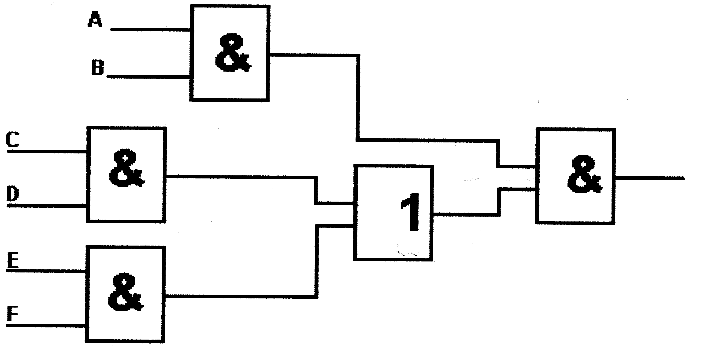  Figure 7.1  Combination diagram of logic gates  - Proof by means of Boolean algebra that:  (A + A). (A + B) = A  QUESTION 8  ELECTRONIC APPARATUS  8.1 Illustrate the principle of operation of a monochrome television receiver by means of a neatly labelled block diagram.  QUESTION 9  SAFETY PRECAUTIONS  9.1 Explain how Aids can be spread from one person to another.  TOTAL: | [14]  (10)  (6)  (5)  (6)  (27)  [20]  [3]  [200]

FORMULA SHEET / FORMULELYS
ELECTRIC CURRENT THEORY / ELEKTRIESE STROOMTEORIE
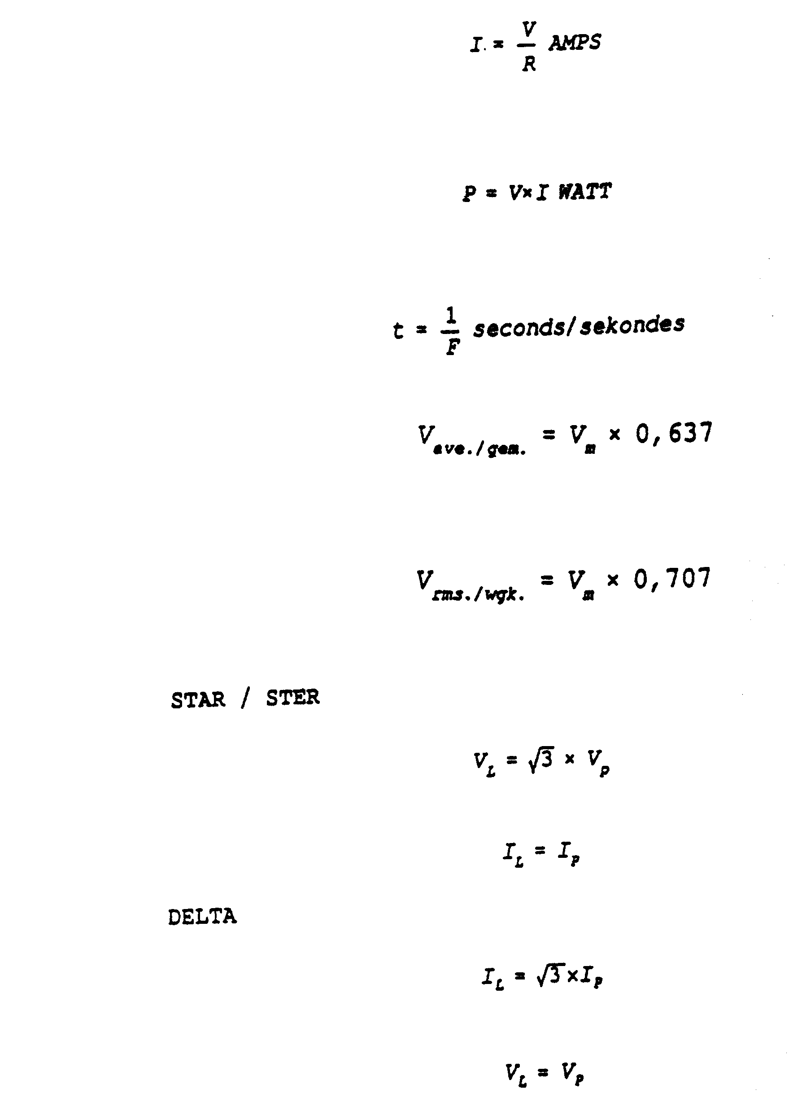
FORMULA SHEET / FORMULELYS
ELECTRIC CURRENT THEORY / ELEKTRIESE STROOMTEORIE
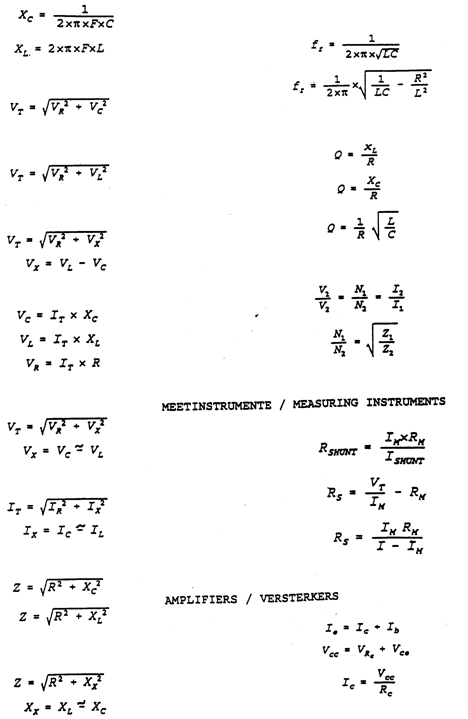
FORMULA SHEET / FORMULELYS
ELECTRIC CURRENT THEORY / ELEKTRIESE STROOMTEORIE
