GAUTENG DEPARTMENT OF EDUCATION

SENIOR CERTIFICATE EXAMINATION

ELECTRONICS SG

TIME: 3 hours

MARKS: 200

INSTRUCTIONS:

- Answer ALL the questions.
- Sketches and diagrams must be large, neat and labelled.
- All calculations must be shown.
- Answers must be clearly numbered.
- An approved pocket calculator may be used.
- A formula sheet (pages 8 – 10) is attached.

QUESTION 1  ELECTRICAL CURRENT THEORY  1.1 A series circuit consists of a resistance of 20 Ω, an inductance of 0,15 H and a capacitor of 100μF, and is connected to a 20 V, 50 Hz supply.  - Sketch a neatly labelled diagram of the circuit.  - Calculate  - the total impedance of the circuit.  - the total current flow.  - the voltage drop over the coil.  - the voltage drop over the capacitor.  - the phase angle.  - the true power in the circuit.  - Sketch a labelled phaser diagram of the circuit.  - Name the conditions at which series resonance occurs.  1.3 Name TWO applications of RLC circuits in practice. | (4)  (10)  (3)  (3)  (3)  (3)  (3)  (5)  (4)  (2)  [40]

QUESTION 2  Ω  Ω  Ω  THREE-PHASE ALTERNATING CURRENT SYSTEMS  2.1 Redraw figure 2.1 in your answer script and connect, with reference to Figure 2.1, the balanced load in a STAR configuration to the three-phase supply.  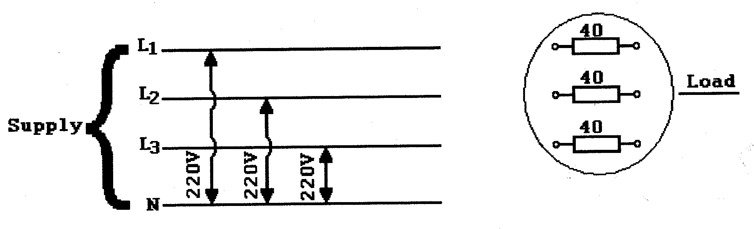  Figure 2.1  Balanced three-phase supply  - Calculate, with reference to question 2.1 the following:  - The line voltage of the system  - The line and phase currents of the system  QUESTION 3  SEMICONDUCTORS  - Identify the following electronic components with reference to the electronic circuit diagram in Figure 3.1. (For example: R381 is a 1 kilo-ohm resistor.)  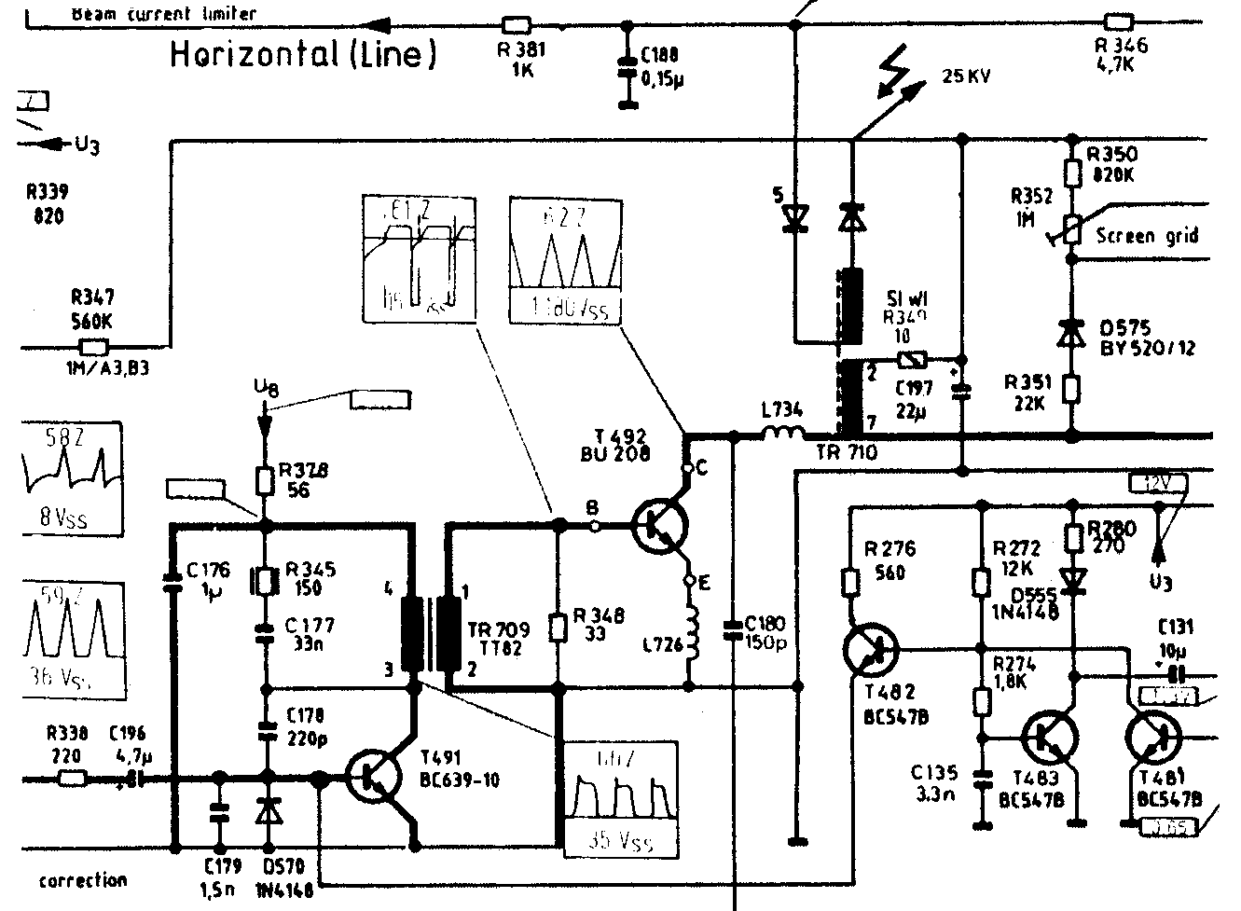  Figure 3.1  Electronic circuit diagram | (5)  (3)  (4)  [12]

- T 491  - Tr 709  - D 570  - C 177  - C 196  - Sketch a neatly labelled diagram to indicate how to obtain 180⁰ phase control over the speed of a motor.  - Sketch a neatly labelled characteristic curve of a silicon controlled rectifier (SCR).  QUESTION 4  AMPLIFIERS  - The push-pull amplifier is classed as a Class B amplifier, and is used in the final stage of power amplification in sound systems. Sketch a fully labelled circuit diagram for this amplifier, and explain its operation for the positive and negative half cycles of an input wave. All relevant wave forms must be shown.  - Sketch the output characteristic curve for a transistor and show the quiescent point for it if it has been biased as a class B amplifier. The input and output signals, as well as the cut-off and saturation regions must be indicated.  QUESTION 5  SWITCHING & CONTROL CIRCUITS  - A practical power supply can be designed to convert 220 V ac supply voltage to a desired dc voltage. Design a simple 30 volt dc power supply circuit. Your circuit should include a step down transformer, a diode rectifier circuit, a filter circuit and a Zener diode as a protection device to external circuits. All the relevant waveforms should be indicated (A diagram of the circuit is required). | (2)  (2)  (1)  (2)  (3)  (7)  (8)  [25]  (20)  (10)  [30]  (16)

5.2 Clippers and clampers are diode wave shaping circuits transmitting parts of waveforms and suppressing others. Find the output voltage wave shape for the inputs shown in Figure 5.1. (Only sketch the output wave shapes in your answer book.)

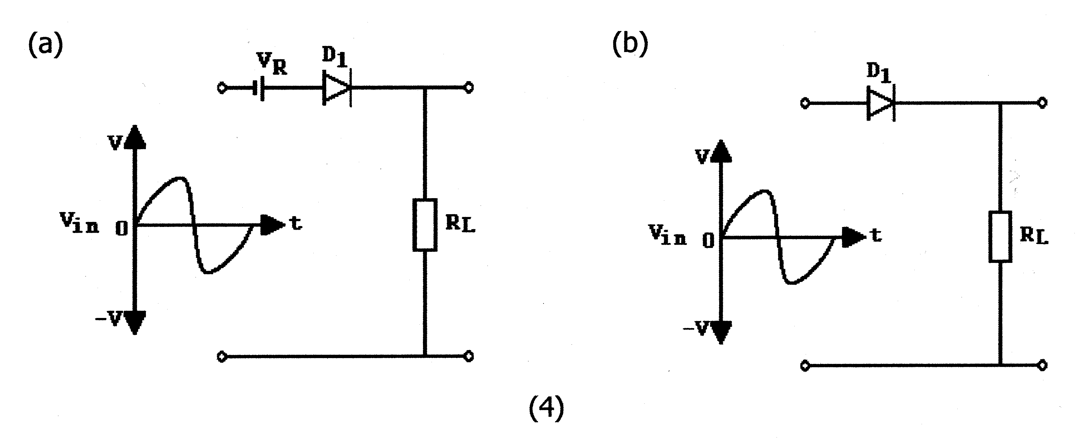  (4)  (2)  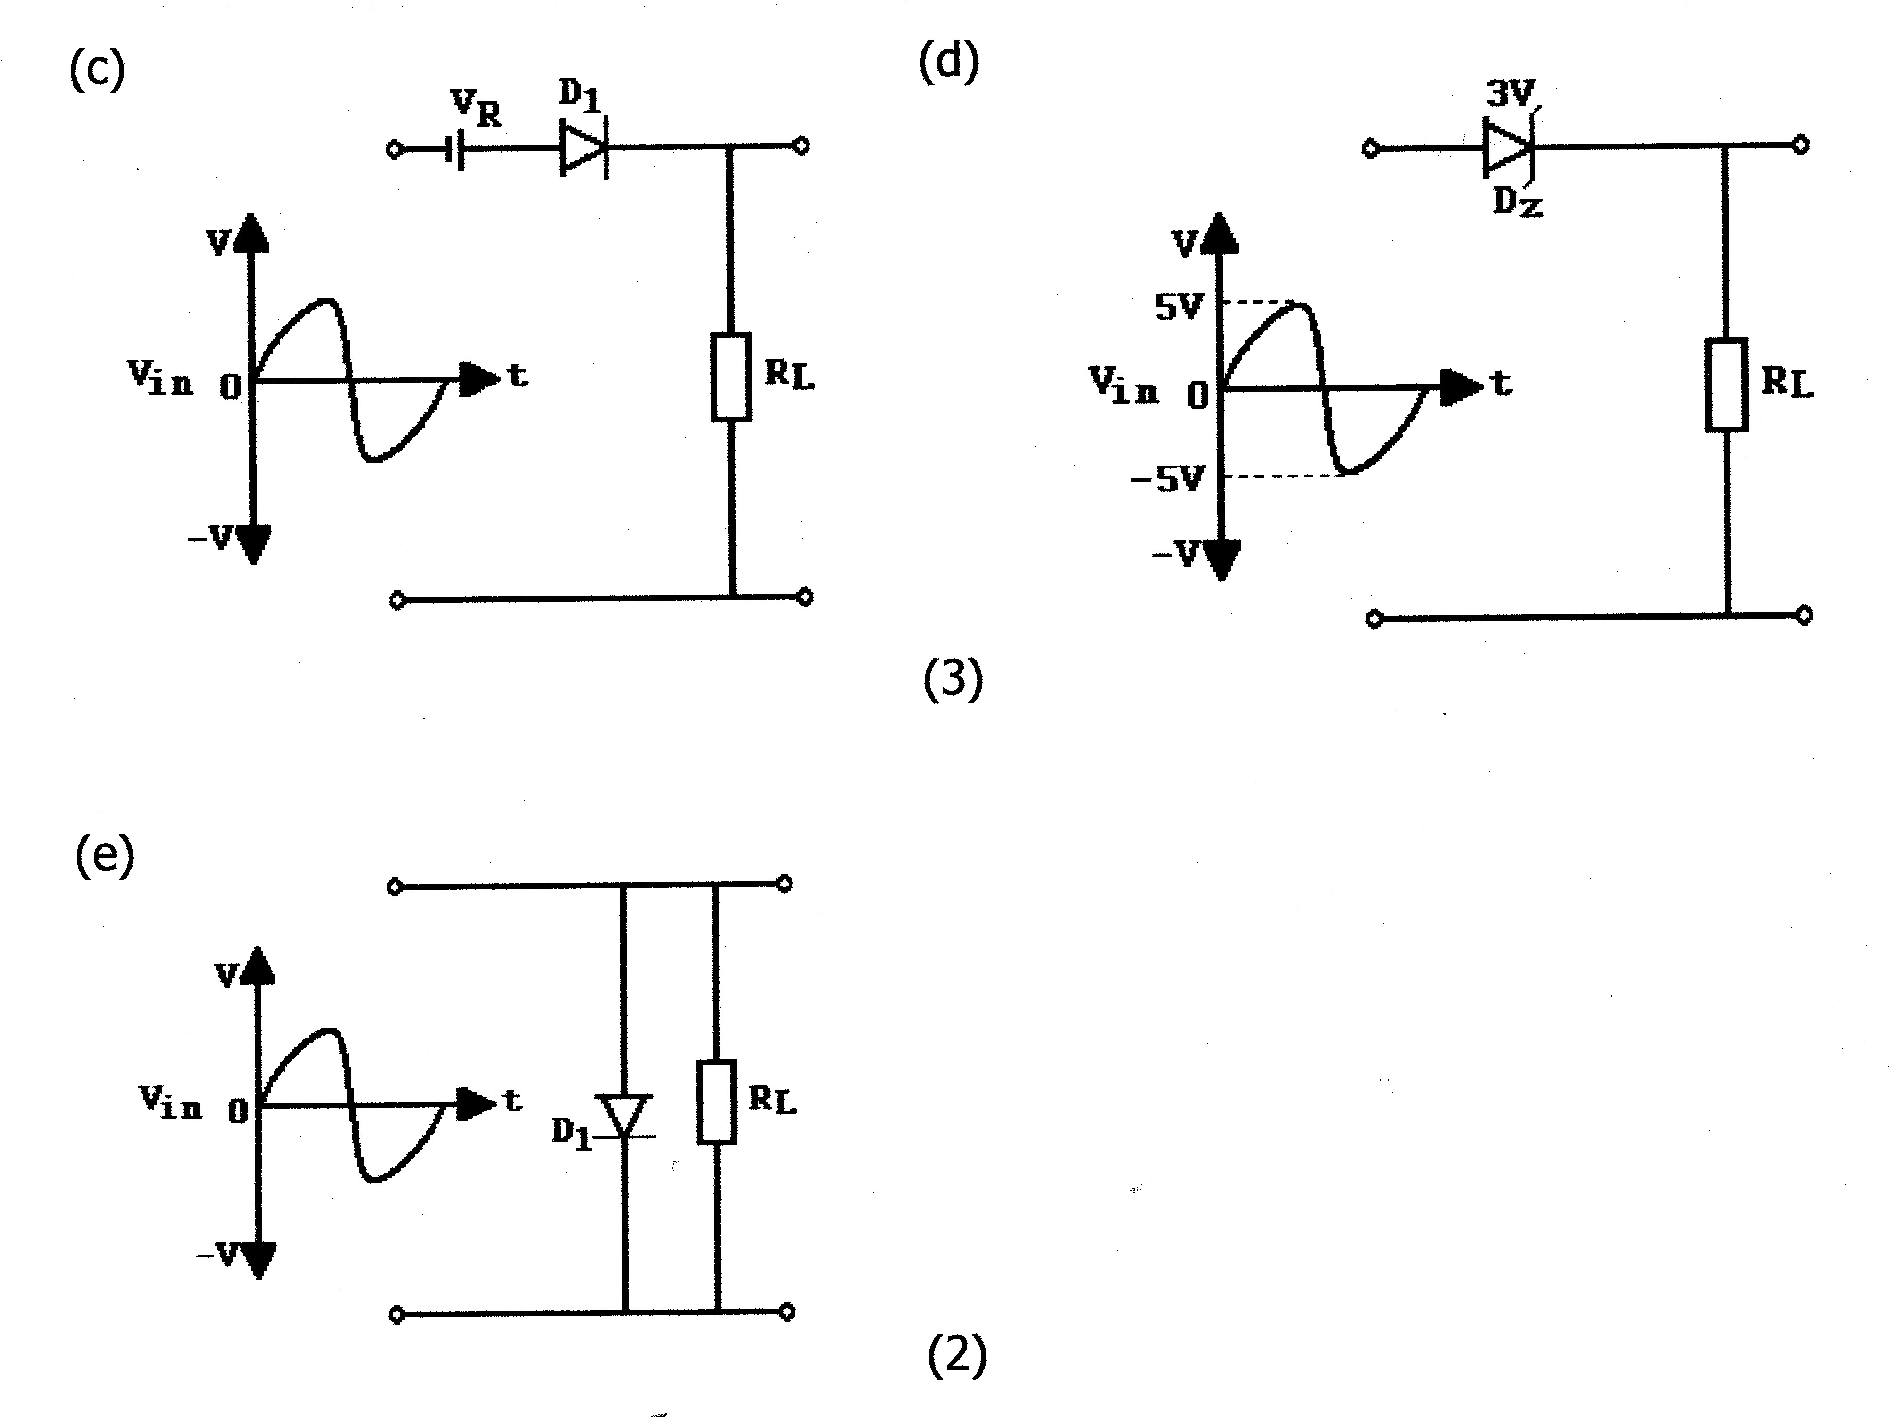  Figure 5.1  Waveshaping circuits | (15)  [31]

QUESTION 6  OSCILLATORS  - Explain with the aid of a neatly labelled circuit diagram and brief discussion the basic operating principle of an oscillator circuit.  6.2 Name TWO applications of oscillator circuits.  QUESTION 7  COMPUTER PRINCIPLES  - Computers consist of large numbers of logic gates and memory elements organised to process data at high speed. To identify these logic circuits it is important to know their symbols. SKETCH the symbols and INDICATE the truth tables of the following gates:  - AND Gate  - NOR Gate  - Indicate the Boolean Expression for the combination circuit in Figure 7.1. Write only the answer in your answer book.  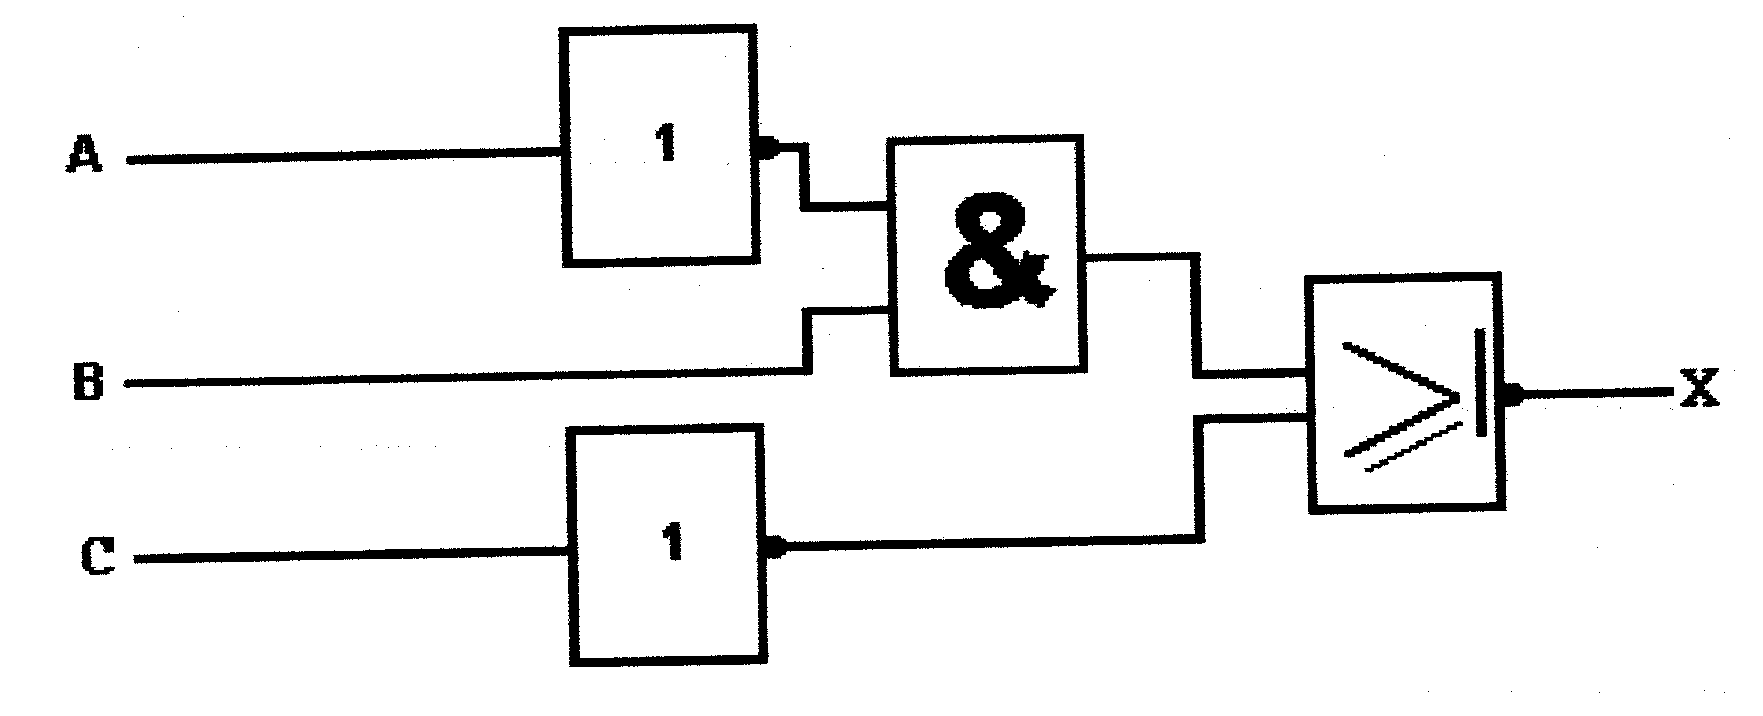  Figure 7.1  Combination diagram of logic gates  - Sketch a combination circuit of logic gates to satisfy the following Boolean Expression:  X = (A + B) + (CD)  - Simplify the following Boolean expression:  X = (A + B) + (A + B) | (9)  (2)  [11]  (6)  (6)  (5)  (5)  (7)  [29]

QUESTION 8  ELECTRONIC APPARATUS  - Sketch a neatly labelled block diagram of a FM receiver.  - A square-wave signal is observed on the screen of an oscilloscope. One cycle measures 8 cm. The horizontal sweep generator is set at 20 μsec/cm. Calculate the signal frequency.  - Calculate the peak to peak voltage of the wave shown in Figure 8.1 if the  VOLT / DIV switch is on 10m V/DIV.  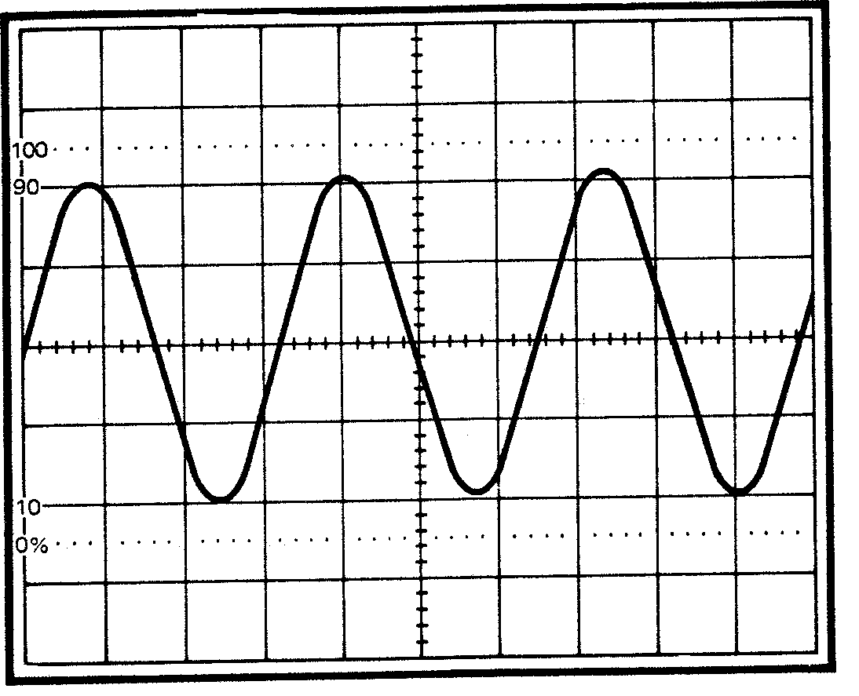  Figure 8.1.  Waveform | (8)  (6)  (3)  [17]

QUESTION 9  SAFETY PRECAUTIONS  - Explain how aids can be spread from one person to another.  - Explain what safety precautions you would follow in your workshop to prevent AIDS from spreading to workers.  TOTAL: | (3)  (2)  [5]  200

