GAUTENG DEPARTMENT OF EDUCATION

SENIOR CERTIFICATE EXAMINATION

ELECTRICIANSWORK SG

TIME: 3 hours

MARKS: 200

REQUIREMENTS:

- Drawing instruments and an approved calculator.

INSTRUCTIONS:

- Answer ALL the questions.
- Draw a line across the page in your answer book after completion of each question.
- Formulae and calculations, where applicable, must be shown.
- A list of formulae is provided on page 7.

QUESTION 1
ELECTRICAL CURRENT THEORY

- An inductor, and a 500 microfarad capacitor, are connected in series across a  12 volts supply. The total resistance of the coil and the connecting wires amounts to 6 ohm. If the frequency is 100 hertz and the capacitive reactance and inductive reactance are equal to each other,  calculate:  1.1.1 The inductance of the inductor in millihenries  - The current in the circuit  - The voltage across the capacitor | (8)  (4)  (2)

1.2 A parallel circuit consists of a resistor of 60 ohm, an coil with an inductance of  50 mH and a capacitor with a capacitance of 150 microfarad. If the supply is  120 V, 50 Hz,  calculate:  - The current in each component  - The total current in the circuit  - The power factor of the circuit  - The phase angle of the circuit | (10)  (3)  (2)  (2)

1.3 An alternating voltage with the equation e = 70,72 sin 314t is connected across a 100 ohm resistor.  - Determine the current through the resistor as measured by an ammeter.  - What is the frequency of the alternating voltage?  - Calculate the instantaneous value of the voltage 2 milli-seconds after it has been switched on. | (5)  (3)  (4)

1.4 Under which circumstances is the use of earth leakage protection equipment necessary? | (2)

1.5 What precautionary measures must an electrician take before he carries out maintenance on a machine with more than one electric motor? | (2)

  - The following readings were obtained as shown in Figure 1. Use all this information and show how these two waveforms will appear on an ossiloscope screen. The time / division is set on 2,5 mS.

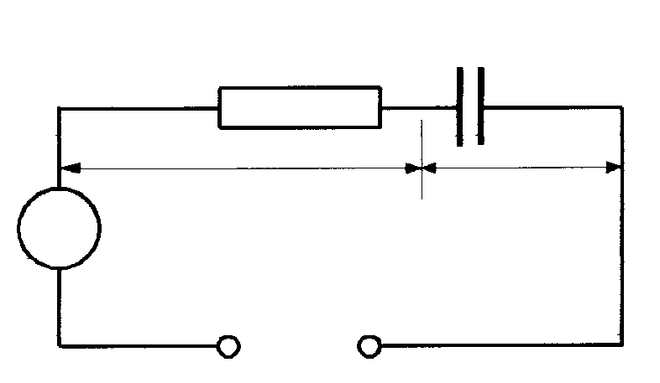  Resistor  Capacitor  Vr = 4 V  Vc = 10 V  A = 250 mA  A  There is a phase difference of 45º leading.  50 Hz | (13)  [60]

Figure 1

QUESTION 2
INSTRUMENTS AND THREE-PHASE ALTERNATING CURRENT SYSTEMS

2.1 Calculate the power factor of a load of 1,5 kW if the supply voltage is 220 volts, and the current taken by the load is 8,5 amperes. | (4)

- Sketch the phasordiagram of the active and re-active components of the current in Question 2.1 above, and calculate the values of these components of the current. | (10)

- Sketch a labelled diagram of a single-phase induction type wattmeter. The connections of the meter to the supply and the load must be clearly shown.  2.3.1 State TWO differences between the current and the voltage coils of the wattmeter. | (10)  (4)

2.4 Show with the aid of a diagram of connections how the wattmeter in Question 2.3 will be connected to an 11 kV supply. | (6)

2.5 What safety precaution must be taken when an ammeter is removed from a current transformer, and why is it necessary to take this precaution? | (6)  [40]

QUESTION 3
TRANSFORMERS

- The primary windings of three single-phase transformers are connected in delta to an 11 kV-supply. The secondary windings are connected to give an output of 380 and 220 volts. Sketch a diagram of the connections and clearly show the various voltages.  3.1.1 If the transformers supply a load of 100 kW, calculate the current in the primary and the secondary windings of each transformer. The power factor of the load is 0,8. | (8)  (8)

- Briefly explain why transformers heat up, and also why cooling is necessary. | (4)

- Sketch a phasor diagram showing the primary and secondary voltages of a single- phase transformer. | (3)

- The windings of an auto-transformer consist of 1200 turns, and are connected to a 220 volt supply. The secondary voltage is tapped at a point taking up 40% of the total winding.  - Draw a diagrammatic, fully labelled sketch, of the auto-transformer.  - Calculate the voltage at the tap. | (3)  (4)  [30]

QUESTION 4
ALTERNATING – CURRENT MOTORS

4.1 Briefly explain why a single phase induction motor without a starting winding cannot turn on its own when it has been switched on. | (2)

4.2 Sketch a labelled circuit diagram of a split-phase induction motor. | (6)

4.3 A two-pole, three-phase induction motor is connected to a 380 volt 50 hertz supply. The slip of the motor is 3%.  Calculate:  4.3.1 The synchronous speed  4.3.2 The rotor speed | (4)  (3)

4.4 Explain briefly the difference between synchronous speed and rotor speed. | (4)

4.5 Draw only the control circuit of the direct-on-line starter that can change the direction of rotation. (Change direction of rotation – three-phase motor) | (10)

4.6 The full load output of a 525 volt three-phase motor is 20 kW. If the input line current at full load is 30 ampere at a power factor of 0,866 what is the efficiency of the motor? | (4)

- The circuit that supplies a motor with power must have an overlead protection. Name FOUR conditions to which this overload protection must comply. | (4)

4.8 Draw a labelled sketch to show how the electron beam of a cathode ray tube is produced, formed, and focussed. | (9)  [46]

QUESTION 5
ELECTRONICS

5.1 A moving coil milli-ammeter has to be used to measure an alternating voltage of approximately 220 volts. Draw a fully labelled diagrammatic sketch of the meter and the components which have to be used with the meter to reach this goal. | (6)

5.2 With reference to a junction diode, explain the term depletion region, and state also the potential difference required to overcome the voltage of the depletion region if the diode is made of germanium. | (6)

5.3 Sketch the circuit diagram of a silicon NPN-transistor which is used as a switch to switch a pilot light on and off. | (5)  [17]

QUESTION 6
OCCUPATIONAL SAFETY

6.1 Explain how Aids can be spread from one person to another. | (3)

6.2 State the FOUR basic causes of industrial accidents. | (4)  [7]

TOTAL: | 200

