GAUTENG DEPARTMENT OF EDUCATION

SENIOR CERTIFICATE EXAMINATION

ELECTRICIANS WORK SG

TIME: 3 hours

MARKS: 200

REQUIREMENTS:

- Drawing instruments and an approved calculator.

INSTRUCTIONS:

- Answer ALL the questions.
- Question 4.7 must be answered on the answer sheet on page 8 and placed at the back of your answer book once you have finished.
- Draw a line across the page in your answer book upon completion of each question.
- Formulae and calculations, where applicable must be shown.
- A list of formulae is provided on page 9.

QUESTION 1
ELECTRICAL CURRENT THEORY

- A series circuit consists of a non-inductive resistor of 270 ohms, an inductor of 1200mH and a capacitor with a capacitance of 150 micro farads. A voltage of 100V, 50Hz is supplied to the circuit.  Calculate:  1.1.1 The impedance of the circuit  - The phase angle  - The current in the circuit  - The total power in the circuit | (9)  (3)  (2)  (3)

1.2 A parallel circuit consists of a non-inductive resistance of 25 ohms, an inductor with an inductive reactance of 120 ohms, and a capacitor with a capacitive reactance of 45 ohms. These components are connected to a 100 V-, 50 Hz supply.  Calculate:  - The current in each component  - The total current in the circuit  - The power factor of the circuit  - The phase angle of the circuit | (6)  (3)  (2)  (2)

1.3 Using projection lines draw a sine wave from a circle, (phasor representation of  an alternating quantity). Show the maximum value, the instantaneous value at an angle on the circle and the corresponding points on the curve. | (10)

1.4 An alternating voltage, represented by the equation e = 325sin 314t volts, is applied to a circuit consisting of the following components:  a 460 ohm resistor  a milli-ampere meter  a voltmeter  a frequency meter  Draw the circuit diagram and determine the readings indicated by the various instruments. | (10)

1.5 Why is the average value of an alternating voltage determined over half a cycle only? | (2)

- A sinusoidal alternating current has a maximum value of 7 ampere.  Determine:  1.6.1 The effective value  1.6.2 The instantaneous value if wt =$\frac{T}{6}$ | (2)  (4)

1.7 Name ONE disadvantage of a low power factor. | (2)  [60]

http://www.education.gpg.gov.za/matricinfo/past%20papers/70320CENG.doc

QUESTION 2
INSTRUMENTS AND THREE-PHASE ALTERNATING CURRENT SYSTEMS

2.1 With the aid of a detailed diagram, show how two single-phase watt meters are used to measure the power of a three-phase load. Indicate whether the load needs to be balanced or unbalanced. | (6)

- Three pure resistances of 50 ohms each are connected to a balanced 400 V three-phase supply.  Calculate:  2.2.1 The phase voltage, phase current, line current and power when the resistances are connected in star.  2.2.2 The phase voltage, phase current, line current and power when the resistances are connected in delta. | (10)  (9)

2.3 Draw a labelled sketch of a cathode-ray tube. | (9)

2.4 State THREE advantages of a three-phase system above a single-phase system. | (6)  [40]

QUESTION 3
TRANSFORMERS

3.1 State THREE methods of cooling used in transformers. | (6)

- A three-phase transformer with 4000 turns on the primary is connected in delta-star to a supply voltage of 5000 V. The full load line current on the primary is 20 A when the secondary line voltage is 400 V and the power factor is 0,95.  Calculate:  3.2.1 The secondary phase voltage  - The transformer turns ratio  - The number of secondary turns  - The primary phase current  - The secondary phase current  - The power output of the transformer | (4)  (4)  (4)  (4)  (4)  (4)  [30]

QUESTION 4
ALTERNATING – CURRENT MOTORS

4.1 What is meant by the power of a motor? | (2)

4.2 State the THREE torques which must be taken into account when a machine is driven. | (3)

4.3 What is the purpose of the star connection in the starting of three-phase motors? | (2)

- A three-phase motor of 20 kW with a lagging power factor of 0,9 is connected to a 380 V supply. The motor has an efficiency of 85% and is connected in delta.  Calculate:  4.4.1 The input power  - The line current  - The current value on which the overload should be set if 20% overload is permitted. | (3)  (3)  (3)

4.5 Explain briefly the difference between synchronous speed and rotor speed. | (4)

4.6 Draw a labelled circuit diagram of a capacitor start-and-run motor. | (6)

- This question must be done on the answer sheet on page 8. Place the answer sheet at the back of your answer book.  4.7.1 Label the motor in Figure 1.  - The end connections of the stator windings of a three-phase motor are usually brought out to a terminal block. Use Figure 2 and connect  Figure 2(a) in delta and Figure 2(b) in star on the answer sheet. | (4)  (6)

4.8 Explain fully what will happen when S1 in the control circuit is pressed. Use Figures 3(a) and 3(b) to answer the question as completely as possible. | (10)  [46]

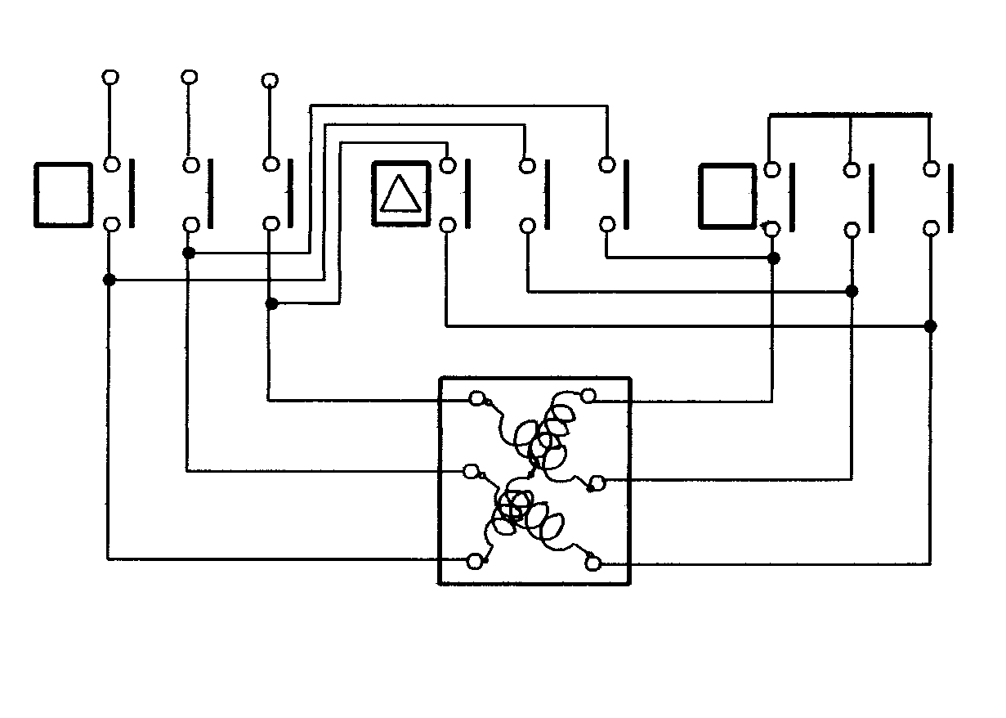
L1
L2
L3
M
Y
MC
c₁
a₂
c₂
b₂
b₁
a₁

Figure 3(a) – Main circuit

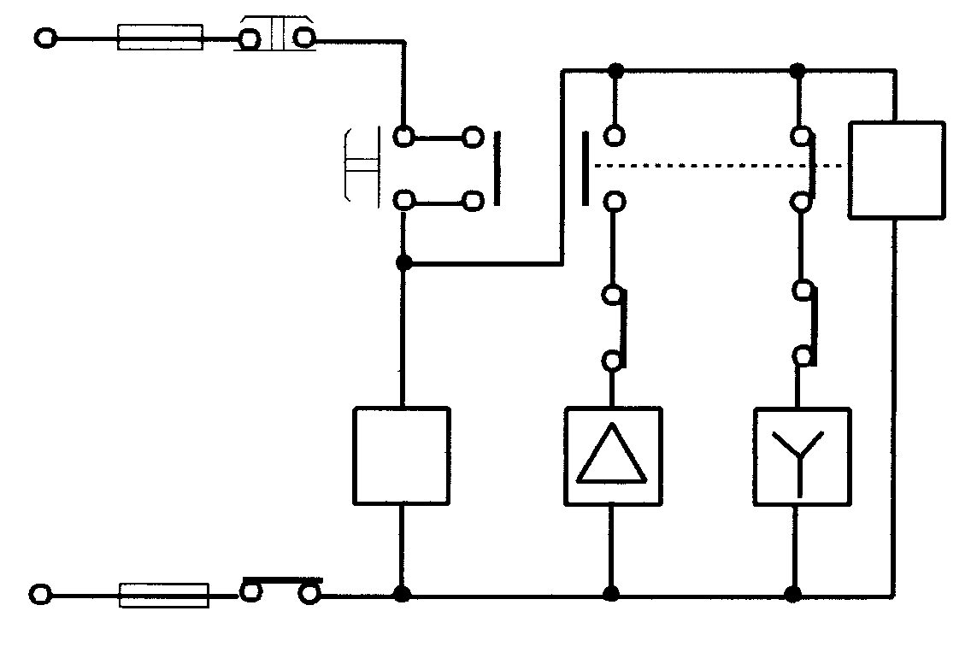
L1
MC 1
L3
S1
O.B
O.L
TR 2
TR
TR 1
MC 2

MC 3
NSS
NVC
M
Note:

TR – Time relay

NVC – No-volt coil

Figure 3(b) – Control circuit

QUESTION 5
ELECTRONICS

5.1 Name ONE characteristic of each of the three transistor configurations. | (3)

5.2 Under which biasing conditions will the bipolar transistor function correctly? | (4)

5.3 By means of a labelled diagram, indicate how a NPN-transistor can be used as a switch by using a globe as load. | (5)

5.4 State FIVE precautionary steps which must be taken when working with an oscilloscope. | (5)  [17]

QUESTION 6
OCCUPATIONAL SAFETY

6.1 Explain how Aids can be spread from one person to another. | (4)

6.2 State the THREE basic causes of industrial accidents. | (3)  [7]

TOTAL: | 200

ANSWER SHEET/ANTWOORDBLAD

EXAMINATION NUMBER/EKSAMENNOMMER

4.7.1
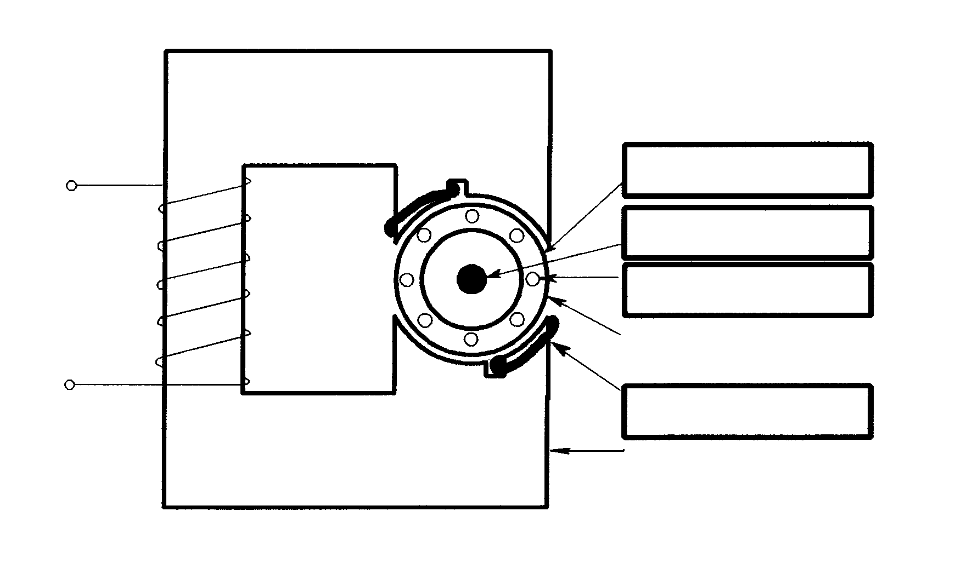
Winding/

Spoel

Supply/

Toevoer
Short circuiting ring/
Kortsluitring

Laminated core/

Gelamineerde kern

Figure/Figuur 1

4.7.2
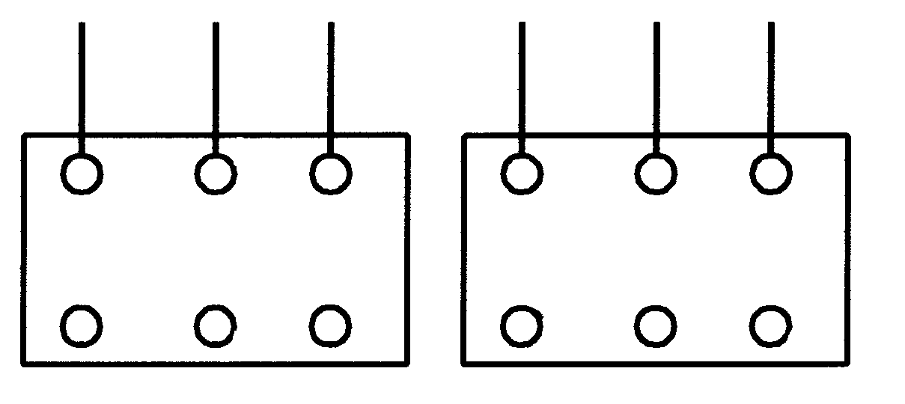
a1
b2
a2
c1
b1
a1
b2
a2
c2
c2
b1
c1
Fig 2(a) –Delta/Delta
Fig 2(b) –Star/Ster

Figure 2 – Terminal block/Figuur 2 – Verbindingsblokke

