GAUTENG DEPARTMENT OF EDUCATION
SENIOR CERTIFICATE EXAMINATION

ECONOMICS SG

TIME: 3 hours

MARKS: 300

INSTRUCTIONS:

- This exam paper consists of TWO sections:
SECTION A: Question 1 is COMPULSORY.
SECTION B: There are seven questions. Answer FIVE questions ONLY.
- Answer Question 1 on the answer sheet on the inside cover of your answer book.
- Facts must be given systematically and where possible, point by point.
- In questions with the instruction LIST, no discussion is required.

SECTION A

COMPULSORY

QUESTION 1

1.1 The total remuneration that South African owners of the factors of production receive for their services in the production processes over a specific period of time is called

A. per capita national income.
B. national income.
C. national expenditure.
D. national production.

1.2 South Africa has an open economy, therefore, business cycles in this country are to a large extent

A. determined by interest rates.
B. determined by unemployment rates.
C. affected by the business cycles of industrial countries.
D. affected by the business cycles of the developing countries.

1.3 The largest component of the National Income is

A. wages/salaries.
B. interest.
C. expenditure by workers.
D. income of landlords.

1.4 The market value of all the final products produced during a certain period within the boundaries of a country, is the

A. per capita GNP.
B. per capita GDP.
C. GNP.
D. GDP.

1.5 A payment for which there is no productive service rendered in exchange is

A. national income.
B. transfer payment.
C. added value.
D. tax.

1.6 Goods produced by a German company in South Africa must be included when determining the

A. real national income.
B. gross domestic product.
C. gross national product.
D. nominal national income.

1.7 Which one of the following will be included in the national income calculations?

A. Unemployment benefits
B. Old age pension
C. Remuneration for part-time work
D. A volunteer worker

1.8 Wants

A. are limited in number.
B. are limited in variety.
C. are unlimited in intensity.
D. complement one another.

1.9 The degree of satisfaction that is derived from the consumption of particular goods or services, is known as

A. marginal utility.
B. utility.
C. exchange value.
D. demand.

1.10 Normally, there will be an increase in the demand for a product if

A. the price of a substitute decreases.
B. income increases.
C. the price increases.
D. the supply increases.

1.11 An example of an economic good is

A. noise.
B. air.
C. sunlight.
D. butter.

1.12 The want for a Pajero 4X4 motor vehicle is an example of a ______ want.

A. natural
B. primary
C. luxury
D. cultural

1.13 An increase in supply, shifts the supply curve

A. to the right.
B. to the left.
C. towards equilibrium.
D. upwards.

1.14 A ton of sand ______ may be recognised as an economic good.

A. in the sea
B. in a river
C. in the desert
D. on a building site

1.15 A characteristic of developing economics is

A. moderate living standards.
B. dependence on industries.
C. low levels of unemployment.
D. low levels of productivity.

1.16 The basic aim of economic development is to

A. promote the knowledge of economic development.
B. stimulate the informal sector.
C. eradicate poverty.
D. foster socialism.

1.17 One of the basic objectives of the RDP/GEAR is to

A. export goods.
B. import goods.
C. meet basic needs.
D. achieve a low growth rate.

1.18 The process whereby people move from rural areas to urban areas is known as

A. immigration.
B. urbanisation.
C. emigration.
D. squatting.

1.19 Illegal businesses are part of the ______ sector.

A. rural
B. recorded
C. formal
D. informal

1.20 The South African economy can best be described as a ______ economy.

A. market
B. dualistic
C. planned
D. gold

1.21 The ratio at which rands are exchanged for pounds is known as the

A. exchange rate.
B. price.
C. bank rate.
D. interest rates.

1.22 Imports create a

A. demand for foreign currency.
B. supply of foreign currency.
C. increase in the circulation of money.
D. stable exchange rate.

1.23 Under a system of fixed exchange rates, the deliberate measure taken by the government to decrease the value of its currency is known as

A. depression.
B. appreciation.
C. devaluation.
D. revaluation.

1.24 The harshest form of protection that a country can apply is

A. custom duties.
B. import quotas.
C. import prohibition.
D. import deposits.

1.25 A country usually imposes import quotas

A. because imported goods are scarce.
B. because its balance of payment is favourable.
C. because it is too expensive to import goods.
D. to restrict the importation of goods.

1.26 When the government wants to restrict imports drastically, a system of import ______ is applied.

A. creation
B. quotas
C. restriction
D. substitution

1.27 Trade with foreign countries is included in a/an ______ economy.

A. open
B. closed
C. mixed
D. macro

1.28 The budget speech is usually delivered by the

A. President of the Reserve Bank.
B. Auditor general.
C. Minister of Economic Affairs.
D. Minister of Finance.

1.29 One of the methods that can be used to reduce government expenditure is

A. privatisation.
B. nationalisation.
C. deregulation.
D. employment.

1.30 Which one of the following is an example of a progressive tax?

A. VAT
B. PAYE
C. A car license
D. A TV license

1.31 The budget is approved by the

A. Parliament.
B. Minister of Industry.
C. State President.
D. Minister of Finance.

1.32 Which one of the following is a punishable offence?

A. Tax evasion
B. Tax avoidance
C. Incidence of tax
D. Shifting of tax

1.33 Shifting of taxes applies to

A. inheritance tax.
B. customs duties.
C. indirect tax.
D. income tax.

1.34 New urgent expenditures, for which no provision has been made in the main budget, are included in the ______ budget.  A. additional  B. supplementary  C. final  D. partial 34x3= | (100)

TOTAL FOR SECTION A: | [100]

SECTION B

Answer any fIVE questions in this section.

QUESTION 2

NATIONAL INCOME

2.1 Study the National Income figures as stated on the table below and answer the questions that follow.

 |  |  | 1995
 | 1. | Compensation of employees | 274 664
 | 2. | Net operating surplus | 145 700
 | 3. | Consumption of fixed capital | 71 827
 | 4. | Gross value added at factor cost | (a)
 | 5. | Other taxes on production | 10 517
 | 6. | less Other subsidies on production | 2 352
 | 7a. | Gross value added at basic prices | (b)
 | 7b. | Gross value added at basic prices (real) | 500 354
 | 8. | Taxes on products | 53 644
 | 9. | less Subsidies on products | 5 898
 | 10a | Gross domestic product at market prices | (c)

2.1.1 Calculate (a).  2.1.2 Calculate (b).  2.1.3 Calculate (c). | (4)  (4)  (3)

2.2 Define the following concepts:

2.2.1 National income  2.2.2 Transfer payment | (3)  (3)

2.3 Choose the correct answer from within the brackets. Write down the numbers 2.3.1 – 2.3.5 one below the other and next to each the correct answer.

2.3.1 The per capita National Income tends to be higher in (agricultural / industrial) countries

2.3.2 (Macro / Micro) economics is the study of a country’s economy as a whole.

2.3.3 Economic growth refers to the (increase / decrease) in the production capacity.

2.3.4 Households (buy / sell) their services from / to the business sector.

- When calculating National Income figures, leisure time (is included / is not included). 5x2= | (10)

2.4 Explain how the availability of natural resources in South Africa can be regarded as a method to increase economic growth. | (5)

2.5 Analyse households’ expenditure. | (8)  [40]

QUESTION 3

PRICE FORMATION

3.1 Explain FOUR characteristics of wants. | (12)

3.2 Explain taste and habits as a cause of a change in demand. | (4)

3.3 Select the correct answer from within the brackets and write only the answer next to the number in your answer book.

3.3.1 An / A (increase / decrease) in price decreases demand.

3.3.2 The fact that one want may give rise to other wants shows that wants are (complementary / substitutes).

3.3.3 Utility is (directly / indirectly) related to the demand for a good or a service.

3.3.4 One cannot survive without the satisfaction of (basic / secondary) wants.

3.3.5 Products are homogenous in the (perfect / imperfect) market. 5x2= | (10)

3.4 Study the graph below and answer the questions that follow.

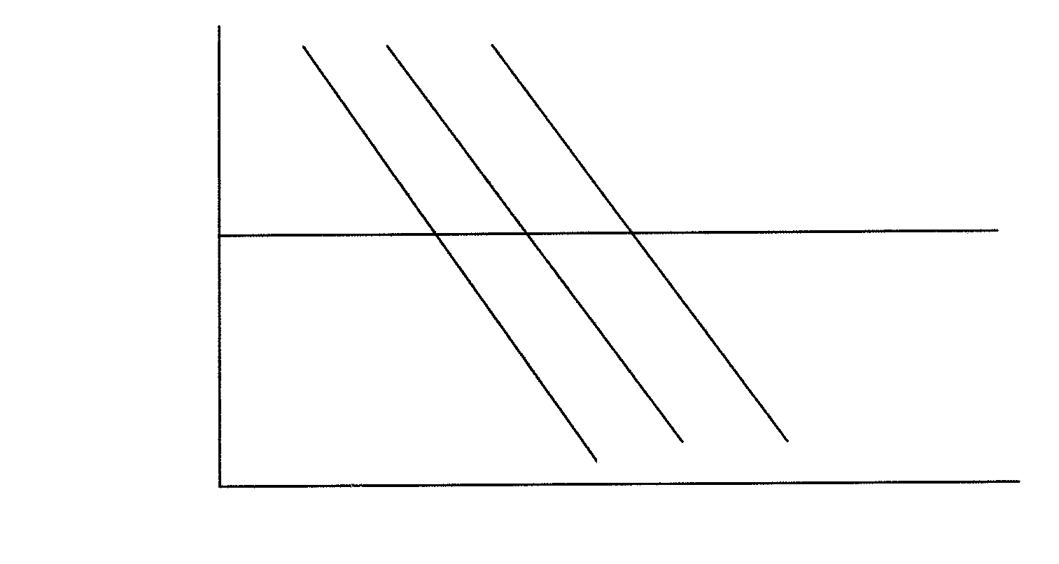
V1
V
V2
250
200
150
100
50
0

PRICE

V1
V
V2

50 | 100 | 150 | 200 | 250 | 300

QUANTITY

3.4.1 Which curve is the original demand curve? | (3)

3.4.2 According to the original demand curve, how much will be demanded at R150? | (3)

3.4.3 After a decrease in quantity demanded, how many goods were purchased at R150? | (3)

3.4.4 Does the demand curve have a positive or a negative slope? | (3)

3.5 Define utility. | (2)  [40]

QUESTION 4

ECONOMIC DEVELOPMENT, REGIONAL DEVELOPMENT AND URBANISATION

4.1 Discuss THREE characteristics of the informal sector. | (12)

4.2 Explain low levels of productivity as a characteristic of developing economies. | (4)

4.3 List TWO advantages of urbanisation. | (4)

4.4 Define the following concepts:

4.4.1 Urbanisation  4.4.2 Regional development | (2)  (2)

4.5 Choose the correct answer from within the brackets. Write only the correct answer next to the corresponding number in your answer book.

4.5.1 South Africa has a (dualistic / monopolistic) economy.

4.5.2 Developing economies usually have a (high / low) mortality rate.

4.5.3 The high levels of unemployment in developing countries are a result of (productivity / lack of skills).

4.5.4 Developing economies depend mainly on the (manufacturing / agricultural) sector.

- The establishment of certain industries in less prosperous areas is  known as (decentralisation / centralisation). 5x2= | (10)

4.6 Study the illustration below and answer the questions that follow.

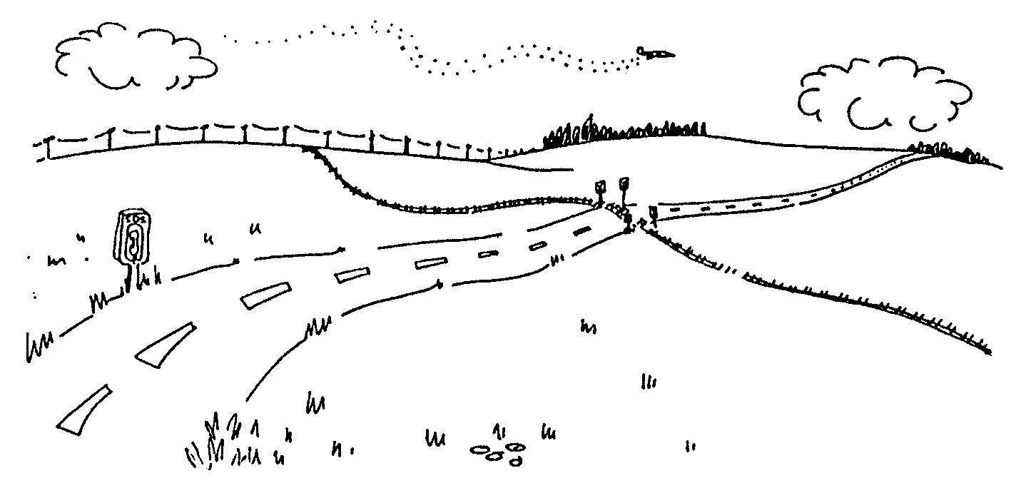

4.6.1 The facilities illustrated above are provided by the government as part of its regional development programme. What are these facilities called? | (3)

4.6.2 Name ONE other focus of government’s regional development programme. | (3)  [40]

QUESTION 5

INTERNATIONAL TRADE

5.1 Explain FIVE causes of international trade. | (15)

5.2 Define the concept rates of exchange. | (2)

5.3 List TWO factors that will create a supply of foreign exchange. | (4)

5.4 Study the table of the balance of payments account and answer the question that follows.

 | Table 31: Balance of Payments Annual Figures R Millions |  | Table 3: Betalingsbalans Jaarsyfers R Miljoene
 |  |  |  | 1995 | 1996 | 1997 | 1998 | 1999
 | 1. | Current account/Lopende rekening
 | 1.1 | Merchandise exports / Goedere uitvoere …………………………………………….. |  | 86 580 | 103 906 | 118 012 | 135 054 | 148 998
 | 1.2 | Nett gold exports / Netto goud uitvoere ……………………………………………….. |  | 22 538 | 26 300 | 25 818 | 25 907 | 24 279
 | 1.3 | Service receipts / Dienste ontvangstes ……………………………………………….. |  | 16 751 | 21 589 | 24 587 | 29 126 | 30 294
 | 1.4 | Income receipts / Inkome ontvangstes ………………………………………………… |  | 4 128 | 4 663 | 6 011 | 7 255 | 8 627
 | 1.5 | Less: Merchandise imports / Min: Goedere invoere ………………..………………. |  | 99 425 | 118 658 | 133 061 | 150 751 | 150 377
 | 1.6 | Less: Payments for services / Min: Betaling vir dienste …………………………… |  | 21 667 | 24 681 | 27 657 | 30 209 | 32 960
 | 1.7 | Less: Income payments / Min: Inkome betalings …………………………………… |  | 14 554 | 18 041 | 20 808 | 23 936 | 26 051
 | 1.8 | Current transfers (nett receipts +) / Lopende oordragte (netto ontvangstes +) …… |  | -2 340 | -3 206 | -3 328 | -4 076 | -5 661
 | 1.9 | Balance on current account / Saldo op lopende rekening ……………………… |  | -7 989 | -8 128 | -10 426 | -11 630 | -2 851
 | 2. | Capital transfer account (nett receipts +)  Kapitaaloordragrekening (netto ontvangstes+) ……………………………………….. |  | -145 | -203 | -892 | -310 | -261
 | 3. | Financial account / Finansiële rekening
 | 3.1 | Direct investment / Direkte beleggings
 | 3.1 | (a) Liabilities / Laste¹ |  | 4 502 | 3 515 | 17 587 | 3 104 | 8 411
 | 3.1 | (b) Assets / Bates² |  | -9 059 | -4 485 | -10 831 | -9 575 | -6 813
 | 3.2 | Nett direct investments / Netto direkte beleggings …………………………………. |  | -4 557 | -970 | 6 756 | -6 471 | 1 598
 | 3.3 | Portfolio investment / Portefeulje beleggings
 | 3.3 | (a) Liabilities / Laste …………………………………………………………………… |  | 10 651 | 17 983 | 51 563 | 50 452 | 82 389
 | 3.3 | (b) Assets / Bates ……………………………………….…………………………….. |  | -1 631 | -8 407 | -20 983 | -30 077 | -31 344
 | 3.3 | (c) Nett portfolio investment / Netto portefeulje beleggings …>………………….. |  | 9 020 | 9 576 | 30 580 | 20 375 | 51 045
 | 3.4 | Other investments / Ander beleggings
 | 3.4 | (a) Liabilities / Laste ……………………………………….…………………………... |  | 17 217 | 7 492 | -1 330 | 6 534 | -19 307
 | 3.4 | (b) Assets / Bates ……………………………………….…………………………….. |  | -1 899 | -2 704 | -8 957 | -2 872 | -8 200
 | 3.4 | (c) Nett other investment / Netto ander beleggings …………...…………………… |  | 15 318 | 4 788 | -10 287 | 3 662 | -27 507
 | 3.5 | Balance on financial account / Saldo op finansiële rekening ………………….. |  | 19 781 | 13 394 | 27 049 | 17 566 | 25 136
 | 3.6 | Unrecorded transactions / On-aangetekende transaksies³ ………………………….. |  | -3 060 | -10 166 | -4 869 | -9 643 | 2 251
 | 4. | Change in nett gold and other foreign reserves owing to balance of payments transactions / Verandering in netto goud- en ander buitelandse reserwes weens betalingsbalanstransaksies ……………………………………. |  | 8 587 | -5 103 | 10 862 | -4 017 | 24 275
 | 4.1 | Change in liabilities related to reserves /  Verandering in laste verwant aan reserwes⁴ .………………………………………… |  | -5 306 | -6 | 8 089 | 4 529 | -65
 | 4.2 | SDR allocations and valuation adjustments /  STR-toekennings en waardasie-aansuiwerings ……………………………………… |  | 315 | 3 245 | 257 | 6 165 | 1 144
 | 5. | Change in gross gold and other foreign reserves ……………………………….. |  | 3 596 | -1 864 | 19 208 | 6 677 | 25 354
 | 1. | Investment by foreigners in enterprises in South Africa in which they have individually or collectively in the case of affiliated organisations or persons at least 10 percent of the voting rights. |  |  |  | Adapted from SARB QB S-84
 | 2. | Investment by South African residents in enterprises abroad in which they have at least 10 percent of the voting rights.
 | 3. | Transactions on the current, capital transfer and financial accounts.
 | 4. | Liabilities related to foreign reserves include all foreign short-term liabilities of the Reserve Bank and short-term foreign loans to the Central government by international organisations.

5.4.1 Name any ONE balance that is reflected on the balance of payments. | (3)

5.4.2 How much was the nett gold export in 1995? | (3)

5.4.3 Was the balance on the current account favourable or unfavourable in 1998? | (3)

5.5 Choose the correct word from within the brackets. Write only the correct answer next to the corresponding question number in your answer book.

5.5.1 The terms appreciation and depreciation relate to (fixed / floating) exchange rates.

5.5.2 An (export subsidy / import deposit) is the financial assistance which the state gives to an industry with great export potential.

5.5.3 Short-term capital transactions normally have a term of (more than 12 months / less than 12 months).

5.5.4 South Africa has a (fixed / floating) rate of exchange.

5.5.5 The currency of Zimbabwe is the Zimbabwean (pound / dollar). 5x2= | (10)  [40]

QUESTION 6

THE STATE

6.1 Name the final stage in the financial procedure of the budget. | (2)

6.2 Explain public debt and its consequences. | (6)

6.3 Match the concept in Column B with the statement in Column A. Write down the numbers 6.3.1 – 6.3.5 one below the other and the correct answer next to each number e.g. 6.3.6 H.

 | COLUMN A |  | COLUMN B
 | 6.3.1 | A worker receives remuneration without working | A.  B.  C.  D.  E.  F.  G. | indirect tax  direct tax  ghost worker  customs duty  import quotas  import restrictions  capital gains tax
 | 6.3.2 | A duty imposed on imported goods | A.  B.  C.  D.  E.  F.  G.
 | 6.3.3 | Value added tax | A.  B.  C.  D.  E.  F.  G.
 | 6.3.4 | Pay as you earn | A.  B.  C.  D.  E.  F.  G.
 | 6.3.5 | Taxation on profits realised on the selling of fixed assets. | A.  B.  C.  D.  E.  F.  G.

5x2= | (10)

6.4 Describe the following concepts with regard to tax:

6.4.1 Tax avoidance | (3)

6.4.2 Progressive taxation | (3)

6.4.3 Incidence of tax | (3)

6.5 Define privatisation. | (4)

6.6 Study the illustration below and answer the questions that follow.

Is that all I’ve got left?
John, I’ve got to take off those deductions. Some of these are voluntary and others are compulsory. Unfortunately they have to be paid to the government.
Do you really have to tell the govern-ment about me?
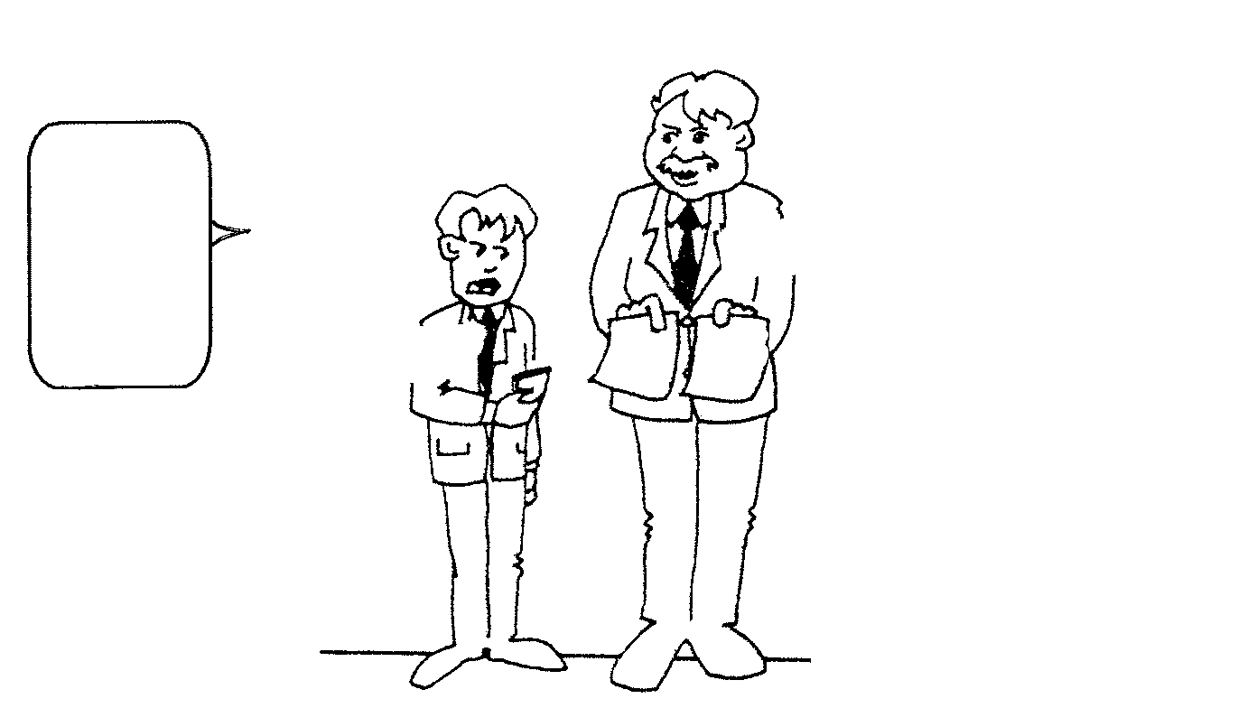
Do you
really have
to tell the govern-
ment about me?

Employee

Employer

6.6.1 What deduction is the employer talking about? | (3)

6.6.2 Can the employee shift this deduction? | (3)

6.6.3 Calculate the total deductions from the employee’s salary? | (3)  [40]

QUESTION 7

Answer any TWO of the following sections.

7.1 LABOUR

7.1.1 Study the picture below and answer the questions that follow.

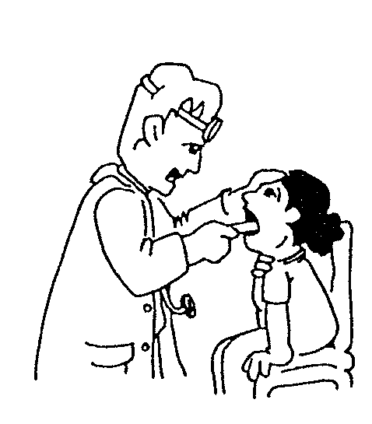

(a) How could you classify the type of labour illustrated above? | (3)

(b) How does South Africa compare to the USA in terms of the type of labour illustrated above? | (3)

(c) List TWO functions of a trade union. | (4)

(d) Discuss how population as a factor determines the supply of labour. | (4)

7.1.2 Choose the correct word from within the brackets. Write down the letters (a) – (c) below one another and next to each the correct answer.

(a) Labour supply is determined by the (population growth / money in circulation).

(b) A trade union is an organization representing (employees / pensioners).

(c) The demand for labour is a (fixed / deduced) demand. | (6)  [20]

7.2 PRODUCTIVITY AND UNEMPLOYMENT

7.2.1 Name TWO methods how education and training can be used to improve the quality of a labour force. | (4)

7.2.2 Explain how the quality of a labour force can be a measure to improve productivity. | (4)

7.2.3 Explain growth of production as a measure to combat unemployment. | (4)

7.2.4 Choose the correct word from within the brackets. Write down the letters (a) – (d) below one another and next to each the correct answer.

(a) Population Development Program deals with the growth of (labour force / industries). | (2)

(b) Productivity (increases / decreases) economic growth rate. | (2)

(c) (Unemployment / Full employment) is a situation commonly experienced in South Africa. | (2)

(d) Generally the effects of unemployment could have a (stabilising / destabilising) impact on a society. | (2)  [20]

7.3 INFLATION

7.3.1 Explain the following concepts:

(a) Cost push inflation  (b) Demand pull inflation  7.3.2 List any THREE fiscal measures that can be applied to fight inflation.  3x2 = | (4)  (4)  (6)

7.3.3 Match the correct concept in Column B with the statement in Column A. Write down the letters (a) – (c) below one another and next to each the correct answer.

 |  | COLUMN A |  | COLUMN B
 | (a) | Can be implemented by the Reserve Bank | A.  B.  C.  D. | inflation  deflation  monetary measure  fiscal measure
 | (b) | The government’s taxation and spending policies | A.  B.  C.  D. | inflation  deflation  monetary measure  fiscal measure
 | (c) | Considerable increase in the general price level as a result of monetary causes | A.  B.  C.  D. | inflation  deflation  monetary measure  fiscal measure
 |  |  | A.  B.  C.  D. | inflation  deflation  monetary measure  fiscal measure | (6)
[20]

7.4 STRATEGIC RESOURCES

7.4.1 Read the extract carefully and answer the questions that follow.

Most of South Africa’s annual rainfall
occurs within 6 months of the year. A
system of water storage is essential in
order to supply water to cities, industry
and agriculture during the dry months.
This is done mostly by the building of
dams.

There are over 300 large dams in South
Africa. Some of these are connected to
electricity generating stations. As water
passes through pipes in the dam wall,
the water’s force is used to power
electricity generators. Electricity made
in this way is called Hydroelectric
Power or H.E.P.

(a) According to the information above, there are TWO reasons for water storage into dams. Name the reasons. | (4)

(b) List FOUR important reasons for water conservation. | (8)

(c) Where in South Africa is the first gas field located? | (2)

7.4.2 Match the correct concept in Column B with the statement in Column A. Write down the letters (a) – (c) below one another and next to each the correct answer.

 | A |  | B
 | (a) | generation of power through water | A. | Escom
 | (b) | produces fuel from coal | B. | Hydroelectricity
 | (c) | supplies electricity | C. | Iscor
 |  |  | D. | Sasol | (6)
[20]

QUESTION 8

GENERAL

8.1 Read the extract carefully and answer the questions that follow.

 | The United States pharmaceutical giant,  Pfizer, will begin distributing the drug  Diflucan free to HIV and Aids patients at  government hospitals and clinics, the  National Health Department and Pfizer  said yesterday.  The Health Department removed a  block to the drug’s distribution by  approving Diflucan for the treatment of  esophageal candidiasis, a fungal infec-  tion of the throat that occurs in up to 40  percent of Aids patients. | A joint news release from the depart-  ment and Pfizer said that the drug maker  was developing labels that fulfilled the  Government’s requirements and that dis-  tribution to patients would begin “within  the next few weeks.”  Konji Sebati, a Pfizer spokesman,  said the programme would include distri-  bution to patients suffering from these  two opportunistic diseases as well as  patient and physician education.
 | The drug, generically known as Flu-  conazole, is already used in South Africa  as treatment for cryptococcal meningitis,  an infection of the brain that occurs in 10  percent of Aids patients.  Health Minister Manto Tshabalala-  Msimang said the approval was “a sig-  nificant step forward in South Africa’s  battle against HIV-Aids.” | Patients would be given the drug for  as long as they needed it. Patients who  are in the programme when it ends in  December 2002 will continue to receive  the medication free, Pfizer said.  Up to 100 000 South Africans are  thought to suffer from the two illnesses.  The programme is expected to cost  Pfizer more than R375 million.  - Sapa-AP  Sowetan 22-02-2001

8.1.1 Who is the Minister of Health? | (3)

8.1.2 How many South Africans are estimated to be affected by the two Aids related diseases? | (3)

8.1.3 What is the impact of Aids on the productivity of labour in South Africa as a developing economy? | (3)

8.1.4 As the drug is distributed freely, who will bear the cost? | (3)

8.2 Discuss protection as one of the functions of the government. | (6)

8.3 Match the concept in Column B with the statement in Column A. Write down the numbers 8.3.1 – 8.3.5 one below the other and next to each the correct answer. E.g. 8.3.6 G.

 | COLUMN A |  | COLUMN B
 | 8.3.1 | During the 1980s, South Africa lost export earnings | A.  B.  C.  D.  E.  F. | currencies  unemployed  surplus  imports  exports  sanctions
 | 8.3.2 | People willing and able to work but who cannot find work | A.  B.  C.  D.  E.  F. | currencies  unemployed  surplus  imports  exports  sanctions
 | 8.3.3 | Refers to money in an international context | A.  B.  C.  D.  E.  F. | currencies  unemployed  surplus  imports  exports  sanctions
 | 8.3.4 | When income exceeds expenditure | A.  B.  C.  D.  E.  F. | currencies  unemployed  surplus  imports  exports  sanctions
 | 8.3.5 | Earn foreign exchange | A.  B.  C.  D.  E.  F. | currencies  unemployed  surplus  imports  exports  sanctions

5x2= | (10)

8.4 Explain THREE arguments in favour of the protection of domestic industries. | (12)  [40]

TOTAL FOR SECTION B: | [200]

TOTAL: | 300

