GAUTENG DEPARTMENT OF EDUCATION
SENIOR CERTIFICATE EXAMINATION

ECONOMICS SG

TIME: 3 hours

MARKS: 300

INSTRUCTIONS:

- This exam paper consists of TWO sections:
SECTION A: Question 1 is COMPULSORY.
SECTION B: There are seven questions. Answer FIVE questions ONLY.
- Answer Question 1 on the answer sheet on the inside cover of your answer book.
- Facts must be given systematically and where possible, point by point.
- In questions with the instruction LIST, no discussion is required.

SECTION A

COMPULSORY

QUESTION 1

1.1 Successive periods of decreasing and increasing economic activities are known as

A. inflation.
B. structural changes.
C. business cycles.
D. economic growth.

1.2 In calculating national income, old age pensions are not included, because

A. they are not a payment for productive services.
B. the state pays the pensions.
C. the amount is relatively small.
D. the amount cannot be calculated accurately.

1.3 Individual economic decision making and behaviour are studied in ______ economics.

A. monetary
B. macro
C. micro
D. public sector

1.4 The purchasing power of the worker is determined by his or her ______ wage.

A. money
B. real
C. actual
D. rental

1.5 Foreign trade is excluded from a/an ______ economy.

A. developed
B. closed
C. open
D. underdeveloped

1.6 The real national income is also known as national income at ______ prices.

A. constant
B. current
C. nominal
D. monetary

1.7 The national income figures of South Africa are inter alia compiled by the

A. Central Statistical Services.
B. Department of Economic Affairs.
C. Department of Finance.
D. Auditor-General.

1.8 The ability of a commodity to satisfy a want is called a

A. want.
B. utility.
C. price.
D. choice.

1.9 Study the table and answer the question that follows.

 | APPLES | utility | TOTAL UTILITY
 | 1 |  | 10
 | 2 |  | 14
 | 3 |  | 17

The utility of the second apple will be ______.

- 4
- 14
- 17
- 3

1.10 If an increase in demand is experienced and the supply remains constant, the

A. demand curve will shift to the left.
B. supply curve will shift to the left.
C. demand curve will shift to the right.
D. supply curve will shift to the right.

1.11 Television sets, trucks and equipment are known as ______ goods.

A. free
B. semi-durable
C. non-durable
D. durable

1.12 The rate at which a particular good can be exchanged for another is called the exchange

A. quality.
B. value.
C. use.
D. quantity.

1.13 In general, there will be an increase in the demand for a product if

A. the price of a substitute drops.
B. income increases.
C. the price increases.
D. the supply increases.

1.14 The value of goods and services is measured by its

A. production cost.
B. usefulness.
C. utility value.
D. price.

1.15 Regional development refers to policies which are aimed at increasing the economic activities of

A. cities.
B. specific areas or regions.
C. homelands.
D. the whole country.

1.16 The general strategy of South Africa’s urbanisation policies determines that

A. urbanisation must take place on a discriminatory basis.
B. undesired individuals or groups be removed.
C. balanced towns should be established.
D. people need not pay for services.

1.17 An expansion in the capacity to produce goods and services is known as

A. economic development.
B. economic growth.
C. urbanisation.
D. economic production.

1.18 The success of regional development can be measured by

A. lower real per capita income.
B. sufficient employment opportunities.
C. more consumption.
D. more imports.

1.19 One of the conditions of a perfect market is

A. that the products are homogenous.
B. discrimination through taxation.
C. restricted access to and from markets.
D. ignorance of prices and activities of sellers.

1.20 The most important method to measure economic development in a country is the

A. literacy rate.
B. national income.
C. rate of industrialisation.
D. exports minus imports.

1.21 Which one of the following is the main component of the South African balance of payment?

A. Goods exported
B. Transfers
C. Current account
D. Gold exported

1.22 One of the problems (difficulties/differences) of trading internationally is that

A. countries use different monetary systems.
B. countries use the same monetary system.
C. there are no transport costs.
D. all countries use the same language.

1.23 A South African tourist is visiting Australia. In the balance of payment, that would be called

A. service receipts.
B. income receipts.
C. merchandise receipts.
D. payments for services.

1.24 The balance on the current account of the balance of payments include

A. capital transfer.
B. foreign exchange reserves.
C. nett portfolio investments.
D. services rendered and received.

1.25 An American investor purchases shares on the Johannesburg Stock Exchange and sells them six months later. This will be reflected in the balance of payment account of South Africa’s

A. financial account.
B. current account.
C. change in nett gold and foreign reserves.
D. shares account.

1.26 Custom duties imposed according to the value of imported goods is called

A. single tariffs.
B. specific tariffs.
C. ad valorem.
D. excise duties.

1.27 The most important purpose of exchange control in South Africa is the

A. restriction of capital outflow.
B. support of the gold price.
C. improved functioning of the financial markets.
D. deflation of the economy.

1.28 Specific duties are levied

A. as a fixed percentage of the value of imported goods.
B. as a certain amount per unit imported.
C. as a fixed percentage plus a certain amount per unit.
D. on each article irrespective of the country of origin.

1.29 The budget for the new, urgent matters which have not been provided for in the main budget, is called a ______ budget.

A. partial
B. additional
C. supplementary
D. capital

1.30 The budget is

A. a document describing expected state income and expenditure.
B. an overview of the economy by the Minister of Finance.
C. a statistical record of all transactions between the citizens of a country.
D. the sum total of local and foreign loans.

1.31 The state’s role in providing health care for its citizens is seen as a function of the state in

A. maintaining law and order.
B. promoting social welfare.
C. controlling money and banking.
D. offering technical advice to private business.

1.32 Which one of the following taxes can be shifted?

A. VAT
B. PAYE
C. A car license
D. A TV license

1.33 One of the aims of privatisation is to transfer ownership and activities from the

A. public sector to the private sector.
B. private sector to the public sector.
C. monetary sector to the fiscal sector.
D. primary sector to the secondary sector.

1.34 A tax system is ______ when everybody is taxed at the same rate.  A. progressive  B. proportional  C. democratic  D. direct 34x3= | (100)

TOTAL FOR SECTION A: | [100]

SECTION B

Answer any fIVE questions in this section.

QUESTION 2

NATIONAL INCOME

2.1 Study the diagram below and answer the questions that follow.

PARTICIPANTS
IN
THE
ECONOMY
 | HOUSE-  HOLDS |  | BUSINESS  SECTOR |  |  |  | THE GOVERNMENT

2.1.1 To which type of economy does the above diagram make reference? | (3)

2.1.2 Which participant supplies the production factors? | (3)

2.1.3 The economy that has foreign trade is called an ______ economy. | (3)

2.2 Explain FOUR problems in determining National Income figures. | (12)

2.3 Match the concept in Column A with the statement in Column B. Write down the numbers 2.3.1 – 2.3.5 below each other and next to each the letter which represents the correct answer. E.g. 2.3.6 G.

 | COLUMN A |  | COLUMN B
 | 2.3.1 | primary sector | A. | various kinds of tax
 | 2.3.2 | economic growth | B. | agriculture, forestry, mining
 | 2.3.3 | government income | C. | excluded in National Income figures
 | 2.3.4 | business cycle | D. | increase in the production capacity
 | 2.3.5 | pollution | E. | prosperity / depression
 |  |  | F. | industries

2x5= | (10)

2.4 Explain how the availability of labour can be seen as a method of increasing productivity. | (6)

2.5 Define economic growth. | (3)  [40]

QUESTION 3

PRICE FORMATION

3.1 Explain THREE conditions of a perfect market. | (9)

3.2 Study the picture below and answer the questions that follow.

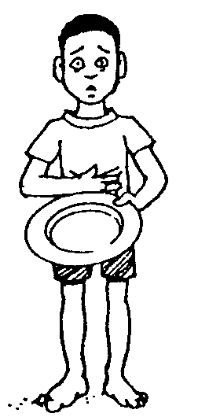

3.2.1 Name the basic want of the child pictured above. | (2)

3.2.2 Name the TWO other basic wants. | (4)

3.2.3 Explain with the aid of an example the concept: wants become habits. | (4)

3.3 Match the statement in Column A with the concept in Column B. Write down the numbers 3.3.1 – 3.3.5 below each other and next to each the letter which represents the correct answer. E.g. 3.3.6 H.

 | COLUMN A |  | COLUMN B
 | 3.3.1 | A desire | A.  B.  C.  D.  E.  F.  G. | utility  price  scarcity  want  cultural want  resources  law of demand
 | 3.3.2 | The amount of money for which an article can be exchanged | A.  B.  C.  D.  E.  F.  G.
 | 3.3.3 | Ability of a product to satisfy a want | A.  B.  C.  D.  E.  F.  G.
 | 3.3.4 | More quantities are demanded at lower prices than at higher prices | A.  B.  C.  D.  E.  F.  G.
 | 3.3.5 | The main problem of the economy | A.  B.  C.  D.  E.  F.  G.

5x2= | (10)

3.4 Define the following concepts:

3.4.1 Value | (3)

3.4.2 Economic goods | (3)

3.5 Indicate on a graph how the demand curve can increase and decrease. | (5)  [40]

QUESTION 4

ECONOMIC DEVELOPMENT AND REGIONAL DEVELOPMENT

4.1 Explain TWO differences between economic growth and economic development. | (8)

4.2 Explain unemployment and underemployment as characteristics of developing economies. | (8)

4.3 Study the estimated population figures in the graph below and answer the questions that follow.

 | Estimated Population of Metropolitan Areas 1990/2005
 |  | Actual Population 1990 |  |  | Estimated Population 2005
0 | 1 | 2 | 3 | 4 | 5 | 6 | 7 | 8 | 9

Million people
 | Gauteng
 | Durban/Pinetown/Pietermaritzburg
 | Cape Peninsula
 | Port Elizabeth/Uitenhage

Source: A Revised Urbanisation Strategy for South Africa, 1992

4.3.1 How many people were living in Gauteng in 1990? | (3)

4.3.2 How many people are expected in Port Elizabeth and Uitenhage by the year 2005? | (3)

4.3.3 Discuss TWO disadvantages of urbanisation. | (8)

4.4 Complete the following statements by choosing the correct answer from within brackets. Write down the numbers 4.4.1 – 4.4.5 one below the other and next to each the correct answer.

4.4.1 A business whose activities are not recorded belongs to the (formal / informal) sector.

4.4.2 South Africa has a (dualistic / socialistic) economy.

4.4.3 When insufficient job opportunities are available, a condition of (under-employment / over-employment) develops.

4.4.4 The process of all aspects of human development, eco-development and physical development in specific geographical areas is (regional development/regional planning).

- The movement of people from rural areas to towns is called  (privatisation / urbanisation). 5x2= | (10)  [40]

QUESTION 5

INTERNATIONAL TRADE

5.1 Define the concept balance of payments. | (3)

5.2 Discuss FIVE causes of international trade. | (15)

5.3 Explain a factor that will create a demand for foreign exchange. | (3)

5.4 Study the following cartoon and answer the questions that follow.

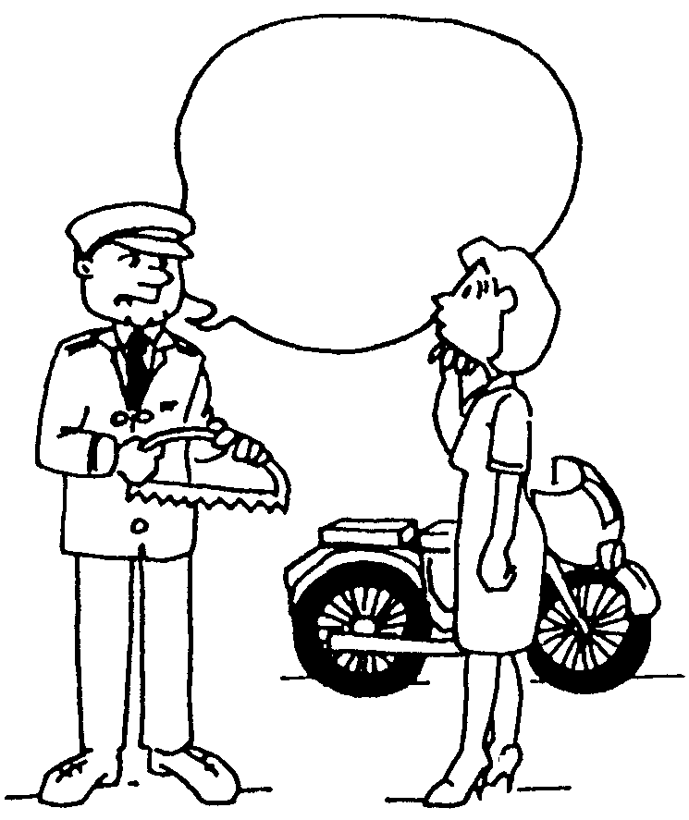
I’m sorry, but only 4 890 and a half motorcycles are allowed from Japan according to our list.

5.4.1 What form of protection is depicted in the above cartoon? | (3)

5.4.2 What will be the impact of this form of protection on the price of the imported commodity? | (3)

5.4.3 Explain export subsidies as a form of protection. | (3)

5.5 Match the concept in Column B with the statement in Column A. Write down the numbers 5.5.1 – 5.5.5 one below the other and next to each the letter which represents the correct answer. E.g. 5.5.6 H.

 | COLUMN A |  | COLUMN B
 | 5.5.1 | The rate at which one currency is exchanged for another | A.  B.  C.  D.  E.  F.  G. | floating exchange rates  exchange rate  devaluation  revaluation  import substitution  balance of payments  surplus
 | 5.5.2 | The account that keeps a record of a country’s transactions with the rest of the world | A.  B.  C.  D.  E.  F.  G.
 | 5.5.3 | Imported goods are substituted for locally produced goods | A.  B.  C.  D.  E.  F.  G.
 | 5.5.4 | A measure taken by the government of a country to decrease the value of its currency | A.  B.  C.  D.  E.  F.  G.
 | 5.5.5 | Market forces are solely responsible for exchange rate determination | A.  B.  C.  D.  E.  F.  G.

5x2= | (10)  [40]

QUESTION 6

THE STATE

6.1 Study the graph below and answer the questions that follow.

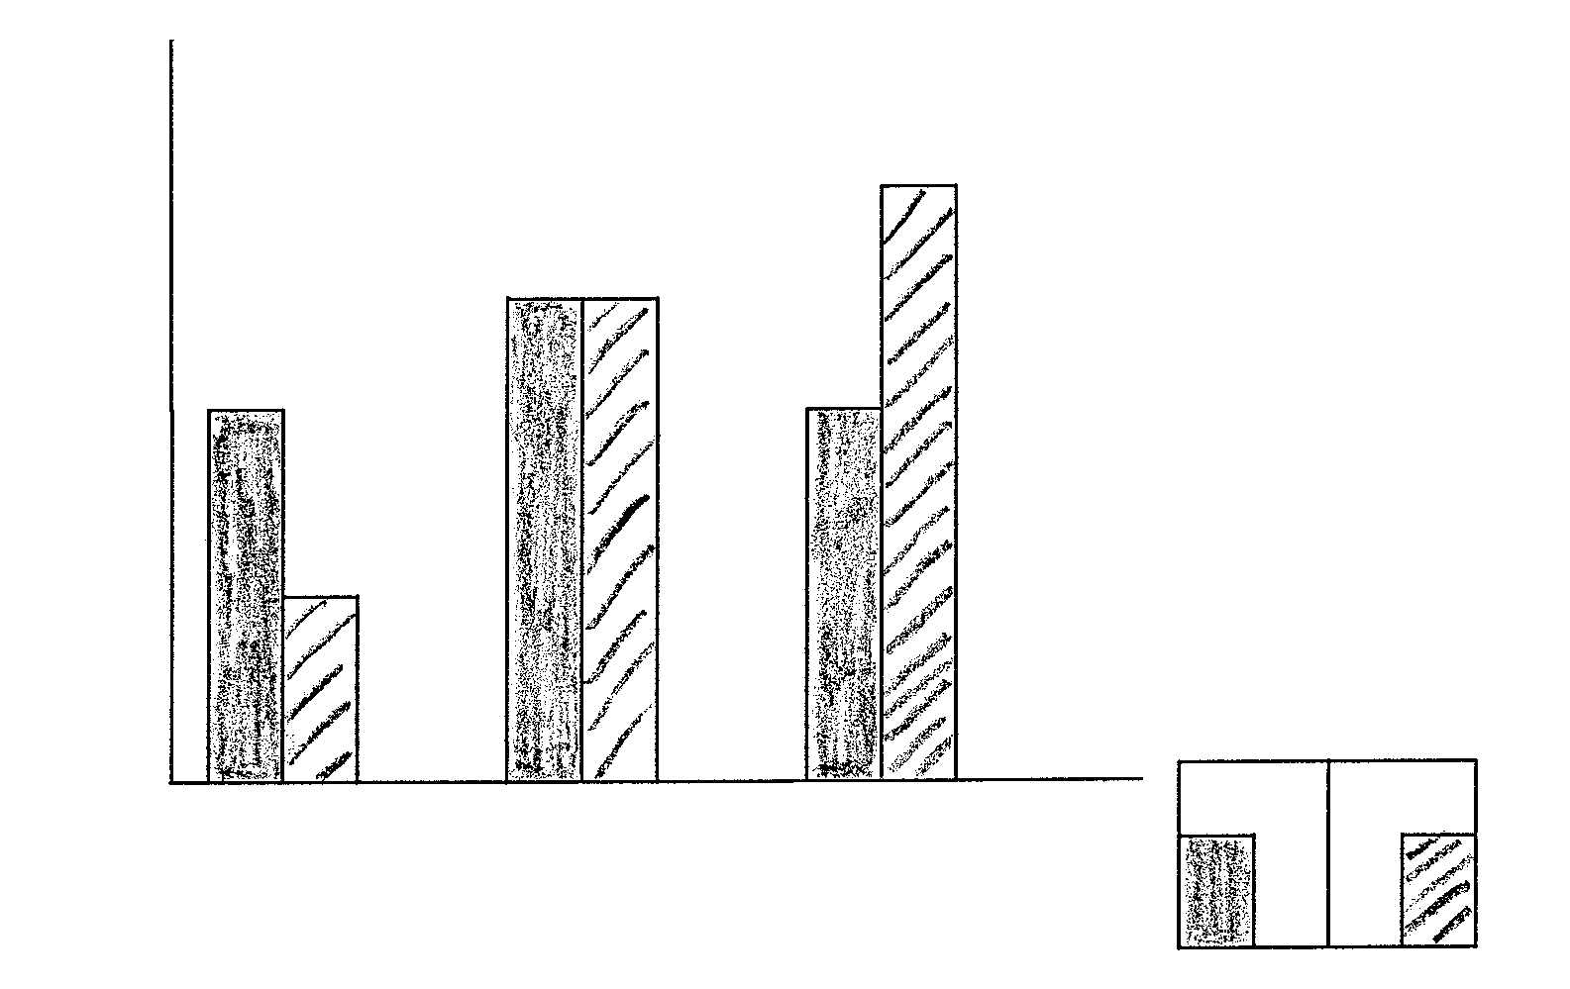
199819992000
YEARS
directindirect
6050403020100
TAX %

6.1.1 Which form of tax produced the most revenue in the year 2000? | (3)

6.1.2 During which year was the percentage contribution of the two taxes equal? | (3)

6.1.3 Name TWO examples of an indirect tax. | (4)

6.1.4 Name TWO examples of a direct tax. | (4)

6.2 Discuss FOUR requirements of a good tax system. | (16)

6.3 Match the concept in Column B with the statement in Column A. Write down the numbers 6.3.1 – 6.3.5 one below the other and next to each the letter which represents the correct answer. E.g. 6.3.6 H.

 | COLUMN A |  | COLUMN B
 | 6.3.1 | Outlined the rules of a good tax system | A.  B.  C.  D.  E.  F.  G. | Parliament  Adam Smith  State President  Tax avoidance  Proportional tax  Progressive tax  Tax evasion
 | 6.3.2 | The budget is approved by | A.  B.  C.  D.  E.  F.  G.
 | 6.3.3 | All taxpayers pay the same percentage of tax | A.  B.  C.  D.  E.  F.  G.
 | 6.3.4 | Higher income groups pay more than the low income groups | A.  B.  C.  D.  E.  F.  G.
 | 6.3.5 | An illegal way to reduce your tax burden | A.  B.  C.  D.  E.  F.  G.

5x2= | (10)  [40]

QUESTION 7

Answer any TWO of the following sections.

7.1 LABOUR

7.1.1 Define the term labour supply. | (3)

7.1.2 Choose the correct words between the brackets. Write down the letters (a) – (c) below one another and the correct answer next to each letter.

(a) The term (labour supply / unemployed) refers to all workers willing to work, regardless of the fact whether work is available or not. | (2)

(b) (Collective bargaining / Striking) is a situation where workers at a factory deliberately lay down tools. | (2)

(c) (Minimum wage / Reasonable wage) refers to a wage level set by government. | (2)

7.1.3 List FOUR functions of trade unions. | (8)

7.1.4 Explain the term compulsory registration as a restriction of trade unions. | (3)  [20]

7.2 PRODUCTIVITY AND UNEMPLOYMENT

7.2.1 With regard to productivity, list

(a) TWO advantages of productivity. | (4)

(b) TWO disadvantages of productivity. | (4)

7.2.2 Explain what is meant by seasonal unemployment. | (4)

7.2.3 Choose the correct term between brackets. Write down the letters (a) – (c) below one another and the correct answer next to each letter.

(a) (UIF / PAYE) is not a measure to restrict unemployment, but to give financial assistance to those who become unemployed. | (2)

(b) The measurement of input by the labourer in the production process is referred to as (production / productivity) | (2)

(c) Grade 12 learners leaving school and in the process of finding work are referred to as (structural / frictional) unemployed. | (2)

7.2.4 Is the following statement true or false?

The only method to determine unemployment is a census. | (2)  [20]

7.3 INFLATION

7.3.1 (a) There are two types of inflation. Name them. | (4)

(b) Discuss TWO measures to control inflation. | (8)

7.3.2 Define the term inflation. | (2)

7.3.3 Choose the correct term in brackets. Write down the letters (a) – (c) below one another and the correct answer next to each letter.

(a) If a person receives an 8% yield on his investment and the inflation rate is 10% he will have a (positive / negative) yield on his investment. | (2)

(b) In inflationary circumstances the nominal wage of a person will (remain constant / decrease). | (2)

(c) (Structural changes / Structural measures) forms part of the anti-inflation policy. | (2)  [20]

7.4 STRATEGIC RESOURCES

7.4.1 Discuss any TWO reasons why water supply and water conservation are important. | (8)

7.4.2 Evaluate the economic applicability of solar energy as a source of energy. | (4)

7.4.3 State why hydro-electricity is more economical than coal-generated power. | (2)

7.4.4 Choose the correct term in brackets. Write down the letters (a) – (c) below one another and the correct answer next to each letter.

(a) (Water / Coal) forms the corner stone of South Africa’s energy resources. | (2)

(b) The Katse Dam forms the major part of the (Orange River Project / Lesotho Highlands Water Project). | (2)

(c) Uranium is used to generate electricity at (Koeberg / Mosselbay) | (2)  [20]  [40]

QUESTION 8

GENERAL

8.1 Read the extract carefully and answer the questions that follow.

Aids will clip savings, ING Barings report warns

Cathy Powers
Johannesburg - The effect of the Aids epidemic over the next 15 years could result in a savings squeeze in an economy already struggling with sluggish growth and a dismal savings ratio.

In a “non-alarmist” report on the effect of Aids on the economy, released yesterday, ING Barings forecast that total domestic savings as a percentage of gross domestic product (GDP) would be an average 2 percentage points lower than without Aids. And the savings rate was unlikely to top the 20 percent of GDP necessary for accelerated growth.

According to the models supplied by local consulting firm Wefa, total domestic savings as a percentage of GDP would be 1,5 percent less than in a scenario with no Aids, rising to 1,7 percent less in 2005 and 2,2 percent in 2011.

“As domestic savings are already low and presenting a real capital constraint to the economy, any further deterioration in the formation of savings will lower the country’s investment potential,” the report said.

8.1.1 In your own words explain what clip savings means. | (3)

8.1.2 What is the impact of Aids on the GDP? | (3)

8.1.3 At what percentage is the saving decline estimated by the year 2005? | (3)

8.1.4 How can the young generation curb the spread of Aids? | (3)

8.2 Choose the correct word from within the brackets. Write down the numbers 8.2.1 – 8.2.5 one below the other and next to each the correct answer.

8.2.1 The tax which is levied on the gain that is realised when a capital asset is disposed off is known as (capital gains/value added) tax.

8.2.2 The extent to which the needs of the population are satisfied is called (wealth / welfare).

8.2.3 The ability of a product to satisfy a need is known as (utility / value).

8.2.4 The primary economic problem is (taxation / scarcity).

- South Africa’s main problem is (lack of job opportunities / lack of  transport). 5x2= | (10)

8.3 Tabulate TWO differences between economic goods and free goods. | (6)

8.4 Indicate why the calculation of National Income figures is necessary in a country. | (6)

8.5 Explain promotion of social welfare as a function of the state. | (6)  [40]

TOTAL FOR SECTION B: | [200]

TOTAL: | 300

