GAUTENG DEPARTMENT OF EDUCATION
SENIOR CERTIFICATE EXAMINATION

ECONOMICS HG

TIME: 3 hours

MARKS: 400

INSTRUCTIONS:

- Answer SEVEN questions:

Section A : Question 1 is COMPULSORY.
Section B : Answer any TWO questions.
Section C : Answer any FOUR questions.

- Answer Question 1 on the answer sheet on the inside cover of your answer book.

- Number your answers clearly and correctly.

- Read the questions carefully.

- Structure your answer neatly and systematically.

- Use the mark allocation as a guide to the scope and length of your answers.

- Where possible, questions should be answered in point form.

SECTION A

COMPULSORY

QUESTION 1

GENERAL

Indicate the correct answer by drawing a cross (X) over the appropriate letter on the answer sheet on the inside cover of your answer book. Each question counts 3 marks.

  - Which one of the following is an example of a transfer payment?

- Family allowances
- Income tax rebates
- Payment made by a rugby club to new players
- Prices charged by nationalised industries

  - Why do the figures for national production only include the value of final foods and services?

- To include the expenditure by authorities
- To eliminate the influence of price increases
- To be able to determine economic growth
- To avoid double counting

  - Use the following statistics to calculate the national income of a country:

Information R million
Salaries and wages 500
Rent 300
Profit 400
Subsidies 100
Interest 200

- R800 million
- R1 000 million
- R1 300 million
- R1 400 million

  - A person repairs a car in his leisure time for payment. The national income will as a result be

- underestimated.
- deflated.
- adjusted.
- overestimated.

1.5 Calculate the real national income for 2000 from the under-mentioned figures.

 | 1995 | 2000
Population | 10 million | 10 million
Nominal National Income (NNI) | R15 000 million | R18 000 million
Price Index (PI) | 100 | 150

- R15 000 million
- R10 000 million
- R12 000 million
- R27 000 million

Study the graph below and answer Questions 1.6 and 1.7.

National income and living standards of the Republic

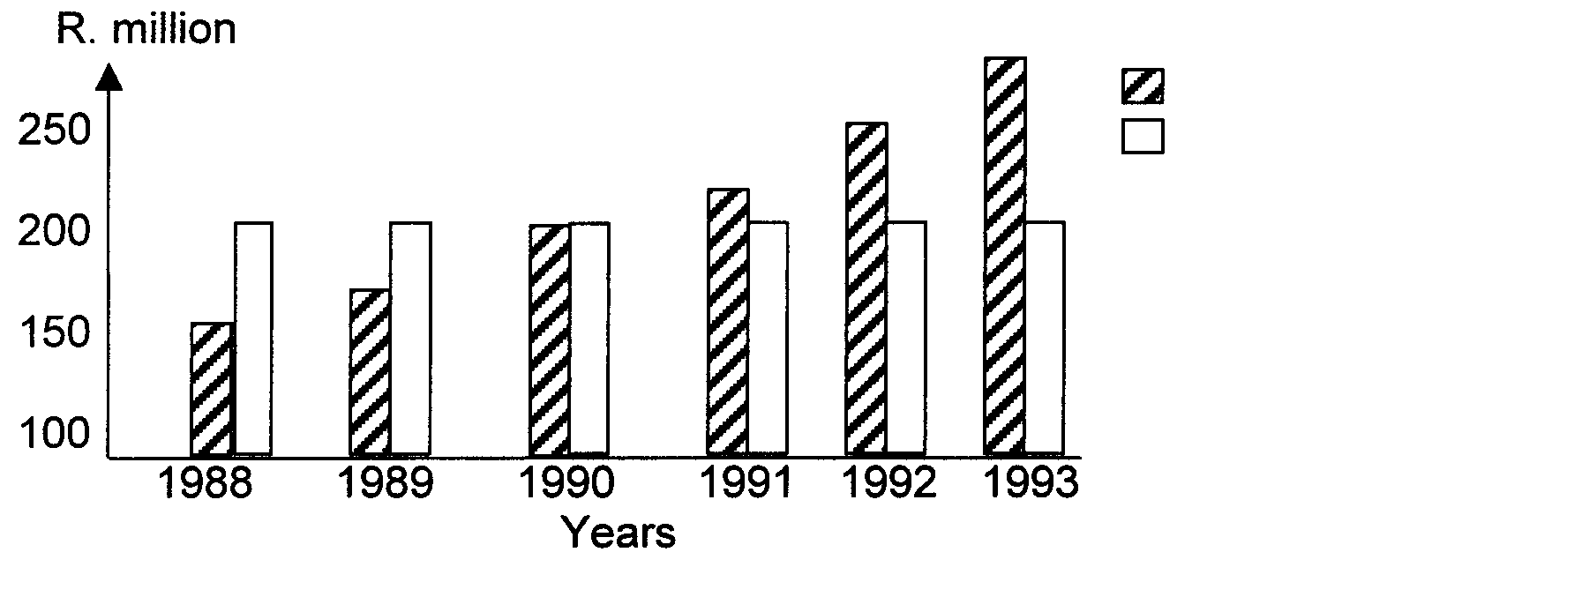

At current prices
At 1990 prices

1.6 Which one of the following statements will best describe the tendency of the Nominal National Income?

- Nominal National Income decreased noticeably.
- Nominal National Income remained constant.
- Nominal National Income showed uniform growth.
- Nominal National Income was first negative then positive.

  - Which statement will best describe the tendency of the Real National Income?

- Real National Income decreased noticeably.
- Real National Income remained constant.
- Real National Income showed sustained growth.
- Real National Income was first negative then positive.

  - The demand for bread is inelastic because

- it is essential.
- it is cheap.
- eating is a habit.
- it is not bought regularly.

  - In the case of a monopoly market

- substitutes are freely available.
- the supply and demand is controlled by a number of people.
- free competition exists between suppliers.
- a single supplier controls the supply of a commodity.

  - A minimum price below which suppliers are not prepared to sell their products, is called the _____ price.

- equilibrium
- market
- reserve
- nominal

  - In South Africa we find a virtually perfect market in respect of

- share trading.
- labour.
- agricultural products.
- housing.

  - Which one of the following factors will influence the supply of a product directly?

- Introduction of substitutes
- Climatic conditions
- The income of consumers
- Changes in consumers’ habits

Study the table below and answer Questions 1.13 and 1.14.

Unit | Total Utility | Marginal Utility
1 | 30 | 30
2 | 55 | -
3 | 73 | -
4 | - | 12
5 | - | 8
6 | - | 4
7 | - | 0
8 | 93 | -4

  - The total utility for the fifth unit is

- 85.
- 73.
- 93.
- 97.

  - Calculate the marginal utility for the third unit.

- 73
- 7
- 16
- 43

  - The institution that provides financial aid to industries that do not have access to capital markets is known as the

- Industrial Development Corporation.
- Development Bank of Southern Africa.
- Small Business Development Corporation.
- Johannesburg Stock Exchange.

  - In essence, South Africa’s regional development policy aims at the

- centralisation of industries.
- development of the formal sector.
- deregulation of certain activities.
- decentralisation of industries.

  - Which of the following can be used to measure economic development?

- The amount of foreign and gold reserves that a country possesses
- The total government income from taxes
- The gross national income figure
- The real national income per capita figure

  - The prosperity of the inhabitants of a country can be improved by

- creating more job opportunities.
- increased government expenditure.
- an increase in taxation.
- allowing more imports.

  - Regional development refers to human, economic and physical development in particular

- countries.
- geographical areas within a country.
- countries in a region.
- provinces in a country.

  - A sound urbanisation policy strives to

- improve the standard of living of individuals.
- create job opportunities for unskilled labourers.
- improve municipal services to ensure maximum satisfaction of needs.
- All the above mentioned.

  - South Africa will attract foreign investment if

- a deregulation policy is implemented.
- the rate of inflation is increased.
- income tax on individuals is reduced.
- political, social and economic stability is maintained.

  - If two exporting countries produce two similar products and each produces one product at a cheaper price, it is known as

- absolute advantage.
- relative advantage.
- comparative advantage.
- marginal advantage.

  - Which one of the following statements can be regarded as a reason for international trade?

- Natural resources are unevenly distributed.
- Natural resources are evenly distributed.
- The mining cost of products does not differ.
- All natural resources can be found in the right climate.

  - The income earned by South African residents in the rest of the world is

- merchandise imports.
- payment for services.
- income receipts.
- income payments.

  - Portfolio investments in the financial account of the balance of payments include

- the residual category of reserve assets.
- shares and gilts purchased and sold.
- properties and businesses purchased and sold.
- local currency and foreign exchange purchased and sold.

  - Transactions reflecting the transfer of fixed and other assets of migrants are reflected in the _____ of the balance of payments.

- current account
- financial account
- capital transfer account
- official account

  - In the official reserve account the valuation adjustment has to be made because the gold reserves are valued at market related prices, which change from

- day to day.
- week to week.
- month to month.
- year to year.

  - Which one of the following types of taxes cannot be shifted?

- VAT
- Personal income tax
- Transfer duties
- Customs and excise duties

  - Which form of tax ensures that everybody who earns an income is taxed?

- Value Added Tax
- Pay As You Earn
- General Sales Tax
- Indirect tax

  - The government will only act as entrepreneur when

- essential goods and services are undervalued by the market.
- huge capital outlays are not required.
- there is not a long waiting period before profits are earned.
- profit margins are high.

  - The functional classification of state expenditure is based on the

- willingness of the community to pay for the services.
- nature of the services that are rendered.
- expenses involved in research and production.
- need for collective services.

  - Fiscal policy refers to the steps that the government takes to

- change taxes.
- change interest rates.
- influence production.
- promote international trade.

  - Which one of the following is an aim of the government’s economic policy?

- Import substitution
- Promotion of dumping
- Extension of political powers
- Redistribution of income

- The incidence of taxes refers to  - legitimate methods to pay less tax.  - the person/instance who must pay the tax.  - the shifting of taxes onto the shoulders of another person.  - illegal methods used to escape paying taxes.  TOTAL FOR SECTION A: | [100]  [100]

SECTION B

Answer any TWO questions in this section. Note that essay answers should have introductions, bodies and conclusions.

QUESTION 2

NATIONAL INCOME

Almost countless units, of which each receives its parts of the national income, is committed to the production of goods and the delivering of services. It is for this reason that it is impossible to make an accurate assessment of national income.  Discuss the general problems, which are experienced in determining national income. | [50]

QUESTION 3

PRICE FORMATION AND MARKETS

Discuss the supply side of a market in detail.  Hint: Make use of graphs. | [50]

QUESTION 4

INTERNATIONAL TRADE

Discuss the South African international trade policy in detail. | [50]

QUESTION 5

THE STATE

In South Africa the government plays an important role in specific economic areas/activities. Discuss this intervention by the government.  TOTAL FOR SECTION B: | [50]  [100]

SECTION C

Answer any FOUR questions in this section.

QUESTION 6

NATIONAL INCOME

  - Study the table below and answer the questions that follow.

Gross Domestic Product according to economic activity.

 | R million
 | 1990 | 1991 | 1992
At current prices
Primary sector | 37 351 | 40 044 | 40 175
Secondary sector | 78 101 | 86 478 | 95 292
Tertiary sector | 121 556 | 141 428 | 160 374
Gross Domestic Product at Factor Costs | 237 008 | 267 950 | 295 841
At constant 1985-prices
Primary sector | 22 982 | 22 908 | 21 160
Secondary sector | 37 527 | 36 795 | 35 680
Tertiary sector | 59 979 | 60 135 | 60 153
Gross Domestic Product at Factor Costs | 120 488 | 119 830 | 116 993

Source: CSS

- Which sector was the biggest contributor towards the real GDP in 1992? Use figures to support your answer.  - Which THREE components make up the GDP at factor costs?  - What can be deducted from the economic growth figures in the table?  - Distinguish between current prices and constant prices.  - What does the abbreviation CSS stand for? | (4)  (6)  (4)  (6)  (2)

6.2 Discuss TWO causes of business cycles. 2 x 6 =  6.3 Explain the concept per capita income. Use the information below to determine the real per capita income. | (12)

General Price Index | 153
Population | 12 million
Nominal National Income | R3 060 million | (6)

- Indicate whether the following are TRUE or FALSE:  6.4.1 The function of the entrepreneur is to obtain the production factors and to coordinate them into goods or services.  - Economic growth is dependent on capital growth.  - Technological development is important for economic growth because it would increase and support factor productivity.  - Capital growth is sustained by investments.  - Because natural resources are made available by nature, they are always available for economic growth. 5 x 2 = | (10)  [50]

QUESTION 7

PRICE FORMATION AND MARKETS

7.1 Indicate whether the following are TRUE or FALSE:

    - The demand for a good refers to the quantity of a good that is made available at a certain time at a given price.

    - Supply is that portion of the total stock that is placed on the market to be sold.

    - The market form where there is only one seller of a certain product is known as the sole proprietor.

    - The price of a product will decrease if the supply of the product remains constant and the demand increases.

    - Price elasticity is the sensitivity of prices in reaction to changes in demand.
5 x 2 = (10)
7.2 Study the graph below and answer the questions that follow.

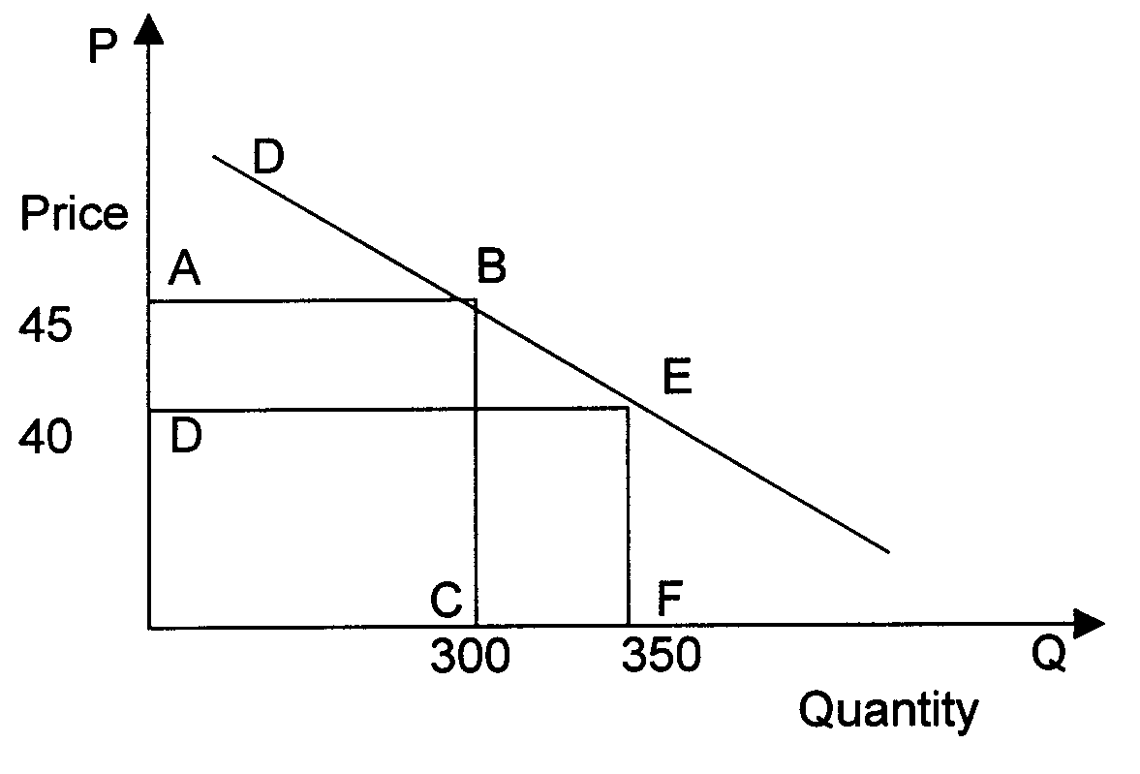

- Calculate the price elasticity of demand.  - Which form of elasticity is illustrated here?  - Describe this form of elasticity. | (6)  (2)  (2)

7.3 One of the conditions of a perfect market is to have many buyers and many sellers. Discuss THREE other conditions.  7.4 With the aid of a graph, explain the concept consumer surplus.  7.5 Explain the term competition and give THREE disadvantages of competition. | (12)  (10)  (8)  [50]

QUESTION 8

ECONOMIC DEVELOPMENT, REGIONAL DEVELOPMENT AND URBANISATION

8.1
Honey, I wonder why your brother doesn’t move to the city.
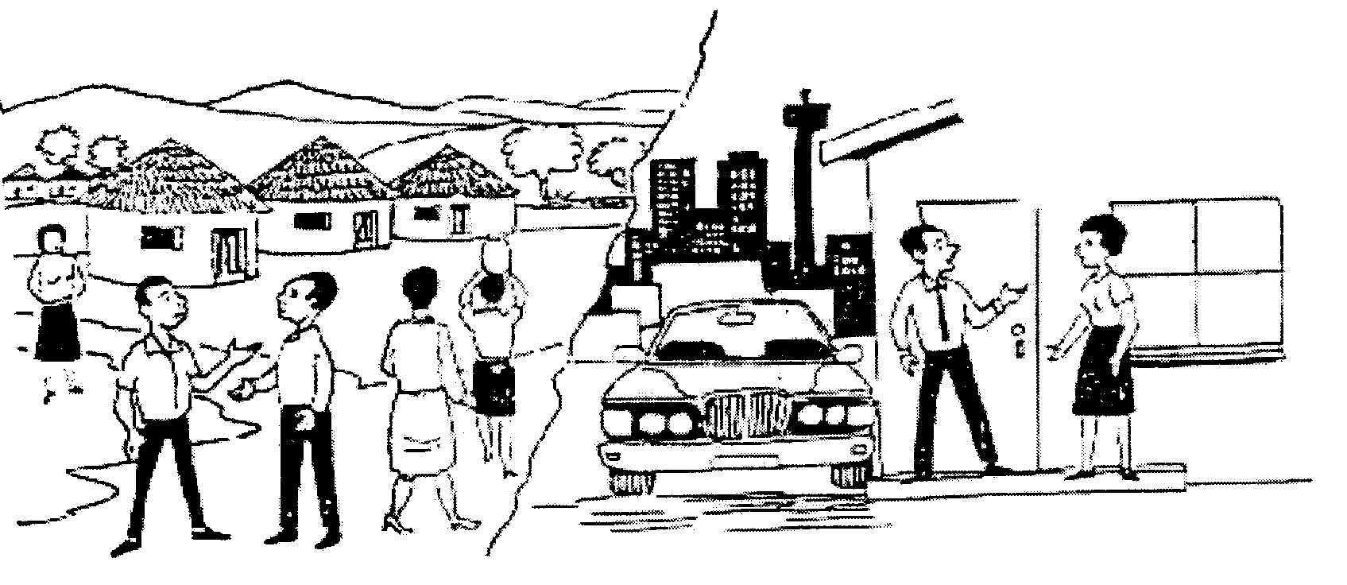
RURAL AREA ……

CITY ……

- Which type of migration is referred to above?  - Although urbanisation is a world-wide tendency, it has a number of disadvantages. Name FOUR disadvantages. | (2)  (8)

8.2 Indicate whether the following statements are TRUE or FALSE.

- Over-urbanisation is a common feature in South Africa. It means that structured planning and co-operation is useless.  - The informal sector plays an important role in combating poverty.  - Economic growth is the most important objective of economic development.  - A growth in the urban population leads to inward industrialisation.  - Informal settlements originate round a full infrastructure. 5 x 2 = | (10)

8.3 Distinguish between the concept economic growth and economic development. | (6)

- Discuss FOUR characteristics of developing economies. 4 x 4 =  - Identify FOUR objectives of regional development. | (16)  (8)  [50]

QUESTION 9

INTERNATIONAL ECONOMICS

9.1 Because very few countries are self-sufficient, economic relationships between them are important. Give FIVE causes of international trade.  0  9.2 Study the graph below and answer the questions that follow. The market for reserves is depicted. | (10)

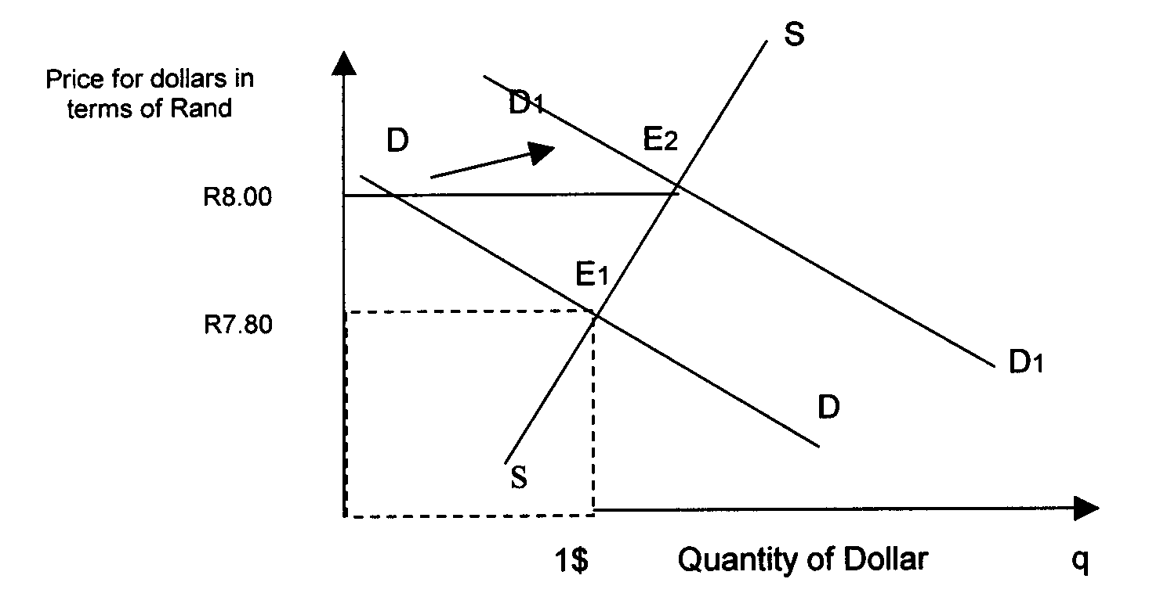

D1
Price for Dollars in terms of Rand

- Give THREE possible reasons for the movement of DD to D₁D_{1.}  - Explain which TWO steps can be implemented in order to move D₁D₁ to DD. | (6)  (4)

9.3 Suppose the exchange rate between South Africa and the USA is R7,50 = $1. If the value of the Rand appreciates by 10%, what would the new exchange rate be? | (5)

9.4 Economic co-operation has existed in Southern Africa for many years. The following economic groupings are important for economic co-operation:

- “SACU”
- “CMA”
- “SADC”

- Write the names in full.  9.4.2 Discuss THREE characteristics of any TWO groupings. | (3)  (12)

9.5 Indicate whether the following statements are TRUE or FALSE:

    - Exports, for example, goods, gold and minerals exported to foreign countries are reflected in the balance of payment.

    - The South African currency floats with the currencies of Lesotho and Swaziland and is thus known as group floating.
- The balancing item on the balance of payments is loans.  - A favourable balance of payments implies that the reserve position of a country has improved.  - The balance on the balance of payments account is the amount of gold exported. | (10)  [50]

QUESTION 10  THE STATE  10.1 Fill in the missing word(s). Write only the correct answer next to the correct number.  - Taxation where all incomes are taxed at the same percentage, is called ______.  - ______ is a tax system whereby a person with a lower income pays a higher percentage of his income in taxes.  - A tax system where a higher income group is taxed at a higher rate, is called ______ tax.  - ______ is failing to meet tax liabilities by not declaring income or profit.  - ______ is legitimate methods to reduce the burden. | (10)

10.2 10.2.1 Define the term taxation.  10.2.2 Discuss THREE kinds of indirect taxes. 3 x 4 =  10.2.3 Explain how a tax policy of direct and indirect taxation can affect the  economy. | (3)  (12)  (5)

10.3 10.3.1 Explain the term privatisation.  10.3.2 Give THREE aims of privatisation. 4 x 2 =  10.4 When the Minister delivers his budget speech, he does it in a fixed pattern. Name this pattern. 4 x 2 =  - Taxation is the most important form of state income. Name TWO other forms.  2 x 2 = | (8)  (8)  (4)  [50]

QUESTION 11

This question consists of FOUR subdivisions of 25 marks each. You must answer any TWO subdivisions. Number your choices exactly the way they are numbered in the question paper.

- Labour Relations  11.1.1 Indicate whether the following statements are TRUE or FALSE.  (a) Workers are free to affiliate to any trade union of their choice.  (b) The aim of a trade union is to promote and maintain the interest of its members in the work situation.  (c) The membership of registered trade unions has remained more or less constant for the past 10 years. 3 x 2 = | (6)

- Discuss THREE characteristics of the South African labour force. 3 x 4 =  - Discuss the limitations trade unions are subject to.  11.1.4 Which trade union is currently the biggest? |  | (12)  (6)  (1)  [25]
11.2 Inflation

Study the cartoon and answer the questions that follow.

What are you going to do about inflation?
Print more money.
You cannot do that.
Why not?
There are not enough gold reserves to cover it.
Wow! For a moment I thought that there was no paper.
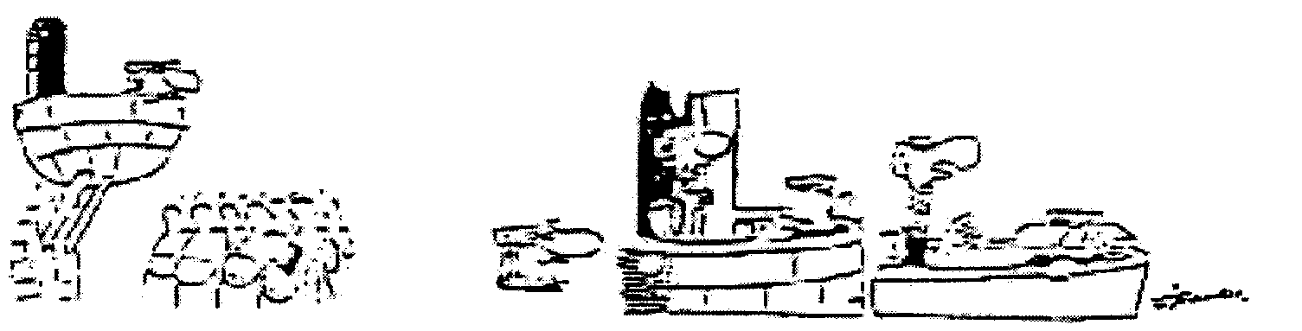

Source: Economics, Vol. 3 p. 29, 1989
- (a) Define inflation.  (b) Distinguish between the TWO forms of inflation.  (c) Discuss THREE causes of each type of inflation. 3 x 4 = | (3)  (4)  (12)

11.2.2 Indicate whether the following statements are TRUE or FALSE.  (a) Stagflation refers to stagnation in the growth of the GDP, high unemployment and a low inflation rate.  - Deflation can be defined as a decline in the price of certain goods and services.  - A characteristic of hyperinflation is that it reveals a condition of excep-tional rapid increases in the general price levels of goods and services. | (6)  [25]

11.3 Productivity and Unemployment

Study the cartoon and answer the questions that follow:

Grab a pen .. be with ya in a sec!
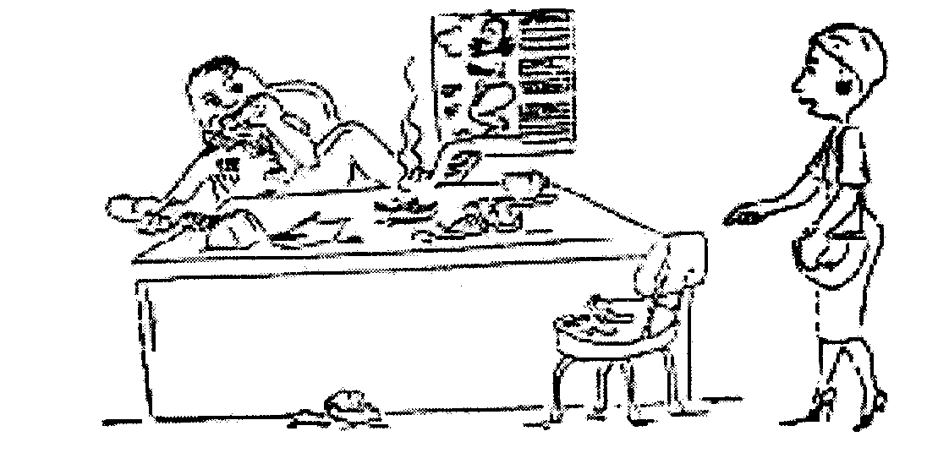
MANAGER

- Describe clearly the concept of productivity.  - Name TWO measures to improve productivity.  - Indicate whether the following statements are TRUE or FALSE.  - Political uncertainty and social conflict in a community can result in low productivity growth.  - Productivity improvement is a non-recurrent measure.  - Productivity and production amount to the same thing. 3 x 2 = | (3)  (4)  (6)

11.3.4 Study the cartoon below and answer the questions that follow:

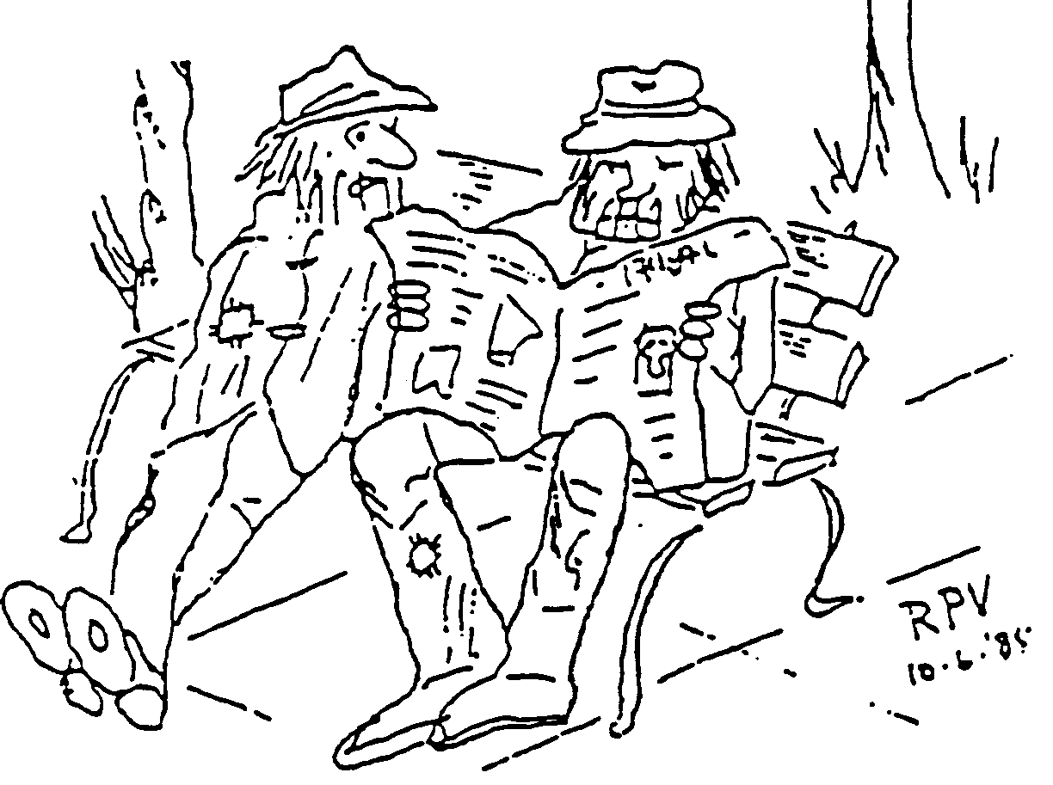

You were lucky to be replaced by the GW16 Exel computer.
I was replaced by a pocket calculator.

- What type of unemployment is referred to in the above-mentioned cartoon?  - Describe or define unemployment.  - Discuss FOUR measures for combating unemployment. | (2)  (2)  (8)  [25]

11.4 Strategic resources in South Africa

- Write the following abbreviations out in full.  (a) ADE  (b) Satour 2 x 2 = | (4)

- Discuss FIVE factors illustrating the importance of water.  11.4.3 Coal forms the basis of our energy sources in South Africa. Name TWO  other sources. | (10)  (4)
- Indicate whether the following are TRUE of FALSE:  - Denel made it possible for South Africa be to an armament exporting country.  - The National Energy Board accepted the task in 1987 to provide energy for South Africa.  - Tidal energy and wave energy have not yet been utilised in South Africa. | (6)

- Choose the correct word between the brackets:  Biomass is (a plant / an animal) matter which can be used for generating energy.  TOTAL FOR SECTION C:  TOTAL: | (1)  [25]  [200]  [400]

