GAUTENG DEPARTMENT OF EDUCATION

SENIOR CERTIFICATE EXAMINATION

ECONOMICS SG

TIME: 3 hours

MARKS: 300

INSTRUCTIONS:

- This exam paper consists of TWO sections.
SECTION A: Question 1 is COMPULSORY.
SECTION B: There are seven questions. Answer FIVE questions ONLY.

- Answer Question 1 on the answer sheet on the inside cover of your answer book.

- Facts must be given systematically and where possible, point by point.

- In questions with the instruction “list”, no discussion is required,

SECTION A
COMPULSORY

QUESTION 1

Indicate the correct answer to each of the following questions by making a cross (X) over the appropriate letter (choose from A – D) on the answer sheet which is on the inside cover of your answer book. Choose ONE answer only.

  - The income of South Africans working overseas, forms part of South Africa’s _____________ income.
- nominal gross domestic
- real gross domestic
- gross national
- gross domestic

  - The process by means of which ownership is transferred from the private sector to the state is known as
- nationalism.
- urbanisation.
- centralisation.
- privatisaion.

  - Which one of the following is a characteristic of the informal sector?
- Heterogeneous activities
- Experience and skill
- Medical aids and unemployment funds
- Payment of taxes for collective services

  - A good system of taxation that involves little expense in the collection thereof is
- impartial.
- elastic.
- economic.
- convenient.

  - Economic growth is measured in terms of
- GNP.
- nominal GNP.
- real GNP per capita.
- nominal GNP per capita.

  - An increase in the productive capacity of a country is known as economic
- development.
- growth.
- distribution.
- reform.

  - When legitimate methods are used to reduce the tax burden, it is known as
- avoidance.
- evasion.
- shifting.
- incidence.

  - Which one of the following kinds of indirect taxation will discourage imports?
- Estate duty
- Income tax
- Company tax
- Customs duty

  - The real flow in the circular flow consists of
- goods and services.
- tax only.
- income from foreign sector.
- domestic income and expenditure

  - Which one of the following will be included in the national income figures?
- Remuneration for the services of a housewife
- The cost of fighting pollution
- Income from illegal activities
- Dividends from shares

  - Added value is the value
- of the final products.
- of the raw materials used in the production process.
- which was added consecutively to give the final value of the product.
- of the labour used in the production process.

  - Wants are
- limited in number.
- limited in variety.
- unlimited in intensity.
- complementary

  - It is illegal for a taxpayer to ____________ tax.
- owe
- shift
- avoid
- evade

  - A “closed” economy refers to the absence of a(n) ___________ sector.
- banking
- international
- domestic
- national

  - The measure which is taken by the Government to increase the value of a currency of a country in terms of the currencies of other countries is known as
- inflation.
- deflation.
- devaluation.
- revaluation.

  - An envisaged advantage of regional development in South Africa is to
- stabilise prices of secondary products.
- ensure improved factory products.
- create more job opportunities in regions where people are poor.
- encourage specialisation in products.

  - Which one of the following is an invisible item on the balance of payment?
- Raw materials
- Sale of armaments
- Tourism
- Re-export of manufactured goods

  - At present exchange rates are determined mainly by the
- quantity of fine gold linked to a monetary unit.
- relative purchasing power of the monetary unit of the countries concerned.
- International Monetary Funds.
- demand and supply of the currencies.

  - One of the problems with the calculation of national income, when pensions are included is:
- Double counting
- Transfer payments
- Value added
- Accuracy

  - Which one of the following has to be taken into consideration in order to calculate the per capita income of a country?
- The nation’s level of prosperity
- The average income per sector
- The nation’s standard of living
- The size of the population

  - The economic welfare in South Africa can be compared to that of Germany by studying both countries’
- general price level.
- net national income at factor cost.
- real per capita income.
- real national income.

  - The balance of trade is the difference between the value of
- invisible imports and exports.
- visible imports and exports.
- total imports and exports.
- gold imports and exports.

  - If a country devalues its currency, the
- price of exports will increase.
- price of imports will decrease.
- standard of living locally will increase.
- price of exports of foreign countries will decrease.

  - A systematic record which keeps account of a country’s transactions with the rest of the world is known as the
- balance of payment.
- current account.
- capital account.
- balance of trade.

  - The policy of the state that affects the economy through taxation and spending is known as the ____________ policy.
- inflation
- monetary
- fiscal
- exchange rate

  - The tax incidence of customs duties usually falls on the
- harbour authorities.
- importers of consumer goods.
- consumer.
- producer.

- The process which is necessary to bring about over time a significant improvement in the general living standards of the majority of the inhabitants of the country is known as economic  - growth.  - development  - policy.  - integration.  - Which one of the following is an advantage of urbanisation in South Africa?  - Accommodation  - An increased standard of living  - Pollution  - Socio-economic problems  - A street vendor is an example of a/an ___________ activity.  - regulated  - informal  - formal  - recorded  - The law of ________ states that if the prices of goods increase, everything else being equal, the quantity offered of those goods will increase.  - supply  - utility  - marginal utility  - demand  - The fundamental economic problem is one of  - prices.  - wants.  - survival.  - scarcity.  - Goods that are desired and are relatively scarce are known as ________ goods.  - public  - economic  - free  - natural  - One of the characteristics of utility is that it  - determines price.  - gives a usage value to an article.  - can be measured.  - has exchange value.  - Dumping takes place when goods from another country (e.g. Hong Kong) are  - available at a lower price in South Africa than in Hong Kong.  - distributed in underdeveloped countries in times of need.  - more expensive in South Africa than in Hong Kong.  - only off-loaded in South Africa.  34x3 =  TOTAL FOR SECTION A: | [100]  [100]

SECTION B  Answer any FIVE questions in this section.  QUESTION 2  NATIONAL INCOME  2.1 Choose the correct option from those provided within brackets.  - When goods are ready for the market they are called (intermediate/finished) goods.  - National income figures (can/cannot) be used to indicate the relative importance of the different sectors of the economy.  - In a closed economy the national production, national expenditure and national income are by definition (equal/unequal) to each other.  - National income (can/cannot) be calculated absolutely accurately.  - The national production of a country includes the value of all the final products and services which are produced and rendered by the (permanent residents/foreigners) in a country within a given year.  - Define the following concepts:  - Per capita national income  - Transfer payments  - Added value  - Name any FOUR shortcomings of the National Income figures.  - Study the table below and answer the questions that follow. | 5x2 = (10)  (4)  (4)  (4)  (8)

YEAR | 1995 | 1996 | 1997
NOMINAL NATIONAL INCOME | 40 000 | 43 000 | 46 200
GENERAL PRICE INDEX | 100 | 110 | 119
REAL NATIONAL INCOME | 40 000 | (a) | (b)

- Calculate the real national income of 1996.  - Calculate the real national income of 1997.  - Did the national income increase in real terms from one year to another?  - Which year was the base year? | (3)  (3)  (3)  (1)  [40]

QUESTION 3  PRICE FORMATION  - Indicate whether the following statements are TRUE or FALSE:  - The type of goods which command a price are economic goods.  - The place where buyers and sellers meet to negotiate a price is known as a market.  - The market situation where there is only a single supplier of a product is typical of a perfect market.  - The type of goods which have no exchange value will have no utility.  - The application of goods and services to satisfy wants is known as utility.  - Name SIX conditions for the existence of a perfect market.  - List THREE advantages of competition in a market economy.  3.4 Use the information below to draw a demand and supply graph. | 5x2 = (10)  6x2 = (12)  3x2 = (6)

PRICE (Rands) | DEMAND | SUPPLY
125 | 100 | 350
100 | 150 | 300
75 | 250 | 250
50 | 400 | 100
25 | 550 | 50
(12)
[40]
question 4  economic development, regional development and urbanisation  - Discuss the concept of urbanisation under the following sub-headings:  - Description  - List FOUR causes of urbanisation. | (3)  4x2=(8)

- Explain regional development in your own words.  - Discuss TWO characteristics of developing countries.  - Select the correct word(s) from between the brackets. Write only the correct word(s) opposite the applicable question number in your answer book.  - The economic activities that are reflected in statistics and financial data are those of the (formal/informal) sector.  - (Developed/developing) countries have a high level of income and capital formation.  - Unlike the formal sector, the informal sector does not use the latest technology and is therefore very (labour/capital) intensive.  - An indicator of economic development is the (gross national expenditure/real gross domestic product per capita).  - One of the institutions that assist entrepreneurs to begin their business is the (IDC / DBSA). | (2)  (8)  5x2= (10)

  - The photo below is an example of a sector that plays an important role in the economy of the RSA.

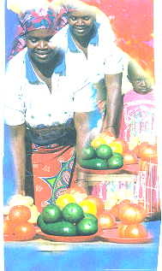

- What type of a sector is indicated above?  - Are the economic activities of this sector recorded in the national records?  - Name any TWO advantages of the sector above.  Please see page 10 for Question 5. | (3)  (2)  (4)  [40]

QUESTION 5  INTERNATIONAL TRADE  - Name FOUR reasons for international trade.  5.2 Study the picture below and answer the questions that follow. | (8)

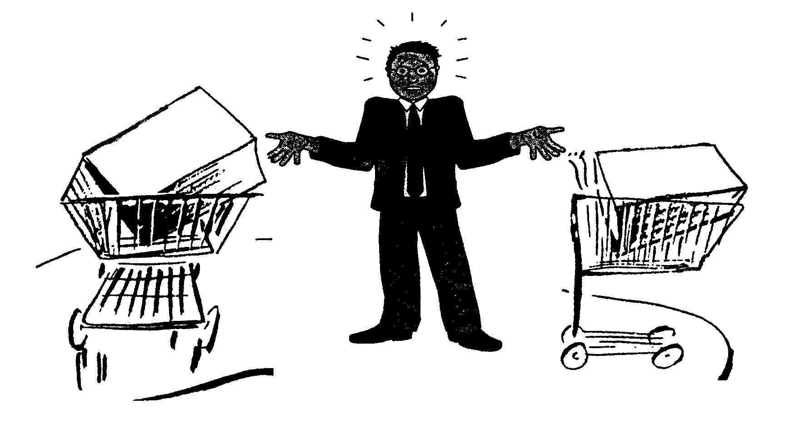
IMPORTED
MANUFACTURED
IN
S.A.

- Goods that were previously imported and are now locally produced are an example of import (substitution/subsidies).  - List TWO advantages of buying locally produced goods rather than imported goods.  - There were TWO reasons why the RSA substituted imported goods with locally produced goods. List these TWO reasons.  - Explain the difference between ad valorem and specific tariffs as forms of import duties.  - List FOUR factors which cause a supply of foreign exchange.  - Select the correct word(s) between brackets to make the following sentences correct. Write only the word(s) next to the applicable number.  - (Long term capital movements/net gold and other foreign reserves) serve as a balancing item in the balance of payments account.  - If the value of exports is higher than the value of imports, the trade account will reflect a (deficit/surplus).  - The (current/capital) account records all payments and receipts for the exchange of goods and services between countries.  - The services in the balance of payments traditionally shows a (surplus/deficit).  - Donations received from abroad are seen as  (transfer/transfer payments). | (2)  (4)  (4)  (4)  (8)  5x2=(10)
[40]

QUESTION 6
THE STATE

6.1 Match the government expenditure (according to the functional classification) in Column A to the appropriate service in Column B.

COLUMN A |  | COLUMN B
6.1.1 | General or collective services | A. | Road building programme
6.1.2 | Community services | B. | Production of iron and steel
6.1.3 | Social services | C. | Military defence
6.1.4 | Economic services | D. | Education
6.1.5 | Protection services | E. | Public air transport
 |  | F. | The police
5x2 = (10)

- State FOUR advantages of direct taxation.  - List THREE advantages of indirect taxation.  6.4 Give any TWO sources from which the state generates its income. | (8)  (6)  (4)

6.5 Study the graph below and answer the questions that follow.

INCOME
A

B

B
%
T
A
X
A
0

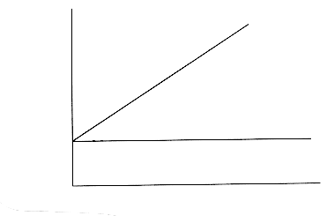

- What method of tax is represented by ‘AA’?  - What method of tax is represented by ‘BB’?  - Which one of the two is used in most countries to calculate income tax?  6.6 Define the concept privatisation. | (3)  (3)  (3)  (3)  [40]

QUESTION 7  IMPORTANT TOPICS IN THE SOUTH AFRICAN CONTEXT  Answer questions on any TWO of the following topics. Number the questions you answer in exactly the same way as they are numbered here.  7.1 Labour relations  Captions like the ones above cause anxiety about the supply of labour in the near future.  - Name FOUR factors that determine the supply of labour.  - Define the concept trade union.  - Name FOUR functions of trade unions. | (8)  (4)  (8)
[20]
  - Productivity and Unemployment

Match the statements in Column B with the terms in Column A.

COLUMN A |  | COLUMN B
7.2.1 | Structural unemployment | A. | Unemployment in the canning industry.
7.2.2 | Seasonal unemployment | B. | Unemployment as a result of a drop in sales in consumers goods.
7.2.3 | Cyclical unemployment | C. | Unemployment after matric.
7.2.4 | Frictional unemployment | D. | Unemployment because of labour saving technology.
(8)

- Define the concept unemployment.  - Explain economic growth as a measure of combating unemployment.  - Give TWO other measures that can be used to combat unemployment.  7.3 Inflation  - List TWO kinds of inflation.  - Discuss the role of expectations in the inflationary process (prices, labour unions, businesses).  - List FOUR characteristics of inflation.  - Define the concept inflation. | (4)  (4)  (4)  [20]  (4)  (4)  (8)  (4)  [20]

7.4 Strategic Recources in South Africa  7.4.1 With the exception of irrigation, list and describe THREE other reasons why water conservation and supply are important.  - List FOUR sources of energy in South Africa.  2x20= | (12)  (8)  [20]  [40]

QUESTION 8
GENERAL

8.1 Choose the description in Column B which matches the concept in Column A. Write down only the number of the question and the correct letter.

COLUMN A |  | COLUMN B
8.1.1 | If a fall in the price of one product raises the demand for another product, the two products are ________. | A | Surcharge
8.1.2 | Tax paid on contracts when properties are registered. | B | Complementary
8.1.3 | Tax paid over and above taxes already payable on particular products. | C | Transfer duty
8.1.4 | Tax levied on cigarettes. | D | Supplementary
8.1.5 | Tax levied on all imports. | E | Customs duty
 |  | F | Excise duty
5x2 = (10)

- List TWO forms of protection in international trade.  - National income figures are used in many ways. List THREE uses of national income figures.  - Give TWO objectives of economic development.  - Discuss the functional development of markets.  - Give FOUR factors which affect changes in want.  TOTAL FOR SECTION B:  TOTAL: | (4)  (6)  (4)  (8)  (8)  [40]  [200]300

