GAUTENG DEPARTMENT OF EDUCATION

SENIOR CERTIFICATE EXAMINATION

ECONOMICS SG

TIME: 3 hours

MARKS: 300

INSTRUCTIONS:

- This exam paper consists of TWO sections:
SECTION A: Question 1 is COMPULSORY.
SECTION B: There are seven questions. Answer FIVE questions ONLY.
- Answer Question 1 on the answer sheet on the inside cover of your answer book.
- Facts must be given systematically and where possible, point by point.
- In questions with the instruction LIST, no discussion is required.
SECTION A

COMPULSORY

QUESTION 1

Indicate the correct answer to each of the following questions by making a cross (X) over the appropriate letter (choose from A – D) on the answer sheet which is on the inside cover of your answer book.

  - The circular flow shows
- only the flow of goods sold in the market.
- the flow of goods, services, income, expenditure and money in circulation.
- how the foreign sector operates in a closed economy.
- how the difference between income and expenditure is calculated in an economic cycle.

  - Which of the following would be regarded as a transfer payment?
- Payment to a part-time employee
- Undistributed company profits
- Non-contributory old age pension
- The salary of a member of parliament

  - Which one of the following is not included when the National Income is calculated?
- Salaries of educators
- All goods and services in a country
- Income of all civil workers
- Services rendered, paid for but unrecorded

  - A compilation of National Income figures is useful in order to
A. estimate the rate of economic growth.
B show which tax is the best for the country.
C. indicate how the Government has to spend its income.
D. assess the state of the stock market.

  - An increase in the National Income figures will be influenced by a/an
- decrease in immigration.
- increase in production.
- increase in the birth rate.
- decrease in the population.

  - In a closed economy, the _____________ sector is absent.
- domestic
- banking
- international
- private

  - Technological development is essential for future economic growth because
- it excludes labour.
- it improves the utilization of factors of production.
- prices of goods decrease.
- the Government increases the state revenue.

  - A product is regarded as a “final good” when it is ready for
- demand.
- consumption.
- production.
- processing.

  - Human wants
- are limited.
- cannot replace one another.
- have a limited intensity.
- are always legal.

  - A want for a satellite dish is regarded as a ___________ want.
- cultural
- natural
- luxurious
- religious

  - The scope /extent of human wants depends mainly on
- natural resources
- the amount of money available.
- the nature of wants.
- technological development

  - In Economics the term utility means
- the importance of a product in the expenditure of the consumer.
- the ability to satisfy needs.
- the ability to produce goods and services.
- that goods are available for exchange.

  - Free goods
- are limited.
- are scarce.
- have usage value.
- have exchange value.

  - An example of free goods is:
- Sand in the hardware store
- Shares in the stock market
- Sand in the desert
- Water from the tap

  - Economic goods
- command a price.
- have no utility.
- are abundant.
- are always available.

  - One of the factors that determines value is:
- needs
- utility
- consumers
- poducers

  - The shifting of the demand curve to the left could be caused by a
- drop in the price of that commodity.
- rise in the quantity demanded.
- drop in the supply.
- change in the consumer’s income.

  - Economic development signifies an improvement in the
- general wealth of capitalists.
- sales of commodities by the business sector.
- general standard of living for the majority of citizens.
- income of all the students that work part-time.

  - One of the aims/objectives of regional development is to
- stimulate economic growth.
- encourage people to travel overseas.
- promote imports from abroad.
- discourage migration.

  - The role of the informal sector is to
- create unemployment.
- provide job opportunities.
- increase the income of the state.
- work for registered companies.

  - Regional development refers to human, economic and physical development in
- certain communities only.
- various regions within a country.
- a particular local community.
- various countries in a region.

  - One of the causes of urbanisation is
- a lack of housing.
- migration from urban areas to rural areas.
- the establishment of factories in the cities.
- the processing of raw materials.

  - Which one of the following is an example of an invisible import?
- A Japanese car
- A French bottle of wine
- A South African tourist abroad
- A R1 million loan to Italy

  - The rate at which the rand is exchanged for dollars is known as the
- interest rate.
- exchange rate.
- inflation rate.
- bank rate.

  - It can be regarded as favourable for the balance of payment of a country when
- exports decrease.
- imports decrease.
- imports increase.
- gold exports decrease.

  - The balance of trade represents the difference between
- invisible imports and exports.
- the import of goods and services.
- services rendered and received.
- the import and export of goods.

  - A process whereby the state discourages the import of certain goods and services whilst encouraging exports is known as
- protection.
- sanctions.
- competition.
- inflation.

- A systematic record that keeps accounts of a country’s transactions with those of the rest of the world is known as the  - capital account.  - balance of payment.  - current account.  - balance of trade.  - Public debt is created when the government borrows money to  - finance capital expenditure  - provide for a surplus on the budget.  - stabilise the bank rate.  - cover a deficit of the budget.  - The budget is a document which contains details of  - planned imports by the state.  - estimated imports and exports of the country.  - preliminary estimated state income and expenditure.  - planned exports and estimated imports.  - When a taxpayer uses a legal method to decrease his/her tax burden, it is referred to as  - tax avoidance.  - shifting of tax.  - tax evasion  - incidence of tax.  - The budget speech is usually presented by the  - State President.  - Minister of Finance.  - Minister of Trade.  - Minister of Labour.  - The policy of the state that affects the economy through taxation and spending is known as the _______________ policy.  - inflation  - monetary  - fiscal  - exchange rate  - The type of tax that is levied on one person but can be shifted to somebody else is a/an __________________ tax.  - impartial.  - indirect.  - direct.  - partial.  34x3 =  TOTAL FOR SECTION A: | [100]  [100]

SECTION B  Answer any FIVE questions from this section.  QUESTION 2  NATIONAL INCOME  - Choose the correct concept in brackets in order to make the following statements true:  - National income figures (can be used / cannot be used) to show the relative importance of the different sectors.  - National Production, National Income, National Expenditure are (equal / not equal) to each other in a closed economy.  - When calculating National Production only (final / intermediate) goods are considered.  - Double counting (reduces / increases) the accuracy of the National Income figures.  - The (business sector / government) buys production factors from and sells finished goods to the households.  5x2 =  - One of the problems of calculating the National Income is ‘transfer payments’.  - Define the concept transfer payments.  - Which ONE of the following allowances is an example of a transfer payment?  John lives with his grandmother. Once a month, John’s granny receives her pension allowance. John works at a restaurant where he receives a weekly wage. Every morning his granny gives him pocket money.  - List any FOUR services that are not included in the National Income figures  - Explain the concept double counting.  - Study the table below and answer the questions that follow: | (10)  (4)  (2)  (8)  (4)

YEAR | POPULATION | GENERAL PRICE INDEX | NOMINAL PER CAPITA
1997 | 6 million | 100 | R220
1998 | 9 million | 115 | R240
1999 | 12 million | 122 | R260

- Calculate the National Income for 1999.  - What is the increase in the Net National Income per capita from  1998 – 1999?  - Calculate the real per capita income for 1999.  - Which year was used as the base year? | (3)  (3)  (3)  (3)  [40]

QUESTION 3  PRICE DETERMINATION  - Select the correct word(s) from those within brackets and write only the correct answer(s) alongside the applicable question number in your answer book.  - Human beings can live without these wants (essential / luxurious).  - An ability for an article to satisfy a want (utility / value).  - (Free goods / Economic goods) are available in limited quantities.  - The quantity of an article that is bought at a certain time at a certain price (demand / want).  - A situation / place where buyers and sellers meet to exchange transactions (warehouse / market).  5x2 =  3.2 Use the information given below to draw a graph. | (10)

PRICE | QUANTITY SUPPLIED
15 | 50
30 | 75
50 | 100
80 | 140
95 | 180
(7)

3.3 Study the graph below and answer the questions that follow:
D1
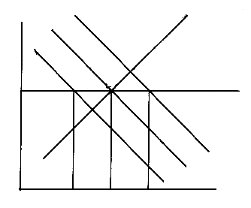
PRICE
S
D1
D
D2
O Q2 Q Q1
S
E
D
D2
QUANTITY

- What is the implication of a change from DD to D1 D1?  - What does E indicate?  - What does it mean if the demand curve moves to the left?  - List FOUR factors that could cause a change in supply.  - Mention THREE conditions of a perfect market. | (3)  (3)  (3)  (8)  (6)  [40]
QUESTION 4
ECONOMIC DEVELOPMENT, REGIONAL DEVELOPMENT AND URBANISATION

4.1 Match the statement in Column B with the concept in Column A.

 | COLUMN A |  | COLUMN B
 | 4.1.1 | Economic growth | (a) | Communities from rural areas move to live in the urban areas
 | 4.1.2 | Economic development | (b) | Economic activities conducted outside the mainstream of the economy
 | 4.1.3 | Urbanisation | (c) | Human, economic, and physical development in various regions of a country.
 | 4.1.4 | Informal sector | (d) | Is concerned with the increase in the real gross domestic product
 | 4.1.5 | Regional development | (e) | Is when the general standard of living of the people increase.
 |  |  | (f) | Forms the formal sector in the calculation of the National Income.
 |  |  | (g) | A deliberate process where National Income is not equal to National Production.
5x2 = |  |  |  |  | (10)

- Give THREE reasons why the informal sector plays an important role in the economy.  - Describe the concept urbanisation.  - List any FOUR objectives of regional development.  - Discuss the following characteristics of developing countries:  - High population growth rate  - Low standard of living  - High dependency in primary sector | (6)  (4)  (8)  (4)  (4)  (4)  [40]

QUESTION 5  INTERNATIONAL TRADE  - Discuss any TWO of the following causes of International Trade:  - Labour  - Climate  - Natural resources  4x2=  - List THREE forms of protection.  - Explain dumping as an argument in favour of protection.  - Choose the correct word from those given in brackets to make the statement true.  - The (balance of trade / balance of payment) is the account of transactions with the rest of the world.  - The (exchange rate / currency) is the ratio at which rands are exchanged for dollars. | (8)  (6)  (4)

- The balance between the goods imported and the goods exported is reflected in the (balance of trade / balance of payment).  - (Depreciation / devaluation) is a decrease in the value of a currency because of market forces.  - The demand for foreign exchange is determined by the (export / import) of goods.  5x2 =  - Study the given information below for Island X and answer the questions that follow. | (10)

GOODS | IMPORTS |  |  | EXPORTS
 | ORDER | R Million | % | ORDER | R Million | %
Mineral products |  |  |  | 8 | 860 | 25
Livestock |  |  |  | 9 | 940 | 29
Fruit and Vegetables | 1 | 3418 | 30
Prepared foods |  |  |  | 6 | 700 | 9
Chemical products | 6 | 720 | 8
Processed leather | 7 | 755 | 14 | 7 | 820 | 20
Paper and Pulp |  |  |  | 3 | 400 | 5
Textiles | 8 | 790 | 18
Machinery | 9 | 830 | 26
Other | 3 | 420 | 4 | 5 | 490 | 12
TOTAL |  | 6933 |  |  | 4210

- What is the total value of exports?  - On which of the imported products does Island X spend the most money?  - Is the balance of payment favourable or unfavourable? Give a reason. | (3)  (3)  (6)  [40]

QUESTION 6  THE STATE  - Name THREE reasons why the state must sometimes act as an entrepreneur.  - List FOUR functions of the state.  - Name TWO criteria for a good system of tax.  - At which rate is VAT currently levied?  - Study the graph below and answer the questions that follow. | (6)  (8)  (4)  (2)

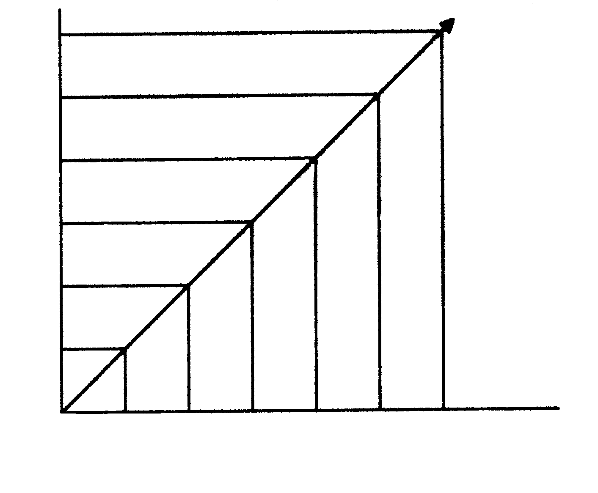
0 2 000 4 000 6 000 8 000 10 000 12 000
Income per month in Rands

30

25

20

15

10

5

5
% Tax payable
- What type of tax is depicted in this diagram?  - What % tax will a person who earns R4 000 pay?  - What income will a person earn if he pays 30% of his income to tax?  - Choose the correct answer from the words within brackets:  - Tax avoidance is (legal / illegal).  - According to the progressive system of taxation all incomes are taxed at the (same / different) rates.  - Tax deducted by the employer from the employee’s salary is called  (VAT / PAYE).  - (Partnership / privatisation) is the transfer of appropriate functions from the public sector to the private sector.  - A levy on imported goods is an example of (excise duty / custom duty).  5x2 =  - Who is the president of the Reserve Bank? | (3)  (3)  (3)  (10)  (1)  [40]

QUESTION 7
IMPORTANT TOPICS IN THE SOUTH AFRICAN CONTEXT
CHOICE MODULES

Answer the questions on any TWO of the topics in this module.

  - LABOUR RELATIONS

Study the chart below and answer the questions that follow.

% showing the demand and supply of labour

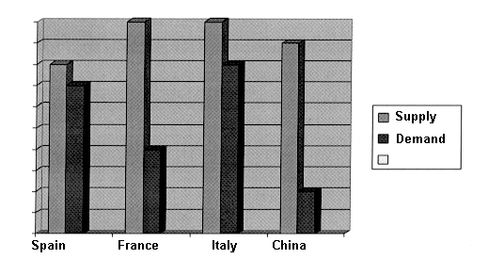
100

90

80

70

60

50

40

30

20

10

0
- Which country has the lowest demand for labour?  - Which country has the least difference between the demand and the supply of labour?  - What do you understand by the statement “the demand for labour is an induced demand”?  - One of the characteristics of the labour market is that “the product of the labour market is a person and not a thing”. How could this be realized in the event of an HIV infected worker?  - List any FOUR functions of trade unions.  - PRODUCTIVITY AND UNEMPLOYMENT  - One of the most serious problems facing South Africa is unemployment.  - Define the concept unemployment  - Name any TWO measures that can be used to combat unemployment.  - Clearly explain structural unemployment.  - List THREE main consequences of unemployment. | (3)  (3)  (3)  (3)  (8)  [20]  (4)  (4)  (6)  (6)  [20]

- INFLATION  - List FIVE consequences of inflation.  - Choose the correct answer from the words within brackets. Write only the answer in your answer book.  - An increase in the value of money as the result of the general decrease in price is called (inflation / deflation).  - (Demand pull inflation / cost push inflation) occurs when labourers claim wages which are higher than their increase in productivity.  - Inflation (encourages / discourages) saving.  - Economic (policy / regulation) refers to the deliberate intervention by the state in the working of the economy in order to effect improvements.  - A period of inflation usually benefits (debtors / creditors).  5x2 =  - STRATEGIC RESOURCES IN SOUTH AFRICA  - List FOUR sources of energy in South Africa.  - Name any FOUR reasons why water is of importance in South Africa.  - List TWO reasons why irrigation schemes are important.  2x20=  QUESTION 8  GENERAL  - Name the FOUR factors of production and list each factors remuneration.  - Name THREE factors that will influence South Africa’s economic growth.  - List FIVE conditions for a perfect market and give ONE example of a perfect market.  - Match the terms in Column A with the information in Column B. | (10)  (10)  [20]  (8)  (8)  (4)  [20]  [40]  (8)  (6)  (12)

 | COLUMN A |  | COLUMN B
 | 8.4.1 | Price equilibrium | (a) | Average national income per head of the population
 | 8.4.2 | National income | (b) | Income of all the factors of production in a country
 | 8.4.3 | South Africa’s financial year | (c) | 01 January – 31 December
 | 8.4.4 | Per capita national income | (d) | Interaction of the demand curve and the supply curve
 | 8.4.5 | Demand | (e) | 01 April – 31 March
 |  |  | (f) | Example of a public good
 |  |  | (g) | A factor determining value
5x2 = |  |  |  |  | (10)

- Explain import quotas as a form of protection.  TOTAL FOR SECTION B:  TOTAL: | (4)  [40]  [200]  300

