GAUTENG DEPARTMENT OF EDUCATION

SENIOR CERTIFICATE EXAMINATION

ECONOMICS HG

TIME: 3 hours

MARKS: 400

INSTRUCTIONS:

- Answer SEVEN questions.

–Section A: Question 1 is COMPULSORY.
–Section B: Answer any TWO questions.
–Section C: Answer any FOUR questions.

- Answer Question 1 on the answer Sheet provided on the inside cover of your answer book.
- Number your answers clearly and correctly.
- Read the questions carefully.
- Structure your answers neatly and systematically.
- Use the mark allocation as a guide to the scope and length of your answers.
- Where possible, questions should be answered in point form.

SECTION A

COMPULSORY

QUESTION 1
GENERAL

NOTE: Indicate the correct answer by drawing a cross (X) over the appropriate letter on the answer sheet on the inside cover of your answer book. Each question counts 3 marks.

  - The largest component of South Africa’s national expenditure is

- private consumer expenditure.
- private fixed investment.
- consumer expenditure by the state.
- total fixed capital expenditure.

  - It is difficult to calculate national income accurately because

- the national income of different countries is expressed in the currencies of those countries.
- reasonably reliable information over long periods of time is not available.
- all services are expressed in terms of money.
- the contribution of the factors of production for a specific service is sometimes calculated twice.

  - The value of all final goods produced and services rendered during a given year by the permanent citizens of a country, represents the

- national product.
- gross domestic product at buyers’ prices.
- gross domestic product at factor prices.
- national income per capita.

  - Indicate the correct statement:

- Gross domestic expenditure is the total amount of expenditure within the boundaries of a country.
- The greatest part of national income is spent on capital goods.
- An increase in the population leads to an increase in the per capita income.
- The income a country’s citizens earn in foreign countries is not part of the gross national product.

  - The gross domestic product at market prices equals the gross domestic product at factor prices

- less indirect taxes.
- plus indirect taxes less subsidies.
- plus subsidies less indirect taxes.
- plus subsidies.

  - Cyclical trends in the economy are also known as

- depressions.
- recessions.
- economic growth rate.
- trade cycles.

  - To obtain market equilibrium price,

- all products must be homogenous.
- demand and supply must be the same at different times.
- demand and supply must be equal at a given point in time.
- the average demand and supply must be the same at different times.

  - In South Africa we find a near perfect market regarding

- share transactions.
- labour.
- agricultural products.
- housing.

  - Which of the following are characteristics of wants?

- As soon as certain wants are satisfied, new ones originate immediately.
- When certain wants are not satisfied, a consumer can switch to another product.
- Wants stay the same at all times.
- Wants are greatly influenced by advertisements.

Choose the correct combination:

- Only (iv)
- (i), (ii) and (iv)
- (i), (ii) and (iii)
- All the above possibilities.

  - Which of the following is a characteristic of utility?

- It is in relation to the quantity demanded.
- Utility is limited in intensity.
- Goods must be transferable.
- Utility determines the lowest price at which goods and services will be provided.

  - Which of the following is characteristic of free goods?

- It is scarce in relation to demand.
- It has utilitarian value.
- The welfare of a person is measured.
- In the modern society free goods are classified more and more as economic goods.

Choose the correct combination:

- Only (iv)
- (i), (ii) and (iii)
- (ii) and (iv)
- (i), (ii) and (iv)

  - Price formation over the short term is charcterised by the fact that

- there is enough time to use new fixed equipment to increase production.
- there is not enough time to use new fixed equipment to increase production.
- there is enough time to use current fixed equipment to increase production.
- cost of production will not decidedly influence price formation.

1.13 Study the following representation and indicate which of the following is the most likely cause of the price increase as illustrated in the diagram:

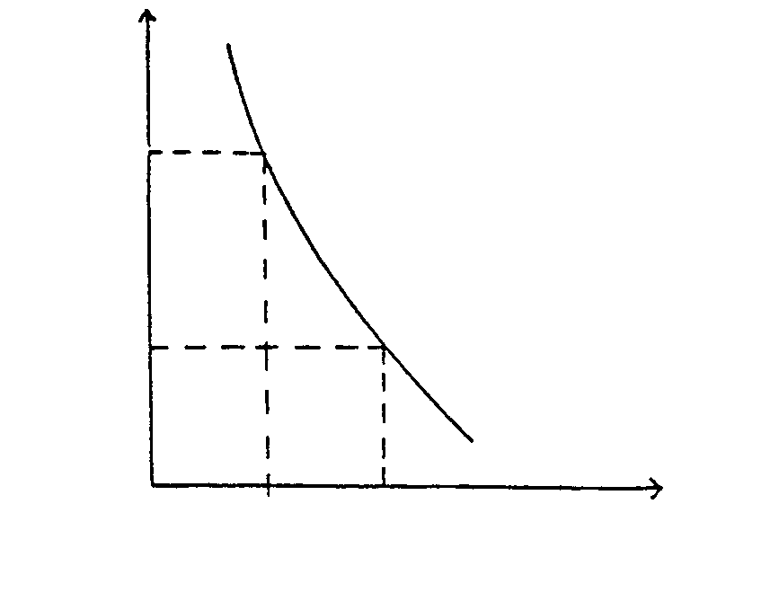
Price

Quantity
V

P
P¹
O

Q

Q

V

- An increase in income
- A successful marketing campaign
- A decrease in supply
- An increase in the price of a substitute product

  - A reason for imperfect competition is

- that there is an unlimited supply of natural resources.
- that the market is relatively large in relation to the extent of the production units producing the product.
- copyrights or patent rights exist on the products that are produced.
- consumers do not care about trademarks and continuously buy new products that enter the market.

1.15 Study the following graph depicting a change in supply from AA to A¹ A¹:

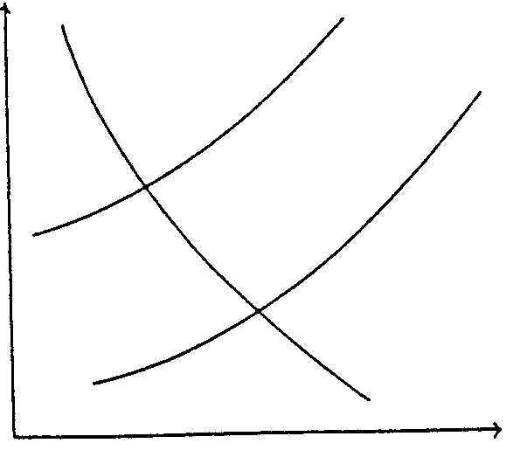
A
A
A¹
A¹

QUANTITY
PRICE
O

A possible reason for the shift of the supply curve from AA to A¹ A¹ is

- a record harvest.
- a change in the cost of factors of production.
- the introduction of tax (VAT).
- the introduction of a subsidy.

1.16 The supply curve normally has an upward incline because

- larger profits can be made by keeping the supply low.
- production can increase as prices increase.
- an increase in production will lead to an increase in demand.
- a price increase will attract a larger number of buyers.

  - Which of the following apply to the informal sector?

- Impossible to regulate
- Tax evasion
- Increasing unemployment figures
- Impossible to do macro-economic calculations

Choose the correct combination:

- (i), (ii) and (iv)
- (i), (iii) and (iv)
- (i), (ii) and (iii)
- All of the above.

  - One of the largest informal providors of informal sector funds is the

- Advice Bureau for Small Business.
- stokvels
- banks.
- Spaza-shops.

  - A healthy urbanisation policy strives to

- better the welfare of its residents.
- create job opportunities, especially for unschooled labour.
- better municipal services to maximise the satisfaction of needs.
- All the above.

  - International trade takes place because

- the wants of individuals are the same all over.
- capital can quite easily be obtained in all countries.
- natural resources are distributed equally around the world.
- the development of transport and communication brings countries into closer contact with one another.

  - When two or more countries form an economic unit with uniform tariffs applying to non-members, and factors of production are allowed to flow freely between these countries, it forms a

- free trade area.
- customs union.
- common market.
- economic union.

  - When a country has to pay more to the foreign sector than it receives for its goods from the foreign sector, its

A. trade balance is favourable.
- budget is unfavourable.
- trade balance is unfavourable.
- balance of payment is favourable.

  - In which of the following cases will a demand for US Dollars originate?

(i) When SA pays dividends on US capital invested here
- When SA exports gold to the USA
- When US tourists visit SA
- When the US transports SA goods per ship

Choose the correct combination:

- (i), (iii) and (iv)
- (i) and (iv)
- (i), (ii) and (iv)
- (ii) and (iii)

  - A country usually institutes import quotas

- to limit the import of goods.
- to discourage the import of goods.
- when the balance of trade is unfavourable.
- when imported goods are scarce.

  - When countries agree on a uniform tariff on goods that are imported from outside their areas, they form a

- monetary union.
- economic union.
- customs union.
- common market.

1.26 Vat is a form of _________ tax.

- progressive
- indirect
- income
- direct

  - Which institution or person handles short term investments on behalf of the public sector?

- Minister of Finance
- Public investment commissioner
- President of the Reserve Bank
- Corporation for Public Deposits

  - Shifting of taxes has bearing on

- inheritance tax.
- VAT.
- income tax.
- taxes on undistributed profits.

1.29
TAX RATE (%)

TAXABLE INCOME
0

The graph illustrates a ____________ tax.

- proportional
- progressive
- regressive
- increasing

1.30 Susan (unmarried) earns R2 000 per year and pays R20 tax. Thabo (unmarried) earns R10 000 per year and pays R800 tax. The implied tax scale is

- progressive
- regressive
- proportional
- functional

  - The correct budget procedure is

- planning/authorisation/execution/responsibility.
- authorisation/planning/responsibility/execution.
- planning/execution/authorisation/responsibility.
- planning/authorisation/responsibility/execution.

  - The fiscal policy is relevant to

- the money supply of a country.
- the financial policy of a country.
- control over state income and expenditure.
- the exchange rate of South Africa.

  - A method that can be used to decrease state expenditure:

- Privatisation
- Deregulation
- Boycotts
- Nationalisation

Choose the correct combination:

- (i) and (ii).
- (ii) and (iii).
- Only (i).
- Only (iv).

- A measure that the state can apply in its monetary policy is a change in  - interest rates.  - taxes.  - import tariffs.  - subsidies.  TOTAL FOR SECTION A: | 34x3=[100]  [100]

SECTION B

Answer any TWO questions in this section.

QUESTION 2
NATIONAL INCOME

During the past year the following information appeared in the newspapers:

EXTENT OF ECONOMIC ACTIVITY

YEAR
New technology.
Profit margins rise.
New era of
development for SA.
Umemployment.
Interest rates hurt.
Recession
prospects?
crest
trough

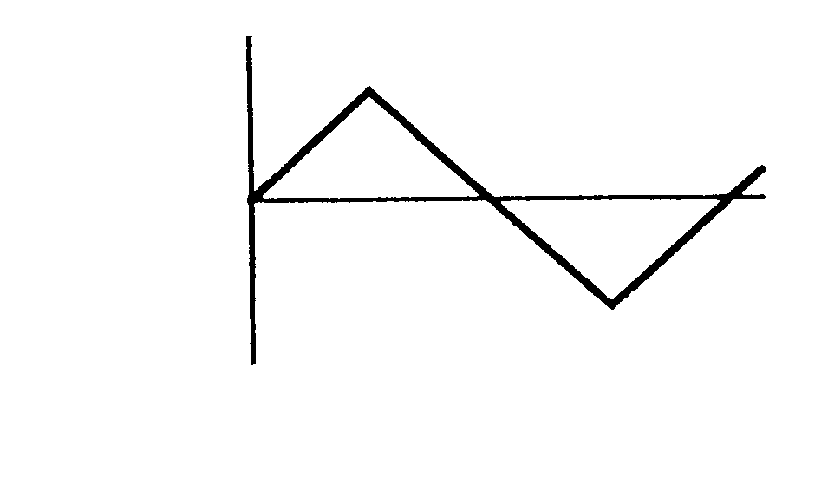

Your classmates do not understand what these articles have to say. Your teacher asks you to explain the causes of business cycles to them. Write your explanation in your examination answer book. | [50]

QUESTION 3
PRICE FORMATION

During your Grade 11 and 12 years you have worked during school holidays and weekends at a famous restaurant. Your aim was to have enough money to buy yourself a car once you have written the final examinations.

You have done a market analysis of the prices of possible models you could afford. One day you see the following caption in a newspaper:

Price war in motor industry

Samkor decreases prices of certain models up to 12%

With regard to the above, dicuss price elasticity of demand in full. | [50]

QUESTION 4

ECONOMIC DEVELOPMENT

Economic development suggests a situation of change where a whole community’s economic circumstances improve.

South Africa has a dualistic economy; therefore it is imperative that economic development takes place so that there can be an increase in the real GDP per capita.

Explain economic development in detail. | [50]

QUESTION 5
THE STATE

First
five years:

Economics
Welfare
Crime

Education
Health

“The intervention of the state in a country depends mainly on the current political and economic conditions in that country.”  Discuss the functions of the South African government as seen by the citizens of the country.  TOTAL FOR SECTION B: | [50]  [100]

SECTION C

Answer any FOUR questions in this section.

QUESTION 6
NATIONAL INCOME

- Distinguish between the following concepts:  6.1.1 Gross Domestic Product and Gross National Product  - Nominal National Income and Real National Income  - Transfer payments and Double counting | (6)  (6)  (6)

6.2 Although the GDP is an indispensable indicator of a country’s economic performance there are, however, certain limitations regarding the figures. List, in full sentences, FIVE of these limitations. | (10)

6.3 The following statistics were published by the SA Developing Commission in 1999.

COUNTRY | CAPITAL | POPULATION  (millions | GNP/  (US$m) | GNP per capita (US$)
South Africa | Pretoria | 37.9 * | 130,919 | 3,160
Angola | Luanda | 11.5 | 4,422 | 410
Botswana | Gaberone | 1.6 | 4,381 | 3,020
Lesotho | Maseru | 2.0 | 1.519 | 770
Madagascar | Antananarivo | 13.5 | 3,178 | 230
Malawi | Lilongwe | 10.0 | 1,622 | 170
Mauritius | Port Louis | 1,1 | 3,815 | 3,380
Mozambique | Maputo | 18.0 | 1,353 | 80
Namibia | Windhoek | 1,6 | 3,098 | 2,000
Swaziland | Mbabane | 0,9 | 1,051 | 1,170
Tanzania | Dar es Salaam | 29,0 | 3,703 | 120
Zambia | Lusaka | 9.5 | 3,605 | 400
Zimbabwe | Harare | 11,2 | 5,933 | 540

* Census ’96, preliminary estimates
Source: Africa Institute

6.3.1 Explain why the GDP-figures are not ideal to do comparisons between countries? | (3)

6.3.2 In which neighbouring country of SA is the standard of living the lowest? | (3)

6.3.3 Define the concept gross national product per capita and explain how it is determined. (Make use of an example from the given table.) | (8)

- Give ONE word for the following:  6.4.1 An economy that trades with the foreign sector.  - Smooth pattern of expansion and shrinkage of economic activities.  - Percentage change in the total quantity of goods and services that are produced within a certain time.  - According to this method the income of the different factors of production in the form of factor remuneration is added.  - Flow of goods and services, factor services, income and expenditure between the different groups of economic participants and markets. | 5X2=(10)  [50]

QUESTION 7
PRICE FORMATION AND MARKETS

7.1 The following information is given to you regarding cold drinks that are sold in your schools’ tuck shop.

Price per can | Quantity demanded | Quantity Supplied
R2,00 | 30 | 5
R2,50 | 20 | 10
R3,00 | 15 | 15
R3,50 | 10 | 20
R4,00 | 3 | 25

7.1.1 If the price is R3,50 per can, determine the surplus or deficit. | (3)

7.1.2 Draw, with regard to these figures, the demand and supply curves. | (7)

7.1.3 The demand curve for cold drinks has a particular slope. Fully explain this slope. | (6)

- Explain how the following goods will determine the quantity demanded:  - compliments  - substitutes | (4)  (4)

7.2 Name points A, B and C on the following graph.

A₁

V

V₁

A₁

V

C

V₁

B

A
Price of pumpkins

Quantity
O

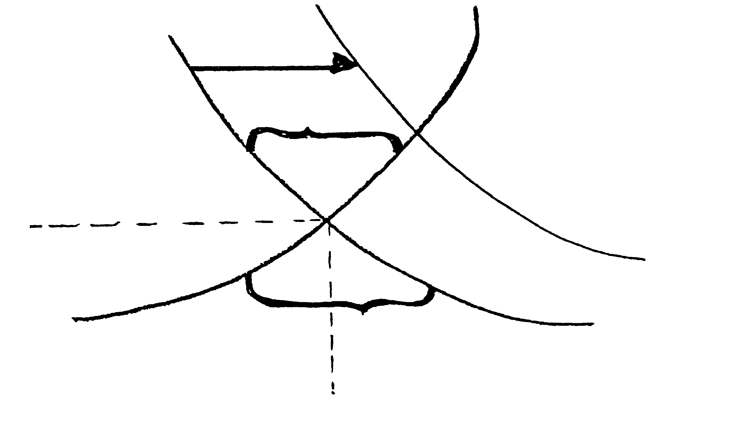

7.3 Discuss economic and legal reasons for the market form in which Eskom operates to supply electricity to SA. | (8)



7.4 Give ONE example of a perfect market. | (2)

7.5 Indicate whether the following statements are TRUE or FALSE

7.5.1 At equilibrium price the same quantity is demanded as the quantity suppied.

7.5.2 A single producer is known as a monopolist

7.5.3 National markets is where families trade with a limited area.

7.5.4 The difference between the price the consumer is willing to pay and the actual price he pays is known as consumersurplus.

7.5.5 The producer’s total ‘sacrifice’ to produce an article is known as the reserve price.

5x2=(10)
[50]

QUESTION 8
REGIONAL DEVELOPMENT, URBANISATION AND THE INFORMAL SECTOR

8.1 Study the following article that appeared in Finance Week (30/5/98) and answer the questions that follow:

The SA tourism trade has the potential to create more than 300 000 new job
opportunities in the year 2000 – nearly the total aimed at by the state’s macro-
economic strategy (GEAR).

The expectation is that foreign tourist figures will double from 1.1 million to
2.2. million per year. This will generate R23 million per year in
foreign exchange and will increase the tourism trade’s contribution to the GDP
to 8%.

For regional tourism to work, transport between the different areas must be easy,
comfortable and cheap – something that can only happen if sufficient money is
invested in infrastructure development and the bureaucratic red tape (especially
with regard to visas) is done away with.

Joan Muller

8.1.1 List the principles that must be kept in mind with regional development. | (6)

8.1.2 Describe the concept GEAR. | (3)

8.1.3 List ONE aim of GEAR. | (2)

8.1.4 Explain infrastructure development as an aim of regional development. | (3)

8.2 Discuss FOUR disadvantages of urbanisation. | (8)

8.3 Explain the following with regard to unrecorded economic activities:
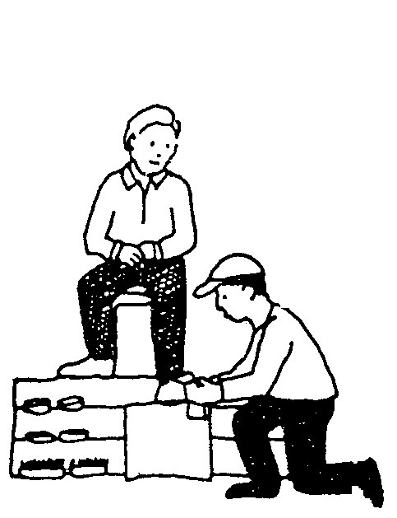
8.3.1 Deregulation    Shu-Shine  Sale of fruit, vegetables and flowers  - Four charac-  teristics | (2)  (16)

8.4 Indicate whether the following statements are TRUE or FALSE

8.4.1 Economic growth will lead to economic integration.

8.4.2 South Africa has a closed economy.

8.4.3 Sufficient job opportunities in rural areas are a reason for regional development.

8.4.4 The informal sector does not make use of the latest technology and therefore is very labour intensive.

8.4.5 Activities in the informal sector are heterogeneous. | 5X2=(10)  [50]

QUESTION 9
INTERNATIONAL TRADE

9.1 Discuss the following causes of international trade:

9.1.1 Labour and entrepreneur traits as well as technical knowledge are not the same everywhere. | (2)

9.1.2 Established industries in older countries enjoy a cost advantage to new industries in younger countries. | (2)

9.1.3 Natural resources | (2)

9.2 Study the following table and answer the questions that follow:

BALANCE OF PAYMENTS¹ : RSA

Quarterly figures
R millions
 |  |  | 1999
 | 1997 | 1998 | 01
Current account
Merchandise exports, f.o.b. | 118 012 | 135 054 | 35 431
Net gold exports | 25 818 | 25 907 | 6 185
Service receipts | 24 587 | 29 126 | 7 387
Income receipts | 6 011 | 7 255 | 1 690
Less: merchandise imports, f.o.b. | 133 061 | 150 751 | 33 687
Less: Payments for services | 27 657 | 30 209 | 7 518
Less: Income payments | 20 808 | 23 936 | 6 444
Current transfers (net receipts+) | -3 328 | -4 076 | -1 019
Balance on current account | -10 426 | -11 630 | 2 025

9.2.1 Name TWO items in the balance of payment which represent an addition entry. | (4)

9.2.2 Was the RSA’s current account in 1998 favourable or unfavourable? Use a figure to substantiate your answer. | (4)

9.2.3 What is the difference between the concepts balance of payments and balance of trade ? | (4)

9.2.4 Explain the concept transfers as it appears in the current account. | (2)

9.3 The following economic indicators appeared in the newspaper:

R/$
4.20pm
Mon 28 Tue 29 Wed 30 Thu 1 Fri 2
6.07

6.06

6.05

6.04

6.03

6.02

June/July 1999
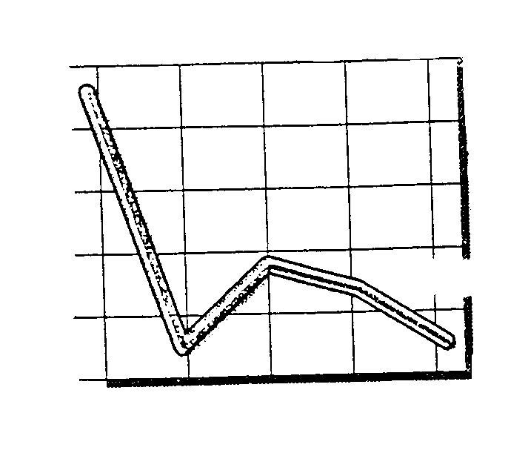

9.3.1 What is illustrated in the graph? | (3)

9.3.2 When was the value of the rand at its lowest? | (3)

- What is the difference between  - devaluation and appreciation of the rand?  - controlled floating and group floating of currencies? | (4)  (4)

9.4 Explain each of the following forms of protection that can be introduced to protect local industries from foreign competition:

- Import quotas  - Import deposits | (2)  (2)

9.5 Define the concept economic integration and co-operation. | (2)

9.6 Choose the correct word(s) in brackets that will make the following sentences TRUE. Write only the answer next to the appropriate number.

9.6.1 The debit entries in the balance of payments consist of payments which the concerned country (owes to/receives from) the rest of the world.

9.6.2 Services rendered or received refer to (invisible/visible) imports and exports.

9.6.3 Supply of foreign exchange develops, amongst others, on the grounds of (imports/exports) of goods.

    - The aim of (SACU/SADC) is to levy a uniform tariff on trade with
non-members.

- (Disinvestments/sanctions) can be described as the withdrawal of foreign companies out of South Africa. | 5X2=(10)  [50]

QUESTION 10
THE STATE

10.1

SA’s economic prospects

Investment – the fuel of economic growth

New tax scales welcomed

The above headlines appeared in newspapers. Discuss the following with regard to the economic policy of the state:  - FOUR aims  - Fiscal policy as a measure to obtain goals | (16)  (6)

10.2 Study the following cartoon with regard to the 1999/2000 budget and answer the questions that follow: | (2)

TREFFER
MANUEL!
PROTECTION
SERVICES
WELFARE
EDUCATION
HOUSING
HEALTH
STOP
FISCAL DRAG
INTEREST ON STATE DEBT
162%
22,1%
9%
10,9%
45%

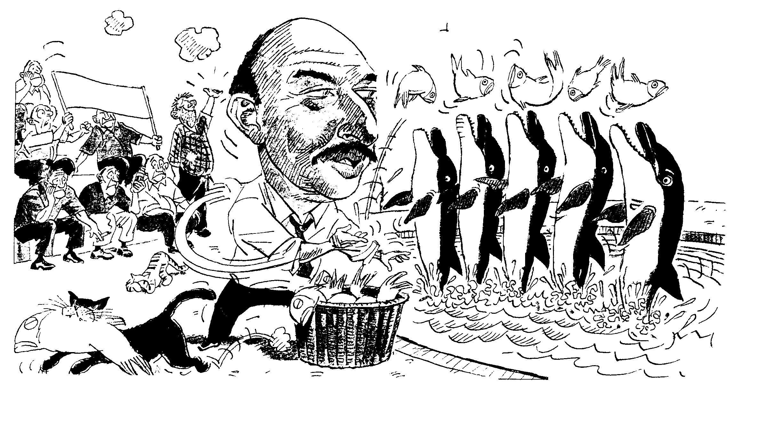

10.2.1 Who is referred to as “Treffer Manuel”? | (2)

10.2.2 List TWO items that are classified under the functional classification of state expenditure. | (4)

10.2.3 What is the main source of state income? | (2)

10.2.4 Discuss the planning stage this budget goes through. | (10)

10.3 Indicate whether the following stements are TRUE or FALSE.

10.3.1 Incidence of taxes is a legal way not to pay taxes.

    - Progressive taxes are based on the fair distribution of the tax burden.

10.3.3 SA’š tax system is elastic because the cost of collection is kept as low as possible.

10.3.4 Vat is an example of indirect taxes.

10.3.5 Inheritance tax can be shifted to another person. | 5X2=(10)  [50]

QUESTION 11
IMPORTANT ECONOMIC TOPICS

NOTE:

- This question consists of four subdivisions of 25 marks each.
- You must answer any TWO subdivisions.
- NUMBER your choices clearly.

11.1 Labour Relations

11.1.1 Who forms part of the labour force? | (3)

11.1.2 List THREE factors that will influence the extent of the labour force. | (6)

11.1.3

‘Better spirit’ developing

Between ‘hard’ capitalism and Ubuntu a new working spirit is developing that will exorcise the disputes of the past.

Promising signs exist that a better relationship is developing between employers and labour unions regarding old disputes like higher wages and insight into working processes.

- Define the concept labour union.  - Labour unions are subjected to legal conditions as described in the Law on ___________.  - Describe FOUR functions of labour unions.  - To which institution can employers and employees turn if disputes originate between them? | (4)  (2)  (8)  (2)  [25]

11.2 Productivity and Unemployment

This is how employment declined … has the turning point been reached?
Total employment in the formal non-agricultural sectors
Sep 95 Sep 96 Sep 97 Jun 98
5,25

5,15

5,05

4,95

4,85

4,85
Millions
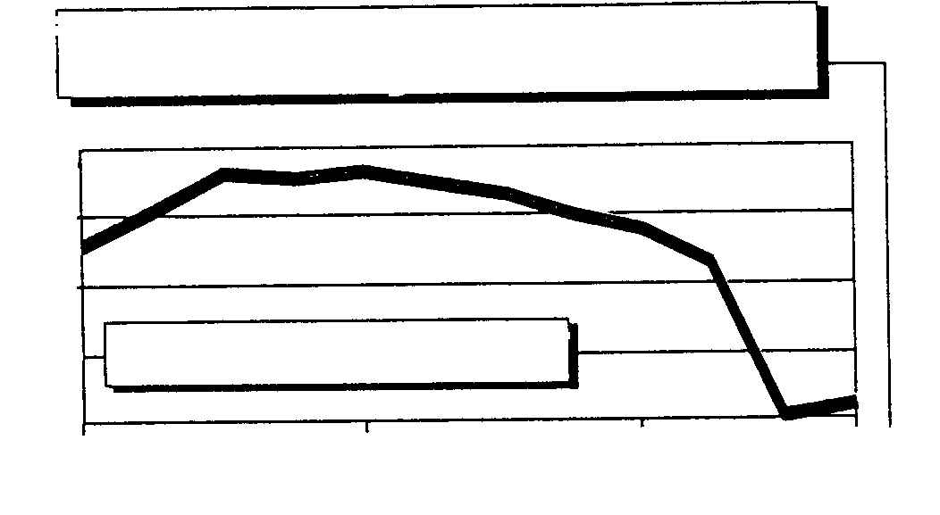

Source: Statistics SA

11.2.1 Which tendency do you observe in the graph regarding unemployment in SA? | (3)

11.2.2 Discuss FOUR causes of unemployment. | (8)

11.2.3 List TWO measures to combat unemployment. | (4)

11.2.4 Study the following fictitious article and answer the questions that follow:

SA’š productivity is low in terms of international standards. One of the biggest problems is a lack of co-operation between management and unions. They tend to fight rather than to understand each other.

Productivity, in the full sense of the word, cannot only be measured in terms of labour. It is important to take into consideration how efficiently capital was used as well as how capital and labour can be applied more productively – how, indeed, the ultimate goal, total factor productivity (TFP), can be improved. This changes the situation drastically.

But there is another important factor regarding SA. Labour productivity is measured according to output per worker per hour. If you give a great part of the labour force an extremely protected environment, a high wage structure and less than the average total working hours, you can expect a larger output per hour.

- What, according to the article, is one of the bigget problems in terms of an increase in productivity?  - Discuss how the productivity of a country can be measured.  - List TWO methods that can be applied to improve the quality of the labour force in SA. | (3)  (3)  (4)  [25]

11.3 Inflation

11.3.1
9,2
7,7
6,1
8,6
6,8
6,6
9,6
9,4
1 2 3 4 1 2 3 4
96
97
10
9

8

7

6

5
% change

Inflation … the rand hump
Bron: SSD

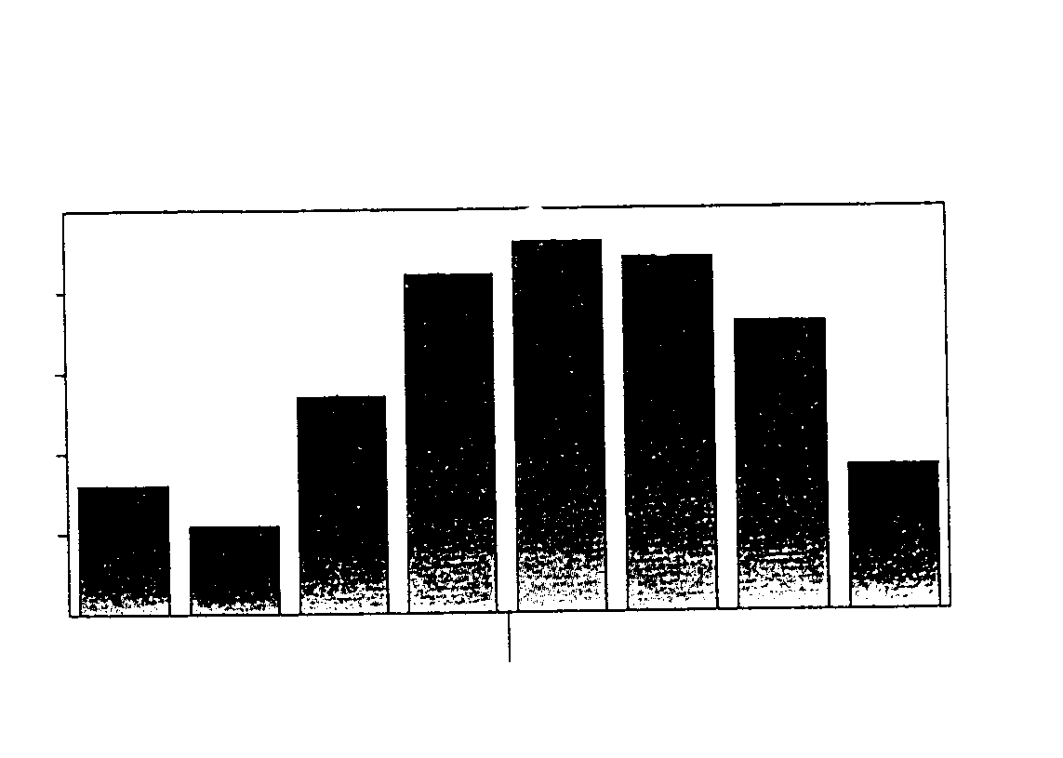

- Define the concept inflation.  - How does inflation influence:  - pensioners?  (ii) creditors? | (4)  (3)  (3)

11.3.2 Inflation is a man-made stupidity that can be overcome with man- made ingenuity.

(a) The editor of a leading business magazine requested you to give a detailed report on TWO consequences of this man- made stupidity.
(b) List TWO measures that the state can apply to overcome this stupidity.

    - The price-weak consumer is heavily burdened by unbelievable
INFLA-TION
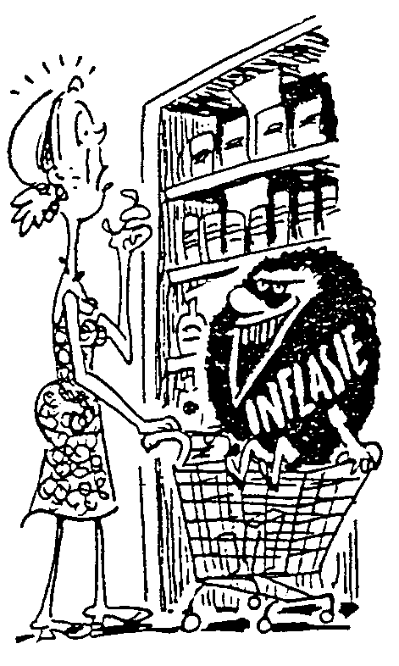
increases in food prices.

What is implied by the price-weak consumer? | (3)  [25]

11.4 Strategic Resources

- Discuss the following TWO reasons why water conservation and supply  are important in SA:  (a) Hydro-electrical power  (b) Industrial development | (3)  (3)

11.4.2 List FOUR other reasons (excluding the above) that contribute to the economic importance of water in South Africa. | (8)

11.4.3 Which neighbouring country, together with SA, embarked on a major water project? | (3)

11.4.4 Explain why coal is one of SA’s most important resources. | (3)

11.4.5 List TWO other (coal excluded) energy resources that are used in SA. | (4)

- Complete:  In 1992 ______ was commercialised and changed its name to DENEL. | (1)  (25)  25x2=[50]

TOTAL FOR SECTION C: | [200]

TOTAL: | 400

