GAUTENG DEPARTMENT OF EDUCATION

SENIOR CERTIFICATE EXAMINATION

ECONOMICS HG

TIME: 3 hours

MARKS: 300

INSTRUCTIONS:

- Answer SEVEN questions.

– Section A: Question 1 is COMPULSORY.
– Section B: Answer any TWO questions.
– Section C: Answer any FOUR questions.

- Number your answers clearly and correctly.

- Read the questions carefully.

- Structure your answers neatly and systematically.

- Use the mark allocation as a guide to the scope and length of your answers.

- Where possible, questions should be answered in point form.

SECTION A

COMPULSORY

QUESTION 1

GENERAL

Indicate the correct answer by drawing a cross (X) over the appropriate letter on the Answer Sheet on the inside cover of your answer book. Each question counts 3 marks.

  - The gross domestic product which is deflated to base year values by applying a price index is also known as the ___________ product.

- real gross domestic
- gross national
- net national
- net domestic

  - The gross domestic product divided by the population is the _________ domestic product.

- real net
- per capita
- net
- real gross

  - The total value of all the finished goods and services produced by South African citizens during 1999 is the

- per capita product.
- real domestic product.
- national product at buyers’ price.
- national product at factor cost.

  - The real national income is also known as national income at __________ prices.

- constant
- nominal
- current
- market

1.5 Study the following information:

 | Cost price | Selling price
Producer | --- | R100
Fabric factory | R100 | R150
Clothing factory | R150 | R200
Clothing retailer | R200 | R220

The value added to the national product is

- R1 120.
- R 220.
- R 450.
- R 670.

1.6 Under which circumstances will the following comparison be true? National product = National income = National expenditure.

- Under no circumstances.
- Only in a closed economy.
- Only in a state of perfect competition.
- If the circular flow includes international transactions.

  - Which of the following will be included in national income?

- Unemployment benefits
- Child’s allowances
- Disability grant
- Payment for repairs to a motorcar

  - The reason for the exclusion of intermediate goods in the national income data, is to

- indicate that value has been added.
- avoid double counting.
- give a more conservative estimate of national product.
- calculate the value of goods from raw materials in the national product.

  - To compare the welfare of countries, nominal figures have to be converted to real figures and real figures must be converted to real _________ figures.

- net
- national
- constant
- per capita

  - The principle of substitution is best illustrated by the following example:

- Lamb versus chicken
- Shoes versus socks
- Motorcar versus petrol
- Butter versus cheese

1.11 The scarcity issue is present in

- America.
- South Africa.
- Mozambique.
- all countries of the world.

1.12 Consider the following graph:
Quantity
pumpkins
PRICE

0

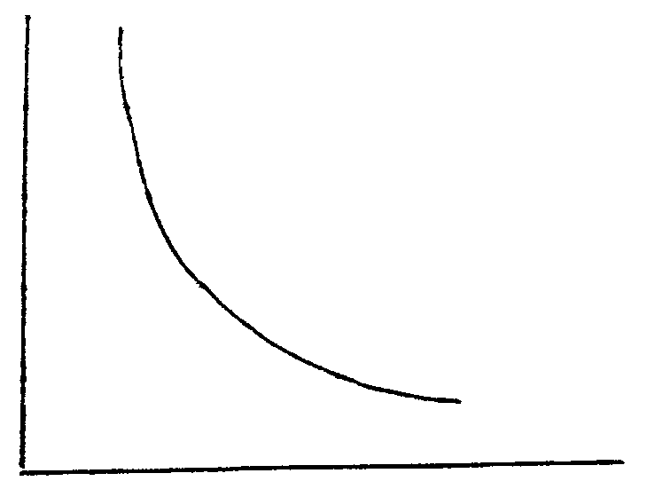

From the graph it can be deduced that the

- demand curve indicates the quantity of pumpkins that Mr X wishes to sell at different prices.
- law of supply equals law of demand.
- supply curve indicates the ratio between the price of pumpkins and the quantity offered.
- demand for pumpkins is completely insensitive to any price changes.

  - Which of the following is an example of economic goods?

- Building sand
- Desert sand
- Sea sand
- River sand

1.14 A successful advertising campaign for tomatoes can have the following result:

- The demand for tomatoes increases.
- A consumer surplus for tomatoes develops.
- Have no effect, because the demand for tomatoes is inelastic.
- A surplus supply develops.

  - A result of an increase in demand for a product at the immediate point of time is that

- supply increases.
- prices decrease.
- prices increase.
- market conditions remain the same.

  - Even if the price of cigarettes increases the demand will stay the same because the demand is

- perfectly elastic.
- an exceptional demand curve.
- perfectly inelastic.
- relatively elastic.

  - The value of goods and services is measured by the ______ the product.

- production cost of
- wants for
- marginal utility of
- price of

  - The market price is also known as the _________ price.

- floor
- equilibrium
- long term
- reserve

  - Which of the following is a condition for the perfect market?

- The product should be homogeneous.
- There are quality differences in products.
- People avoid the trouble of changing to another supplier
- The supplier is considered a pleasant and helpful person.

  - One of the most important advantages of urbanisation is that

- the number of non-economically active people declines
- personal income per capita is higher
- higher population growth occurs
- it has a negative impact on life expectancy

  - Regional development has the objective to

- encourage the creation of job opportunities.
- create a more productive economy.
- control the negative impact of the informal sector.
- prevent the income gap between citizens of the same country.

  - Informal activities include

- trade activities such as hawking.
- production activities e.g. candle making.
- illegal activities such as drug trade.
- all the above possibilities.

  - A dualistic economy consists of

- free and economic goods.
- traders and producers.
- developed and developing sectors.
- households and business sectors.

1.24 With regard to international economics:

R

A

N

D
0 1 2 3 4
+ 1%
- 1%
YEAR

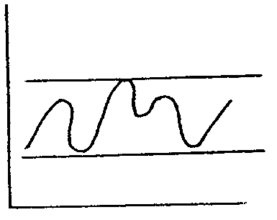

the above is a graphic illustration of

- fixed rates of exchange.
- floating rates of exchange.
- balance of payments problems.
- revaluation of the rand.

  - Which one of the following will result in a greater demand for the dollar?

- The rand has appreciated against the dollar.
- The dollar has become cheaper against the rand.
- Import of goods increases.
- More services are supplied to other countries.

  - Financial support out of public funds to industries that show export potential is known as

- import duties.
- export deposits.
- export subsidies.
- surcharge.

  - Economic integration refers to

- efforts made to restrict the free movement of goods across the borders of countries.
- the quest for closer economic liaison among countries.
- efforts to prevent free movement of labour and capital among countries.
- the free utilisation of natural resources by all countries.

  - Which of the following is not a problem with the application of the protection
policy with regard to industries in South Africa?

- To identify industries that need protection
- The period of protection
- Must be in pace with the fiscal and monetary policy.
- National independence in terms of strategic goods must be promoted

  - Import duties calculated as a certain amount per unit, mass or size of an
article, are known as ________ tariffs.

- ad valorem
- specific
- singular
- multiple

  - The first stage in the preparation of the annual budget is the

- formulation of the policy by the minister and his advisors.
- routine aspects in the compilation of the budget.
- minister’s budget speech in Parliament.
- approval of the budget by Parliament.

  - The _________________ policy of the state is applied with the aid of the Reserve Bank and aims to control the quantity of money and credit.

- fiscal
- monetary
- economic
- marketing

  - Expenditure of ______ is collective in nature.

- the state
- households
- industries
- the international sector

  - A ____________________________ gives rise to public debt.

- surplus on the balance of payments
- high inflation rate
- high standard of living
- budget shortfall to be financed with loans

- Mike earns R60 000 per year and pays 25% direct tax, while Ike earns R70 000 per year and pays 30% tax. The tax system which is applied here is  - proportional.  - regressive.  - progressive.  - democratic. | 34x3=(100)

TOTAL FOR SECTION A: | [100]

SECTION B  Answer any TWO questions in this section.  QUESTION 2  NATIONAL INCOME  Economic growth is important to create jobs and prosperity. Discuss economic growth in full. | [50]

QUESTION 3  MARKETS  Discuss the conditions for the various types of markets in a micro-economic sense in South Africa. | [50]

QUESTION 4  INTERNATIONAL TRADE  According to a report of the Reserve Bank, South Africa has made great progress on the way to economic restructuring through its international trade strategy.  Discuss the various forms of protection that can be used. | [50]

QUESTION 5  THE STATE  Discuss the requirements for a good system of taxation and evaluate the PAYE system in terms of these requirements.  TOTAL FOR SECTION B: | [50]  [100]

SECTION C

Answer any FOUR questions in this section.

QUESTION 6

NATIONAL INCOME

6.1 Study the following table and answer the questions that follow:

GROSS DOMESTIC AND NATIONAL
PRODUCT
At current prices R millions
 | 1989 | 1990 | 1991 | 1992 | 1993 | 1994
Remuneration of employees | 119 963 | 140 746 | 160 639 | 181 429 | 199 563 | 231 467
Net operating surplus¹ | 49 645 | 53 192 | 60 321 | 64 058 | 74 227 | 91 557
Provision for depreciation² | 38 402 | 43 070 | 46 990 | 50 127 | 53 081 | 59 537
Gross domestic product at factor cost | 208 0101 | 237 008 | 267 950 | 295 614 | 326 871 | 382 561
Indirect taxes | 30 224 | 33 048 | 35 881 | 38 082 | 46 055 | 57 736
less Subsidies | 4 806 | 5 853 | 5 936 | 6 628 | 7 678 | 7 544
Gross domestic product at market prices | 233 428 | 264 203 | 297 895 | 327 068 | 365 248 | 432 753
less Net factor payments to the rest of the world | 9 479 | 10 020 | 9 509 | 9 145 | 10 130 | 10 561
Gross national product at market prices | 228 530 | 262 489 | 297 845 | 327 068 | 365 248 | 422 192
Real gross national product (at 1990 prices) | 125 767 | 264 531 | 263 437 | 257 387 | 261 192 | 269 956
- After provision for depreciation and after inventory valuation adjustment..
- At replacement value.

Source: SARB Quarterly Bulletin, Š-91

6.1.1 Indicate the difference between gross domestic product and gross national product. | (6)

6.1.2 Name the participants in the economic activities involved with gross domestic production. | (8)

6.1.3 What does “at current prices” mean? | (2)

6.1.4 Why are subsidies subtracted to calculate the GDP at market prices? | (2)

6.1.5 Distinguish between GDP at market prices and GDP at factor prices. | (10)

6.2 The following is a comparison between South Africa’s gross national product and other African countries’ gross domestic product.

COUNTRY | CAPITAL | POPULATION  (millions) | GNP  (US$m) | GNP PER CAPITA  (US$)
South Africa | Pretoria | 37.9 | 130.191 | 3.160
Angola | Luanda | 11.5 | 4.422 | 410
Botswana | Gaborone | 1.6 | 4.381 | 3.020
Lesotho | Maseru | 2.0 | 1.519 | 770
Madagascar | Antananarivo | 13.5 | 3.178 | 230
Malawi | Lilongwe | 10.0 | 1.622 | 170
Mauritius | Port Louis | 1.1 | 3.815 | 3.380
Mozambique | Maputo | 18.0 | 1.353 | 80
Namibia | Windhoek | 1.6 | 3.098 | 2.000
Swaziland | Mbabane | 0.9 | 1.051 | 1.170
Tanzania | Dar es Salaam | 29.0 | 3.703 | 120
Zambia | Lusaka | 9.5 | 3.605 | 400
Zimbabwe | Harare | 11.2 | 5.933 | 540

- Census ’96, Preliminary estimates
- Source: Afrika Institue

6.2.1 Why is it difficult to compare the welfare between countries? | (3)

6.2.2 What figures are used as a measure to compare countries with one another? | (3)

6.3 Although there are shortcomings in the calculation of national income figures, it is useful to every country. Name in full sentences THREE of these shortcomings that overestimate the welfare of South Africa. | (6)

6.4 Indicate if the following statements are TRUE or FALSE.

6.4.1 Per capita national income is the nominal GDP divided by the total population.

6.4.2 Economic growth can be described as successive periods of increasing and decreasing economic activities.

6.4.3 South Africa’s cyclical trends are constantly monitored by the Reserve Bank.

6.4.4 The sum of wages, profits, rent and interest is national statistics.

6.4.5 The nominal income is income at current prices. | 5x2=(10)  [50]

QUESTION 7

PRICE FORMATION

7.1 You are requested by your school’s tuck shop to do a survey regarding the cold drinks that your friends use on a sportsday so that the tuck shop can fulfil your wants. Your research shows the following information:

Quantity of tins per  learner per day | Total utility | Marginal utility
1 | 12 | 12
2 | 22 | 10
3 | 29 | 7
4 | 32 | 3
5 | 32 | 0

You are requested to explain the following:

- Define the law of diminishing utility. (Use the above figures in your explanation). | (4)

- Where does every learner’s saturation point lie? Indicate whether it is  temporary or permanent. | (4)

7.1.3 Draw a graphic representation of total utility and marginal utility on the same axis. | (8)

7.1.4 Discuss TWO characteristics of wants that encourage your friends to operate in a specific manner. | (8)

7.2 Study the following graph and answer the questions that follow:

Price of pumpinks
(in cent)
140

120

100

80

60

40

20
0 4 6 8 12 16 22 24 28 32

Quantity of pumpkins
D
D1
A
B
C
D1
D
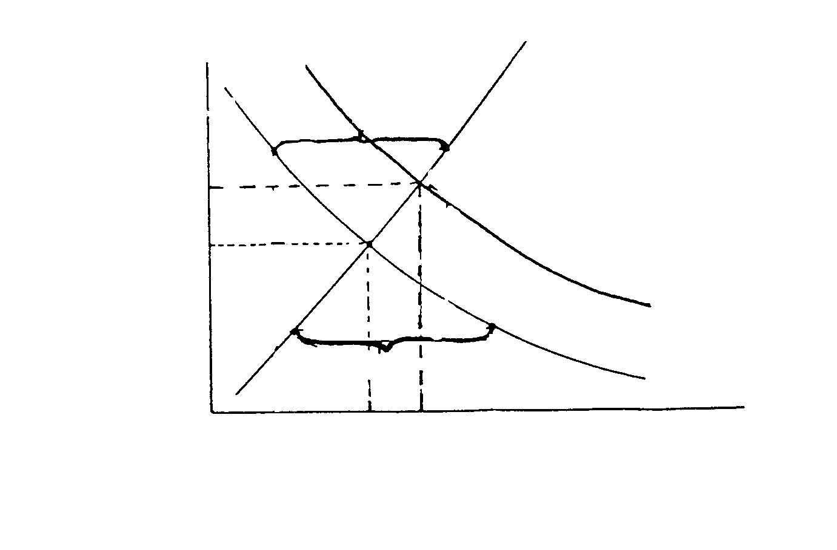

7.2.1 Name points A, B and C. | (9)

7.2.2 Supply ONE possible reason for the movement from D to D1. | (3)

7.3 The following are forms of price elasticity of demand. Describe the demand curves in terms of elasticity.

7.3.1 The demand curve is ______.
80

60

40

20

0

Price of product
1 2 3 4 5 6 7 8 9

Quantity requested
A1
A2
A2
A1

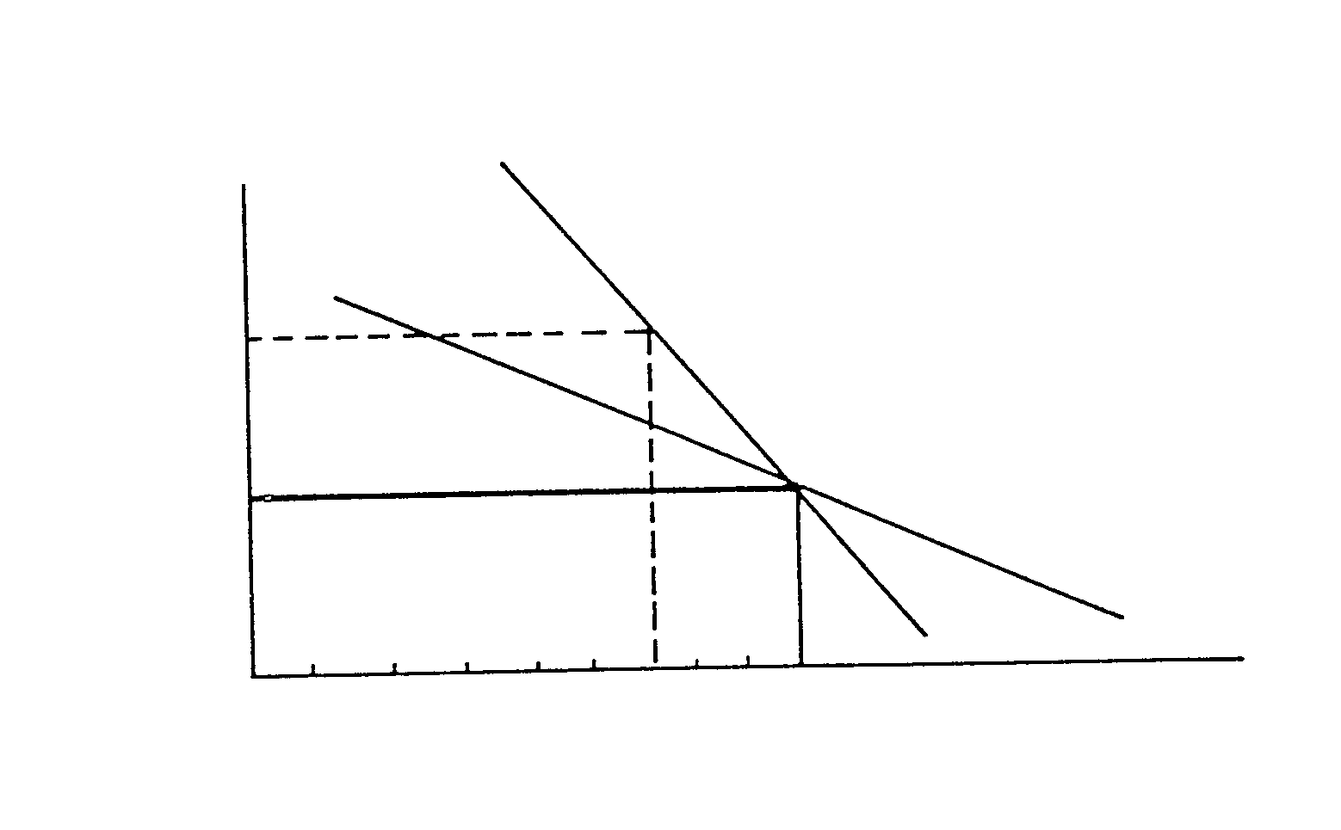

7.3.2 The demand curve is ______.  Price of product  1 2 3 4 5 6 7 8 9  Quantity requested  A2  A1  A2  A1  12  11  9  6  3  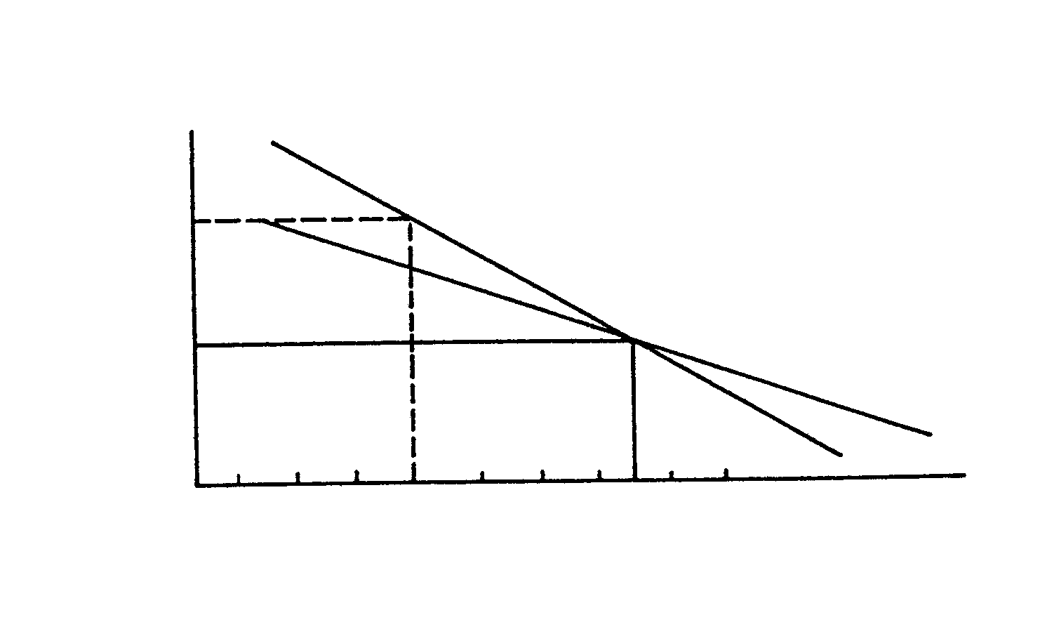 | (6)

- Indicate whether the following statements are TRUE or FALSE.  7.4.1 The multiplicity of wants forces the economy in an increasing way to transform free goods into economic goods.  - The price that a consumer is willing to pay for a cold drink is determined by the marginal utility.  - The supply curve has a positive slope.  - The production cost of a product will influence the supply thereof. | 4x2=(8)  [50]

QUESTION 8

ECONOMIC DEVELOPMENT

8.1 The following information appears in newspapers and financial magazines. Your classmates ask you to answer the questions that follow.

GEAR: Please do Gear in top gear
ForesTry sector does its part for GEAR

Export – the oil of GEAR

Needed: a Gear-plan that works

Why gear will resist pressure

SA’s macro economic strategy, GEAR, has established credibility amongst the local business sector and foreign investors for the economic strategy of the country.

8.1.1 What is GEAR? | (3)

8.1.2 Distinguish between economic growth and economic development. | (4)

8.1.3 List ONE aim of GEAR. | (2)

8.1.4 List and discuss FOUR characteristics of developing economies. | (16)

8.2 Discuss migration as a cause for urbanisation. | (3)

8.3 Give the term for unregistered economic activities and list SIX characteristics of this sector. | (14)

  - Choose from the following concepts those that suit each description:

IDC; Informal Sector; Regional development; Growth rate;
Underdeveloped economy; Economic active population; Dualistic economy

8.4.1 A country with a real national income per capita that is relatively low in relation with developed countries, e.g. the USA.
8.4.2 The development of quite a number of areas around a growth centre.
8.4.3 The organisation that lends financial assistance to new industries.
8.4.4 South Africa has such an economy because characteristics of both developed and developing economies are present. | 4x2=(8)  [50]

QUESTION 9

INTERNATIONAL TRADE

9.1 Study the following Balance of Payments on page 17 and answer the questions that follow.

BALANCE OF PAYMENTS
Annual figures
R millions
 | 1989 | 1990 | 1991 | 1992 | 1993 | 1994 | 1995 | 1996
Merchandise exports, f.o.b² | 38 384 | 42 735 | 44 709 | 49 010 | 56 059 | 66 378 | 80 991 | 98 818
A | 19 140 | 18 177 | 19 587 | 18 356 | 22 229 | 22 661 | 20 153 | 26 294
Service receipts | 11 543 | 11 346 | 12 386 | 13 310 | 14 277 | 16 058 | 20 285 | 21 978
less merchandise imports, f.o.b² | 44 266 | 43 408 | 47 385 | 51 883 | 58 812 | 76 081 | 98 443 | 116 325
less Payments for services | 21 539 | 23 711 | 23 312 | 25 153 | 28 178 | 31 310 | 35 779 | 39 060
Total goods and services (net  receipts +) | 3 262 | 5 139 | 5 985 | 3 640 | 5 575 | -2 294 | -12 793 | -8 296
Transfers (net receipts +) | 205 | 185 | 202 | 300 | 358 | 205 | 137 | -183
B | 3 457 | 5 324 | 6 187 | 3 940 | 5 933 | -2 089 | -12 656 | -8 479
Long-term capital movements | -606 | -102 | -1 730 | -1 511 | 1 500 | 1 430 | 12 517 | 4 885
Public authorities | -177 | 903 | 782 | 2 092 | -2 073 | 3 000 | 1 608 | 3 335
General government | -10 | 1 391 | 1 166 | 2 122 | -380 | 2 965 | - | -
Public business enterprises | -167 | -488 | -384 | -30 | -1 693 | 35 | - | -
Public corporations | -292 | -392 | 269 | 1 050 | -1 674 | -482 | 2 430 | 3 578
Monetary sector | -122 | 37 | -124 | -689 | -57 | -1 375 | 1 326 | -1 202
Non-monetary private sector | -15 | -650 | -2 657 | -3 964 | 2 304 | 287 | 7 153 | 826
C | 2 861 | 5 222 | 4 457 | 2 429 | 4 433 | -659 | -139 | -3 594
Short-term capital movements not related to reserves⁴ | -2 830 | -1 670 | -424 | -2 162 | -14 773 | 3 780 | 9 216 | 1 029
Public authorities | -409 | 32 | -327 | -4 | -25 | 1 801 | -1 720 | -
Public corporations | -211 | 11 | -89 | -35 | 96 | -168 | 164 | 217
Monetary sector⁶ | 1 268 | 638 | 2 621 | 3 306 | -2 809 | 3 851 | 8 994 | 10 796
Non-monetary private sector² | -3 478 | -2 351 | -2 629 | -5 429 | -12 035 | -1 704 | 1 778 | -12 042
Change in net gold and other foreign reserves owing to blance of payments transactions | 31 | 3 552 | 4 033 | 267 | -10 340 | 3 121 | 9 077 | -4 623
Change in liabilities related to reserves⁴ | 1 358 | -2 673 | -1 024 | 808 | 7 399 | -1 | -4 992 | -4
SDR allocations and valuations adjustments | -1 190 | -520 | -468 | 326 | 2 786 | -68 | 1 | 3 243
Change in gross gold and other foreign reserves | 199 | 359 | 2 541 | 1 401 | -155 | 3 052 | 4 086 | -1 384
Memo item: Total capital movements not related to reserves | -3 436 | -1 772 | -2 154 | -3 673 | -16 273 | 5 210 | 21 733 | 3 856

Bron: Source: SARB Quarterly Bulletin, S-79

9.1.1 Name the missing items A, B and C. | (9)

9.1.2 What does the basic balance proof? | (3)

- What do the following concepts mean?  - Transfers  - SDR-allocations | (2)  (2)

9.1.4 Name ONE party that can be involved in short and long term capital movements. | (2)

9.1.5 Tourists visiting South Africa spend money on goods and services. In which component of the Balance of Payments will this transaction be registered? | (2)

9.2 The following is an extract from an article that appeared in a newspaper:

SARB-signals weaken Rand

The Rand has weakened the last week against all the major currencies.

Last Friday the Rand traded at R6.15 against the dollar, R9.95 against the
Pound and R6.57 against the Euro.

According to Mr Jean-Francois Mercier,economist of Salomon Smith
Barney in London, the value of the Rand can weaken in the short run
as a result of the SARB’s actions.

Freely translated from Rapport, 1 August 1999

9.2.1 Explain the phrase: “… the Rand traded at R6.15 against the dollar.” | (3)

9.2.2 Explain the concept Euro. | (3)

9.2.3 Who replaced Chris Stals as president of the Reserve Bank? | (2)

9.2.4 Give ONE word for “the value of the Rand has weakened.” | (3)

9.2.5 What will the effect be when distrust is created in the Rand? | (3)

9.2.6 Name and describe the exchange rate system that SA uses. | (4)

9.2.7 Clearly distinguish between appreciation and revaluation. | (4)

9.3 Indicate whether the following statements are TRUE or FALSE:

9.3.1 The difference between visible imports and exports represents the balance of payments.

9.3.2 Disinvestation can be described as the withdrawal of foreign companies from South Africa.

9.3.3 Tax concessions are usually granted to promote urbanisation.

9.3.4 Ad valorem tariffs are calculated as a percentage of the value of the imported goods.

9.3.5 SADC’s aim is to impose a uniform tariff on trade with non- members. | 5x2=(10)

QUESTION 10

THE STATE

10.1 Study the following information and answer the questions that follow.

Revenue

Expenditure
Tax on international trade: 3,4%
Property tax: 1,5%
Excise duties
12,3%
Other: 0,9%
Personal income tax 46,6%
Company tax: 15%
Education: 22,1%
Housing: 4,5%
Other: 6,16%
Economic Services 8,6%
Welfare: 9%
Health:10,9%
Protection services: 16,2%
Interest on debt::
22,1%
VAT: 24,3%

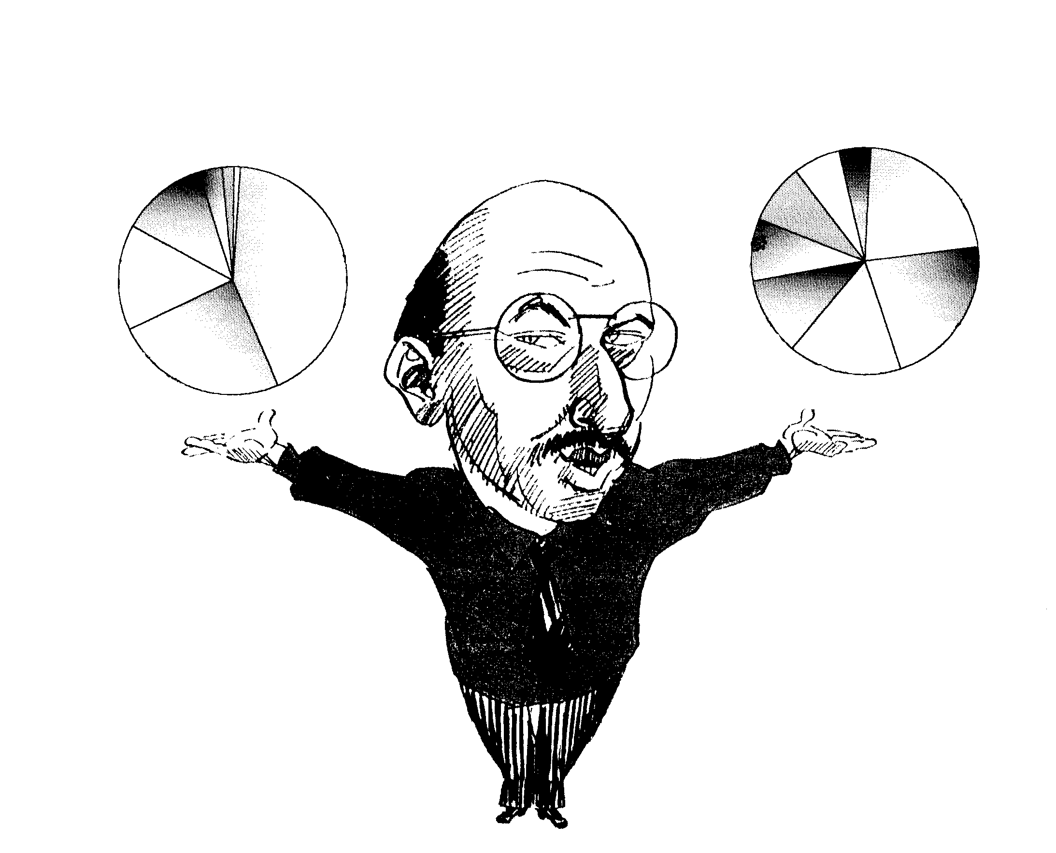

10.1.1 List TWO items that fall under the functional classification of state expenditure and give an example of each. | (8)

10.1.2 On which item (according to the example) are most of state funds spent? | (2)

10.1.3 With the exception of taxes, list TWO other sources of state income. | (4)

10.1.4 Classify the type of tax that delivers the biggest contribution to state income and list TWO advantages of this type of taxation. | (6)

10.1.5 Explain the effect of an increase in VAT on the economy of a country. | (2)

10.2 What does the concept evasion of taxes mean? | (2)

- In many countries the government interferes in the economy and performs as entrepreneur, sometimes even in competition with the private sector.  Discuss TWO projects where the above situation can develop. | (8)

10.4 Discuss briefly TWO aims of the state’s economic policy. | (8)

10.5 Provide ONE word/concept for the following:

10.5.1 The measure that the SARB uses to control the supply of money.

10.5.2 This depicts the nature and scope of a country’s fiscal policy.

10.5.3 This type of tax rate is aimed at the fair division of the tax load.

10.5.4 Tax payable on contracts at the registration of property.

10.5.5 It refers to the transfer of functions from the state to the private sector. | 5x2=(10)  [50]

QUESTION 11

IMPORTANT ECONOMIC TOPICS

NOTE:

- This question consists of four sub-division of 25 marks each.
- You may answer any TWO sub-divisions.
- NUMBER YOUR CHOICES CLEARLY.

11.1 LABOUR RELATIONS

Three Labour Unions in Telkom
vote this week on striking

Jan de Lange,
Labour reporter

Three labour unions in Telkom, representing nearly 20 000 workers,
vote this week on striking in order to force Telkom to increase its wage
offer of 5%.

This will be the first time that these three labour unions, which mainly
consist of highly skilled labour, go on strike. A strike will disrupt international telephone calls, especially if it continues for too long term, and required repair
work at the Hartbeeshoek Centre cannot be done.

With regard to the above article dicuss labour unions under the following:

11.1.1 Aim of Labour Unions in Telkom. | (3)

11.1.2 What will the action of the labour unions be if their demands are not met? | (3)

11.1.3 What will the implication of such action be? | (3)

11.1.4 List in full sentences FIVE restrictions regarding labour unions. | (10)

- Name THREE factors that will influence the supply of labour in  South Africa. | (6)  [25]

11.2 PRODUCTIVITY AND UNEMPLOYMENT

Percentage change over four quarters

Productivity of labour, remuneration excluding agriculture
20

15

10

5

0
Nominal remuneration per worker

Productivity of labour
1994 1995 1996 1997 1998
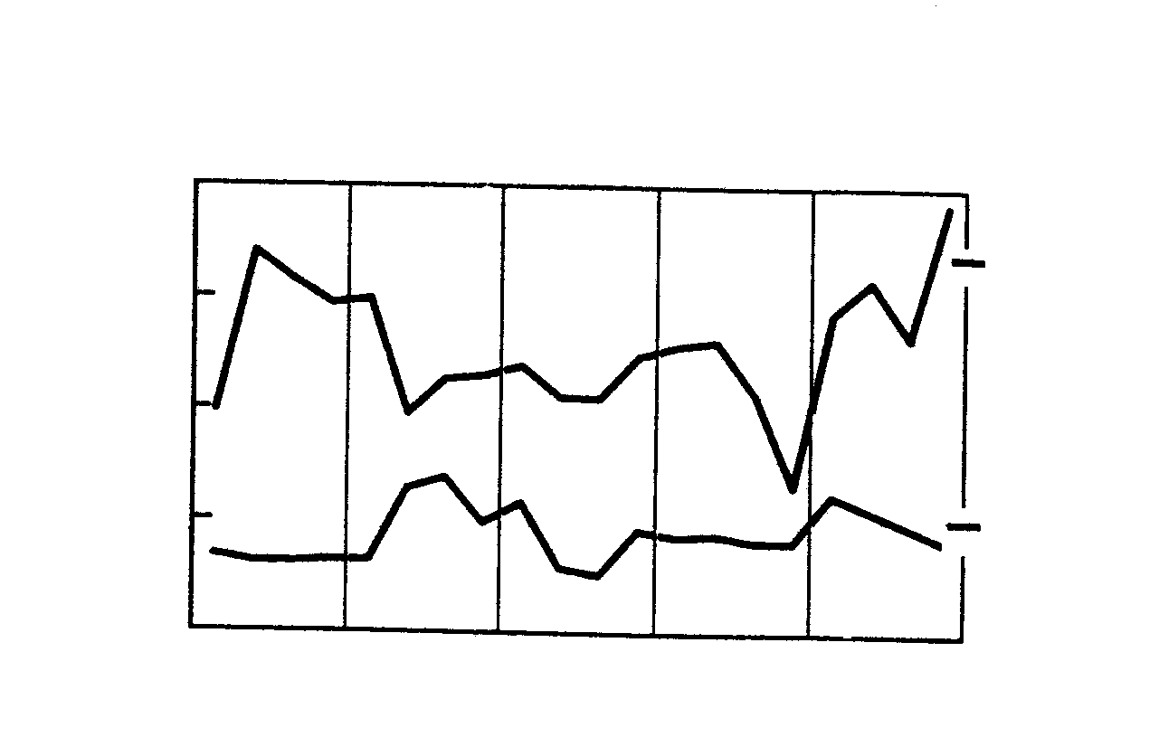
Source: SARB Quarterly Bulletin

11.2.1 What is your conclusion regarding SA’s level of production as seen in the graph? | (3)

11.2.2 In which year was SA’s level of production the highest? | (3)

11.2.3 Discuss THREE measures to increase productivity. | (6)

11.2.4 Explain ONE advantage that higher productivity holds for SA. | (3)

11.2.5 Study the following graph and answer the questions that follow:
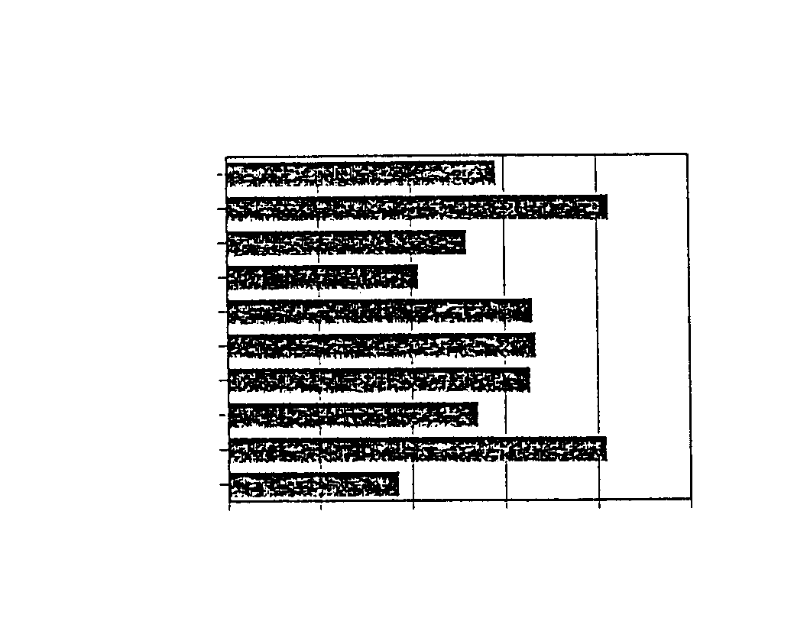
SA
Eastern Cape
Free State
Gauteng
KwaZulu Natal
Mpumalanga
North West
Northern Cape
Northern Province
Western Cape
0 10 20 30 40 50

Percentage

UNEMPLOYMENT RATES
Total unemployed: 4m

Source: October Household Survey, CSS

(a) Which province has the lowest unemployment rate? | (2)

(b) List TWO consequences that a high rate of unemployment holds for South Africa. | (4)

11.2.6 The following headings appeared in newspapers and magazines:

AIDS threatens economy

AIDS-curve becoming steeper

AIDS-management is urgently required

Discuss the effect of AIDS on the economy of the country. | (4)  [25]

11.3 INFLATION

Study the following and answer the questions that follow:

Percentage
20

15

10

5

0
85 86 87 88 89 90 91 92 93 94 95 96 97 98

Inflation Rate

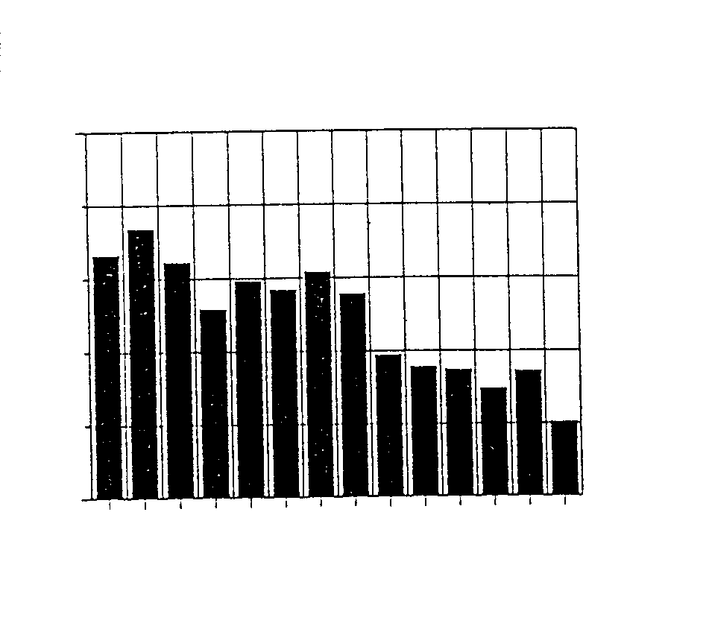

11.3.1 In which year was the inflation rate in South Africa the highest? | (3)

11.3.2 What happened to the inflation rate between 1988 and 1998? | (3)

11.3.3 Explain the THREE monetary measures the state can implement to induce this trend (see 11.3.2) | (6)

- Explain how inflation will influence the following groups:  - Shareholders  - Debtors  - Pensioners | (3)  (3)  (3)

    - The following is an extract from an article:

“He said that an increase of 1% in VAT can put pressure on the inflation rate, but this can partly be counteracted if the bank rate decreases.”

(a) What type of inflation will occur if VAT is increased? | (2)
(b) What type of measure is under discussion if a decrease in the bank rate can counteract inflation? | (2)  [25]

11.4 STRATEGIC RESOURCES

This project is one of the most extensive projects of its kind in the world, and is aimed at unlocking the water resources in Lesotho to the mutual benefit of South Africa and Lesotho. South Africa will receive water essential for consumption in the PWV region and Lesotho will benefit from a hydro-electric power station, the royalties that it will receive and the utilisation of its tourism potential.

Above-mentioned information was provided by the Department of Water Affairs.  - To which project does this refer?  - Why is this project so important for South Africa?  - Discuss FIVE issues to emphasise the economic importance of water supply and conservation in South Africa.  - Match Column B with Column A: Write only your selection (a – f) next to the question number in your answer book. | (3)  (3)  (10)

COLUMN A  - Most important export product and largest earner of foreign exchange following gold.  - Is used in the production of nuclear energy.  - Is supplied by coal-fired power stations.  4. Is supplied to consumers by means of photovoltaic systems and wind turbines. | COLUMN B  - Petroleum refining  - Renewable energy  - Electricity  - Coal  - Synthetic fuels  - Uranium
4x2=(8)
- Complete:  Armscor was commercialized in 1992 and its name changed to __________ | (1)  [25]

TOTAL : | 400

