GAUTENG DEPARTMENT OF EDUCATION
SENIOR CERTIFICATE EXAMINATION

DANCE SG
(Second Paper: Health Care and Anatomy)

TIME: 1½ hours

MARKS: 45

INSTRUCTIONS:

- Answer ALL the questions.
- NOTE: Each fact counts half a mark.

SECTION A

ANATOMY

QUESTION 1

The following statements/sentences refer to skeletal muscles. There is only one correct answer for each statement/sentence. Read each carefully, and decide which is the correct one. Write the letter of the correct statement next to the corresponding number in your answer book.

1.1 The triceps muscle

- extends the wrist.  - rotates the humerus laterally.  - extends the forearm.  - All of the above. 0.5x2 = | (1)

1.2 The deltoid muscle is inserted at the

- elbow joint.  - clavicle.  - tuberosity of the humerus.  - scapula. 0.5x2 = | (1)

1.3 The iliopsoas muscle is a hip

- adductor.  - flexor.  - rotator.  - abductor. 0.5x2 = | (1)

1.4 The sartorius muscle originates at the

- front of the hipbone.  - sacrum.  - femur.  - outer third of the pubic bone. 0.5x2 = | (1)

1.5 The trapezius muscle

- pulls the shoulders together.  - raises the shoulders.  - pulls the shoulders down.  - All of the above. 0.5x2 = | (1)  [5]

QUESTION 2

By using your basic knowledge of skeletal muscles, supply the name/term for each of the following definitions:

2.1 The main muscle which contracts to bring about an action (movement) 0.5x2 = | (1)

- The state of readiness/constant partial contraction of a muscle 0.5x2 = | (1)

2.3 Muscles that hold one part of the body while another part is moving 0.5x2 = | (1)

2.4 The name of a muscle tendon when it is broad and flat 0.5x2 = | (1)

- A muscle which helps/aids the main muscle to bring about a movement  0.5x2 = | (1)  [5]

QUESTION 3

3.1 Muscle contraction is said to shorten a muscle fibre by one third of its length. Explain how muscle contraction occurs. 0.5x4 = | (2)

3.2 3.2.1 Which THREE types of muscle contraction is a skeletal muscle able to perform? 1x3 = | (3)

3.2.2 Explain each of the muscle contractions identified in Question 3.2.1, stating to which contraction you are making reference. 1x3 = | (3)

- State each type of contraction and supply a dance example for  each. 1x3 = | (3)

- Name the waste product produced during muscle contraction. 0.5x2 = | (1)  [12]

QUESTION 4

The questions below all relate to the following diagram. Study the diagram carefully and then answer the questions.

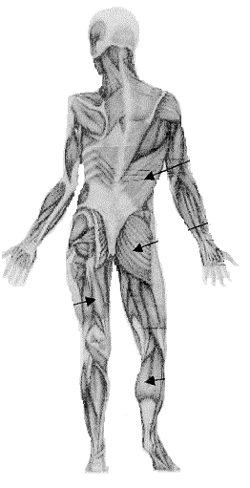
1
2
4
3

4.1 4.1.1 Name the muscle numbered 1. | (0.5)

- The muscle identified in Question 4.1.1 is responsible for certain actions. Name these actions. 0.5x4 = | (2)

4.2 4.2.1 Which actions does the muscle numbered 2 perform as a whole?  0.5x3 = | (1.5)

4.2.2 Where does the Gluteus Maximus insert? 0.5x2 = | (1)

4.3 4.3.1 Name all the muscles which make up the group numbered 3. 0.5x3 = | (1.5)

4.3.2 Where do the muscles identified in Question 4.3.1 originate? 0.5x2 = | (1)

4.4 The muscles numbered 4 are responsible for a certain action. Name the action. | (0.5)  [8]

TOTAL FOR SECTION A: | [30]

SECTION B

HEALTH CARE

QUESTION 5

Attending dance classes every day is essential for a dancer. It is also important to supplement your dance classes with aerobic, stretch and strength training in order for your body to perform beyond what is required in class.

Answer the following questions relating to these THREE components of fitness.

5.1 Explain the training effect, and say how this is achieved. 0.5x4 = | (2)

- How will you know if you are over-exerting yourself during aerobic  training? 1x5 = | (5)

5.3 How is a muscle strengthened? 0.5x2 = | (1)

5.4 Discuss the warm up stretch in detail. 0.5x4 = | (2)

5.5 Explain FIVE points that you should remember whilst stretch training. 1x5 = | (5)  [15]

TOTAL FOR SECTION B: | [15]

TOTAL: | 45

