GAUTENG DEPARTMENT OF EDUCATION
SENIOR CERTIFICATE EXAMINATION

DANCE SG
(Second Paper: Health Care and Anatomy)

TIME: 1½ hours

MARKS: 45

INSTRUCTIONS:

- Answer ALL the questions.
- NOTE: Each fact counts half a mark.

SECTION A

ANATOMY

QUESTION 1

One of our primary interests as dancers is the movement of the body. Movement can only take place if the skeletal muscles of our body contract. Explain fully the following words which relate to skeletal muscles:

- Origin 0.5 x 2 =  - Synergist 0.5 x 2 =  - Antagonist 0.5 x 2 =  - Agonist 0.5 x 2 =  - Fixator 0.5 x 2 = | (1)  (1)  (1)  (1)  (1)  [5]

QUESTION 2

2.1 Draw a simple sketch of the skeletal muscle to show its structure, and how it attaches to bone. Label your diagram fully. 0.5 x 6 = | (3)

2.2 Why is it important to warm up before exercise, and to cool down after exercise? 0.5 x 6 = | (3)

2.3 Explain stabilisation in the following areas:

- Trunk 0.5 x 4 =  - Pelvis 0.5 x 4 =  - Knee 0.5 x 4 = | (2)  (2)  (2)  [12]

QUESTION 3

The questions that follow, relate to the diagram below. Study the diagram carefully and then answer the questions that follow.

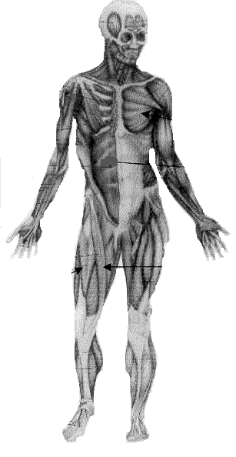
3
4
2
1
5

3.1 Give the actions of the muscles numbered 1, 2, and 3. 0.5x7 = | (3.5)

3.2 Supply the name, origin and insertion of the muscle numbered 4. 0.5x4 = | (2)

3.3 Where do the muscles numbered 1 and 3 insert? 0.5x4 = | (2)

- Name the muscle numbered 5 and supply its action and origin. 0.5x5 = | (2.5)  [10]

QUESTION 4

You have sustained an injury whilst dancing a very technical jazz class. The physiotherapist has suggested that you should not dance for four weeks. Answer the questions which follow regarding your injury.

- Which first aid measures could you have applied yourself, before you saw a doctor? 0.5x4= | (2)

4.2 Which TWO effects is your whole body likely to experience over the next four weeks? 0.5x2 = | (1)  [3]

TOTAL FOR SECTION A: | [30]

SECTION B

HEALTH CARE

QUESTION 5

5.1 Name FIVE types of resistance that can be used to strengthen a muscle. 1x5 = | (5)

5.2 Explain FOUR purposes of stretching. 1x4 = | (4)

5.3 Why is it important for a dancer to cross-train aerobically? 1x5 = | (5)

5.4 Explain why a 5-minute recovery phase is required after a vigorous aerobic workout. 0.5x2 = | (1)  [15]

TOTAL FOR SECTION B: | [15]

TOTAL: | 45

