DANCE SG
2
2
(First Paper) 609-2/1 H

GAUTENG DEPARTMENT OF EDUCATION

SENIOR CERTIFICATE EXAMINATION

DANCE SG
(First Paper: History and Music)

TIME: 3 hours

MARKS: 105

INSTRUCTIONS:

- Questions 1, 2, 3, 4 (History) and 9 (Music) are COMPULSORY.
- Choose FIVE other questions from the following options, e.g. choose Question 5 or 6, 7 or 8, 10 or 11, 12 or 13, 14 or 15.

QUESTIONS 1, 2, 3, 4 AND 9 ARE COMPULSORY  QUESTION 1  - As the reviewer for the highly recommended magazine, Dance Now, you have to review a dance production which has been performed on stage during 2001 or 2002 or which is available on video. Discuss this work as follows:  - The relevant detail of the production (title, company, place, composer, designer, choreographer)  - The content or plot (synopsis) and analysis of the choice of set, score and movement style  - Your own opinion (substantiated) regarding the success of the production  - The relevance of the production in South Africa today. Motivate your opinion  - Your personal gain/non-gain in attending the production  1.2 Write a short résumé on a dance company of your choice. Make reference to the company’s artistic management, repertoire and choreographic style. | (3)  (3)  (1)  (1)  (1)  (3)  [12]

DANCE SG
3
3
(First Paper) 609-2/1 H

QUESTION 2  The smoking of tobacco poses a threat to the development and prosperity of our country. Your school is planning a Stop Smoking Campaign and you are responsible for the dance contribution to this campaign. List your ideas in point format.  2.2 Does dance feature in your personal life as a means of communication? Motivate your answer. | (6)  (2)

2.3 Your school has to increase the number of learners in the dance discipline. Write a press release in which you advertise your dance department and vocational possibilities. | (2)  [10]

QUESTION 3  3.1 Write down a practical dance form of your choice.  3.2 Motivate and explain your choice by answering the following questions:  - How should you place your body to operate effectively?  3.2.2 Which principles underpin your chosen style of dance?  3.2.3 How did this style of dancing originate?  - How do you view the relevance of this dance form today?  - List and explain at least FOUR terms which are used during  the practical tuition of this dance form.  - Identify any TWO genres represented by the fragments. | (1)  (2)  (2)  (1)  (2)  [8]

QUESTION 4  - List ONE choreographer under each of the following categories:  - The United Kingdom (UK)  - South Africa (SA)  - The United States of America (USA)  4.1.4 Europe | (4)

4.2 Choose TWO of the choreographers you listed in Question 4.1 to be included in an academic publication entitled Great Choreographers of the Twentieth Century and write a brief biography of each choreographer. | (6)  [10]

DANCE SG
4
4
(First Paper) 609-2/1 H

ANSWER EITHER QUESTION 5 OR QUESTION 6  QUESTION 5  Choose ONE popular African dance work from the works which you have studied. Write an article for the magazine Innovative Choreography on this dance work according to the aspects listed below.  - The title of the work and choreographer  - The origin of the work  - The influence of the work | (2)  (2)  (3)

5.4 The cultural, social and entertainment value of the work | (5)  [12]

QUESTION 6  Choose ONE popular ballet from the six dance productions which you have studied. Write an article for the magazine Innovative Choreography on this ballet according to the aspects listed below:  - The historical context and choreographic style of the first production  - The main characters and a brief synopsis of the work  - The relevance of traditional productions of this work today  - A subsequent production reflecting a departure of style from this work  Orchestration. | (2)  (8)  (1)  (1)  [12]

5

ANSWER EITHER QUESTION 7 OR QUESTION 8  QUESTION 7  African dance is considered to be a dynamic dance form.  With reference to African dance, discuss:  - The body parts that are commonly used  - How movements are executed in African dance  - How African movement styles differ from one another | [8]

QUESTION 8  Balanchine is considered the icon of neoclassicism in twentieth-century dance. Discuss his contribution to this style, motivating your answer with relevant examples from the dance repertoire. | [8]

DANCE SG
5

(First Paper) 609-2/1 H

QUESTION 9 IS COMPULSORY  QUESTION 9  - 9.1 To illustrate your knowledge of note values and rests, write a four-bar phrase with correctly grouped notes and rests in simple duple time.  9.2 Study the attached score excerpt Albrecht and the Wilis I from Giselle, on page 8. Number the bars and answer the following questions in your answer book.  - Give the meaning of Andante.  9.2.2 Name or describe the time signature. | (4)  (1)  (1)

- Give the English equivalents for ONE of the Italian terms in bars 1, 11  or 12.  9.2.4 In which bar does an accent occur?  - Write the abbreviation espress. (bar 2) in full or give the English equivalent for this term. | (1)  (1)  (1)  [9]

6

ANSWER EITHER QUESTION 10 OR QUESTION 11  QUESTION 10  - Use your knowledge of African music to write a short article for your local newspaper under the heading Celebrating the sounds of Africa. Keep in mind that the object is to attract the attention of your readers to the joys of African music. Adopt a dynamic, interesting writing style.  - Define any SIX of the following music terms:  - Binary form (AB)  - Melody  - Interval  - Pitch  - Polyphonic texture  - Pulse  - Dynamics  - Tone colour  - Rhythm  - Polyrhythm | (6)  (6)  [12]

DANCE SG
6

(First Paper) 609-2/1 H

QUESTION 11  - To which movement in music, which reacted against Romanticism and Impressionism, would you ascribe the slogan ‘Back to Bach’?  - According to your answer for Question 11.1, answer the following questions:  - Which characteristics would you ascribe to the music in this style?  - Choose a representative composer of this style and write a concise biography of him/her.  - Name ONE dance work by the composer mentioned in Question 11.2.2. | (1)  (4)  (6)  (1)  [12]

7

ANSWER EITHER QUESTION 12 OR QUESTION 13  QUESTION 12  - List FOUR of your favourite performers of African music (individual performers or bands).  12.2 Choose TWO of these performers. (List them under 12.2 1 and 12.2.2.) Write a paragraph on each performer in which you refer to his/her music style, the career and the repertoire).  12.2.1 Performer No. 1  12.2.2 Performer No. 2 | (4)  (4)  (4)  [12]

QUESTION 13  - List FOUR of your favourite composers of Ballet music.  13.2 Choose TWO of these composers. (List them under Question 13.2.1 and Question 13.2.2) Write a paragraph on each composer in which you refer to his/her music style, the career and the repertoire (works) for the dance stage.  13.2.1 Composer No. 1  - 13.2.2 Composer No. 2 | (4)  (4)  (4)  [12]

DANCE SG
7

(First Paper) 609-2/1 H

ANSWER EITHER QUESTION 14 OR QUESTION 15

QUESTION 14

Your dance educator is ill. You have been requested by the principal to explain African Music Instruments to a Grade 10 class. You decide to do this by using a table format.

The format will include the following:
- The classification of instruments
- TWO examples of instruments
- Sound production

Prepare for this lesson by copying and completing the table below in your answer book:

Classification | Sound production | TWO examples  Instruments
(1) | (1) | (2)
(1) | (1) | (2)
(1) | (1) | (2)

[12]

8

QUESTION 15

Your dance educator is ill. You have been requested by the principal to explain Dance Types to a Grade 10 class. You decide to do this by using a table format. This format will refer to THREE different dance types, the tempo and time signature of each and the country of origin of each.

Prepare for this lesson by copying and completing the table below.

Dance type | Tempo | Time signature | Country of origin
(1) | (1) | (1) | (1)
(1) | (1) | (1) | (1)
(1) | (1) | (1) | (1)

[12]

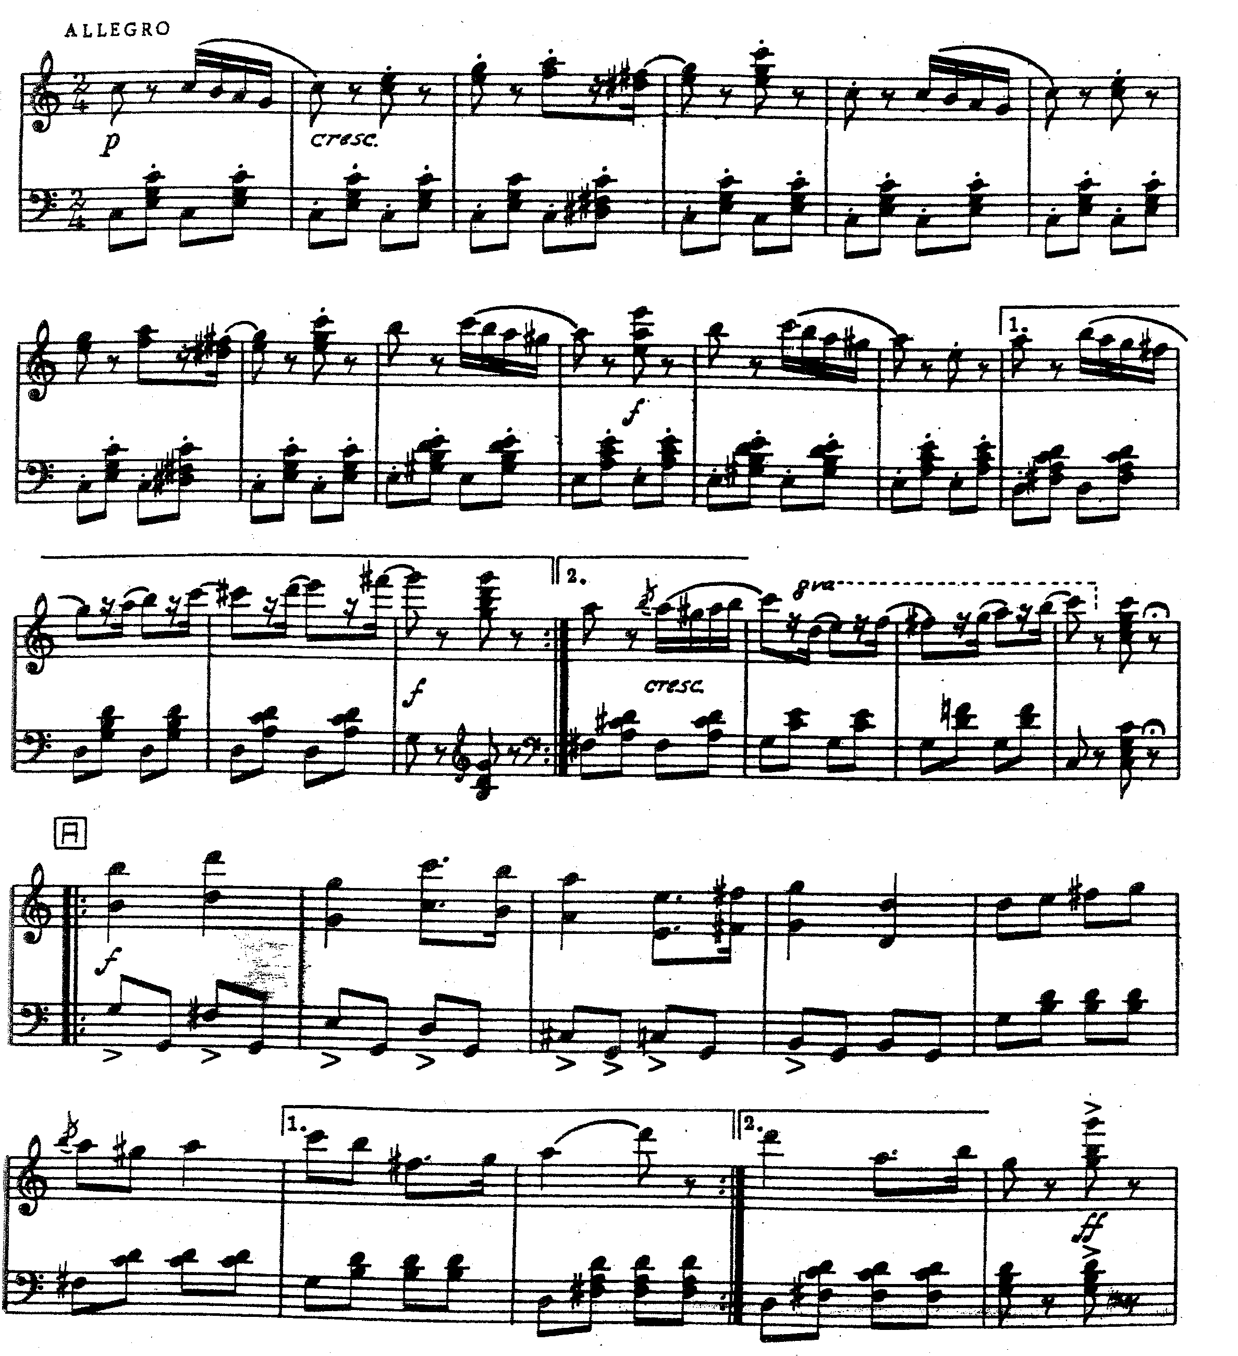
TOTAL: | 105

DANCE / DANS SG
9
8
(First Paper / Eerste Vraestel)

609-2/1 H

ADDENDUM: Albrecht and the Wilis I from Giselle

