GAUTENG DEPARTMENT OF EDUCATION
SENIOR CERTIFICATE EXAMINATION

DANCE HG
(Second Paper: Health Care and Anatomy)

TIME: 2 hours

MARKS: 60

INSTRUCTIONS:

- Answer ALL the questions.

- NOTE: Each fact counts half a mark.

SECTION A
ANATOMY

QUESTION 1

As a physiotherapist who is rehabilitating an injured patient, there are some words that need explaining in order for your patient to put his exercises to full use. Explain the following words to him:  1.1 Aponeurosis 0.5 x 2 =  1.2 Insertion 0.5 x 2 =  1.3 Fixator 0.5 x 2 =  1.4 Synergist 0.5 x 2 =  1.5 Antagonist 0.5 x 2 = | (1)  (1)  (1)  (1)  (1)  [5]

QUESTION 2

2.1 You are a dance educator who is rather concerned with the fact that your students start a class without warming up, and leave after the class without cooling down. Set aside 10 minutes of your next class to explain the importance of warming up and cooling down. Write down what you would say. 0.5 x 6 = | (3)

2.2 Skeletal muscles can contract in several different ways. Fully explain each type of contraction which a skeletal muscle can perform. 0.5 x 8 = | (4)  [7]

QUESTION 3

Study the picture below of Rudolf Nureyev, and answer the questions that follow, relating to actions, origins and insertions of muscles.

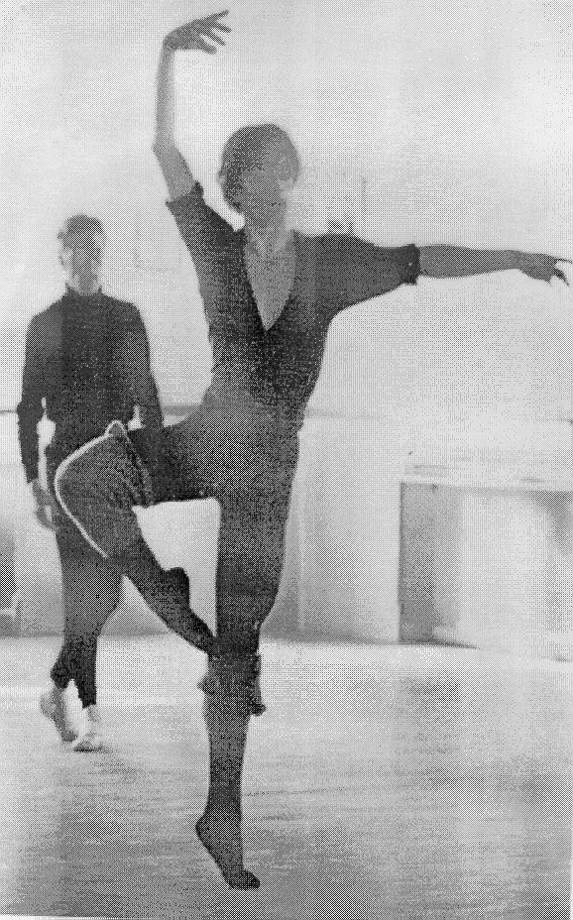

- Supply the name and insertion of the agonist that raised Mr Nureyev’s arm above his head. 0.5 x 3 =  3.2 3.2.1 What anatomical action is being performed at the supporting leg’s ankle joint?  - Name the muscles responsible for bringing about this movement.  0.5 x 5 =  - Name each muscle mentioned in Question 3.2.2 and state where it originates from and where it inserts. 0.5 x 2 =  3.3 Which TWO muscles, when relaxed, would show if Mr Nureyev is to sink in his supporting hip? 0.5 x 2 =  3.4 Name the THREE muscles (muscle groups) that are turning out the supporting leg.  0.5 x 3 = | (1.5)  (0.5)  (2.5)  (1)  (1)  (1.5)  [8]

QUESTION 4

Supply a detailed breakdown of the following possible movements. Include aspects such as antagonists, contraction, anatomical action, fixators etc.  - “Retiré”, that is, the drawing up of the foot from first position, up along the supporting leg until the foot is toucsynergists, hing the leg at knee height. 0.5 x 8 =  - A forward bend of the upper body (in either a turned out or parallel position), including muscles that are maintaining posture. 0.5 x 6 =  - A backward bend of the upper body (in either a turned out or parallel position), including muscles which are maintaining posture. 0.5 x 6 =  TOTAL FOR SECTION A: | (4)  (3)  (3)  [10]  [30]

SECTION B
HEALTH CARE

QUESTION 5

You are leading a workshop for a newly formed dance group who were previously disadvantaged. They are very passionate about dancing, but as yet have not had any formal training. You decide to cover the THREE components of fitness, namely endurance training, strength training and stretch training in your workshop.  - Discuss why you think it important that fitness be a foundation for all dance techniques. Divide your discussion into the THREE components of fitness.  0.5 x 14 =  5.2 5.2.1 Explain how aerobic/endurance training is effectively accomplished so that an individual’s aerobic condition improves. 0.5 x 4 =  5.2.2 Why is it important to allow a 5-minute recovery phase after aerobic training, and what does this entail? 0.5 x 4 =  - Explain to the members in your workshop what kinds of resistance they can use to increase the strength of a muscle. 0.5 x 8 =  5.4 5.4.1 Fully discuss the difference between ballistic and progressive static stretching. Explain which type of stretching should be preferred and why. 1 x 5 =  5.4.2 Explain what is meant by the stretch reflex, and how it can be used to improve flexibility. 0.5 x 4 = | (7)  (2)  (2)  (2.5)  (5)  (2)  [20.5]

QUESTION 6  You are an 18-year-old who has only recently taken up dancing, and are experiencing many minor injuries. You approach an expert in physiology to try and understand why this is happening to you. Write down the answers you received to the following questions:  - What could be the cause of the injuries I’m experiencing? 0.5 x 8 =  - How can I prevent more injuries from occurring? 1 x 5 =  - Is Pilates an aerobic or anaerobic form of rehabilitation?  TOTAL FOR SECTION B:  TOTAL: | (4)  (5)  (0.5)  [9.5]  [30]  60

