GAUTENG DEPARTMENT OF EDUCATION
SENIOR CERTIFICATE EXAMINATION

DANCE HG
(Second Paper: Health Care and Anatomy)

TIME: 2 hours

MARKS: 60

INSTRUCTIONS:

- Answer ALL the questions.

- NOTE: Each fact counts half a mark.

SECTION A
ANATOMY

QUESTION 1

By using your basic knowledge of skeletal muscles, supply the name/term of each of the following definitions:  - The main muscle to bring about an action (movement) 0.5 x 2 =  - The point of muscle attachment where movement occurs 0.5 x 2 =  - Muscles, which hold one part of the body while another part is moving 0.5 x 2 =  - The name of a muscle tendon when it is broad and flat 0.5 x 2 =  - A muscle which helps/aids the main muscle to bring about a movement 0.5 x 2 = | (1)  (1)  (1)  (1)  (1)  [5]

QUESTION 2

- The structure of skeletal muscle is designed in such a way, that it promotes flexibility, contraction and strength. Draw a simple labelled sketch of the structure of skeletal muscles to explain this. 0.5 x 6 =  - Muscle contraction is said to shorten a muscle fibre by one third of its length. Explain what happens in order for a muscle to contract. 0.5 x 4 = | (3)  (2)  [5]

QUESTION 3

Study the picture below of Mikhail Baryshnikov and Kate Johnson, and answer the following questions relating to origin, insertion and action of skeletal muscles:

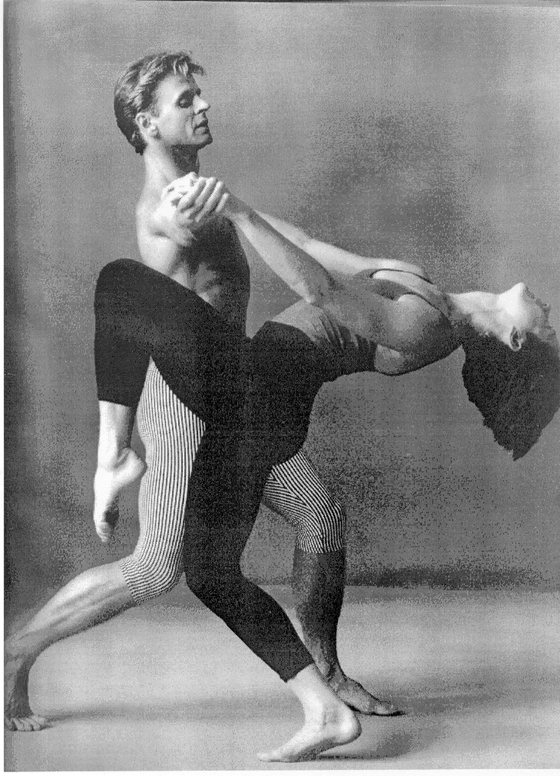

- Which muscles are stabilising Mikhail’s shoulder girdle? 0.5 x 2 =  - Supply the name, origin and insertion of the muscle that is eccentrically contracting to allow Kate to do her back bend. 0.5 x 6 =  - Name the anatomical action being brought about at the hip, knee and ankle joint of Kate’s raised leg. 0.5 x 3 =  - Supply the names and insertions of the muscles involved in bringing about the actions at the above hip and knee joints. Set your answers out clearly, for example:  Knee joint: Name  Insertion  Hip joint: Name  Insertion 0.5 x 9 = | (1)  (3)  (1.5)  (4.5)  [10]

QUESTION 4

The following are possible dance movements. Think about them carefully, and then give a detailed muscle analysis of each movement. Include aspects such as agonists, antagonists, anatomical actions, contractions, etc.

- Carriage of the arms from the thigh, out sideways to horizontal, then towards each other until in line with the sternum, and then straight down in front of the body to the original position. 0.5 x 8 =  - Movement of the leg from a turned out first position, to an extended leg to the side (keeping the foot on the ground). 0.5 x 12 =  TOTAL FOR SECTION A: | (4)  (6)  [10]  [30]

SECTION B
HEALTH CARE

QUESTION 5

- As a dance educator, you notice that your students are increasing in their flexibility, but they do not have the strength to utilise it properly. You decide to give them a lecture on strength training to try and rectify the problem. Write down all that you would say to them in your lecture. 0.5 x 12 =  - The editor of a dance gazette has asked you to write a short article on how aerobic/endurance training can improve a dancer’s dancing. Write down your final draft in your answer book. 1 x 4 =  - You are a very famous dancer with a leading company in Europe and as such you are often asked to give talks at various centres of dance education. The most popular topic for discussion is how you became so flexible. Prepare a talk explaining the importance of stretching, the stretch reflex as well as some points to remember when stretching. 0.5 x 12 = | (6)  (4)  (6)  [16]

QUESTION 6

Whilst doing a complicated lift in a pas de deux (a couple dance), you dislocated your shoulder joint. The joint capsule has been torn, and you won’t be able to dance for another four weeks.  - How did you treat your injury before you were able to see a doctor? 0.5 x 2 = | (1)

- What effects are you likely to experience in your whole body over the next four weeks? 1 x 4 =  - In what ways could you have prevented this, or any other injury from occurring?  1 x 5 =  - Would you make use of Pilates to rehabilitate your shoulder? Motivate your answer. 1 x 4 =  TOTAL OF SECTION B:  TOTAL: | (4)  (5)  (4)  [14]  [30]  60

