GAUTENG DEPARTMENT OF EDUCATION

SENIOR CERTIFICATE EXAMINATION

COMMERCIAL MATHEMATICS SG

TIME: 3 hours

MARKS: 300

REQUIREMENTS:

- Commercial Tables S_{n}⎤ a_{n}⎤
- Graph Paper
- Information Sheets have been provided at the end of this examination paper. You may use the information contained in the information sheets to answer this examination paper.

INSTRUCTIONS:

- Answer ALL the questions.
- All calculations must be shown. Answers must be given correct to the nearest cent or two decimal places.
- Write the number of the question above each answer.
- Do not write in the margins.
- You may use a calculator for all calculations except Question 1.2.
- Neatness and the systematic arrangement of work will count in your favour.
- Use commercial tables when answering Question 8.
- Use the graph paper provided when answering Question 10.
- Π = ²²/₇

QUESTION 1  - Calculate the average price per 500g if 5kg coffee at R23 per kg is mixed with 7kg of coffee at R35 per kg.  1.2 Simplify without the use of a calculator: 3 ⁵/₈ + 6 ½ ÷ 9 ³/₄.  - A and B share R4 000, half of which was divided in the ratio 2:3 and the rest in the ratio 4:1. Calculate in what ratio the total was shared.  - The farmer sold ³/₈ of his fruit crop and sent ²/₅ of the balance to a canning factory. What fraction of the crop remains?  - R1 000 is deposited with a bank on May 10 and withdrawn at the same time of the day on October 3. Calculate the interest if the interest rate is 10% simple interest.  1.6 How many US Dollars can be bought for R26 891,70 if $1 = R9,273? | (6)  (6)  (6)  (6)  (6)  (6)

- A trader incurs a loss of 12½ % on the selling price by selling an article for R350. Calculate the cost of the article.  - An insolvent estate paid a dividend of 65 cents in the rand. A creditor received R1 749,80. What was the total value of the claim?  - An asset valued at R75 000 was depreciated for two successive years at 12,5% and 20% respectively on the diminishing value method. Calculate the book value at the end of the second year.  - Find the volume of a sphere with a diameter of 42cm.  10x6 = | (6)  (6)  (6)  (6)  [60]

QUESTION 2

2.1 The assets of an insolvent estate consisted of a cash sum of R9 240 and a fixed property on which there was a bond of R160 000 and which was sold for
R150 000. Outstanding debts owing to the estate amounted to R7 200 of which only 80% could be collected. The trustees’ expenses for the administration of the estate amounted to R4 200 and creditors’ claims to R8 000.
Calculate:  2.1.1 The final dividend paid out to unsecured creditors  2.1.2 The sum paid to the mortgagee | (21)  (4)  [25]

QUESTION 3  3. A and B started a partnership on 1 March 2000, with R60 000 and R27 500, respectively. On 31 August 2000, A decreased his capital by R10 000. They shared profits and losses in the ratio of capitals. The total profit for the year amounted to R600 000. The partnership agreement makes allowance for the following:  Interest on capitals at 10% per annum  Salaries as follows:  A – R4 000 per month  B – R3 000 per month  9% of the total profit be set aside as a reserve fund.  3.1 Calculate the ratio of the capital amount in its simplest form on 28 February 2001.  3.2 Calculate the total interest and salaries for A and B.  3.3 Calculate the reserve fund amount.  3.4 Show that A’s share of the remaining profit (net profit) is R302 500. | (4)  (9)  (3)  (4)  [20]

QUESTION 4  - A manufacturer sells equipment to a dealer for R3 230. The dealer sells it to a customer so as to make a 25% profit on cost price after allowing 15% trade discount and a further 5% cash discount. Calculate the marked price of the dealer.  - By selling an article for R600, after allowing 10% trade discount, a dealer makes a profit of 20% on cost price.  Calculate:  - The marked price of the article  - The profit or loss percentage on selling price | (10)  (4)  (11)  [25]

QUESTION 5  - A person sells 8 000 7% stock at 110 and invests the amount received in R3,50 ordinary shares at R2,75.  Calculate:  - The amount received from the sale of stock  - The number of shares bought  - An investor annually receives a dividend of R321 on 12,5% stock.  Calculate:  - The nominal value of stock  - The amount invested in the stock if it was bought at 125  - Calculate which one of the following investments is most profitable:  - R3 920 in 14% stock at 80  - 15% Government Stock at 90  - 75c shares at 80c per share on which a dividend of 16% is declared | (3)  (3)  (4)  (3)  (3)  (3)  (6)  [25]

QUESTION 6  - A wire, 10 metres long, is fastened to the top of a pole and to a point on the ground 6 metres from the pole. Calculate the height of the pole.  6.2 A square lawn, one side of which is 27m, is surrounded by a path 2,5m wide.  - Calculate the area of the lawn.  - Show that the area of the path is 295m².  - If only 150m² of the path is to be tiled at R59 per m², calculate the cost. | (4)  (2)  (5)  (2)

- A measuring wheel makes 20 revolutions going around a circle with an area 154m². Find the diameter of the measuring wheel in centimetres.  6.4 The internal radius of a cylindrical pipe is 25cm and the concrete is 20cm thick. Calculate the volume in cubic metres of the concrete used in the construction of a pipe 2m long. | (14)  (8)  [35]

QUESTION 7  7.1 Determine which is the better investment:  7.1.1 R500 at 5,5% for 5 years annual compound interest or  7.1.2 R500 at 5% for 5 years bi-annually at compound interest.  - Goods are valued at R80 000. The insurance premium is 35 cents per cent.  Calculate the premium  - if the policy does not cover the premium.  - if the policy covers the premium. | (5)  (7)  (3)  (5)  [20]

QUESTION 8  Use the commercial tables to calculate the following:  - The annual instalment to redeem a loan of R600 000 at 5% per annum compound interest in 15 equal instalments  - The principal to be invested at the end of each year to yield R60 000 after  10 years if the investment earns 4½ % per annum compound interest  - The amount due to a person at the end of 8 years if the person invests R3 000 at the beginning of each year at 4% per annum compound interest  - What annuity can be bought annually for the sum of R2 780 for a period of 5 years if the interest rate is 6% per annum, compounded annually, and the first instalment is paid immediately? | (4)  (4)  (6)  (6)  [20]

QUESTION 9  - You are a buyer for a South African company. Assume the following exchange rate is applicable:  $1 (US) = R9,273 (South African Rand) = ¥119,75  The following prices are quoted to you in SA:  - One computer costs $250 in the USA  - One computer costs ¥28 000 in Japan  From which country would you import computers? Motivate your answer.  (Show all calculations.)  - The Johannesburg Metropolitan Municipality bills its customers as follows:  Electricity at 23,67 cents per kilowatt (kw)  Water rates are as follows:  First 6kl Free  6 – 10kl R2,15 per kl  10 – 20kl R3,25 per kl  20 – 40 kl R4,48 per kl  +40 kl R5,58 per kl  How much does a consumer pay if the consumer used 938 kw of electricity and 35 kl of water? | (8)  (12)

  - HIV prevalence by age group among the members of a certain organisation in South Africa in 2000 is depicted in the graph below.

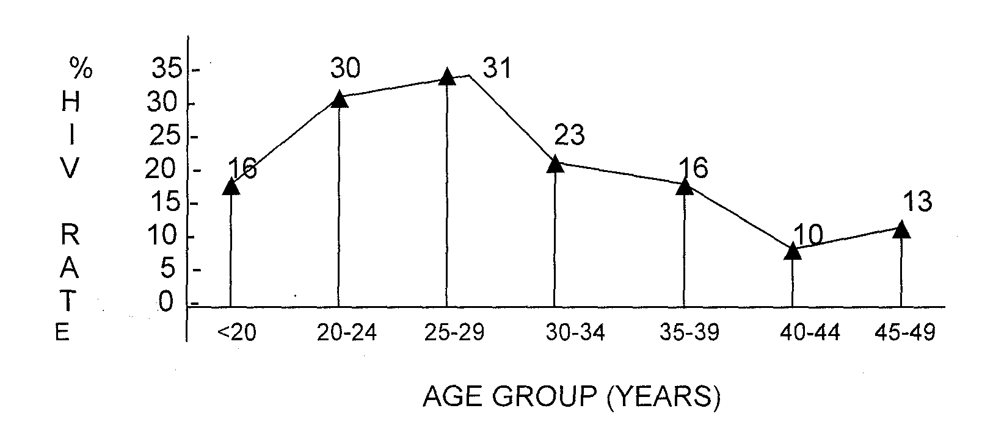
%
H
I
V

R
A
T
E

Use the above graph to answer the following:  - Which age group has the highest HIV rate percentage?  - Which age group has the lowest HIV rate percentage?  - Find the mean, mode and median of HIV rate % among the members for the age group 0 – 49 years. | (2)  (2)  (7)

9.3.4 If the HIV rate % for the age group 50 and above is 3%, find the mean of the HIV rate % among the members. | (4)  [35]

QUESTION 10

The following table compares the simple interest on R100 at 5% p.a. and compound interest on R100 at 5% p.a. respectively for a period of 35 years.

Years | 0 | 2 | 5 | 10 | 15 | 20 | 25 | 30 | 35
Simple Interest in R | 0 |  |  | 50 |  | 100 |  | 150
Compound Interest to the nearest Rand | 0 | 10 | 28 | 63 | 108 | 165 | 239 | 333 | 452

- Represent the information in the above table graphically.  Use the scale :  Horizontal Axis: 2cm represent 5 years  Vertical Axis: 2cm represent R50  Use the graph paper that has been provided on page 10.  - Use the graph to determine the following (show your readings with dotted lines):  - The simple interest and compound interest on R100 at 5% p.a. after 27 years  - The number of years it would take for a principal of R100 to amount to R300 at 5% p.a. compound interest  - The difference between compound interest and simple interest on R100 at 5% p.a. after 33 years  TOTAL: | (24)  (11)  [35]  300

CANDIDATE’S NUMBER / KANDIDAAT SE NOMMER:

INSTRUCTIONS / INSTRUKSIES:

- Complete this graph paper for Question 10, and place at the back of your answer book.
- Voltooi hierdie grafiekpapier vir Vraag 10, and plaas dit agter in jou antwoordboek.

