GAUTENG DEPARTMENT OF EDUCATION
SENIOR CERTIFICATE EXAMINATION

BUILDING CONSTRUCTION SG

TIME : 3 hours

MARKS : 300

REQUIREMENTS:

- Answer book
- A3 size drawing paper
- Drawing instruments
- Pocket calculator

INSTRUCTIONS:

- Answer any FIVE questions.
- All calculations and written answers must be done in the Answer book.
- Use both sides of the drawing paper.
- Drawings and sketches must be fully dimensioned and neatly finished off with titles and labels to conform with the SABS Recommended Practice for Building Drawings.
- For the purpose of this examination, the brick size should be taken as
220 mm x 110 mm x 75 mm.

QUESTION 1

- State any FIVE aspects to which an inspector must pay attention during the inspection of a sewerage system.  - Name TWO instances where fall pipes can be used.  - Describe how the air-pressure test and water test are carried out on sewerage systems to detect any possible leakages.  - A person who is injured and bleeding, must be handled with extreme care. State the safety measures which are applicable in the treatment of such an injury.  1.5 Name THREE aspects of surveying that can be done by using a dumpy level. | (10)  (2)  (4)  (6)  (3)

- Describe any FIVE safety measures which apply to scaffolding.  - State FIVE requirements with which material used for formwork must comply.  - A solar hot water heating system consists of a solar collector and an electric storage cylinder which must be installed in a dwelling with a 30° pitched roof. The cold water supply to the electric hot water storage cylinder is controlled by a pressure reducing valve. By making use of a neat line diagram, show the arrangement of all the components of the system. Also indicate by means of arrows, the direction of the flow of water when the system is in use. | (5)  (5)  (25)  [60]

QUESTION 2

  - A front door of a dwelling consists of fielded and raised panels, a moulded top rail and a semicircular fanlight.

Use the following specifications:

Frame : Stiles and transome 115 mm x 75 mm
Door : Stiles and top rail 115 mm x 45 mm
Lock and bottom rails : 200 mm x 45 mm
Muntin : 100 mm x 45 mm
Raised panels : 22 mm thick
Semicircular fanlight : Stiles and rails 60 mm x 45 mm

2.1.1 Draw to a scale of 1:2 a horizontal section through the door stile and frame stile, approximately 500 mm from the bottom.  - Draw to a scale of 1:2 a vertical section through the bottom rail of the fanlight, the transome and the top rail of the door.  The necessary mouldings must also be shown. | (12)  (18)

2.2 Draw to a scale of 1:2 a horizontal section through the muntin and the two window frame stiles of the double casement window and frame with fanlights.  Use the following specifications:  Frame material : Stiles and muntin 115 mm x 75 mm  Window frame : Stiles 65 mm x 44 mm  All components are moulded with ovolo mouldings. | (10)

2.3 Draw a neat sectional sketch in proportion to show the construction of a septic tank which is connected to a french drain. Also describe the working process of the septic tank and the purpose of the french drain. | (20)  [60]

QUESTION 3

  - The plan of a dwelling is shown in Figure 1 below. The dwelling has a gable roof covered with corrugated iron on 75 mm x 50 mm purlins and has open eaves with an overhang of 450 mm and a pitch of 30 degrees. The roof has 100 mm x 100 mm square gutters with downpipes of 75 mm diameter and
230 mm x 20 mm fascia boards. The ceiling is finished off with 6,4 mm gypsum board, 38 mm x 38 mm brandering and 75 mm cornices.

The 2800 mm superstructure and the 450 mm substructure are built in a one brick wall on a 610 mm x 230 mm concrete foundation, 150 mm below ground level. The 75 mm concrete floor goes 110 mm into the 220 mm external wall and is 300 mm above ground level. The 2000 mm x 900 mm door opening and all the windows must be placed in the correct position by using the measurements given in the window schedule.

Draw to a scale of 1:50, a vertical section through the dwelling at A-A.

3000
3000
1500
1500
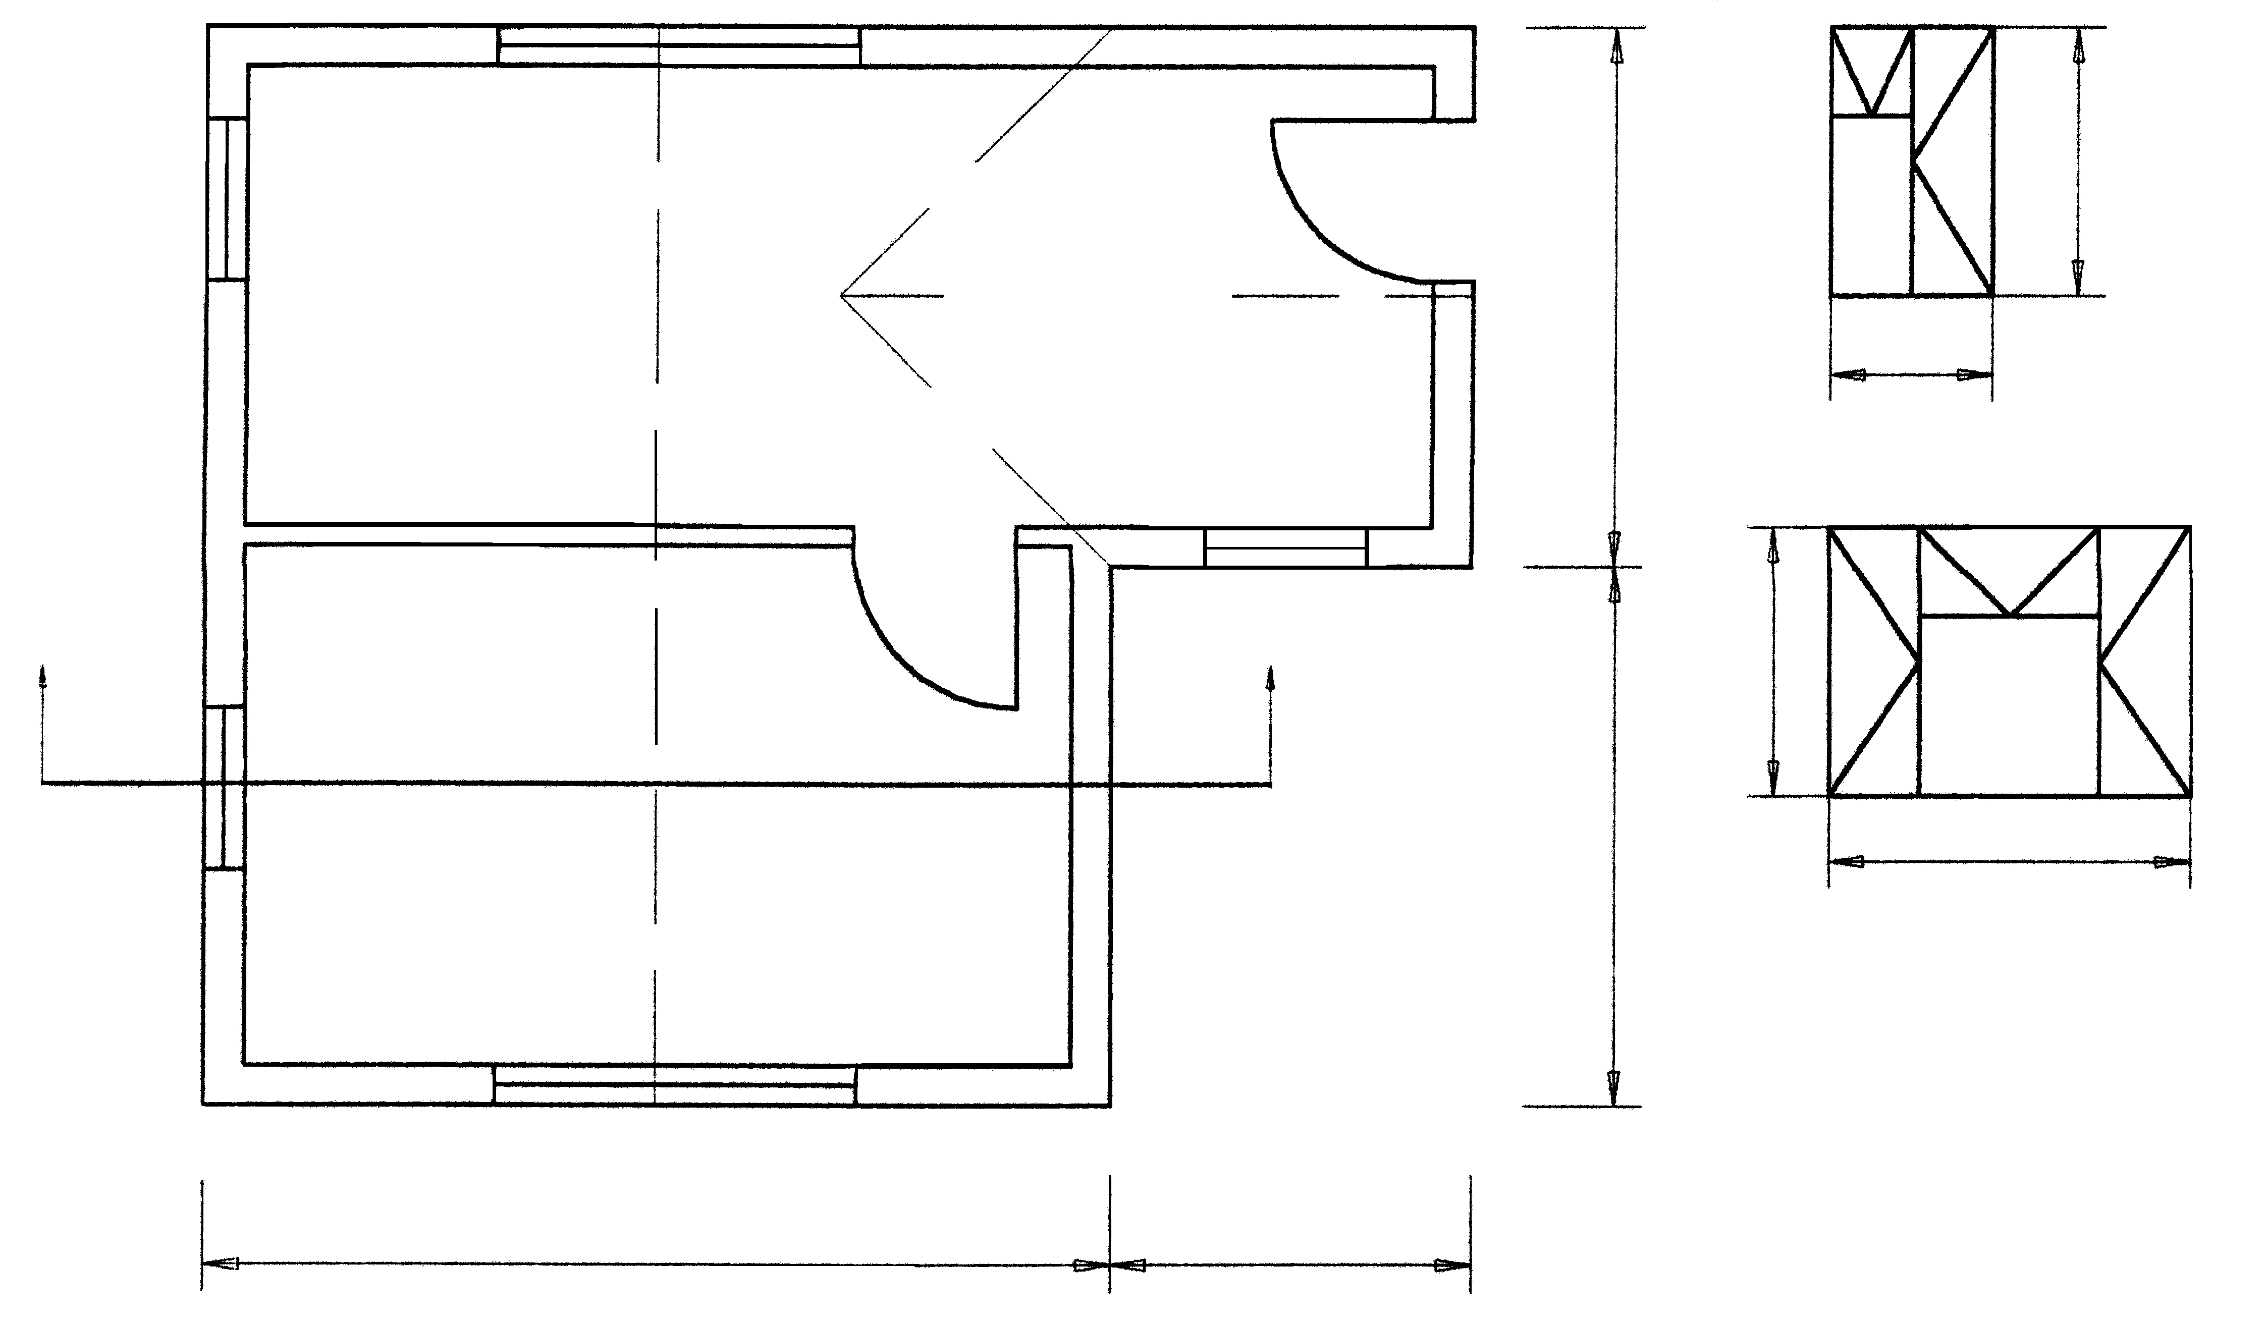
A
B
A

B
A
A
B
5000
2000
900
WINDOW SCHEDULE
2000

Figure 1 | [60]

QUESTION 4

- Draw to a scale of 1:10 a vertical section through the total length of the straight flight of concrete staircase and show the necessary formwork for the erection of this staircase. The concrete staircase consists of six stairs, a landing of  900 mm by 100 mm and a 220 mm unplastered external wall which supports the landing. The stairs have a rise of 150 mm and a tread of 275 mm.  - Figure 2 shows a 150 mm concrete floor which is supported by a 500 mm by 350 mm concrete beam. Use the following specifications and draw to a scale of 1:10 a vertical section through the concrete beam and floor to show the necessary concrete reinforcement.  Specifications:  Concrete beam : Main bars with a diameter of 20 mm.  Stirrups with a diameter of 6 mm.  Concrete floor : Distribution bars with a diameter of 12 mm and a centre distance of 240 mm.  Main bars with a diameter of 16 mm. | (40)  (20)
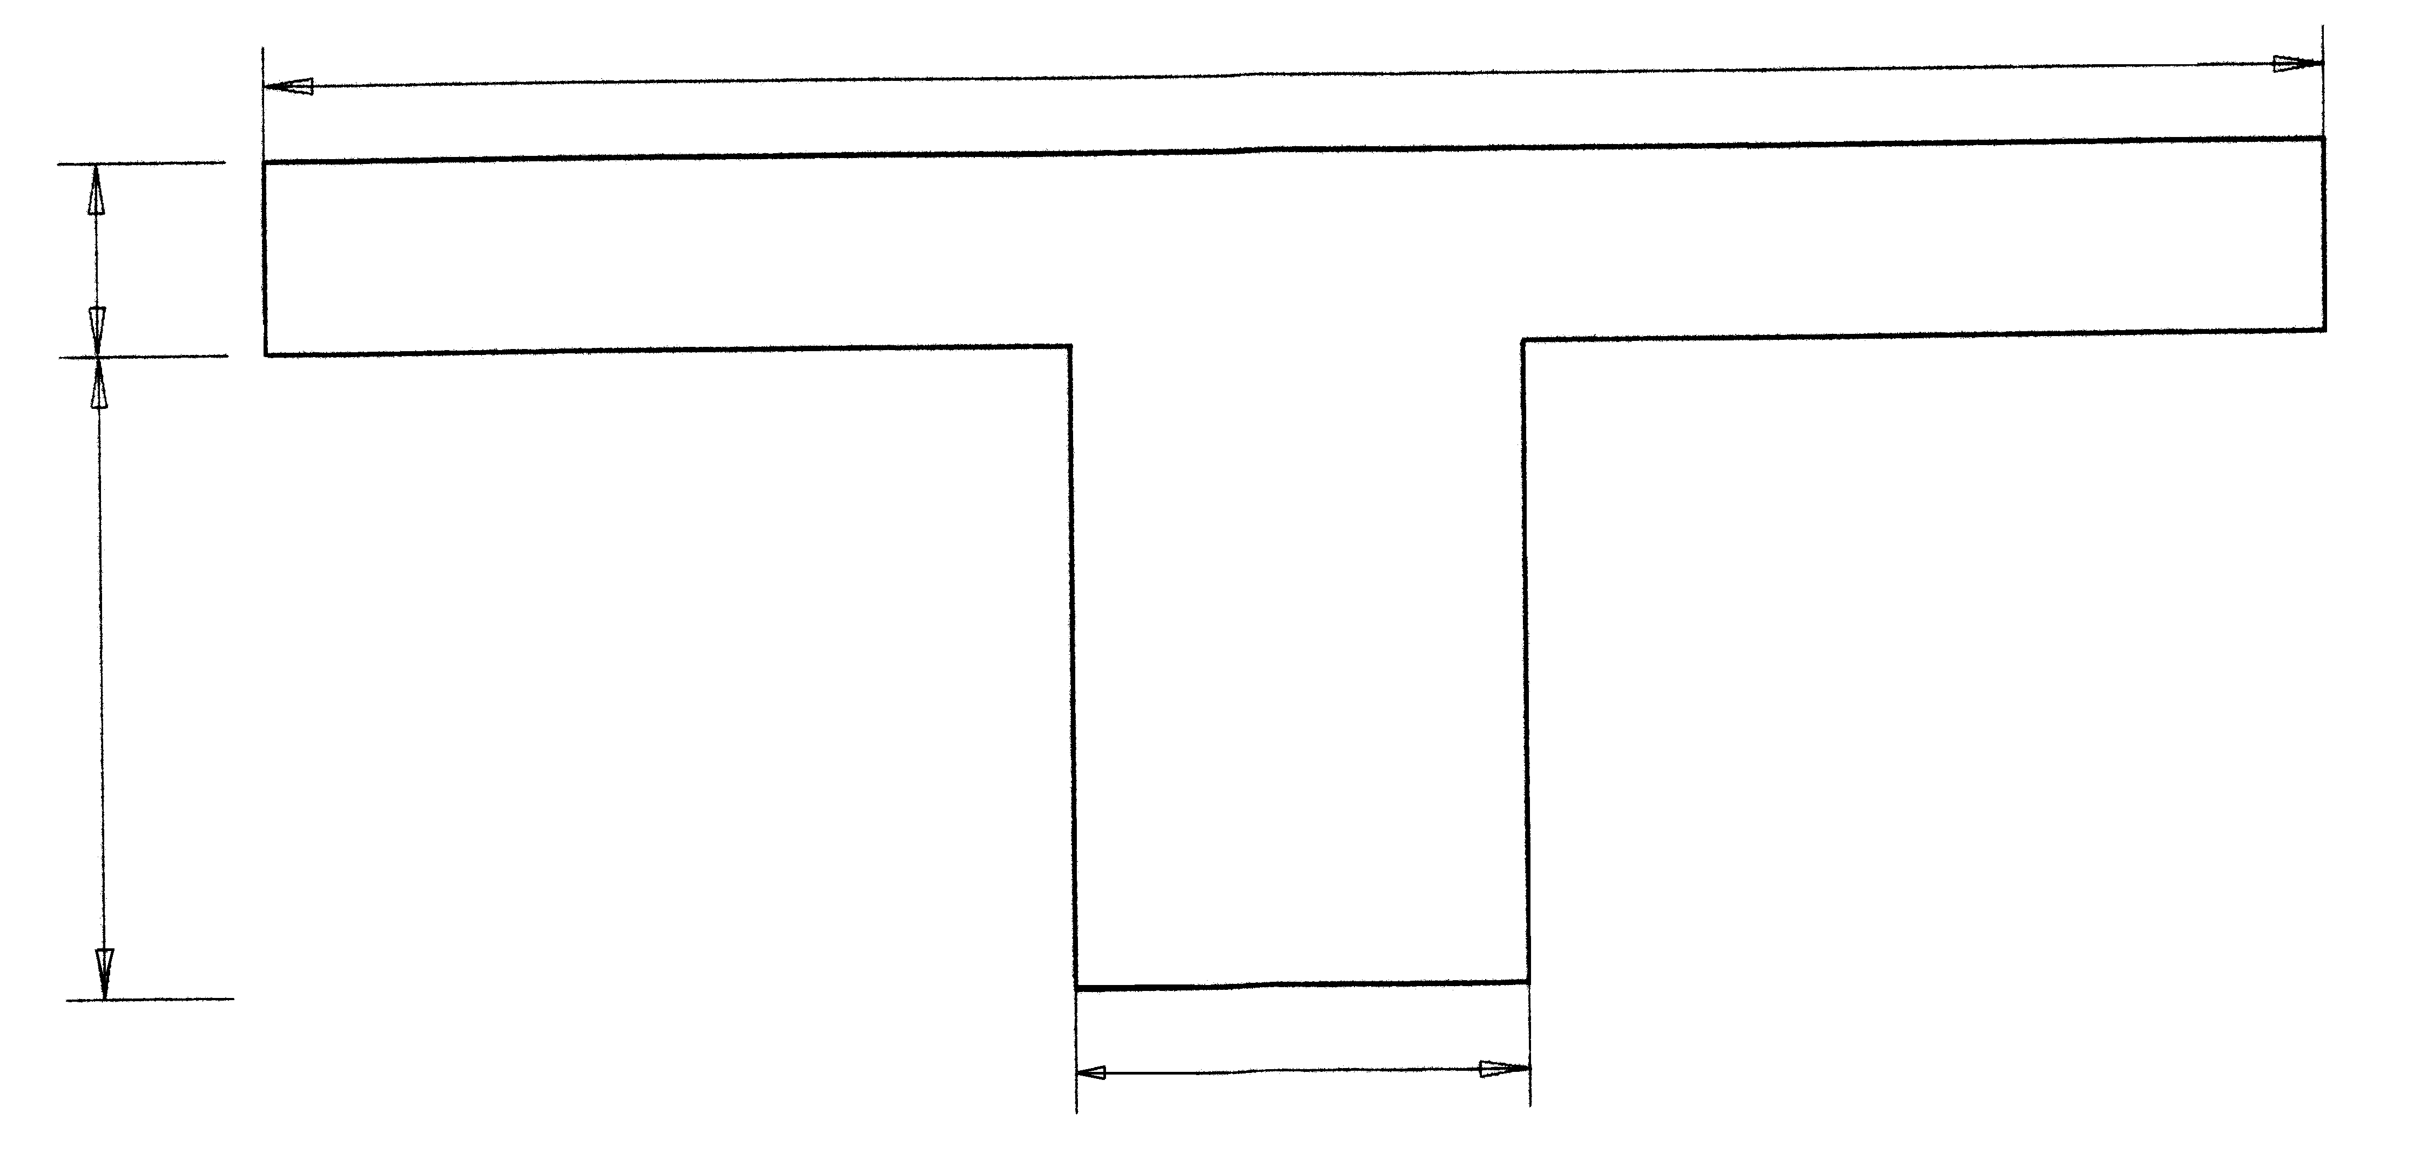
1600
150
500
350

Figure 2 | [60]

QUESTIONS 5

Figure 3 shows the plan of a building which is to be erected.
Calculate the number of bricks required for:

  - The substructure
  - The superstructure
  - The total number of bricks for the building

Only the number of bricks for the windows and doors must be deducted.
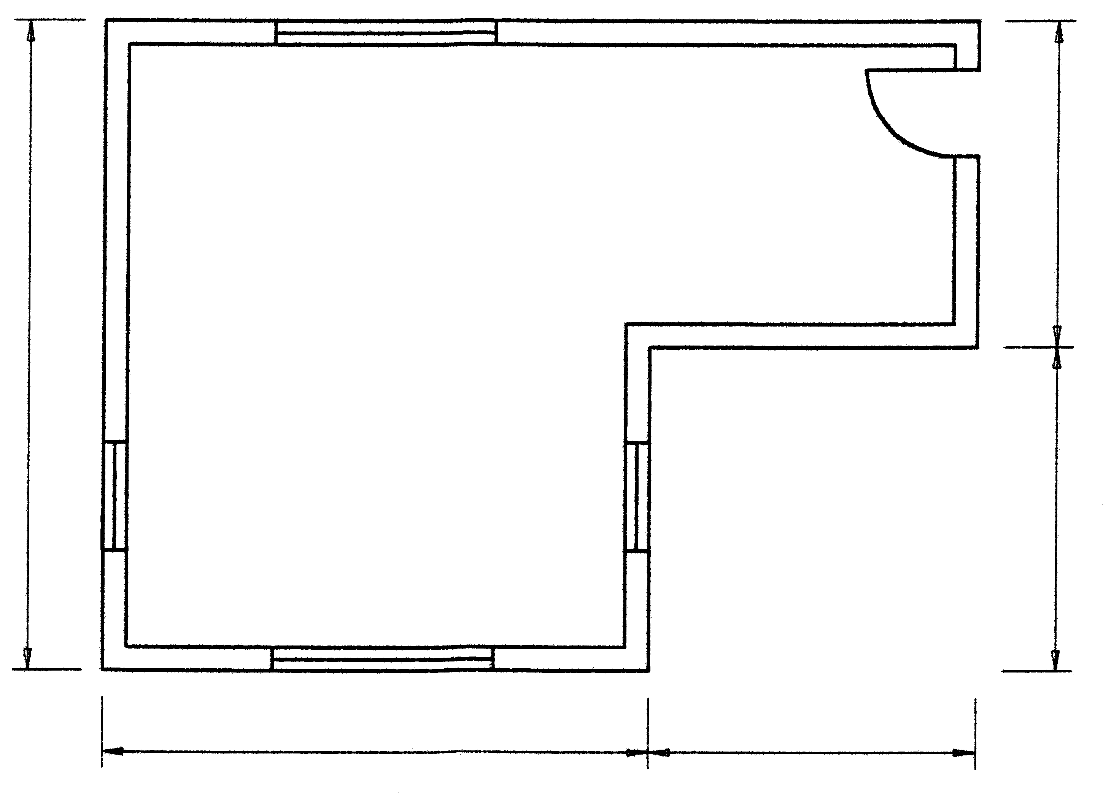
6000
3000
3000
A
B
B
A
5000
3000

Figure 3

Use the following specifications:  Use 50 bricks per square metre for a half brick wall.  The height of the superstructure is 2800 mm and is a one brick wall.  The height of the substructure is 450 mm and is a one brick wall.  The door opening is 2000 mm by 800 mm.  Windows A are 2000 mm by 1500 mm.  Windows B are 1000 mm by 1500 mm.  Allow 5% bricks for wastage.  Tabulate your answer according to the standard columns. | (40)

- The floor of the basement level of a building is 2700 mm below ground level and is 100 mm thick. The total height between the basement floor and the  100 mm concrete floor of the ground floor is 3000 mm. The exterior wall of the building is one and a half bricks thick and plastered on the inside with vertical dampproofing built in half brick thickness from the exterior of the wall. Draw, using a scale of 1:20, a vertical section through the exterior wall and part of the two concrete floors to show the necessary dampproofing which is needed to ensure that no moisture will penetrate the basement level. | (20)  [60]

QUESTION 6

Figure 4 shows a loaded beam which is supported at the ends. The beam is loaded with two point loads and a universal spreaded load of 3 kN/m.

  - Calculate the reaction forces at P and Q.
  - Calculate the shear forces at A, B, C, D and E.
  - Calculate the bending moments at A, B, C, D and E.
  - Draw the space diagram, shear force and bending moment diagrams.

Use the following scales:

Space diagram : 1 : 100
Shear force diagram : 1 kN = 5 mm
Bending moment diagram : 1 kN.m = 2 mm

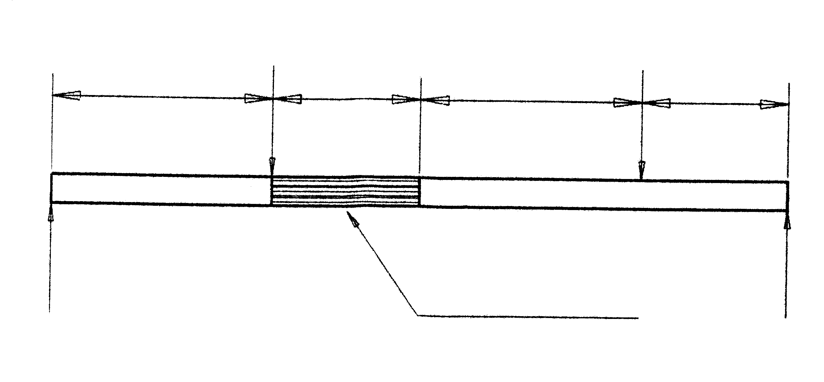
4 kN
6 kN
3000 2000 3000 2000
A
B
C
D

E
P
3 kN/m
Q

Figure 4 | [60]

QUESTION 7

Figure 5 shows a line diagram of a steel roof truss with four vertical loads which are simply supported.

  - Draw the space diagram to a scale of 1 : 100.
  - Draw the vector diagram to a scale of 1 kN = 10 mm.
  - Determine graphically the nature and magnitude of the force in each component of the framework.
5 kN
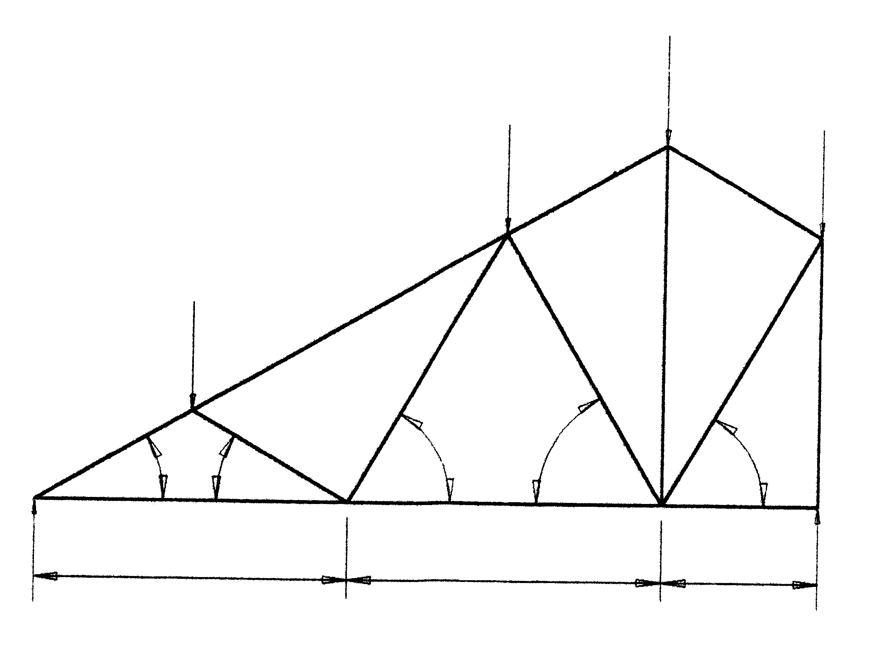
4 kN
E
M
60°
60°
60°
30°
30°

G
H
J
K L
5000 5000 2500
P = 5 kN
Q = 11 kN

A
3 kN
B
4 kN
C
D

F

Figure 5

Draw the table below in your answer book and answer Question 7.3 within the table.

MEMBER | FORCE | NATURE
AG
FG
GH
BH
HJ
FJ
JK
CK
KL
DC
LM
ME
FM

TOTAL: | [60]  300

