GAUTENG DEPARTMENT OF EDUCATION
SENIOR CERTIFICATE EXAMINATION

BUILDING CONSTRUCTION SG

TIME : 3 hours

MARKS : 300

REQUIREMENTS:

- Answer book

- A3 size drawing paper

- Drawing instruments

- Pocket calculator

INSTRUCTIONS:

- Answer any FIVE questions.

- All calculations and written answers must be done in the Answer book.

- Answer Question 4.2 on the answer sheet on page 8. Please detach this sheet and place it at the back of your Answer book when you have finished.

- Use both sides of the drawing paper.

- Drawings and sketches must be fully dimensioned and neatly finished off with titles and labels to conform with the SABS Recommended Practice for Building drawings.

- For the purpose of this examination, the brick size should be taken as
220 mm x 110 mm x 75 mm.

QUESTION 1

- State FIVE requirements with which material for reinforcement must comply.  - Name FIVE general safety precautions that are applicable on the building site.  - Name any TWO tests which can be carried out on sewerage systems to detect any possible leakages.  - State any FIVE aspects to which an inspector must pay attention during the inspection of a sewerage system.  - Describe any FIVE important aspects which must be taken into consideration, for maximum efficiency, when installing a solar water heating system.  - List any THREE requirements with which damp proof course must comply.  - Make a neat, and proportional sectional sketch of the joint between two  100 mm PVC sewerage pipes. | (10)  (10)  (4)  (10)  (10)  (6)  (10)  [60]

QUESTION 2

- A solar hot water heating system consists of a solar collector, an electric storage cylinder and a hot water cylinder which must be installed in a dwelling with a 30° pitched roof. The cold water supply to the electric hot water storage cylinder is controlled by a pressure reducing valve.  By making use of a neat line diagram, show the arrangement of all the components of the system. Also indicate by means of arrows, the direction of the flow of water when the system is in use.  - A front door of a dwelling consists of fielded and raised panels, a moulded top rail and a semicircular fanlight.  Use the following specifications:  Door : 2000 mm by 800 mm  Frame : Stiles and transom 115 mm x 75 mm  Door : Stiles and top rail 115 mm x 45 mm  Lock and bottom rail : 200 mm x 45 mm  Muntin : 100 mm x 45 mm  Raised panels : 22 mm thick  Semicircular fanlight : Stiles and rails 60 mm x 45 mm  - Draw to a scale of 1 : 5, a horizontal section through the door, approximately 500 mm from the bottom.  - Draw to a scale of 1 : 2, a vertical section through the bottom rail of the fanlight, the transom and the top rail of the door.  The necessary mouldings must also be shown. | (30)  (18)  (12)  [60]

QUESTION 3

The plan of a dwelling is shown in Figure 1 below. The dwelling has a gable roof covered with corrugated iron and has open eaves with an overhang of 500 mm and a pitch of 30°. The roof has 100 mm x 100 mm square gutters with downpipes of 75 mm diameter and 200 mm fascia and barge boards.  The superstructure is 2800 mm high and the substructure 450 mm of which 4 layers of bricks are above ground level. The dwelling has a framed Z-batten door and all the windows must be placed in the correct position by using the sizes given in the window schedule.  The windowsills are made of 150 mm by 150 mm by 25 mm clay tiles.  Show by means of a drawing the method of determining the height of the roof.  Draw, according to a scale of 1:100, a North and West elevation of this dwelling. | [60]
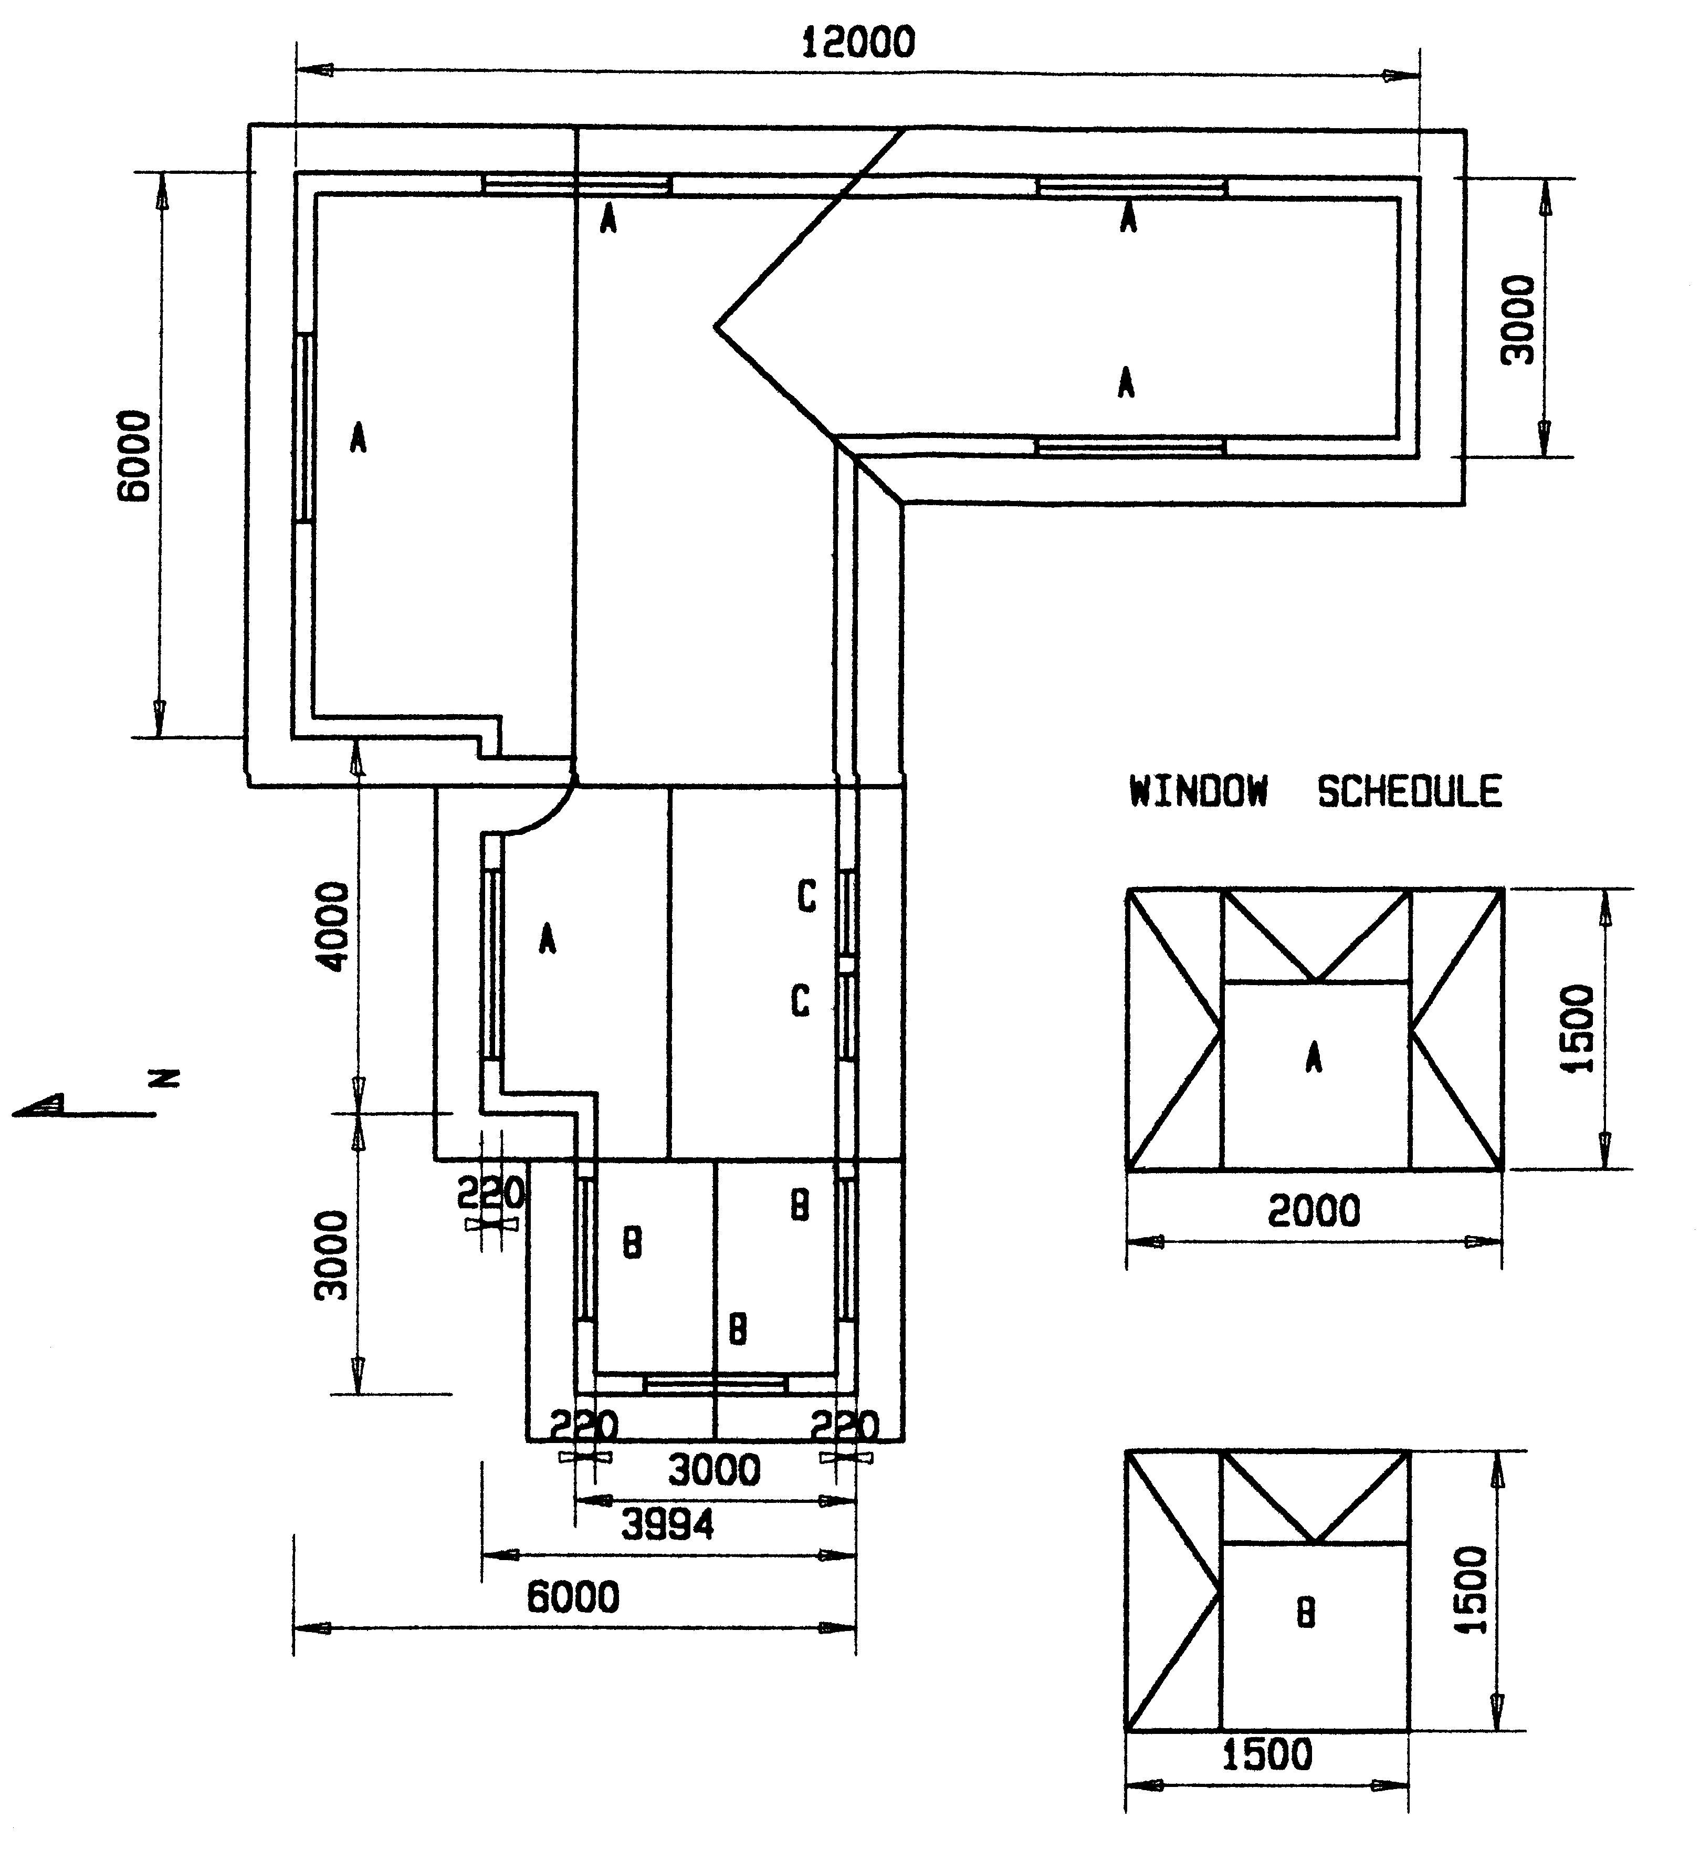

Figure 1

QUESTION 4

- The first floor of a building consists of a 150 mm thick concrete floor supported by a 300 mm x 500 mm concrete beam. The total height of the floor and the beam is 500 mm. Draw, to a scale of 1 : 10, a vertical section through the beam and parts of the floor on both sides of the beam to show the formwork, reinforcement as well as the top and bottom parts of the props in position.  4.2 The answer sheet on page 8 shows part of a plan of a dwelling with outbuildings. Standard abbreviations are used to show the sanitary fitments. Use this answer sheet and draw a suitable and effective drainage system for the building. Show all drainage details by means of standard abbreviations.  Write your examination number in the space provided, detach the answer sheet and place it at the back of your answer book. | (40)  (20)  [60]

QUESTION 5

Figure 2 below shows a loaded beam which is supported at the ends. The beam is loaded with two point loads and a universal spreaded load of 4 kN/m.

  - Calculate the reaction forces at LR and RR.
  - Calculate the shear forces at A, B, C, D and E.
  - Calculate the bending moments at A, B, C, D and E.
  - Draw the space, shear force and bending moment diagrams.

Use the following scales:

Space diagram : 1 : 100
Shear force diagram : 1 kN = 5 mm
Bending moment diagram : 1 kN.m = 2 mm
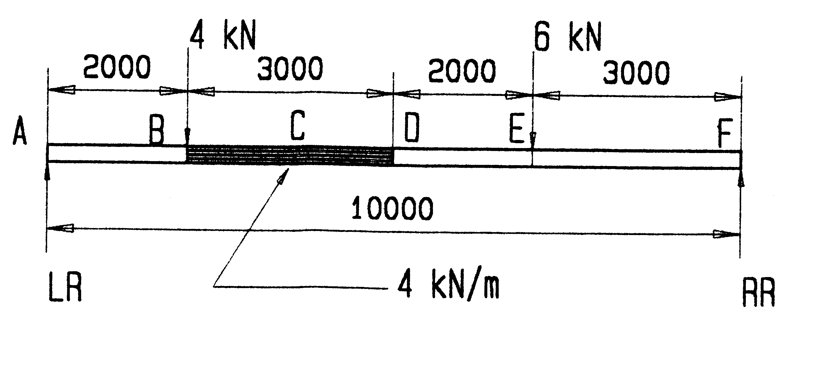
[60]

Figure 2

QUESTION 6

Figure 3 shows a line diagram of a steel roof truss with three vertical loads which is simply supported.

  - Draw the space diagram to a scale of 1 : 100.
  - Draw the vector diagram to a scale of 1 kN = 10 mm.
  - Determine graphically the nature and magnitude of the force which impacts on each component of the framework.
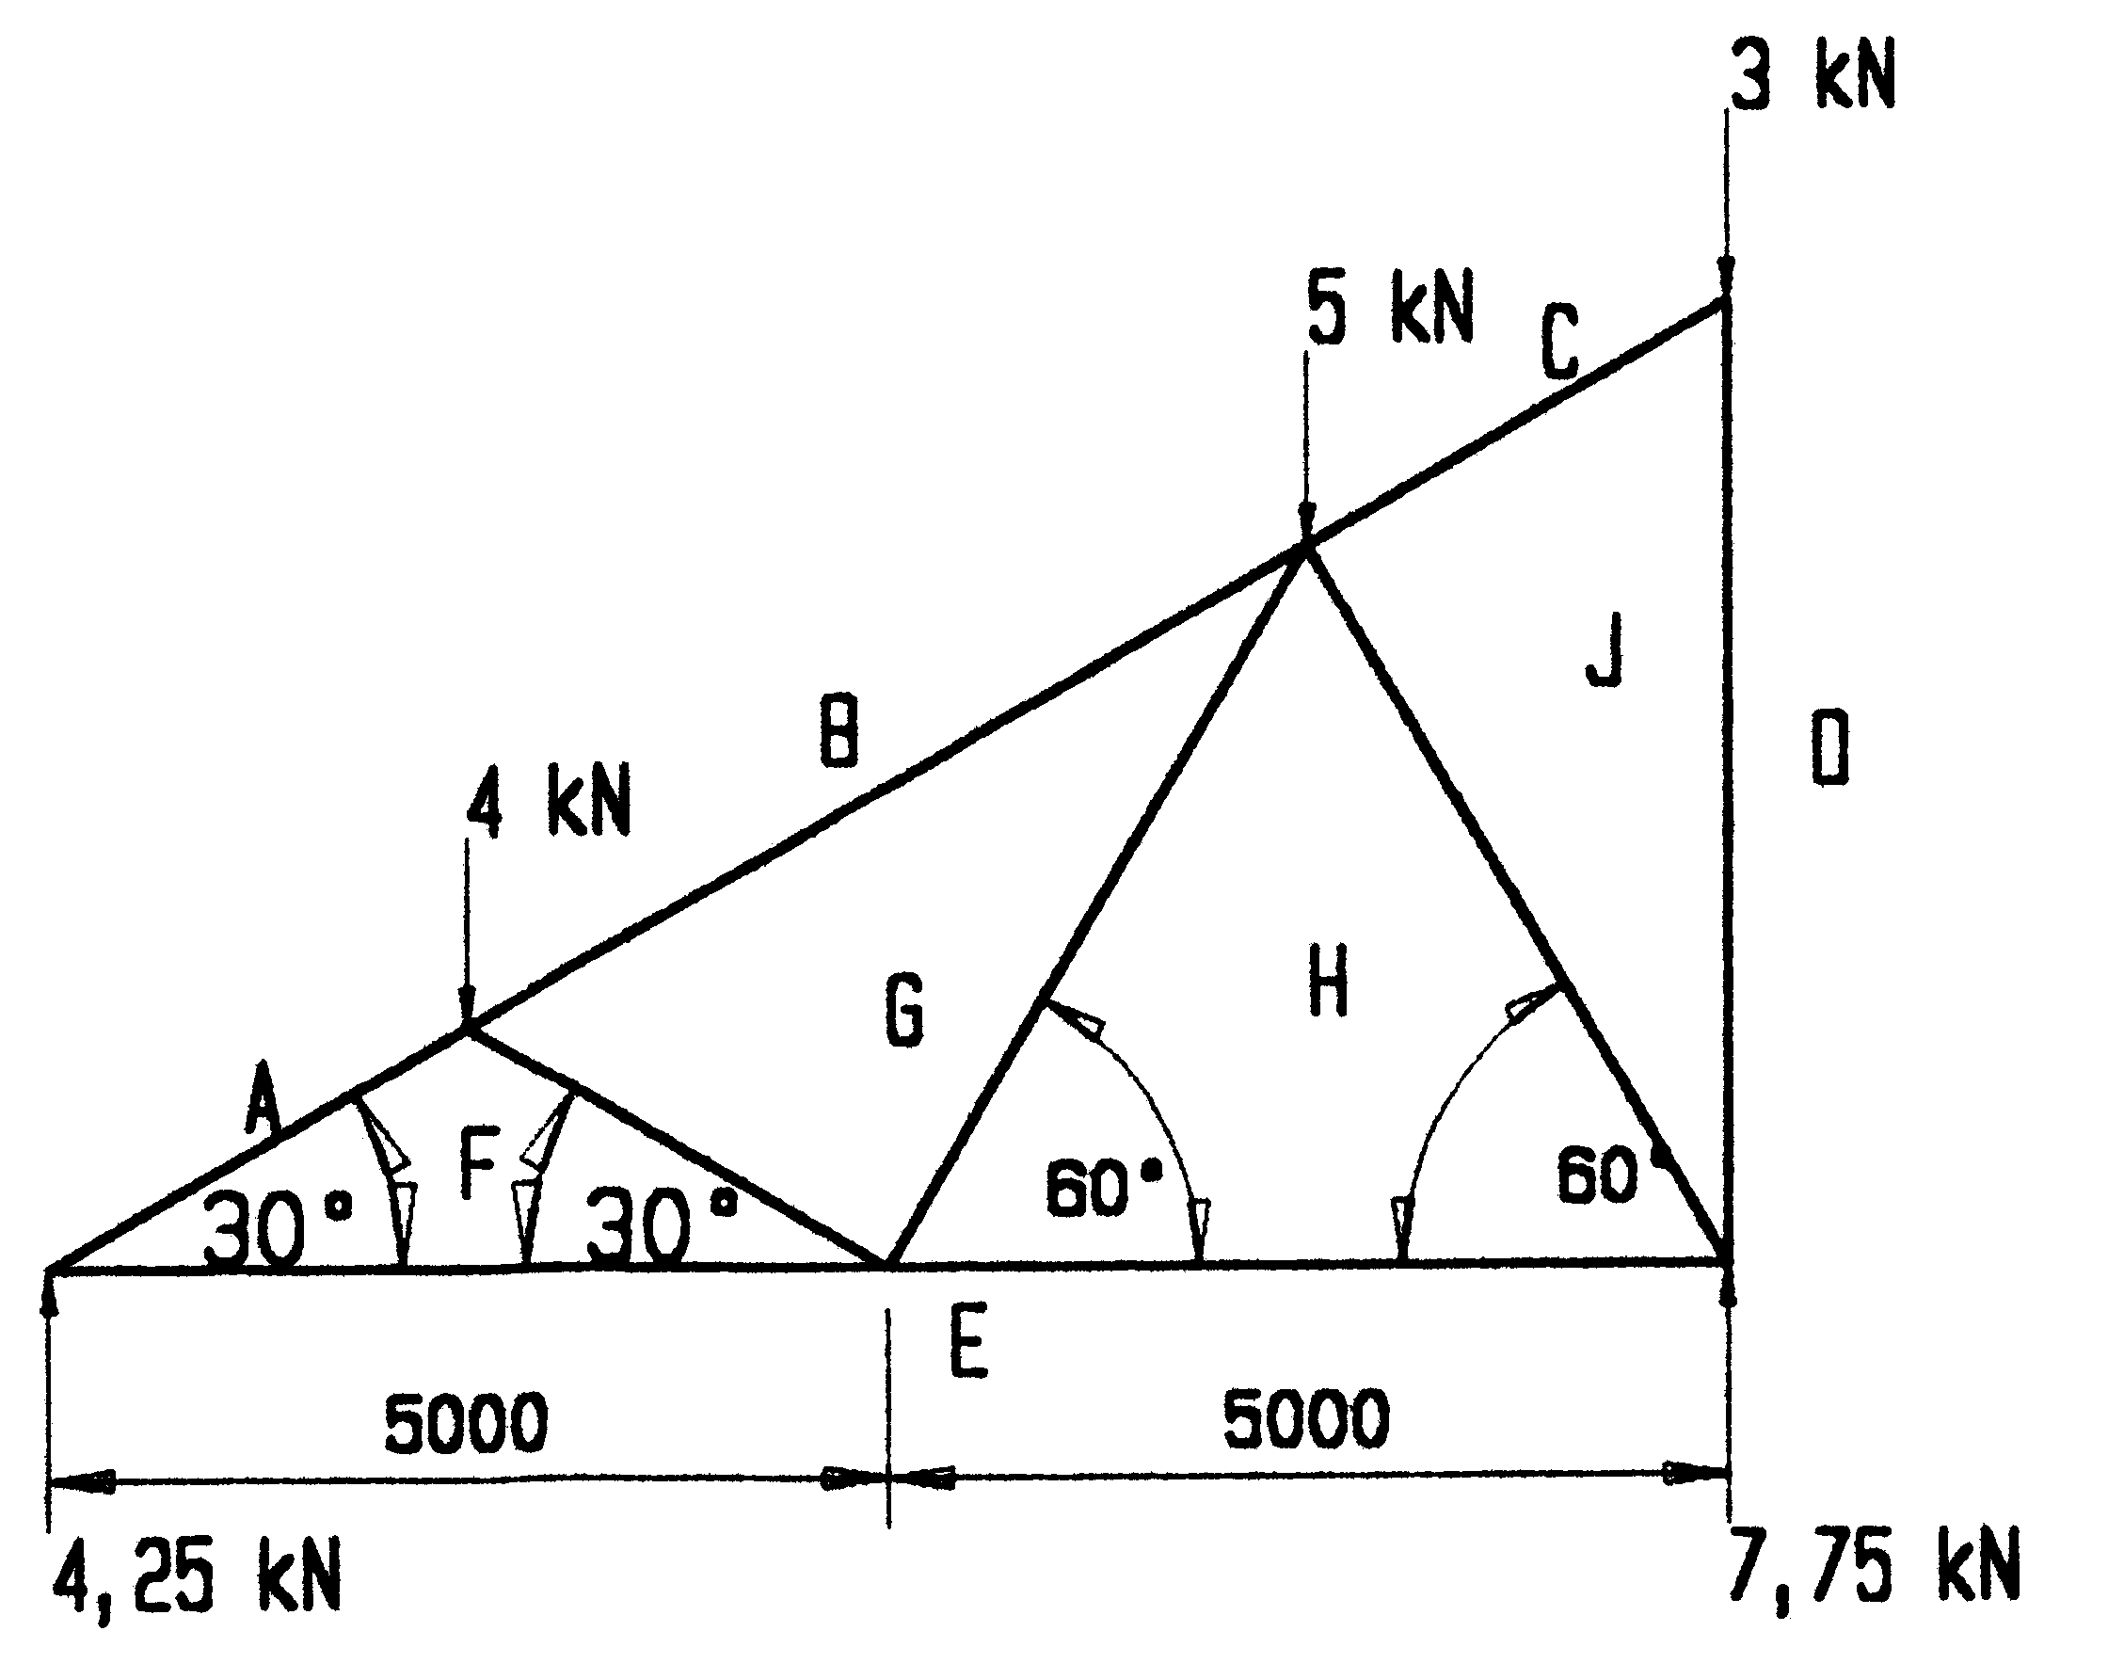

Figure 3

Draw the table below in your answer book and answer Question 6.3 within the table.

MEMBER | FORCE | NATURE
AF  EF  FG  BG  GH  EH  HJ  CJ  JD |  |  |  | [60]

QUESTION 7

Figure 4 shows the plan of a building which is to be erected. Calculate the number of bricks required for the following:

  - The substructure (330 mm)
  - The superstructure (outer wall 220 mm)
  - The total number of bricks to erect the building.

Use the following specifications:

- The height of the substructure is 450 mm.
- The height of the superstructure is 2900 mm from the concrete floor.
- Use 50 bricks per square metre for a half brick wall.
- The door openings are 2000 mm by 800 mm.
- Window A is 2000 mm by 1500 mm.
- Window B is 900 mm by 1500 mm.
- Allow 5% bricks for wastage.

Tabulate your answer according to the standard columns.

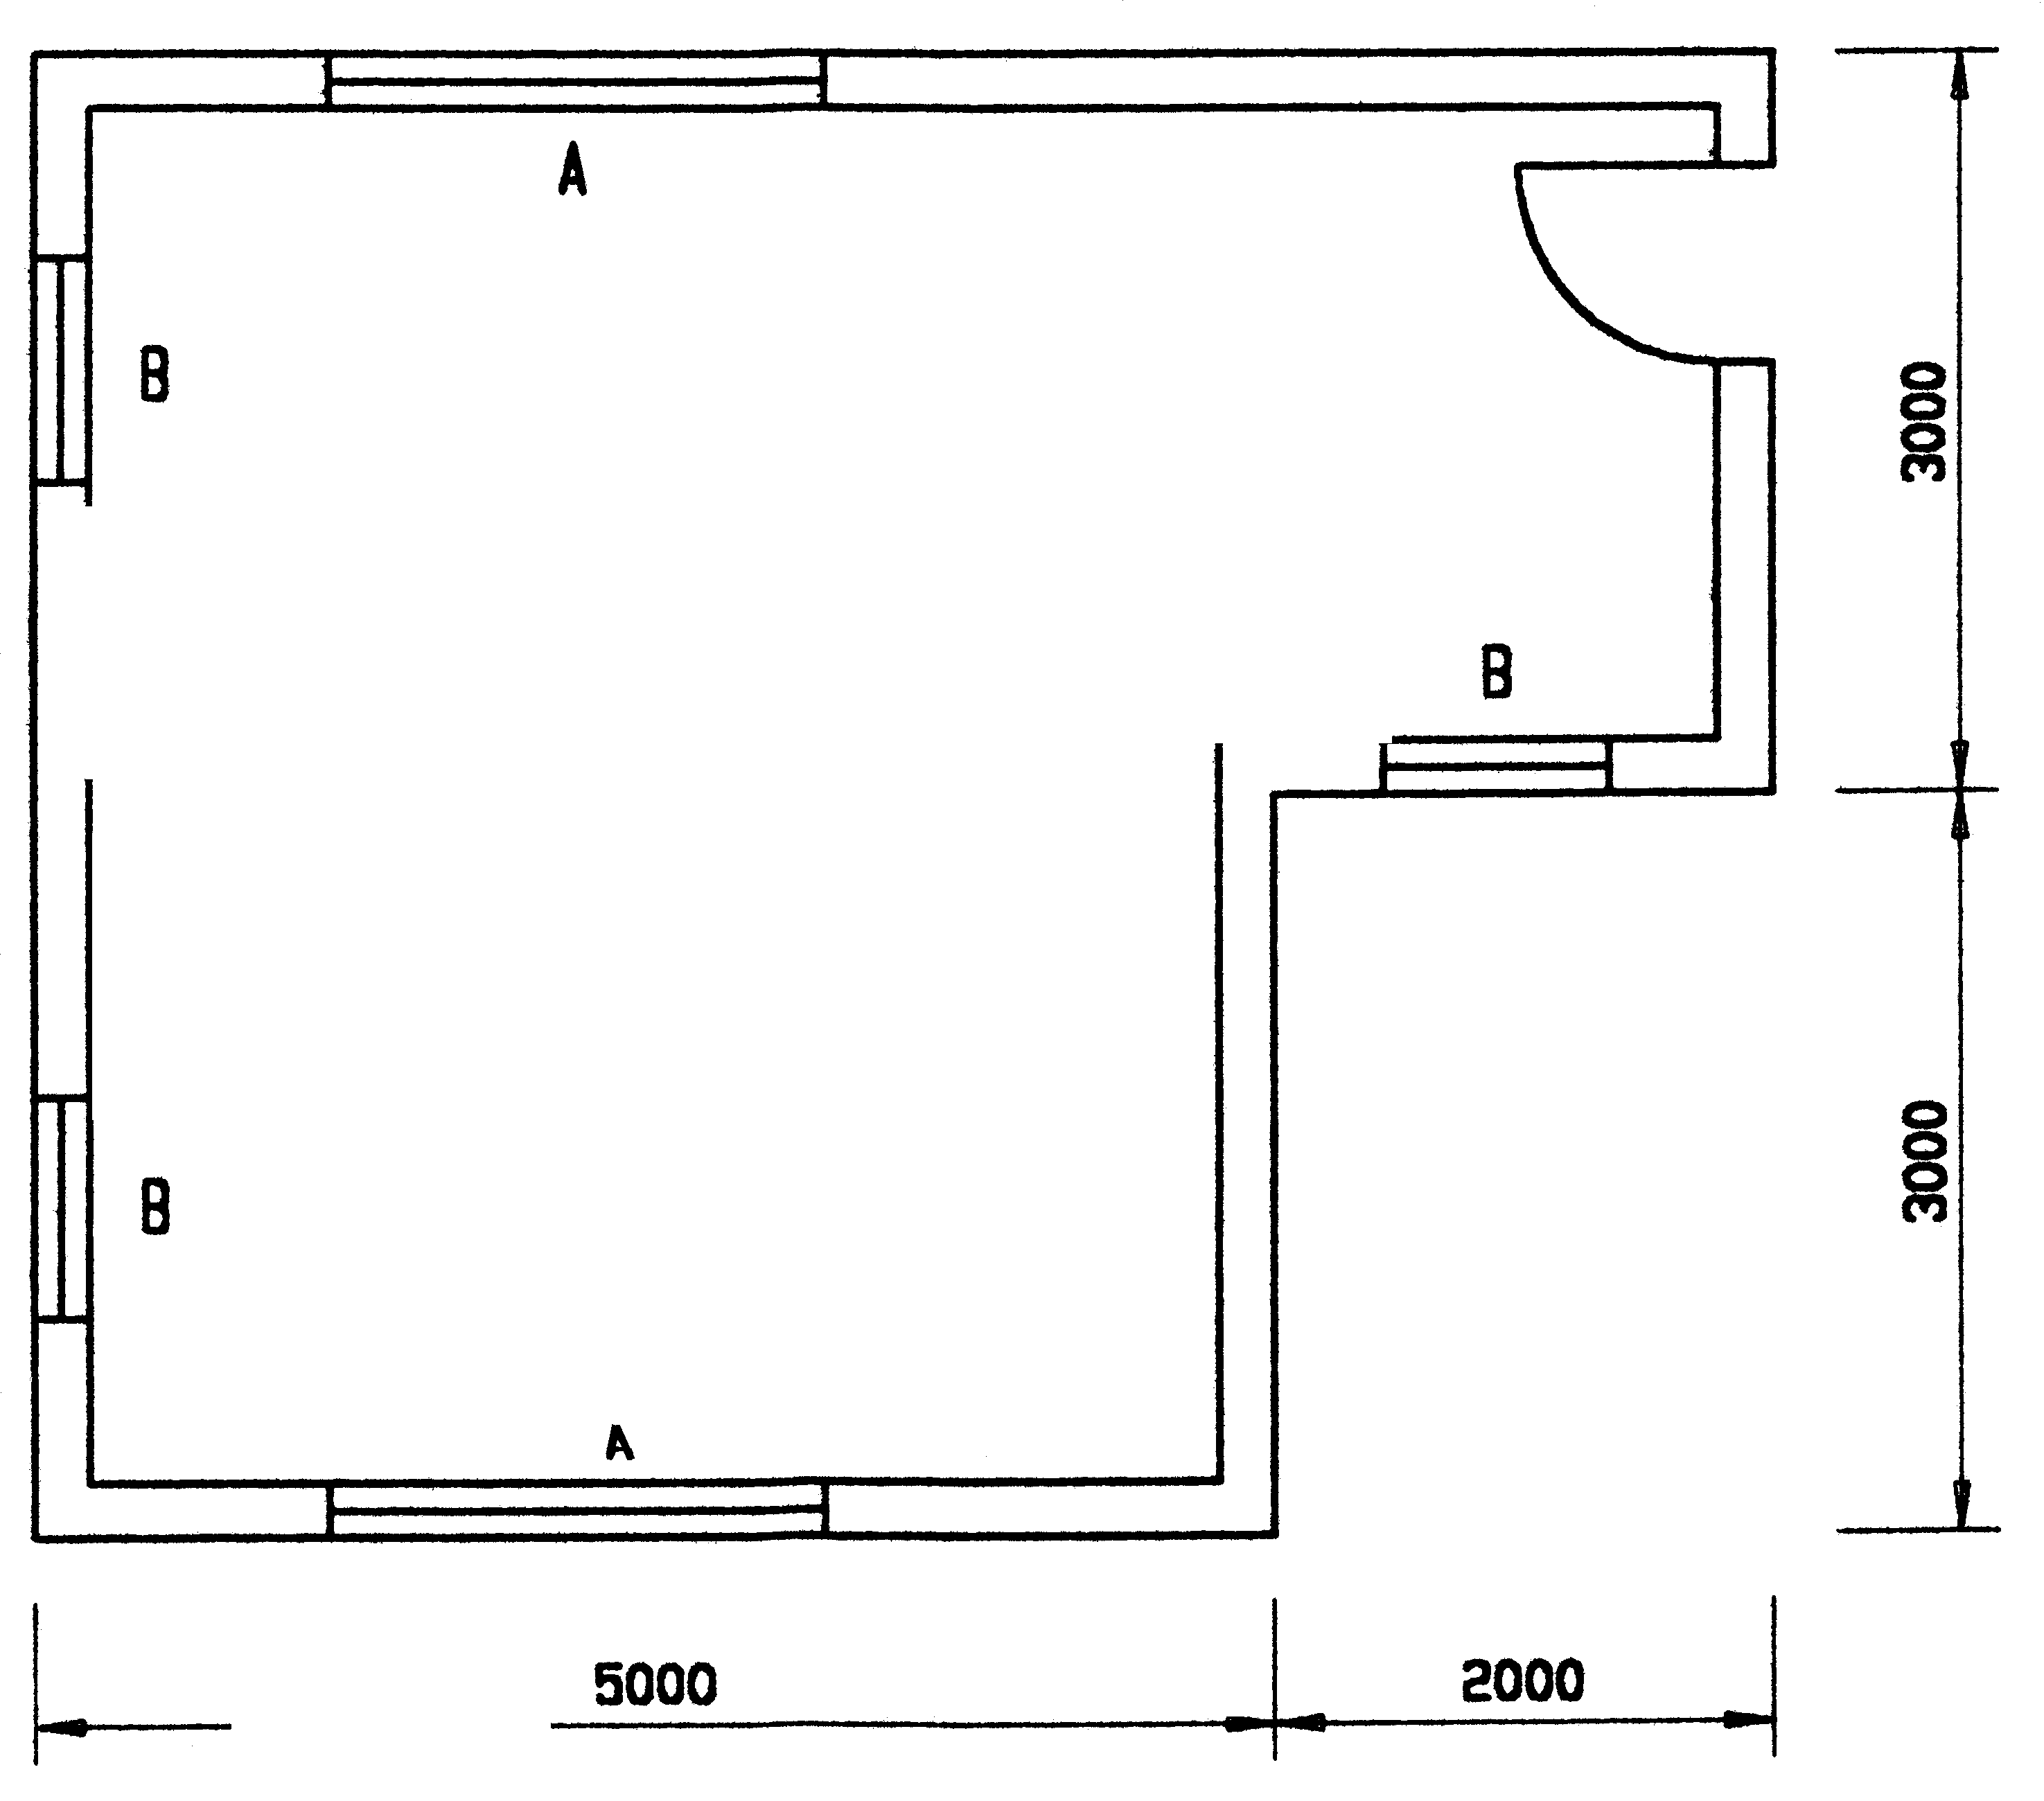

Figure 4

TOTAL: | [60]  [300]

EXAMINATION NUMBER / EKSAMENNOMMER

ANSWER SHEET SG 702-2/0 (C)
ANTWOORDBLAD SG 702-2/0 (C)
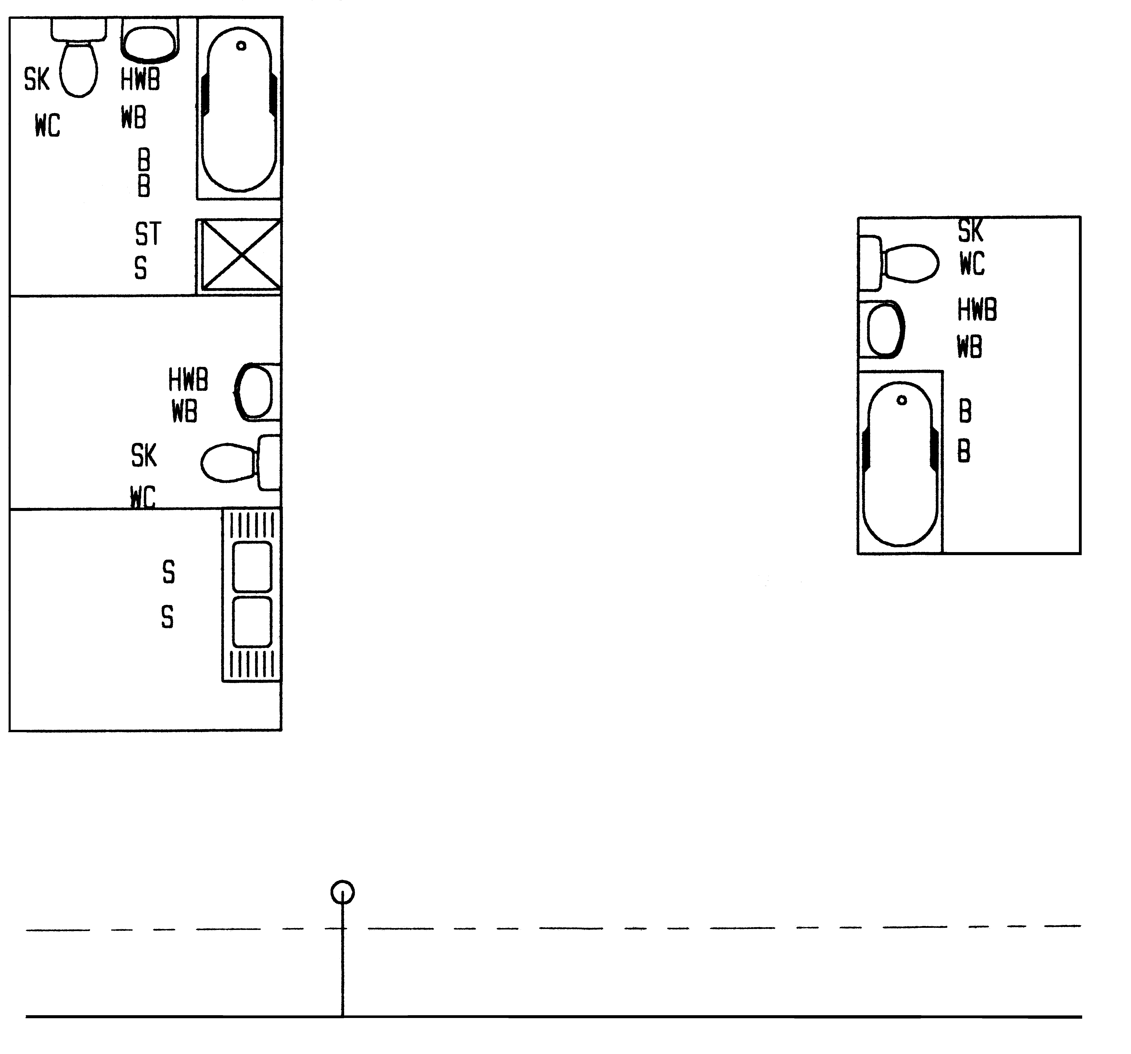
CONNECTION / AANSLUITING
MAIN SEWERAGE / HOOFRIOOL

