GAUTENG DEPARTMENT OF EDUCATION
SENIOR CERTIFICATE EXAMINATION

BRICKLAYING AND PLASTERING SG

TIME: 3 hours

MARKS: 300

REQUIREMENTS:

- A3 Drawing Paper

- Calculators may be used.

INSTRUCTIONS:

- Answer ALL questions.

- Use both sides of the drawing paper.

- All drawings must be done in pencil on the drawing paper.

- Assume the dimensions of a brick to be:

Length: 220 mm
Width: 110 mm
Height: 75 mm

QUESTION 1

1.1 Briefly explain how Portland cement is manufactured. | (6)

1.2 Name FIVE different types of cement. | 1x5=(5)

1.3 Briefly describe the correct procedure used to mix concrete by hand. | (11)

1.4 Name and describe FIVE methods that can be used to cure concrete. | 2x5=(10)

- The slump test is used for determining the desired workability of concrete.  Name the equipment required and describe how the test is carried out. | (18)  [50]

QUESTION 2

2.1 List FIVE different checks you would carry out to ensure that a tubular scaffold is safe to work on. | 5x2=(10)

2.2 Name TEN safety precautions which are applicable when erecting and using a scaffold. | 2x10=(20)

2.3 Figure 1 on page 6 illustrates different parts of an independent tubular scaffold. Write down the label numbers 1 to 10 in your answer book and fill in the missing labels. | 2x10=(20)  [50]

QUESTION 3

3.1 Figure 2 on page 7 shows different parts of an arch. Label these parts  (1 to 7) shown in the diagram. | 2x7=(14)

3.2 To a scale of 1:10, draw an isometric view of a 90º corner formed between two one-and-a-half-brick walls built in Flemish bond. The one wall which forms the corner is 5½ bricks long, with a stopped end and the other wall is 6¼ bricks long with raking back. Your wall must be FIVE courses high. | (24)

3.3 Draw, to an approximate scale of 1:10, a vertical section through the bottom 8 courses of a one-brick wall. The drawing must show the following details:

Concrete foundation: 600 mm x 300 mm  Ground level  Damp course  Floor slab: 75 mm  Hard core: 75 mm  Plaster internally: 15 mm  Wooden skirting: 75 mm x 13 mm | (20)  [58]

QUESTION 4

4.1 Fully describe how boning rods and sight rails are set up and used in the excavation of a sewer trench which is to have a uniform fall. | (22)

4.2 Give the standard abbreviations for the following drainage fittings:

- Vent pipe  - Drain pipe  - Soilwater pipe  - Wastewater pipe  - Gulley | 2x5=(10)

4.3 State the main difference between a vacuum tank and a septic tank. | (6)

4.4 Under what circumstances are vacuum tanks installed? | (6)

4.5 Write brief descriptive notes on each of the terms listed below:

- Bay window  - Battered retaining wall  - Ramp man-hole  - Inspection-eye | 4x4=(16)  [60]

QUESTION 5

5.1 What is the main purpose of a flue in a fireplace? | (4)

5.2 Name FIVE factors that cause chimneys to smoke. | 2x5=(10)

5.3 A fireplace (hearth) is built into a long wall of a room at first-floor level of a building. The long wall is 1½ bricks thick, and is reduced to a one-brick wall at first-floor level.

The fireplace breasts are 440 mm wide and project 220 mm to the inside of the room and are built 800 mm apart.

Now, use a scale of 1:10 and draw a top view of the hearth showing the timber construction around the hearth.

The 152 mm x 76 mm trimming joists are each carried by a  100 mm x 100 mm x 10 mm thick angle-iron at the front of the fireplace breasts.  Your drawing must show the distances from the floor and the sides of the fireplace breasts as well as the spacing of the 152 mm x 38 mm flooring joist. No flooring boards need be shown. | (30)  [44]

QUESTION 6

Figure 3 on page 8 shows the plan of a small building.

Specifications:

Door = 1x2 m  Window A = 3x2 m  Window B = 2x1 m  Height of wall = 2,7 m  110 bricks per 1 m² are needed to build a one-brick wall.  Calculate the number of bricks necessary to erect this building. | [38]

TOTAL: | 300

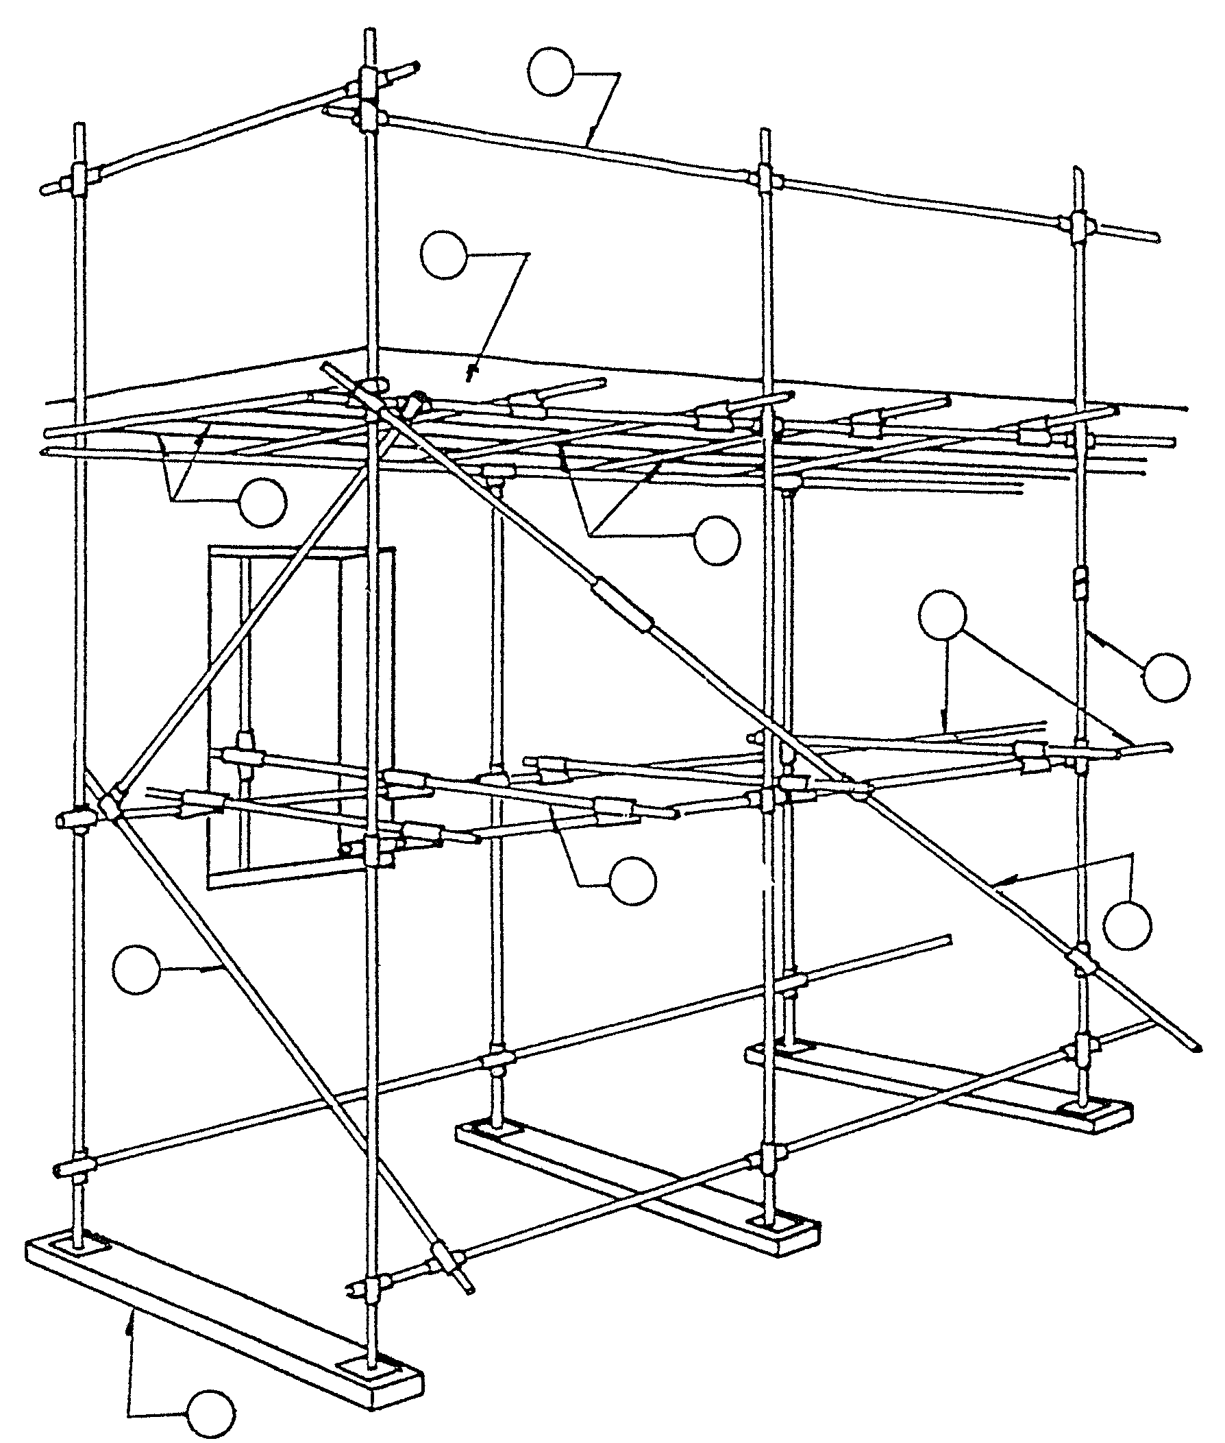  6  7  10  8  5  4  9  3  2  1 | 10x2=(20)

Figure / Figuur 1

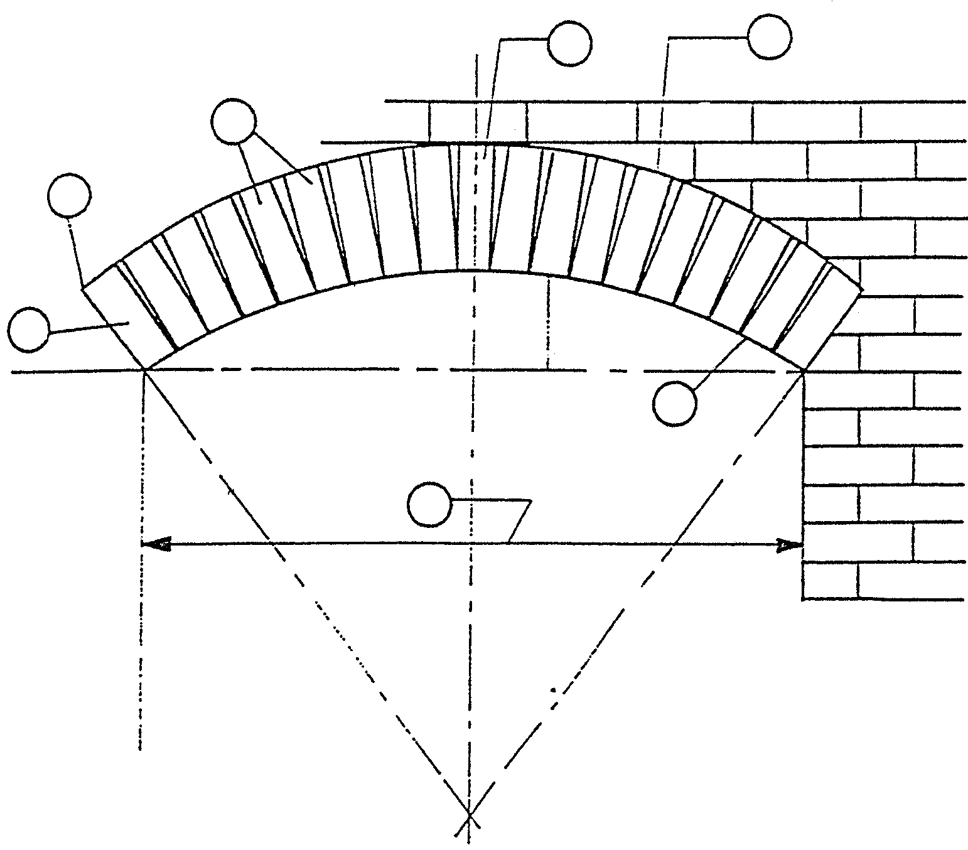
1
2
3
4
5
6
7

Figure / Figuur 2

PLAN OF A SMALL BUILDING / PLAN VAN ’N KLEIN GEBOU
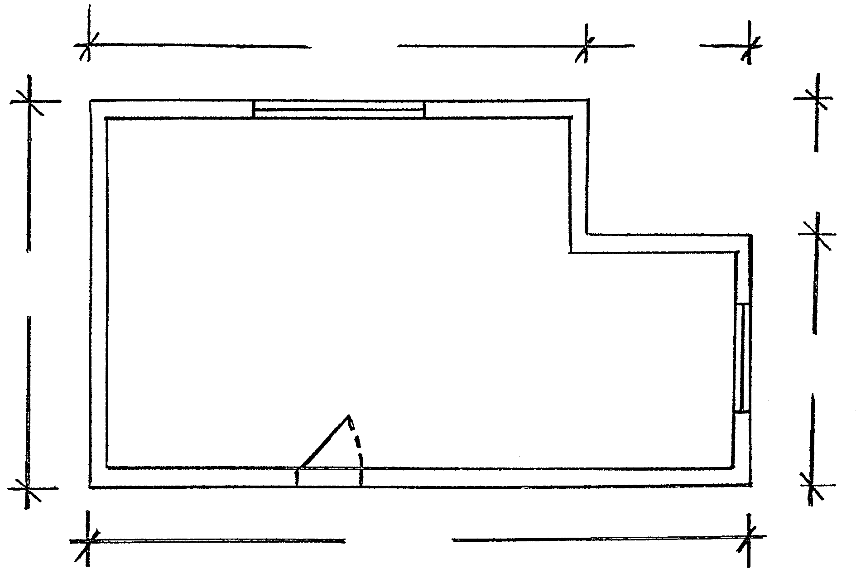
8 m
3 m
5 m
10 m
3 m
A
B
13 m

Figure / Figuur 3

