GAUTENG DEPARTMENT OF EDUCATION

SENIOR CERTIFICATE EXAMINATION

BRICKLAYING AND PLASTERING SG

TIME: 3 hours

MARKS: 300

REQUIREMENTS:

- Answer Book

- A2 drawing paper

- Calculators may be used.

INSTRUCTIONS:

- Answer ALL questions

- Use both sides of the drawing paper.

- All drawings must be done on the drawing paper in pencil only.

- Assume the dimensions of a brick to be:

- Length: 220mm

- Width: 110mm

- Height: 75mm

QUESTION 1

  - Indicate whether each of the following statements is TRUE or FALSE.
Write the numbers 1.1.1 – 1.1.10 with the correct answers alongside each number.

1.1.1 Concrete is a mixture of sand, cement and water.

1.1.2 Bricks should have a high water absorption capacity.

1.1.3 No-fines concrete means concrete without fine aggregate.

1.1.4 Admixtures are added to concrete to change the properties of the mix.

1.1.5 The centre is the permanent formwork on which arch bricks are supported during construction.

1.1.6 A wooden float is used when laying bricks.

1.1.7 Reveals are the vertical sides of an opening.

1.1.8 Curing means keeping the cast concrete dry.

1.1.9 A good trap must retard the flow of water.

1.1.10 Fire bricks are bricks that can withstand high temperatures. | 10x1(10)

1.2 Answer the following questions:

1.2.1 What is the main purpose of a flue in a fireplace? | (2)

1.2.2 Define the term cavity wall. | (2)

1.2.3 Moisture can penetrate a wall in one of three ways. Name the THREE ways. | (3)

1.2.4 Name the desired properties of a fire brick. | (6)

1.2.5 Name the FOUR basic causes of accidents on a building site. | (4)

1.2.6 Define the term concrete. | (3)

1.2.7 Name FIVE different types of natural sand. | (5)

1.2.8 Define the term coarse aggregate. | (3)

1.2.9 Define the term fine aggregate. | (3)

1.2.10 Name FOUR advantages of using a cavity wall construction compared with a solid outside wall. | (4)
[45]

QUESTION 2

2.1 Briefly explain how Portland cement is manufactured. | (6)

2.2 Name FIVE different types of cement. | (5)

2.3 Briefly describe the correct procedure used to mix concrete by hand. | (11)

2.4 Name and describe FIVE methods that can be used to cure concrete. | (10)

2.5 The slump test is used for determining the desired workability of concrete. Name the equipment required for the test and describe how the test is carried out. | (18)
[50]

QUESTION 3

3.1 Draw to an approximate scale of 1:10 the alternate plan courses of a corner formed by two one-and-a half brick walls in English bond. The one wall is 1320mm long with a stopped end and the other wall is 1000mm long. | (20)

3.2 Name FIVE joint profiles that can be used to finish-off unplastered brickwork. | (10)

To a scale of 1:10, draw a vertical section through the bottom eight courses of a 270mm cavity wall construction. Show the following detail:  - Concrete strip foundation 600mm x 300mm  - 75mm concrete floor slab  - Screed 20mm  - Hardcore  - 15 mm internal plaster  - Ground level  - Damp proof course at floor level height  - Wall tie  - Weep holes  - Cavity filled with concrete up to DPC level | (20)
[50]

QUESTION 4

4.1 List FIVE different checks you would carry out to ensure that the tabular scaffolding is safe to work on. | 5x2=(10)

4.2 Name TEN safety precautions which are applicable when erecting or using a scaffold. | 10x2=(20)

- The different members of the independent tabular scaffold are illustrated in Figure 1. Write down the question numbers  4.3.1 – 4.3.10 in your answer book and fill in the correct missing terms. | 10x2=(20)
[50]

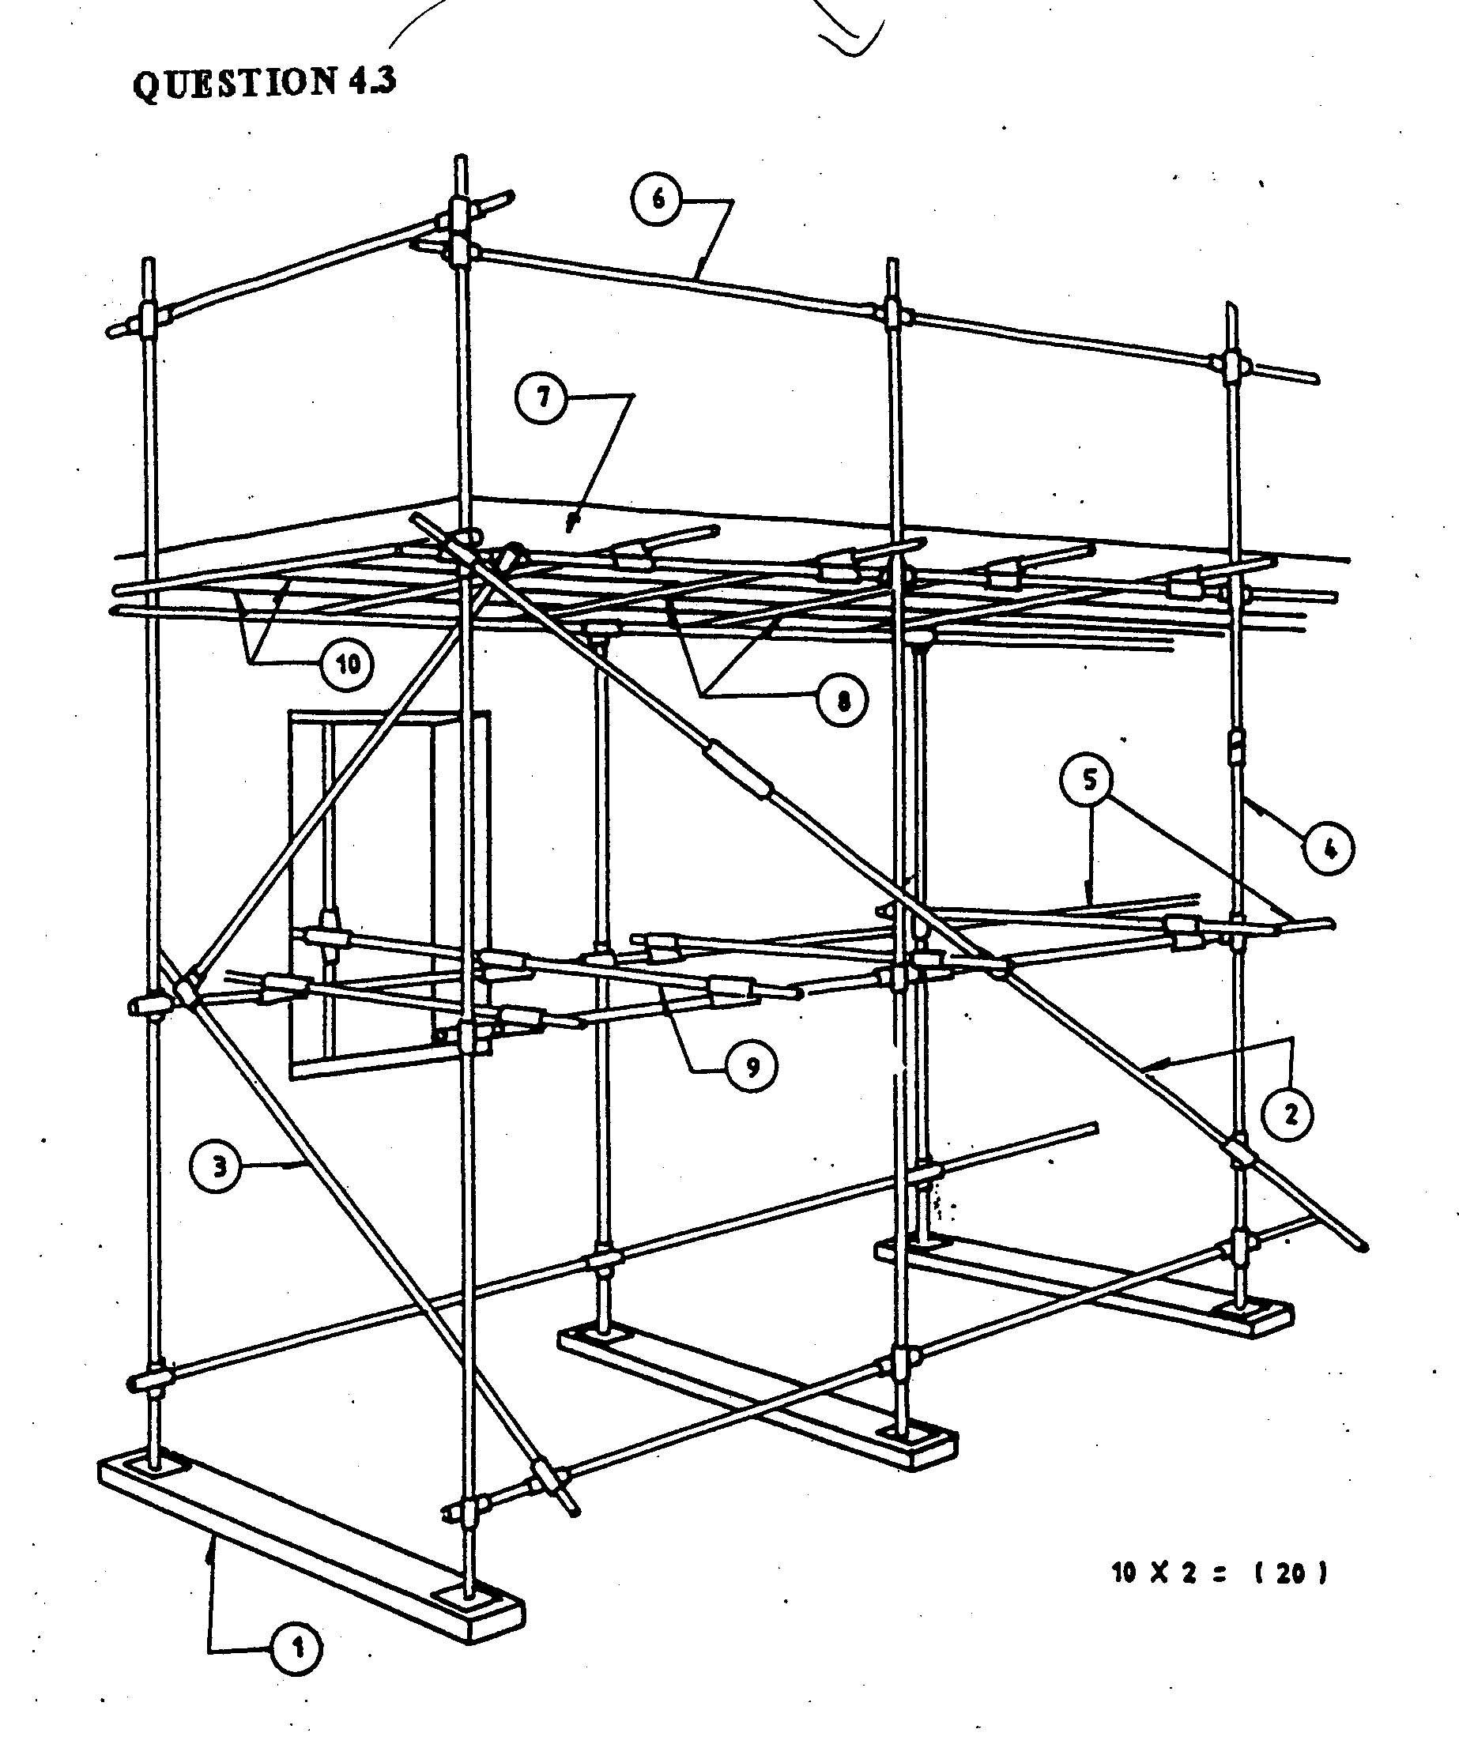

Figure 1

QUESTION 5

5.1 Illustrate by means of neat sketches, the drawing symbols for the following building materials:  - Earth filling  - Plaster  - Hard core  - Concrete  - Glass | 5x2=(10)

5.2 There are basically four different types of fireplaces.  Name the FOUR types. | (8)

5.3 Name FIVE factors that cause chimneys to smoke. | (10)

Draw to a scale of 1:10, a vertical section through a fireplace. Your drawing must show the following detail:  Concrete strip foundation 600mm x 200mm  Back wall 220mm  Chimney back 110mm  Concrete slab 75mm  Back hearth 450mm  Screed 30 mm finished with ceramic tiles  Front hearth 600mm finished with a 50x60mm trimmer  Throat 100 mm  Half brick wall bedded on the concrete against the external wall to form the back of the recess which is gathered forward to form a 100mm throat against the lintel.  Hearth opening 650mm x 450mm  Concrete lintel over opening  220 mm flue  Wall above the lintel gathered over (corbeling) to form a 220mm chimney flue. | (27)
[55]

QUESTION 6

Calculate the number of bricks and pockets of cement, as well as the amount of sand required to build the structure in Figure 2.  Use the following:  - The walls are 2,40m high.  - The doors are 2,00m high and 1,00 m wide.  - 110 bricks per 1m² are needed to build a one brick wall.  - 55 bricks per 1m² are needed to build a half brick wall.  - 1m³ sand per 1000 bricks  - 5 pockets of cement per 1000 bricks | [50]

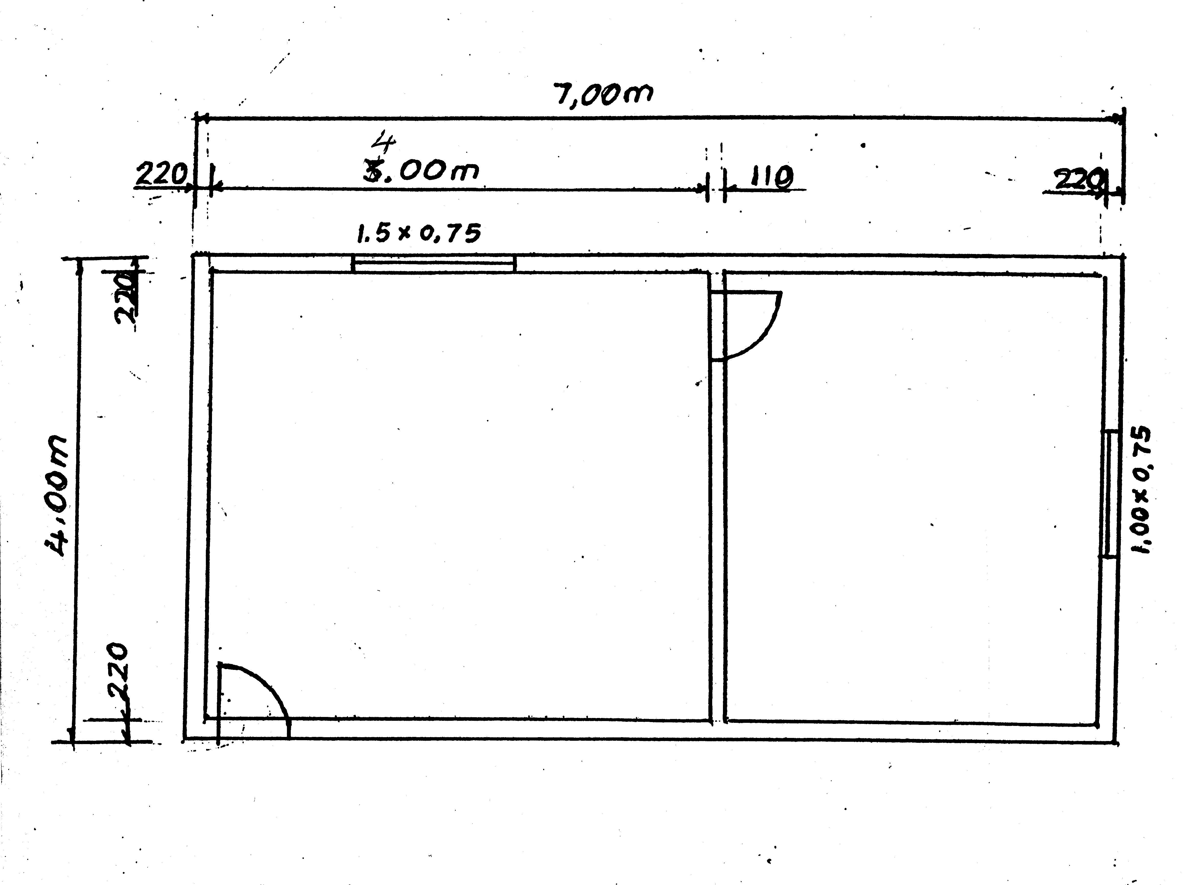

Figure 2

TOTAL: 300

