GAUTENG DEPARTMENT OF EDUCATION

SENIOR CERTIFICATE EXAMINATION

BRICKLAYING AND PLASTERING SG

TIME: 3 hours

MARKS: 300

REQUIREMENTS:

- Answer Book

- A2 drawing paper

- Calculators may be used.

INSTRUCTIONS:

- Answer ALL questions.

- Use both sides of the drawing paper.

- All drawings must be done on the drawing paper in pencil only.

- Assume the dimensions of a brick to be:

Length: 220mm

Width: 110 mm

Height: 75 mm

QUESTION 1  - Name FIVE qualities of a good brick.  1.2 State FOUR reasons why some bricks have perforations.  1.3 Name TWO reasons why sand is added to a concrete mix.  1.4 Safety precautions require certain standards to be maintained when working on a building site. Name THREE of these requirements.  - State the reasons for using pile foundation.  1.6 Define the term concrete.  1.7 Describe FOUR methods that can be used to cure concrete. | (10)  (8)  (4)  (9)  (3)  (4)  (12)  [50]

QUESTION 2

- Fully describe how boning rods and sight rails are set up and used in the excavation of a sewer trench which is to have a uniform fall.  - Give the standard abbreviations for the following drainage fittings:  2.2.1 Vent pipe  - Drain pipe  - Soilwater pipe  - Wastewater pipe  - Gulley  2.3 State the main difference between a vacuum tank and a septic tank.  2.4 Under what circumstances are vacuum tanks installed? | (22)  2x5=(10)  (6)  (6)  [44]

QUESTION 3

- Describe briefly what the following terms regarding scaffolds mean:  3.1.1 Toe board  - Guard rail  - Brace  - Sole plate  - Scaffold boards  3.1.6 Base plate | (4)  (4)  (4)  (4)  (4)  (4)

3.2 You are asked to make checks on a scaffold, to make sure that it is safe for working on. Mention SIX points that you would check.  3.3 Figure 1 illustrates different members of an independent scaffold. Write down  the question numbers 3.3.1 - 3.3.12 in your answer book and fill in the missing terms. | (12)  (24)  [60]

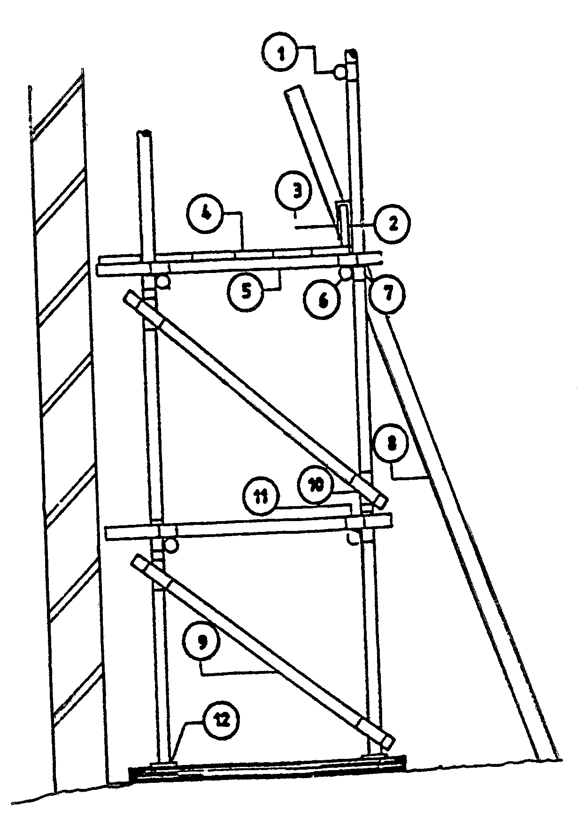
Figure 1

QUESTION 4

4.1 To a scale of 1:10, draw the alternate plan courses of a one-and-a-half brick  T-junction in Flemish bond.  - Describe the method used to mark off a gauge rod.  4.3 A South African type roof truss is constructed out of 38 mm x 114 mm timber and the roof is covered with corrugated sheet iron. The overhang of the roof is 460 mm and rests on a one-brick wall plastered internally. Draw to a scale of 1:10 the elevation of just more than half of the truss and name all the parts.  4.4 Name THREE materials that can be used for coping. | (20)  (10)  (20)  (6)  [56]

QUESTION 5

- Name FIVE places where fire bricks are normally used.  - Name FIVE external factors that may cause a chimney to smoke.  - Describe the slump test for concrete.  - Briefly describe the procedure to plaster a blank wall with one coat of cement plaster. The wall receives a wooden float finish. | (5)  (10)  (14)  (15)  [44]

QUESTION 6

Calculate the number of bags of cement required to cast a concrete pile with  diameter 600mm and depth 20,5 metres. The concrete mix is 1:2:3.  Assuming the volume of one bag of cement to be 0.033 m², calculate the quantity of cement required to the nearest bag. Ignore the bulking effect of sand.  6.2 Calculate the number of tiles of 300 mm x 300 mm required to tile a floor of 12.5 m x 3.45 m.  6.3 Calculate the number of bricks required to build a one-brick wall 20000 mm long and 21000 mm high. Assume that there are 110 bricks per 1m². | (20)  (18)  (8)  [46]

TOTAL: `300

