INSTRUCTIONS

Read the following carefully before answering the questions:

1.  2.  3.  4.  5.  6.  7.  8. | Answer ALL the questions.  Write ALL the answers in the ANSWER BOOK.  Number the answers exactly as the questions are numbered.  Start the answer to each question at the top of a new page.  All drawings should be made in pencil and labelled in ink.  Write neatly and legibly.  Calculators may be used.  The diagrams in the question paper may not necessarily be drawn to scale.

SECTION A

QUESTION 1

Various possible answers are provided for each question. Indicate the correct answer by writing only the letter next to the relevant question number.

1.1 | Questions 1.1.1, 1.1.2 and 1.1.3 refer to the diagram below. The diagram represents a living plant cell in a concentrated salt solution.

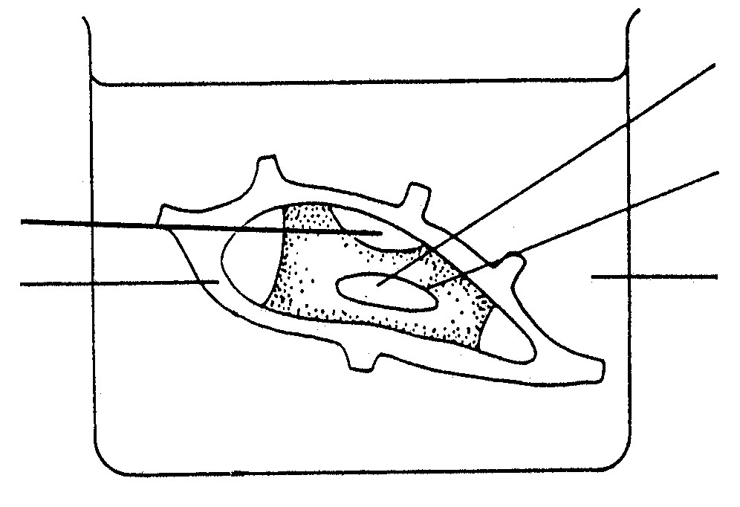
vacuole

tonoplast
Y

salt solution
X

 | 1.1.1 | Choose the term that represents the phenomenon indicated in the diagram:

 |  | A  B  C  D | Endosmosis  Wilting  Plasmolysis  Turgor

 | 1.1.2 | Which ONE of the following statements is TRUE of the part marked X in the diagram? It is composed of ...

 |  | A  B  C  D | cellulose and is differentially permeable.  cellulose and is impermeable.  proteins and fat and is permeable.  cellulose and is permeable.

 | 1.1.3 | Y indicates ...

 |  | A  B  C  D | water.  cytoplasm.  salt solution.  cell sap.

 | 1.1.4 | Which property of xylem tissue promotes capillarity?

 |  | A  B  C  D | Narrow, hollow tubes  Thickened cell walls  Perforated side walls  Many pits

 | 1.1.5 | On a hot day humans would produce urine that is ...

 |  | A  B  C  D | more concentrated than their body fluid.  less concentrated than their body fluid.  of the same concentrations as their body fluid.  of varying concentration.

 | 1.1.6 | Urine leaves each mammalian kidney through a muscular tube known as the …

 |  | A  B  C  D | urethra.  ureter.  bladder.  collecting duct.

Questions 1.1.7 and 1.1.8 are based on the accompanying diagram of a
neuron:

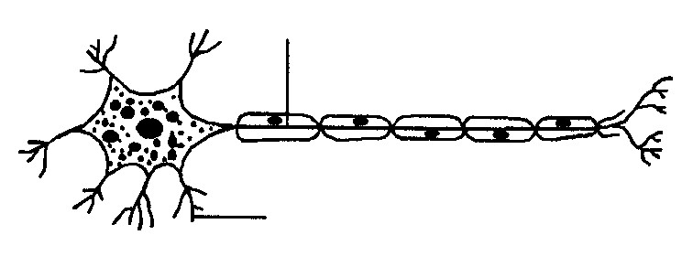

A

B

 | 1.1.7 | Part A is the ...

 |  | A  B  C  D | axon.  ganglion.  dendrite.  cytoplasm.

 | 1.1.8 | The function of B is to ...

 |  | A  B  C  D | stimulate muscles and glands to function.  transmit impulses in two directions.  transmit impulses to the cell body.  transmit and discharge impulses.

 | 1.1.9 | The use of iodised salt prevents …

 |  | A  B  C  D | diabetes.  goitre.  high blood pressure.  giantism.

 | 1.1.10 | Auxins increase or decrease the rate of ... in plant cells.

 |  | A  B  C  D | transpiration  respiration  photosynthesis  cell elongation (10 × 2) |  | (20)

1.2 | Give the correct biological term for each of the following descriptions. Write only the term next to the relevant question number.

 | 1.2.1 | The loss of water in liquid form from pores on the edge of the leaf

 | 1.2.2 | The growth reaction of a plant as a result of a directional, external stimulus

 | 1.2.3 | The process in which molecules move from an area of high concentration to an area of low concentration

 | 1.2.4 | The apparatus used to determine the influence of external factors on the rate of transpiration

 | 1.2.5 | The functional and structural unit of the human kidney

 | 1.2.6 | The name of the specialised epithelium cells in the Bowman’s capsule

 | 1.2.7 | The functional unit of the nervous system

 | 1.2.8 | The ability of the eyes to focus on an object, whether near or far

 | 1.2.9 | The part of the nervous system which forms the link between the brain and the spinal cord

 | 1.2.10 | A collective group of animals whose body temperature is regulated by the external temperature |  | (10)

1.3 | Match the information in COLUMN II with the term in COLUMN I by writing only the correct letter next to the relevant question number.

 |  | COLUMN I |  | COLUMN II
 | 1.3.1  1.3.2  1.3.3  1.3.4  1.3.5 | Turgor pressure  Xylem  Pinna  Hypothalamus  Renal pyramid | A  B  C  D  E  F  G  H  I | Removal of water  Carries urine from kidney to urinary bladder  Consists of vessels and tracheids  Tough membrane protecting kidney on the outside  Pressure of the cell contents on the cell wall  Directs sound waves into auditory canal  Responsible for voluntary actions  A group of renal tubes in the medulla of the kidney  Body temperature control centre
 | (5 x 2) |  |  |  |  | (10)

1.4 | Label parts 1 to 8. Write the answers next to the relevant numbers.

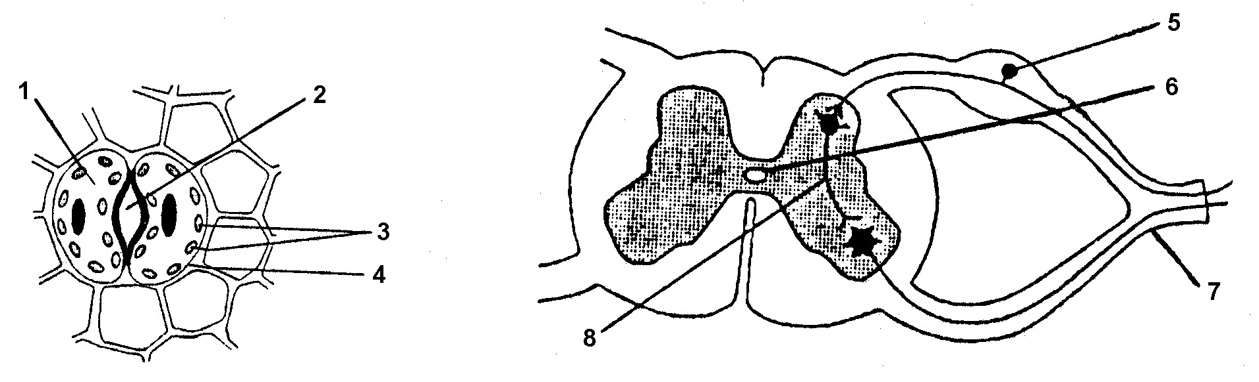

(8)

1.5 | What is the aim of each of the following experiments?

1.5.1

paraffin or oil
water

(1)

 | 1.5.2 | 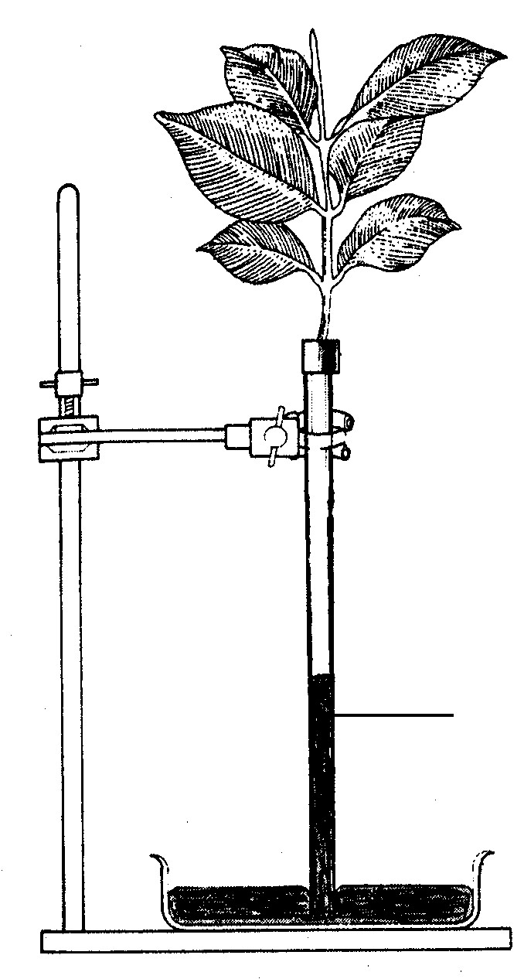

mercury

(1)

TOTAL SECTION A: |  | 50

SECTION B

QUESTION 2

2.1 | Study the diagrams below and answer the questions that follow:

water

 | 2.1.1  2.1.2  2.1.3  2.1.4  2.1.5  2.1.6 | Which organ is represented by cross-section A?  Identify the parts numbered 1 to 5.  Give ONE function of each of the following:  (i) Number 1  (ii) Number 4  (iii) Number 5  Discuss any THREE structural characteristics, which allow effective functioning of parts 1 and 4.  Explain the process taking place at B.  Make a labelled drawing of the apparatus used in the laboratory to illustrate the process in Question 2.1.5. |  | (1)  (5)  (1)  (1)  (1)  (6)  (5)  (5)  (25)

QUESTION 3

3.1 | The diagram below illustrates a part of an osmoregulatory structure in humans. Study the diagram and answer the questions that follow:

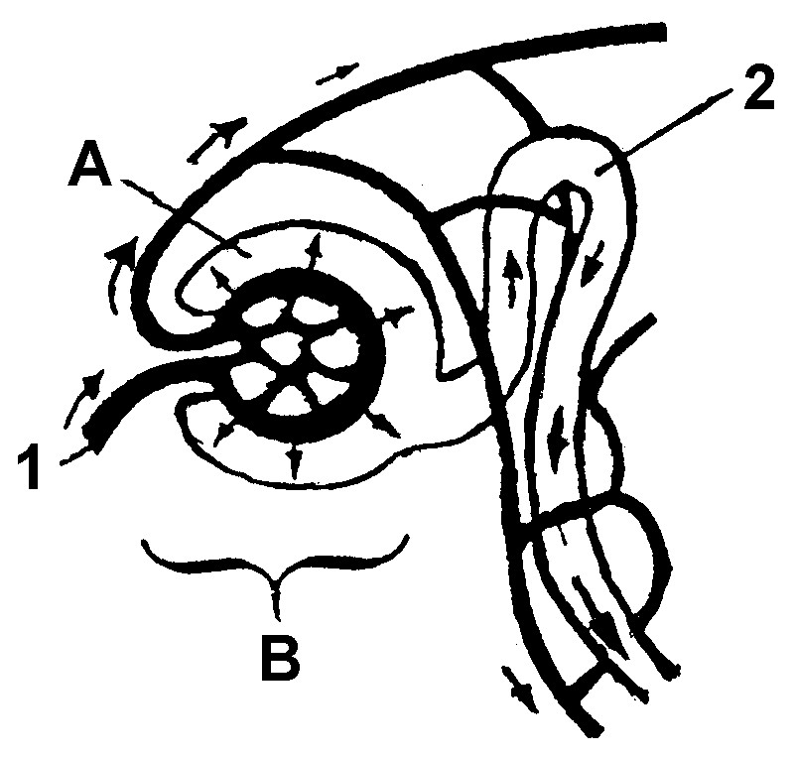

 | 3.1.1  3.1.2  3.1.3  3.1.4  3.1.5  3.1.6  3.1.7 | What is meant by the term osmoregulation?  Name the macroscopic osmoregulatory structure of which the diagram is a part.  Identify structure B.  Name THREE structural adaptations which ensure successful functioning of structure B.  By which process does fluid enter part A?  Name THREE other parts of a nephron not shown in the diagram.  The following substances are present in part 1:  blood platelets, blood corpuscles, plasma proteins, glucose, amino acids, urea, water, salts  Name THREE of these substances not found in 2. |  | (2)  (1)  (1)  (3)  (1)  (3)  (6)

3.2 | Discuss the role of ADH after someone drinks a great deal of water. |  | (6)

3.3 | Define homeostasis. |  | (2)  (25)

QUESTION 4

4.1 | Study the diagram below which represents a section through a part of the human eye and answer the questions that follow:

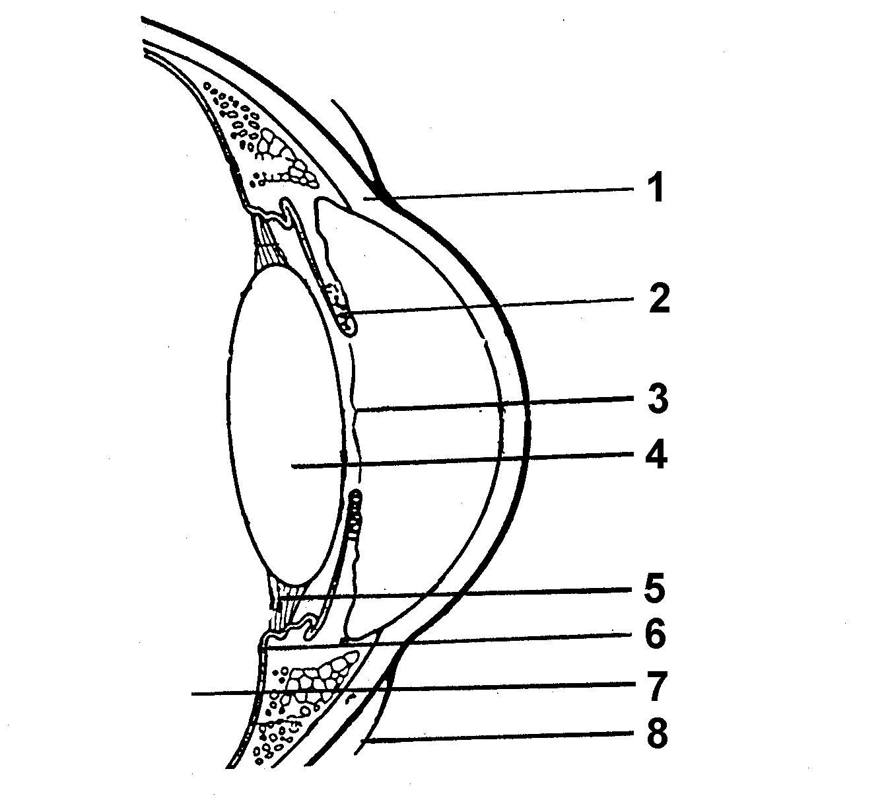

 | 4.1.1 | Write down the NUMBERS of the parts that are involved in the following:

 | (i)  (ii) | Changing the shape of the lens  Regulating the amount of light entering the eye |  | (2)  (2)

 | 4.1.2 | Identify the parts numbered 7 and 8. |  | (2)

4.2 | Give TWO functions of lachrymal fluid (tears). |  | (2)

4.3 | Study the diagram below and answer the questions that follow:

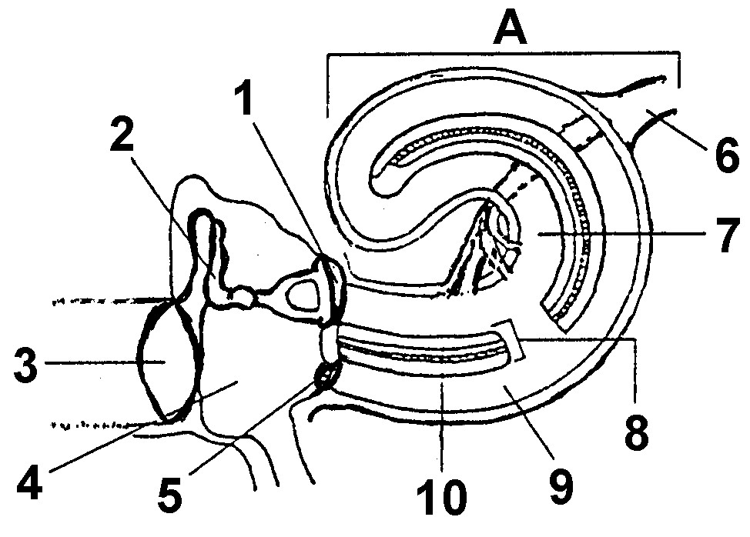

 | 4.3.1 | Label parts 1, 2, 3, 4 and 5. |  | (5)

 | 4.3.2 | What is found in number 4 under normal conditions and how is it maintained? |  | (4)

 | 4.3.3 | Write down the name of the part responsible for each of the following functions:

 |  | (i)  (ii) | Vibrations to the oval window  Transports nerve impulses to the brain |  | (1)  (1)

4.4 | Study the diagram below and answer the questions that follow:

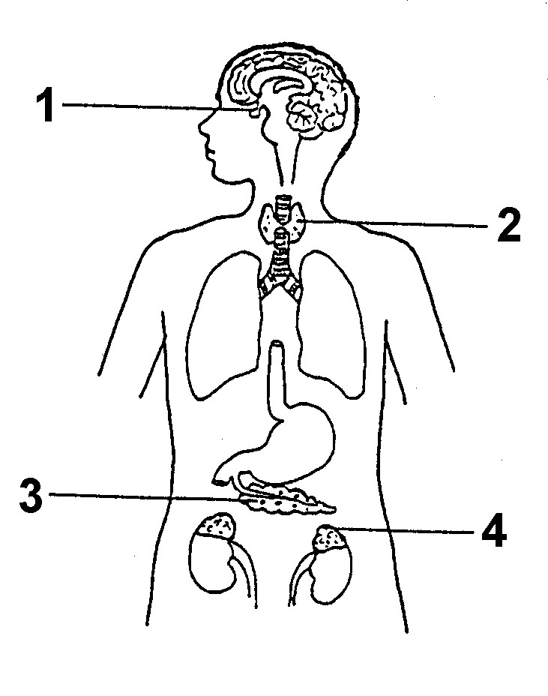

 | 4.4.1 | Identify the endocrine glands 1 to 4. |  | (4)

 | 4.4.2 | Write down the numbers of the glands where each of the following hormones are synthesised:

 |  | (i)  (ii) | Insulin  Adrenalin |  | (2)  (25)

QUESTION 5

5.1 | Study the diagram below of a part of the human central nervous system and answer the questions that follow:

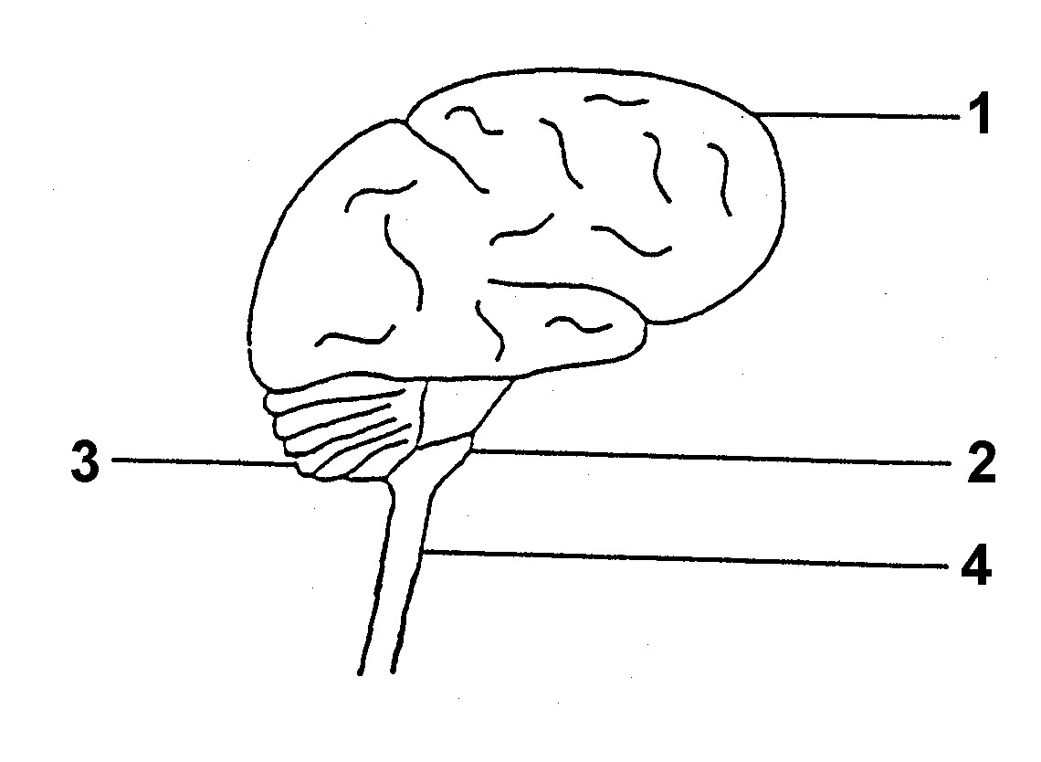

 | 5.1.1 | Identify the parts numbered 1 to 4. |  | (4)

 | 5.1.2 | State:

 |  | (i) THREE functions of the brain  (ii) TWO functions of the spinal cord |  | (3)  (2)

5.2 | The graph below shows how the body temperature of two animals varies with changes in the environmental temperature surrounding the animals.

60

50

40

30

20

10

0
Body temperature (°C) | dog
 |  |  | lizard
0 10 20 30 40 50
Air temperature (°C)

 | 5.2.1 | When the air temperature is 20 °C, give the body temperature of:

 | (i)  (ii) | The lizard  The dog |  | (1)  (1)

 | 5.2.2 | As the air temperature increases from 20 °C to 40 °C, how much body temperature change is observed in:

 | (i)  (ii) | The lizard  The dog |  | (2)  (2)

 | 5.2.3 | Explain how this change, referred to in Question 5.2.2 (i), might affect the activity of the lizard. |  | (2)

 | 5.2.4 | On a very hot day the dog might pant. Explain how this helps to cool the dog. |  | (3)

5.3 | Study the diagram of a part of the lymphatic system and related structures indicating blood and lymph vessels in human tissues. Answer the questions that follow:

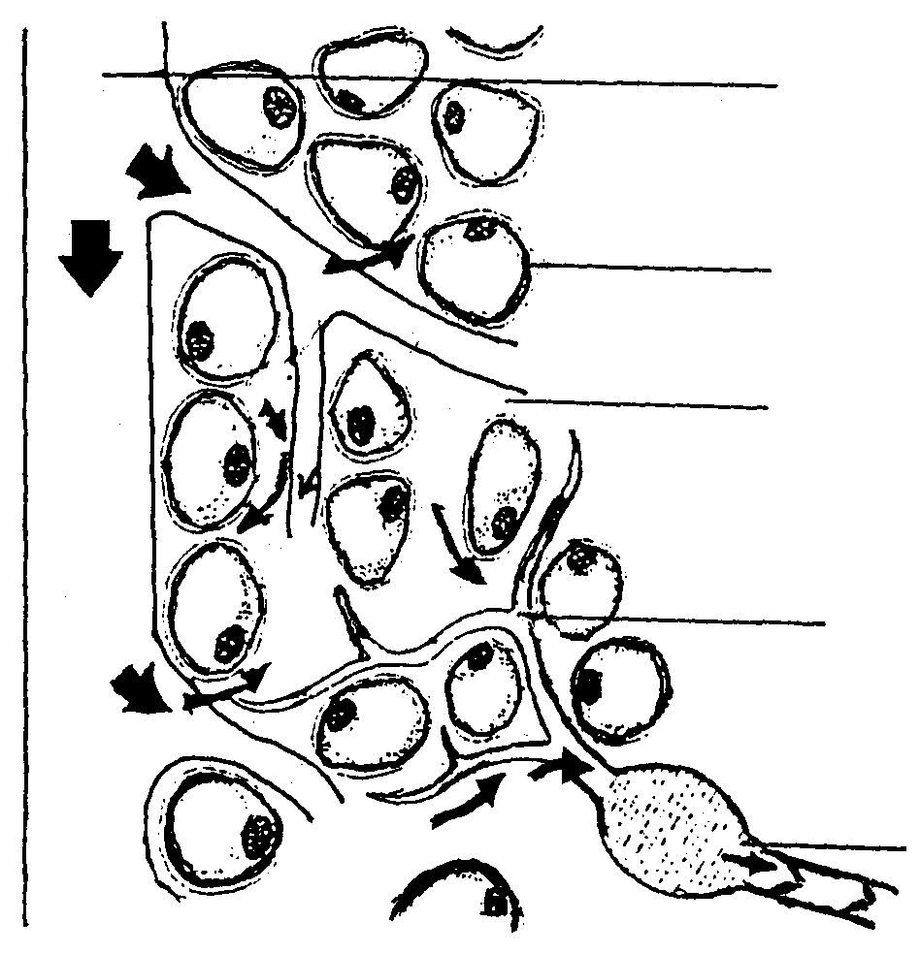
1

2

3

lymphatic duct

lymphatic node

 | 5.3.1  5.3.2 | Identify the parts numbered 1 to 3.  Name TWO substances which are needed for ordinary cell metabolism. |  | (3)  (2)  (25)

TOTAL SECTION B:  GRAND TOTAL: |  | 100  150

