INSTRUCTIONS

Read the following carefully before answering the questions:

1.  2.  3.  4.  5.  6.  7.  8. | Answer ALL the questions.  Write ALL the answers in the ANSWER BOOK.  Number the answers exactly as the questions are numbered.  Start the answer to each question at the top of a new page.  All drawings should be made in pencil and labelled in ink.  Calculators may be used.  Write neatly and legibly.  The diagrams in the question paper may not necessarily be drawn to scale.

SECTION A

QUESTION 1

1.1 | Various possible answers are provided for each question. Indicate the correct answer by writing only the letter next to the question number.

 | 1.1.1 | Under which conditions will guttation occur in plants?

 |  | A  B  C  D | Root pressure is low and the air is humid.  Root pressure is high and the stomatal pores are wide open.  Root pressure is high and the air is humid.  Root pressure is high and the wind is blowing strongly.

Questions 1.1.2, 1.1.3 and 1.1.4 are based on the graph below which indicates the relationship between the width of a stomatal pore and light intensity.

B C

Width of
stomatal
opening

A Light intensity

 | 1.1.2 | Which of the following conditions exist in the guard cells at A just before they progress towards the conditions at point B and C on the graph?

 | (i)  (ii)  (iii)  (iv) | Solutes begin to enter  Has a low water potential  Has a high turgor pressure  Has a low turgor pressure

 |  | A  B  C  D | (i) and (ii)  (ii) and (iii)  (i) and (iv)  (i), (ii) and (iv)

 | 1.1.3 | Why did the width of the stomatal opening not increase further  after B?

 | A  B  C  D | The concentration of soluble substances at B and C was optimal and the water potential in the guard cells remained high.  The concentration of soluble substances at B and C was the same and the turgor pressure in the guard cells remained low.  The turgor pressure of the guard cells at B is high and the water potential in the guard cells at C is low.  The water potential in the guard cells at B was high and the turgor pressure in the guard cells at C remained low.

 | 1.1.4 | Which process took place in the guard cells between A and B on the graph?

 |  | A  B  C  D | Plasmolysis  Endosmosis  Exosmosis  Isosmosis

 | 1.1.5 | An animal that has very long loops of Henlé, probably lives in a/an ... environment.

 |  | A  B  C  D | aquatic  terrestrial  arid  humid

 | 1.1.6 | The ability of the lens to change its curvature is known as …

 |  | A  B  C  D | optic chiasm.  stereoscopic vision.  accommodation.  optical illusion.

In experiments with plant growth substances in young stems the following results were obtained. Study the results in the diagrams below and answer Questions 1.1.7 – 1.1.9 that follow:

TREATMENT RESULT

1 layer of animal fat

LIGHT

growing point cut off and replaced on a layer of animal fat no further growth

2 layer of gelatin

LIGHT

growing point cut off and replaced on a layer of gelatin growth towards light

3

LIGHT

no treatment growth towards light
aluminium foil cap
4

LIGHT

growing point covered growth upwards

 | 1.1.7 | Which of the following combinations of treatments indicated that the growth substances were produced in the tip of the stems?

 |  | A  B  C  D | 1 and 2  2 and 3  3 and 4  1, 2, 3 and 4

 | 1.1.8 | Which of the following combinations of treatment(s) indicated that the growth substances were sensitive to light?

 |  | A  B  C  D | Only 1  2, 3 and 4  Only 4  3 and 4

 | 1.1.9 | Which functional properties of growth substances are illustrated by treatments 2 and 4? Growth substances are...

 |  | A  B  C  D | sensitive to light and soluble in animal fats.  produced in the tip of the stem, but not influenced by light.  produced below the growing points of stems and insoluble in fats.  sensitive to light.

 | 1.1.10 | A plant which was accidentally given too much fertiliser started to wilt and died after two days. The probable reason was that the …

 |  | A  B  C  D | cell membranes became impermeable to water.  water potential of the soil solution was lower than the water potential in the vacuoles of root hairs.  root hairs absorbed too much fertiliser.  fertiliser increased the water potential of the soil water.  (10 × 2) |  | (20)

1.2 | Give the biological term for each of the following descriptions. Write only the term next to the relevant question number.

 | 1.2.1 | A small, unthickened area of the secondary cell wall which allows substances to pass between cells

 | 1.2.2 | The layer of cells surrounding the central cylinder (stele) forming the innermost part of the cortex of the root

 | 1.2.3 | Differentially permeable membrane enclosing the cell sap
 | 1.2.4 | Layer on the surface of leaves reducing the rate of transpiration
 | 1.2.5 | A strengthening, non-cellulose compound found in the xylem vessels
 | 1.2.6 | A growth hormone which promotes the ripening of fruit
 | 1.2.7 | Cone-shaped columns of tissue in the medulla of the kidney
 | 1.2.8 | The fluid found in the renal pelvis of the kidney

 | 1.2.9  1.2.10 | Vision made possible by two eyes with different, but overlapping, visual fields  The part of the eye which prevents reflection of light |  | (10)

1.3 | Match the word/term in COLUMN II with the information in COLUMN I by writing only the correct letter next to the relevant question number.

 | 1.3.1  1.3.2  1.3.3  1.3.4  1.3.5 | COLUMN I  Insulating layer of a neuron  The hormone preparing the body for emergencies  The part of the brain responsible for muscle tone  Part of the central nervous system at the upper end of the spinal cord  Area of chemical transfer of impulses | A  B  C  D  E  F  G  H  I  J  K  L  M  N | COLUMN II  Hypothalamus  Medulla oblongata  ADH  Adrenalin  Myelin sheath  Cerebellum  Thyroid gland  Synapse  Insulin  Reduced growth  Epineurium  Hypophysis  Cerebrum  Gigantism

 | (5 x 2) |  | (10)

1.4 | Study the diagram of an experiment below and answer the questions that follow:
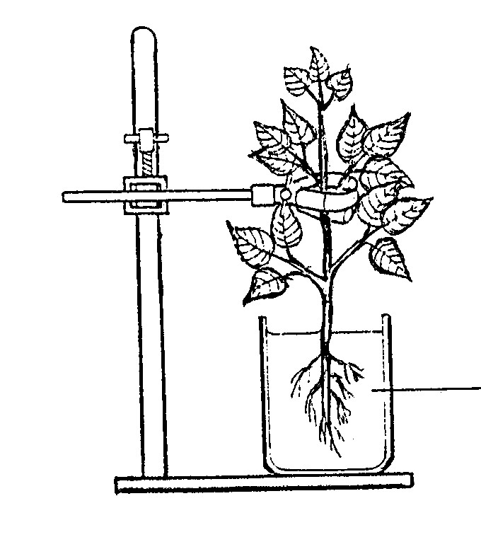

eosin solution
(red solution)

 | 1.4.1 | What is the aim of the above experiment? |  | (2)

 | 1.4.2 | Give ONE precautionary measure to be taken when setting up the experiment. |  | (2)

 | 1.4.3 | Draw a cross-section through the stem of the plant in this experiment and indicate the result. |  | (4)

1.5 | State whether each of the phrases in COLUMN II applies to A only, B only, both A and B or none in COLUMN I. Write down A only, B only, A and B or none next to the appropriate question number.

 | 1.5.1 | COLUMN I  A - Cornea  B - Conjunctiva | COLUMN II  Contain pain receptors to protect the eye
 | 1.5.2 | A - Olfactory receptor cell  B - Taste buds | Chemoreceptors reacting to gases
 | 1.5.3 | A - Neuron  B - Nephron | Conduct stimuli
 | 1.5.4 | A - Selectively permeable  membrane  B - Permeable membrane | Re-absorption in proximal convoluted tubules
 | 1.5.5 | A - Filtration  B - pH balance | Takes place in distal convoluted tubules
 | 1.5.6 | A - Mammals  B - Fishes | Use countercurrent heat exchange mechanism for thermo regulation
 | (6 × 2) |  |  |  | (12)

 |  | TOTAL SECTION A: |  | 60

SECTION B

QUESTION 2

2.1 | Study diagrams A and B below, illustrating sections of the nephron, and answer the questions that follow:
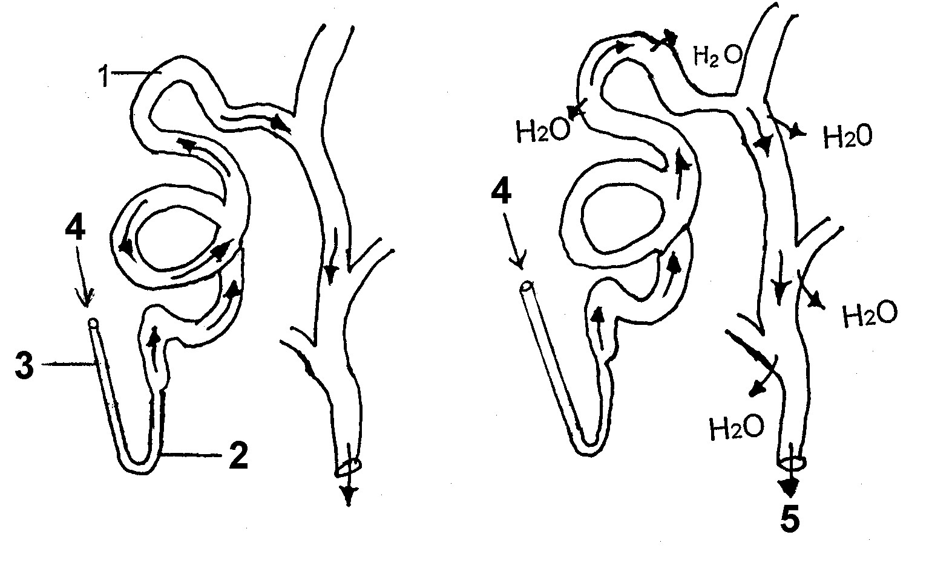

A B
Diluted urine Concentrated urine

 | 2.1.1 | Label parts 1 and 2. |  | (2)

 | 2.1.2 | Explain what caused the difference in urine concentration between diagrams A and B. |  | (6)

 | 2.1.3 | Give possible reasons for the difference in concentration mentioned in Question 2.1.2. |  | (4)

 | 2.1.4 | Tabulate FOUR differences between the fluid entering at 4 and leaving at 5. |  | (8)

2.2 | Give FIVE ways in which the glomerulus is structurally adapted for its function. |  | (5)

2.3 | Explain why the process in the kidney is called filtration rather than diffusion. |  | (6)

2.4 | How does the kidney regulate the blood pH when it becomes too low? |  | (4)  (35)

QUESTION 3

3.1 | The diagram below illustrates the structure of the central nervous system and part of the spinal cord of a person who has had an accident. Study the diagram and answer the questions that follow:

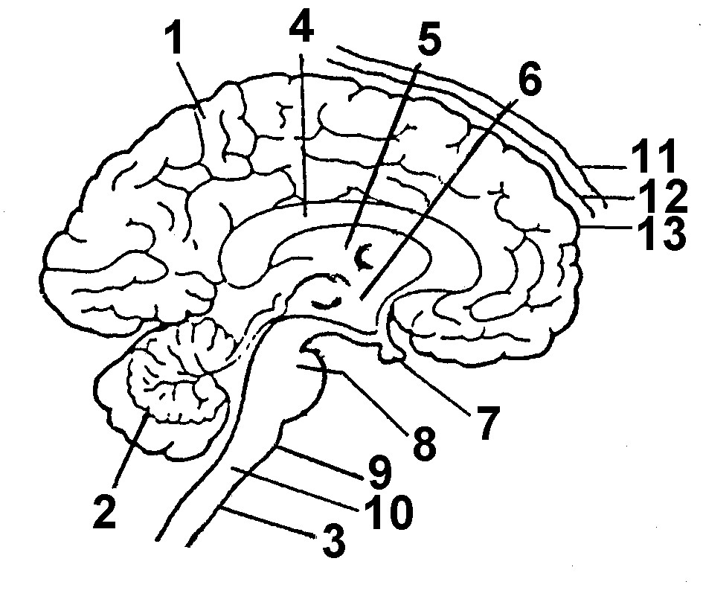

 | 3.1.1 | Label numbers 1, 2, 3 and 9. |  | (4)

 | 3.1.2 | Give the number(s) of the part(s) responsible for the following responses in this person:

 |  | (i)  (ii)  (iii)  (iv) | Deep breathing  Controlling high body temperature  Increased pulse rate  Loss of memory |  | (8)

 | 3.1.3 | In order to determine the condition of the person, a doctor examined fluid taken from between the parts marked 11 and 12.

 |  | (i)  (ii)  (iii) | Identify parts 11 and 12.  Name the fluid present between 12 and 13.  Give TWO functions of the above-mentioned fluid. |  | (2)  (1)  (2)

3.2 | In order to stabilise the condition of the injured person, he was injected intravenously with adrenalin. The following graph illustrates the changes that occurred in the pulse rate of this person after the injection was administered. Study the graph below and answer the questions that follow:

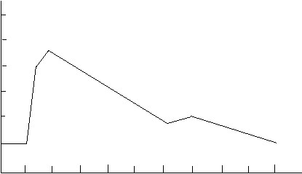
Pulse rate (beats per minute) per minute
110

100

90

80

70
inspuiting toegedien
injection given
60

50
1 2 3 4 5 6 7 8 9 10
Time (minutes)

 | 3.2.1  3.2.2  3.2.3  3.2.4 | Give the pulse rate before the injection.  What is the pulse rate ONE minute after the injection?  Explain why the pulse rate increased after the injection and then decreased again.  Give TWO other functions of adrenalin. |  | (1)  (1)  (4)  (2)

3.3 | Describe the pathway of a sound stimulus and the impulse it generates until it reaches the brain. |  | (10)  (35)

QUESTION 4

4.1 | Study the diagram below illustrating a section of the skin and answer the questions that follow:
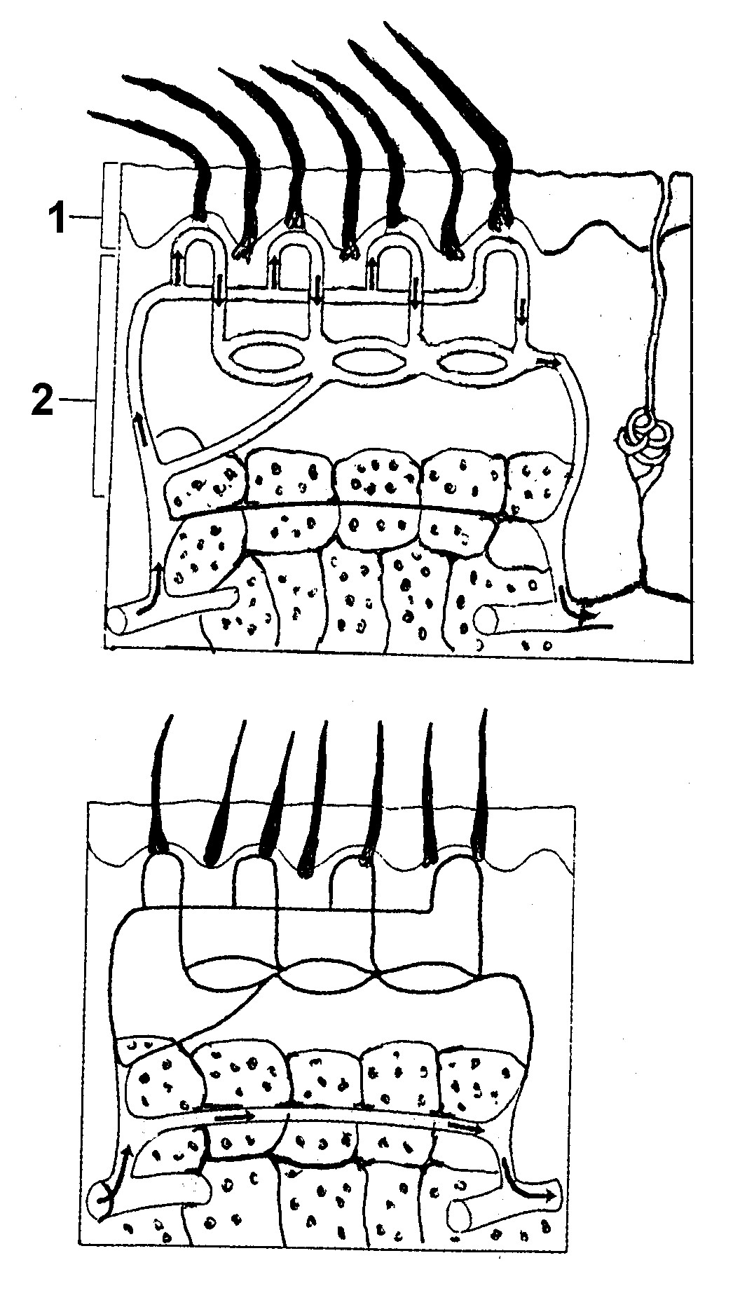

A

B

 | 4.1.1  4.1.2  4.1.3  4.1.4 | Label layers 1 and 2.  Which diagram, A or B, shows what happens on a cold day? Give TWO reasons for the answer.  Name FOUR parts in layers 1 and 2 that play a role in thermo-regulation.  Explain the role of the parts mentioned in Question 4.1.3 on a hot day. |  | (2)  (3)  (4)  (8)

4.2 | An athlete puts ice on his/her painful ankle. At first he/she complains that the pack is too cold, but soon the pack feels warmer. Explain this phenomenon. |  | (3)

4.3 | Study the diagram below, illustrating the relationship between body cells and their surroundings.

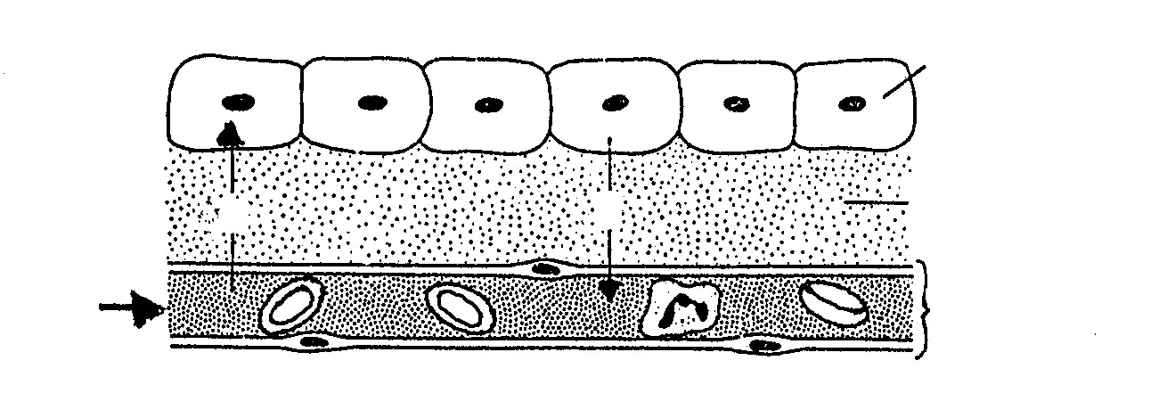
body cell

fluid C
B
A

blood flow

 | 4.3.1  4.3.2 | What is the name of fluid C?  Name TWO substances which are transported through fluid C as indicated by A and B, respectively. |  | (1)  (4)

4.4 | A person touching a pan coming out of an oven pulls his/her hand away. Explain why the person was able to respond before thinking. |  | (3)

4.5 | Name any THREE changes which occur in the body of a person suffering from an undersecretion of insulin. |  | (3)

4.6 | Why is iodised table salt better for one’s health than non-iodised salt? |  | (4)  (35)

 | TOTAL SECTION B : |  | 105

SECTION C

QUESTION 5

5.1 | In an experiment five blocks of a carrot were cut so that each block was of the same mass. They were placed in different test tubes, A to E, each containing different concentrations of sugar solutions. After 8 hours the blocks were removed and dried with a paper towel. Some of the blocks gained mass and some had lost mass. The results are shown in the table below:

Concentration sugar solution  (g/100 cm³) | A | B | C | D | E
Concentration sugar solution  (g/100 cm³) | 2 | 6 | 10 | 14 | 18
Change in mass  (g) | + 1,2 | + 0,5 | 0 | - 0,4 | - 0,8

 | 5.1.1 | Draw a line graph to illustrate the results in the table above. |  | (9)

 | 5.1.2 | Give ONE reason why there was no change in the mass of block C. | (2)

 | 5.1.3 | How would the vacuoles of block A differ from those of block E after 8 hours? Give a reason for the answer. |  | (4)

 | 5.1.4 | What would you expect if block E is taken out of its test tube and placed in distilled water? Give a reason for the answer. |  | (2)

5.2 | Explain the upward movement of water from roots to the atmosphere in mesophytic plants and how environmental factors may affect this movement.  Content: 15  Synthesis: 3  TOTAL SECTION C: |  | (18)  35

 | GRAND TOTAL: |  | 200

